|  |  |  |
| --- | --- | --- |
|  | | **MINISTRY OF EDUCATION AND TRAINING** |
|  | | |
| Capstone Project Document | | |

KARYWELL SYSTEM

|  |  |  |
| --- | --- | --- |
| **KARYWELL System** | | |
| **Group Members** | Le Van Quy Hoang | SE90184 |
| Tran Dinh Hoang Huy | SE90201 |
| Nguyen Khac Hoang | SE02564 |
| Kieu Cao Khanh | SE02960 |
| Nguyen Van Quyen | SE02884 |
| Nguyen Thi Hong Nhung | SE02437 |
| **Supervisor** | Mr. Tran Binh Duong | |
| **Project code** | KW | |

**- Hanoi, 12/2015 -**

**Acknowledge**

*We specially thank to Mr.Tran Binh Duong, our supervisor, for his support throughout this project. His instruction and motivation has been lessons for us not only about technique, but also about how to work as a team in a real project.*

*We also thank to our families and friends. Their encouragement has helped us to overcome many pressure to complete our product.*

TABLE OF CONTENTS

I. INTRODUCTION 1

1. PROJECTINFORMATION 1

2. PROJECT TEAM 1

3. INITIAL IDEAL 2

Background 2

Literature review 5

Our Proposal 11

II. PROJECT MANAGEMENT PLAN 14

4. PROJECT OVERVIEW 14

1.1 Project description 14

1.2 Scope and purpose 14

1.3 Standard Objectives 15

1.4 Milestones and Deliverables 15

1.4.1. Milestones 15

1.4.2. Deliverables 16

2. PROJECT ORGANIZATION 18

2.1 Software Process Model 18

2.2 Project Lifecycle 18

2.3 Roles and Responsibilities 19

3. TOOLS AND INFRASTRUCTURES 20

4. SCHEDULES 21

4.1. Detail Schedules 21

5. COMMUNICATION MANAGEMENT 22

5.1. Stakeholders and Contacts 22

5.2. Communication Management Approach 22

5.3. Communication Method and Technologies 23

5.4. Escalation procedures for resolving issues 23

5.5 Communication Matrix 24

6. RISK MANAGEMENT 27

6.1. Risk Management Approach 27

6.2. Risk Identification 27

6.3. Risk Monitoring 27

6.4. Risk Register 28

6.4.1. Risk description 28

6.4.2. Probability – Impact matrix 30

6.4.3. Risk response plan& Risk status 31

7. QUALITY MANAGEMENT 33

7.1. Quality Management Overview 33

7.1.1. Organization, Responsibilities, and Interfaces 33

7.1.2. Tools, Environment, and Interfaces 33

7.2. Quality Planning 34

7.2.1. Define Project Quality 34

7.2.2. Measure Project Quality 35

7.3. Quality Assurance 35

7.3.1. Analyze Project Quality 35

7.3.2. Improve Project Quality 36

7.4. Quality Control 38

7.5. Action Plan 39

III. SOFTWARE REQUIREMENT SPECIFICATION 40

1. INTRODUCTION 40

1.1. Purpose 40

1.2. Scope 40

1.4. Overview 40

2. OVERVIEW DESCRIPTION 41

2.1. Product perspective 41

2.2. Product functions 41

2.3. User characteristics 41

2.4. Constraint 42

2.5. Assumption and dependencies 42

2.6. Activity Diagram 42

2.7. State Machine Diagram 43

2.8. Entity Relationship Diagram 44

3. FUNCTIONAL REQUIREMENTS 45

3.1. Web application for Admin 45

3.1.1. User Case Diagram 45

3.1.2. Functions 46

3.2. Web application for Store 103

3.2.1. User Case Diagram 103

3.2.2. Function 104

3.3. Mobile application for Shipper 153

3.3.1. User Case Diagram 153

3.3.2. Function 154

4. NON – FUNCTIONAL REQUIREMENTS 193

4.1. Usability 193

4.2 Performance 193

4.3 Reliability 193

4.4 Maintainability 194

4.5 Security 194

IV. SOFTWARE DETAIL DESIGN 195

1. ARCHITECTURE DESIGN 195

1.1 Introduction 195

1.1.1. Purpose 195

1.1.2.Scope 195

1.1.3. Overview 195

1.2. Description 196

1.2.1. Use case view 196

1.2.2. Logical view 196

1.2.3. Implementation view 196

1.2.4. Deployment view 196

1.2.4. Process view 197

1.3. Architecture goal & constraints 197

1.3.1. Technical Platform 197

1.3.2. Communication 197

1.3.3. Security 197

1.3.4. Reliability/Availability 197

1.3.5. Performance 197

1.3.6. Maintainability 197

1.4. Use case view 198

1.4.1. Admin 198

1.4.2. Store 199

1.4.3. Shipper 200

1.5. Deployment view 201

1.6. Implementation view 202

1.7. Choice of architecture design 202

1.8. QUALITY 204

2. DETAIL DESIGN 205

2.1. Introduction 205

Purpose 205

2.2. Detail design 205

2.2.1. Mobile Application 206

2.2.2. Web Application 221

3. DATABASE DESIGN 272

3.1. Introduction 272

3.1.1. Purpose 272

3.1.2. Overview 272

3.1.3. Definition and Acronyms 272

3.2. Database design 273

3.2.1. Entity Relationship Diagram 273

3.2.2. Table Diagram 274

4. INTERFACE DESIGN 283

4.1. Introduce 283

4.2. Interface Design of Mobile Application 283

4.2.1. Structure and Layout 283

4.2.2. Screen Description 284

4.3. Interface Design of Web Client 293

4.3.1. Admin 293

4.3.2. Store 323

V. TEST 343

1. TEST PLAN 343

1.1. Introduction 343

1.1.1. Purpose 343

1.1.2. Scope of testing 343

1.1.3. Contraints 343

1.1.4. Risks List 344

1.2. Requirement For Test 344

1.2.1. Features to be tested 344

1.2.2. Features not to be tested 346

1.3. Acceptance Test Criteria 346

1.4. Test strategy 346

1.4.1. Test type 346

1.4.2. Test stages 349

1.4.3 Test Model 351

1.4.4. Testing Process 352

1.5. Resource 352

1.5.1. Human resource 352

1.5.2. Environmentrecourse 353

1.6. Test Milestones 353

1.7. Deliverables 354

2. TEST CASE 354

2.1. Unit test 354

2.2. Integration test 354

2.3. System test 354

3. TEST REPORT 355

3.1. Unit test 355

3.2. Integration test 359

3.3. System test 359

3.3.1. Increment 1 359

3.3.2. Increment 2 360

3.4. Bug control chart 362

4. CHECKLIST 363

VI. INSTALLATION GUIDE AND USER MANUAL 364

1. INSTALLTION GUIDE 364

1.1.1. Prerequisites 364

1.1.2. Installation procedures 364

1.1.3. Uninstall procedures 364

1.2.1. 前提条件 364

1.2.2. インストール手順 365

1.2.3. アンインストール手順 365

2.1.1. Admin 365

2.1.2. Store 376

VII. CONCLUSION 400

1. LESSONS LEARN 400

2. FUTURE WORK 400

**ACRONYMS & ABBREVIATIONS**

| Abbreviations | Description | Note |
| --- | --- | --- |
| KW | Kary Well |  |
|  |  |  |
|  |  |  |
|  |  |  |
|  |  |  |
|  |  |  |
|  |  |  |
|  |  |  |
|  |  |  |
|  |  |  |
|  |  |  |
|  |  |  |
|  |  |  |
|  |  |  |
|  |  |  |
|  |  |  |
|  |  |  |
|  |  |  |
|  |  |  |
|  |  |  |
|  |  |  |
|  |  |  |
|  |  |  |

# I. INTRODUCTION

1. PROJECTI**NFORMATION**

* **Project name:** KaryWell System
* **Project code:** KW
* **Project type:** Web application, Mobile application
* **Project category:** New development
* **Business domain:** Education
* **Project manager:** Le Van Quy Hoang
* **Timeline:** September 7th 2015 to December 15th 2015

1. **PROJECT TEAM**

* **Supervisor**

|  |  |  |
| --- | --- | --- |
| **Name** | **Email** | **Title** |
| **Tran Binh Duong** | duongtb@fpt.edu.vn | Supervisor |

* **Team member**

|  |  |  |  |
| --- | --- | --- | --- |
| **Name** | **Student Roll** | **Email** | **Role** |
| **Le Van Quy Hoang** | SE90184 | hoanglvqse90184@fpt.edu.vn | Leader |
| **Tran Dinh Hoang Huy** | SE90201 | huytdhse90201@fpt.edu.vn | Member |
| **Nguyen Khac Hoang** | SE02564 | hoangnkse02564@fpt.edu.vn | Member |
| **Kieu Cao Khanh** | SE02960 | khanhkcse02960@fpt.edu.vn | Member |
| **Nguyen Van Quyen** | SE02884 | quyennvse02884@fpt.edu.vn | Member |
| **Nguyen Thi Hong Nhung** | SE02437 | nhungnthse02437@fpt.edu.vn | Member |

1. **INITIAL IDEAL**

## **Background**

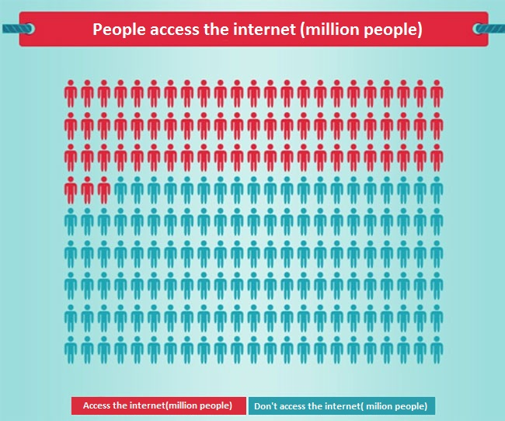According to the statistics of **Vietnam E-Commerce and Information Technology Agency**, in 2013 the population of Viet Nam is up to 90 million, in which 36%(31,3 million people) Internet access and more than half of this is shopping online.

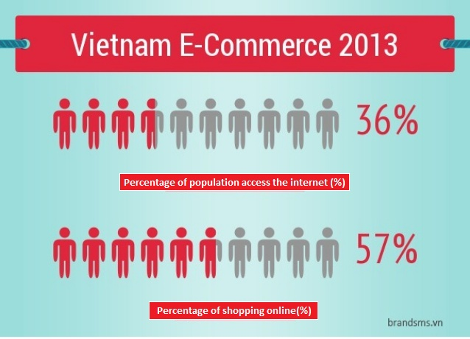

Results of the survey on users purchasing methods in the Asia - Pacific in 2014 have indicated that the number of people who regularly use computers and phones to shop has been very high. Online shopping market, as a result, is very large.

Indeed, nowadays there are a variety of fan pages and online shopping sites with classified advertising such as enbac, muare, rongbay, etc. Therefore, all enterprises are constantly upgrading the quality of customer service to remain competitive in the market.

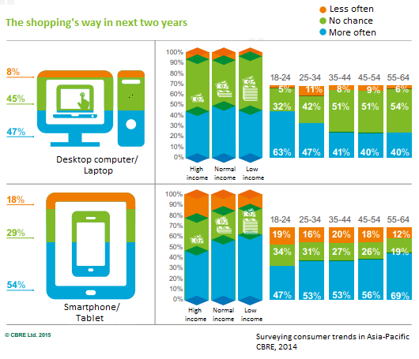

Figure 1: Surveying consumer trends in Asia- Pacific (2014)

According to FTA Research & Consultant’s survey report, home delivery service is one of the customers’ most-concerning criterions. 61% of people said that home delivery is very important when shopping online. 58% said that fast delivery is very important. As a result, there have been many businesses investing in developing home delivery service. That makes the service become a potential market.

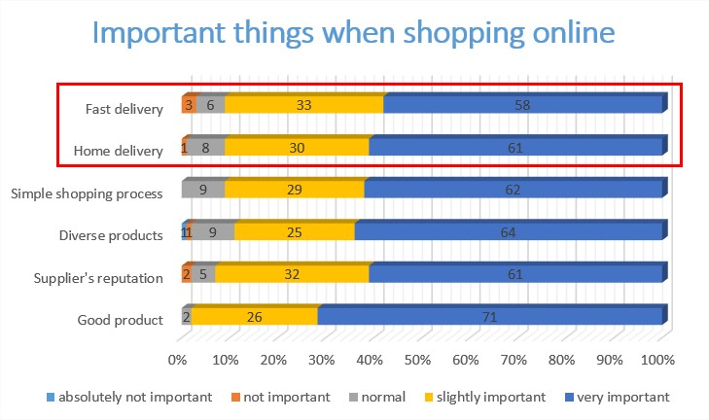

In Vietnam the legal procedures to become a delivery services enterprise very simple.

According to Clause 1 of Article 12 of Decree No.128/2007/NĐ-CP dated 02nd August 2007 on Delivery Services, Enterprises set up under Vietnamese law may deal in delivery services when they are granted a delivery service business registration certificate, for enterprises with domestic investment capital, or a certificate of investment in the domain of delivery in Vietnam, for enterprises with foreign investment capital of which capital portions contributed by foreign partners do not exceed 51%.

Besides this Decree also shows the very clear provisions on the rights and obligations of enterprises and users of delivery services. Therefore, enterprises can easily solve the problem related to law.

Such as, at the point “a” of Clause 1 of Article 20 in this Decree says that Delivery service enterprises have the right: “To request consignors to permit the examination of contents of information in the form of document (excluding mails), merchandise packages or packs to be delivered”.

At point a of Clause 2 of Article 21 in this Decree says that delivery service users have the obligation: ”To bear responsibility before law for the contents of information in the form of document, merchandise packages or packs”

## Literature review

The current shipping service providers can be devided into 2 groups:

* + 1. Free shipper

This is a group of free shippers through applications to search ship orders. The shipper does not belong to an organization or company. But having just under 100 download times and not work anymore.

Example: Fship, Shipme app.

* + 1. Shipper companies

This is a group of large companies but have different modes of operation.

* + - 1. Via Facebook

This group use Facebook to advertise and use GoogleForm as a tool for received order.

Example: Family Shipper, Shipper Team.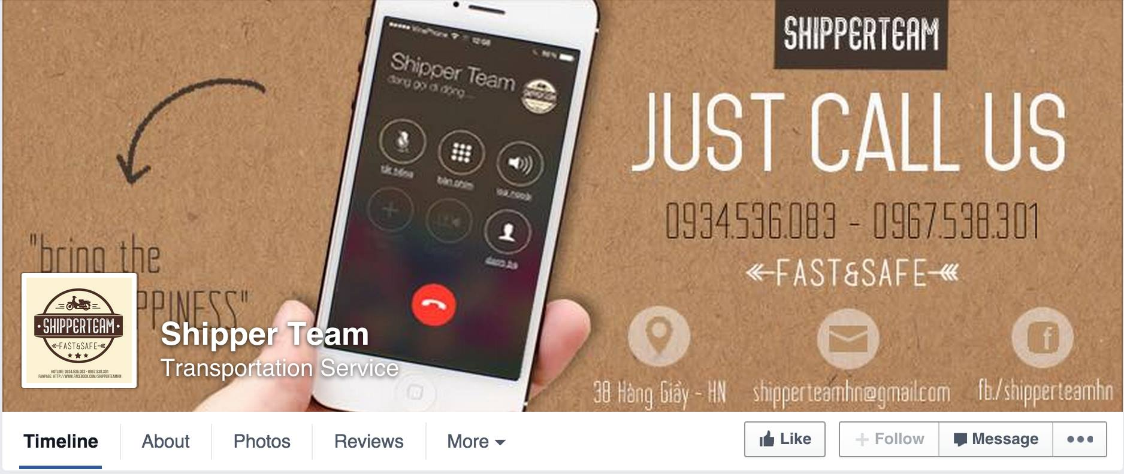

Shipper Team is the best in this group. Shipper Team is a shipping serviceoperates pretty well in Hanoi. All the transactions is confirmed via Facebook and phone. This group use Google Forms as a send and receive order tool.

Bellow are information of Shipper Team:

**Functions:**

- Register usual location to receive products

- Make phone call, comment on Facebook or use Google Forms to create order

- Help the stores collect money

**Pros**

* Express shipping after receiving order
* Work from 8:30 till 21:00 each day, 7 days per week including holiday
* Ensure collecting money without guarantee fee

**Cons:**

* No statistics for customer
* Price is not competitive
* All transactions which shippers are make by telephone.
* All the processes are performed directly by humans.
* Can’t track order’s status.
  + - 1. Via website

This group just have website for receiving order from the stores, don’t apply technology to support transportation and delivery process.

Example**: - Giaohangnhanh**, HanoiShip, GoGoShip, ShipViet.

* **ZoZoShip**, ProShip (Big companies but haven’t exploited North Vietnam market)

**Giaohangnhanh.vn**

Giaohangnhanh.vn is an express delivery system that delivers commodities and letters nationwide.

**Functions:**

* Customer register
* Create orders to request ship
* Track order’s status
* Create usual order receive location
* Deliver and help customer in collecting cash (Cash on delivery-COD)

**Some screenshots:**

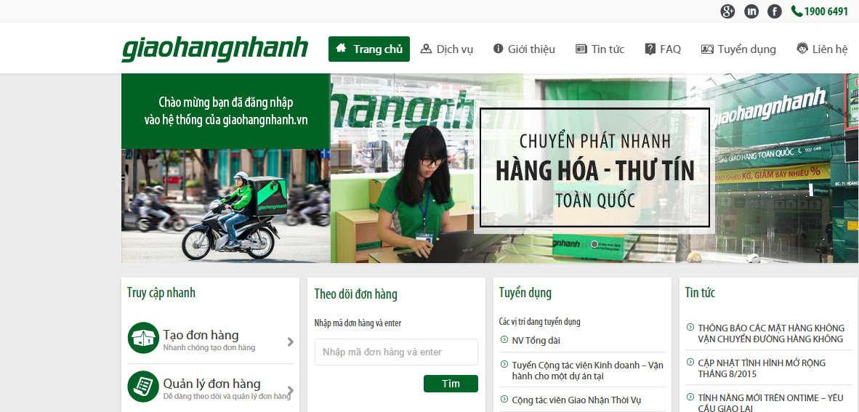

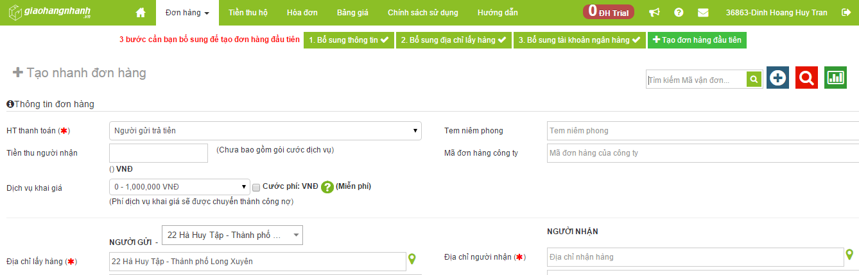

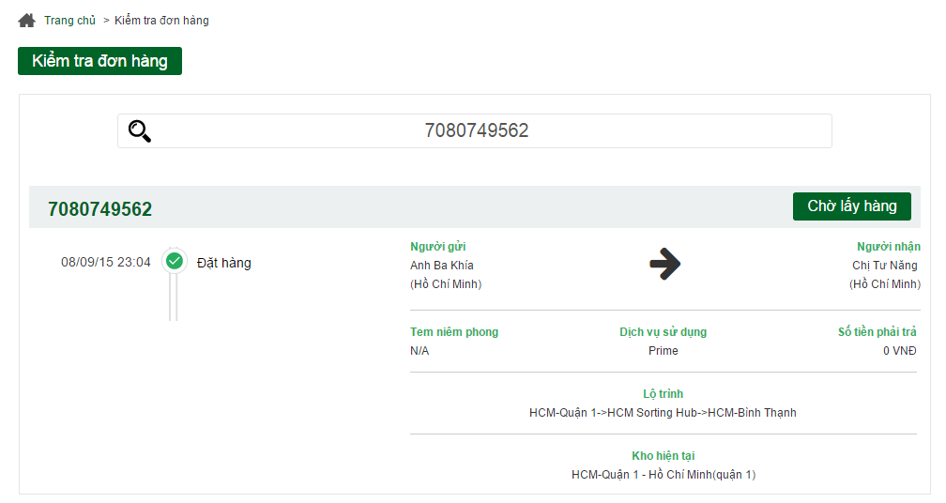

**Pros:**

* Well know brand image in Vietnam
* Having many shippers, system can receive lots of orders
* Low price

**Cons:**

* Don’t apply technology to immediately find the nearest shipper to the order, must wait for staffs to arrange
* Track order function is not well interface, just use text to display status (Wait, Shipper is comming, Shipping, Done)
* Don’t have express delivery service.
* Don’t have mobile app for shipper to find the way.

**ZOZOSHIP:** [**http://zozoship.vn/**](http://zozoship.vn/)

ZoZoShip is a shipper system that has work method: Customer calls to customer service center or creates order via website. So ZoZo’s shipper go to customer’s store, get commodity and delivers to requested place. When the transaction is done, get receivable money and return to pay back for the store.

**Functions:**

* Customer register
* Create order on website, enter goods information
* Update, add common delivery – received place
* Bank transfer cash on delivery

**Some screenshot:**

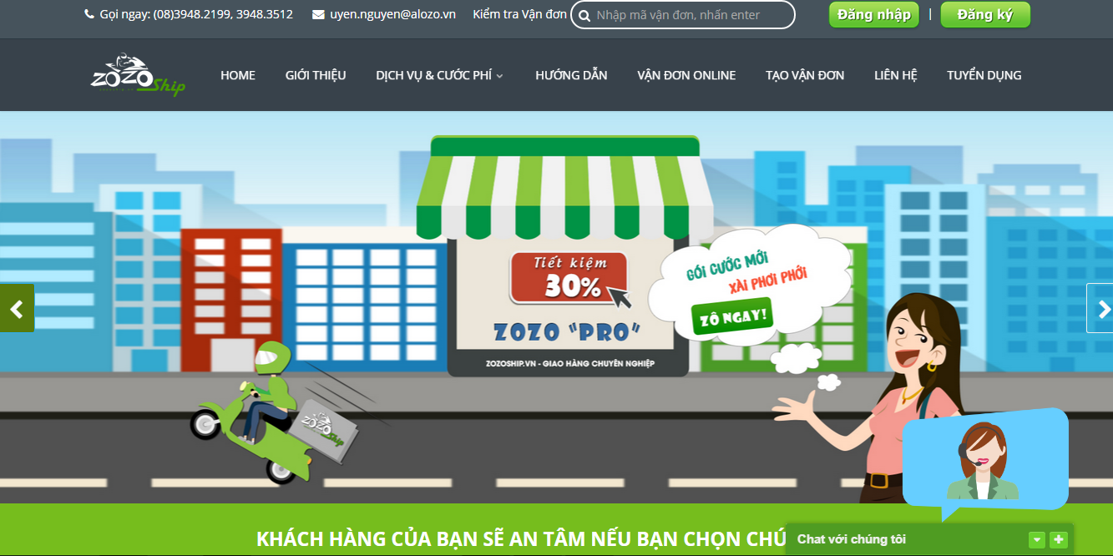

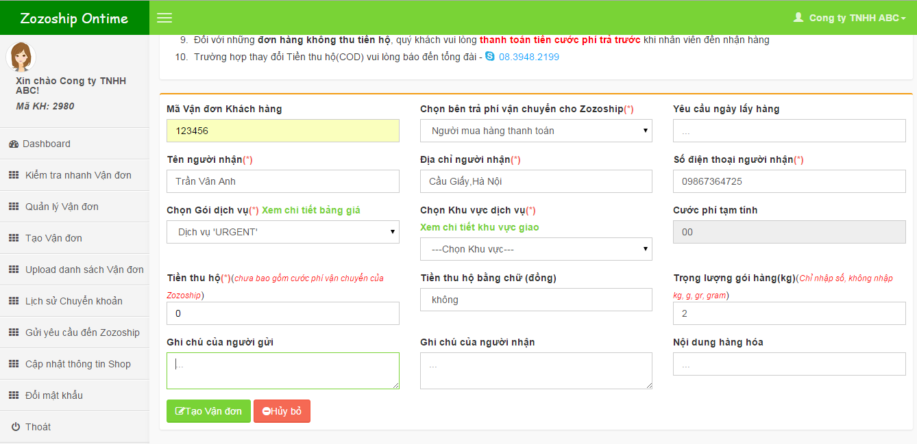

**Pros:**

* Track order status on website
* Deliver under 1 day
* Website has good interface, easy to use
* Many service pack with clearly information
* Nationwide delivery
* Goods insurance

**Cons:**

* Working are: only Ho Chi Minh city
* Don’t apply technology to immediately find the nearest shipper to the order, must wait for staffs to arrange
* Track order function is not well interface, just use text to display status (Wait, Shipper is comming, Shipping, Done)
* Return cash on delivery on Monday, Wednesday, Friday (instead of daily return)
* Working time is limited: 8.00 – 18.00 on Monday to Saturday, order that come after 17h will be ship in the next day.
* Don’t have mobile app for shipper to find the way.
  + 1. Overrall disadvantage of current background

Most of the shipping companies don’t apply technology into system. This leads to many problems in the management and operation of the system.

1. The current Shipping Service Providers don’t apply technology to optimize shipper selection, instead that, they use management staff to arrange work. If there’re many orders, shippers must choose the shortest way up to their experience. These cause the following problems:

* **For shipping providers (shipping companies):** CAN’T optimize transport distance, so the cost will be raised up. Hence, those companies get difference in balance between service’s price and profit.
* **For the stores:** The waiting time is long because of the shipper wait for staff to arrange. That make bad affects for the prestige and quality of the stores.
* **For the shippers:** Optimizing the transport ways is so difficult.

1. Current systems don’t apply technology in track transporting orders continuously. When the problems occur, the shippers must call to the staff directly, there isn’t any support from software system. These cause the following problems:

* **For shipping providers:** CAN’T be sure about goods during transportation. Difficult to come up with alternative solutions in time if the incidents occur.
* **For the stores:** CAN’T track transportation process. Don’t know their where their goods is.

1. Current systems don’t use security code for goods receiving process between shippers and the stores. When shippers receive goods, they confirm with the store by hard-copy list. This causes the following problems:

* **For shipping providers:** DON’T know the status of goods and the time of consign process => unmanageable
* **For the stores:** DON’T know whether the consignee is reliable or not.

1. Current systems don’t send security code to the customer that shipper and customer will use to confirm delivery was done.

* **For shipping providers:** CAN’T solve the problem in case the customer has received before, but continue to demand products.
* **For the shippers:** CAN’T be sure that goods was delivered to right person.
* **For the customers:** Could receive wrong products.

*Table 1: Comparison between KW system and the current system*

|  |  |  |  |  |
| --- | --- | --- | --- | --- |
|  | Giaohangnhanh.vn | ZOZO SHIP | Shipper  Team | KW |
| Working on Hanoi | 🗸 |  | 🗸 | 🗸 |
| Auto find the shipper nearest to the order |  |  |  | 🗸 |
| Shippers can find the shortest way base on maps |  |  |  | 🗸 |
| Express delivery |  |  | 🗸 | 🗸 |
| Allow the stores to track transportation process |  |  |  | 🗸 |
| Cash on delivery service | 🗸 | 🗸 | 🗸 | 🗸 |
| Have statistic for stores |  |  |  | 🗸 |
| Method confirm shippers | Paper bill | Paper bill | Payer bill | Code/ Shipper information |
| Method confirm shippers deliver to right customers | Phone call/ Paper bill | Phone call/ Paper bill | Phone call/ Paper bill | Code |

* .

Our Proposal

We’ll develop a system that include 4 part:

Part 1: Web application for store that support store’s employee everything they need to create an order, verify shipper who come to takes goods. Store also knows location of shipper (goods) on maps, status of order, shipper delivered to right customer of not. Beside, Store can view history of delivery and finance transactions.

Part 2: Mobile-application for shipper that support shipper view information of order, find the best way to receive and delivery address. Beside, sipper can notify to system if have issue while delivering.

Part 3: Web application for admin that help system managers manage shipper, store, transaction history (finance, delivery) and know about issue of delivery process.

Part 4: Web service that save all information of store, shipper and transaction history (finance, delivery). System will calculate the best way for shipper, notify admin when have any issue.

Below are main functions for each part:

* 1. 1. Web application for store
* Create order
* Edit order information
* Track state of shipper
  + Location of shipper on maps
  + Profile of shipper
  + Estimate when shipper will meet customer
* Rate and send feedback for each shipper when an order completed.
* View payment history.
* View report by day, week, and month.
  + 1. Mobile application for shipper
    - Find the best way to go to target
    - Change working status.(offline / online)
    - View profile.
    - Grab order.
    - View order.
    - Confirm received code with store, delivered code with customer.
    - See locations that need to receive goods.
    - Notify to system when have issue on delivered process.
    - View report about delivered history.
    1. Web application for admin
* Add stores
* Manage stores
* Send message to stores when have any issue.
* Confirm the payment of stores.
* View exchange history with stores.
* Add shippers
* Manage shippers
* View working history of shippers.
* Due with issue message from shipper
* Start collect orders function (collect normal orders) / Assign task for shippers
* Create orders.
* Manage orders
  + 1. Web service
    - Save exchange history of store and shipper
    - Real-time for post and get messages
    - Save shipper’s information, store’s information
    - Save finance exchange history.
    - Send message to admin when have issue
    1. Out of scope
* Combine order function
* Online payment function
* Auto due with issue
* Chat between store and admin function
* Auto reconnect after disconnect because of error.

# II. PROJECT MANAGEMENT PLAN

1. PROJECT OVERVIEW

1.1 Project description

|  |  |  |  |
| --- | --- | --- | --- |
| Project Code | KW | Contract Type | None |
| Customer | None | 2nd Customer | None |
| Project Level | Group | Project Rank | None |
| Application Type | Website, Application | Project Manager | Le Van Quy Hoang |
| Project Category | Development | Business Domain | Delivery Service |

This project will support for managing delivery service. Store which wants to use delivery service, will go to website developed by us and use our service such as creating order, tracking order,…We also develop a website for admin to manage shipper, store, issue and a mobile application for shipper to support them to do their works. Beside, a server is developed to connect website and shipper’s application, save data. Therefore, our system will provide stores the most convenient service, fastest service and safest service in their business.

1.2 Scope and purpose

The scope of project will contain all processes from planning, requirement specification, analysis and design, development to test.

We develop this project for supporting and managing delivery service. This project will contain:

* A system service: The server will receive request from website and application then processing the request and return response through API. Besides, it can save information about exchange history, shipper’s information, store’s information and send message to admin when any issue occurs.
* 2 web-app:
  + A web-app for admin to manage stores, shippers and issue in system.
  + A web-app for store to use system’s functions such as creating order, tracking order, finding shipper, view history of exchange, rate, feedback shipper,..
* An mobile-app: The mobile application was built on Android, IOS for shipper to help them work more efficiently with functions: find best way , see location, pick order, confirm received code with store,….

Beside, the system has to adapt conditions of non-functional requirements:

* Time delay from sending request to receiving response must be optimized.
* GUI has to be clear, good looking and simple to use.

1.3 Standard Objectives

* This project started from 7/9/2015 and must be finished no later than 13/12/2015.
* The final application covers 90% of requirements.
* The 6 team members must give the best effort and work based on schedule that team defined.

1.4 Milestones and Deliverables

### 1.4.1. Milestones

|  |  |  |  |
| --- | --- | --- | --- |
| **No** | **Task** | **Start date** | **End date** |
| 1 | Approve Project's idea | 9/9/2015 | 9/9/2015 |
| 2 | Complete introduction document | 9/13/2015 | 9/13/2015 |
| 3 | Submit report 1 to supervisor | 9/13/2015 | 9/13/2015 |
| 4 | Complete PMP document ver1.0 | 9/18/2015 | 9/18/2015 |
| 5 | Submit report 2 to supervisor | 9/20/2015 | 9/20/2015 |
| 6 | Complete SRS document | 9/28/2015 | 9/28/2015 |
| 7 | Submit report 3 to supervisor | 10/4/2015 | 10/4/2015 |
| 8 | Complete SAD document ver1.0 | 10/21/2015 | 10/21/2015 |
| 9 | Complete source code ver1.0 | 11/6/2015 | 11/6/2015 |
| 10 | Complete test plan document | 10/26/2015 | 10/26/2015 |
| 11 | Complete test report v1.0 | 11/8/2015 | 11/8/2015 |
| 12 | Submit report 4 to supervisor | 11/8/2015 | 11/8/2015 |
| 13 | Complete PMP document ver2.0 | 11/9/2015 | 11/9/2015 |
| 14 | Complete SAD document ver2.0 | 11/10/2015 | 11/10/2015 |
| 15 | Complete source code ver2.0 | 11/27/2015 | 11/27/2015 |
| 16 | Complete test plan document ver2.0 | 11/9/2015 | 11/9/2015 |
| 17 | Complete test report ver2.0 | 11/30/2015 | 11/30/2015 |
| 18 | Submit report 5 to supervisor | 11/22/2015 | 11/22/2015 |
| 19 | Complete PMP document ver3.0 | 12/2/2015 | 12/2/2015 |
| 20 | Complete final test report | 12/13/2015 | 12/13/2015 |
| 21 | Complete final source code | 12/13/2015 | 12/13/2015 |
| 22 | Complete install and user manual document | 12/9/2015 | 12/9/2015 |
| 23 | Complete final report | 12/11/2015 | 12/11/2015 |
| 24 | Submit report 6 to supervisor | 12/13/2015 | 12/13/2015 |
| 25 | Complete slide | 12/15/2015 | 12/15/2015 |
| 26 | Submit final report to FPT University | 12/16/2015 | 12/16/2015 |
| 27 | Presentation | 12/23/2015 | 12/23/2015 |

### 1.4.2. Deliverables

|  |  |  |  |  |  |  |
| --- | --- | --- | --- | --- | --- | --- |
| **No** | **Deliverables** | **Format** | | **Delivery date** | **Verified by** | **Deliver Medium** |
| 1 | Introduction Document | .pdf | | 09/13/2015 | Supervisor | Email |
| 2 | Meeting minute_09092015 | .pdf | | 09/13/2015 | Supervisor | Email |
| 3 | Progress Report_09132015 | .pdf | | 09/13/2015 | Supervisor | Email |
| 4 | Communication matrix ver1.0 | .xls | | 09/20/2015 | Supervisor | Email |
| 5 | Risk register ver1.0 | .xls | | 09/20/2015 | Supervisor | Email |
| 6 | Work schedule | .mpp | | 09/20/2015 | Supervisor | Email |
| 7 | Project Management plan document ver1.0 | .pdf | | 09/20/2015 | Supervisor | Email |
| 8 | Meeting minute_09162015 | .pdf | | 09/20/2015 | Supervisor | Email |
| 9 | Progress Report_09202015 | .pdf | | 09/20/2015 | Supervisor | Email |
| 10 | Software Requirement Specification Document | .pdf | | 10/04/2015 | Supervisor | Email |
| 11 | Meeting minute_09232015 | .pdf | | 10/04/2015 | Supervisor | Email |
| 12 | Progress Report_10042015 | .pdf | | 10/04/2015 | Supervisor | Email |
| 13 | Software Architecture Document ver1.0 | .pdf | | 11/08/2015 | Supervisor | Email |
| 14 | Meeting minute_09302015 | .pdf | | 11/08/2015 | Supervisor | Email |
| 15 | Progress Report_11082015 | .pdf | | 11/08/2015 | Supervisor | Email |
| 16 | Test Plan Document ver2.0 | .pdf | | 11/22/2015 | Supervisor | Email |
| 17 | Source code | .zip | | 11/22/2015 | Supervisor | Email |
| 18 | Meeting minute_11282015 | .pdf | | 11/22/2015 | Supervisor | Email |
| 19 | Progress Report_11222015 | .pdf | | 11/22/2015 | Supervisor | Email |
| 20 | Source code final | .zip | | 11/29/2015 | Supervisor | Email |
| 21 | Meeting minute_11252015 | .pdf | | 11/29/2015 | Supervisor | Email |
| 22 | Progress Report_11292015 | .pdf | | 11/29/2015 | Supervisor | Email |
| 23 | Final report document | .pdf | Hard copy | 12/06/2015 | FPT University | Direct |

# 2. PROJECT ORGANIZATION

## 2.1 Software Process Model

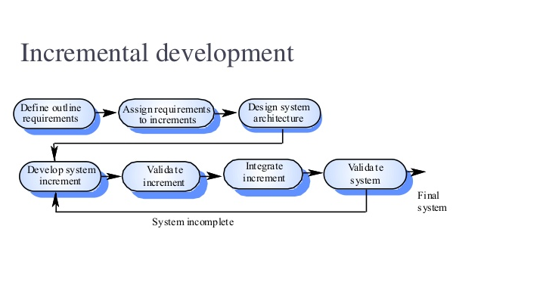

Figure 3: Incremental Model

In this project, we apply Incremental model as development process model because this model has these useful advantages:

* Some main functions can be developed early & quickly
* More flexible - Easy & less costly to change if having.
* Testing and debugging during smaller iteration is easy
* Iterations may be run simultaneously. A design team starts the next iteration while the current one is under test
* The project team learns from first iterations and may use best practices and experiences in next iterations
* Easier to manage risk because risky pieces are identified and handled during its iteration.

## 2.2 Project Lifecycle

This project is divided into 5 phases: Initiation, Increment 1, Increment 2, Increment 3, Increment 4, Closing. Each Increment will goes through Project Plan, System Architecture Design, Implementation, Testing and Evaluation. We will iterate Increment phase until we meet requirement. In each Incremental, we bases on result of the previous Increment to plan for next Increment and update for system. Project manager monitors and controls the progress of project team follow this process.

## 2.3 Roles and Responsibilities

Figure 4: Organization structure

|  |  |  |  |
| --- | --- | --- | --- |
| Role | Full name | | Responsibility |
| Supervisor | Tran Binh Duong | | * Give instruction for project team * Verify deliverables * Supervise project team’s status |
| PM | Le Van Quy Hoang | | Have overall responsibility of the project   * Assign task to team members * Tracking team member’s work * Plan schedule for project team * Review documents and source code |
| * Development team | | | |
| Technical Leader | | Nguyen Khac Hoang | * Create coding convention * Decide technique and tools to be used * Code server and admin’s website |
| Developer #1 | | Tran Dinh Hoang Huy | * Study Ionic framework and code mobile app |
| Developer #2 | | Nguyen Van Quyen | * Study Ionic framework and code mobile app |
| Developer #3 | | Le Van Quy Hoang | * Design website’s interface * Create coding convertion * Create skeleton for system * Coding server and store’s website |
| Developer #4 | | Kieu Cao Khanh | * Design website’s interface * Coding admin’s website |
| * Test team | | | |
| Test leader | Nguyen Thi Hong Nhung | | * Create test plan * Create test cases * Execute text cases * Report test result |

# 3. TOOLS AND INFRASTRUCTURES

|  |  |  |
| --- | --- | --- |
| **Item** | **Description** | **Note** |
| Development Environment | | |
| Operating System | Window 8.1 (32 bit, 64 bit) |  |
| Android(4.2 or more) |  |
| IOS(7.1 or more) |  |
| Browser | Chrome, Firefox (all version) |  |
| Development language | AngularJS | Web app |
| NodeJS | Web service |
| Database | PostGresSQL |  |
| Technique | | |
| Framework | Ionic | Mobile app |
| Test Environment | | |
| Operating System | Window 8.1 (32 bit, 64 bit) |  |
| Android(4.2 and more) |  |
| iOS(7.1 and more) |  |
| Browser | Chrome50.0 |  |
|  | Firefox 40.0 |  |
| Equipment & Tools | | |
| Source code management tool | GitHub.com |  |
| Source Tree |
| Development tool | WebStorm 10.0.0.4 |  |
| Design tool | Astah 6.8 |  |
| Adobe Photoshop CS6 |  |
| www.lucidchart.com |  |
| Office tool | Microsoft Word 2013 |  |
| Microsoft Excel 2013 |  |
| Microsoft PowerPoint 2013 |  |
| Management tool | Microsoft Project 2010 |  |
| Kanbanflow.com |  |

# 4. SCHEDULES

## 4.1. Detail Schedules

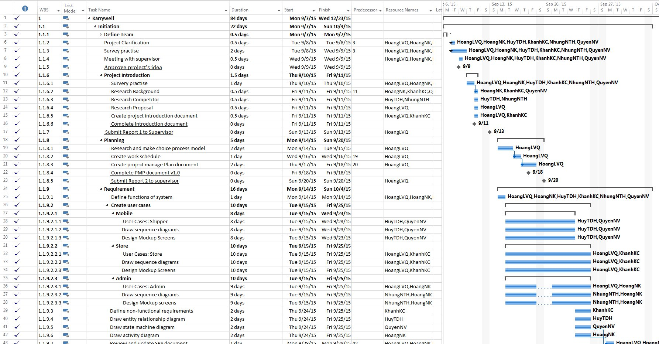

*Figure 5: A part of Schedule*

The detail project schedule is available in file “**KW_ProjectSchedule.mpp**”.

# 5. COMMUNICATION MANAGEMENT

## 5.1. Stakeholders and Contacts

|  |  |  |  |
| --- | --- | --- | --- |
| **Name** | **Title** | **Role** | **Contacts** |
| Tran Binh Duong | Mr. | Supervisor | [duongtb@fpt.edu.vn](mailto:duongtb@fpt.edu.vn)  (84) 936-168-165 |
| Le Van Quy Hoang | Mr. | PM | [hoanglvqse90184fpt.edu.vn](mailto:Nhungbhse02082@fpt.edu.vn)  (84) 924-500-699 |
| Nguyen Khac Hoang | Mr. | Technical Leader | [hoangnkse02564@fpt.edu.vn](mailto:hoangnkse02564@fpt.edu.vn)  (84) 973-528-902 |
| Kieu Cao Khanh | Mr. | Developer | [khanhkcse02960@fpt.edu.vn](mailto:khanhkcse02960@fpt.edu.vn)  (84) 165-249-3444 |
| Tran Dinh Hoang Huy | Mr. | Developer | [huytdhse90201@fpt.edu.vn](mailto:huytdhse90201@fpt.edu.vn)  (84) 905-507-734 |
| Nguyen Van Quyen | Mr. | Developer | [quyennvse02884@fpt.edu.vn](mailto:quyennvse02884@fpt.edu.vn)  (84) 167-921-2683 |
| Nguyen Thi Hong Nhung | Mrs. | Test Leader | [nhungnthse02437@fpt.edu.vn](mailto:nhungnthse02437@fpt.edu.vn)  (84) 169-495-1497 |

## 5.2. Communication Management Approach

Project team communicate frequently to ensure the progress of each member’s work. PM reports to the Supervisor frequently and honestly so that the Supervisor can track the team’s work and give support/advice as need.

All request for change or proposal of new ideal must be discussed in team. If project team agree to change, project team must discuss with the Supervisor. Once the change is approved, PM will update the plan and notify to project team and Supervisor.

When any members have issue they have to immediately notify to PM for resolves soon as possible

The communications requirements are documented in the Communications Matrix of this document. The Communications matrix will be used as guide for what/when/how/who/whom to communicate throughout the project.

The PM will communicate with the Supervisor in order to determine his preferred frequency and time of communication.

As all project team members still take part in classes while doing project, PM should communicate to understand their schedule, and therefore specify appropriate communication plan for the team.

## 5.3. Communication Method and Technologies

* Create a Facebook private group for team member to discuss and share informal information and activity. This would be a place for member to communicate freely, and therefore would help in strengthen relationship between members.
* Use Github to manage documents and source code. Public source code, documents and task reports in Github to keep them tidy, save and easy to manage.
* Use Google Sheets to manage bugs.
* Use website www.KanbanFlow.com to assign and tracking tasks. This will help PM in tracking work of team members, and also help team member understand progress of the others.
* Creating a document that contains a revision history log. When changes occur, the document’s revision history log will reflect an updated version number as well as the date, the owner making the change, and change description will be recorded in the revision history log of the document.

## 5.4. Escalation procedures for resolving issues

Tran Binh DuongTr Hoangfdsfdsfdsf Increment 4,

Team Memberea

Le Van Quy Hoang

Le Van Quy Hoang LTr Hoangfdsfdsfdsf Increment 4,

## 5.5 Communication Matrix

|  |  |  |  |  |  |  |  |
| --- | --- | --- | --- | --- | --- | --- | --- |
| **Communication Type** | **Objective** | **Medium** | **Frequency** | **Audience** | **Owner** | **Deliverable** | **Format** |
| **Project Meeting** | | | | | | | |
| Kickoff Meeting | - Supervisor meet Project Team  - Discuss and agree on project objective, and scope | * Face to face | Once (At the start of the project) | * Supervisor * Project Team | PM | * Meeting Minutes | * Soft copies on Microsoft Word |
| Project Team Meeting | - Motivate Project Team  - Review status of the project.  - Discuss solutions for any raised issues. | * Face to face * Conversation (Skype/Hangout) | 6 times per week. | * Project Team | PM | - Progress report | * Soft copies on Microsoft Word |
| GUI Design Meeting | Discuss, contribute and review GUI Design | * Face to face | As needed | * Project Team | Technical Leader | * Meeting Minutes * GUI Design * Document | * Soft copies on Microsoft Word * GUI Design on Photoshop |
| Architecture Design Meeting | Review prototype  Discuss, contribute and review System Architecture Design | * Face to face | As needed | * Project Team | Technical Leader | * Meeting Minutes * System Architecture Design Document | * Soft copies on Microsoft Word * System Architecture Design on Astah |
| Project Plan Meeting | Discuss and planning project process | * Face to face * Conversation (Skype/Hangout) | As needed | * Project Team | PM | * Meeting Minutes * Project Management Plan | * Soft copies on Microsoft Word * WBS on Microsoft Project |
| Database Design Meeting | Discuss, contribute and review Database Design | * Face to face | As needed | * Project Team | Technical Leader | * Meeting Minutes * Database Design | * Soft copies on Microsoft Word |
| Test Plan Meeting | Discuss, and review Test Plan | * Face to face | As needed | * Project Team | Technical Leader | * Meeting Minutes * Test Plan | * Soft copies on Microsoft Word |
| Meeting with Supervisor | Report project status of team’s work to Supervisor  Get advices for project from Supervisor | * Face to face * Conversation (Skype/Hangout) * Email | Every Wednesday | * Supervisor * Project Team | PM | * Meeting Minutes * Team Weekly Report | * Soft copies on Microsoft Word |
| **Project tasks assign** | | | | | | | |
| Task schedule | Plan schedule for project | * Face to face | As needed | * Project Team | PM | * Project schedule | * Project schedule on Microsoft Project |
| Task assign | Assign task for each member on Project Team | * Face to face * KanbanFlow | As needed | * Project team | PM | * Assigned tasks | * Assigned tasks on KanbanFlow |
| **Project Report** | | | | | | | |
| Bug Report | Report found bugs to team members and assign fix tasks | * Face to face * Github * Email * Google Sheets | As needed | * Project Team | Test Leader | * Bug Report | * Soft copies on Microsoft Excel, Google Sheets |
| Personal Weekly Report | Report task status (what is done, what will be done next week, any issue) of personal work | * Google Sheets * Github | Every Friday | * Project team | PM | * Personal Weekly Report | * Soft copies on Microsoft Excel, Google Sheets |
| Project team weekly report | Report task status (what is done, what will be done next week, any issue) | * Email | Every Sunday | * Supervisor | PM | * Weekly report | * Soft copies on Microsoft word |
| Unexpected Issue | Find a solution for any unexpected raised issues. | * Face to face * Conversation (Skype/Hangout) * Facebook private group | As needed | * Supervisor * Project Team | PM | * Meeting Minutes | * Soft copies on Microsoft Word |

# 6. RISK MANAGEMENT

## 6.1. Risk Management Approach

The project manager working with the project team and ensure that risks are actively identified, analyzed, and managed throughout the life of the project. Risks will be identified as early as possible in the project so as to minimize their impact. The steps for accomplishing this are outlined in the following sections. The PM will serve as the Risk Manager for this project.

## 6.2. Risk Identification

The following methods were used to assist in the identification of risks associated with Super Shipper System Project:

* Brainstorming
* SWOT (Strengths, Weaknesses, Opportunities and Threats)

Project team identify various risks. Finally, PM choose top risks with high impact or most likely to happen.

## 6.3. Risk Monitoring

Risk monitoring will be a continuous process throughout the project. Avoidance plan should be taken carefully from start of the project. In case a risk is about to happen, PM will apply contingency plan to prevent risk. If risk is already happen, PM apply fall back plan to minimize impact.

## 6.4. Risk Register

### 6.4.1. Risk description

|  |  |  |  |  |  |  |  |  |
| --- | --- | --- | --- | --- | --- | --- | --- | --- |
| **No** | **Rank** | **Risk** | **Description** | **Category** | **Root Cause** | **Triggers** | **Probability** | **Impact** |
| **R1** | 2 | Lack of team member | The number of members decreases and not enough for work | People | Member out team | Dissatisfied with other members, have unexpected trouble | Low | High |
| **R2** | 1 | Conflict among team members | Team member disagree with others and refuse to work or work below their ability | People | Unclear requirement specification. Team members do not unify on solutions | Has issue inside team | Medium | High |
| **R3** | 3 | Lack of skill and knowledge for a specified work | Team member don't have enough skill, knowledge to do their task. Example: can't control new technologies in project | People | Member don't have enough time to learn/improve needed skills | Member inform that they don't know how to do. Low productivity. | Medium | High |
| **R4** | 4 | Requirement change | The scope may change, some requirements may be added | Requirement | SRS not good (not realistic, not feasibility, not meet customer needs) | Project team cannot develop the system as description in SRS. | High | Medium |
| **R5** | 5 | Team member distraction | Team members don't pay enough time for working in the project, productivity is low | People | Undisciplined and habit of team member, loose management | Team members does not spend time for work and tasks are not completed on time | Medium | Medium |
| **R6** | 7 | Inability to verify/validate products with requirements. | Can't be sure that the deliverable products whether meet the requirements or not | Process | Problem in product quality control | Can’t make clearly test cases for that requirements | Medium | Low |
| **R7** | 6 | Can’t commit work because internet connection | Internet connection is down and team members can't submit work, merge code, ... | Technology | Can’t connect to the git repository server | Internet connection is down | Low | Medium |
| **R8** | 8 | Product doesn’t meet requirement | Some functions doesn't satisfy the requirement in SRS | Process | Team member not understand requirement | Function doesn’t meet the requirement | Medium | Low |

### 6.4.2. Probability – Impact matrix

|  |  |  |  |  |
| --- | --- | --- | --- | --- |
| **Probability** | **High** |  | R3, R4 |  |
| **Medium** | R6, R8 | R5 | R2, |
| **Low** |  | R7 | R1, |
|  | **Low** | **Medium** | **High** |
|  | **Impact** | | | |

### 6.4.3. Risk response plan& Risk status

|  |  |  |  |  |  |  |
| --- | --- | --- | --- | --- | --- | --- |
| **No** | **Risk** | **Avoidance plan** | **Contingency plan** | **Fallback plan** | **Risk owner** | **Status** |
| **R1** | Lack of team member | PM need to have a meeting with this member and suggest him/her still be there. | Resolve the problems inside team. For example: PM has some methods to motivate members | reduce scope | HoangLVQ | Not yet active |
| **R2** | Conflict among team members | Plan some team building to improve teammate | Have a meeting to solve conflict problem | Team create meeting to secret vote for choices | HuyTDH | Activated / Solved |
| **R3** | Lack of skill and knowledge for a specified work | Have detail training plan.  All members must know what skills and what kinds of knowledge they must have. | Team members help each other improve skill and ability | Working over time | HoangNK | Activated / Solved |
| **R4** | Requirement change | Requirement should be paid a lot of attention. SRS should be peer reviewed, reviewed carefully by PM and the supervisor. | With each requirement changes, the project team should have a meeting to analysis the change requests and take actions. | Re-estimate and update plan. | HoangLVQ | Not yet active |
| **R5** | Team member distraction | Setting rule and minus of do not meet the deadline: punish money and named at meeting minute. | Daily meeting to tracking work and motivate member when working performance go down | Working over time | HoangLVQ | Activated / Solved |
| **R6** | Inability to verify/validate products with requirements. | Create detail testing plan. Research to find out suitable test method | Print out the result to check by eyes. Debug into code to see how the code is running | Ask for help from supervisors Team discuss to make requirement more clearly or change it. | NhungNTH | Not yet active |
| **R7** | Can’t commit work because internet connection | Have a backup local repository | Manage resource via local repository while can't connect to the internet one. | Copy resource by using USB | HuyTDH | Not yet active |
| **R8** | Delivery project doesn’t meet requirement | PTL have to review source code and follow requirement | Fix bugs | Assign other members doing those functions | HoangNK | Not yet active |

# 7. QUALITY MANAGEMENT

## 7.1. Quality Management Overview

### 7.1.1. Organization, Responsibilities, and Interfaces

|  |  |  |
| --- | --- | --- |
| **Name** | **Role** | **Responsibilities** |
| Tran Binh Duong | Supervisor | * Helps define product quality expectations. * Determines final acceptance of product’s quality. |
| Le Van Quy Hoang | PM | * Creates quality plan * Facilitates resolution of quality issues, escalating as needed |
| Nguyen Thi Hong Nhung | Test leader | - Provides test and test management |
| Team members:   * Le Van Quy Hoang * Tran Dinh Hoang Huy * Nguyen Van Quyen * Nguyen Khac Hoang * Kieu Cao Khanh | Developer | * Provides feedback on quality plan, help determine metrics and criteria for this project * Be a part of quality reviews and provide feedback on deliverables |

### 7.1.2. Tools, Environment, and Interfaces

|  |  |
| --- | --- |
| **Tool** | **Description** |
| **Cause-and-effect diagram** | Used to analyze the causes and effect of a problem. Used to find the root cause problem when there are a complaint about quality problems. |
| **Control chart** | Used of control charts is to prevent defects. Apply Seven Run Rule. |
| **Flowchart** | Used to analyze how problems occur and how processes can be improved |

## 7.2. Quality Planning

### 7.2.1. Define Project Quality

* ***System output:***+ A Web application to support admin manages entity ship system.

***+*** A Web application to support store manages own orders fast and convenient.

+ An Android application to support shipper’s business (find the best way of transfer, grab order...)

* ***Functionality:***

+ Web application:

* + - For Admin: allow admin to login, add/ block/ update shipper or orders and analyze and export reports.
    - For Store: allow login to system, create order, tracking state of shipper, feedback for each shipper and view reports.

+ Android application has main functions: The system can find best way to go to target location, shipper can pick order and view report about delivered history.

* ***Performance:***

+ Time delay for find shipper who nearest with place of delivery is less than 10seconds.

+Time delay on web application for tracking state of shipper on map is less than 5minutes.

+ Server can handle least 2000 clients concurrently.

+Other functions of server perform well while have many order running on application.

* ***Reliability:***

+ The application is available 24/7.

+ Find the way to go to places of receive and place of delivery are at least 90%.

* ***Maintainability:***

+ Web application is easily to maintain without any crashes. Source code is readability, organized into groups of skeleton (modules) and complies with coding convention.

+Android application is easily to be updated and synchronize with Web application without any crashes. Source code is readability, complies with coding convention.

+ System’s architecture has to be design to be easy to extend.

* ***Security:***

+ Information of admin/ root admin / data on server is secured.

+Information of store and shipper on server is secured.

### 7.2.2. Measure Project Quality

|  |  |
| --- | --- |
| **Metric** | **Goal** |
| Accurate | * Find the way to go to places of receive and place of delivery are at least 90%. * Display the current position of shipper on map exactly. |
| Response of web application | * Time delay for find shipper <= 10s |
| Bugs/Lines of Code | * UT: 8 – 9 bugs / KLOC * ST: 2 – 4 bugs / KLOC   *(based on Fsoft norms)* |
| Maximum deep of loops | <= 4 |
| Android Program Size | <= 100 MB |
| Algorithm complexity | <= O(n^2) |
| Android version support | Support Android version 4.4.2 Kitkat to 5.0.1 Lollipop |
| Android screen support | Multiscreen  Must be tested on 320x480, 768x1024, 768x1336,1080x1920 screens |
| Website support browser | Support Chrome version 41.0.xxx, Firefox version 36.0 or later. |

## 7.3. Quality Assurance

### 7.3.1. Analyze Project Quality

|  |  |  |  |
| --- | --- | --- | --- |
| **Milestone** | **Deliverables** | **Goal** | **Review and Approved** |
| 10/04/2015 | Final Software Requirement Specification Document | * Have content right with actual research process. | HoangLVQ |
| 11/29/2015 | Final Interface design | * Good looking & easy-to-use. * Cover all functions specified in SRS. | HoangLVQ |
| 11/23/2015 | Final Software architecture design document | * Design to be easy to extend. * Cover all functions in SRS document | Supervisor |
| 11/29/2015 | Web application | * Information of admins / root admins and shopkeeper on server are secured. * Provide information of order and push notification for mobile application. * Time delay for searching a order <=3s. | HoangLVQ.  Supervisor |
| 11/29/2015 | Mobile application | * Tracking road and received order. * - Notify to system when have issue on delivered process. | HoangLVQ,  Supervisor |
| 12/4/2015 | Integration test report | * 30 – 34 test cases / KLOC * 2 – 4 bugs / KLOC | NhungNTH |
| 12/4/2015 | System test report | * 30 – 34 test cases / KLOC * 2 – 4 bugs / KLOC | NhungNTH |

### 7.3.2. Improve Project Quality

|  |  |
| --- | --- |
| **Issue** | **Action** |
| Difficult to track project’s progress | * Submit weekly report to supervisor * Meeting up team member everyday (work 6 days / week). Sometime extending the last days to keep deadline and fix bugs. * Using kanbanflow tool to track team members’ work([www.kanbanflow](http://www.kanbanflow)) * Using Github to manage source of project (documents, source code) |
| Coding application does not match with User Requirement | * Team has to define clearly requirement specification and Software Architecture Design. * Develop Team must study about the document and comply with the content of document. * Any changes in process have to approve of PM |
| Maintainability | * Specify coding conventions document * Spend a lot of time to research architecture design. Then, decide the most appropriate architecture for maintaining easily. |
| Low quality code | * Create and execute types of test (unit test, integration test, system test). * Peer review, peer coding among developers. * Using Open Source and Framework to improve the quality code: NodeJS, AngularJS, Ionic framework. * Developers have to comply with the coding convention document. |
| Technology | * Predict and list the problems of technologies that are the bottleneck of project. Then, organize research to find solution from the beginning. * Have knowledge-training schedule for members. |
| Reward and discipline | * Teambuilding to increase communication ability between project’s members * Have punishment rules when:   + Member comes late or Miss meeting  + Make mistake in member document writing. Reviewed by Supervisor.  + Submit terrible code (which causes to re-coding more than 10%)  + Miss deadline |
| Acceptance of users | Do survey to discovery what features user want from this projects. Do it before design progress. |

## 7.4. Quality Control

|  |  |  |  |
| --- | --- | --- | --- |
| **Deliverables** | **Goal** | **Quality control activity** | **Frequency /**  **Interval** |
| Interface design | * Good looking &easy-to-use: don’t using many button, don’t many minor detail. * Cover all functions specified in SRS | Designer has to:   * Ask for advice of some other designer * Take comment from friends on completed work * Have approve from SRS leader | Each time design a new screen |
| Software architecture design | Design to be easy to extend | Have review and judgment from Supervisor | On completion |
| Web application | * Information of admins / root admins and shopkeeper on server are secured. * Provide information of order and push notification for mobile application. * Time delay for searching a order <=3s. | Testers execute security test and system test | On completion |
| Mobile application | - Tracking road and received order.  - Notify to system when have issue on delivered process. | Testers execute system test | On completion |
| Integration test report | 30 – 34 test cases / KLOC  2 – 4 bugs / KLOC | PM requires testers to report on work | Weekly |
| System test report | 30 – 34 test cases / KLOC  2 – 4 bugs / KLOC | PM requires testers to report on work | Weekly |

## 7.5. Action Plan

|  |  |  |  |  |
| --- | --- | --- | --- | --- |
| **What** | **Who** | **When** | **How** | **Output** |
| Define coding convention | HoangLVQ,  HuyTDH | 25/09/2015 | * Read standard coding convention of NodeJS * Extract and modify to reuse it | Coding Convention Document |
| Training kanbanflow | All team | 16/09/2015  to 17/09/2015 | * Hoang LVQ guides team members how to use kanbanflow | Understand how to use kanban tool and use this tool in processes. |
| Market research | All team | 9/10/2015 to 9/13/2015 | * Enjoy survey in practice * Analytics and evaluate market depend on survey document. | Survey summary |
| Training NodeJS,  AngularJS, | HoangLVQ | 10/12/2015 to  10/13/2015 | * Read AngularJS documents * Find out how to set up and complete ‘Hello World’ tutorial. * Try some core class and functions for image processing. | Guide & tutorial document |
| Training design UI | HoangLVQ, KhanhKC | 10/12/2015 to  10/13/2015 | * Guide developers understand how to design and use design tool | Guide & tutorial  document |
| Training for Ionic frame work | HuyTDH  QuyenNV | 10/12/2015 to  10/13/2015 | * Read Ionic frame work document. * Routing in ionic frame work * Find how to setup Ionic using plugin of cordova: geolocation, device. | Guide & tutorial document |
| Training Unit Test | NhungNTH | 10/12/2015 to  10/13/2015 | * Training how to create and perform Unit Test | Understand the types of test, how to use in project |
| Create a specific WBS | HoangLVQ | 9/20/2015 | * List all tasks in each process. * Define larger tasks to smaller tasks for individual and add into MS Project. * Assign tasks for suit member | - Tasks are assigned to suitable member.  - All team members know about their tasks and can complete it on time  - PM can manage tasks via WBS in MS Project |

# III. SOFTWARE REQUIREMENT SPECIFICATION

# INTRODUCTION

## 1.1. Purpose

This document provides developers, tester, QAs a complete and comprehensive description of both the functional requirement and non-functional requirements of the KaryWell system. Developers base on this document to develop the system, and testers base on this to assure the quality of the output system. Project manager base on this document to create schedule and assign task to team members.

## 1.2. Scope

This document defines all functional and non-functional requirements for KaryWell system. Beside, creating the diagrams to helps developers be easy to understand in Software Architecture Design stage.

## 1.4. Overview

Section 2 of this document provides overall information of the project, while excluding the specific requirements. Instead, it provides the background for those requirements, which are defined in Section 3

Section 3 describes all the requirements in detail, including functional requirements and non-functional requirements. Each function is described based on the following format:

Use Case: the detailed description of all use cases

Screen: The mockup/prototype of the screen which describes the workflow of the Use Case

# OVERVIEW DESCRIPTION

## 2.1. Product perspective

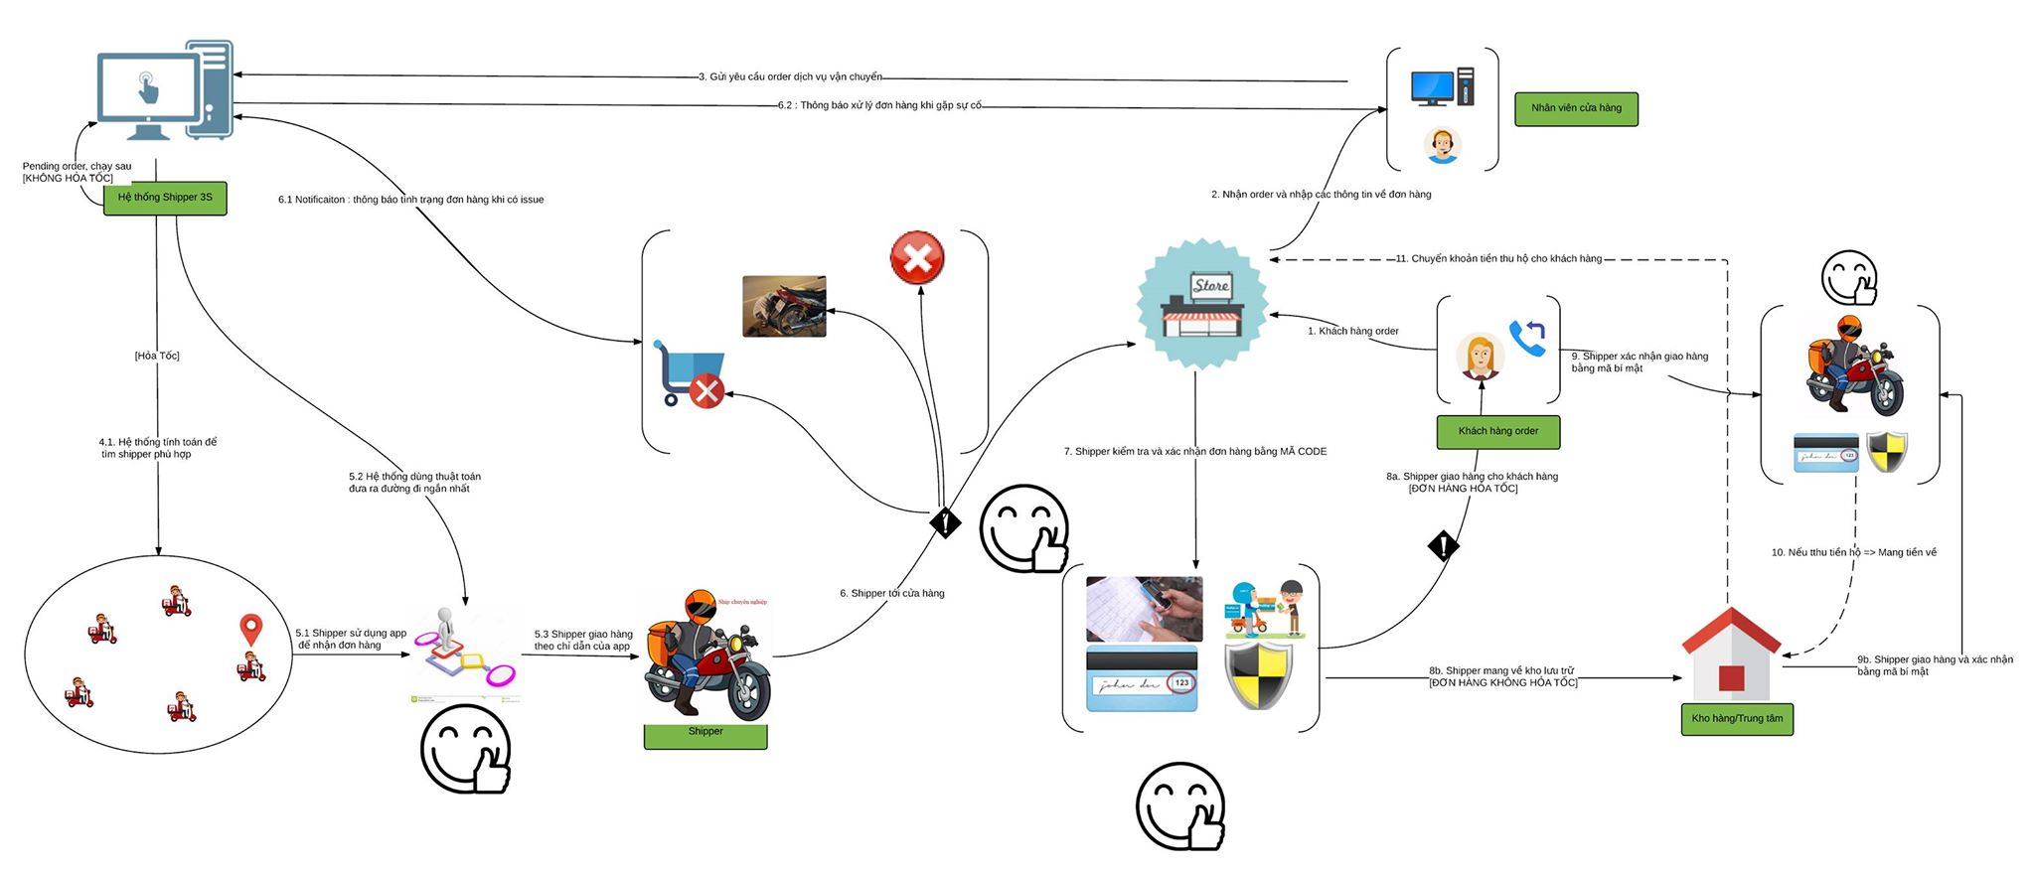The below rich picture describes all perspectives of product:

Figure : Business rich picture of system

The product includes 3 types:

* Web Service: This is linking between Web App with Mobile App. Beside, executing logic to response data (JSON) for clients through API.
* Web App: This is an app that supports for 2 types of user
  + Admin: Manage (Shipper, Store), Resolve Issue, Control & Tracking Orders, …
  + Store: Create Order, Find Shipper, Confirm Code, Rate, Send Feedback. …
* Mobile App: This is an app that supports for shipper’s business
  + Shipper: Receive/Reject order, find short path, Send issues message …

## 2.2. Product functions

Refer to Section 3

## 2.3. User characteristics

There are three main actors that system support:

* Store: This system towards the stores which have demand to transport goods to clients but don’t have a team of professional shipper.
* Shipper: They are transformers that enjoy system to get income.
* Administrator: They use all functions that supported by system to manage activities of system.

## 2.4. Constraint

* All products of system have to meets the deadline
* All processes and related documents have to observe procedure of FPT

## 2.5. Assumption and dependencies

* Receive the guidance and good support of teacher
* No one of member got sick in the software development process
* In the development process, no device got fail
* Evert report meets the deadline
* Team member do not conflict and get high responsibility in the working process

## 2.6. Activity Diagram

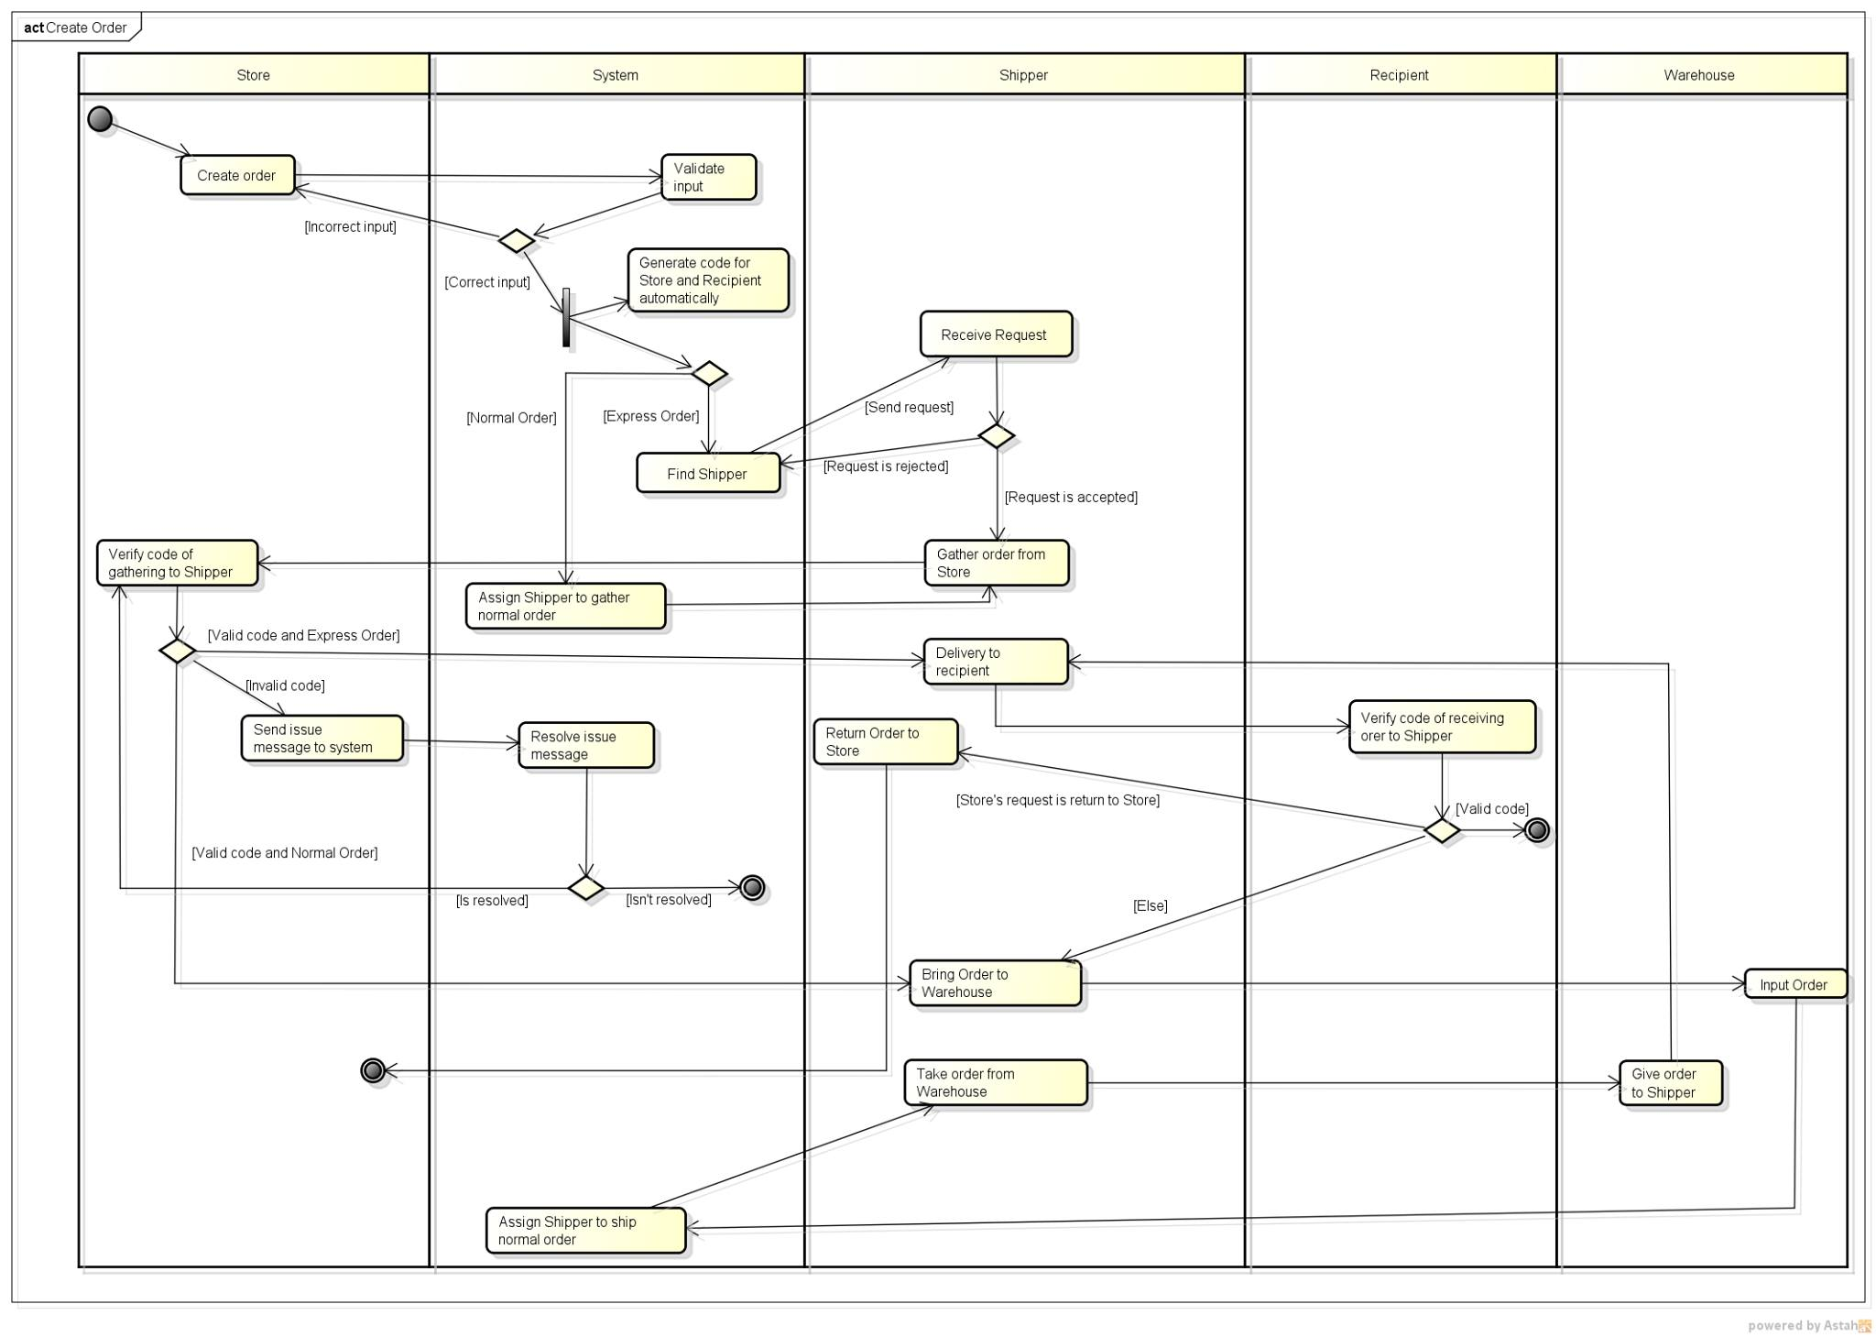This diagram describes the procedure of order

Figure : Activity diagram

## 2.7. State Machine Diagram

This diagram describes the status of order:

In case express delivery:

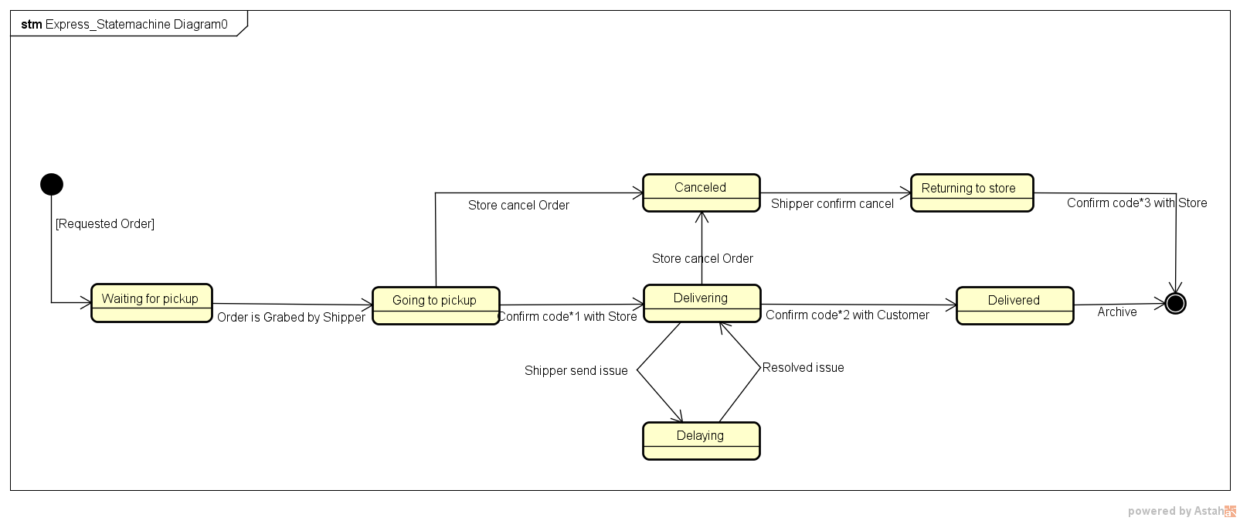

Figure 4: State machine for express order

In case normal delivery:

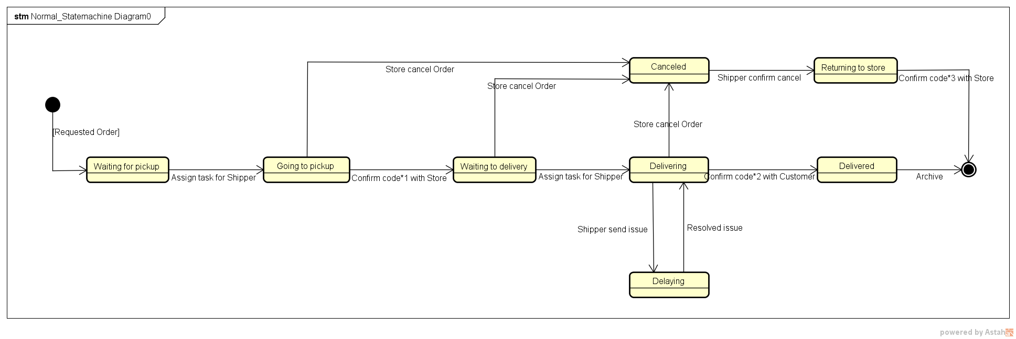

Figure 5: State machine for normal order

## 2.8. Entity Relationship Diagram

This diagram describes the relationship among entities of system

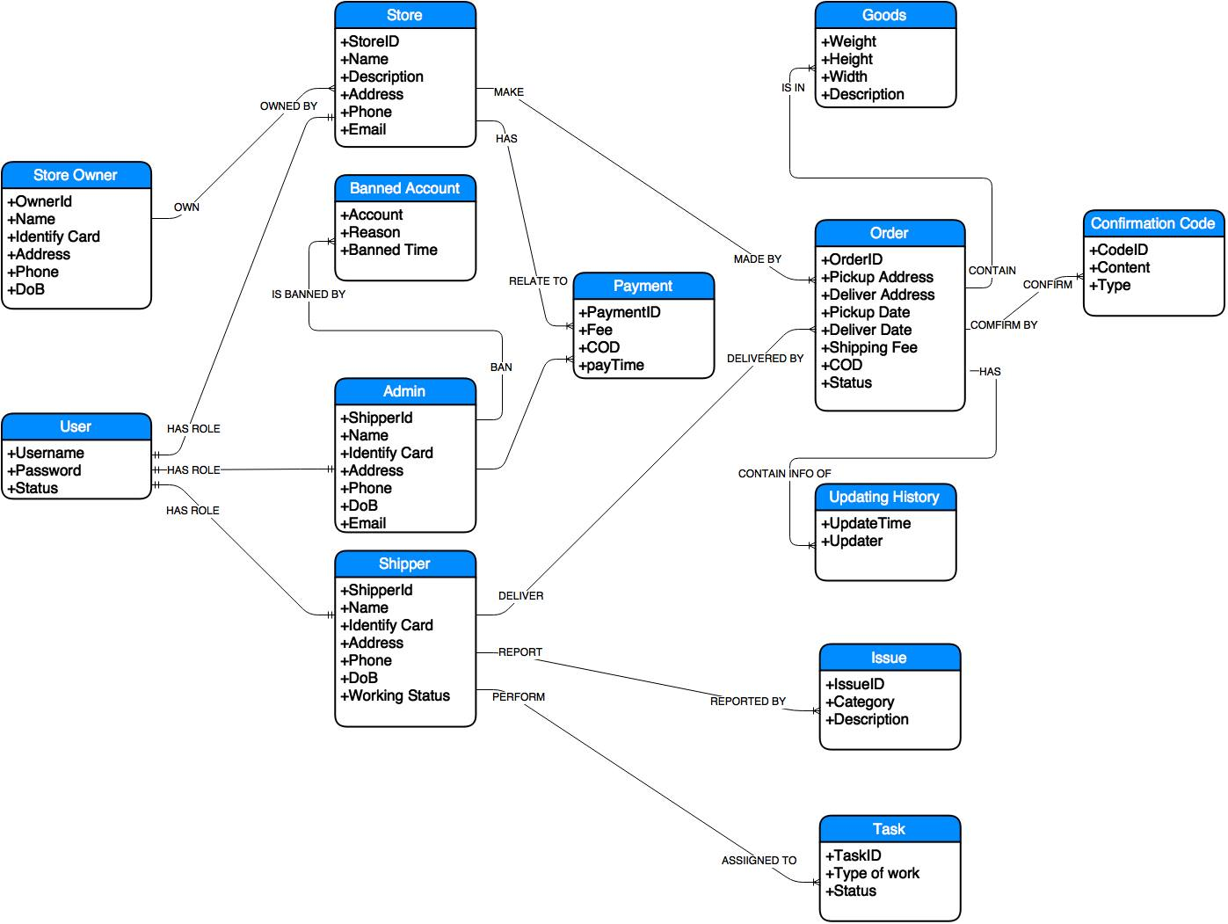

Figure : Entity relationship diagram

# FUNCTIONAL REQUIREMENTS

## 3.1. Web application for Admin

### 3.1.1. User Case Diagram

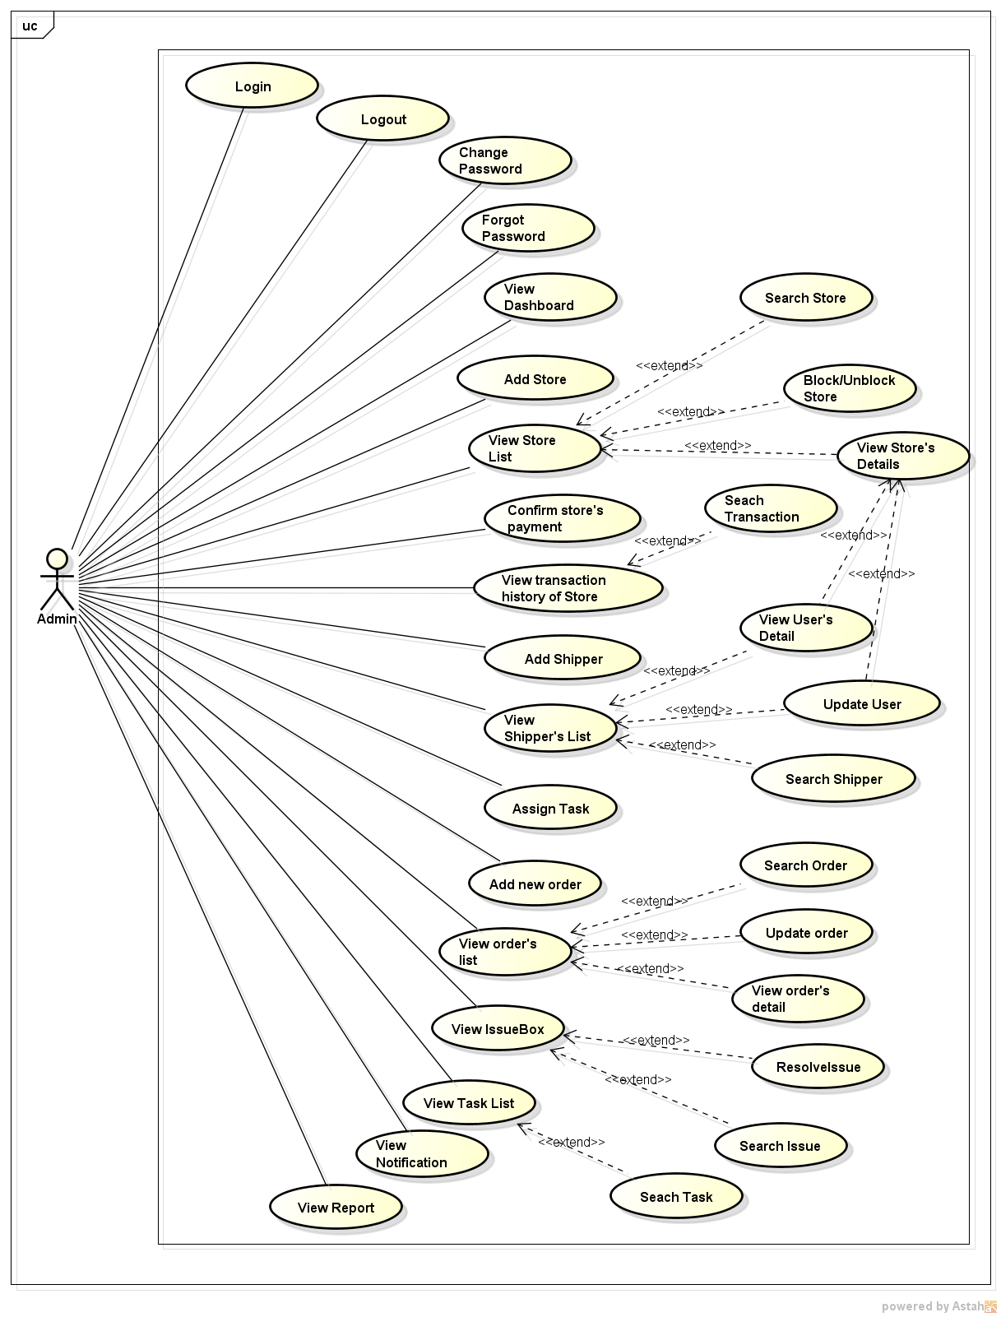

Figure 11: User case diagram of Web Application for Admin

### 3.1.2. Functions

###### *UC-101: Login*

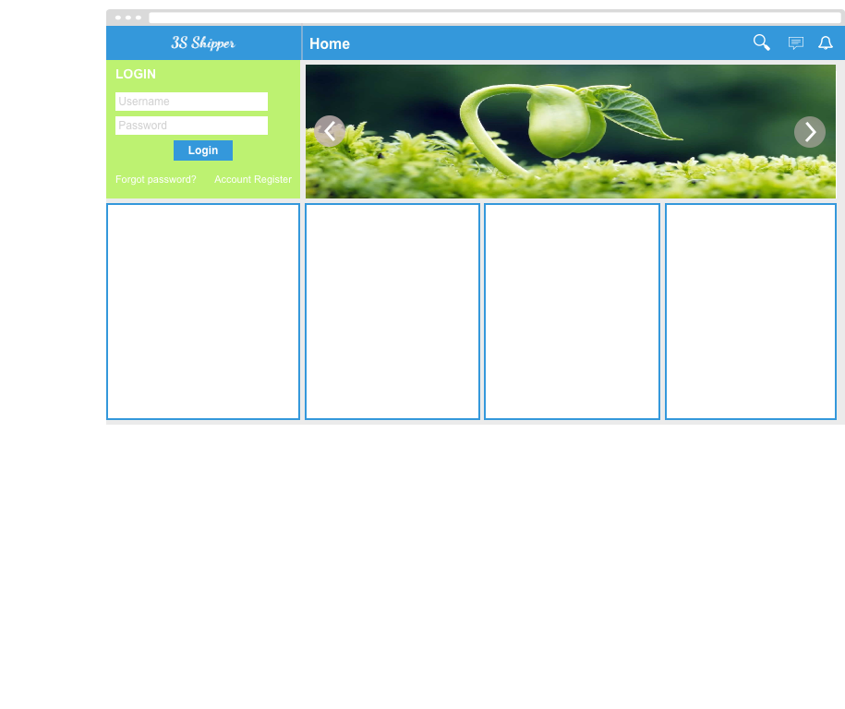

Figure 7: Login screen

|  |  |  |  |  |
| --- | --- | --- | --- | --- |
| **Use Case ID:** | | UC-101 | | |
| **Use Case Name:** | | Login | | |
| **CreatedBy:** | | HoangNK | **Last UpdatedBy:** | HoangNK |
| **Date Created:** | | 19/09/2015 | **DateLast Updated:** | 02/10/2015 |
| **Actor:** | | Store | | |
| **Description:** | | Users who are not logged in to system can only view the “Homepage”. Admin needs to logins to system to use functions of system. | | |
| **Triggering event:** | | Admin wants to login to system | | |
| **Preconditions:** | | - Admin is on the “Homepage” of KarryWell website  - Admin account must be exits | | |
| **Post conditions:** | | Logs Admin into system  Redirects Admin to “Dashboard” screen (Refer to UC-125: View Dashboard) | | |
| **Priority:** | | High | | |
| **FrequencyofUse:** | | Sometime | | |
| **Main flow** | | | | |
| Step | Actor | Action | | |
|  | Admin | Enters User name and Password | | |
|  | Admin | Clicks “Login” | | |
|  | System | Check “Username” and “Password” in database. | | |
|  | System | Logs Admin into system | | |
|  | System | Redirects to “Dashboard” screen. | | |
| **Alternative:** | | | | |
| **Exceptions:** | | | | |
| EC1 | At step 3 in main flow, if Admin entered wrong User name or Password | | | |
| Step | Actor | Action | | |
| 3.1 | System | Displays message “Username or Password is wrong” | | |
| **Includes:** | | N/A | | |
| **Special requirements:** | | N/A | | |
| **Notes and Issues:** | | N/A | | |

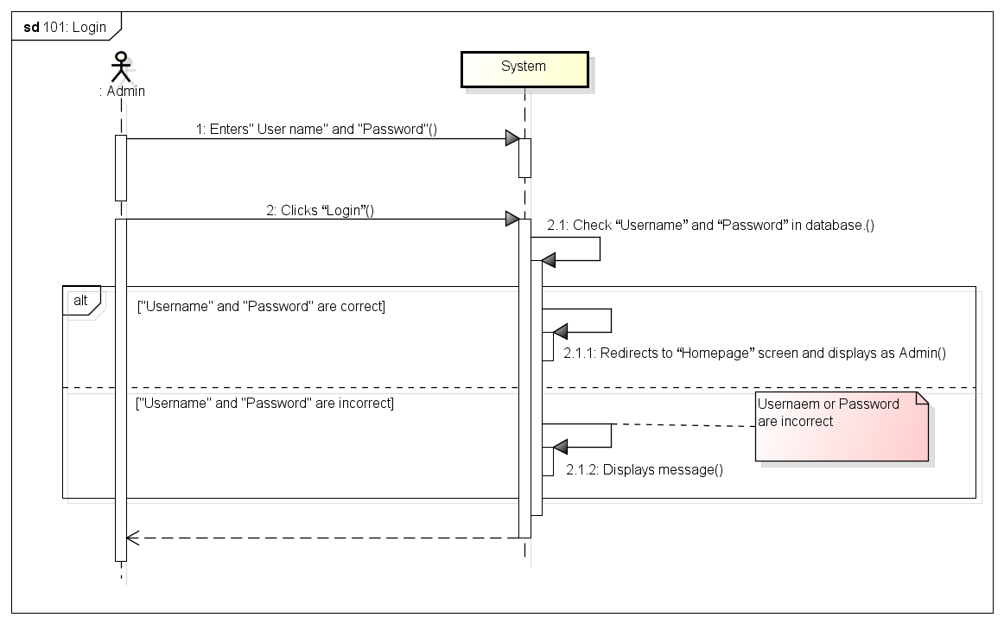

Figure 8: for Login user case

###### *UC-102: Logout*

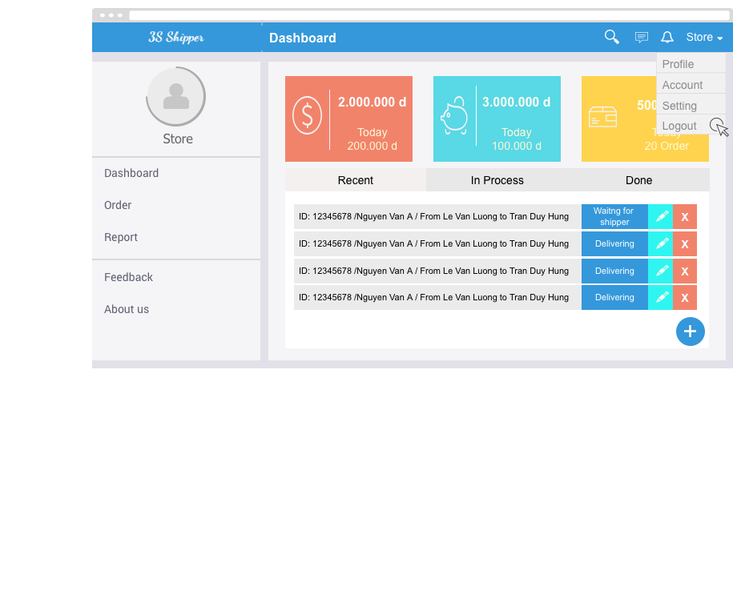

Figure 9: Logout screen

|  |  |  |  |  |
| --- | --- | --- | --- | --- |
| **Use Case ID:** | | UC-102 | | |
| **Use Case Name:** | | Logout | | |
| **CreatedBy:** | | KhanhKC | **Last UpdatedBy:** | KhanhKC |
| **Date Created:** | | 19/09/2015 | **DateLast updated:** | 02/10/2015 |
| **Actor:** | | Admin | | |
| **Description:** | | When Admin logouts from system, Admin will cannot continue using functions of system. Admin needs to login again to be able to use the function of system. | | |
| **Triggering event:** | | Admin wants to logout from system. | | |
| **Preconditions:** | | Admin logged in to system | | |
| **Post conditions:** | | Logs Admin out from system.  Redirects to “Homepage” screen (Refer to UC218: View Homepage) | | |
| **Priority:** | | High | | |
| **FrequencyofUse:** | | Often | | |
| **Main flow** | | | | |
| Step | Actor | Action | | |
|  | Admin | Clicks Logout | | |
|  | System | Logouts Admin from system | | |
|  | System | Displays Homepage for Guest | | |
| **Alternative Flows:** | | N/A | | |
| **Exceptions:** | | N/A | | |
| **Includes:** | | N/A | | |
| **SpecialRequirements:** | | N/A | | |
| **Notes andIssues:** | | N/A | | |

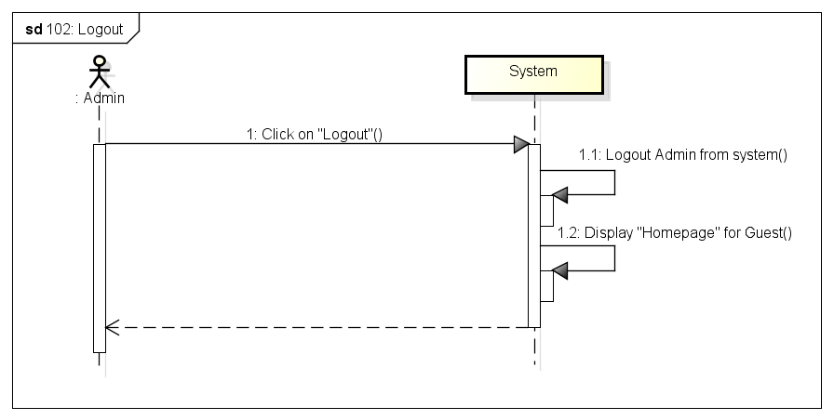

Figure 10: for Logout user case

###### *UC-103: Change password*

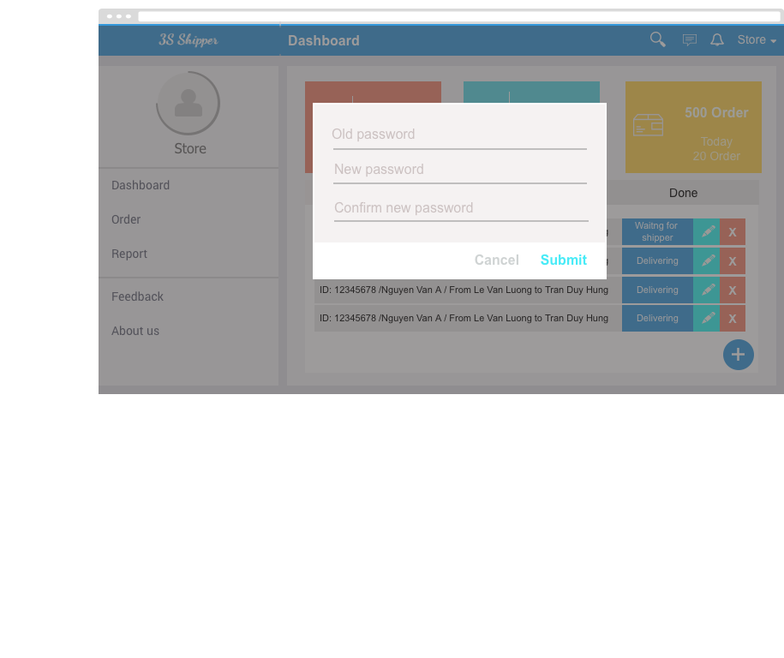

Figure 11: Change password screen

|  |  |  |  |  |
| --- | --- | --- | --- | --- |
| **Use Case ID:** | | UC-204 | | |
| **Use Case Name:** | | Change password | | |
| **CreatedBy:** | | KhanhKC | **Last UpdatedBy:** | KhanhKC |
| **Date Created:** | | 19/09/2015 | **DateLast updated:** | 02/10/2015 |
| **Actor:** | | Admin | | |
| **Description:** | | Admin can change login password but Admin need to remember old password. | | |
| **Triggering event:** | | Admin wants to change password. | | |
| **Preconditions:** | | Admin logged in to system | | |
| **Post conditions:** | | New password has been saved in database. | | |
| **Priority:** | | High | | |
| **FrequencyofUse:** | | Sometime | | |
| **Main flow** | | | | |
| Step | Actor | Action | | |
|  | Admin | Clicks “Change password” | | |
|  | System | Displays “Change password” screen includes:  - Old password text box  - New password text box  - Confirm new password text box  - Submit button | | |
|  | Admin | Enters data in fields | | |
|  | Admin | Clicks “Submit” button | | |
|  | System | Validates data | | |
|  | System | Displays “Change password” screen with message “ Changes password successful” | | |
| **Alternative Flows:** | | N/A | | |
| **Exceptions:** | | | | |
| EC1 | At step 4, required fields are not entered | | | |
| Step | Actor | Action | | |
| 4.1 | System | Displays “Change password” screen with error message “*is require” | | |
| EC2 | At step 4, “Old password” is incorrect | | | |
| Step | Actor | Action | | |
| 4.1 | System | Displays “Change password” screen with error message: “Old password is incorrect” | | |
| EC3 | At step 4, confirm new password is not the same with new password | | | |
| Step | Actor | Action | | |
| 4.1 | System | Displays “Change password” screen with error message.” Confirm new password is not the same with new password. Please enter again!” | | |
| **Includes:** | | N/A | | |
| **SpecialRequirements:** | | Length of “New password” must between 6 and 10. | | |
| **Notes andIssues:** | | N/A | | |

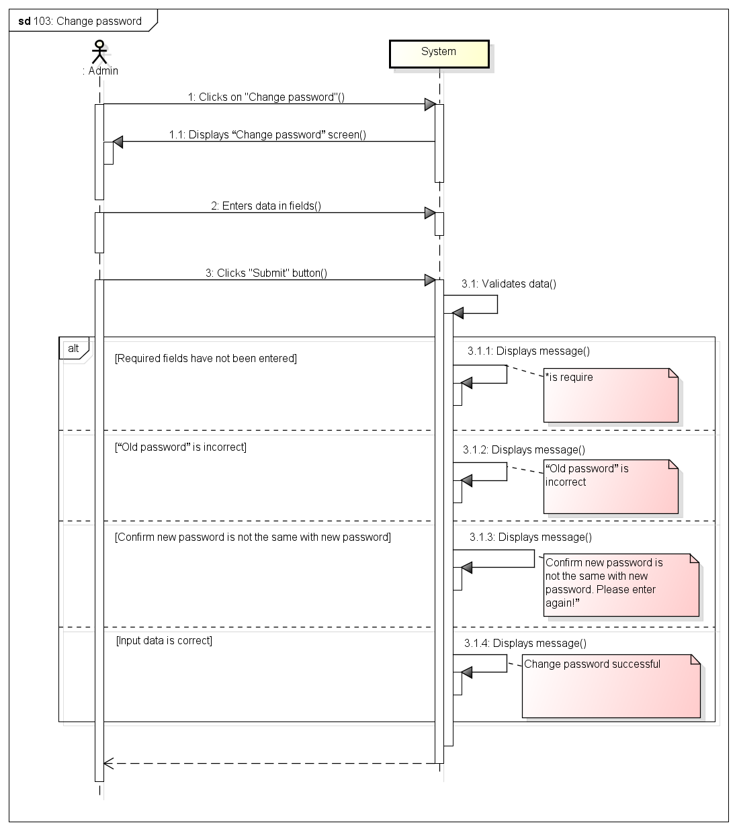

Figure 12: for Change password user case

###### *UC-104: Forgot password*

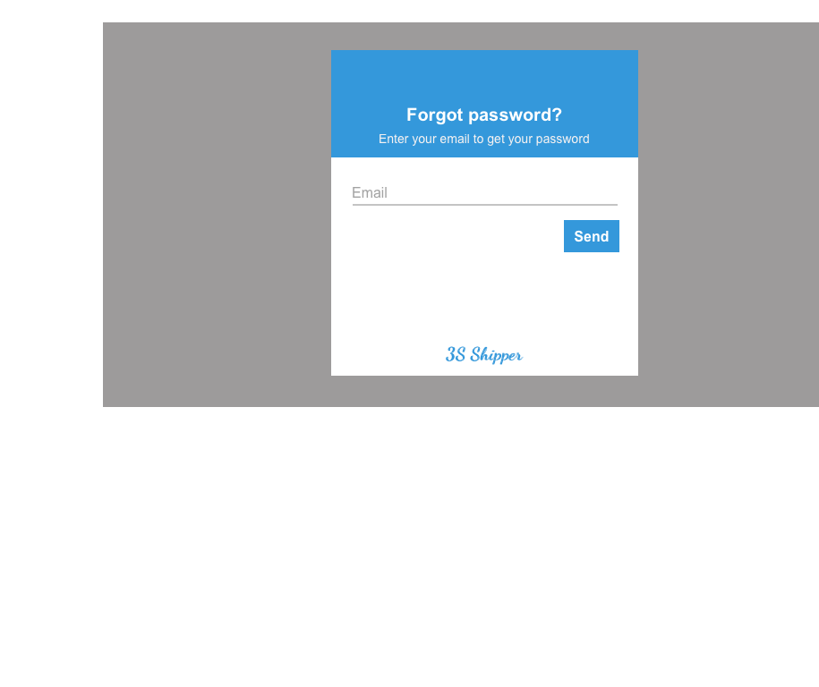

Figure 13:Forgot screen

|  |  |  |  |  |
| --- | --- | --- | --- | --- |
| **Use Case ID:** | | UC-205 | | |
| **Use Case Name:** | | Forgot password | | |
| **CreatedBy:** | | KhanhKC | **Last UpdatedBy:** | KhanhKC |
| **Date Created:** | | 19/09/2015 | **DateLast updated:** | 02/10/2015 |
| **Actor:** | | Admin | | |
| **Description:** | | This function help Admin receive their login password when Admin forgot. | | |
| **Triggering event:** | | Admin requests system to receive new password. | | |
| **Preconditions:** | | Admin is on the “Homepage” (Refer to UC-218: View Homepage) | | |
| **Post conditions:** | | - A new password has been updated for Admin  - An email has been send to registered email of Admin include new password. | | |
| **Priority:** | | High | | |
| **FrequencyofUse:** | | Sometime | | |
| **Main flow** | | | | |
| Step | Actor | Action | | |
|  | Admin | Clicks “Forgot password” hyperlink on “Login” box | | |
|  | System | Displays “Forgot password” popup includes:  - Email text box  - Submit button | | |
|  | Guest | Enters registered email. | | |
|  | Guest | Clicks “Submit” button | | |
|  | System | Validates data | | |
|  | System | Updates a new password for Admin | | |
|  | System | Sends the new password to registered email of Admin | | |
|  | System | Displays message : “Please check your email to get your new password” | | |
| **Alternative Flows:** | | N/A | | |
| **Exceptions:** | | | | |
| EC1 | At step 3, email are not a registered email | | | |
| Step | Actor | Actor | | |
| 4.1 | System | Displays error message:” Email is not exist” | | |
| **Includes:** | | N/A | | |
| **SpecialRequirements:** | | N/A | | |
| **Notes andIssues:** | | N/A | | |

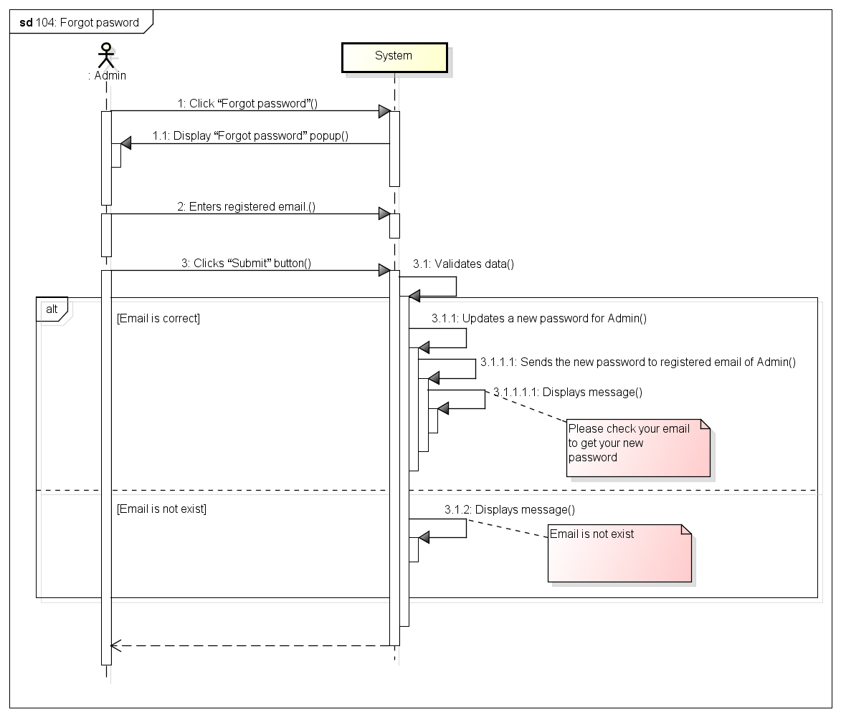

Figure 14: Sequence diagram for Forgot password user case

###### *UC- 105: Add Store*

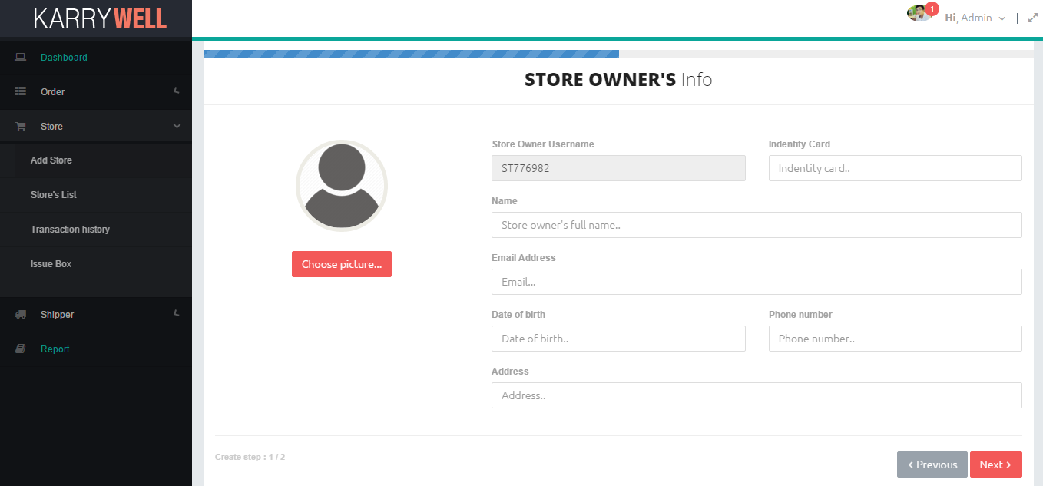

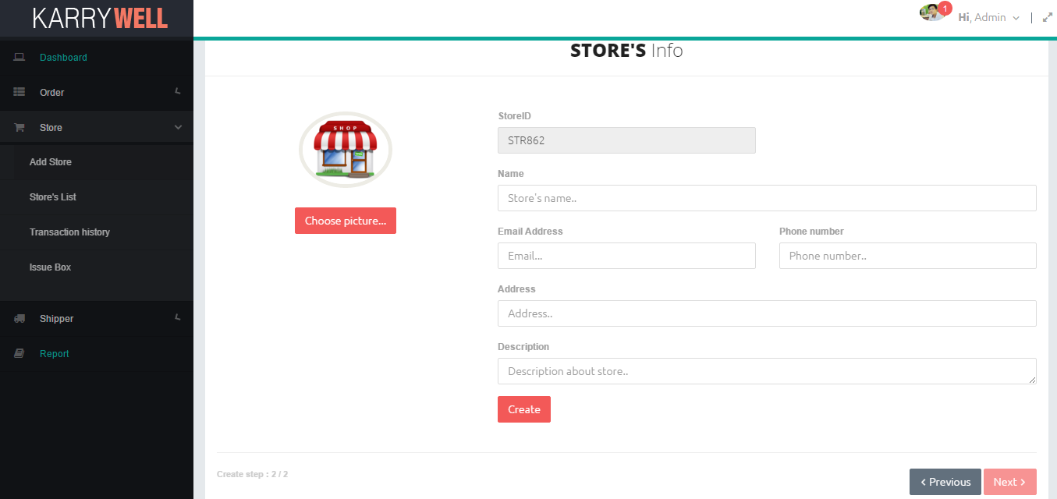

Figure 15: Add store screen

|  |  |  |  |  |
| --- | --- | --- | --- | --- |
| **Use Case ID:** | | UC-105 | | |
| **Use Case Name:** | | Add Store | | |
| **CreatedBy:** | | HoangNK | **Last UpdatedBy:** | HoangNK |
| **Date Created:** | | 19/09/2015 | **DateLast updated:** | 02/10/2015 |
| **Actor:** | | Admin | | |
| **Description:** | | Store send information to admin, after that admin add new Store by this information then an email about Store’s detail will be sent to the Store | | |
| **Triggering Event:** | | Admin wants to add new Store to system | | |
| **Preconditions:** | | Admin logged in to system | | |
| **Post conditions:** | | New Store is added to database | | |
| **Priority:** | | High | | |
| **FrequencyofUse:** | | Sometime | | |
| **Main flow** | | | | |
| Step | Actor | Action | | |
|  | Admin | Clicks “Store” button in left navigate bar | | |
|  | System | Displays “Store” menu includes: Add Store, Store’s List and Transaction History | | |
|  | Admin | Clicks “Add Store” button | | |
|  | System | Display in “Add Store” step 1 screen includes information of store owner:   * Store owner username textbox * Identity card textbox * Email textbox * Date of birth textbox * Phone number textbox * Address textbox * Choose avatar button * Previous and Next button | | |
|  | Admin | Enters information in these textbox then click button “Next” | | |
|  | System | Validates input | | |
|  | System | Displays “Add Store” step 2 screen includes information of store:   * StoreID textbox * Name textbox * Description textbox * Phone number textbox * Email textbox * Address textbox * Choose picture of profile button * Previous and Next button * Create button * Choose avatar button | | |
|  | Admin | Enters store’s information in textbox then click button “Create” | | |
|  | System | Validates input | | |
|  | System | Adds new Store to database of System, notify to admin a message about adding result and redirect to store’s list page | | |
| **Alternative Flows:** | | N/A | | |
| **Exceptions:** | | | | |
| EC1 | At step 6, if admin doesn’t type any textbox | | | |
| Step | Actor | Action | | |
| 6.1 | System | Displays error message “* is required” | | |
| EC2 | At step 6, if admin types wrong format | | | |
| Step | Actor | Action | | |
| 6.1 | System | Displays error message:   * This value must should be digits * This value should be a valid email. * This value length is invalid. It should be between 10 and 11 characters long. | | |
| EC3 | At step 9, if admin doesn’t type any textbox | | | |
| Step | Actor | Action | | |
| 9.1 | System | Displays error message “* is required” | | |
| EC4 | At step 9, if admin types wrong format | | | |
| Step | Actor | Action | | |
| 9.1 | System | Displays error message:   * * must should be digits * * should be a valid email. * * length is invalid. It should be between 10 and 11 characters long. | | |
| EC5 | At step 10, if email, identity card or phone number has been already existed | | | |
| Step | Actor | Action | | |
| 10.1 | System | Shows error notify: “* has been already existed” | | |
| EC6 | At step 10, system is failed to add new Store by other reason | | | |
| Step | Actor | Action | | |
| 10.1 | System | Shows error notify: “Adding fail” | | |
| **Includes:** | | N/A | | |
| **SpecialRequirements:** | | * Email must be valid email format * Identity card must be digits and value length is 9 to 12 characters * Phone number must be digits and value length is 10 or 11 characters * StoreID will be generated automatically by system by format “STR***” (* is digits) * Store’s owner username will be generated automatically by system by format “ST*****” (* is digits) * Default account and password for new Store is store’s owner username, Store can change them by website later | | |
| **Notes andIssues:** | | N/A | | |

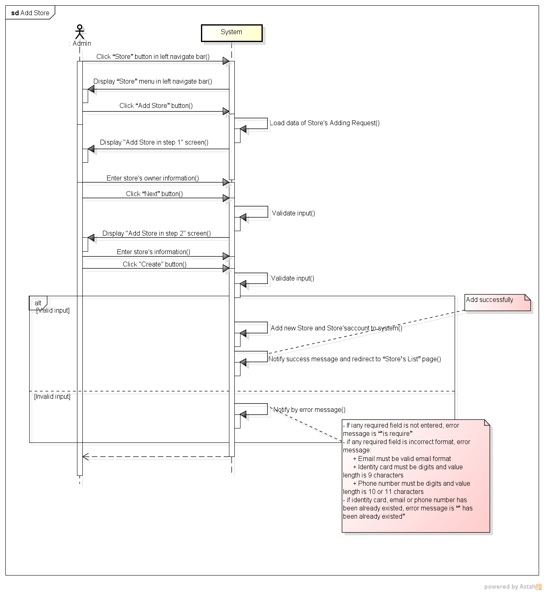

Figure 16: for Confirm Store’s Adding Request Use case

###### *UC- 106: Search Store*

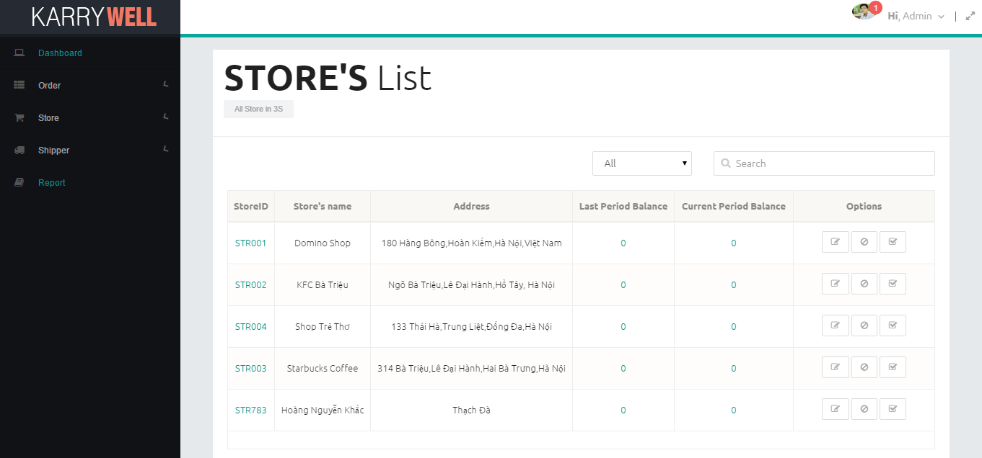

Figure 17: Screen of Search Store Use case

|  |  |  |  |  |
| --- | --- | --- | --- | --- |
| **Use Case ID:** | | UC-106 | | |
| **Use Case Name:** | | Search Store | | |
| **CreatedBy:** | | HoangNK | **Last UpdatedBy:** | HoangNK |
| **Date Created:** | | 19/09/2015 | **DateLast updated:** | 02/10/2015 |
| **Actor:** | | Admin | | |
| **Description:** | | Admin wants the system to list all Stores related to a specific keyword and type, after that, Admin can choose a Store to view details, update information and block or unblock this Store. | | |
| **Triggering Event:** | | Admin wants to search store | | |
| **Preconditions:** | | Admin is in view store’s list page ( refer case UC-107 ) | | |
| **Post conditions:** | | Stores have information which matches search key is displayed | | |
| **Priority:** | | High | | |
| **FrequencyofUse:** | | Always | | |
| **Main flow** | | | | |
| Step | Actor | Action | | |
|  | Admin | Chooses type of searching | | |
|  | Admin | Enters text to “Search” text box | | |
|  | System | Displays Stores have information which matches search key | | |
| **Alternative Flows:** | | N/A | | |
| **Exceptions:** | | N/A | | |
| **Includes:** | | N/A | | |
| **SpecialRequirements:** | | * Result of search is case insensitive * Types of search are All, Name, Address and ID | | |
| **Notes andIssues:** | | N/A | | |

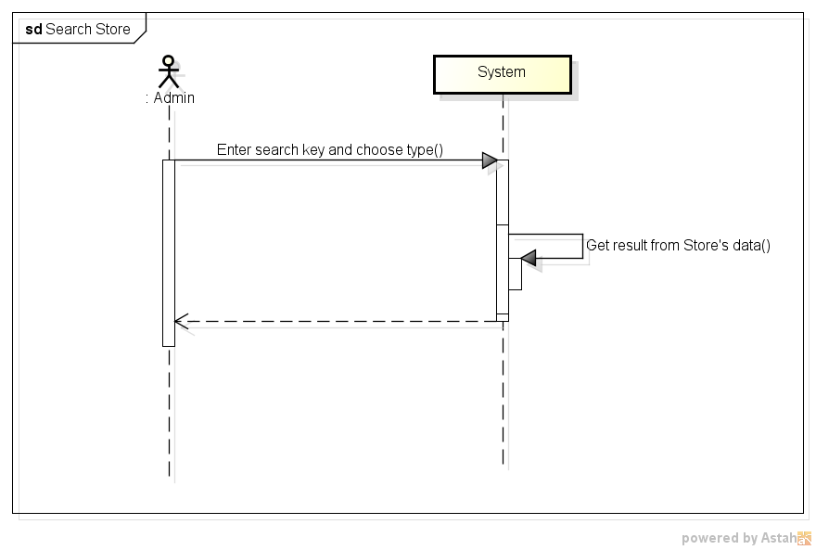

Figure 18: for Search Store Use case

###### *UC- 107:View Store’s list*



Figure 19: Screen of View Store’s List Use case

|  |  |  |  |  |
| --- | --- | --- | --- | --- |
| **Use Case ID:** | | UC-107 | | |
| **Use Case Name:** | | View Store’s list | | |
| **CreatedBy:** | | HoangNK | **Last UpdatedBy:** | HoangNK |
| **Date Created:** | | 19/09/2015 | **DateLast updated:** | 19/09/2015 |
| **Actor:** | | Admin | | |
| **Description:** | | Admin views all Store with their position in map and basic information (address, name, payment,..), so after that, Admin can choose a Store to confirm payment, edit and block or unblock | | |
| **Triggering Event:** | | Admin wants to view all of Store and related information | | |
| **Preconditions:** | | Admin logged in to system | | |
| **Post conditions:** | | List of store is displayed to screen | | |
| **Priority:** | | High | | |
| **FrequencyofUse:** | | Always | | |
| **Main flow** | | | | |
| Step | Actor | Action | | |
|  | Admin | Clicks “Store” button in left navigate bar | | |
|  | System | Displays “Store” menu in left navigate bar includes: Add Store, Store’s List and Transaction History | | |
|  | Admin | Clicks “Store’s list” button | | |
|  | System | Gets Store’s data then display “Store’s List” screen includes:   * Map of all store * Search textbox and button * Filter drop-downlist * Related Store’s information: storeID, name, address, last balance period, current balance period with 3 buttons Update, Confirm payment and Block or Unblock in a table | | |
| **Alternative Flows:** | | N/A | | |
| **Exceptions:** | | | | |
| EC1 | At step 4, system can’t get data from database because the internet or the database disconnect | | | |
| Step | Actor | Action | | |
| 4.1 | System | Shows error message: “Failed to load data” | | |
| **Includes:** | | N/A | | |
| **SpecialRequirements:** | | * “All” is default type * The default Store’s list is ordered by Name | | |
| **Notes andIssues:** | | N/A | | |

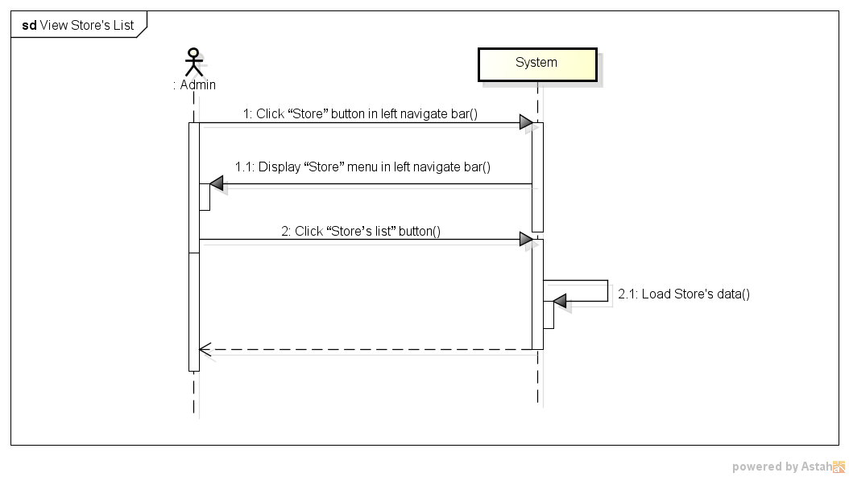

Figure 20: for View Store’s List Use case

###### *UC- 108:Block/Unblock store*

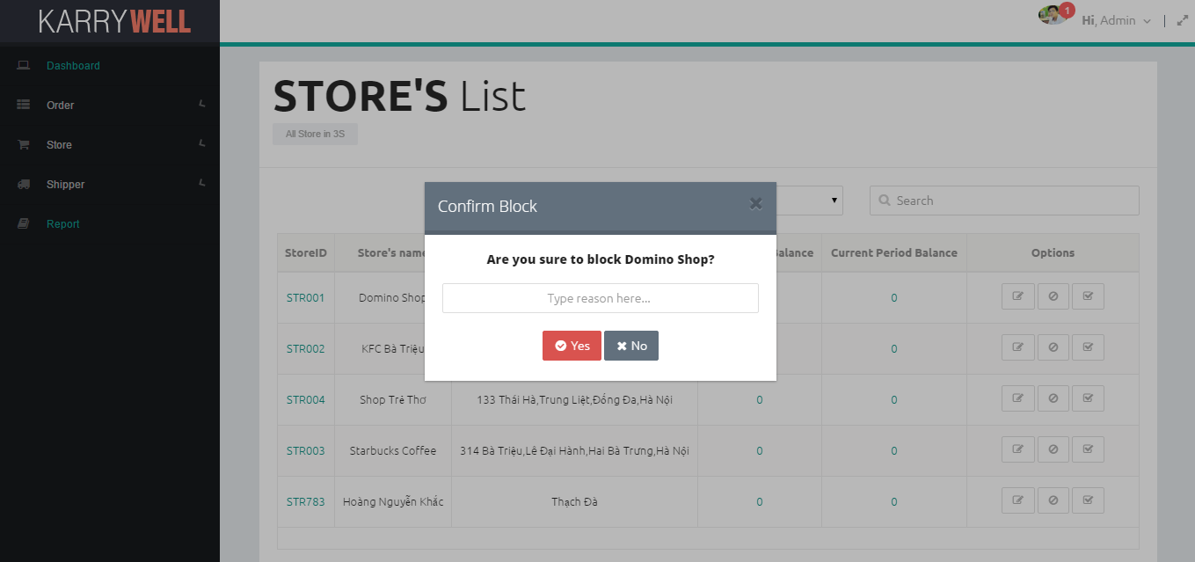

Figure 21: Screen of Block and Unblock Store Use case

|  |  |  |  |  |
| --- | --- | --- | --- | --- |
| **Use Case ID:** | | UC-108 | | |
| **Use Case Name:** | | Block/Unblock store | | |
| **CreatedBy:** | | HoangNK | **Last UpdatedBy:** | HoangNK |
| **Date Created:** | | 19/09/2015 | **DateLast updated:** | 02/10/2015 |
| **Actor:** | | Admin | | |
| **Description:** | | Admin bans the store from system if the store has serious breach of contract, so they can’t do any function of system if they were banned. Besides, Admin can unban the Store which is banned to give this Store permission of using Store’s functions | | |
| **Triggering Event:** | | Admin wants to blocks or unblocks store | | |
| **Preconditions:** | | Admin is in view store’s list page ( refer case UC-107 ) | | |
| **Post conditions:** | | Store is blocked or unblocked | | |
| **Priority:** | | Normal | | |
| **FrequencyofUse:** | | Sometime | | |
| **Main flow** | | | | |
| Step | Actor | Action | | |
|  | Admin | Clicks “Block”(“Unblock”) button/ | | |
|  | System | Displays confirm popup includes “Yes” and “No” button with reason textbox(if block) | | |
|  | Admin | Enters reason (if block) then clicks “Yes” button | | |
|  | System | Hides popup and change store’s status of blocking | | |
| **Alternative Flows:** | | N/A | | |
| **Exceptions:** | | | | |
| EC1 | At step 2, Admin clicks on “No” button | | | |
| Step | Actor | Action | | |
| 2.1 | System | Closes popup | | |
| **Includes:** | | N/A | | |
| **SpecialRequirements:** | | N/A | | |
| **Notes andIssues:** | | N/A | | |

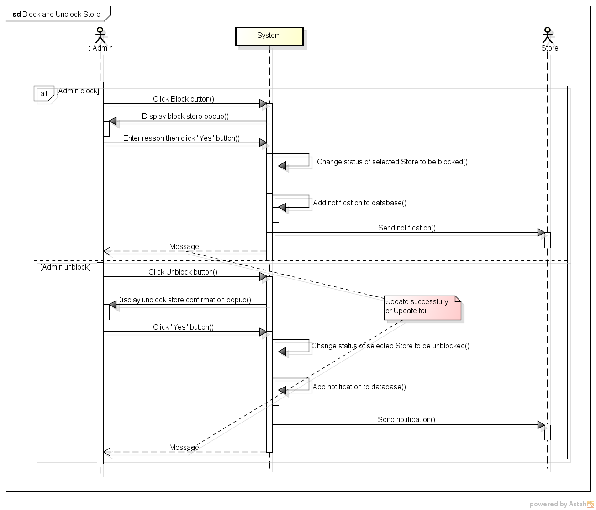

Figure 22: for Block and Unblock Store Use case

###### *UC- 109:View Store’s details*

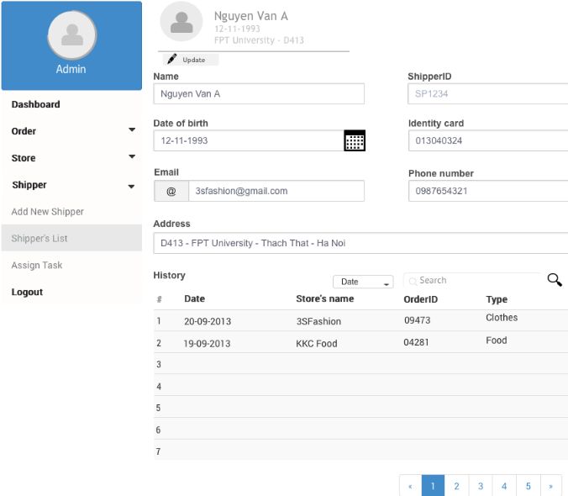

Figure 23: Screen of View Store’s Details Use case

|  |  |  |  |  |
| --- | --- | --- | --- | --- |
| **Use Case ID:** | | UC-109 | | |
| **Use Case Name:** | | View Store’s details | | |
| **CreatedBy:** | | HoangNK | **Last UpdatedBy:** | HoangNK |
| **Date Created:** | | 19/09/2015 | **DateLast updated:** | 02/10/2015 |
| **Actor:** | | Admin | | |
| **Description:** | | Admin views all Store’s details (address, name, registered date, phone number, store’s manager, payment, identity card) so after that, Admin can edit and block or unblock this Store | | |
| **Triggering Event:** | | Admin wants to view all information of a Store | | |
| **Preconditions:** | | Admin is in view store’s list page ( refer case UC-107 ) | | |
| **Post conditions:** | | Details of Store are displayed | | |
| **Priority:** | | Normal | | |
| **FrequencyofUse:** | | Sometime | | |
| **Main flow** | | | | |
| Step | Actor | Action | | |
|  | Admin | Clicks Store’s name in row (hyperlink) | | |
|  | System | Loads data of selected Store and display “View Store’s details” screen includes store’s details includes: address, name, registered date, phone number, store’s manager, identity card, Change avatar button and Update button | | |
| **Alternative Flows:** | | N/A | | |
| **Exceptions:** | | | | |
| EC1 | At step 2, system can’t get data from database because the internet or the database disconnect | | | |
| Step | Actor | Action | | |
| 2.1 | System | Shows error message: “Failed to load data” | | |
| **Includes:** | | N/A | | |
| **SpecialRequirements:** | | N/A | | |
| **Notes andIssues:** | | N/A | | |

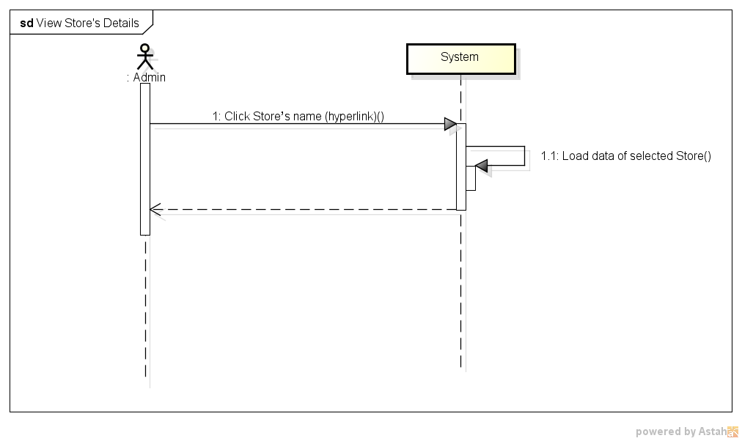

Figure 24: for View Store’s Details Use case

###### *UC- 111:Confirm Store’s payment*

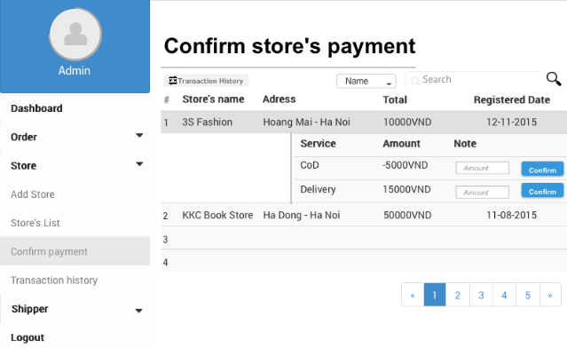

Figure 25: Screen of Confirm Store’s Payment Use case

|  |  |  |  |  |
| --- | --- | --- | --- | --- |
| **Use Case ID:** | | UC-111 | | |
| **Use Case Name:** | | Confirm Store’s payment | | |
| **CreatedBy:** | | HoangNK | **Last UpdatedBy:** | HoangNK |
| **Date Created:** | | 19/09/2015 | **DateLast updated:** | 02/10/2015 |
| **Actor:** | | Admin | | |
| **Description:** | | After receiving and sending money to the Store, admin updates Store’s payment by confirming amount of money of transactions | | |
| **Triggering Event:** | | Admin wants to confirms the store’s payment | | |
| **Preconditions:** | | Admin is in view store’s list page ( refer case UC-107 ) | | |
| **Post conditions:** | | Payment of this store is updated in database | | |
| **Priority:** | | High | | |
| **FrequencyofUse:** | | Always | | |
| **Main flow** | | | | |
| Step | Actor | Action | | |
|  | Admin | Clicks “Confirm store’s payment” button | | |
|  | System | Displays “Confirm store’s payment” popup includes:   * Amount textbox and button * Payfrom drop-downlist * Store’s basic payment information: store’s name, delivery cost, cash on delivery | | |
|  | Admin | Picks payform, enters amount then clicks “Confirm” button | | |
|  | System | Validates input | | |
|  | System | Gives confirm by displaying confirm popup includes summary information, “Yes” and “No” button | | |
|  | Admin | Clicks “Yes” button | | |
|  | System | Updates payment of this store to database | | |
| **Alternative Flows:** | | N/A | | |
| **Exceptions:** | | | | |
| EC1 | At step 4, if amount textbox is blank | | | |
| Step | Actor | Action | | |
| 4.1 | System | Displays error message “* is required” | | |
| EC2 | At step 4, if amount textbox is incorrect format | | | |
| Step | Actor | Action | | |
| 4.1 | System | Displays error message “* should be digits” | | |
| EC3 | At step 4, if value of amount textbox is 0 | | | |
| Step | Actor | Action | | |
| 4.1 | System | Displays error message “Update fail… amount must greater than 0” | | |
| EC4 | At step 6, if Admin click “No” button | | | |
| Step | Actor | Action | | |
| 6.1 | System | Closes popup | | |
| **Includes:** | | N/A | | |
| **SpecialRequirements:** | | * Default value of amount textbox is 0 * The value of amount textbox is only number and not equal 0 | | |
| **Notes andIssues:** | | N/A | | |

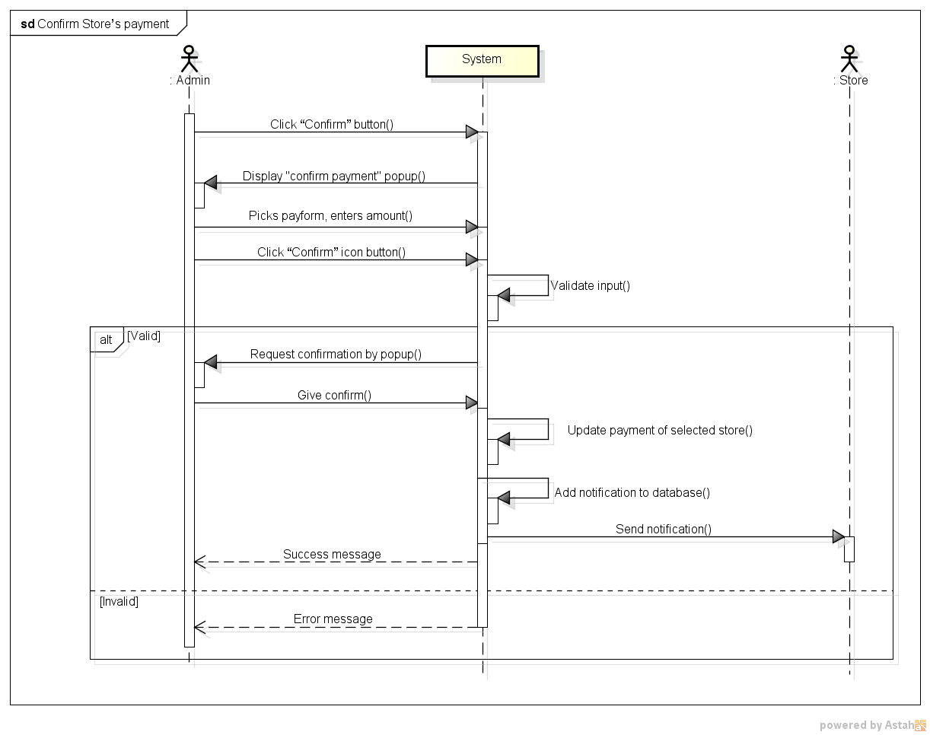

Figure 26: for Confirm Store’s payment user case

###### *UC- 112:View transaction history of Store*

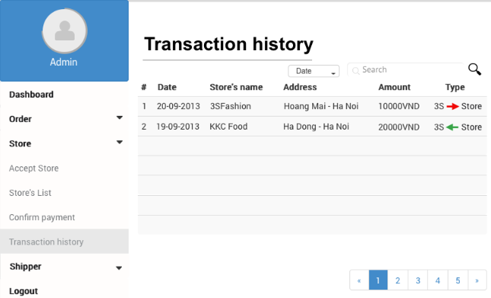

Figure 27: Screen of View Transaction History of Store Use case

|  |  |  |  |  |
| --- | --- | --- | --- | --- |
| **Use Case ID:** | | UC-112 | | |
| **Use Case Name:** | | View transaction history of Store | | |
| **CreatedBy:** | | HoangNK | **Last UpdatedBy:** | HoangNK |
| **Date Created:** | | 19/09/2015 | **DateLast updated:** | 19/09/2015 |
| **Actor:** | | Admin | | |
| **Description:** | | Admin wants the system to list all Store’s transaction with basic information (store’s name, address, amount of money, type,..) | | |
| **Triggering Event:** | | Admin wants to view transaction history of Stores | | |
| **Preconditions:** | | Admin logged in to system | | |
| **Post conditions:** | | List of transaction history of Store is displayed | | |
| **Priority:** | | Normal | | |
| **FrequencyofUse:** | | Sometime | | |
| **Main flow** | | | | |
| Step | Actor | Action | | |
|  | Admin | Clicks “Store” button in left navigate bar | | |
|  | System | Display “Store” menu in left navigate bar includes: Add Store, Store’s List, Transaction History | | |
|  | Admin | Clicks “Transaction history” button | | |
|  | System | Load data of transaction and display “Transaction history” screen includes   * Search textbox and button * Filter drop-downlist * Two tab auto payment and custom payment with related information(ledgerid, store name, last balance, amount, amount, total delivery, total cod, paydate, note) of transactions | | |
| **Alternative Flows:** | | N/A | | |
| **Exceptions:** | | | | |
| EC1 | At step 4, system can’t get data from database because the internet or the database disconnect | | | |
| Step | Actor | Action | | |
| 4.1 | System | Shows error message: “Failed to load data” | | |
| **Includes:** | | N/A | | |
| **SpecialRequirements:** | | * “All” is default type * The default transaction list is ordered by Paydate | | |
| **Notes andIssues:** | | * If amount is negative, this transaction is pay from store to system and vice versa | | |

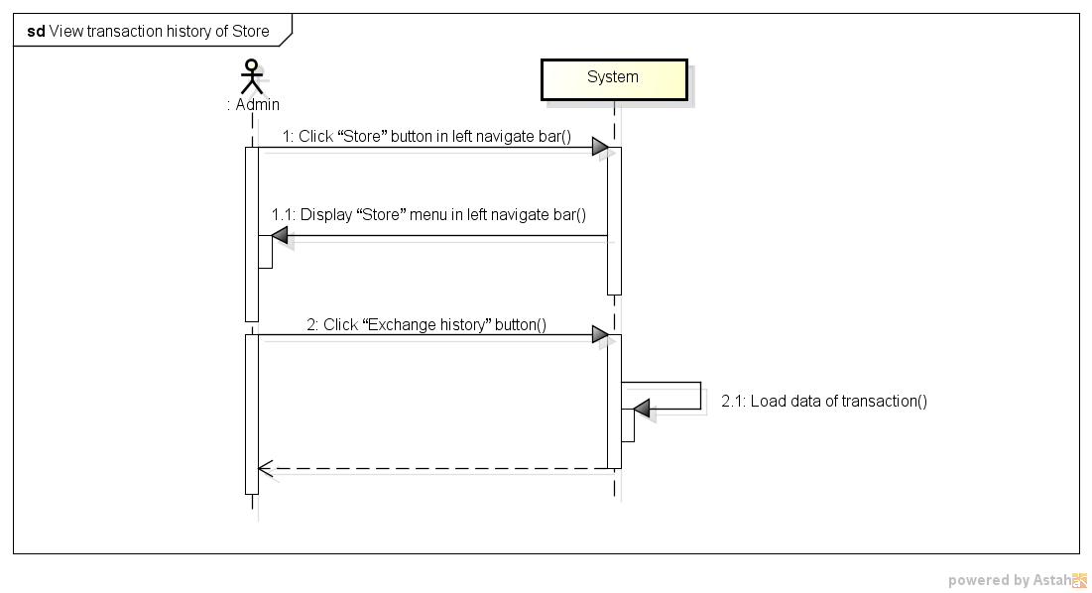

Figure 28: for View Transaction history of Store Use case

###### *UC- 113:Add Shipper*

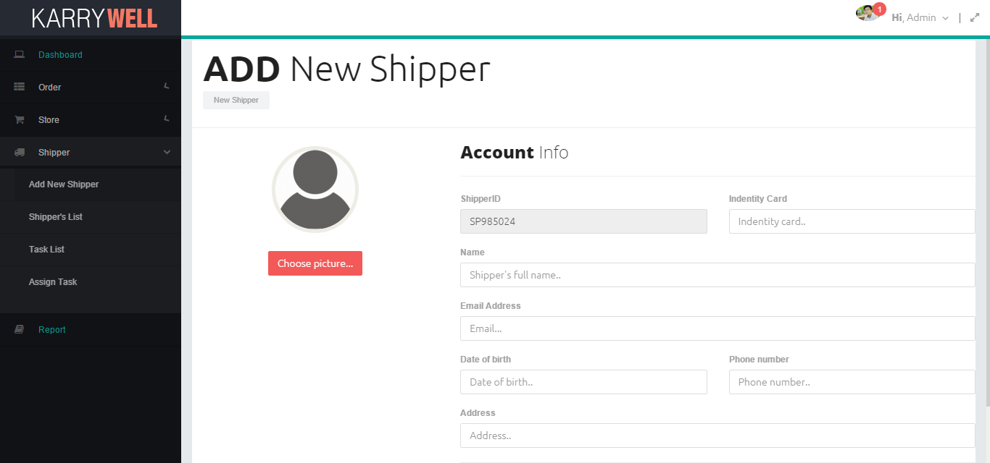

Figure 29: Screen of Add Shipper Use case

|  |  |  |  |  |
| --- | --- | --- | --- | --- |
| **Use Case ID:** | | UC-113 | | |
| **Use Case Name:** | | Add New Shipper | | |
| **CreatedBy:** | | HoangNK | **Last UpdatedBy:** | HoangNK |
| **Date Created:** | | 19/09/2015 | **DateLast updated:** | 19/09/2015 |
| **Actor:** | | Admin | | |
| **Description:** | | Admin creates new account to new Shipper with basic information of Shipper: name, date of birth, email, phone number, identity card, address,… | | |
| **Triggering Event:** | | Admin wants to adds a new Shipper to system | | |
| **Preconditions:** | | Admin logged in to system | | |
| **Post conditions:** | | New Shipper and new account for this Shipper are added to database | | |
| **Priority:** | | High | | |
| **FrequencyofUse:** | | Often | | |
| **Main flow** | | | | |
| Step | Actor | Action | | |
|  | Admin | Clicks “Shipper” button in left navigate bar | | |
|  | System | Displays “Shipper” menu in left navigate bar includes Add New Shipper, Shipper’s List, Task’s List and Assign Task | | |
|  | Admin | Clicks “Add new Shipper” button | | |
|  | System | Displays “Add new Shipper” form includes:   * ShipperID textbox * Identity card textbox * Email textbox * Date of birth textbox * Phone number textbox * Address textbox * Choose avatar button * Create button | | |
|  | Admin | Enter new Shipper’s information into fields | | |
|  | Admin | Clicks “Create” button | | |
|  | System | Validate input | | |
|  | System | Add new Shipper and new account of this Shipper to database then redirects to “Shipper’s List” page | | |
| **Alternative Flows:** | | N/A | | |
| **Exceptions:** | | | | |
| EC1 | At step 7, if any required field is not entered | | | |
| Step | Actor | Action | | |
| 7.1 | System | Notify in screen by error message “*is require” | | |
| EC2 | At step 7, if any required field is incorrect format | | | |
| Step | Actor | Action | | |
| 7.1 | System | Displays error message:   * * must should be digits * * should be a valid email. * * length is invalid. It should be between 10 and 11 characters long. | | |
| EC3 | At step 7, if identity card or email has been already existed | | | |
| Step | Actor | Action | | |
| 7.1 | System | Notify in screen by error message “* has been already existed” | | |
| EC6 | At step 10, system is failed to add new Shipper by other reason | | | |
| Step | Actor | Action | | |
| 10.1 | System | Shows error notify: “Adding fail” | | |
| **Includes:** | | N/A | | |
| **SpecialRequirements:** | | * Email must be valid email format * Identity card must be digits and value length is 9 to 12 characters * Phone number must be digits and value length is 10 or 11 characters * ShipperID will be generated automatically by system by format “SP******” (* is digits) * Default account and password for new Shipper is shipperID, Shipper can change them by mobile app later | | |
| **Notes andIssues:** | | N/A | | |

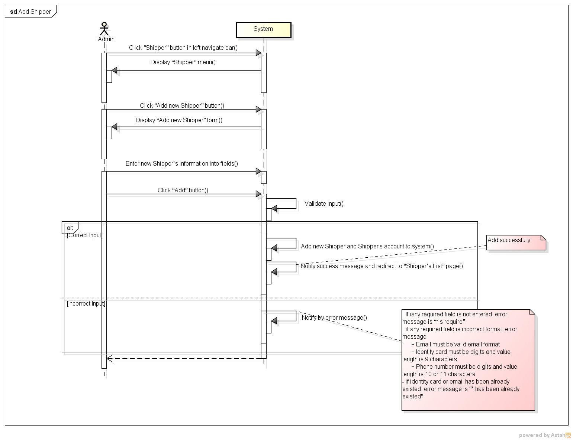

Figure 30: for Add Shipper Use case

###### *UC- 114:View Shipper’s list*

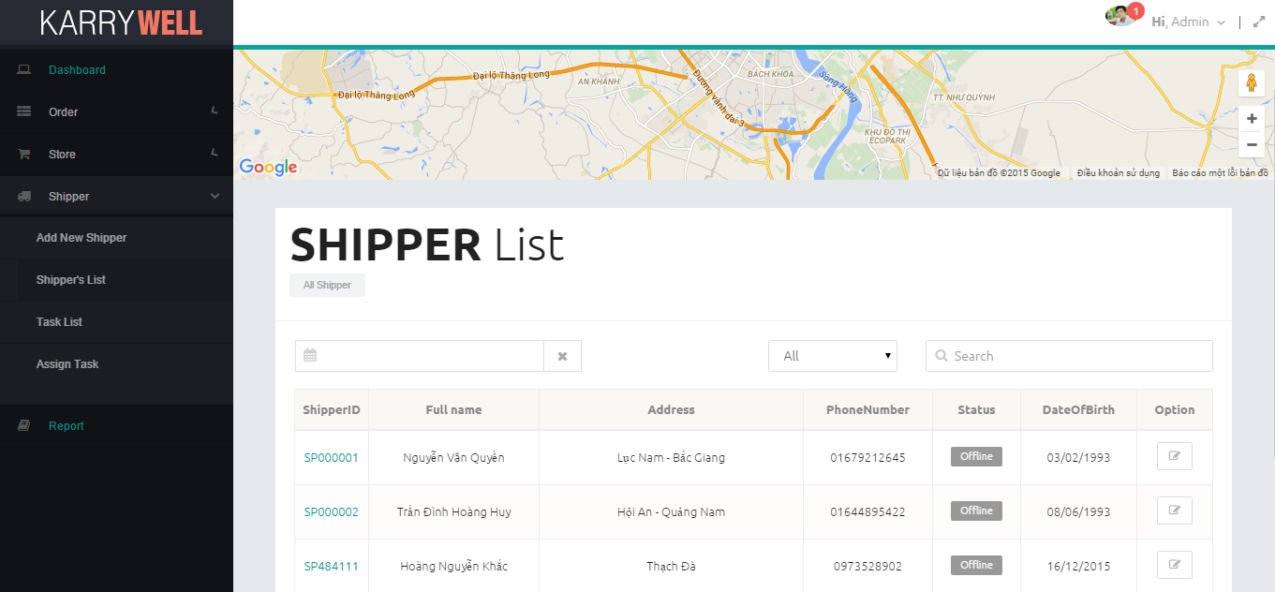

Figure 31: Screen of View Shipper’s List Use case

|  |  |  |  |  |
| --- | --- | --- | --- | --- |
| **Use Case ID:** | | UC-114 | | |
| **Use Case Name:** | | View Shipper’s list | | |
| **CreatedBy:** | | HoangNK | **Last UpdatedBy:** | HoangNK |
| **Date Created:** | | 19/09/2015 | **DateLast updated:** | 19/09/2015 |
| **Actor:** | | Admin | | |
| **Description:** | | Admin views all Shipper with their position in map and basic information (address, name, date of birth,..), so after that, Admin can choose a Shipper to update information | | |
| **Triggering Event:** | | Admin wants to view all Shipper | | |
| **Preconditions:** | | Admin logged in to system | | |
| **Post conditions:** | | List of shipper is displayed | | |
| **Priority:** | | High | | |
| **FrequencyofUse:** | | Always | | |
| **Main flow** | | | | |
| Step | Actor | Action | | |
|  | Admin | Clicks “Shipper” button in left navigate bar | | |
|  | System | Display “Shipper” menu in left navigate bar includes Add New Shipper, Shipper’s List, Task’s List and Assign Task | | |
|  | Admin | Clicks “Shipper’s list” button | | |
|  | System | Load Shipper's data and display “Shipper’s List” screen includes:   * Map of all online shipper * Search textbox and button * Filter drop-downlist * All Shipper’s basic information(shipperid, full name, address, phone number, status, date of birth) with Update icon buttons | | |
| **Alternative Flows:** | | **N/A** | | |
| **Exceptions:** | | | | |
| EC1 | At step 4, system can’t get data from database because the internet or the database disconnect | | | |
| Step | Actor | Action | | |
| 4.1 | System | Shows error message: “Failed to load data” | | |
| **Includes:** | | N/A | | |
| **SpecialRequirements:** | | * The default Shipper’s list is ordered by Name * “All” is default type | | |
| **Notes andIssues:** | | N/A | | |

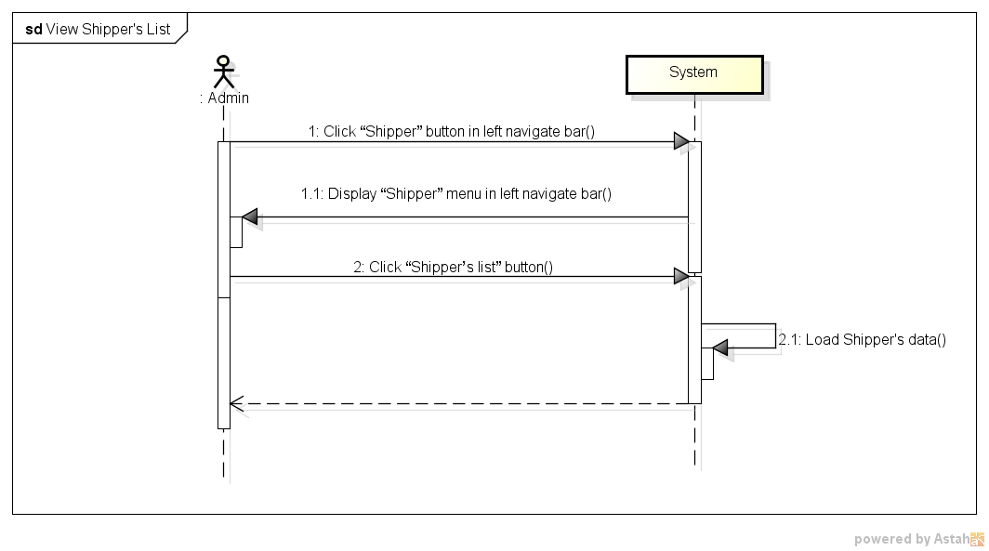

Figure 32: for View Shipper List Use case

###### *UC- 115:View Order’s list*

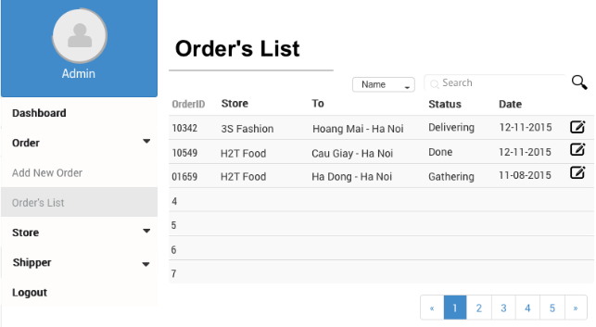

Figure 33: Screen of View Order’s List Use case

|  |  |  |  |  |
| --- | --- | --- | --- | --- |
| **Use Case ID:** | | UC-115 | | |
| **Use Case Name:** | | View Order’s list | | |
| **CreatedBy:** | | HoangNK | **Last UpdatedBy:** | HoangNK |
| **Date Created:** | | 19/09/2015 | **DateLast updated:** | 19/09/2015 |
| **Actor:** | | Admin | | |
| **Description:** | | Admin views all Order with basic information (orderID, store’s name, recipient’s address, status, date,..), so after that, Admin can choose an Order to update information | | |
| **Triggering Event:** | | Admin wants to view all Orders | | |
| **Preconditions:** | | Admin logged in to system | | |
| **Post conditions:** | | List of order is displayed | | |
| **Priority:** | | High | | |
| **FrequencyofUse:** | | Always | | |
| **Main flow** | | | | |
| Step | Actor | Action | | |
|  | Admin | Clicks “Order” button in left navigate bar | | |
|  | System | Display “Order” menu in left navigate bar includes Add Add New Order, Order’s List | | |
|  | Admin | Clicks “Order’s list” button | | |
|  | System | Load Order's data and display “Order’s List” screen includes   * Search textbox and button * Filter drop-downlist * All Order’s basic information(orderID, store’s name, pickup address, delivery address, pickup date, delivery date, status, type) with Update icon buttons | | |
| **Alternative Flows:** | | **N/A** | | |
| **Exceptions:** | | | | |
| EC1 | At step 4, system can’t get data from database because the internet or the database disconnect | | | |
| Step | Actor | Action | | |
| 4.1 | System | Shows error message: “Failed to load data” | | |
| **Includes:** | | N/A | | |
| **SpecialRequirements:** | | * The default Shipper’s list is ordered by complete Date * “All” is default type | | |
| **Notes andIssues:** | | N/A | | |

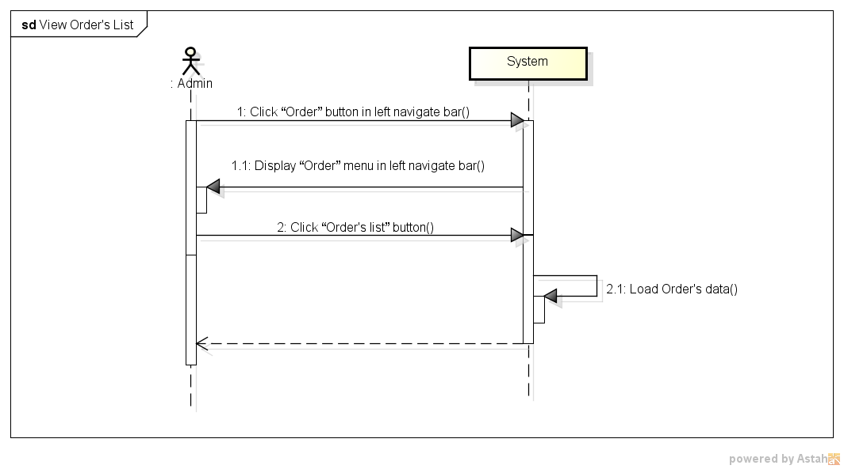

Figure 34: for View Order’s List Use case

###### *UC- 116:Search Shipper*

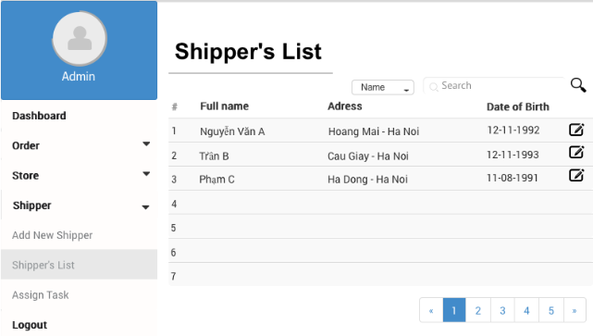

Figure 35: Screen of Search Shipper Use case

|  |  |  |  |  |
| --- | --- | --- | --- | --- |
| **Use Case ID:** | | UC-116 | | |
| **Use Case Name:** | | Search Shipper | | |
| **CreatedBy:** | | HoangNK | **Last UpdatedBy:** | HoangNK |
| **Date Created:** | | 19/09/2015 | **DateLast updated:** | 19/09/2015 |
| **Actor:** | | Admin | | |
| **Description:** | | Admin wants the system to list all Shipper related to a specific keyword and type, after that, Admin can choose a Shipper to update information | | |
| **Triggering Event:** | | Admin wants to search Shipper | | |
| **Preconditions:** | | Admin is in view shipper’s list page ( refer case UC-114 ) | | |
| **Post conditions:** | | Shippers have information which matches search key is displayed | | |
| **Priority:** | | High | | |
| **FrequencyofUse:** | | Always | | |
| **Main flow** | | | | |
| Step | Actor | Action | | |
|  | Admin | Chooses type of searching | | |
|  | Admin | Enters text to “Search” text box | | |
|  | System | Displays Shippers have information which matches search key | | |
| **Alternative Flows:** | | N/A | | |
| **Exceptions:** | | N/A | | |
| **Includes:** | | N/A | | |
| **SpecialRequirements:** | | * Result of search is case insensitive * Types of search are All, Name, Address and shipperID | | |
| **Notes andIssues:** | | N/A | | |

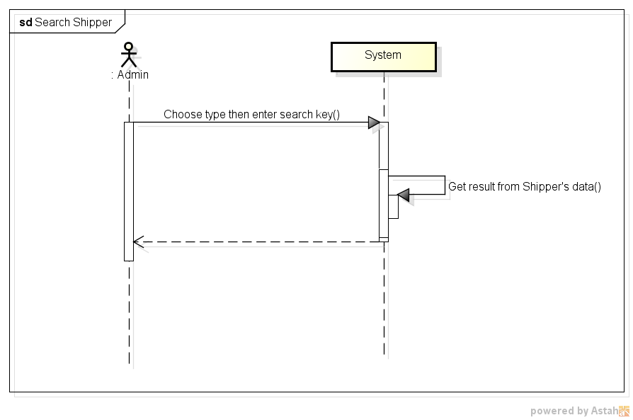

Figure 36: for Search Shipper Use case

###### *UC- 117:Search Order*



Figure 37: Screen of Search Order Use case

|  |  |  |  |  |
| --- | --- | --- | --- | --- |
| **Use Case ID:** | | UC-117 | | |
| **Use Case Name:** | | Search Order | | |
| **CreatedBy:** | | HoangNK | **Last UpdatedBy:** | HoangNK |
| **Date Created:** | | 19/09/2015 | **DateLast updated:** | 19/09/2015 |
| **Actor:** | | Admin | | |
| **Description:** | | Admin wants the system to list all Order related to a specific keyword and type, after that, Admin can choose an Order to update information | | |
| **Triggering Event:** | | Admin wants to search Order | | |
| **Preconditions:** | | Admin is in view order’s list page ( refer case UC-115 ) | | |
| **Post conditions:** | | Orders have information which matches search key is displayed | | |
| **Priority:** | | High | | |
| **FrequencyofUse:** | | Always | | |
| **Main flow** | | | | |
| Step | Actor | Action | | |
|  | Admin | Chooses type of Order | | |
|  | Admin | Enters text to “Search” text box | | |
|  | System | Displays Orders have information which matches search key | | |
| **Alternative Flows:** | | N/A | | |
| **Exceptions:** | | N/A | | |
| **Includes:** | | N/A | | |
| **SpecialRequirements:** | | * Result of search is case insensitive * Types of search are All, store’s name, pickup address, delivery address, status | | |
| **Notes andIssues:** | | N/A | | |

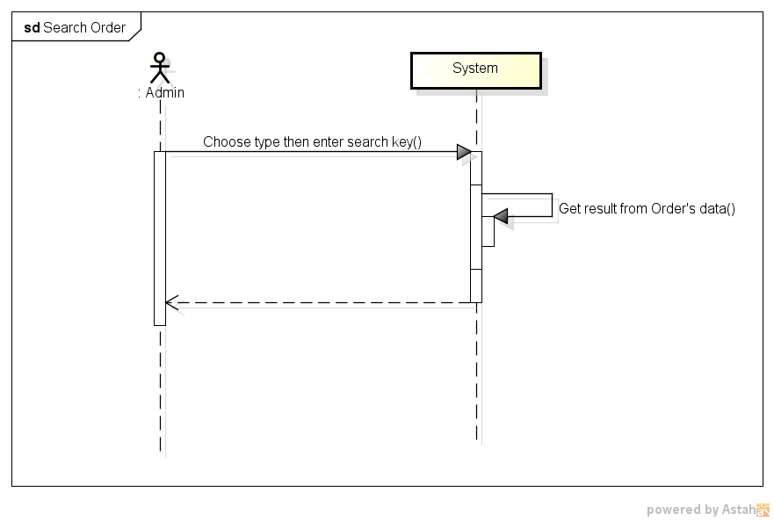

Figure 38: for Search Order Use case

###### *UC- 118:View User’s Detail*

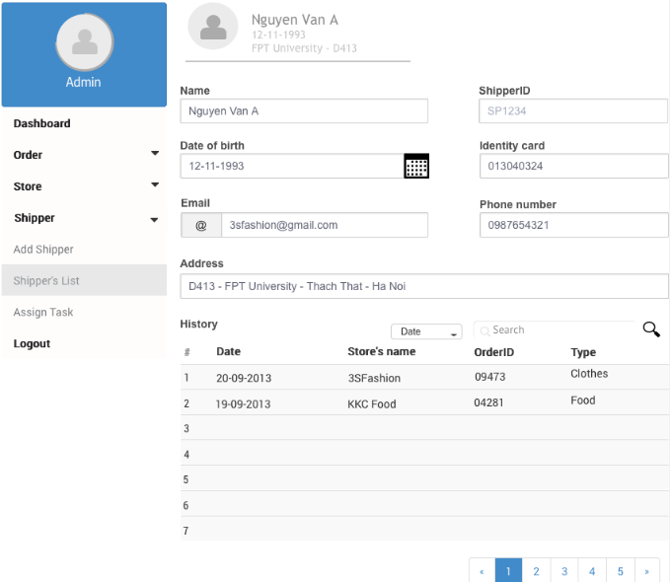

Figure 39: View User’sDetail screen

|  |  |  |  |  |
| --- | --- | --- | --- | --- |
| **Use Case ID:** | | UC-118 | | |
| **Use Case Name:** | | View User’sDetail | | |
| **CreatedBy:** | | HoangNK | **Last UpdatedBy:** | HoangNK |
| **Date Created:** | | 19/09/2015 | **DateLast updated:** | 02/10/2015 |
| **Actor:** | | Admin | | |
| **Description:** | | Admin views all User’s details (address, name, date of birth, phone number, email, address) so after that, Admin can update user information | | |
| **Triggering Event:** | | Admin wants to view profile of a user | | |
| **Preconditions:** | | Admin is in view shipper’s list page ( refer case UC-114 ) | | |
| **Post conditions:** | | Profile of Shipper is displayed | | |
| **Priority:** | | Normal | | |
| **FrequencyofUse:** | | Sometime | | |
| **Main flow** | | | | |
| Step | Actor | Action | | |
|  | Admin | Clicks user name in row (hyperlink) | | |
|  | System | Load data of selected user and display “View Shipper’s profile” screen includes information of name, date of birth, phone number, email, address, Change avatar button and Update button | | |
| **Alternative Flows:** | | N/A | | |
| **Exceptions:** | | | | |
| EC1 | At step 2, system can’t get data from database because the internet or the database disconnect | | | |
| Step | Actor | Action | | |
| 2.1 | System | Shows error message: “Failed to load data” | | |
| **Includes:** | | N/A | | |
| **SpecialRequirements:** | | N/A | | |
| **Notes andIssues:** | | N/A | | |

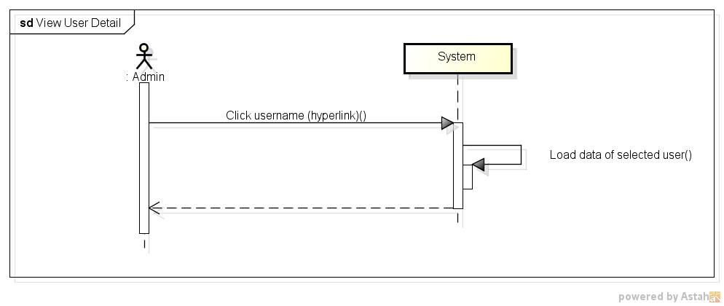

Figure 40: Sequence Diagram of View User’sDetail Use case

###### *UC- 119:View Order’s Detail*

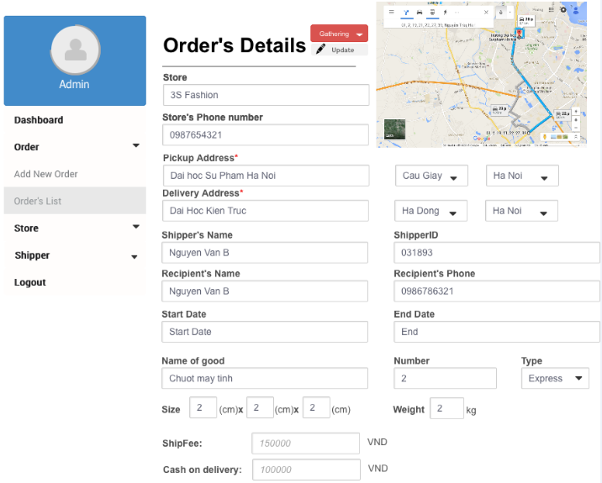

Figure 41: View Order’s details screen

|  |  |  |  |  |
| --- | --- | --- | --- | --- |
| **Use Case ID:** | | UC-119 | | |
| **Use Case Name:** | | View Order’s Detail | | |
| **CreatedBy:** | | HoangNK | **Last UpdatedBy:** | HoangNK |
| **Date Created:** | | 19/09/2015 | **DateLast updated:** | 19/09/2015 |
| **Actor:** | | Admin | | |
| **Description:** | | Admin views all Order’s details (status of the order , store’s name, pickup and delivery address and date, shipper’s name, recipient’s name, recipient’s phone, goods, type of delivery, size, fee, cash on delivery, …), so after that, Admin can update Shipper information | | |
| **Triggering Event:** | | Admin wants to view all information of the Order | | |
| **Preconditions:** | | Admin is in view shipper’s list page ( refer case UC-115) | | |
| **Post conditions:** | | Details of Order is displayed | | |
| **Priority:** | | Normal | | |
| **FrequencyofUse:** | | Sometime | | |
| **Main flow** | | | | |
| Step | Actor | Action | | |
|  | Admin | Clicks Order’s name in row (hyperlink) | | |
|  | System | Load data of selected Order and display to “View Order’s details” screen includes information of status of the order , store’s name, pickup and delivery address and date, shipper’s name, recipient’s name, recipient’s phone, goods, type of delivery, size, fee, cash on delivery, … | | |
| **Alternative Flows:** | | N/A | | |
| **Exceptions:** | |  | | |
| EC1 | At step 2, system can’t get data from database because the internet or the database disconnect | | | |
| Step | Actor | Action | | |
| 2.1 | System | Shows error message: “Failed to load data” | | |
| **Includes:** | | N/A | | |
| **SpecialRequirements:** | | N/A | | |
| **Notes andIssues:** | | N/A | | |

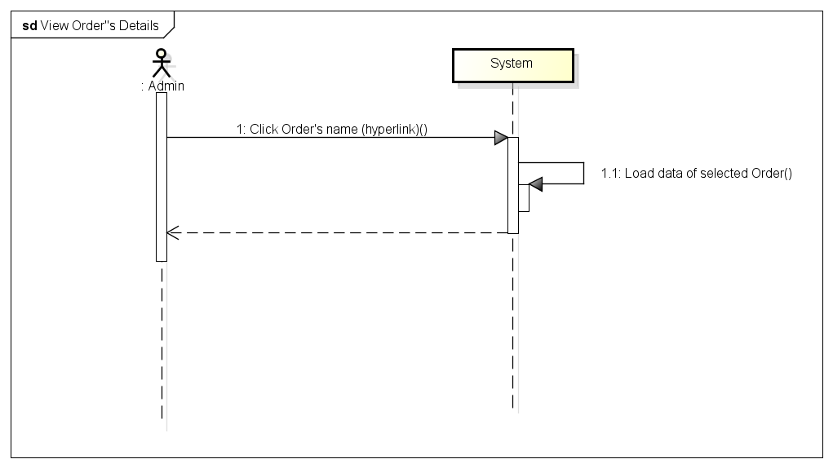

Figure 42: for View Order Details Use case

###### *UC- 120:Update User’s Profile*

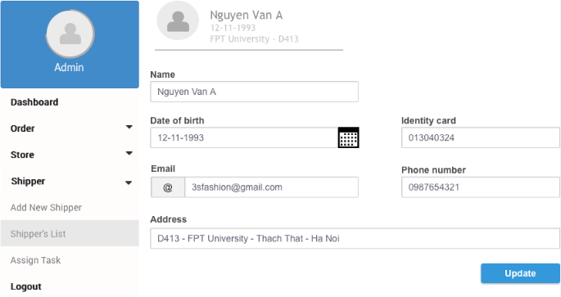

Figure 43: Update User’s Profile screen

|  |  |  |  |  |
| --- | --- | --- | --- | --- |
| **Use Case ID:** | | UC-120 | | |
| **Use Case Name:** | | Update User’s Profile | | |
| **CreatedBy:** | | HoangNK | **Last UpdatedBy:** | HoangNK |
| **Date Created:** | | 19/09/2015 | **DateLast updated:** | 19/09/2015 |
| **Actor:** | | Admin | | |
| **Description:** | | Admin modifies an existed Shipper or Store’s Owner with related information about name, date of birth, identity card, email, phone number, address,.. | | |
| **Triggering Event:** | | Admin wants to update Shipper or Store’s Owner information | | |
| **Preconditions:** | | Admin is in view shipper’s list page ( refer case UC-114 ) | | |
| **Post conditions:** | | New information of user is updated in database | | |
| **Priority:** | | Normal | | |
| **FrequencyofUse:** | | Sometime | | |
| **Main flow** | | | | |
| Step | Actor | Action | | |
|  | Admin | Clicks icon “Update” button | | |
|  | System | Get data of selected user and display “Update” screen includes textbox of information about name, date of birth, phone number, email, address, Change avatar button and Update button | | |
|  | Admin | Enter new information to fields then clicks “Update” button | | |
|  | System | Validate input | | |
|  | System | Update user’s new information to database then notify success message “Update successfully” | | |
| **Alternative Flows:** | | | | |
| AT1 | At step 1, if Admin is in view store’s list page ( refer case UC-107 ) | | | |
| Step | Actor | Action | | |
| 1 | Admin | Clicks icon “Update” button | | |
| 2 | System | Go to step 2 of main flow and continue | | |
| **Exceptions:** | | | | |
| EC1 | At step 4, if any required field is not entered | | | |
| Step | Actor | Action | | |
| 4.1 | System | Notify in screen by error message “*is require” | | |
| EC2 | At step 4, if any required field is incorrect format | | | |
| Step | Actor | Action | | |
| 4.1 | System | Displays error message:   * * must should be digits * * should be a valid email. * * length is invalid. It should be between 10 and 11 characters long. | | |
| EC3 | At step 4, if new identity card or email has been already existed | | | |
| Step | Actor | Action | | |
| 4.1 | System | Notify in screen by error message “* has been already existed” | | |
| EC6 | At step 5, system is failed to update new user by other reason | | | |
| Step | Actor | Action | | |
| 5.1 | System | Shows error notify: “Update fail” | | |
| **Includes:** | | N/A | | |
| **SpecialRequirements:** | | * Email must be valid email format * Identity card must be digits and value length is 9 to 12 characters * Phone number must be digits and value length is 10 or 11 characters | | |
| **Notes andIssues:** | | N/A | | |

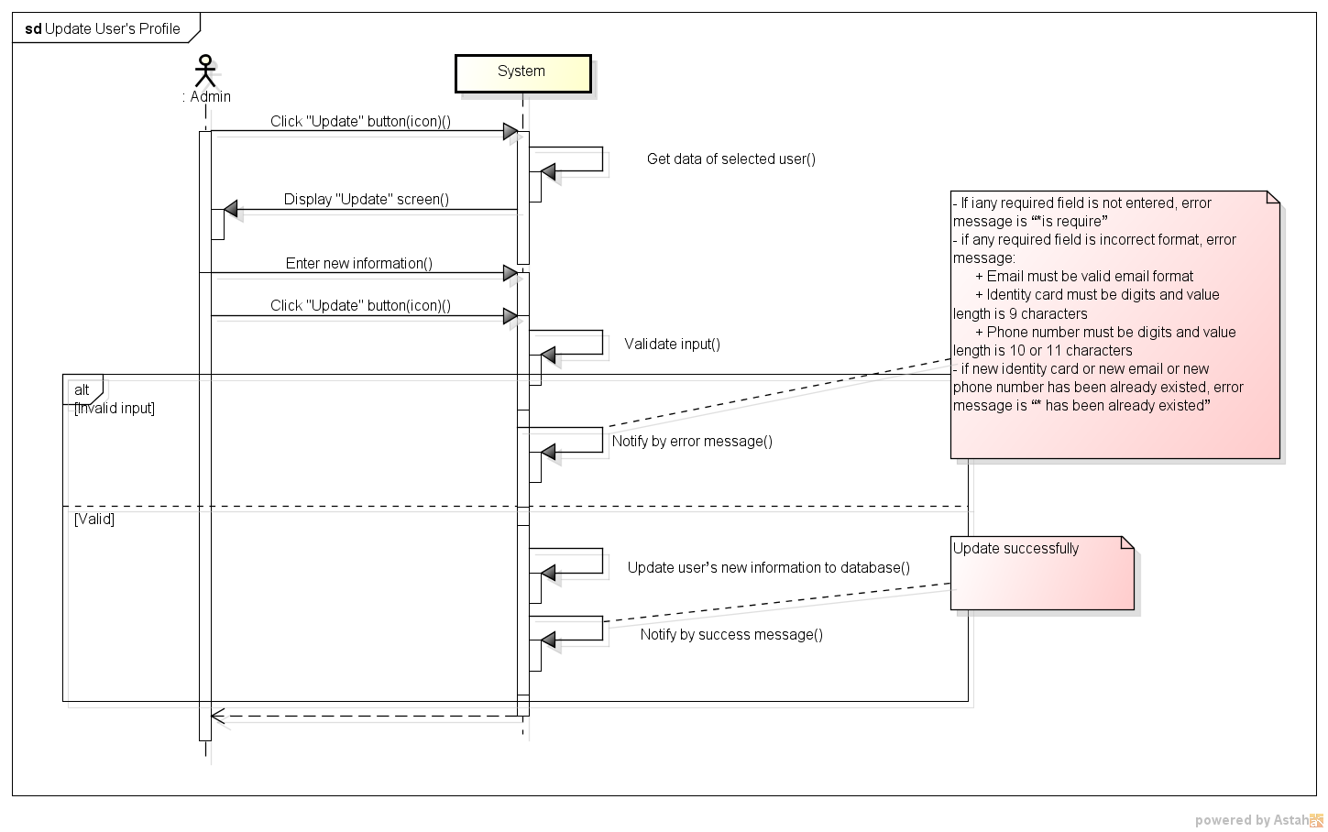

Figure 44: for Update Shipper Use case

###### *UC- 121:Update Store’s Information*



Figure 45: Update Store’s Information screen

|  |  |  |  |  |
| --- | --- | --- | --- | --- |
| **Use Case ID:** | | UC-121 | | |
| **Use Case Name:** | | Update Store’s Information | | |
| **CreatedBy:** | | HoangNK | **Last UpdatedBy:** | HoangNK |
| **Date Created:** | | 19/09/2015 | **DateLast updated:** | 19/09/2015 |
| **Actor:** | | Admin | | |
| **Description:** | | Admin modifies an existed Store related information about name, email, phone number, address,.. | | |
| **Triggering Event:** | | Admin wants to update Store’s information | | |
| **Preconditions:** | | Admin is in view store’s list page ( refer case UC-114 ) | | |
| **Post conditions:** | | New information of Store is updated in database | | |
| **Priority:** | | Normal | | |
| **FrequencyofUse:** | | Sometime | | |
| **Main flow** | | | | |
| Step | Actor | Action | | |
|  | Admin | Clicks icon “Update” button | | |
|  | System | Get data of selected Store and display “Update” screen includes textbox of information about address, name, phone number, store’s manager, identity card, Change avatar button and Update button | | |
|  | Admin | Enter new information to fields then clicks “Update” button | | |
|  | System | Validate input | | |
|  | System | Update Store’s new information to database then redirects to Shipper’s profile page | | |
| **Alternative Flows:** | | N/A | | |
| **Exceptions:** | | | | |
| EC1 | At step 4, if any required field is not entered | | | |
| Step | Actor | Action | | |
| 4.1 | System | Notify in screen by error message “*is require” | | |
| EC2 | At step 4, if any required field is incorrect format | | | |
| Step | Actor | Action | | |
| 4.1 | System | Displays error message:   * * must should be digits * * should be a valid email. * * length is invalid. It should be between 10 and 11 characters long. | | |
| EC3 | At step 4, if new identity card or email has been already existed | | | |
| Step | Actor | Action | | |
| 4.1 | System | Notify in screen by error message “* has been already existed” | | |
| EC6 | At step 5, system is failed to update new Store by other reason | | | |
| Step | Actor | Action | | |
| 5.1 | System | Shows error notify: “Update fail” | | |
| **Includes:** | | N/A | | |
| **SpecialRequirements:** | | * Email must be valid email format * Identity card must be digits and value length is 9 to 12 characters * Phone number must be digits and value length is 10 or 11 characters | | |
| **Notes andIssues:** | | N/A | | |

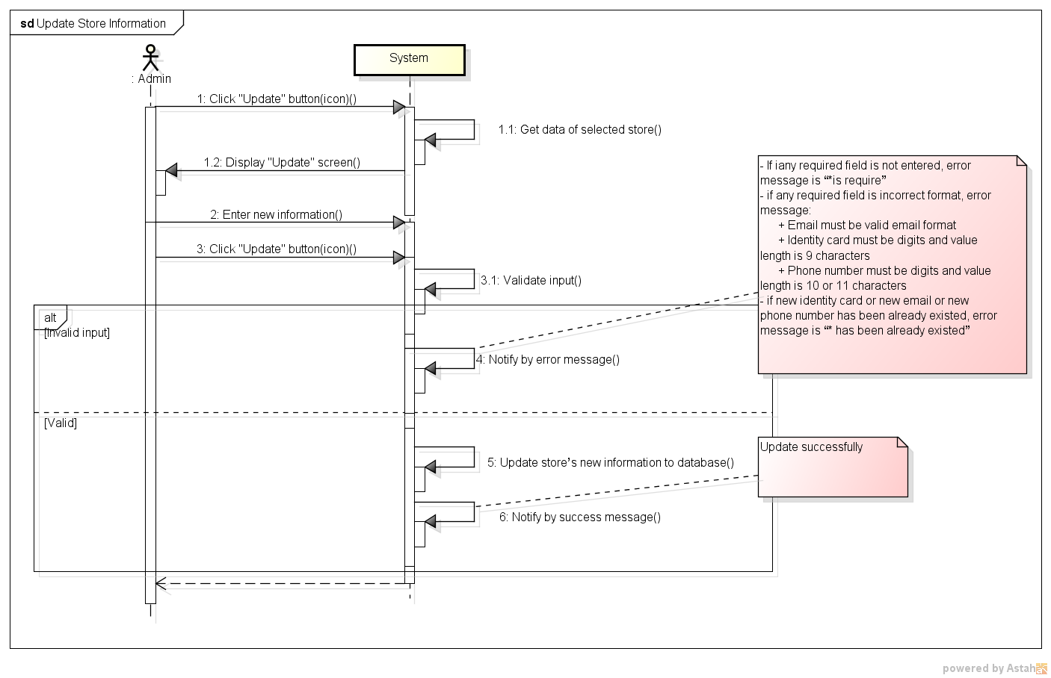

Figure 46: for Update Store’s Information Use case

###### *UC- 124:Assign Task*

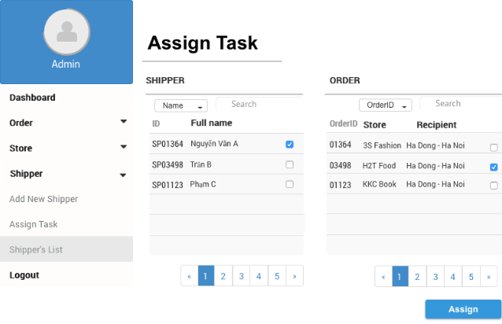

Figure 47: Screen of Assign Task Use case

|  |  |  |  |  |
| --- | --- | --- | --- | --- |
| **Use Case ID:** | | UC-124 | | |
| **Use Case Name:** | | Assign Task | | |
| **CreatedBy:** | | HoangNK | **Last UpdatedBy:** | HoangNK |
| **Date Created:** | | 19/09/2015 | **DateLast updated:** | 19/09/2015 |
| **Actor:** | | Admin | | |
| **Description:** | | Admin assigns orders which hasn’t been assign for any Shipper to available Shipper or orders which has issue to other shipper | | |
| **Triggering Event:** | | Admin wants to assign task for Shipper | | |
| **Preconditions:** | | Admin logged in to system | | |
| **Post conditions:** | | Task is assigned for Shipper | | |
| **Priority:** | | High | | |
| **FrequencyofUse:** | | Often | | |
| **Main flow** | | | | |
| Step | Actor | Action | | |
|  | Admin | Clicks “Shipper” button in left navigate bar | | |
|  | System | Displays “Shipper” menu in left navigate bar includes Add Shipper, Assign Task, Shipper’s List | | |
|  | Admin | Clicks “Assign Task” button | | |
|  | System | Gets data of Order and Shipper then display “Assign Task” screen includes:   * 3 tables of available Shipper, Task of picked shipper and Order with related information(shipperid, shipper’s name, taskid, task status, ordered, order status, pickup and delivery address) * Search textbox and Filter on each table * Inbox button * Assign button | | |
|  | Admin | Picks a Shipper in Shipper’s list then picks Orders for this Shipper in Order’s list | | |
|  | Admin | Clicks “Assign” button | | |
|  | System | Update Shipper’s information in database, send notification to shipper and notify success message to Admin | | |
| **Alternative Flows:** | | **N/A** | | |
| **Exceptions:** | | | | |
| EC1 | At step 5, if Admin doesn’t pick any shipper | | | |
| Step | Actor | Action | | |
| 5.1 | System | Doesn’t allow to pick order | | |
| EC2 | At step 7, if assign task fail because any reason | | | |
| Step | Actor | Action | | |
| 7.1 | System | Notify message “Assign fail” | | |
| **Includes:** | | N/A | | |
| **SpecialRequirements:** | | * Only available Orders are displayed in Order’s list | | |
| **Notes andIssues:** | | N/A | | |

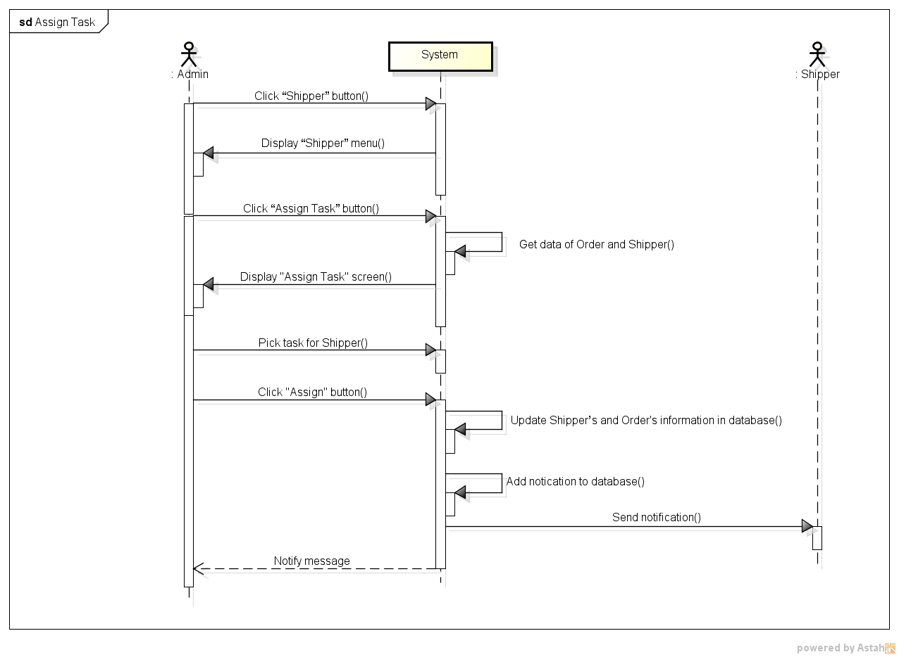

Figure 48: for Assign Task Use case

###### *UC- 125:View Dashboard*

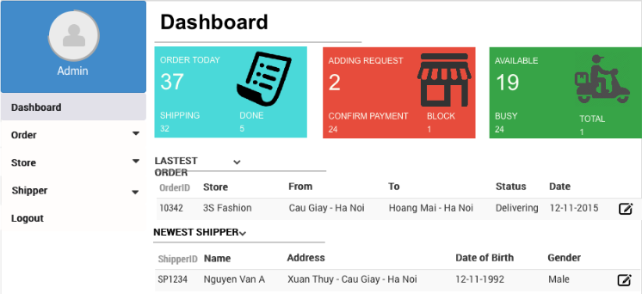

Figure 49: Screen of View Dashboard Use case

|  |  |  |  |  |
| --- | --- | --- | --- | --- |
| **Use Case ID:** | | UC-125 | | |
| **Use Case Name:** | | View dashboard | | |
| **CreatedBy:** | | HoangNK | **Last UpdatedBy:** | HoangNK |
| **Date Created:** | | 19/09/2015 | **DateLast updated:** | 19/09/2015 |
| **Actor:** | | Admin | | |
| **Description:** | | A view of some statistics about order, shipper, store and task information (active, inactive, done, fail) is displayed to Admin so Admin has a general view about order, store, shipper and task | | |
| **Triggering Event:** | | Admin wants to view dashboard with the statistics | | |
| **Preconditions:** | | Admin logged in to system | | |
| **Post conditions:** | | Dashboard screen with statistics is displayed | | |
| **Priority:** | | Normal | | |
| **FrequencyofUse:** | | Sometime | | |
| **Main flow** | | | | |
| Step | Actor | Action | | |
|  | Admin | Clicks “Dashboard” button in left navigate bar | | |
|  | System | Display “Dashboard” screen includes:   * Map of all online shippers and store * Statistics of order, shipper and store in box * List of task | | |
| **Alternative Flows:** | | N/A | | |
| **Exceptions:** | | | | |
| EC1 | At step 2, system can’t get data from database because the internet or the database disconnect | | | |
| Step | Actor | Action | | |
| 2.1 | System | Shows error message: “Failed to load data” | | |
| **Includes:** | | N/A | | |
| **SpecialRequirements:** | | N/A | | |
| **Notes andIssues:** | | N/A | | |

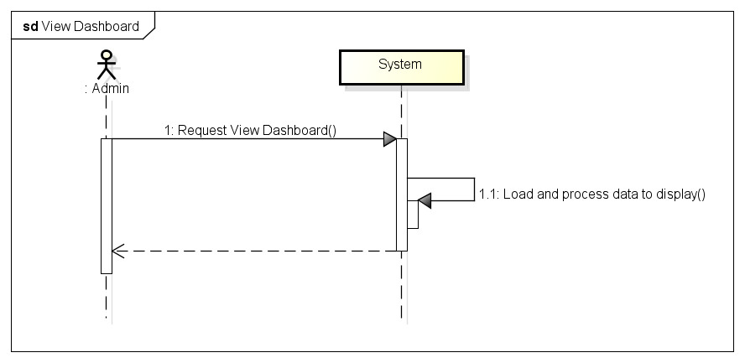

Figure : Sequence Diagram for View Dashboard Use case

###### *UC- 126:View IssueBox*

|  |  |  |  |  |
| --- | --- | --- | --- | --- |
| **Use Case ID:** | | UC-126 | | |
| **Use Case Name:** | | View IssueBox | | |
| **CreatedBy:** | | HoangNK | **Last UpdatedBy:** | HoangNK |
| **Date Created:** | | 19/09/2015 | **DateLast updated:** | 19/09/2015 |
| **Actor:** | | Admin | | |
| **Description:** | | A view of list of all issues and their detail, so Admin can resolve issue after check it | | |
| **Triggering Event:** | | Admin wants to view issue and their detail | | |
| **Preconditions:** | | Admin logged in to system | | |
| **Post conditions:** | | IssueBox screen with this issue and it’s detail | | |
| **Priority:** | | Normal | | |
| **FrequencyofUse:** | | Sometime | | |
| **Main flow** | | | | |
| Step | Actor | Action | | |
|  | Admin | Clicks “IssueBox” button in left navigate bar | | |
|  | System | Display “IssueBox” screen includes:   * List of all issue and related information of each issue: type, category, date, is resolved or not,… * Issue detail include: order has issue and it’s status, shipper and store has issue, content of issue, date of issue, type, category, resolve issue button * Filter issue drop-downlist * Search textbox | | |
| **Alternative Flows:** | | N/A | | |
| **Exceptions:** | | | | |
| EC1 | At step 2, system can’t get data from database because the internet or the database disconnect | | | |
| Step | Actor | Action | | |
| 2.1 | System | Shows error message: “Failed to load data” | | |
| **Includes:** | | N/A | | |
| **SpecialRequirements:** | | * The default issue’s list is ordered by Date(decrease) * “All” is default type of search | | |
| **Notes andIssues:** | | N/A | | |

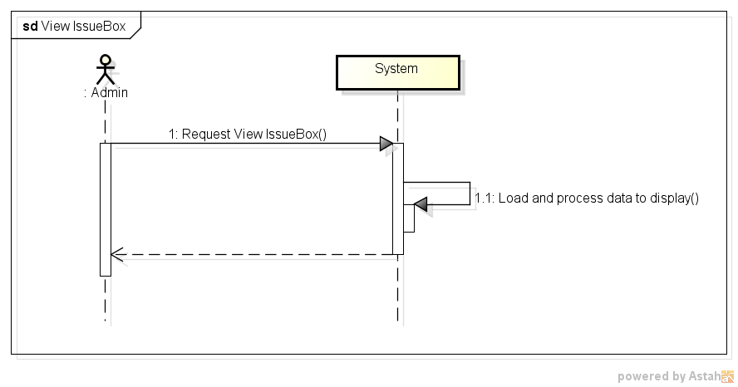

Figure 51: for View IssueBox Use case

###### *UC- 127:Resolve Issue*

|  |  |  |  |  |
| --- | --- | --- | --- | --- |
| **Use Case ID:** | | UC-127 | | |
| **Use Case Name:** | | Resolve Issue | | |
| **CreatedBy:** | | HoangNK | **Last UpdatedBy:** | HoangNK |
| **Date Created:** | | 19/09/2015 | **DateLast updated:** | 19/09/2015 |
| **Actor:** | | Admin | | |
| **Description:** | | After checking issue which is sent by shipper or store, Admin chooses type of resolve issue to resolve | | |
| **Triggering Event:** | | Admin wants to resolve issue | | |
| **Preconditions:** | | Admin is in view of issue box page ( refer case UC-126 ) | | |
| **Post conditions:** | | Issue is resolved and related information is updated | | |
| **Priority:** | | Normal | | |
| **FrequencyofUse:** | | Sometime | | |
| **Main flow** | | | | |
| Step | Actor | Action | | |
|  | Admin | Chooses resolve type to resolve issue (3 types of issue: shipper pending, shipper cancel, store request cancel), then clicks on resolve button | | |
|  | System | Shows confirm popup contain resolve information | | |
|  | Admin | Clicks “Yes” button to give confirm | | |
|  | System | Updates issue and related information, sends notification to shipper and store and notifies success message | | |
| **Alternative Flows:** | | | | |
| AT1 | At step 2, if admin clicks “Assign Task” button (for resolve pending issue) | | | |
| Step | Actor | Action | | |
| 1 | System | Redirect to Assign Task Page | | |
| 2 | Admin | Picks processing task for other shipper then click Assign button | | |
| 3 | System | Updates tasks, issue and related information | | |
| 4 | System | Adds notification to database, send notification to store and shipper and notify success message to admin | | |
| **Exceptions:** | | | | |
| EC1 | At step 1, system can’t get data from database because the internet or the database disconnect | | | |
| Step | Actor | Action | | |
| 1.1 | System | Shows error message: “Failed to load data” | | |
| EC2 | At step 4, if resolve issue fail because any reason | | | |
| Step | Actor | Action | | |
| 4.1 | System | Notify message “Update fail” | | |
| **Includes:** | | N/A | | |
| **SpecialRequirements:** | | * The default issue’s list is ordered by Date(decrease) * “All” is default type of search | | |
| **Notes andIssues:** | | N/A | | |

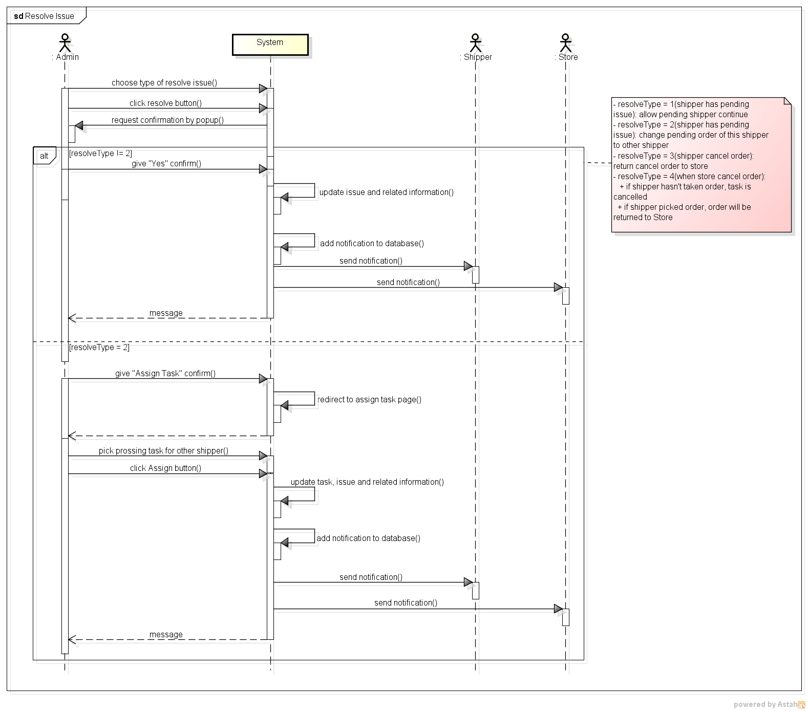

Figure 52: for Resolve Issue user case

###### *UC- 128:View Task’s list*

|  |  |  |  |  |
| --- | --- | --- | --- | --- |
| **Use Case ID:** | | UC-128 | | |
| **Use Case Name:** | | View Task’s list | | |
| **CreatedBy:** | | HoangNK | **Last UpdatedBy:** | HoangNK |
| **Date Created:** | | 19/09/2015 | **DateLast updated:** | 19/09/2015 |
| **Actor:** | | Admin | | |
| **Description:** | | Admin views all task with basic information (shipperid, orderid, store’s name, type, status, task date) | | |
| **Triggering Event:** | | Admin wants to view all Task | | |
| **Preconditions:** | | Admin logged in to system | | |
| **Post conditions:** | | List of task is displayed | | |
| **Priority:** | | High | | |
| **FrequencyofUse:** | | Always | | |
| **Main flow** | | | | |
| Step | Actor | Action | | |
|  | Admin | Clicks “Shipper” button in left navigate bar | | |
|  | System | Display “Shipper” menu in left navigate bar includes Add New Shipper, Shipper’s List, Task’s List and Assign Task | | |
|  | Admin | Clicks “Task’s list” button | | |
|  | System | Load Task’s data and display “Task’s List” screen includes:   * Search textbox and button * Filter drop-downlist * All Shipper’s basic information(shipperid, taskid, orderid, storeid, task status, order status, task type, task date) | | |
| **Alternative Flows:** | | **N/A** | | |
| **Exceptions:** | | | | |
| EC1 | At step 4, system can’t get data from database because the internet or the database disconnect | | | |
| Step | Actor | Action | | |
| 4.1 | System | Shows error message: “Failed to load data” | | |
| **Includes:** | | N/A | | |
| **SpecialRequirements:** | | * The default Task’s list is ordered by Task Date(decrease) * “All” is default type | | |
| **Notes andIssues:** | | N/A | | |

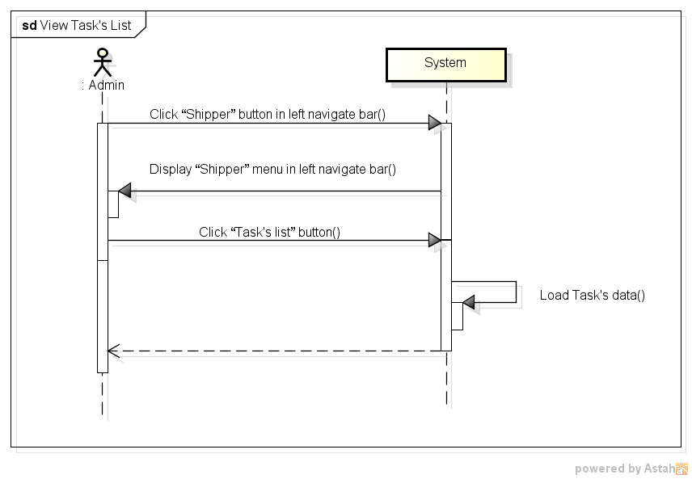

Figure 53: for View Task’s List Use case

###### *UC- 129:View Report*

|  |  |  |  |  |
| --- | --- | --- | --- | --- |
| **Use Case ID:** | | UC-129 | | |
| **Use Case Name:** | | View Report | | |
| **CreatedBy:** | | HoangNK | **Last UpdatedBy:** | HoangNK |
| **Date Created:** | | 19/09/2015 | **DateLast updated:** | 19/09/2015 |
| **Actor:** | | Admin | | |
| **Description:** | | Admin views statistics about Store, Shipper and Order in week, month and year | | |
| **Triggering Event:** | | Admin wants to report about system | | |
| **Preconditions:** | | Admin logged in to system | | |
| **Post conditions:** | | Report information is displayed | | |
| **Priority:** | | High | | |
| **FrequencyofUse:** | | Always | | |
| **Main flow** | | | | |
| Step | Actor | Action | | |
|  | Admin | Clicks “Report” button in left navigate menu | | |
|  | System | Load Report data and display screen includes:   * Graph of order, finance by month, year * Over view of system: shipper, store, order, task | | |
| **Alternative Flows:** | | **N/A** | | |
| **Exceptions:** | | | | |
| EC1 | At step 2, system can’t get data from database because the internet or the database disconnect | | | |
| Step | Actor | Action | | |
| 2.1 | System | Shows error message: “Failed to load data” | | |
| **Includes:** | | N/A | | |
| **SpecialRequirements:** | | N/A | | |
| **Notes andIssues:** | | N/A | | |

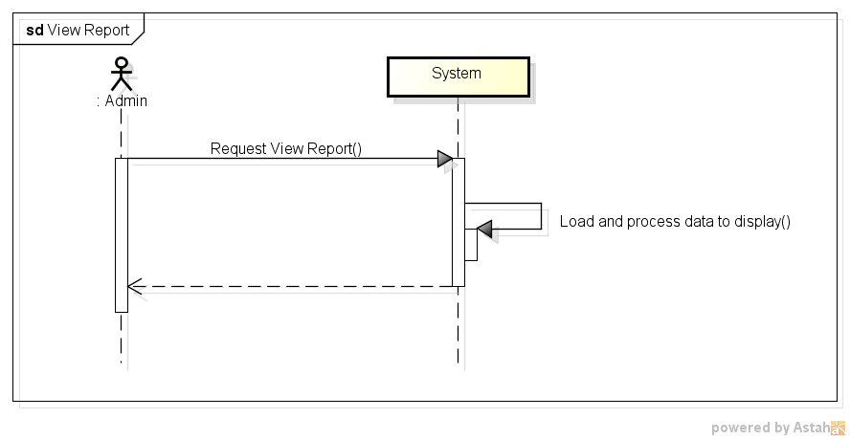

Figure 54: for View Task’s List Use case

###### *UC- 130: Search Task*

|  |  |  |  |  |
| --- | --- | --- | --- | --- |
| **Use Case ID:** | | UC-130 | | |
| **Use Case Name:** | | Search Task | | |
| **CreatedBy:** | | HoangNK | **Last UpdatedBy:** | HoangNK |
| **Date Created:** | | 19/09/2015 | **DateLast updated:** | 02/10/2015 |
| **Actor:** | | Admin | | |
| **Description:** | | Admin wants the system to list all Tasks related to a specific keyword and type | | |
| **Triggering Event:** | | Admin wants to search task | | |
| **Preconditions:** | | Admin is in view task’s list page ( refer case UC-128) | | |
| **Post conditions:** | | Tasks have information which matches search key is displayed | | |
| **Priority:** | | High | | |
| **FrequencyofUse:** | | Always | | |
| **Main flow** | | | | |
| Step | Actor | Action | | |
|  | Admin | Chooses type of searching | | |
|  | Admin | Enters text to “Search” text box | | |
|  | System | Displays Tasks have information which matches search key | | |
| **Alternative Flows:** | | N/A | | |
| **Exceptions:** | | N/A | | |
| **Includes:** | | N/A | | |
| **SpecialRequirements:** | | * Result of search is case insensitive * Types of search are : All, ShipperID, OrderID, StoreID, Order status, Task status, Type | | |
| **Notes andIssues:** | | N/A | | |

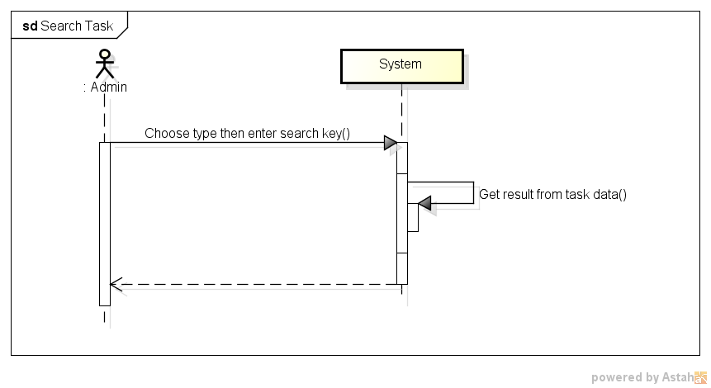

Figure 55: for Search Task Use case

###### *UC- 131: Search Transaction*

|  |  |  |  |  |
| --- | --- | --- | --- | --- |
| **Use Case ID:** | | UC-131 | | |
| **Use Case Name:** | | Search Transaction | | |
| **CreatedBy:** | | HoangNK | **Last UpdatedBy:** | HoangNK |
| **Date Created:** | | 19/09/2015 | **DateLast updated:** | 02/10/2015 |
| **Actor:** | | Admin | | |
| **Description:** | | Admin wants the system to list all Transaction related to a specific keyword and type | | |
| **Triggering Event:** | | Admin wants to search transaction | | |
| **Preconditions:** | | Admin is in view transaction history page ( refer case UC-112) | | |
| **Post conditions:** | | Transactions have information which matches search key is displayed | | |
| **Priority:** | | High | | |
| **FrequencyofUse:** | | Always | | |
| **Main flow** | | | | |
| Step | Actor | Action | | |
|  | Admin | Chooses type of searching | | |
|  | Admin | Enters text to “Search” text box | | |
|  | System | Displays Transactions have information which matches search key | | |
| **Alternative Flows:** | | N/A | | |
| **Exceptions:** | | N/A | | |
| **Includes:** | | N/A | | |
| **SpecialRequirements:** | | * Result of search is case insensitive * Types of search are : All, ledgerid, store, amount, balance | | |
| **Notes andIssues:** | | N/A | | |

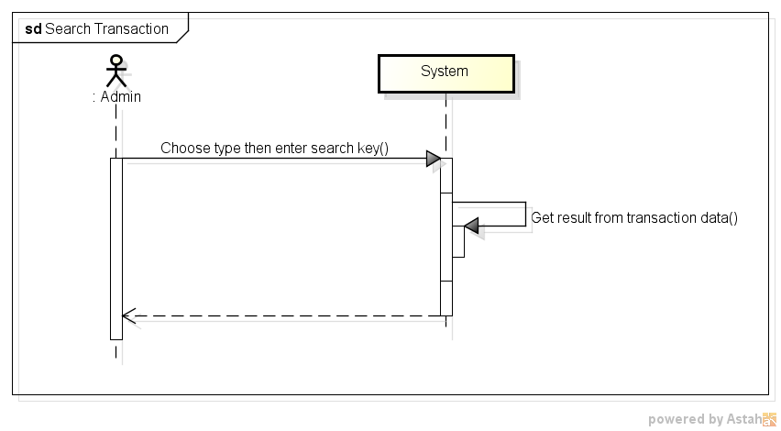

Figure 56: for Search Transaction Use case

###### *UC- 132: Search Issue*

|  |  |  |  |  |
| --- | --- | --- | --- | --- |
| **Use Case ID:** | | UC-132 | | |
| **Use Case Name:** | | Search Issue | | |
| **CreatedBy:** | | HoangNK | **Last UpdatedBy:** | HoangNK |
| **Date Created:** | | 19/09/2015 | **DateLast updated:** | 02/10/2015 |
| **Actor:** | | Admin | | |
| **Description:** | | Admin wants the system to list all Issue related to a specific keyword | | |
| **Triggering Event:** | | Admin wants to search issue | | |
| **Preconditions:** | | Admin is in view issue box page ( refer case UC-126) | | |
| **Post conditions:** | | Issues have information which matches search key is displayed | | |
| **Priority:** | | High | | |
| **FrequencyofUse:** | | Always | | |
| **Main flow** | | | | |
| Step | Actor | Action | | |
|  | Admin | Enters text to “Search” text box | | |
|  | System | Displays Issues have information which matches search key | | |
| **Alternative Flows:** | | N/A | | |
| **Exceptions:** | | N/A | | |
| **Includes:** | | N/A | | |
| **SpecialRequirements:** | | * Result of search is case insensitive | | |
| **Notes andIssues:** | | N/A | | |

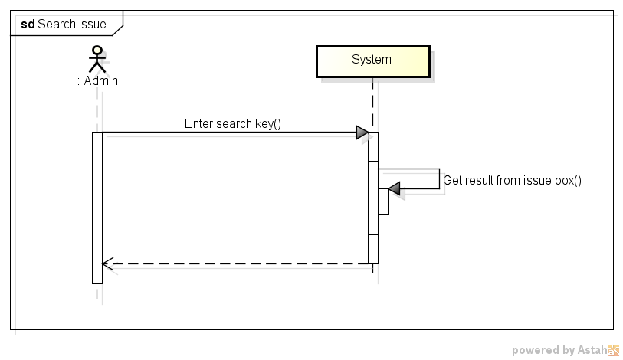

Figure 57: for Search Issue Use case

## 3.2. Web application for Store

### 3.2.1. User Case Diagram

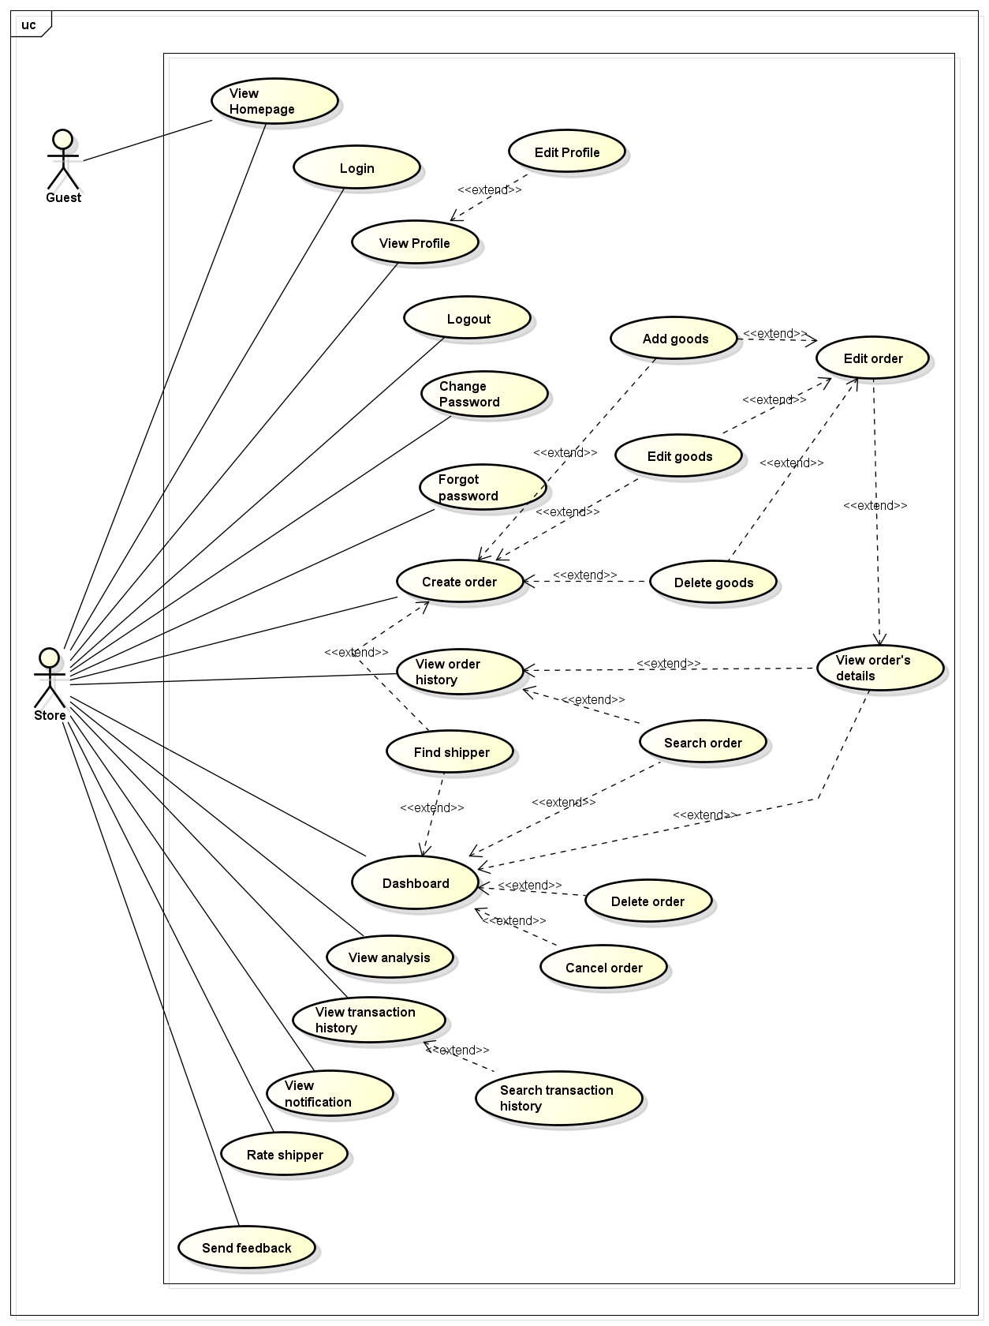

Figure 58: User case diagram for Store web application

### 3.2.2. Function

###### *UC-200:View Homepage*



Figure 59: View home page screen

|  |  |  |  |  |
| --- | --- | --- | --- | --- |
| **Use Case ID:** | | UC-200 | | |
| **Use Case Name:** | | View Homepage | | |
| **CreatedBy:** | | KhanhKC | **Last UpdatedBy:** | KhanhKC |
| **Date Created:** | | 02/10/2015 | **DateLast updated:** | 02/10/2015 |
| **Actor:** | | Store, Guest | | |
| **Description:** | | “Homepage” show information about KarryWell service, a “Login” button that help Store login system. Beside, “Homepage” also shows advertisement of system. | | |
| **Triggering event:** | | Store or Guest access to KarryWell website. | | |
| **Preconditions:** | | Store or Guest accessed to KarryWell website. | | |
| **Post conditions:** | | “Homepage” screen has been displayed. | | |
| **Priority:** | | High | | |
| **FrequencyofUse:** | | Always | | |
| **Main flow** | | | | |
| Step | Actor | Action | | |
|  | Store, Guest | Access to KarryWell website. | | |
|  | System | Loads data | | |
|  | System | Displays “Homepage” screen. | | |
| **Alternative Flows:** | | N/A | | |
| **Exceptions:** | | N/A | | |
| **Includes:** | | N/A | | |
| **SpecialRequirements:** | | N/A | | |
| **Notes andIssues:** | | N/A | | |

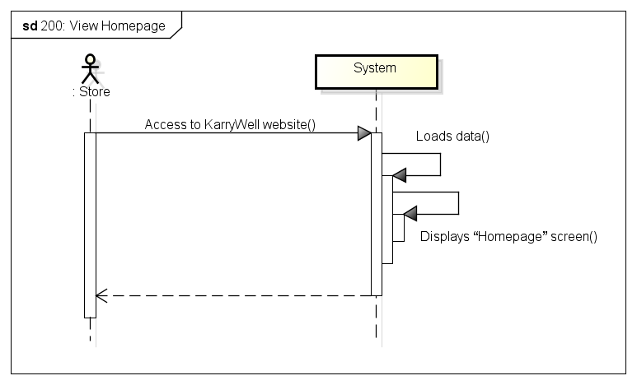

Figure 60: for view homepage user case

###### *UC-201:View dashboard*



Figure 61: View dashboard screen

|  |  |  |  |  |
| --- | --- | --- | --- | --- |
| **Use Case ID:** | | UC-201 | | |
| **Use Case Name:** | | View Dashboard | | |
| **CreatedBy:** | | KhanhKC | **Last UpdatedBy:** | KhanhKC |
| **Date Created:** | | 19/09/2015 | **DateLast Updated:** | 02/10/2015 |
| **Actor:** | | Store | | |
| **Description:** | | Dashboard has a maps that helps show location of shipper who are working for store and location of store’s customers. Dashboard also displays list of in process orders. | | |
| **Triggering event:** | | Store wants to view dashboard | | |
| **Preconditions:** | | Store logged in to system | | |
| **Post conditions:** | | “Dashboard” screen is displayed | | |
| **Priority:** | | High | | |
| **FrequencyofUse:** | | Always | | |
| **Main flow** | | | | |
| Step | Actor | Action | | |
|  | Store | Clicks “Login” | | |
|  | System | Displays “Dashboard” screen | | |
| **Alternative :** | | N/A | | |
| **Exceptions:** | | N/A | | |
| **Includes:** | | N/A | | |
| **Special requirements:** | | N/A | | |
| **Notes and Issues:** | | N/A | | |

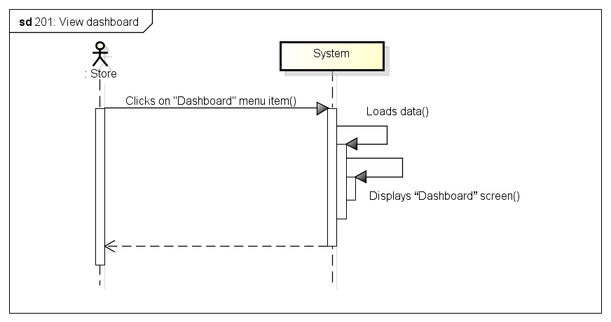

Figure 62: for view dashboard user case

###### *UC-202:Login*



Figure 63: Login screen

|  |  |  |  |  |
| --- | --- | --- | --- | --- |
| **Use Case ID:** | | UC-202 | | |
| **Use Case Name:** | | Login | | |
| **CreatedBy:** | | KhanhKC | **Last UpdatedBy:** | KhanhKC |
| **Date Created:** | | 19/09/2015 | **DateLast Updated:** | 02/10/2015 |
| **Actor:** | | Store | | |
| **Description:** | | Users who are not logged in to system can only view the “Homepage”. Store needs to logins to system to use functions of system. | | |
| **Triggering event:** | | Store wants to login to system | | |
| **Preconditions:** | | - Store is on the “Homepage” of KarryWell website  - Store account must be exits | | |
| **Post conditions:** | | Logs Store into system  Redirects Store to “Dashboard” screen (Refer to UC-201: View Dashboard) | | |
| **Priority:** | | High | | |
| **FrequencyofUse:** | | Always | | |
| **Main flow** | | | | |
| Step | Actor | Action | | |
|  | Store | Enters User name and Password | | |
|  | Store | Clicks “Login” | | |
|  | System | Check “Username” and “Password” in database. | | |
|  | System | Logs Store into system | | |
|  | System | Redirects to “Dashboard” screen. | | |
| **Alternative:** | | | | |
| **Exceptions:** | | | | |
| EC1 | At step 3 in main flow, if Store entered wrong User name or Password | | | |
| Step | Actor | Action | | |
| 3.1 | System | Displays message “Username or Password is wrong” | | |
| **Includes:** | | N/A | | |
| **Special requirements:** | | N/A | | |
| **Notes and Issues:** | | N/A | | |

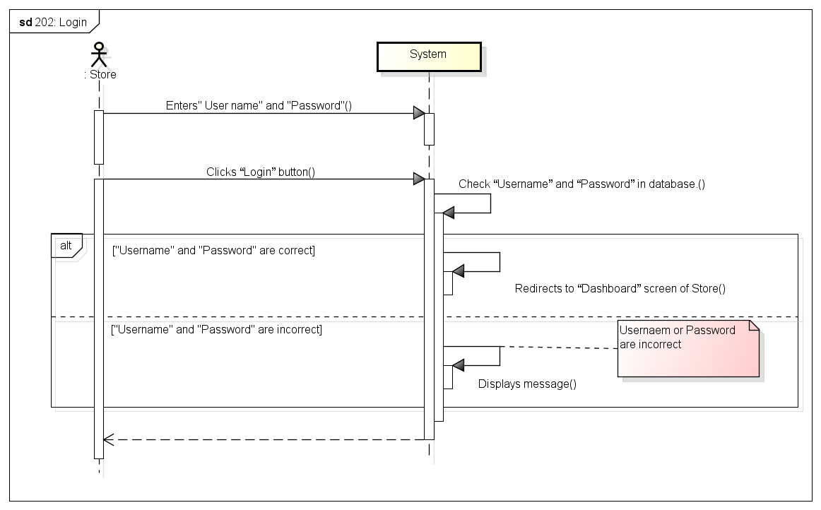

Figure 64: for Login user case

###### *UC-203:Logout*



Figure 65: Logout screen

|  |  |  |  |  |
| --- | --- | --- | --- | --- |
| **Use Case ID:** | | UC-203 | | |
| **Use Case Name:** | | Logout | | |
| **CreatedBy:** | | KhanhKC | **Last UpdatedBy:** | KhanhKC |
| **Date Created:** | | 19/09/2015 | **DateLast updated:** | 02/10/2015 |
| **Actor:** | | Store | | |
| **Description:** | | When Store logouts from system, Store will cannot continue using functions of system. Store needs to login again to be able to use the function of system. | | |
| **Triggering event:** | | Store wants to logout from system. | | |
| **Preconditions:** | | Store logged in to system | | |
| **Post conditions:** | | Logs Store out from system.  Redirects Store to “Homepage” screen | | |
| **Priority:** | | High | | |
| **FrequencyofUse:** | | Often | | |
| **Main flow** | | | | |
| Step | Actor | Action | | |
|  | Store | Clicks on “Logout” | | |
|  | System | Logouts Store from system | | |
|  | System | Displays Homepage for Guest | | |
| **Alternative Flows:** | | | | |
| **Exceptions:** | | N/A | | |
| **Includes:** | | N/A | | |
| **SpecialRequirements:** | | N/A | | |
| **Notes andIssues:** | | N/A | | |

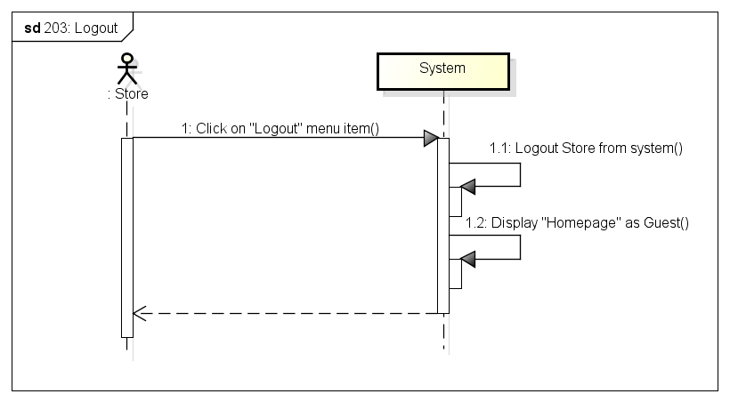

Figure 66: Sequence diagram for Logout user case

###### *UC-204: Change password*



Figure 67: Change password screen

|  |  |  |  |  |
| --- | --- | --- | --- | --- |
| **Use Case ID:** | | UC-204 | | |
| **Use Case Name:** | | Change password | | |
| **CreatedBy:** | | KhanhKC | **Last UpdatedBy:** | KhanhKC |
| **Date Created:** | | 19/09/2015 | **DateLast updated:** | 02/10/2015 |
| **Actor:** | | Store | | |
| **Description:** | | Store can change login password but Store need to remember old password. | | |
| **Triggering event:** | | Store wants to change password. | | |
| **Preconditions:** | | Store logged in to system | | |
| **Post conditions:** | | New password has been saved in database. | | |
| **Priority:** | | Medium | | |
| **FrequencyofUse:** | | Sometime | | |
| **Main flow** | | | | |
| Step | Actor | Action | | |
|  | Store | Clicks “Change password” | | |
|  | System | Displays “Change password” screen includes:  - Old password text box  - New password text box  - Confirm new password text box  - Submit button | | |
|  | Store | Enters data in fields | | |
|  | Store | Clicks “Submit” button | | |
|  | System | Validates data | | |
|  | System | Displays “Change password” screen with message “ Changes password successful” | | |
| **Alternative Flows:** | | N/A | | |
| **Exceptions:** | | | | |
| EC1 | At step 4, required fields are not entered | | | |
| Step | Actor | Action | | |
| 4.1 | System | Displays “Change password” screen with error message “*is require” | | |
| EC2 | At step 4, “Old password” is incorrect | | | |
| Step | Actor | Action | | |
| 4.1 | System | Displays “Change password” screen with error message: “Old password is incorrect” | | |
| EC3 | At step 4, confirm new password is not the same with new password | | | |
| Step | Actor | Action | | |
| 4.1 | System | Displays “Change password” screen with error message.” Confirm new password is not the same with new password. Please enter again!” | | |
| **Includes:** | | N/A | | |
| **SpecialRequirements:** | | Length of “New password” must between 6 and 10. | | |
| **Notes andIssues:** | | N/A | | |

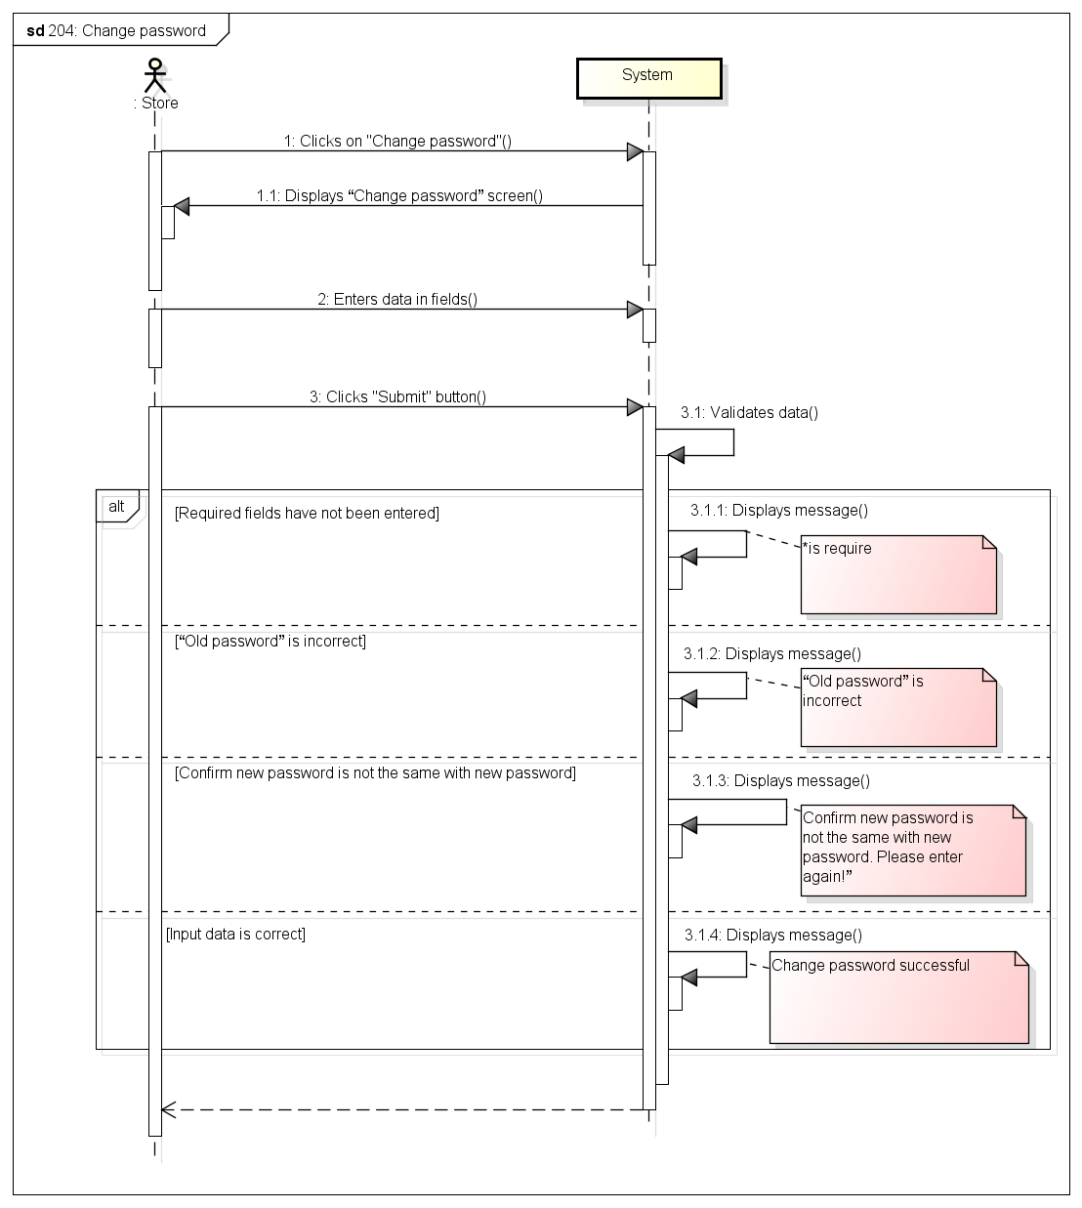

Figure 68: Sequence diagram for Change password user case

###### *UC-205:Forgot password*



Figure 69: Forgot password screen

|  |  |  |  |  |
| --- | --- | --- | --- | --- |
| **Use Case ID:** | | UC-205 | | |
| **Use Case Name:** | | Forgot password | | |
| **CreatedBy:** | | KhanhKC | **Last UpdatedBy:** | KhanhKC |
| **Date Created:** | | 19/09/2015 | **DateLast updated:** | 02/10/2015 |
| **Actor:** | | Store | | |
| **Description:** | | This function help Store receive their login password when Store forgot. | | |
| **Triggering event:** | | Store requests system to receive new password. | | |
| **Preconditions:** | | Store is on the “Login” popup (Refer to UC-202: Login) | | |
| **Post conditions:** | | - A new password has been updated for Store  - An email has been send to registered email of Store include new password. | | |
| **Priority:** | | Medium | | |
| **FrequencyofUse:** | | Sometime | | |
| **Main flow** | | | | |
| Step | Actor | Action | | |
|  | Store | Clicks “Forgot password” hyperlink on “Login” popup | | |
|  | System | Displays “Forgot password” popup includes:  - Email text box  - Submit button | | |
|  | Guest | Enters registered email. | | |
|  | Guest | Clicks “Submit” button | | |
|  | System | Validates data | | |
|  | System | Updates a new password for Store | | |
|  | System | Sends the new password to registered email of Store | | |
|  | System | Displays message : “Please check your email to get your new password” | | |
| **Alternative Flows:** | | N/A | | |
| **Exceptions:** | | | | |
| EC1 | At step 3, email are not a registered email | | | |
| Step | Actor | Actor | | |
| 4.1 | System | Displays error message:” Email is not exist” | | |
| **Includes:** | | N/A | | |
| **SpecialRequirements:** | | N/A | | |
| **Notes andIssues:** | | N/A | | |

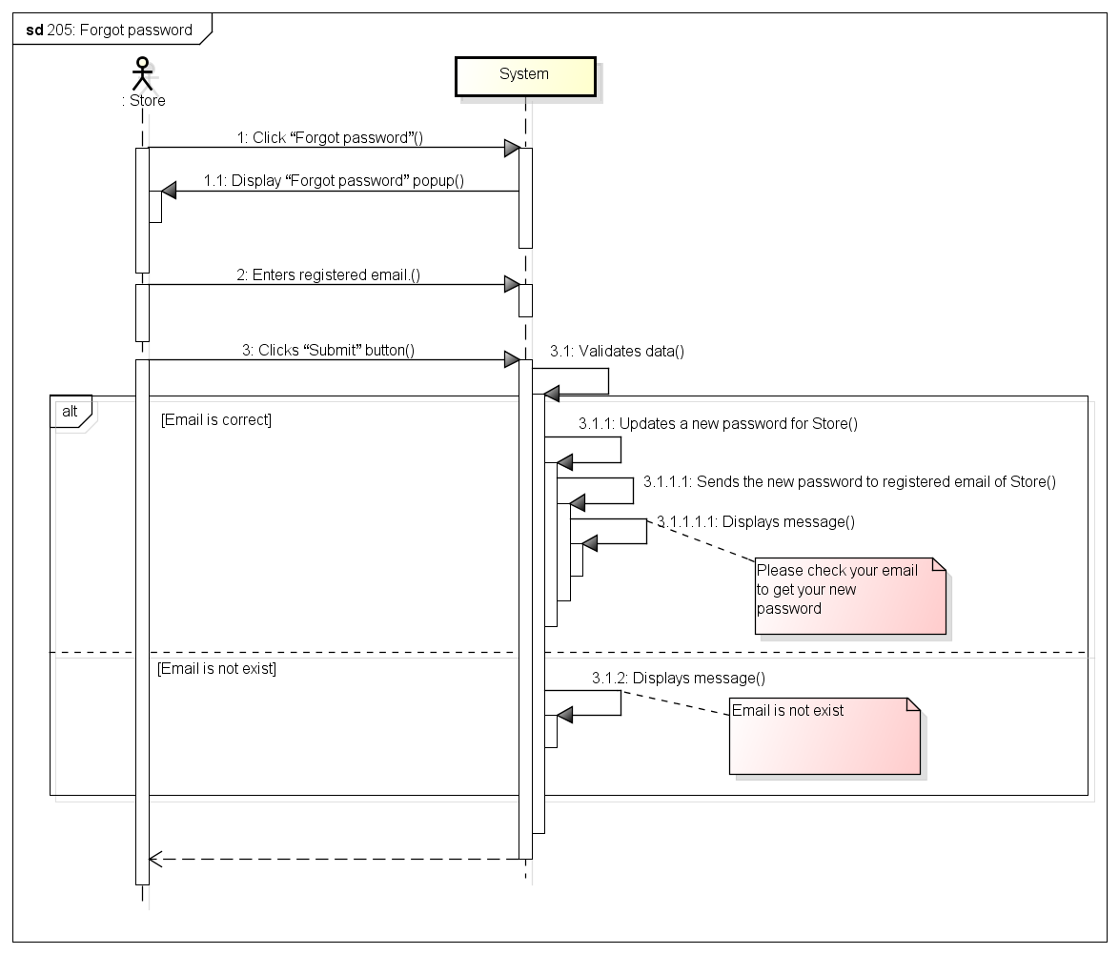

Figure 70: Sequence diagram for Forgot password user case

###### *UC-206:View profile*

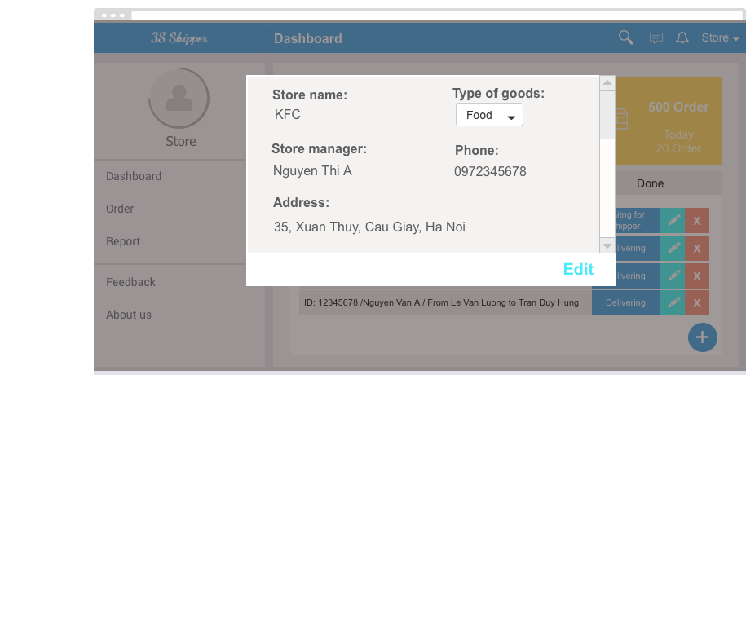

Figure 71: View profile screen

|  |  |  |  |  |
| --- | --- | --- | --- | --- |
| **Use Case ID:** | | UC-206 | | |
| **Use Case Name:** | | View profile | | |
| **CreatedBy:** | | KhanhKC | **Last UpdatedBy:** | KhanhKC |
| **Date Created:** | | 19/09/2015 | **DateLast updated:** | 02/10/2015 |
| **Actor:** | | Store | | |
| **Description:** | | “View profile” screen displays detail information of Store and information of store’s manager. | | |
| **Triggering event:** | | Store wants to view profile. | | |
| **Preconditions:** | | Store logged into system. | | |
| **Post conditions:** | | “Profile” screen are displayed | | |
| **Priority:** | | Medium | | |
| **FrequencyofUse:** | | Sometime | | |
| **Main flow** | | | | |
| Step | Actor | Action | | |
|  | Store | Clicks on “Profile” | | |
|  | System | Loads data | | |
|  | System | Displays “Profile” screen includes details information of Store and information of Store’s manager | | |
| **Alternative Flows:** | | N/A | | |
| **Exceptions:** | | N/A | | |
| **Includes:** | | N/A | | |
| **SpecialRequirements:** | | N/A | | |
| **Notes andIssues:** | | N/A | | |

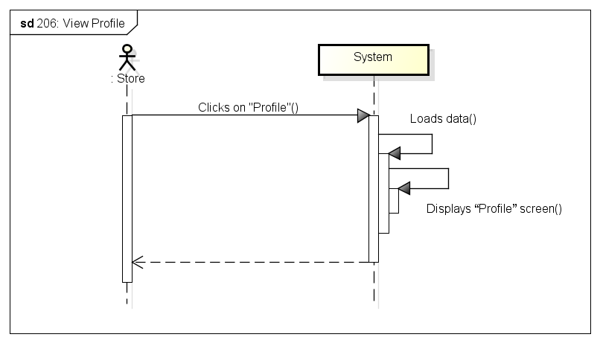

Figure 72: Sequence diagram for View profile user case

###### *UC-207:Update profile*

Figure : Update profile screen

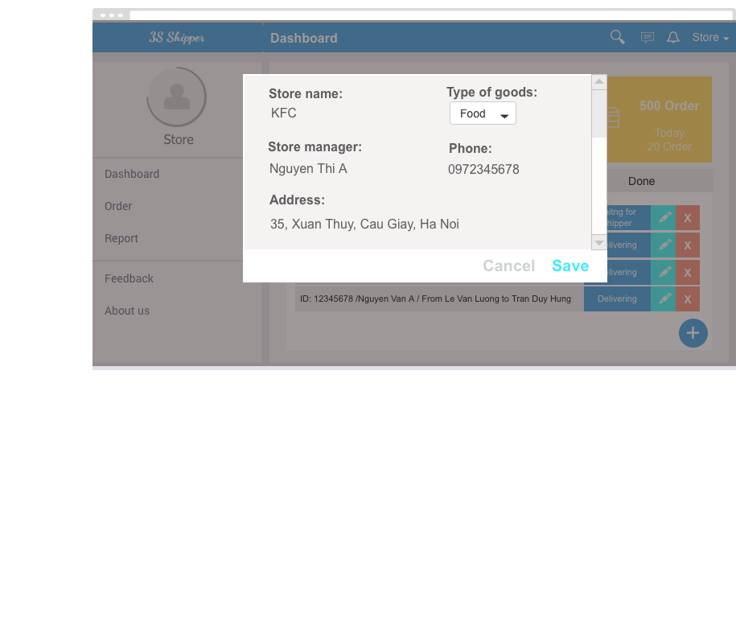

|  |  |  |  |  |
| --- | --- | --- | --- | --- |
| **Use Case ID:** | | UC-207 | | |
| **Use Case Name:** | | Update profile | | |
| **CreatedBy:** | | KhanhKC | **Last UpdatedBy:** | KhanhKC |
| **Date Created:** | | 19/09/2015 | **DateLast updated:** | 02/10/2015 |
| **Actor:** | | Store | | |
| **Description:** | | Store can edit detail information such as: Store name; type of goods; Store address… This information will be updated to database. | | |
| **Triggering event:** | | Store wants to update profile. | | |
| **Preconditions:** | | Store are on “Profile” screen | | |
| **Post conditions:** | | New profile have been displays on “Profile screen” and updated in database. | | |
| **Priority:** | | Normal | | |
| **FrequencyofUse:** | | Sometime | | |
| **Main flow** | | | | |
| Step | Actor | Action | | |
|  | Store | Clicks “Update profile” button on “Profile” screen | | |
|  | System | Enable fields on profile screen. | | |
|  | Store | Enters data in fields | | |
|  | Store | Clicks “Submit” button | | |
|  | System | Validates entered data. | | |
|  | System | Updates data to database | | |
|  | System | Displays “View Profile” screen. (Refer to UC-206: View Profile” | | |
| **Alternative Flows:** | | N/A | | |
| **Exceptions:** | | | | |
| EC1 | At step 3, require fields are empty | | | |
| Step | Actor | Action | | |
| 4.1 | System | Displays error message at empty fields: “* is require” | | |
| EC2 | At step 4, Store Clicks “Cancel” button | | | |
| Step | Actor | Action | | |
| 4.1 | System | Displays “View profile” screen (Refer to UC-206: View Profile” | | |
| **Includes:** | | N/A | | |
| **SpecialRequirements:** | | N/A | | |
| **Notes andIssues:** | |  | | |

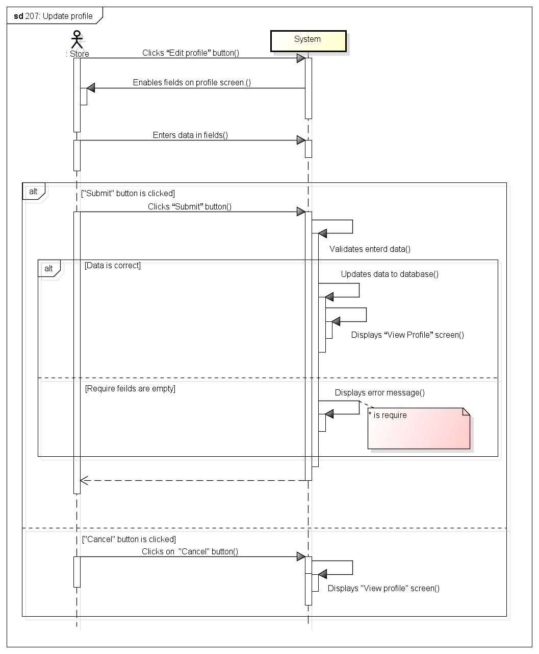

Figure 74: Sequence diagram for Create order user case

###### *UC-208:Create order*

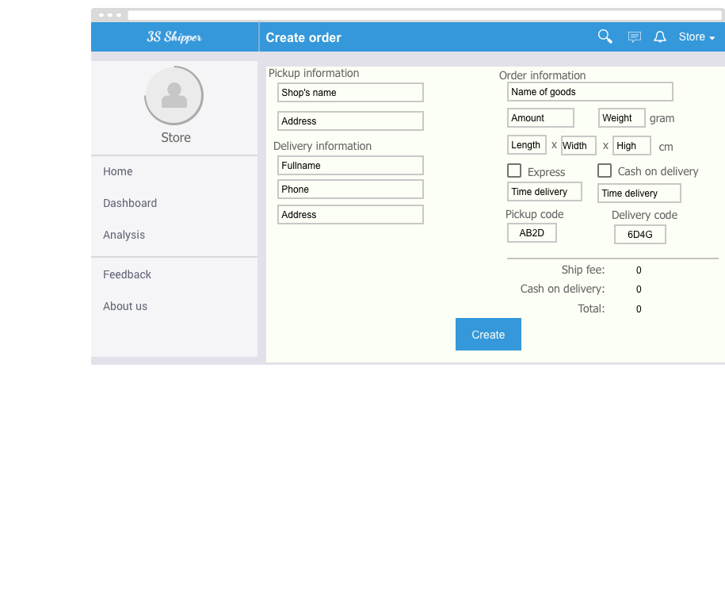

Figure 75: Create order screen

|  |  |  |  |  |
| --- | --- | --- | --- | --- |
| **Use Case ID:** | | UC-208 | | |
| **Use Case Name:** | | Create order | | |
| **CreatedBy:** | | KhanhKC | **Last UpdatedBy:** | KhanhKC |
| **Date Created:** | | 19/09/2015 | **DateLast updated:** | 02/10/2015 |
| **Actor:** | | Store | | |
| **Description:** | | Store creates an order to requests delivery service from system | | |
| **Triggering event:** | | Store wants to create a new order. | | |
| **Preconditions:** | | Store are logged into system. | | |
| **Post conditions:** | | Order information have been send to system and saved to database. | | |
| **Priority:** | | High | | |
| **FrequencyofUse:** | | Always | | |
| **Main flow** | | | | |
| Step | Actor | Action | | |
|  | Store | Clicks “Make an order” button | | |
|  | System | Displays “Create order” screen has a wizard form at “Step1” includes:  - “Full name” text box  - “Phone” text box  - “Province” dropdown list  - “District” dropdown list  - “Ward” dropdown list  - “Address” text area  - “Next” button  - “Previous” button | | |
|  | Store | Enters data in fields | | |
|  | Store | Clicks “Next” button | | |
|  | System | Validate data | | |
|  | System | Displays “Step2” of wizard from include:  - “List goods” table  - “Add goods” button  - “Express” radio button  - “Normal” radio button  - “Cash on delivery” text box  - “Previous” button  - “Next” button | | |
|  | Store | Enters data in fields | | |
|  | Store | Add information of goods (Refer to UC211: Add goods) | | |
|  | Store | Clicks “Next” button | | |
|  | System | Validate data | | |
|  | System | Displays “Step3” of wizard from include:  - “Store” dropdown list  - “Phone” text box  - “Address” text box  - “Previous” button  - “Next” button | | |
|  | Store | Select store | | |
|  | Store | Clicks “Submit” button | | |
|  | System | Saves data to database | | |
|  | System | Displays message (Create order successfully!) | | |
| **Alternative Flows:** | | | | |
| AT1 | At step 13, “Express” radio button is checked | | | |
| Step | Actor | Action | | |
| 4.1 | Store | Clicks on “Submit” button | | |
| 4.2 | System | Go to UC-220: Find Shipper | | |
| **Exceptions:** | | | | |
| EC1 | At step 4, Store clicks on “Previous” button. | | | |
| Step | Actor | Action | | |
| 4.1 | Store | Clicks on “Previous” | | |
| 4.2 | System | Displays “Step1” of wizard form | | |
| EC2 | At step 4, input data is incorrect. | | | |
| Step | Actor | Action | | |
| 4.1 | Store | Clicks “Next” button | | |
| 4.2 | System | Displays message (message is depend on type of each data) | | |
| EC3 | At step 9, Store click on “Previous” button. | | | |
| Step | Actor | Action | | |
| 3.1 | Store | Clicks on “Previous” button | | |
| 3.2 | System | Displays “Step2” of wizard form | | |
| EC4 | At step 9, input data is incorrect | | | |
| Step | Actor | Action | | |
| 3.1 | Store | Clicks on “Next” button | | |
| 3.2 | System | Displays message (message is depend on type of each data) | | |
| EC4 | At step 9, store didn’t add any goods | | | |
| Step | Actor | Action | | |
| 3.1 | Store | Clicks on “Next” button | | |
| 3.2 | System | Displays message (“You must add at least on goods”) | | |
| **Includes:** | | N/A | | |
| **SpecialRequirements:** | | N/A | | |
| **Notes andIssues:** | | N/A | | |

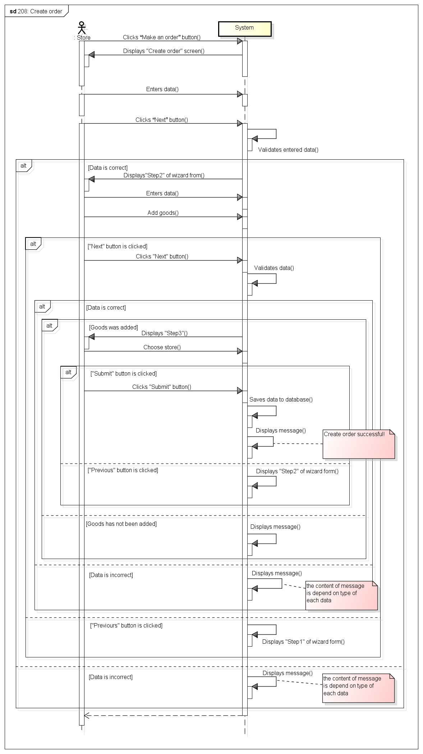

Figure 76: Sequence diagram for Create order user case

###### *UC-209:Find shipper*

|  |  |  |  |  |
| --- | --- | --- | --- | --- |
| **Use Case ID:** | | UC-209 | | |
| **Use Case Name:** | | Find shipper | | |
| **CreatedBy:** | | KhanhKC | **Last UpdatedBy:** | KhanhKC |
| **Create date:** | | 19/09/2015 | **DateLast updated:** | 02/10/2015 |
| **Actor:** | | Store | | |
| **Description:** | | After store create an express order, system will find the nearest shipper for store. Store also can find a shipper again. | | |
| **Triggering event:** | | Store create an express order or store want to find a shipper. | | |
| **Preconditions:** | | Store logged in | | |
| **Post conditions:** | | - A news task added to database with information of order and shipper.  - Status of order changed to “Waiting” | | |
| **Priority:** | | High | | |
| **FrequencyofUse:** | | Always | | |
| **Main flow** | | | | |
| Step | Actor | Action | | |
|  | Store | Create an express order and clicks submit button on create order screen (Refer UC-208: Create Order) | | |
|  | System | Displays “Find shipper” pop-up contain a “Cancel” button to cancel finding process | | |
|  | System | Send request to 5 nearest shipper. | | |
|  | System | * If success  - Display “Shipper info” popup include:  +Avatar of shipper: Image  +Information of shipper (Name, phone number, ID)  - Add order to table of order on “Dashboard screen” at “In process” tab.  * If fail: Display “Message” popup include:  - Message: “Sorry now all shipper are busy!”  - Add order to table of order on “Dashboard” screen at “Draft” tab | | |
| **Alternative Flows:** | | | | |
| AT1 | At step 1, store can click on “Find shipper” button on “Dashboard” screen (Refer to UC-201:View dashboard screen) | | | |
| Step | Actor | Action | | |
| 1.1 | Store | Clicks “Find shipper” button. | | |
| 1.2 | System | Go to step 2. | | |
| **Exceptions:** | | | | |
| EC1 | At step 2, store clicks on “Cancel” button. | | | |
| Step | Actor | Action | | |
| 2.1 | Store | Clicks “Cancel” button. | | |
| 2.2 | System | Stop finding shipper process | | |
| 2.3 | System | Close finding shipper popup | | |
| **Includes:** | | N/A | | |
| **SpecialRequirements:** | | N/A | | |
| **Notes andIssues:** | | Finding shipper popup will auto close after 1 minute if didn’t find any shipper. | | |

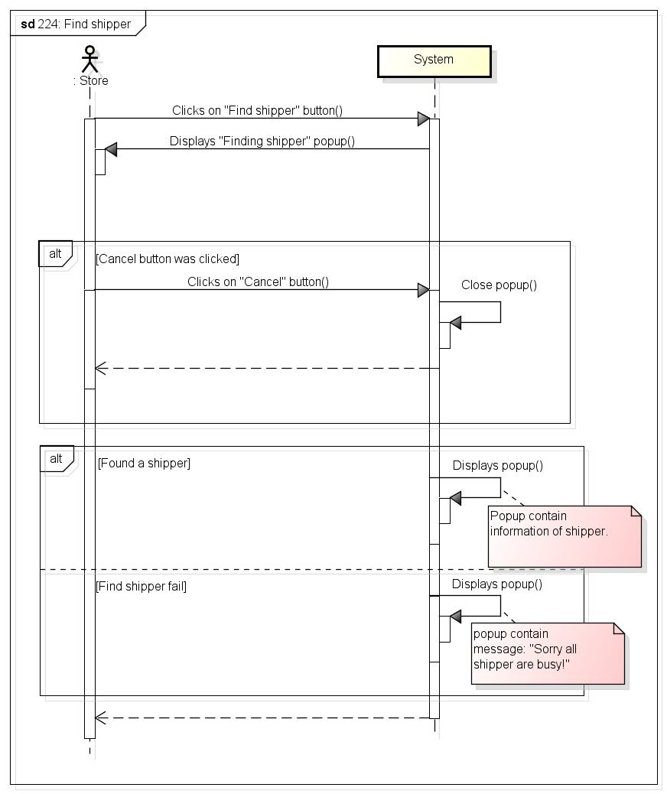

Figure 77: Sequence diagram for Find shipper user case

###### *UC-210:Edit Order*

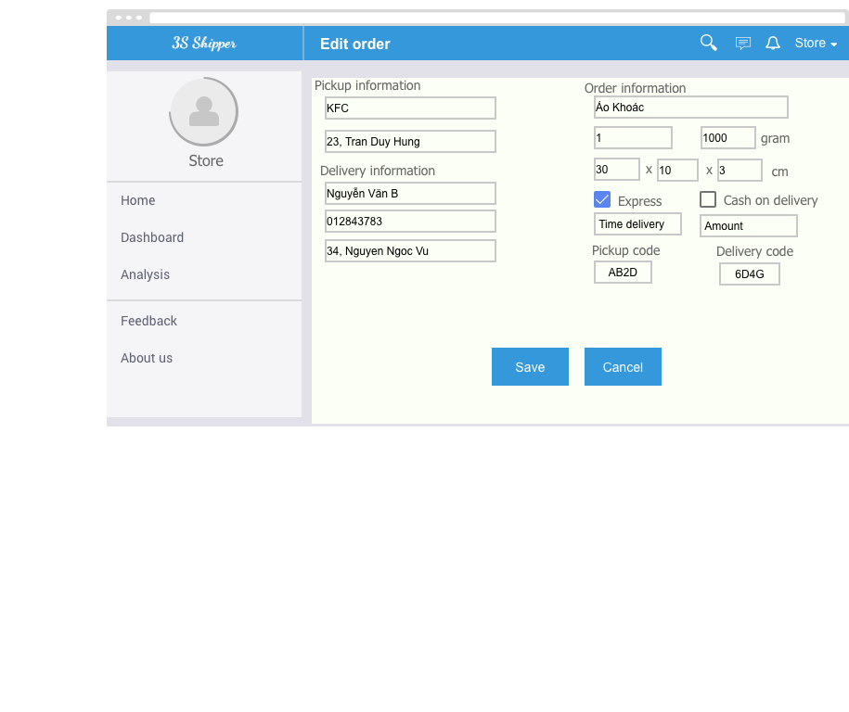

Figure 78: Edit order screen

|  |  |  |  |  |
| --- | --- | --- | --- | --- |
| **Use Case ID:** | | UC-210 | | |
| **Use Case Name:** | | Edit Order | | |
| **CreatedBy:** | | KhanhKC | **Last UpdatedBy:** | KhanhKC |
| **Date Created:** | | 19/09/2015 | **DateLast updated:** | 02/10/2015 |
| **Actor:** | | Store | | |
| **Description:** | | Store can edits some information that Store entered when create orders. But the status of order must be in status “waiting” (waiting for shipper go to pick up) | | |
| **Triggering event:** | | Store wants to edits order | | |
| **Preconditions:** | | Store are on “Order details” screen. (Refer to UC-218: Order’s details) | | |
| **Post conditions:** | | Updated information of order have been displays on “Order’s details” screen and updated in database. | | |
| **Priority:** | | High | | |
| **FrequencyofUse:** | | Sometimes | | |
| **Main flow** | | | | |
| Step | Actor | Action | | |
|  | Store | Clicks “Edit” button on “Order’s detail” screen. | | |
|  | System | Enable element on “Order’s detail” screen. | | |
|  | Store | Edit information of order. | | |
|  | Store | Clicks “Update order” button | | |
|  | System | Displays “Order details” screen with updated information. | | |
| **Alternative Flows:** | | | | |
| **Exceptions:** | | | | |
| EC1 | At step 4, if input data is incorrect | | | |
| Step | Actor | Action | | |
| 4.1 | Store | Clicks “Update order” button | | |
| 4.2 | System | Displays message (content of message is depend on type of each data) | | |
| EC2 | At step 4, if table of goods is empty | | | |
| Step | Actor | Action | | |
| 4.1 | Store | Clicks “Update order” button | | |
| 4.2 | System | Displays message: “You must add at least one goods to order” | | |
| EC3 | At step 4, if Store clicks on “Cancel” button | | | |
| Step | Actor | Action | | |
| 4.1 | Store | Clicks “Cancel” button | | |
| 4.2 | System | Disable elements on “Order’s details” screen and displays previous data. | | |
| **Includes:** | | N/A | | |
| **SpecialRequirements:** | | N/A | | |
| **Notes andIssues:** | | N/A | | |

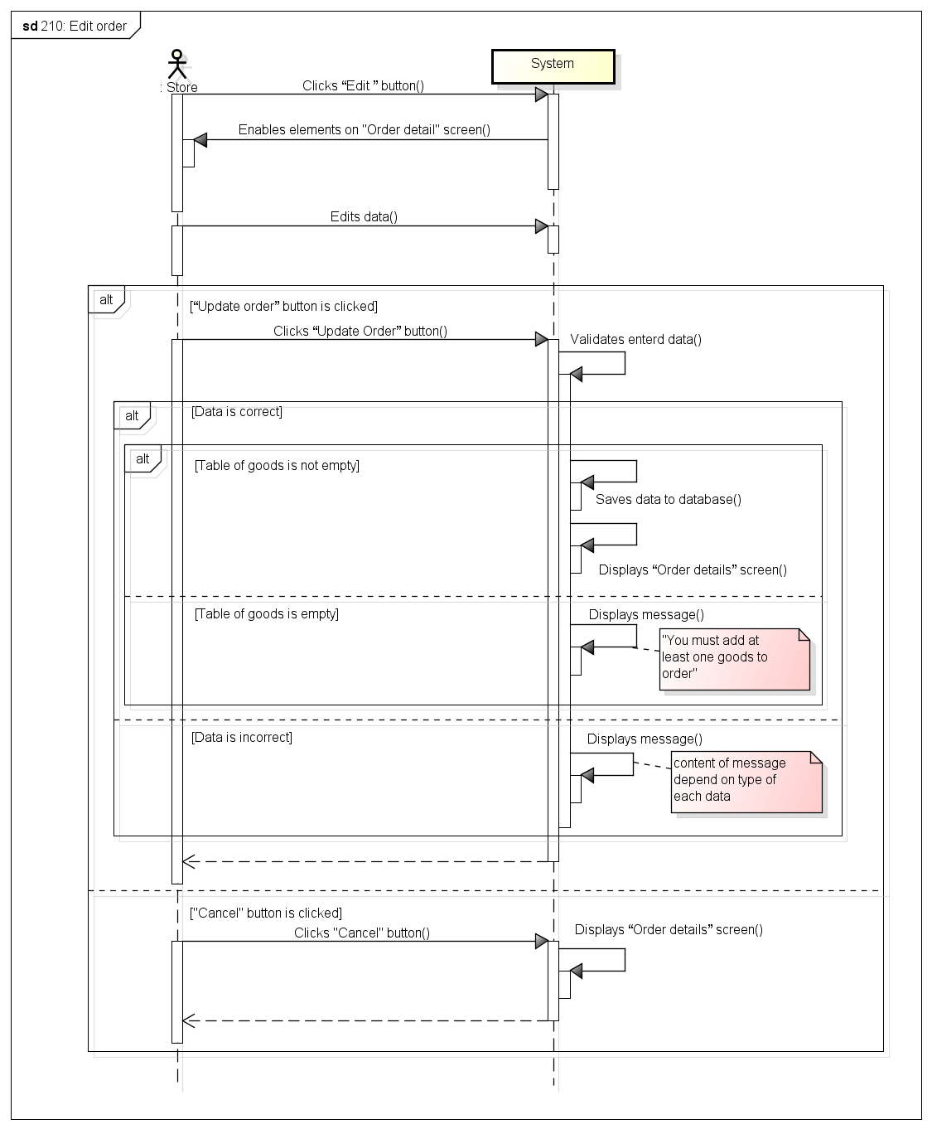

Figure 79: Sequence diagram for Edit order user case

###### *UC-211:Add goods*



Figure 80: Add goods screen

|  |  |  |  |  |
| --- | --- | --- | --- | --- |
| **Use Case ID:** | | UC-211 | | |
| **Use Case Name:** | | Add goods | | |
| **CreatedBy:** | | KhanhKC | **Last UpdatedBy:** | KhanhKC |
| **Date Created:** | | 19/09/2015 | **DateLast updated:** | 02/10/2015 |
| **Actor:** | | Store | | |
| **Description:** | | Store add information of goods for an orders include: goods name, weight, amount, height, width, length, description. | | |
| **Triggering event:** | | Store wants to add a goods | | |
| **Preconditions:** | | Store are on “Create order” screen (Refer to UC-208: Create order) or “Order’s details” screen (Refer to UC-210: Edit order) | | |
| **Post conditions:** | | A goods has been added to table of goods | | |
| **Priority:** | | High | | |
| **FrequencyofUse:** | | Always | | |
| **Main flow** | | | | |
| Step | Actor | Action | | |
|  | Store | Clicks “Add goods” button | | |
|  | System | Displays “Add goods” popup includes:  - “Goods name” text box  - “Amount” text box  - “Weight” text box  - “Height” text box  - “Length” text box  - “Width” text box  - “Description” text box  - “Add” button  - “Cancel” button | | |
|  | Store | Enters data in fields | | |
|  | Store | Clicks “Add” button | | |
|  | System | Validate data | | |
|  | System | Add goods to table of goods | | |
|  | System | Closes popup | | |
| **Alternative Flows:** | | N/A | | |
| **Exceptions:** | | | | |
| EC1 | At step 4, Store clicks on “Cancel” button. | | | |
| Step | Actor | Action | | |
| 4.1 | Store | Clicks on “Cancel” button | | |
| 4.2 | System | Close popup | | |
| EC2 | At step 5, if input data is incorrect | | | |
| Step | Actor | Action | | |
| 4.1 | Store | Clicks on “Add” button | | |
| 4.2 | System | Displays messages (content of messages is depend in type of each data) | | |
| EC3 | At step 4, if total weight of all goods is greater than 30Kg | | | |
| Step | Actor | Action | | |
| 4.1 | Store | Clicks on “Add” button | | |
| 4.2 | System | Displays messages “Total weight must < 30000 gram” | | |
| **Includes:** | | N/A | | |
| **SpecialRequirements:** | | N/A | | |
| **Notes andIssues:** | | N/A | | |

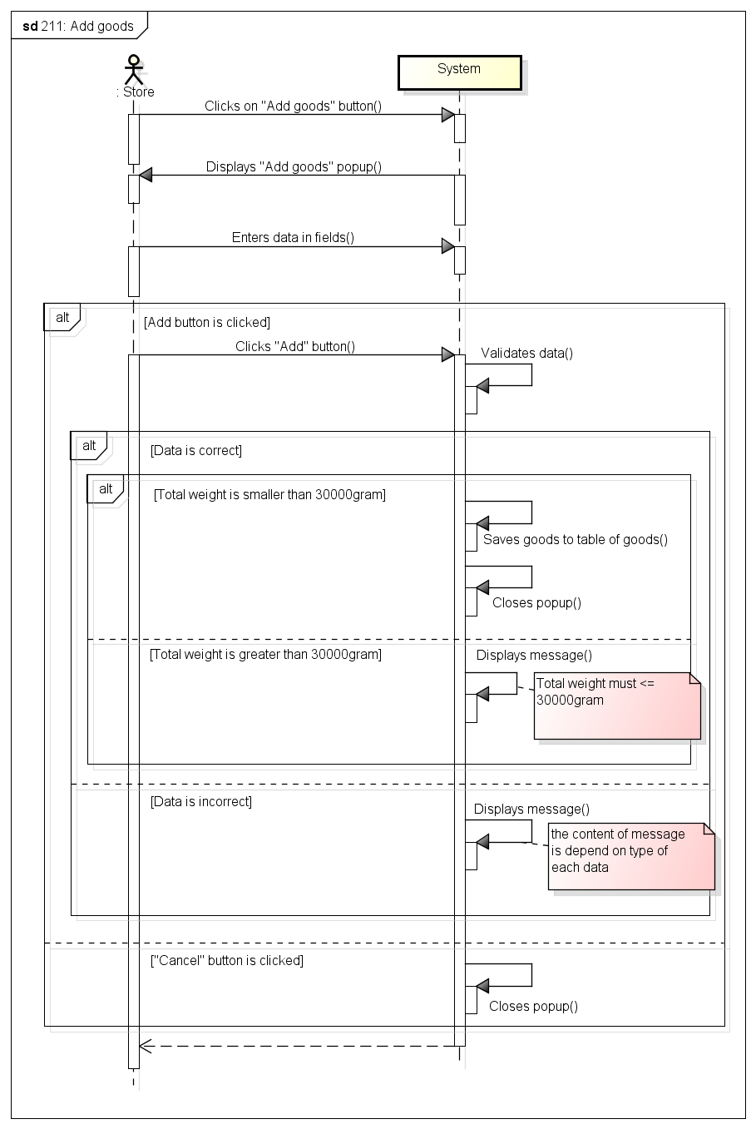

Figure 81: Sequence diagram for Add goods user case

###### *UC-212: Edit goods*



Figure 82: Edit goods screen

|  |  |  |  |  |
| --- | --- | --- | --- | --- |
| **Use Case ID:** | | UC-212 | | |
| **Use Case Name:** | | Edit goods | | |
| **CreatedBy:** | | KhanhKC | **Last UpdatedBy:** | KhanhKC |
| **Date Created:** | | 19/09/2015 | **DateLast updated:** | 02/10/2015 |
| **Actor:** | | Store | | |
| **Description:** | | Store edit information of goods such as: goods name, weight, amount, height, width, length, description. | | |
| **Triggering event:** | | Store wants to edit a goods | | |
| **Preconditions:** | | Store are on “Create order” screen (Refer to UC-208: Create order) or “Order’s details” screen (Refer to UC-210: Edit order) | | |
| **Post conditions:** | | Information of goods has been updated to table of goods | | |
| **Priority:** | | High | | |
| **FrequencyofUse:** | | Sometimes | | |
| **Main flow** | | | | |
| Step | Actor | Action | | |
|  | Store | Clicks “Edit ” button on each row of table of goods | | |
|  | System | Displays “Edit goods” popup includes:  - “Goods name” text box  - “Amount” text box  - “Weight” text box  - “Height” text box  - “Length” text box  - “Width” text box  - “Description” text box  - “Save” button  - “Cancel” button | | |
|  | Store | Edit data in fields | | |
|  | Store | Clicks “Save” button | | |
|  | System | Validate data | | |
|  | System | Updated information of goods to table of goods | | |
|  | System | Closes popup | | |
| **Alternative Flows:** | | N/A | | |
| **Exceptions:** | | | | |
| EC1 | At step 4, Store clicks on “Cancel” button. | | | |
| Step | Actor | Action | | |
| 4.1 | Store | Clicks on “Cancel” button | | |
| 4.2 | System | Close popup | | |
| EC2 | At step 5, if input data is incorrect | | | |
| Step | Actor | Action | | |
| 4.1 | Store | Clicks on “Save” button | | |
| 4.2 | System | Displays messages (content of messages is depend in type of each data) | | |
| EC3 | At step 4, if total weight of all goods is greater than 30Kg | | | |
| Step | Actor | Action | | |
| 4.1 | Store | Clicks on “Save” buttons | | |
| 4.2 | System | Displays messages “Total weight must < 30000 gram” | | |
| **Includes:** | | N/A | | |
| **SpecialRequirements:** | | N/A | | |
| **Notes andIssues:** | | N/A | | |

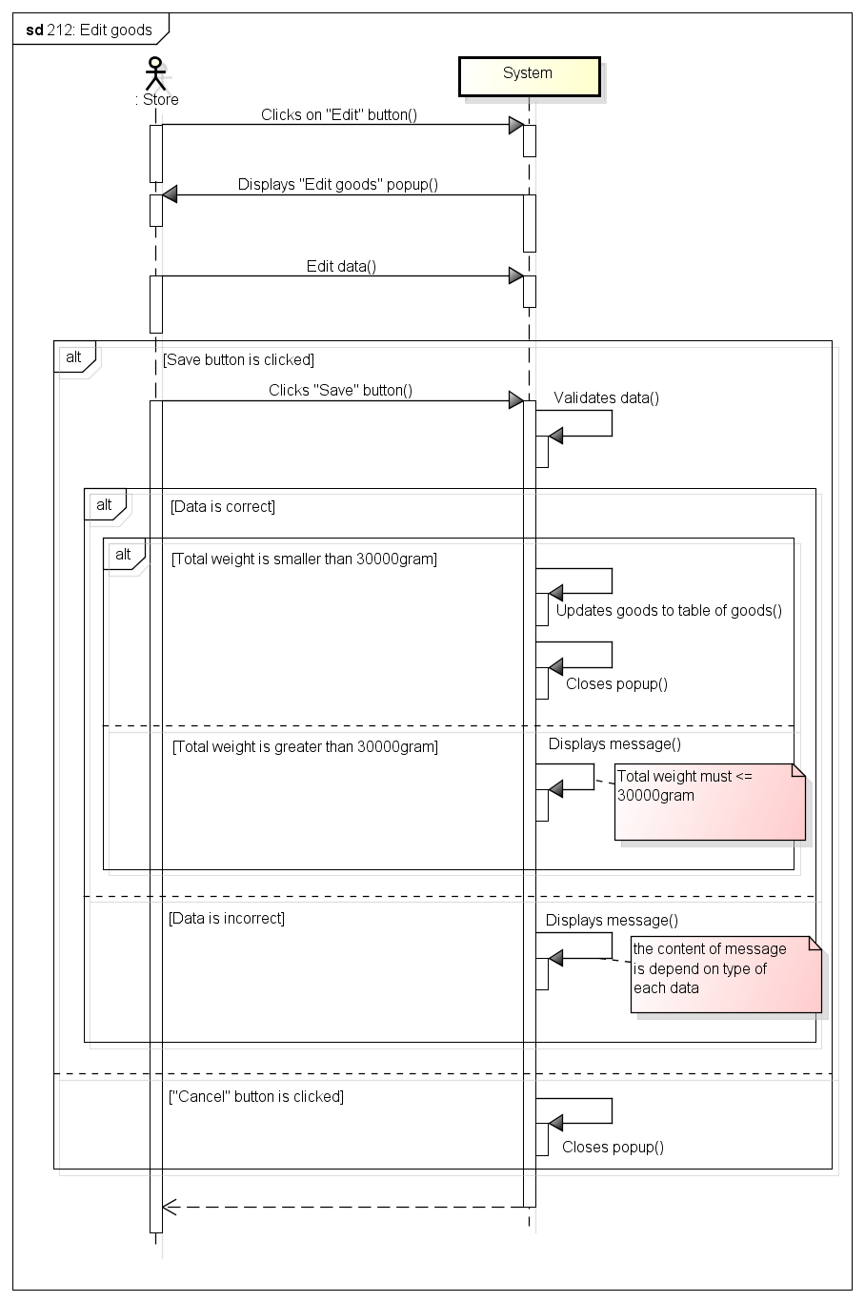

Figure 83: Sequence diagram for Edit goods user case

###### *UC-213: Delete goods*

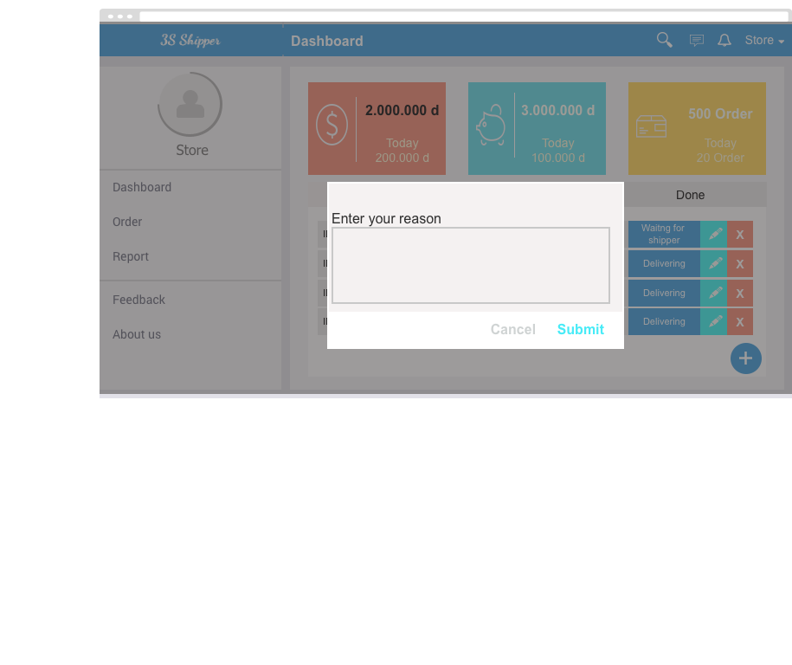

Figure 84: Delete goods screen

|  |  |  |  |  |
| --- | --- | --- | --- | --- |
| **Use Case ID:** | | UC-213 | | |
| **Use Case Name:** | | Delete goods | | |
| **CreatedBy:** | | KhanhKC | **Last UpdatedBy:** | KhanhKC |
| **Date Created:** | | 19/09/2015 | **DateLast updated:** | 02/10/2015 |
| **Actor:** | | Store | | |
| **Description:** | | Store can delete goods on table of goods | | |
| **Triggering event:** | | Store wants to delete a goods. | | |
| **Preconditions:** | | Store are on “Create order” screen (Refer to UC-208: Create order) or “Order’s details” screen (Refer to UC-210: Edit order) | | |
| **Post conditions:** | | Goods has been deleted from table of goods | | |
| **Priority:** | | High | | |
| **FrequencyofUse:** | | Sometimes | | |
| **Main flow** | | | | |
| Step | Actor | Action | | |
|  | Store | Clicks “Delete” button | | |
|  | System | Displays “Confirm delete” popup | | |
|  | Store | Clicks “Yes” button | | |
|  | System | Delete goods from table of goods | | |
|  | System | Closes popup | | |
| **Alternative Flows:** | | N/A | | |
| **Exceptions:** | | | | |
| EC1 | At step 3, Store Clicks “No” button | | | |
| Step | Actor | Action | | |
| 3.1 | System | Closes popup | | |
| **Includes:** | | N/A | | |
| **SpecialRequirements:** | | N/A | | |
| **Notes andIssues:** | | N/A | | |

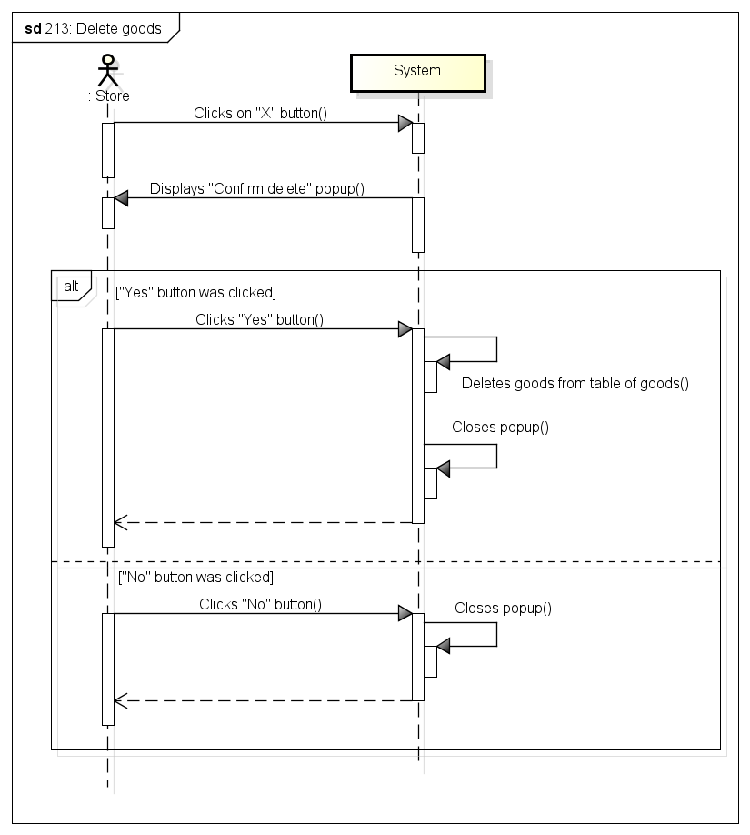

Figure 85: Sequence diagram for Delete goods user case

###### *UC-214:View order’s history*

|  |  |  |  |  |
| --- | --- | --- | --- | --- |
| **Use Case ID:** | | UC-214 | | |
| **Use Case Name:** | | View order’s history | | |
| **CreatedBy:** | | KhanhKC | **Last UpdatedBy:** | KhanhKC |
| **Date Created:** | | 19/09/2015 | **DateLast updated:** | 02/10/2015 |
| **Actor:** | | Store | | |
| **Description:** | | “View order’s history” screen displays list of all orders that created by and function buttons that help Store cancels and edits information of orders. | | |
| **Triggering event:** | | Store wants to view order history. | | |
| **Preconditions:** | | Store logged into system. | | |
| **Post conditions:** | | “Order’s history” screen are displayed | | |
| **Priority:** | | High | | |
| **FrequencyofUse:** | | Sometimes | | |
| **Main flow** | | | | |
| Step | Actor | Action | | |
|  | Store | Clicks on “Order’s history” on menu | | |
|  | System | Loads data | | |
|  | System | Displays “Order’s history” screen | | |
| **Alternative Flows:** | | N/A | | |
| **Exceptions:** | | N/A | | |
| **Includes:** | | N/A | | |
| **SpecialRequirements:** | | N/A | | |
| **Notes andIssues:** | | N/A | | |

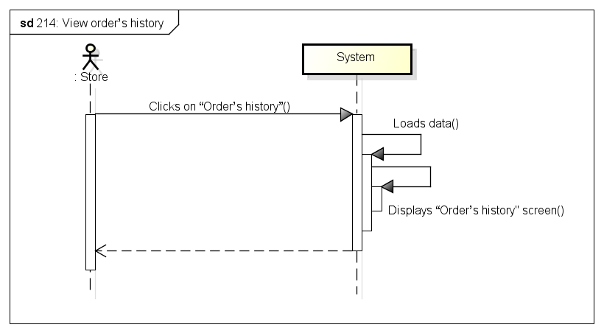

Figure 86: Sequence diagram for View order history user case

###### *UC-215:Search orders*

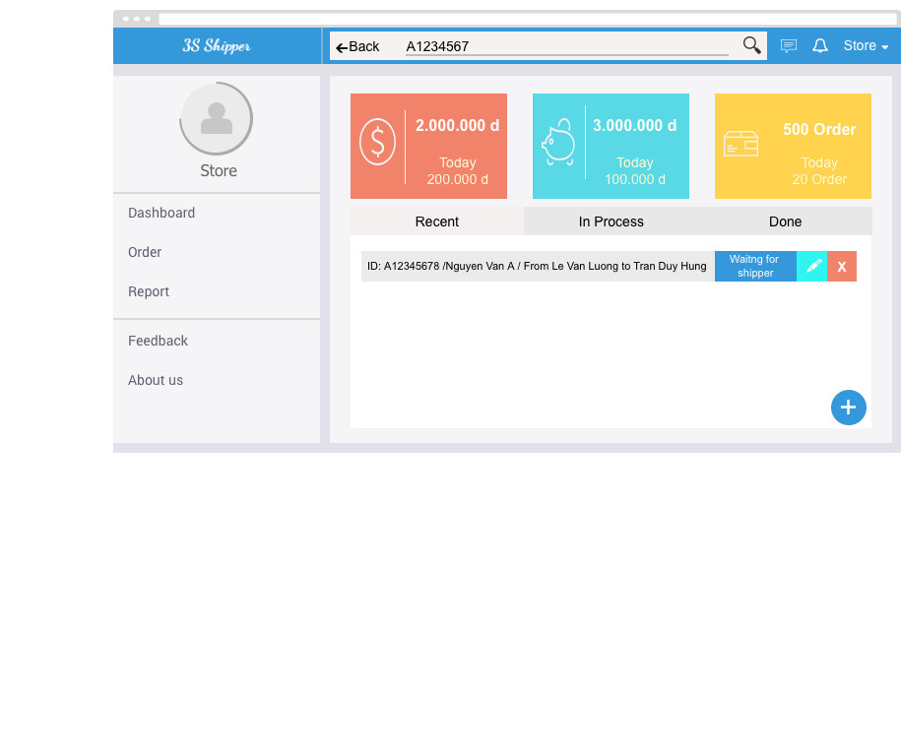

Figure 87: Search order screen

|  |  |  |  |  |
| --- | --- | --- | --- | --- |
| **Use Case ID:** | | UC-215 | | |
| **Use Case Name:** | | Search orders | | |
| **CreatedBy:** | | KhanhKC | **Last UpdatedBy:** | KhanhKC |
| **Date Created:** | | 19/09/2015 | **DateLast updated:** | 02/10/2015 |
| **Actor:** | | Store | | |
| **Description:** | | Store can use order’s information to search orders in list of orders that were created by Store. Example search order by orderid, create date… | | |
| **Triggering event:** | | Store wants to search order | | |
| **Preconditions:** | | Store is on “Order’s history” screen. (Refer to UC-214: View order’shistory) or “Dashboard” screen (Refer to UC-201: View dashboard) | | |
| **Post conditions:** | | Search result are displayed on screen. | | |
| **Priority:** | | High | | |
| **FrequencyofUse:** | | Often | | |
| **Main flow** | | | | |
| Step | Actor | Action | | |
|  | Store | Selects item on drop down list to search | | |
|  | Store | Types on search box | | |
|  | System | Loads data | | |
|  | System | Displays search result on screen. | | |
| **Alternative Flows:** | | N/A | | |
| **Exceptions:** | | N/A | | |
| **Includes:** | | N/A | | |
| **SpecialRequirements:** | | N/A | | |
| **Notes andIssues:** | | N/A | | |

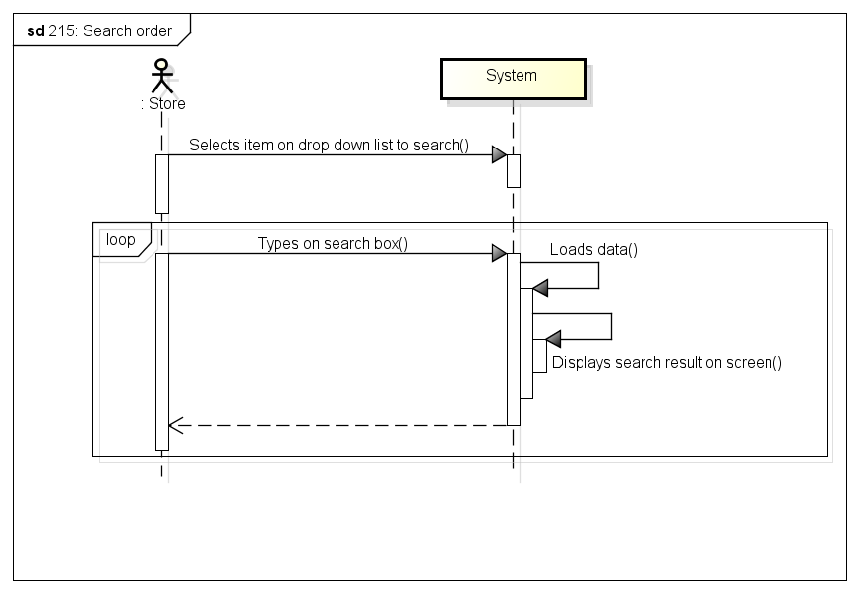

Figure 88: Sequence diagram for Search order user case

###### *UC-216:Cancel order*



Figure 89: Cancel order screen

|  |  |  |  |  |
| --- | --- | --- | --- | --- |
| **Use Case ID:** | | UC-216 | | |
| **Use Case Name:** | | Cancel order | | |
| **CreatedBy:** | | KhanhKC | **Last UpdatedBy:** | KhanhKC |
| **Date Created:** | | 19/09/2015 | **DateLast updated:** | 02/10/2015 |
| **Actor:** | | Store | | |
| **Description:** | | Stores can cancel uncompleted orders. But Store has to pay 10% ship fee of order. | | |
| **Triggering event:** | | Store wants to cancel orders. | | |
| **Preconditions:** | | Store are on “Dashboard” screen (Refer to UC-201: View dashboard) or “Order’s detail” screen (Refer to UC-218: View order’s details”) | | |
| **Post conditions:** | | - Order status has been changed to “Canceling”  - Notification has been send to admin. | | |
| **Priority:** | | Medium | | |
| **FrequencyofUse:** | | Sometime | | |
| **Main flow** | | | | |
| Step | Actor | Action | | |
|  | Store | Clicks “Cancel” button | | |
|  | System | Displays “Confirm Cancel” popup | | |
|  | Store | Clicks “Yes” button | | |
|  | System | Changes status of order to “Canceling” | | |
|  | System | Sends notification to admin | | |
| **Alternative Flows:** | | N/A | | |
| **Exceptions:** | | | | |
| EC1 | At step 3, Store Clicks “No” button | | | |
| Step | Actor | Action | | |
| 3.1 | System | Closes popup | | |
| **Includes:** | | N/A | | |
| **SpecialRequirements:** | | N/A | | |
| **Notes andIssues:** | | N/A | | |

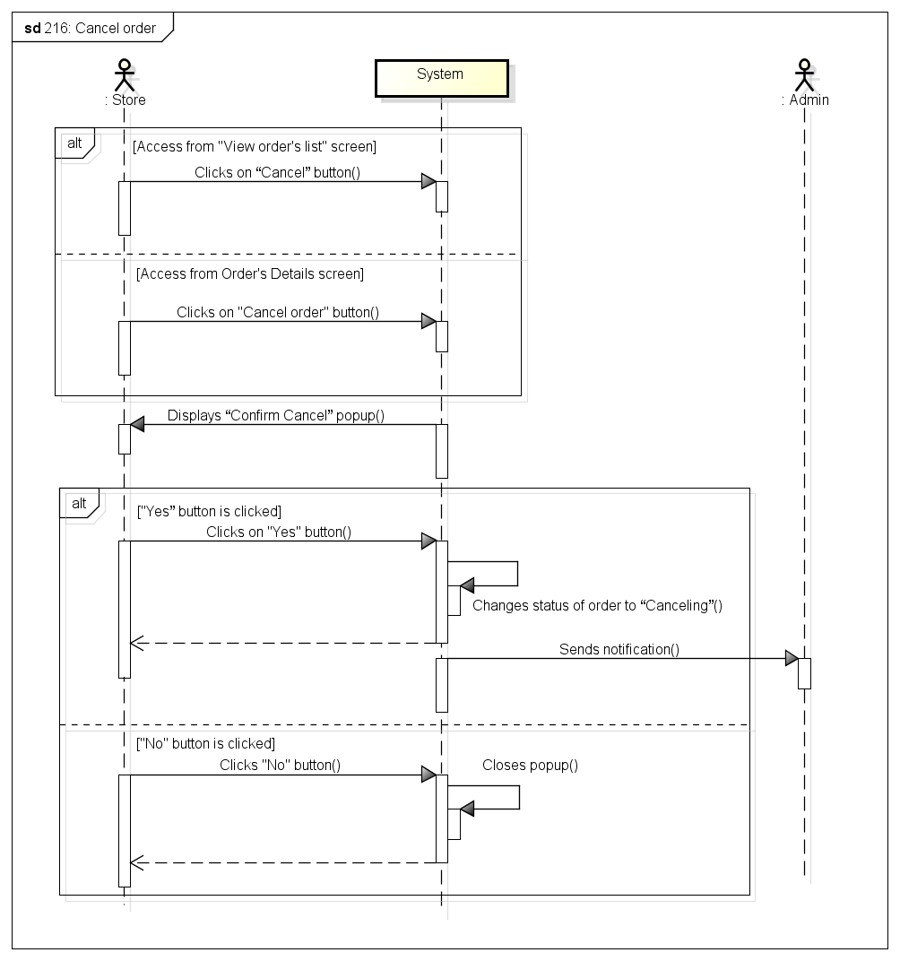

Figure 90: Sequence diagram for Cancel order user case

###### *UC-217:Delete order*



Figure 91: Delete order screen

|  |  |  |  |  |
| --- | --- | --- | --- | --- |
| **Use Case ID:** | | UC-217 | | |
| **Use Case Name:** | | Delete order | | |
| **CreatedBy:** | | KhanhKC | **Last UpdatedBy:** | KhanhKC |
| **Date Created:** | | 19/09/2015 | **DateLast updated:** | 02/10/2015 |
| **Actor:** | | Store | | |
| **Description:** | | Store can delete draft order (Express order that have not yet been grabbed by any shipper) | | |
| **Triggering event:** | | Store wants to delete an order. | | |
| **Preconditions:** | | Store are on “Dashboard” screen (Refer to UC-201: View dashboard) | | |
| **Post conditions:** | | - Order status has been deleted in database | | |
| **Priority:** | | Medium | | |
| **FrequencyofUse:** | | Sometime | | |
| **Main flow** | | | | |
| Step | Actor | Action | | |
|  | Store | Clicks “Delete” button | | |
|  | System | Displays “Confirm delete” popup | | |
|  | Store | Clicks “Yes” button | | |
|  | System | Delete order in database | | |
|  | System | Displays message “Delete order successfully!” | | |
| **Alternative Flows:** | | N/A | | |
| **Exceptions:** | | | | |
| EC1 | At step 3, Store Clicks “No” button | | | |
| Step | Actor | Action | | |
| 3.1 | System | Closes popup | | |
| **Includes:** | | N/A | | |
| **SpecialRequirements:** | | N/A | | |
| **Notes andIssues:** | | N/A | | |

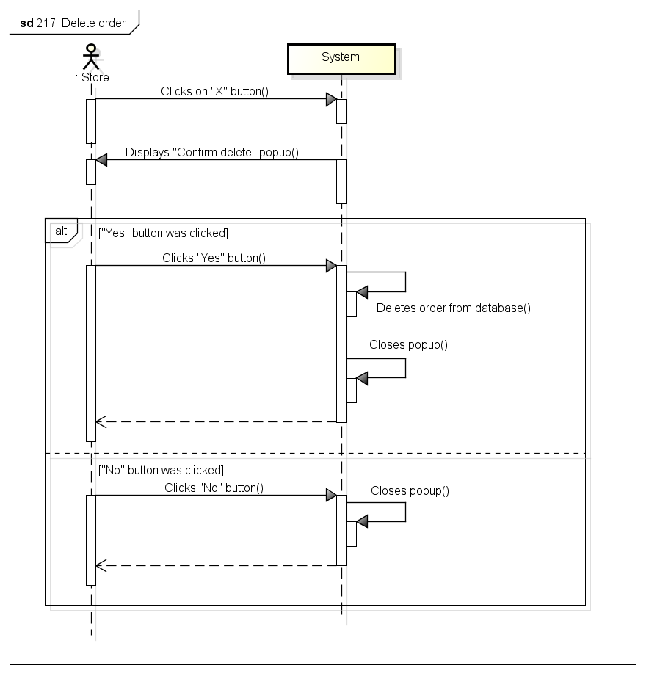

Figure 92: Sequence diagram for Delete order user case

###### *UC-218:* View o*rder’s details*

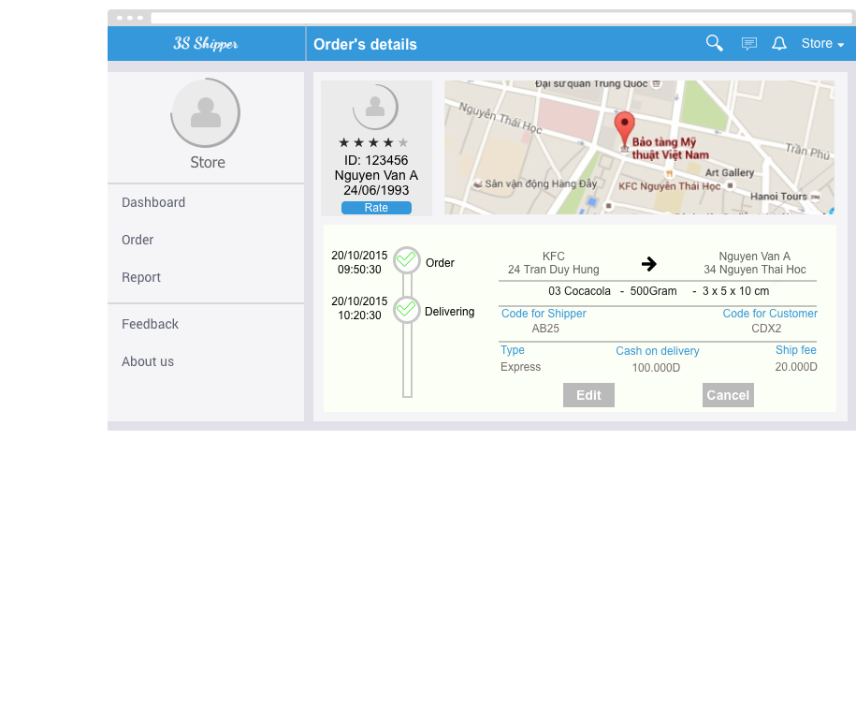

Figure 93: View order detail screen

|  |  |  |  |  |
| --- | --- | --- | --- | --- |
| **Use Case ID:** | | UC-218 | | |
| **Use Case Name:** | | Order’ Details | | |
| **CreatedBy:** | | KhanhKC | **Last UpdatedBy:** | KhanhKC |
| **Date Created:** | | 19/09/2015 | **DateLast updated:** | 02/10/2015 |
| **Actor:** | | Store | | |
| **Description:** | | Displays details information of orders with a maps that help Store checking location of Shippers | | |
| **Triggering event:** | | Store wants to view order details | | |
| **Preconditions:** | | Store is on “Order’s history” screen (Refer to UC-214: View order’s history) or “Dashboard” screen (Refer to UC-201: View dashboard) | | |
| **Post conditions:** | | “Order’s details” screen is displayed | | |
| **Priority:** | | High | | |
| **FrequencyofUse:** | | Always | | |
| **Main flow** | | | | |
| Step | Actor | Action | | |
|  | Store | Clicks on “View” button on row contain order brief information | | |
|  | System | Loads data | | |
|  | System | Displays “Order’s details” screen | | |
| **Alternative Flows:** | | N/A | | |
| **Exceptions:** | | N/A | | |
| **Includes:** | | N/A | | |
| **SpecialRequirements:** | | N/A | | |
| **Notes andIssues:** | | N/A | | |

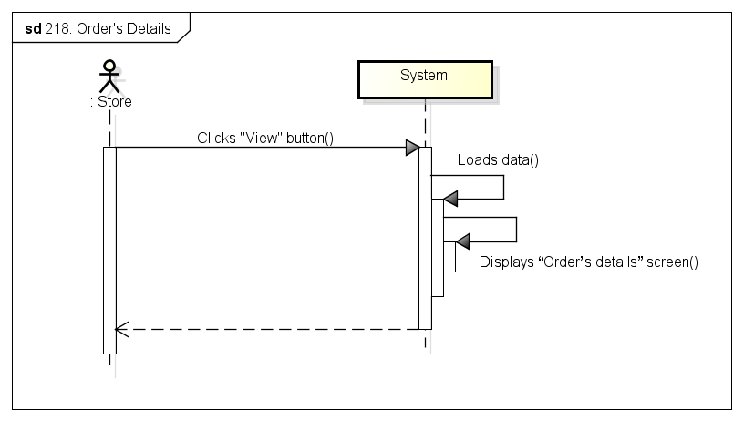

Figure 94: Sequence diagram for Order detail user case

###### *UC-219:View transaction history*

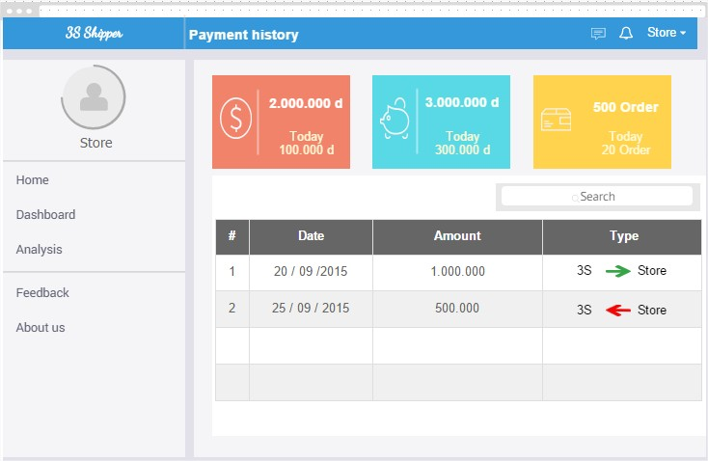

Figure 95: View transaction history screen

|  |  |  |  |  |
| --- | --- | --- | --- | --- |
| **Use Case ID:** | | UC-219 | | |
| **Use Case Name:** | | View transaction history | | |
| **CreatedBy:** | | KhanhKC | **Last UpdatedBy:** | KhanhKC |
| **Date Created:** | | 19/09/2015 | **DateLast updated:** | 02/10/2015 |
| **Actor:** | | Store | | |
| **Description:** | | Displays transaction history between Store and system | | |
| **Triggering event:** | | Store wants to view transaction history | | |
| **Preconditions:** | | Store is on “Store” screen. | | |
| **Post conditions:** | | “Transaction history” screen are displayed | | |
| **Priority:** | | Medium | | |
| **FrequencyofUse:** | | Sometime | | |
| **Main flow** | | | | |
| Step | Actor | Action | | |
|  | Store | Clicks on “Transaction history” menu item on “Navigation bar” | | |
|  | System | Loads data | | |
|  | System | Displays “Transaction history” screen. | | |
| **Alternative Flows:** | | N/A | | |
| **Exceptions:** | | N/A | | |
| **Includes:** | | N/A | | |
| **SpecialRequirements:** | | N/A | | |
| **Notes andIssues:** | | N/A | | |

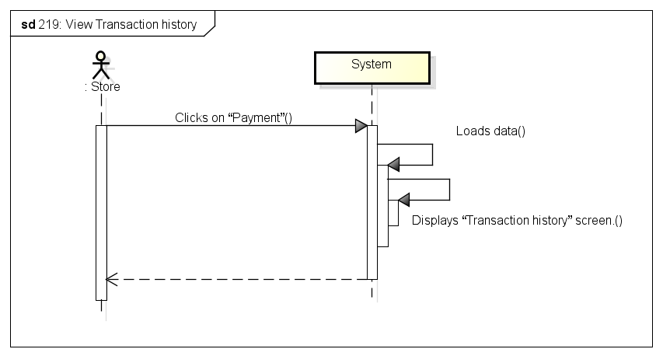

Figure 96: Sequence diagram for View transaction history user case

###### *UC-220:Search transaction history*



Figure 97: Search transaction history screen

|  |  |  |  |  |
| --- | --- | --- | --- | --- |
| **Use Case ID:** | | UC-220 | | |
| **Use Case Name:** | | Search transaction history | | |
| **CreatedBy:** | | KhanhKC | **Last UpdatedBy:** | KhanhKC |
| **Date Created:** | | 19/09/2015 | **DateLast updated:** | 02/10/2015 |
| **Actor:** | | Store | | |
| **Description:** | | Store can use transaction’s information to search transaction in list of transactions. Example search transaction by balance, create date… | | |
| **Triggering event:** | | Store wants to search transaction | | |
| **Preconditions:** | | Store is on “Transaction’s history” screen. (Refer to UC-219: View transaction’shistory) | | |
| **Post conditions:** | | Search result are displayed on screen. | | |
| **Priority:** | | Medium | | |
| **FrequencyofUse:** | | Sometimes | | |
| **Main flow** | | | | |
| Step | Actor | Action | | |
|  | Store | Selects item on drop down list to search | | |
|  | Store | Types on search box | | |
|  | System | Loads data | | |
|  | System | Displays search result on screen. | | |
| **Alternative Flows:** | | N/A | | |
| **Exceptions:** | | N/A | | |
| **Includes:** | | N/A | | |
| **SpecialRequirements:** | | N/A | | |
| **Notes andIssues:** | | N/A | | |

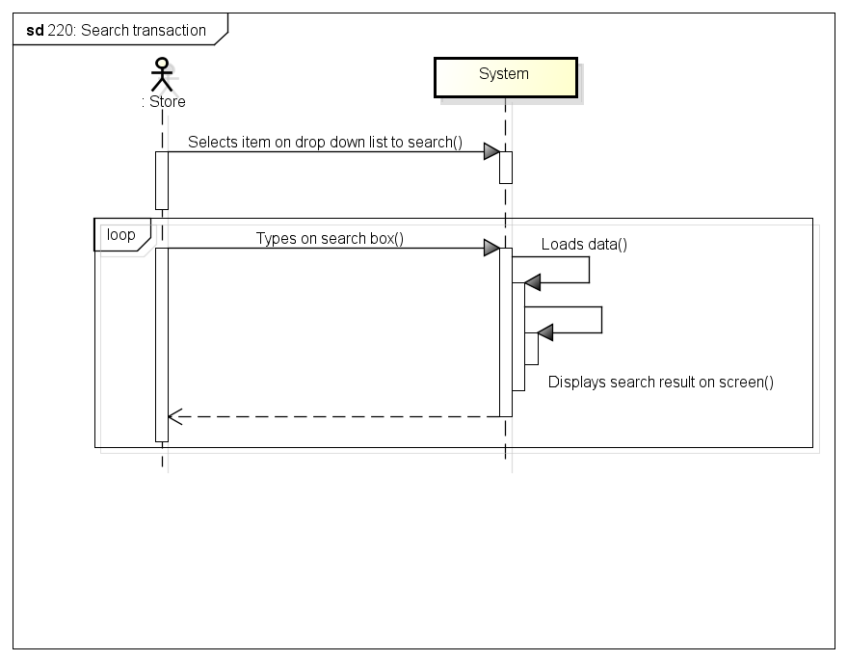

Figure 98: Sequence diagram for Search transaction user case

###### *UC-221:View notifications*

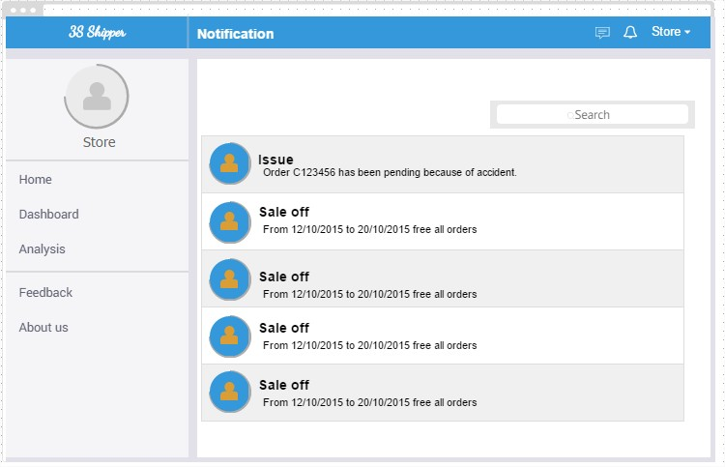

Figure 99: View notification screen

|  |  |  |  |  |
| --- | --- | --- | --- | --- |
| **Use Case ID:** | | UC-221 | | |
| **Use Case Name:** | | View notifications | | |
| **CreatedBy:** | | HuyTDH | **Last UpdatedBy:** | KhanhKC |
| **Date Created:** | | 19/09/2015 | **DateLast updated:** | 02/10/2015 |
| **Actor:** | | Store | | |
| **Description:** | | “View notification” screen displays notification about information, issue of orders and message form admin. | | |
| **Triggering event:** | | Store wants to view notification. | | |
| **Preconditions:** | | Store logged in, internet connection is on | | |
| **Post conditions:** | | All notifications will be listed out | | |
| **Priority:** | | High | | |
| **FrequencyofUse:** | | Often | | |
| **Main flow** | | | | |
| Step | Actor | Action | | |
|  | Store | Clicks on “Notification” icon | | |
|  | System | Loads data | | |
|  | System | Displays “Notifications” screen. | | |
| **Alternative:** | | N/A | | |
| **Exceptions:** | | N/A | | |
| **Includes:** | | N/A | | |
| **SpecialRequirements:** | | N/A | | |
| **Notes and Issues:** | | N/A | | |

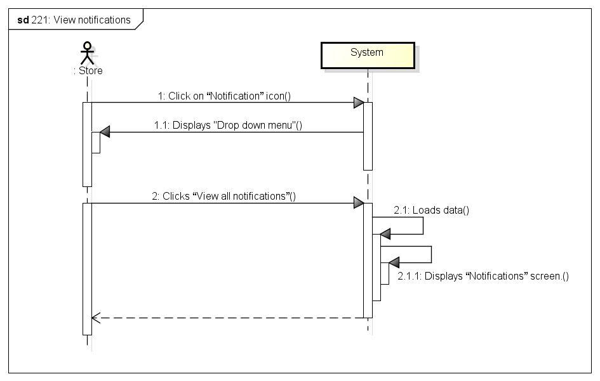

Figure 100: Sequence diagram for View notification user case

###### *UC-222:Rate shipper*

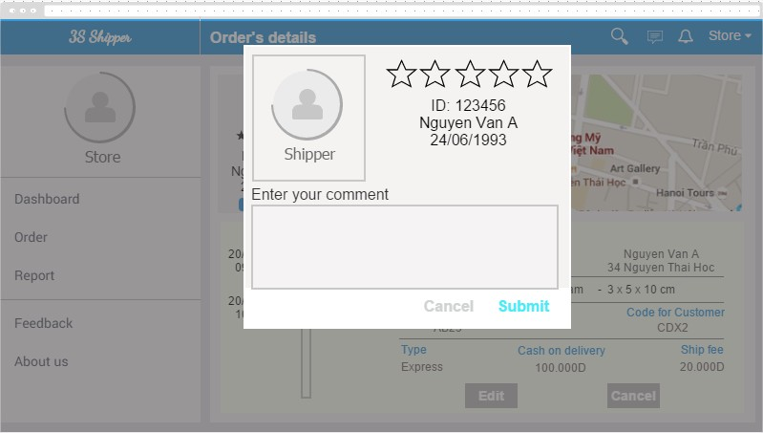

Figure 101: Rate shipper screen

|  |  |  |  |  |
| --- | --- | --- | --- | --- |
| **Use Case ID:** | | UC-222 | | |
| **Use Case Name:** | | Rate shipper | | |
| **CreatedBy:** | | HuyTDH | **Last UpdatedBy:** | KhanHKC |
| **Date Created:** | | 19/09/2015 | **DateLast updated:** | 02/10/2015 |
| **Actor:** | | Store | | |
| **Description:** | | Store rates service quality of shipper for each order by chooses number of star and enters comment. | | |
| **Triggering event:** | | Store rates shipper. | | |
| **Preconditions:** | | Store logged in, there’s a shipper bears responsibility for shipping store’s order | | |
| **Post conditions:** | | Shipper rating send to system | | |
| **Priority:** | | Medium | | |
| **FrequencyofUse:** | | Often | | |
| **Main flow** | | | | |
| Step | Actor | Action | | |
|  | Store | Goes to “Order List” | | |
|  | Store | Clicks on “Rate” button | | |
|  | System | Displays “Shipper Rating” pop-up | | |
|  | Store | Selects rate score (1-5 stars) | | |
|  | Store | Enters some content | | |
|  | Store | Clicks on “Send” button | | |
|  | System | Save data to database | | |
|  | System | Displays message “Thanks for your rating!” | | |
| **Alternative Flows:** | | | | |
| **Exceptions:** | | | | |
| EC1 | At step 9, Store Clicks “Cancel” button | | | |
| Step | Actor | Action | | |
| 4.1 | Store | Store Clicks “Cancel” button | | |
| 4.2 | System | Close popup. | | |
| **Includes:** | | N/A | | |
| **SpecialRequirements:** | | N/A | | |
| **Notes andIssues:** | | N/A | | |

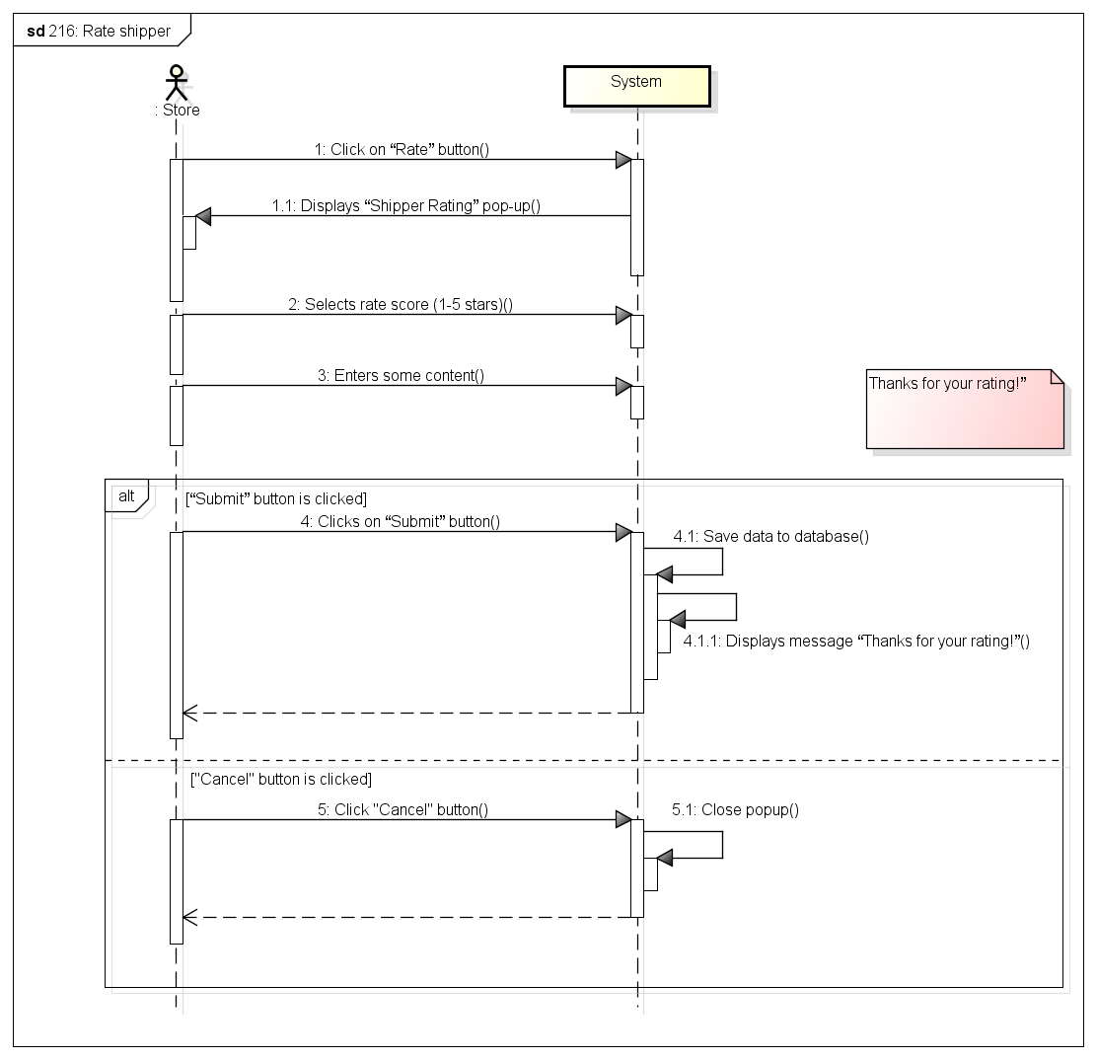

Figure 102: Sequence diagram for Rate shipper user case

###### *UC-223:Send feedback*

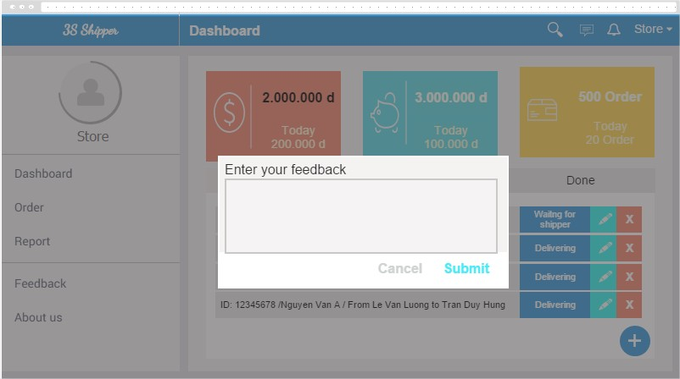

Figure 103: Send feedback screen

|  |  |  |  |  |
| --- | --- | --- | --- | --- |
| **Use Case ID:** | | UC-223 | | |
| **Use Case Name:** | | Send feedback | | |
| **CreatedBy:** | | HuyTDH | **Last UpdatedBy:** | KhanhKC |
| **Create date:** | | 19/09/2015 | **DateLast updated:** | 02/10/2015 |
| **Actor:** | | Store | | |
| **Description:** | | Store send feedback about any service of system by enters some content. | | |
| **Triggering event:** | | Store send feedback about service to system | | |
| **Preconditions:** | | Store logged in  Internet connection is on | | |
| **Post conditions:** | | Feedback will be sent to system | | |
| **Priority:** | | Medium | | |
| **FrequencyofUse:** | | Sometimes | | |
| **Main flow** | | | | |
| Step | Actor | Action | | |
|  | Store | Clicks on “Send feedback” on navigation bar | | |
|  | System | Displays “Send feedback” pop-up | | |
|  | Store | Enters some content | | |
|  | Store | Clicks on “Submit” | | |
|  | System | Validate content | | |
|  | System | Shows message “Thanks for your feedback!” | | |
| **Alternative Flows:** | | N/A | | |
| **Exceptions:** | | | | |
| EC1 | At step Store doesn’t enter content | | | |
| Step | Actor | Action | | |
| 4.1 | Store | Store Clicks “Submit” | | |
| 4.2 | System | System shows message “Please enter content of feedback!” | | |
| **Includes:** | | N/A | | |
| **SpecialRequirements:** | | N/A | | |
| **Notes andIssues:** | | N/A | | |

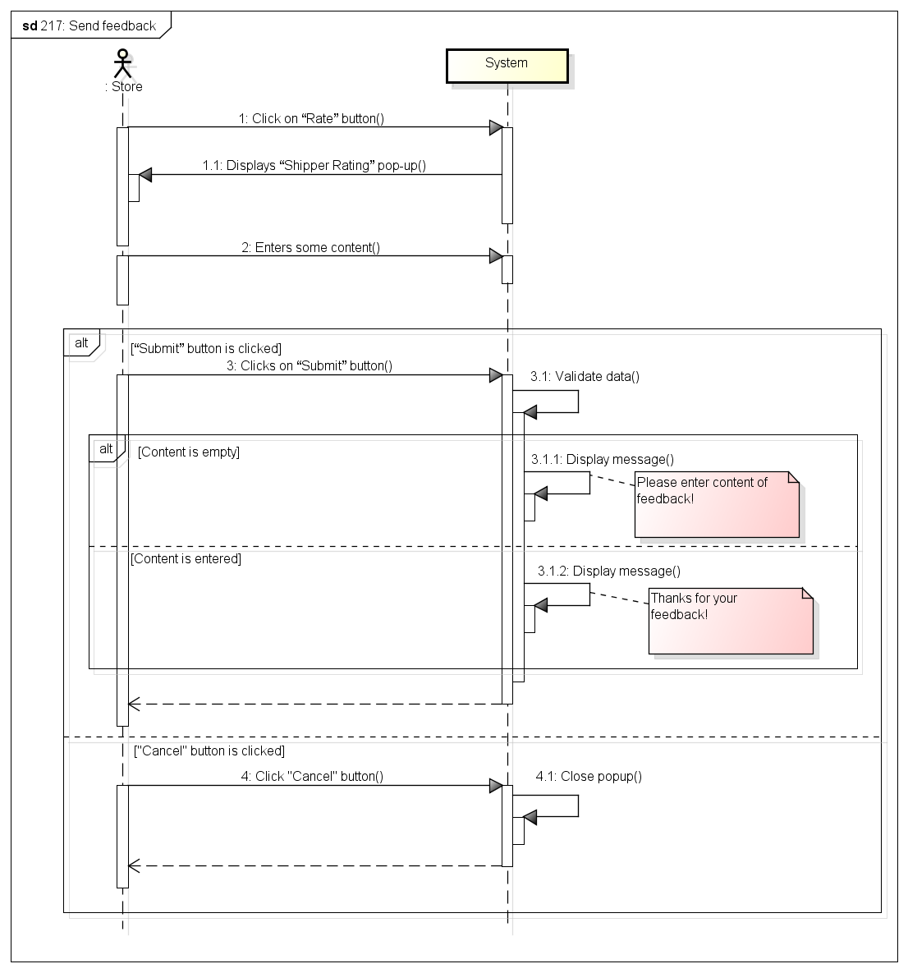

Figure 104: Sequence diagram for Send feedback screen

## 3.3. Mobile application for Shipper

### 3.3.1. User Case Diagram

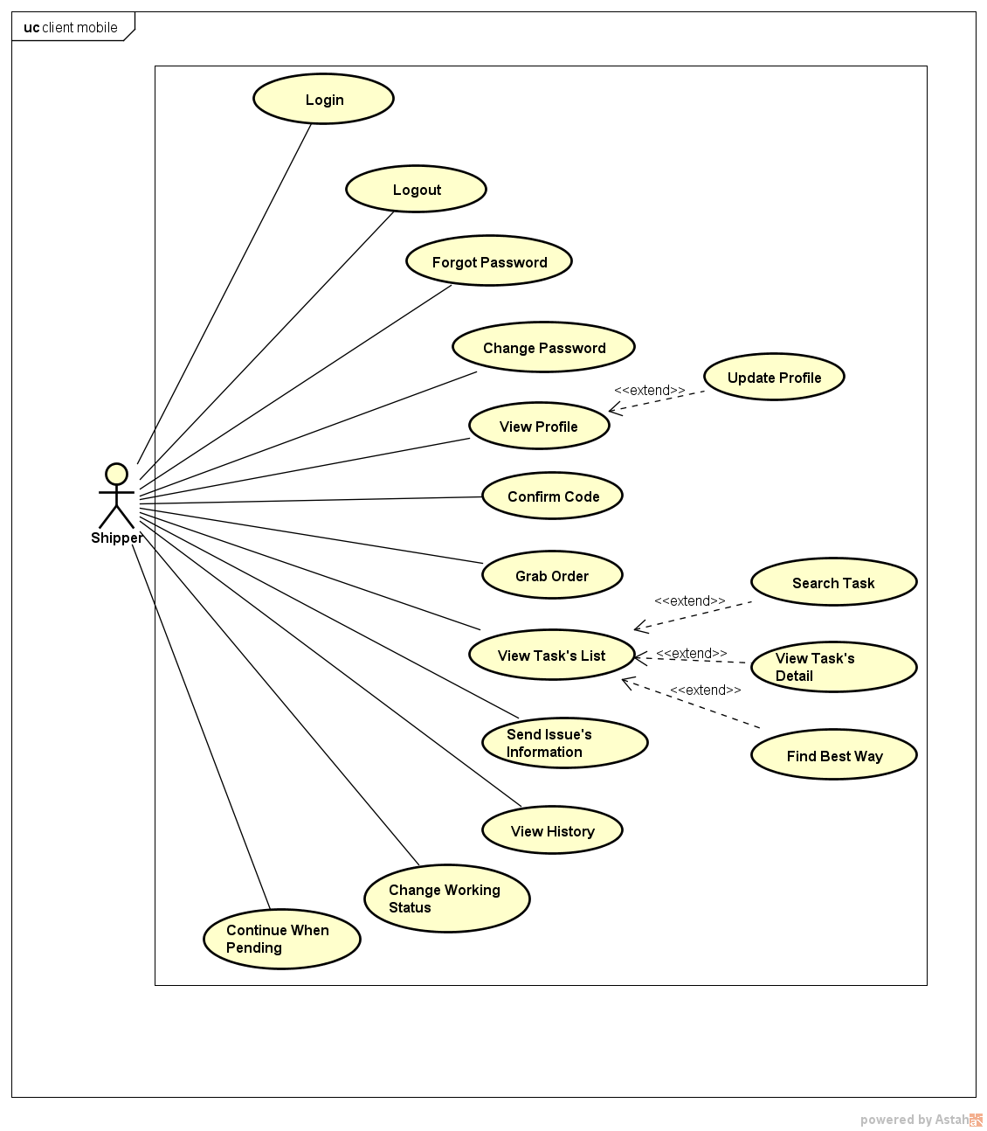

Figure 105: User case diagram for mobile application

### 3.3.2. Function

###### *UC-301:Login*

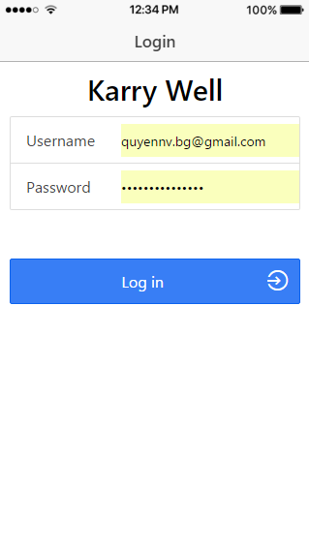

Figure 106:Shipepr Login screen

|  |  |  |  |  |
| --- | --- | --- | --- | --- |
| UseCaseID: | | UC-301 | | |
| UseCaseName: | | Login | | |
| CreatedBy: | | QuyenNV | Last UpdatedBy: | QuyenNV |
| Date Created: | | 19/09/2015 | DateLast Updated: | 02/10/2015 |
| Actor: | | Shipper | | |
| Description: | | System provides his or her access credentials in order to use system. | | |
| Triggering event | | Shipper wants to login to system. | | |
| Preconditions: | | - To be pre-registered in the System.  - Internet connection is established. | | |
| Post- conditions: | | The shipper’s token is store in local Storage | | |
| Priority: | | High | | |
| FrequencyofUse: | | Sometime | | |
| **Main flow** | | | | |
| Step | Actor | Action | | |
| 1 | Shipper | Tabs on application | | |
| 2 | System | Request the shipper input the following fields are available:  + Username  + Password | | |
| 3 | Shipper | Enter information (Username and Password). Shipper clicks on Log In and request api login(application program interface) | | |
| 4 | System | Queries to shipper database. | | |
| 5 | System | The system validates Username and Password to accept or rejects the login request. | | |
| 6 | System | Login successful into application. The login request is accepted shipper will be redirected to the Task’s list screen. | | |
| **Alternative Flows:** | | N/A | | |
| **Exceptions:** | | | | |
| EC1 | At step 4, If system cannot establish a connection to the database due to some reasons (ex: network failure). | | | |
| Step | Actor | | | |
| 4.1 | System | Display an error message “Your network connection failed. Please check your network connection and try again” will show up on screen to tell the shipper about the problem. | | |
| EC2 | At step 5, if account’s information is invalid | | | |
| Step | Actor | Action | | |
| 5.1 | System | Display an error message “ Username or Password is invalid. Try again.” on [Login] screen | | |
| **Includes:** | | N/A | | |
| **SpecialRequirements:** | | N/A | | |
| **Notes andIssues:** | | N/A | | |

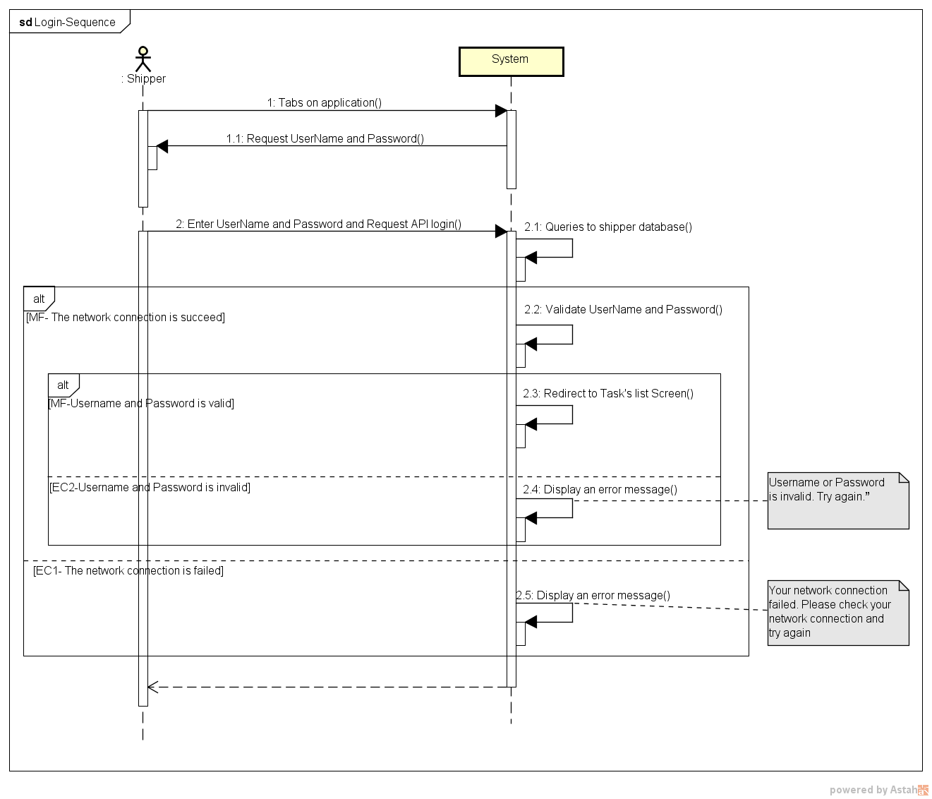

Figure 107: Sequence diagram for Shipper login user case

###### *UC-302:Logout*

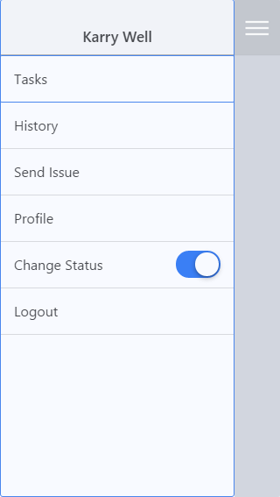

Figure 108: Shipper login screen

|  |  |  |  |  |
| --- | --- | --- | --- | --- |
| Use Case ID: | | UC-302 | | |
| Use Case Name: | | Logout | | |
| CreatedBy: | | QuyenNV | Last UpdatedBy: | QuyenNV |
| Date Created: | | 19/09/2015 | DateLast Updated: | 02/10/2015 |
| Actor: | | Shipper | | |
| Description: | | When shipper finish their work they will logout of the System. | | |
| Triggering event | | Shipper wants to logout of the system. | | |
| Preconditions: | | * To be logged in the system * Internet connection is established. | | |
| Post- conditions: | | * The connection to the server is terminated. | | |
| Priority: | | High | | |
| FrequencyofUse: | | Sometime | | |
| **Main flow** | | | | |
| Step | Actor | Action | | |
|  | Shipper | Clicks “log out” button. | | |
|  | System | Terminates the connection. Destroy token in Local storage of application. | | |
|  | System | Redirects to “Login” screen of application | | |
| **Alternative Flows:** | | N/A | | |
| **Exceptions:** | | N/A | | |
| **Includes:** | | N/A | | |
| **SpecialRequirements:** | | N/A | | |
| **Notes andIssues:** | | N/A | | |

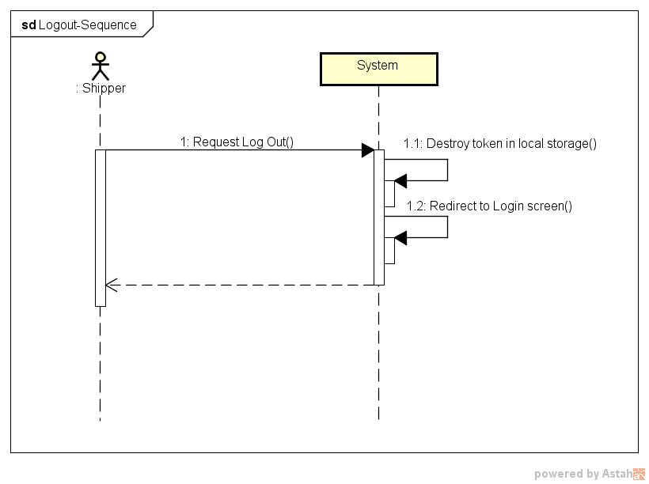**:**

Figure : Sequence diagram for Shipper logout user case

###### *UC-303:Forgot password*

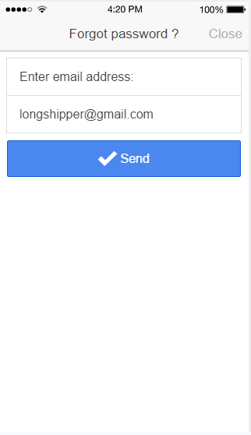

Figure 110: Forgot password screen

|  |  |  |  |  |
| --- | --- | --- | --- | --- |
| UseCaseID: | | UC-303 | | |
| UseCaseName: | | Forgot password | | |
| CreatedBy: | | QuyenNV | Last UpdatedBy: | QuyenNV |
| Date Created: | | 19/09/2015 | DateLast Updated: | 30/09/2015 |
| Actor: | | Shipper | | |
| Description: | | * When shipper wants to login into system but they forgot their password. Shipper wants reset their password. They will receive a new password via their email address. | | |
| Triggering event | | * Shipper forgot password and they wants to reset their password. | | |
| Preconditions: | | * To have internet connection through device. * Shipper haven’t logged in to the system yet. * On “Login” screen | | |
| Post- conditions: | | * New password is sent to email of shipper | | |
| Priority: | | High | | |
| FrequencyofUse: | | Sometime | | |
| **Main flow** | | | | |
| Step | Actor | Action | | |
|  | Shipper | Clicks “Forgot password” | | |
|  | System | A new page ‘Forgot password’ appears. | | |
|  | Shipper | Enter email address used for registration. Shipper clicks the [Send] button. | | |
|  | System | Validate Email Address. | | |
|  | System | Send new password via email address of shipper | | |
|  | System | The page is refreshed. The message is displayed: “New passwords has been sent to your email” | | |
| **Alternative Flows:** | | N/A | | |
| **Exceptions:** | | | | |
| EC1 | At step 4, if email is invalid | | | |
| Step | Actor | Action | | |
| 4.1 | System | Notify in screen with error message “Your email is invalid. Please enter try again.” | | |
| **Includes:** | | N/A | | |
| **SpecialRequirements:** | | **Email Address:** A string from 1 to 244 characters in length, can contain any kind of characters, followed by “@gmail.com”. (Ex: longshipper@gmail.com). Cannot be null. | | |
| **Notes andIssues:** | | N/A | | |

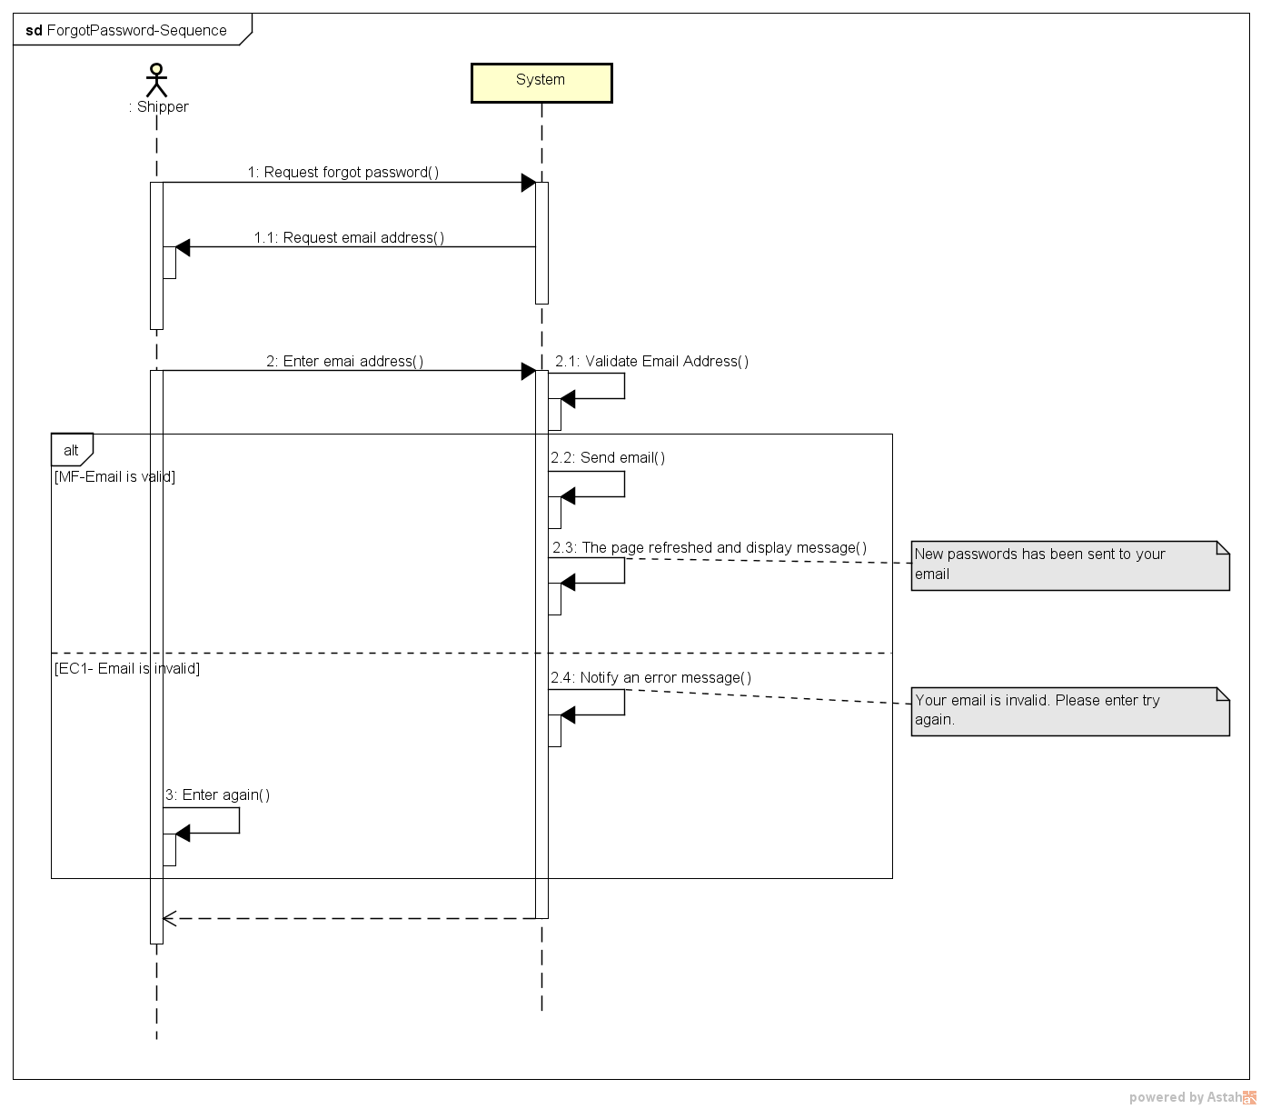

Figure : Sequence diagram for Shipper change password user case

###### *UC-304:Change password*

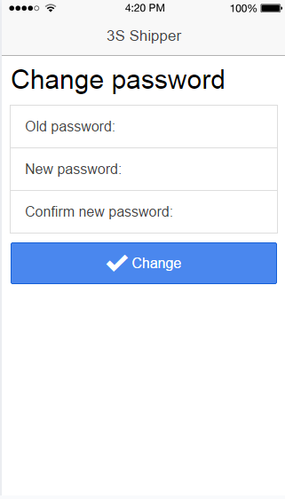

Figure 112: Change password screen

|  |  |  |  |  |
| --- | --- | --- | --- | --- |
| UseCaseID: | | UC-304 | | |
| UseCaseName: | | Change password | | |
| CreatedBy: | | QuyenNV | Last UpdatedBy: | QuyenNV |
| Date Created: | | 19/09/2015 | DateLast Updated: | 30/09/2015 |
| Actor: | | Shipper | | |
| Description: | | If shipper forgot their password and would like to change their password for security reasons. | | |
| Triggering event | | Shipper wants to change password. | | |
| Preconditions: | | * To have internet connection through device * To be logged in the system * Switch to “Profile” screen | | |
| Post- conditions: | | * New password stored in database. Shipper changes password is successfully | | |
| Priority: | | High | | |
| FrequencyofUse: | | Sometime | | |
| **Main flow** | | | | |
| Step | Actor | Action | | |
|  | Shipper | Clicks “Change Password” button | | |
|  | System | “Change Password” screen shows up. | | |
|  | Shipper | Enter required information (Old Password, new password, confirm new password) and clicks “Change” button. | | |
|  | System | Validate input information. | | |
|  | System | Update new password of this account to database and redirects to the “Profile” screen. | | |
| **Alternative Flows:** | | N/A | | |
| **Exceptions:** | | | | |
| EC1 | At step 4, if any field is incorrect format or blank | | | |
| Step | Actor | Action | | |
| 4.1 | System | Notify in screen with a message “Please fill out all field” on “Change Password” screen. | | |
| EC2 | At step 4, if shipper provides new password doesn’t match the confirm password | | | |
| Step | Actor | Action | | |
| 4.1 | System | Display an error message “Password doesn't match the confirmation” on “Change password” screen. | | |
| **Includes:** | | N/A | | |
| **SpecialRequirements:** | | **Old Password:** Cannot be null.  **New Password:** Minimum of password is 7 character and needs at least one number.  **Re-Enter Password**: Cannot be null. | | |
| **Notes andIssues:** | | N/A | | |

:

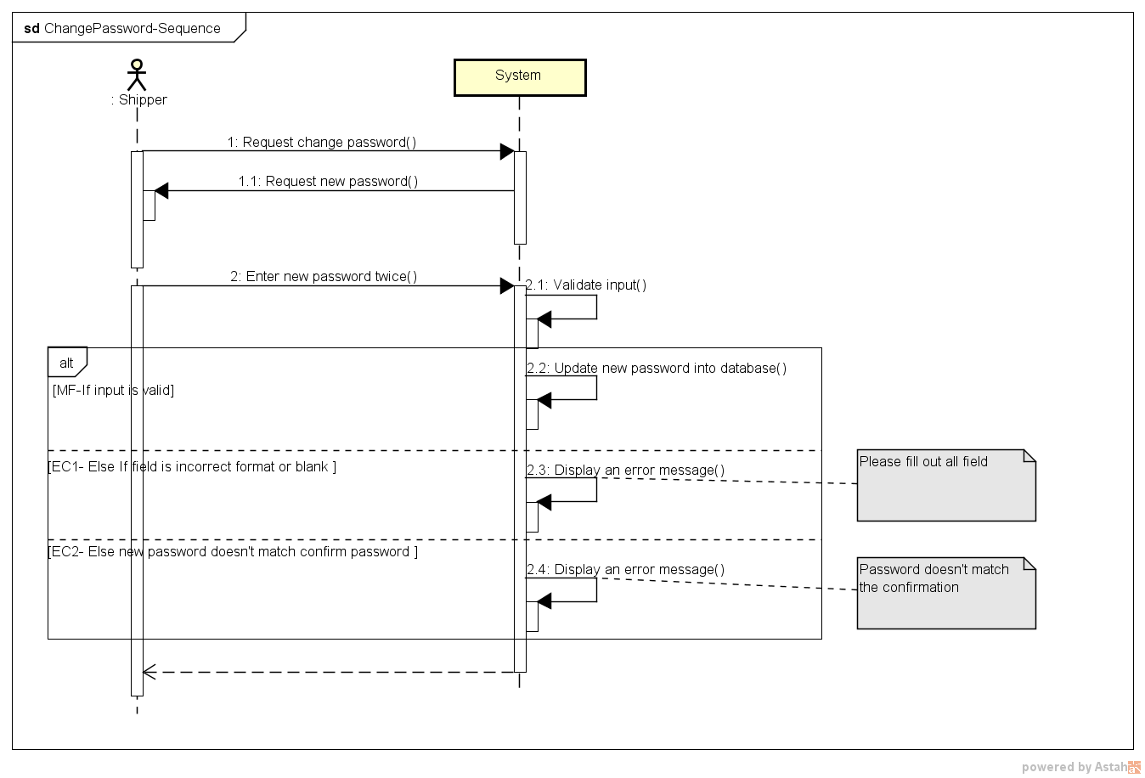

###### *UC-305:View Profile*

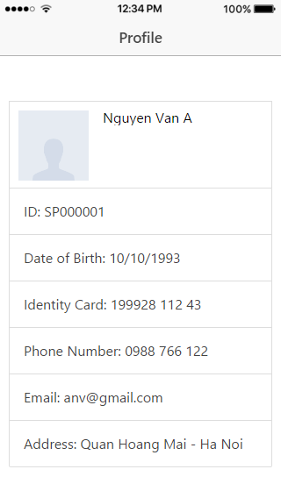

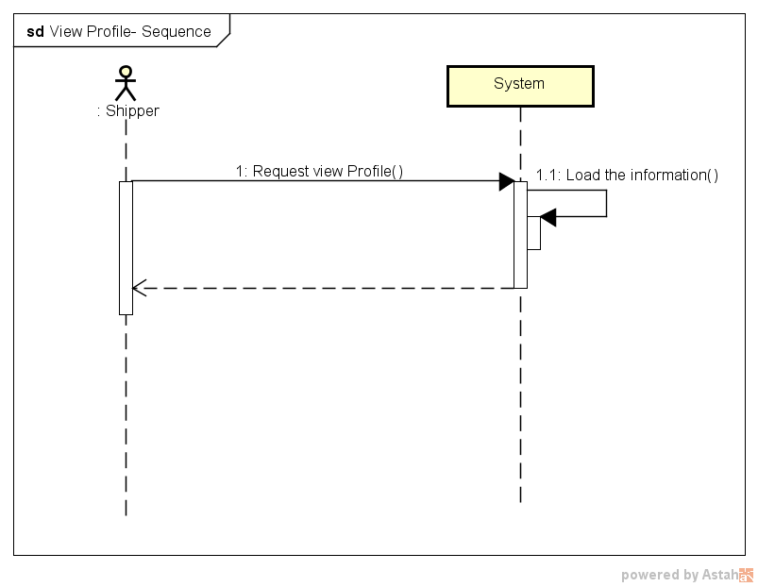

|  |  |  |  |  |
| --- | --- | --- | --- | --- |
| **Use Case ID:** | | UC-005 | | |
| **Use Case Name:** | | View Profile | | |
| **CreatedBy:** | | QuyenNV | **Last UpdatedBy:** | QuyenNV |
| **Date Created:** | | 19/09/2015 | **DateLast updated:** | 30/09/2015 |
| **Actor:** | | Shipper | | |
| **Description:** | | Shipper can view his/her information. Such as Name, Date of Birth, Identity Card, Phone Number, Email, Address. | | |
| **Triggering event** | | Shipper wants to view Profile | | |
| **Preconditions:** | | * To have internet connection through a device * To be logged in the system | | |
| **Post conditions:** | | The information of current logged in will appear in the ‘Profile’ screen. | | |
| **Priority:** | | High | | |
| **FrequencyofUse:** | | Sometime | | |
| **Main flow** | | | | |
| Step | Actor | Action | | |
| 1 | Shipper | Clicks “Profile” button in left navigate bar | | |
| 2 | System | Load information of shipper and Display “Profile” screen | | |
| **Alternative Flows:** | | **N/A** | | |
| **Exceptions:** | | | | |
| **Includes:** | | N/A | | |
| **SpecialRequirements:** | | N/A | | |
| **Notes andIssues:** | | N/A | | |

Figure : Sequence diagram for Shipper view profile user case

###### *UC-306:Update Profile*

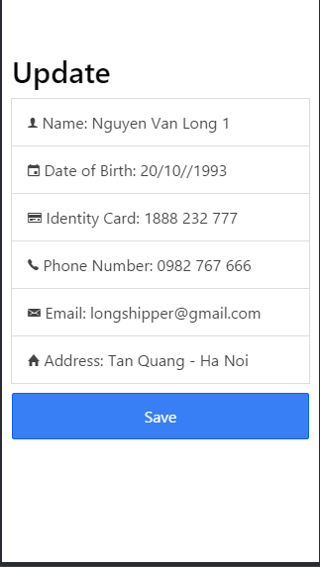

Figure 114: Update profile screen

|  |  |  |  |  |
| --- | --- | --- | --- | --- |
| **Use Case ID:** | | UC-006 | | |
| **Use Case Name:** | | Update Profile | | |
| **CreatedBy:** | | QuyenNV | **Last UpdatedBy:** | QuyenNV |
| **Date Created:** | | 19/09/2015 | **DateLast updated:** | 30/09/2015 |
| **Actor:** | | Shipper | | |
| **Description:** | | When Shipper change personal information. They can modify their related information (Email, Date of Birth, Phone Number, Identity Card, Address) | | |
| **Triggering event** | | Shipper wants to update profile | | |
| **Preconditions:** | | * To have internet connection through a device * To be logged in the system * Switch to [Profile] screen. | | |
| **Post conditions:** | | Update new information in database. Update Profile is successfully. | | |
| **Priority:** | | Low | | |
| **FrequencyofUse:** | | Sometime | | |
| **Main flow** | | | | |
| Step | Actor | Action | | |
| 1 | Shipper | Clicks [Edit Profile] button | | |
| 2 | System | Display [Edit profile] screen | | |
| 3 | Shipper | Enter required information (Name, Email, Phone Number, Identity Card, Date of Birth, Address) | | |
| 5 | System | Validate input | | |
| 6 | System | Store new information of Shipper into database | | |
| 7 | System | Display an success message “Your profile has been updated successfully” | | |
| **Alternative Flows:** | | **N/A** | | |
| **Exceptions:** | | | | |
| EC1 | At step 5 | If any required field is not entered | | |
| Step | Actor | Action | | |
| 5.1 | System | Notify an error message “*is require” | | |
| **Includes:** | | N/A | | |
| **SpecialRequirements:** | | N/A | | |
| **Notes andIssues:** | | N/A | | |

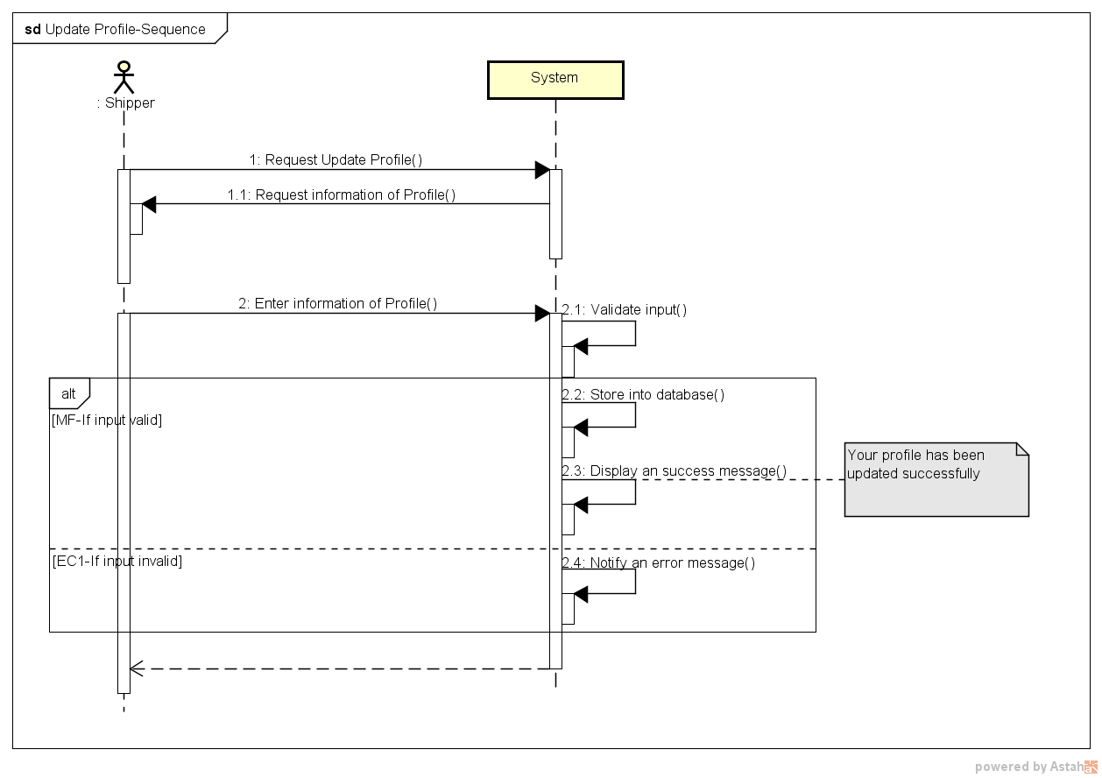

Figure 115: Sequence diagram for Shipper update profile user case

###### *UC-307:Confirm Code*

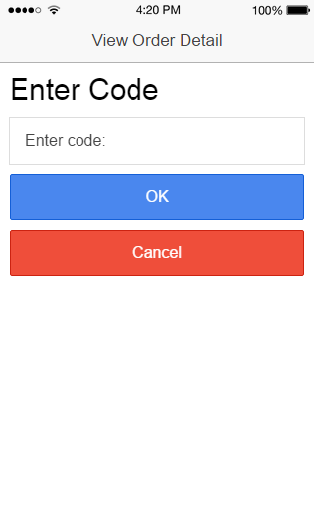

Figure 116: Confirm code screen

|  |  |  |  |  |
| --- | --- | --- | --- | --- |
| **Use Case ID:** | | UC-007 | | |
| **Use Case Name:** | | Confirm code | | |
| **CreatedBy:** | | QuyenNV | **Last UpdatedBy:** | HuyTDH |
| **Date Created:** | | 19/09/2015 | **DateLast updated:** | 30/10/2015 |
| **Actor:** | | Shipper | | |
| **Description:** | | When a task was given to a shipper, the shipper has responsibility to change order status at the end of each step in their task schedule.  In case when the shipper comes to pick up order, gives goods to customer or takes goods into or out from stock, he/she has to provide respective confirmation codes – which are automatically generated by system. These code are generated when the store creates an order.  Using a confirmation code to avoid mistakes in picking up, delivering, or checking in, out stock. | | |
| **Triggering event** | | Shipper wants to confirm with store, stock manager or customer that he has done a step in his task (picking up; check in, check out stock; giving goods to customer) | | |
| **Preconditions:** | | * To have internet connection through a device * To be logged in the system * Shipper is on [View Task’s Details] screen. | | |
| **Post conditions:** | | The order is moved to next step of task schedule | | |
| **Priority:** | | High | | |
| **FrequencyofUse:** | | Always | | |
| **Main flow** | | | | |
| Step | Actor | Action | | |
| 1. | Shipper | Clicks [Check Code “ABC”] button, with “ABC” is the current status of order | | |
| 2. | System | Displays [Enter Code] pop-up | | |
| 3. | Shipper | Enters code which be provided by the store and clicks “Enter” button. | | |
| 4. | System | Queries the Order database to confirm that was right code for this status of this order and if this shipper is the one who has responsibility to this task. | | |
| 5. | System | Display an success message pop-up on [View Task’s Details] screen | | |
| **Alternative Flows:** | | **N/A** | | |
| **Exceptions:** | | | | |
| EC1 | At step 2, if Shipper doesn’t enter confirmation code. | | | |
| Step | Actor | Action | | |
| 2.1 | Shipper | Taps on “Cancel” button | | |
| 2.2 | System | Hide check code pop-up and displays “View Task’s Detail” screen | | |
| EC2 | At step 4, if code does not exist in database or the system cannot establish a connection to the database due to some reasons (ex: network failure). | | | |
| Step | Actor | Action | | |
| 4.1 | System | An error message “Wrong code” will be showed up on screen to tell the shipper about the problem. | | |
| 4.2 | Shipper | Tabs on [‘Ok’] button | | |
| 4.3 | System | Hides the message | | |
| EC3 | At step 4, Order cannot establish a connection to the database due to some reasons (ex: network failure). | | | |
| Step | Actor | Action | | |
| 4.1 | System | Display a popup message “Something went wrong! Try again” will show up on screen to tell the shipper about the problem. | | |
| **Includes:** | | N/A | | |
| **SpecialRequirements:** | | N/A | | |
| **Notes andIssues:** | | N/A | | |

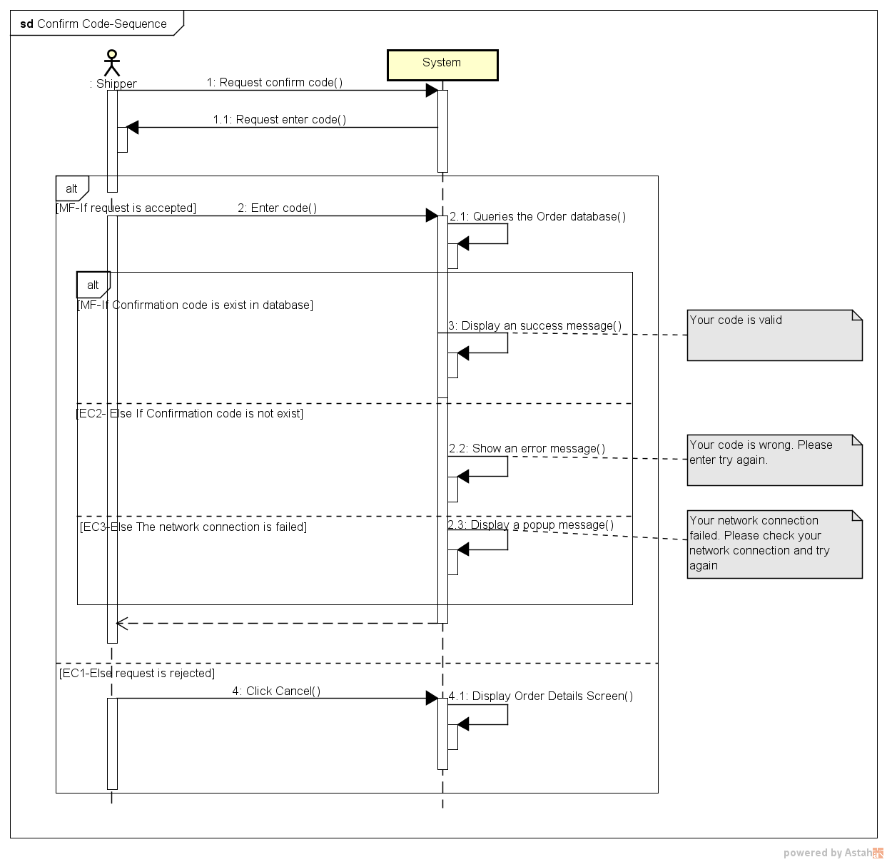

Figure 117: Sequence diagram for Shipper confirm code user case

###### *UC-308:Grab order*

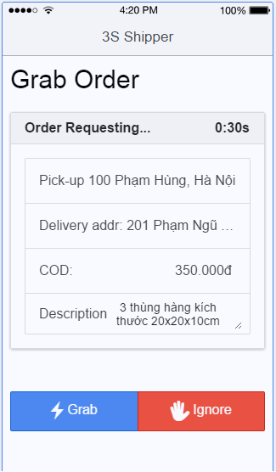

Figure 118: Grap order screen

|  |  |  |  |  |  |  |
| --- | --- | --- | --- | --- | --- | --- |
| **Use Case ID:** | | | UC308 | | | |
| **Use Case Name:** | | | Grab order | | | |
| **Created By:** | | | HuyTDH | | **Last UpdatedBy:** | HuyTDH |
| **Date Created:** | | | 19/09/20155 | | **DateLast updated:** | 08/10/2015 |
| **Actor:** | | | Shipper | | | |
| **Description:** | | | When the sever concurrently sends shipping order to 5 shippers, the shipper who grabs order at the earliest time will take that order into his in working list | | | |
| **Triggering Event:** | | | Server sends shipping request to that shipper | | | |
| **Pre-conditions:** | | | Shipper logged in, internet connection is on, shipper’s current active task less than 3, system is requesting to ship order | | | |
| **Post-conditions:** | | | The order has been added to shipper’s task list with status is active and task type is express. | | | |
| **Priority:** | | | High | | | |
| **Frequency of Use:** | | | Often | | | |
| **Main flow** | | | | | | |
| Step | Actor | | Action | | | |
|  | System | | Sends shipping request to shipper’s app | | | |
|  | Shipper | | Tabs on button “Grab” to take the order | | | |
|  | System | | Validates whether the shipping that request has been taken by another shipper or not | | | |
|  | System | | Displays message “You just grab a new order!” | | | |
|  | System | | Adds order to shipper’s task | | | |
|  | System | | Disables this request to other shippers | | | |
| **Alternative:** | | | | | | |
| N/A | | | | | | |
| **Exceptions:** | | | | | | |
| EC1 | | Shipper ignores request at step 2 | | | | |
| Step | | Actor | | Action | | |
| 2.1 | | Shipper | | Tabs on button “Ignore” | | |
| 2.2 | | System | | Shows confirm box | | |
|  | | Shipper | | Confirms to ignore | | |
|  | | System | | Shows warning “You have ignored x order(s) today!” | | |
| EC2 | | Shipper tabs on button “Grab” later than another shipper at step 2 | | | | |
| Step | | Actor | | Action | | |
| 2.1 | | Shipper | | Tabs on “Grab” | | |
| 2.2 | | System | | Shows message “Store STxxxxxx has found another shipper or canceled order” | | |
| **Includes:** | | | N/A | | | |
| **SpecialRequirements:** | | | Shipper who receives shipping request is in top 5 nearest available ones from the store of that order. | | | |
| **Notes and Issues:** | | | N/A | | | |

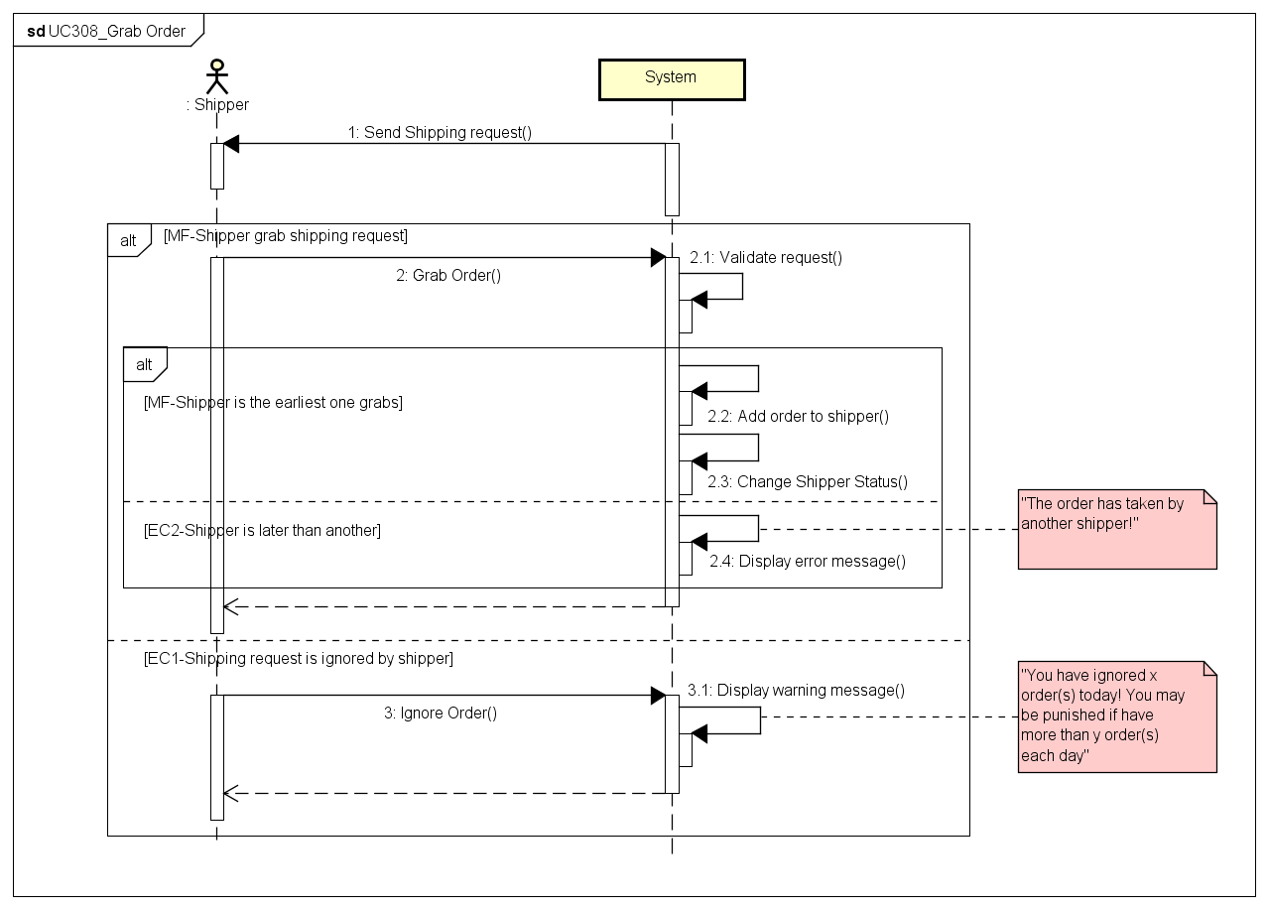

Figure 119: Sequence diagram for Shipper grap order user case

###### *UC309: View Task’s List*

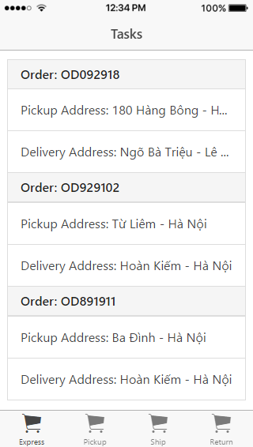

Figure 120: View task list screen

|  |  |  |  |  |
| --- | --- | --- | --- | --- |
| **Use Case ID:** | | UC309 | | |
| **Use Case Name:** | | View tasks list | | |
| **CreatedBy:** | | HuyTDH | **Last UpdatedBy:** | QuyenNV |
| **Date Created:** | | 19/09/2015 | **DateLast updated:** | 02/10/2015 |
| **Actor:** | | Shipper | | |
| **Description:** | | Shipper sees the list of his in-working tasks (all of his Active or Inactive of tasks will be displayed here) | | |
| **Triggering Event:** | | Shipper wants to see all tasks that he has to do | | |
| **Preconditions:** | | Shipper logged in and shipper doesn’t have issue. | | |
| **Post conditions:** | | List in-working tasks of shipper is showed. | | |
| **Priority:** | | High | | |
| **FrequencyofUse:** | | Always | | |
| **Main flow** | | | | |
| Step | Actor | Action | | |
|  | Shipper | Expands menu bar and tabs on “Tasks” | | |
|  | System | Check Shipper’s issue | | |
|  | System | Get list task of shipper from database | | |
|  | System | Shows list tasks as list item, by tab (Express, Pickup, Ship, Return) includes content:   * Order code * Task status * Pickup address * Delivery address | | |
| **Alternative Flows:** | | | | |
| AT1 | At step 2 of main flow:  If shipper has issue then display ‘continue’ screen from task. | | | |
| Step | Actor | Action | | |
| 1.1 | System | Display ‘continue’ screen | | |
|  |  | Go to use case: ‘UC316: Continue when pending’ | | |
| **Exceptions:** | | | | |
|  | | | | |
| **Includes:** | | N/A | | |
| **SpecialRequirements:** | | N/A | | |
| **Notes andIssues:** | | At step 4: Current tasks of shipper is empty then displays message ‘No Task’ in Tasks Screen | | |

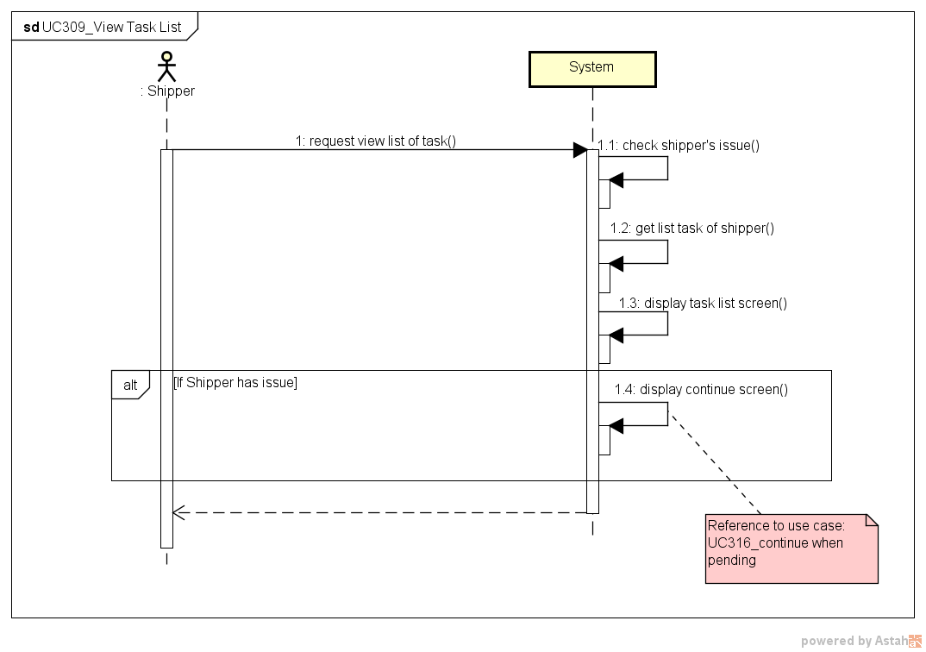

Figure : Sequence diagram for Shipper view task list user case

###### *UC310: Search Order*

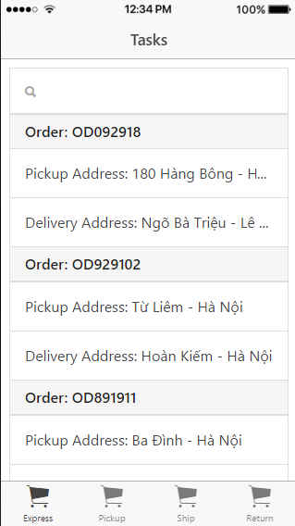

Figure 122: Search order screen

|  |  |  |  |  |  |  |
| --- | --- | --- | --- | --- | --- | --- |
| **Use Case ID:** | | | UC310 | | | |
| **Use Case Name:** | | | Search order | | | |
| **CreatedBy:** | | | HuyTDH | | **Last UpdatedBy:** | HuyTDH |
| **Date Created:** | | | 19/09/2015 | | **DateLast updated:** | 25/09/2015 |
| **Actor:** | | | Shipper | | | |
| **Description:** | | | Shipper enters full or a part of order code to search order(s) from list of many orders. | | | |
| **Triggering Event:** | | | Shipper want to find a specific order(s) by code | | | |
| **Preconditions:** | | | Shipper on View Orders List: UC309 (See above) | | | |
| **Post conditions:** | | | Orders that match search condition will be displayed | | | |
| **Priority:** | | | Normal | | | |
| **FrequencyofUse:** | | | Sometimes | | | |
| **Main flow** | | | | | | |
| Step | Actor | | Action | | | |
|  | Shipper | | Goes to “View orders list” screen (refer to UC309 View order list) | | | |
|  | Shipper | | Types order’s code to search box | | | |
|  | System | | Filters orders data from current list | | | |
|  | System | | Displays all in-working orders that match with search key | | | |
| **Alternative Flows:** | | | | | | |
| **Exceptions:** | | | | | | |
| EC1 | | There’s no order matches with code which is entered by shipper | | | | |
| Step | | Actor | | Action | | |
| 3.1 | | System | | Displays info message “There’s no order matches with your code” | | |
| **Includes:** | | | N/A | | | |
| **SpecialRequirements:** | | | Order code has format **ODxxxxxx** but shipper no need to enter **OD** prefix of code Case insensitive search | | | |
| **Notes andIssues:** | | | Code format will be defined in the later phrase | | | |

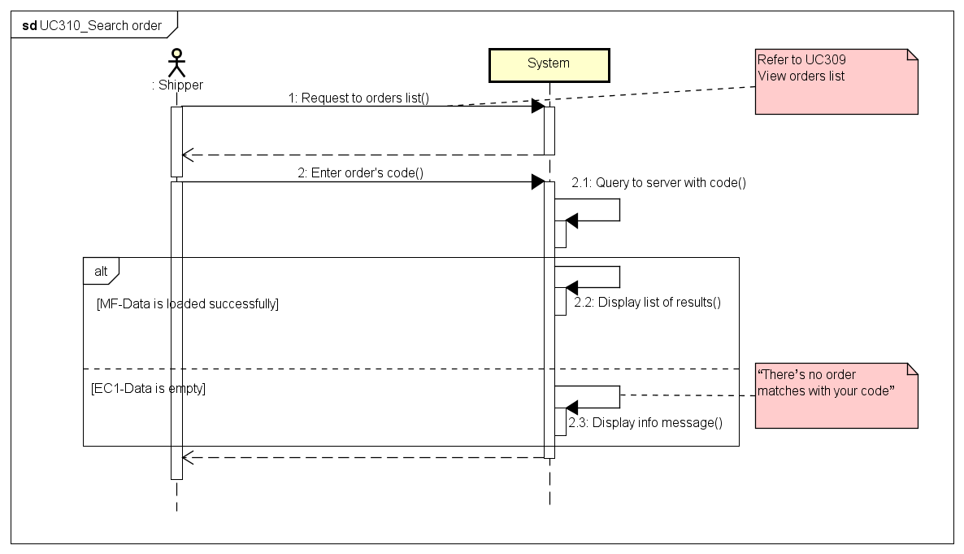

Figure : Sequence diagram for Shipper search order user case

###### *UC311: View Task’s Detail*

**Mockup Design**



Figure 124: View task detail screen

|  |  |  |  |  |
| --- | --- | --- | --- | --- |
| **Use Case ID:** | | UC311 | | |
| **Use Case Name:** | | View order’s detail | | |
| **CreatedBy:** | | HuyTDH | **Last UpdatedBy:** | HuyTDH |
| **Date Created:** | | 19/09/2015 | **DateLast updated:** | 08/10/2015 |
| **Actor:** | | Shipper | | |
| **Description:** | | Shipper views detail information of an order. This order could be selected from “Tasks List” screen or from “Working History” screen of the shipper. | | |
| **Triggering Event:** | | Shipper wants to see order’s detail information | | |
| **Preconditions:** | | Shipper is on list orders screen or working history screen | | |
| **Post conditions:** | | Detail information of that order is displayed | | |
| **Priority:** | | High | | |
| **FrequencyofUse:** | | Always | | |
| **Main flow** | | | | |
| Step | Actor | Action | | |
|  | Shipper | Enters “**In-Working Tasks**” screen (Refer to UC309 above) | | |
|  | Shipper | Tabs on an task from the list | | |
|  | System | Loads detail info of that order from server | | |
|  | System | Displays the detail information of order, includes:   * Google Map * Task schedule progress bar * Order code * Order status * Recipient (name and phone) * Pick-up address * Pick-up date * Stock * Delivery address * Delivery date * COD (cast on delivery amount) * Fee (shipping fee) * Goods information * A button to change order status to next status in this task schedule   *Notes:*   * If task type is picking up, don’t show the delivery information (Recipient, Delivery address and date) * When the task is done, the button at the bottom of screen will be removed. | | |
| **Alternative Flows::** | | | | |
| AT1 | Shipper views detail from history: | | | |
| Step | Actor | Action | | |
| 1.1 | Shipper | Accesses “History” screen | | |
| 1.2 | Shipper | Tabs on an order from the list | | |
|  |  | Go to step 3 of main flow | | |
| **Exceptions:** | | | | |
| N/A | | | | |
| **Includes:** | | N/A | | |
| **SpecialRequirements:** | | N/A | | |
| **Notes andIssues:** | | N/A | | |

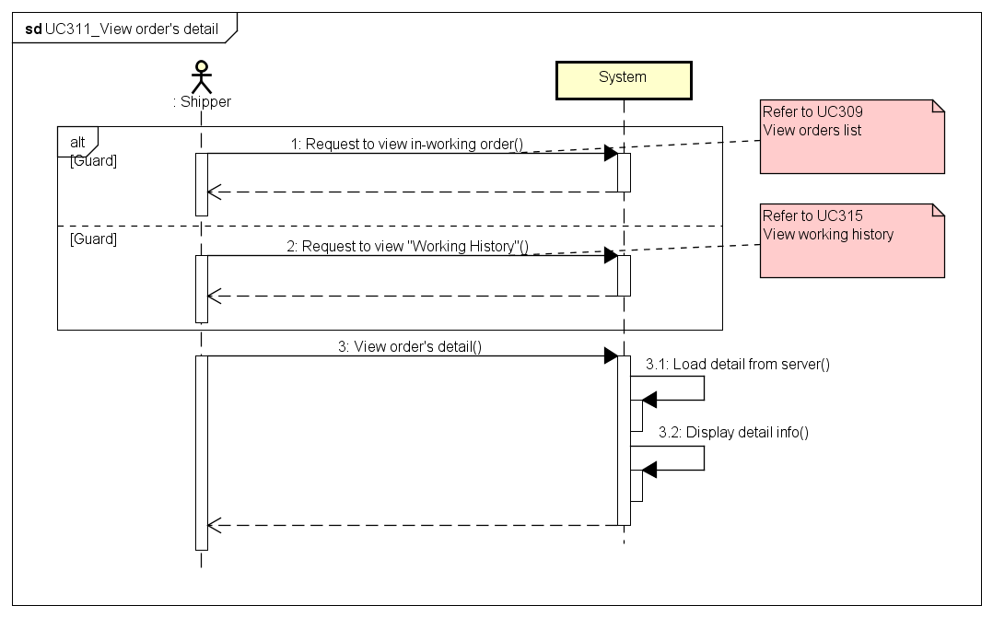

Figure 125: Sequence diagram for view task detail user case

###### *UC312: Find Best Way*

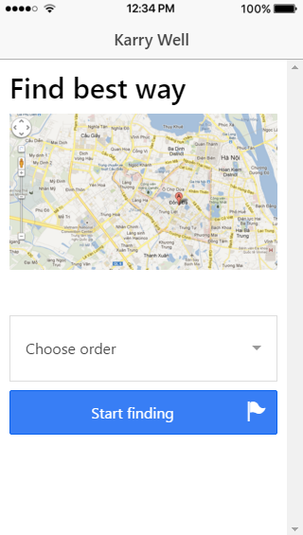

Figure 126: Find best way screen

|  |  |  |  |  |
| --- | --- | --- | --- | --- |
| **Use Case ID:** | | UC312 | | |
| **Use Case Name:** | | Find best way | | |
| **CreatedBy:** | | HuyTDH | **Last UpdatedBy:** | HuyTDH |
| **Date Created:** | | 19/09/2015 | **DateLast updated:** | 25/09/2015 |
| **Actor:** | | Shipper | | |
| **Description:** | | Shipper uses KaryWell system to find out the shortest way to go to destinations. A path, which goes through all the selected descriptions and has least duration, will be drawn on the map. | | |
| **Triggering event:** | | Shipper wants to find best way to go for his in-working orders. | | |
| **Preconditions:** | | Shipper logged in  Internet connection is on  GPS is on | | |
| **Post conditions:** | | The shortest way that go through all selected destinations will be displayed on map. | | |
| **Priority:** | | High | | |
| **FrequencyofUse:** | | Always | | |
| **Main flow** | | | | |
| Step | Actor | Action | | |
|  | Shipper | Selects “Find best way” from menu | | |
|  | System | Shows “Find best way” screen, includes:   * Google map * Destinations select box * “Find” button | | |
|  | Shipper | Chooses one or all destinations | | |
|  | Shipper | Tabs on “Find” | | |
|  | System | Call Google API to get the best way | | |
|  | System | Displays the shortest way to destinations on the map | | |
| **Alternative Flows:** | | N/A | | |
| **Exceptions:** | | | | |
| EC1 | At step 1 if GPS is off | | | |
| Step | Actor | Action | | |
| 1.1 | System | System displays message “Please turn on GPS and retry” | | |
| 1.2 | Shipper | Shipper turn on GPS | | |
|  | | Go to step 2 of main flow | | |
| **Includes:** | | N/A | | |
| **SpecialRequirements:** | | Shipper can choose <= 7 destinations | | |
| **Notes andIssues:** | | N/A | | |

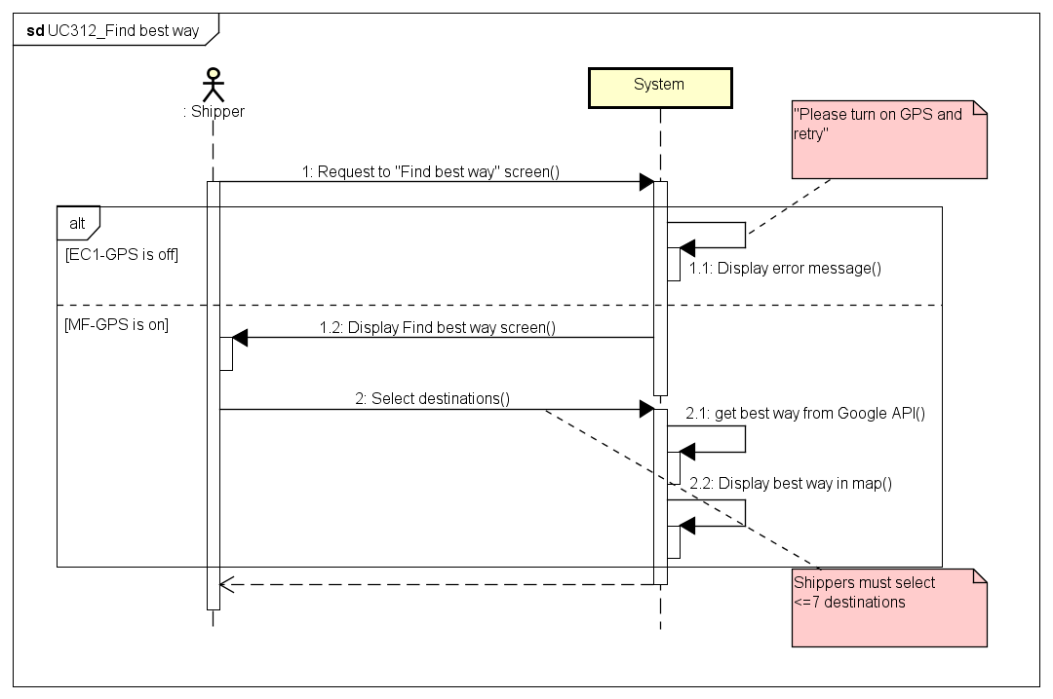

Figure : Sequence diagram for Find best way user case

###### *UC313 Send Issue’s Information*

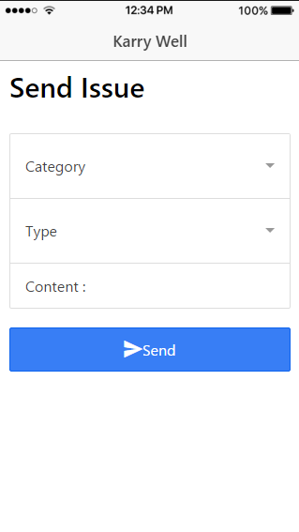

Figure 128: Send issue screen

|  |  |  |  |  |
| --- | --- | --- | --- | --- |
| **Use Case ID:** | | UC313 | | |
| **Use Case Name:** | | Send issue’s information | | |
| **CreatedBy:** | | HuyTDH | **Last UpdatedBy:** | QuyenNV |
| **Date Created:** | | 19/09/2015 | **DateLast updated:** | 04/10/2015 |
| **Actor:** | | Shipper | | |
| **Description:** | | Shipper sends issues to Adminto solve. Issue’s content will contain the most important information such as category(Pending, Cancel) of issue and type(Vehicle, Accident, Other, …) of issue., the orders which this issue influents and a short description from shipper. | | |
| **Triggering Event:** | | Shipper got issues and need to send to Admin. | | |
| **Preconditions:** | | Shipper logged in and shipper | | |
| **Post conditions:** | | Issue has been sent to Admin notification about issue has been display in admin’s screen and store’s screen.  A ‘Continue’ screen will appear with message: ‘Your task is pending. Click 'Continue' to continue’ | | |
| **Priority:** | | High | | |
| **FrequencyofUse:** | | Sometimes | | |
| **Main flow** | | | | |
| Step | Actor | Action | | |
|  | Shipper | Chooses “Send Issue” from Menu or Icon link to Issue screen on the right of header bar. | | |
|  | System | Displays “Send Issue Box”, includes:   * “Issue Category” selected box (Pending, Cancel) * “Issue type” selected box (Traffic jam, Vehicle, Accident, Other, Good is broken, cannot contact with customer) * “Order” multi-selected box | | |
|  | Shipper | Chooses “Issue Category”, “Issue Type”, types “Content” and could select one or all of his in-working orders. | | |
|  | Shipper | Tabs on “Send” | | |
|  | System | Shows message “Issue has sent to system. Wait for Admin to resolve” | | |
|  | System | Sends notification to admin about issue | | |
| **Alternative Flows:** | | N/A | | |
| AT1 | At step 3 of main Flow:  + If shipper chooses ‘Issue Category’ is ‘Pending’ then ‘Issue Type’ are list of reason (Traffic jam, Vehicle, Accident, Other) and doesn’t appear ‘Order’ multi-selected box.  + If shipper chooses ‘Issue Category’: ‘Cancel’ and ‘Issue Type’ are list of reason (Good is broken, cannot contact to customer) and appear ‘Order’ multi-selected box. | | | |
| AT2 | At step 4 of main Flow:  + If shipper chooses category of issue is ‘Pending’ then display ‘continue’ screen after send issue. Go to use case: ‘UC316: Continue when pending’ | | | |
| **Exceptions:** | | | | |
| EC1 | At step 3, shipper doesn’t enter about Category, Type, Order, Content | | | |
| Step | Actor | Action | | |
| 1.1 | System | System alert popup with a message depends on the fields Refer Note and Issues (Popup message). | | |
| 1.2 | Shipper | Shipper re-enter information | | |
|  | | Go to step 4 of main flow | | |
| **Includes:** | | N/A | | |
| **SpecialRequirements:** | | N/A | | |
| **Notes andIssues:** | | - Popup message:  + Category: ‘Please choose category’  + Type: ‘Please choose reason’  + Order: ‘Please choose order’  + Content: ‘Please write content’  - The content of Issue should have 30 - 250 characters  - If type of Issue is ‘Good is broken’ then list of order include:  + ‘Ship’ tab and status of task is Delivering on Task screen.  + ‘Return’ tab and status of task is Delivering on Task screen.  + ‘Express’ tab and status of task is Delivering on Task screen.  - If type of Issue is: ‘Cannot contact with customer’ then list of order include:  + ‘Ship’ tab and status of task is Delivering of Task screen. | | |
|  | |  | | |

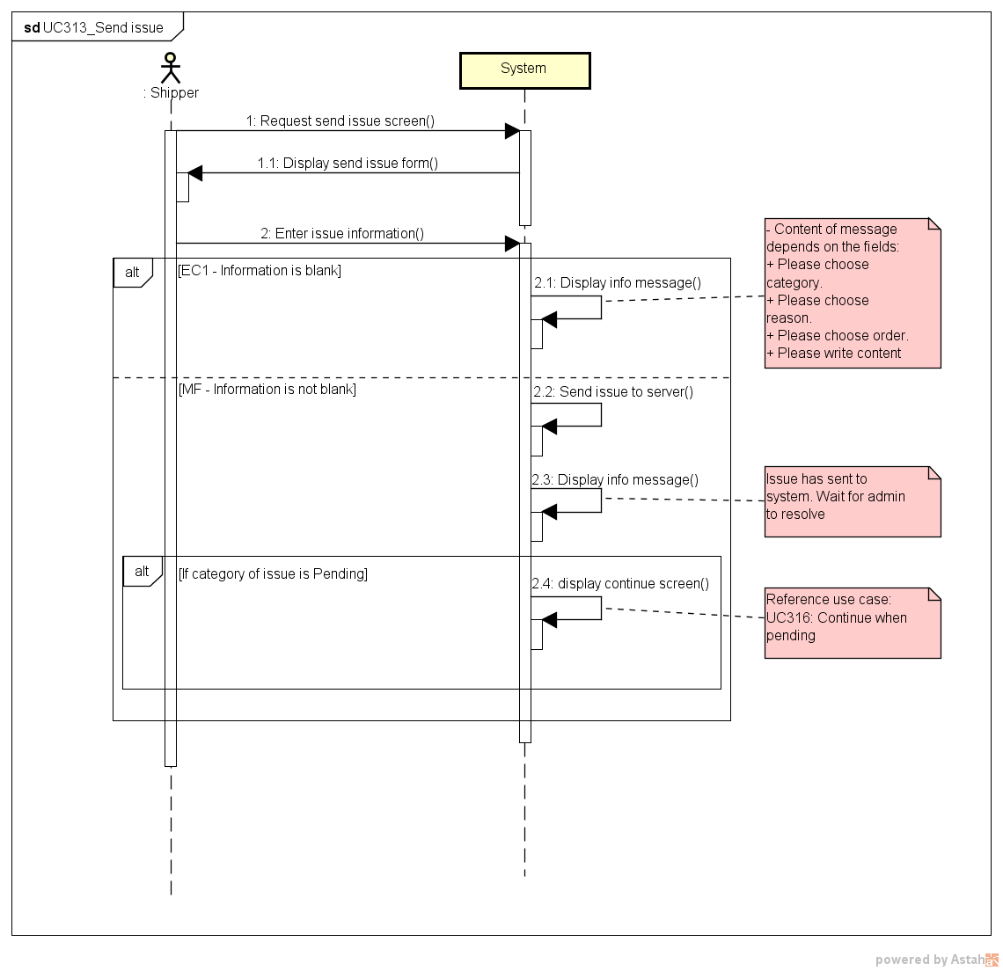

Figure : Sequence diagram for Send issue user case

###### *UC314 Change Working Status*



Figure 130: Change working status screen

|  |  |  |  |  |
| --- | --- | --- | --- | --- |
| **Use Case ID:** | | UC314 | | |
| **Use Case Name:** | | Change status | | |
| **CreatedBy:** | | HuyTDH | **Last UpdatedBy:** | HuyTDH |
| **Date Created:** | | 19/09/2015 | **DateLast updated:** | 02/10/2015 |
| **Actor:** | | Shipper | | |
| **Description:** | | Shipper changes his working status “On working” / “Away”. The system will depend on this status to decide to send shipping request to the shipper or not. | | |
| **Triggering Event:** | | Shipper want to switch his status between ready to work or not ready. | | |
| **Preconditions:** | | Shipper logged in  To have internet connection via device | | |
| **Post conditions:** | | Working status switched to “On” / ”Off” | | |
| **Priority:** | | Normal | | |
| **FrequencyofUse:** | | Sometimes | | |
| **Main flow** | | | | |
| Step | Actor | Action | | |
|  | Shipper | Shipper expands menu bar | | |
|  | System | System displays current status as a menu item, includes “Change status” label and switch button is on if current status of the shipper is “On” and is off for the opponent case. | | |
|  | Shipper | Shipper switches status button | | |
|  | System | System shows confirm message “Confirm change your status to [ABC]” ([ABC] is “On” or ”Off”) | | |
|  | Shipper | Shipper tabs on “Confirm” | | |
|  | System | System changes the status | | |
| **Alternative Flows:** | | N/A | | |
| **Exceptions:** | | | | |
| EC1 | Shipper has some active tasks (the tasks he has to done as soon as possible) | | | |
| Step | Actor | Action | | |
| 1 | System | System displays current status “On” | | |
| 2 | Shipper | Shipper tabs on switch button “Change Status” | | |
|  | System | System shows message “You are having x active task(s). Complete them first or contact to Admin” | | |
| **Includes:** | | N/A | | |
| **SpecialRequirements:** | | N/A | | |
| **Notes andIssues:** | |  | | |

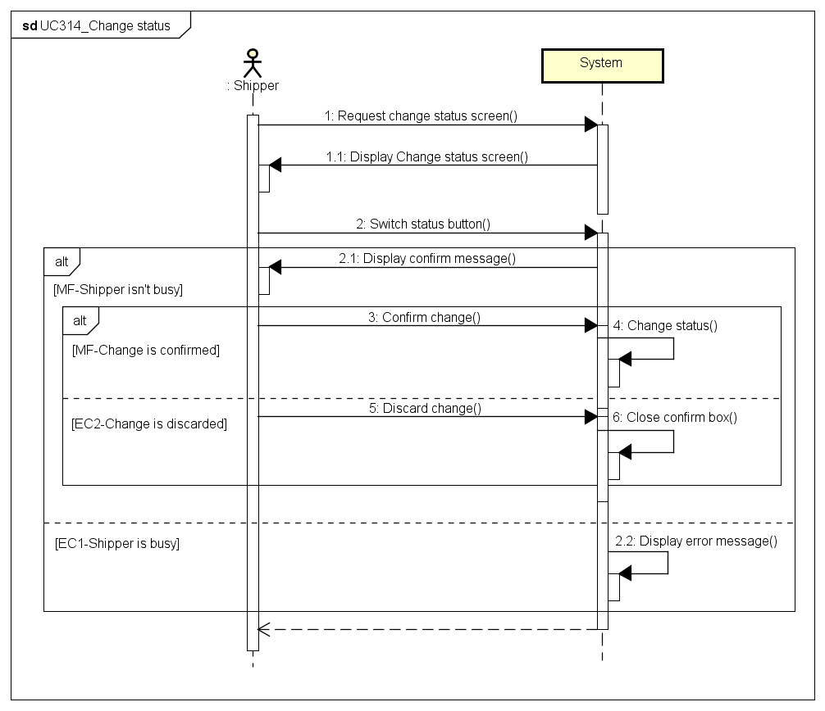

Figure 131: Sequence diagram for Change working status user case

###### *UC315 View History*

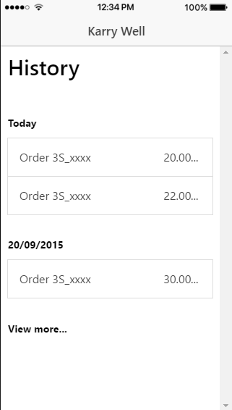

Figure 132: View history screen

|  |  |  |  |  |
| --- | --- | --- | --- | --- |
| **Use Case ID:** | | UC315 | | |
| **Use Case Name:** | | View history | | |
| **CreatedBy:** | | HuyTDH | **Last UpdatedBy:** | HuyTDH |
| **Date Created:** | | 19/09/2015 | **DateLast updated:** | 02/10/2015 |
| **Actor:** | | Shipper | | |
| **Description:** | | Shipper views his working history to know how much salary and bonus money he will get base on amount of his done orders. | | |
| **Triggering Event:** | | Shipper wants to review history | | |
| **Preconditions:** | | Shipper logged in | | |
| **Post conditions:** | | Working history of that shipper will be displayed | | |
| **Priority:** | | High | | |
| **FrequencyofUse:** | | Often | | |
| **Main flow** | | | | |
| Step | Actor | Action | | |
|  | Shipper | Shipper chooses “History” from menu | | |
|  | System | System load history saving in device memory | | |
|  | System | System displays working history of that shipper, also includes bellow feature:   * Date label to group working history by date * List of history orders * “View more” link if there more orders is not yet displayed | | |
| **Alternative Flows:** | | | | |
| AT1 | At step 2, working history local storage in device was cleared and shipper has to load from server | | | |
| Step | Actor | Action | | |
| 2.1 | System | System shows message “Can’t find working history. Reload from server?” | | |
| 2.2 | Shipper | Shipper tabs on “Reload” | | |
| 2.3 | System | Load history log from server and save to device | | |
|  |  | Go to step 3 of main flow | | |
| N/A | | | | |
| **Exceptions:** | | | | |
| EC1 | At step 2.2 of Alternative 1 history can’t be loaded from server | | | |
| Step | Actor | Action | | |
| 2.2.1 | System | Displays error message “"History could not be loaded. Retry!"” | | |
| **Includes:** | | N/A | | |
| **SpecialRequirements:** | | Default will display last 20 orders Clicks “See more” will load 20 more orders | | |
| **Notes andIssues:** | | History will be save in device memory Shipper don’t need internet to load history | | |

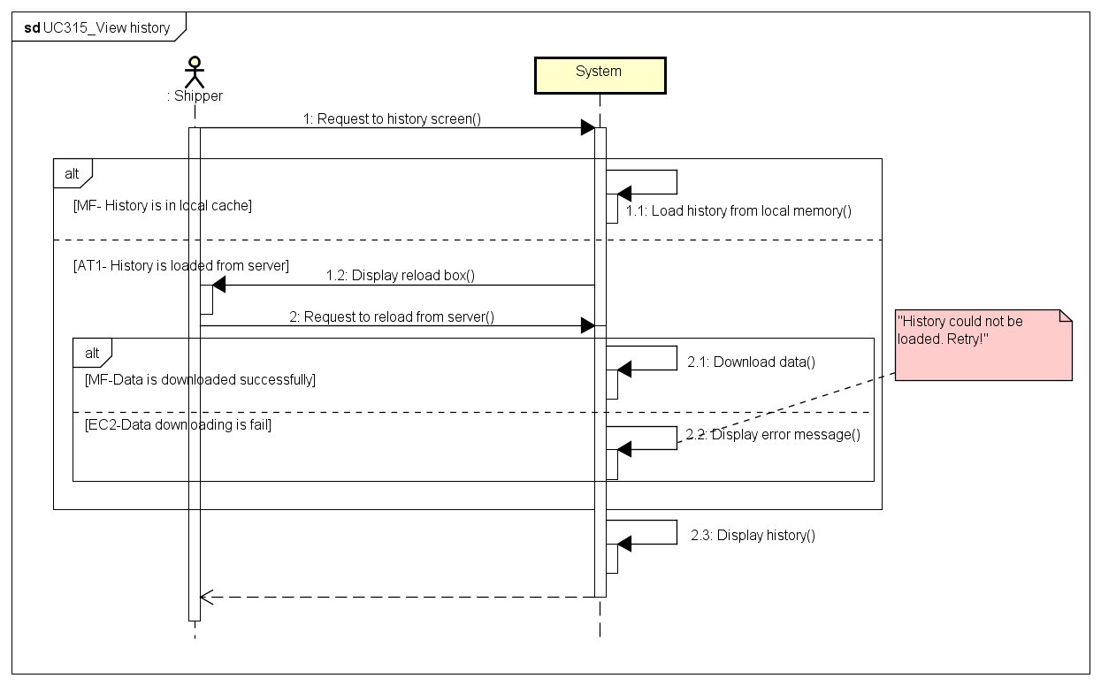

Figure 133: Sequence diagram for view history user case

###### *UC316 Continue When Pending*

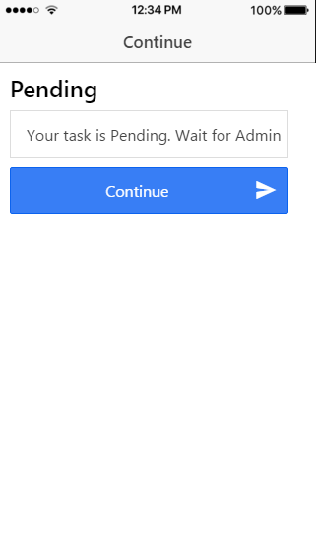

Figure 134: Continue when pending screen

|  |  |  |  |  |
| --- | --- | --- | --- | --- |
| **Use Case ID:** | | UC316 | | |
| **Use Case Name:** | | Continue when pending | | |
| **CreatedBy:** | | QuyenNV | **Last UpdatedBy:** | QuyenNV |
| **Date Created:** | | 19/09/2015 | **DateLast updated:** | 02/10/2015 |
| **Actor:** | | Shipper | | |
| **Description:** | | When shipper has issue then shipper cannot continue his/her task. If shipper wants continue his/her task then shipper have to wait for Admin to resolve. | | |
| **Triggering Event:** | | Shipper wants continue his/her task. | | |
| **Preconditions:** | | Shipper has issue or shipper send issue with category of issue is pending. | | |
| **Post conditions:** | | ‘Continue’ screen is hide. Shipper continue his/her task. | | |
| **Priority:** | | High | | |
| **FrequencyofUse:** | | Often | | |
| **Main flow** | | | | |
| Step | Actor | Action | | |
| 1 | Shipper | Shipper click button ‘Continue’ on ‘Continue’ screen. | | |
| 2 | System | Check Shipper’s issue | | |
| 3 | System | Display success message: ‘You can continue’ and Hide the ‘Continue’ screen. | | |
| **Alternative Flows:** | | N/A | | |
| **Exceptions:** | | | | |
| EC1 | At step 2 of main flows. If issue of shipper doesn’t resolve. | | | |
| Step | Actor | Action | | |
| 1 | System | Display alert with message ‘Your Issue is not resolved. Please waiting for Admin or contact to Admin.’ And ‘Continue’ screen was going show. | | |
| **Includes:** | | N/A | | |
| **SpecialRequirements:** | |  | | |
| **Notes andIssues:** | |  | | |

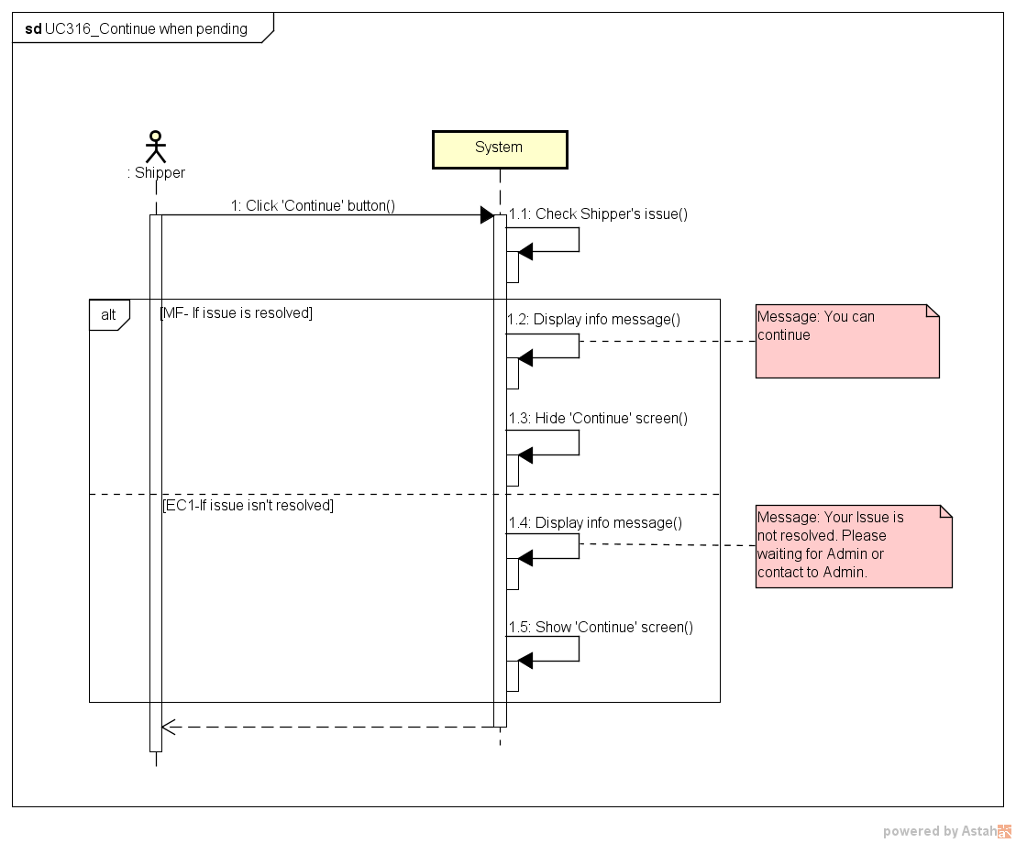

Figure 135: Sequence diagram for Continue when pending user case

# NON – FUNCTIONAL REQUIREMENTS

## 4.1 Usability

* User interface should be clear and easy to use.
* User can complete each function in less than 10 actions

## 4.2 Maintainability

* Application is easily to maintain without any crashes.

## 4.3 Scalability

* The system is easy to extend and add new feature.

## 4.3 Availability

* The application is available 24/7

## 4.4 Performance

* + - * System could support a large number of users at the same time.
      * Other functions of system perform normal while have many order running on application

## 4.5 Security

* Information of user on server is secured.
* With store, order is ensured that execute exactly and in time.

1. **OUT OF SCOPE**

Although we defined all use cases that relate to the requirement of this project. But in a short time, we couldn’t complete all use case as defined. Therefore, we focus on developing main use case. With the rest of use cases, we are approved by supervisor to skip. If we have more time, we will continue to complete. The list of use case is out of scope:

##### Store

* + UC-204: Change password
  + UC-205: Forgot password
  + UC-207: Update profile
  + UC-222: Rate shipper
  + UC-223: Send feedback

##### Admin

* + UC-103: Change password
  + UC-104: Forgot password

##### Shipper

* + UC-303: Forgot password
  + UC-304: Change password
  + UC-306: Update Profile
  + UC310: Search Order
  + UC312: Find Best Way

# IV. SOFTWARE DETAIL DESIGN

# 1. ARCHITECTURE DESIGN

## 1.1 Introduction

### 1.1.1. Purpose

The Software Architecture Design Document provides a comprehensive architectural overview of the Karywell system offered by Karywell team. It presents a number of different architectural views to depict different aspects of the system. It is intended to capture and convey the significant architectural decisions, which have been made on the system.

The development team should read carefully this document to review the architecture of the system before develop. It would also be very helpful for the upgrade and maintain.

### 1.1.2.Scope

The scope of this SAD is to depict the architecture design of the Karywell system created by Karywell team. Documents describing the elements and the most basic acts within the system to help the stakeholders can see the system overall.

### 1.1.3. Overview

This SADD include the flowing subsection:

Section 2: Describes the use of each view in 4+1 views

Section 3: Describes the goal and constraint of architecture.

Section 4: Describes all the use case of system

Section 5: Describe how the system will be deployed.

Section 6: Describe the layers and subsystems of the system.

Section 7: Describe the choice of Architecture Design.

Section 8: Describe any aspects related to the quality of service attribute

## 1.2. Description

This section depicts the architecture using the views defined in the “4+1” model as below:

Figure : View Model 4+1

**Logical view**

**Implementation view**

**Process view**

**Deployment view**

### 1.2.1. Use case view

* **Audience:** all the stack holder of the system
* **Area:** specific description of each use-case and their role in the system.
* **Related Artifacts:** use-Case Model

### 1.2.2. Logical view

* **Audience:** Designer
* **Area:** Function Requirements: describes the design’s object model. Also describes the most important use-case realizations
* **Related Artifacts:** Class diagram, Sequence diagram, Communication diagram

### 1.2.3. Implementation view

* **Audience:** Programmers
* **Area:** Software components: describes the layers and subsystem of the application
* **Related Artifacts:** Component diagram, package diagram

### 1.2.4. Deployment view

* **Audience:** Manager
* **Area:** Topology: describes the mapping of the software onto the hardware and shows the system-distributed aspects.
* **Related Artifacts:** Deployment diagram

### 1.2.4. Process view

* **Audience:** Integrators
* **Area:** Non-functional requirements: describes the designer’s concurrency and synchronization aspects
* **Related Artifacts:** Activity diagram

## 1.3. Architecture goal & constraints

### 1.3.1. Technical Platform

The Karywell Web Application will be deployed onto Amazon Cloud Service (EC2).

This application will be deployed as a hybrid application that can run on Android and IOS platform.

### 1.3.2. Communication

The mobile application and web application request to web service and get response as JSON objects.

### 1.3.3. Security

- Information of admin data on server is secured.

- Information of store and shipper on server is secured.

### 1.3.4. Reliability/Availability

- The application is available 24/7.

- Find the way to go to places of receive and place of delivery are at least 90%.

### 1.3.5. Performance

* Time delay for find shipper who nearest with place of delivery is less than 60s.
* Time delay on web application for tracking state of shipper on map is less than 5m.
* Server can handle least 2000 clients concurrently.
* Other functions of server perform well while have many order running on application.

### 1.3.6. Maintainability

- Web application is easily to maintain without any crashes. Source code is readability, organized into groups of skeleton (modules) and complies with coding convention.

- Mobile application is easily to be updated and synchronize with Web application without any crashes. Source code is readability, complies with coding convention. - System’s architecture has to be design to be easy to extend.

## Use case view

This section list all use cases of Karywell system. Details on SRS

### 1.4.1. Admin



**Figure 137. Use case view of Admin**

### 1.4.2. Store

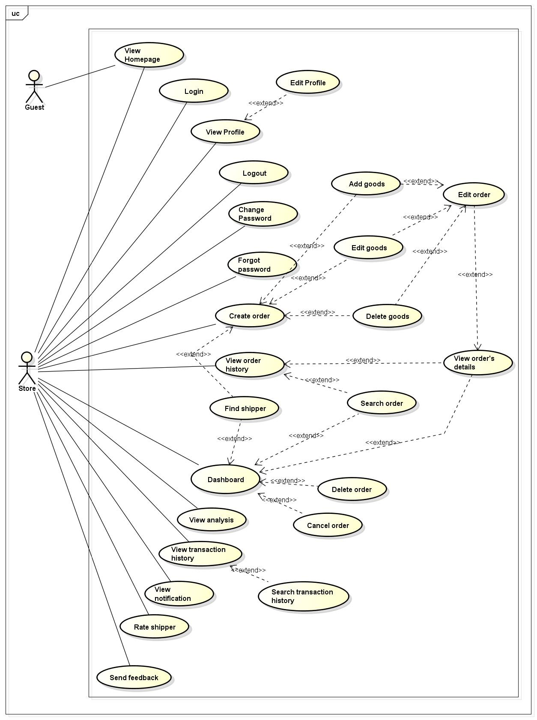Figure 138: Use case view of Store

### 1.4.3. Shipper

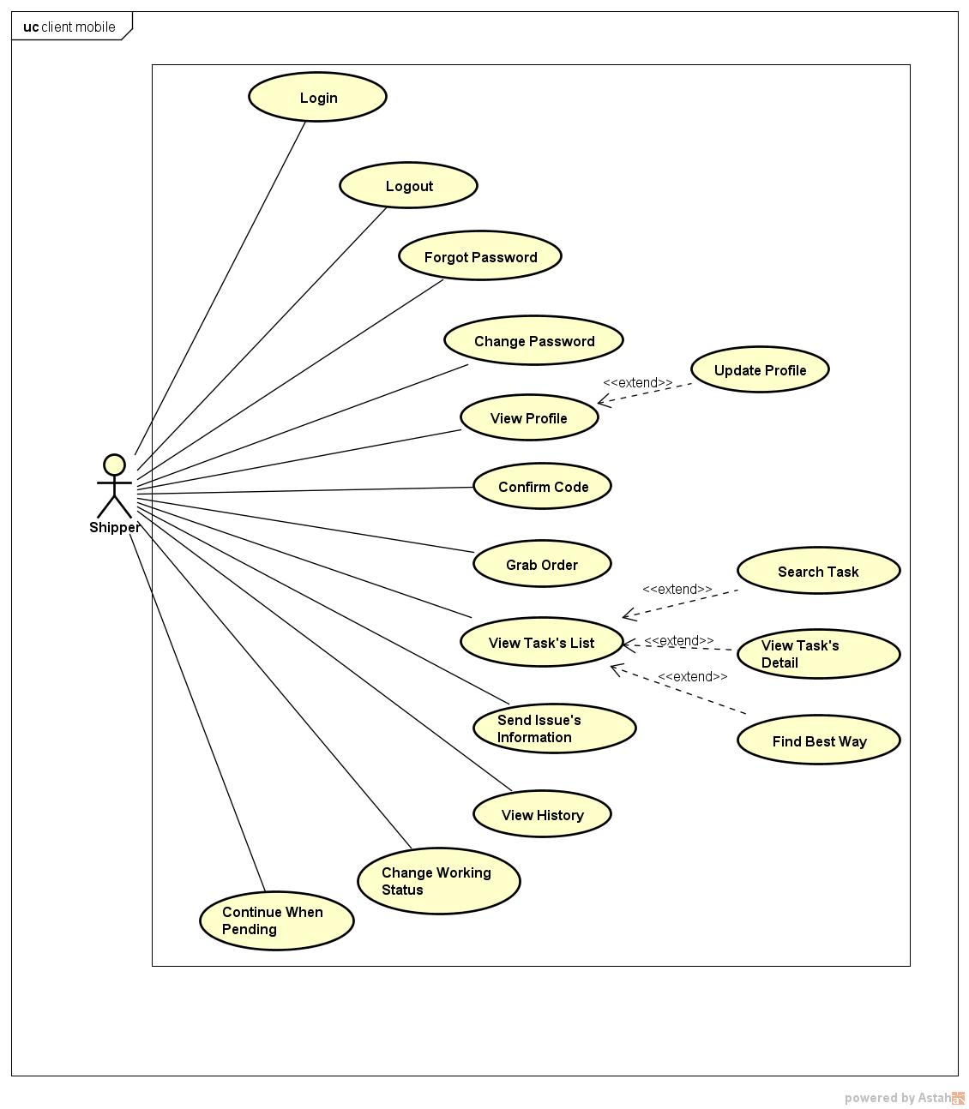

Figure 139: Use case view of Shipper

## Deployment view

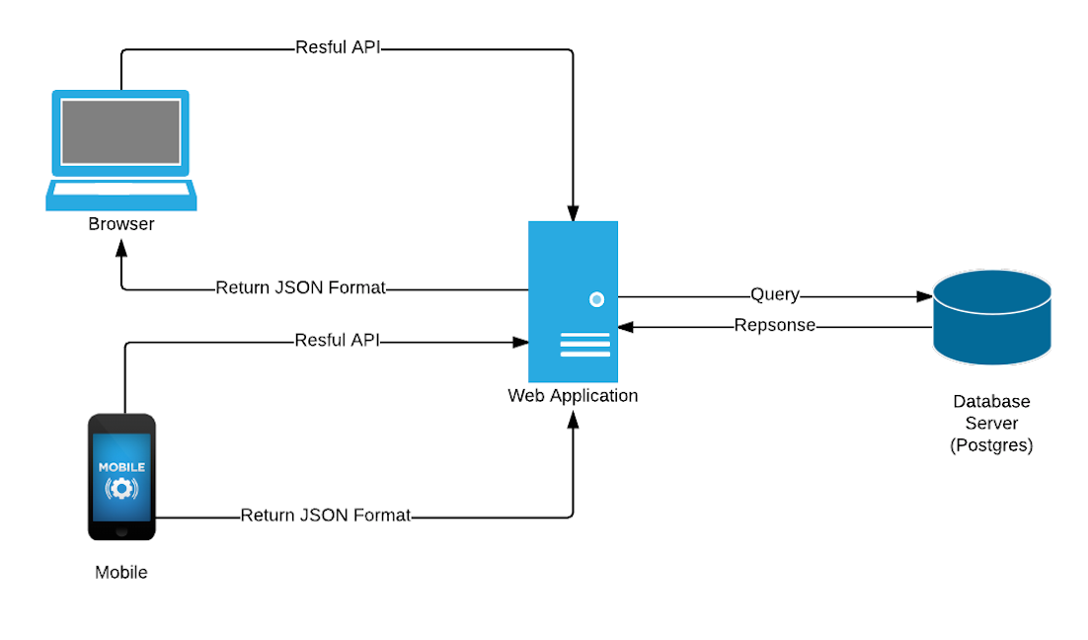

*Figure 5: Overview of Karywell system*

## 1.6. Implementation view

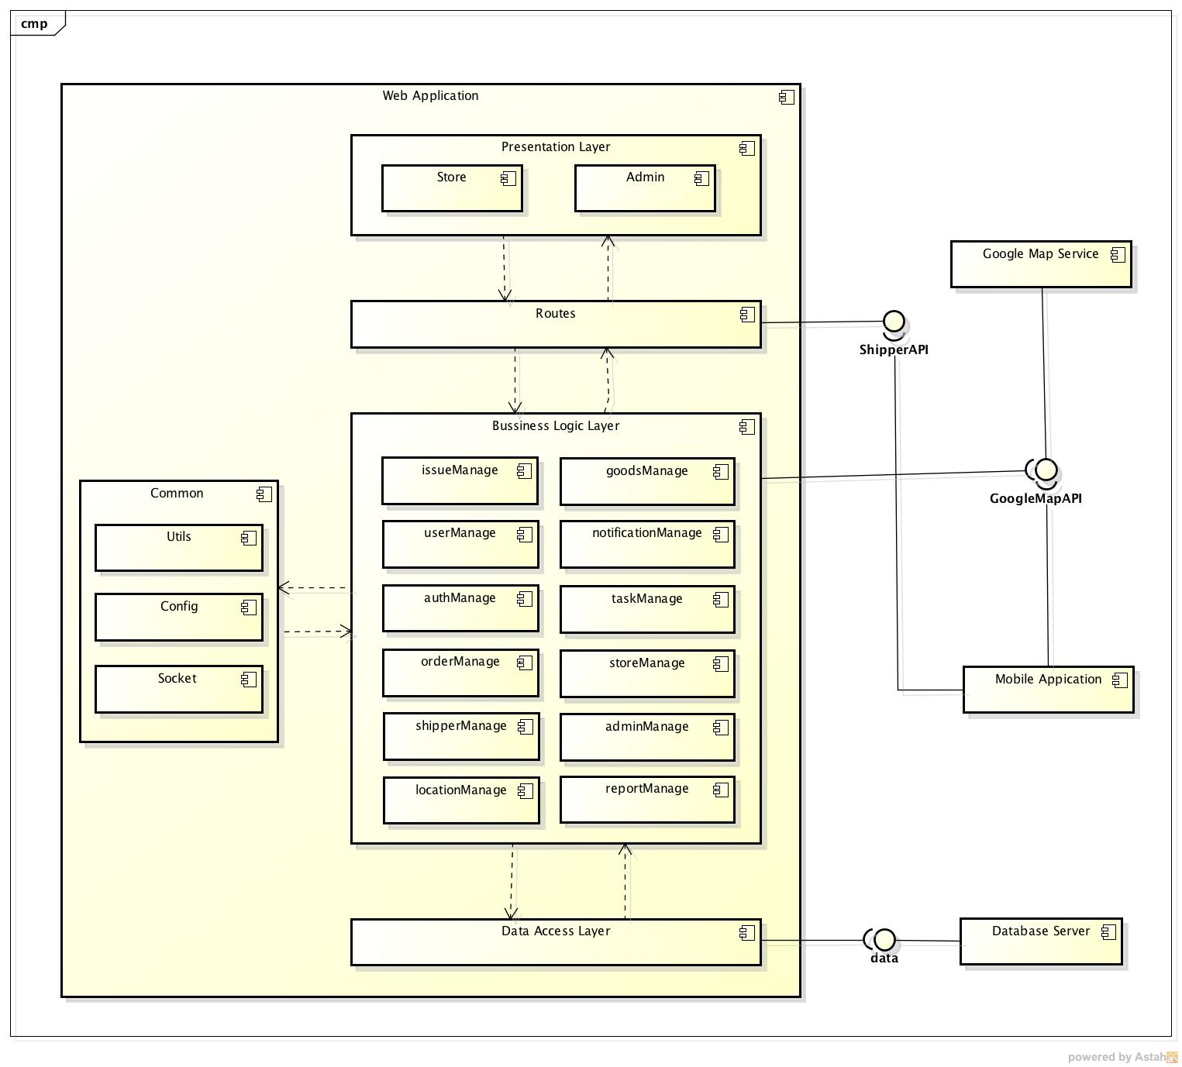

*Figure 6: Component Diagram*

## 1.7. Choice of architecture design

* Mobile application

Because we want to create an application that build once but run on many platform mobile (IOS, Android...). Therefore we choose the IONIC framework to create a hybrid application. This framework bases on Angular JS framework which allows us easy to develop application following MVC model.

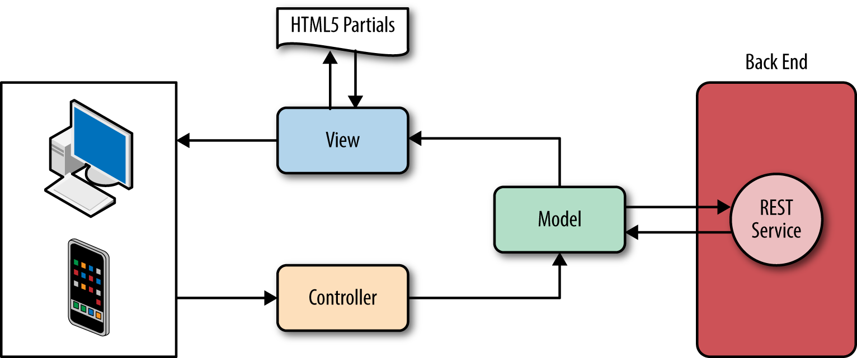

*Figure 7: MVC in Angular JS*

* Web application

We use Three-layers model to build web application.

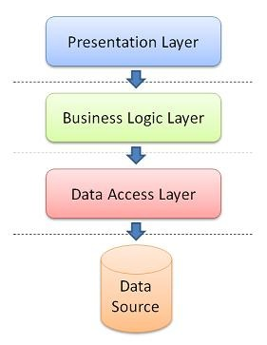

*Figure 8: Three layers model*

The benefits of Three-layers model:

* The maintenance of application is easier because of the low coupling between layers.
* It's easy to distribute layers over multiple physical tiers. This can make a very good impact on application by improving performance (sometimes), scalability and fault tolerance.
* Layers make your application more testable.
* During the development process, developers and designers can work more independently and concurrently on their components.

## 1.8. QUALITY

Karywell system architecture design aimed at the quality goals as specified below:

* Scalability:
  + - Description: The system is easy to extend and add new feature.
    - Solution: During time of defining requirement of system, we thought of many features, which should add to system. But because of limit time (4 months) we couldn’t do it. Therefore, we choose the three-layers architecture to help us easy extend system late. Beside, we designed database model that meet the change in future.
* Availability:
  + - Description: The application is available 24/7
    - Solution:

The karywell system was developed on AMS ES2. Therefore, whenever user could connect to system. Beside, we have a schedule to track the status of system to ensure that system always active. In future, we’ll deploy the system on many servers to backup when having any error occurs.

* Usability:
  + - Description: Mobile and web application easy to use.
    - Solution: The interface of mobile and application are designed friendly, simply; ensure that user could be easy to use. Beside, we provide user manual document to support user during interacting with system. With mobile application, we publish on Google Play or Apple Store to help user (shipper) download and install.
* Performance:
  + - Description:
      * System could support a large number of users at the same time.
      * Other functions of system perform normal while have many order running on application
    - Solution: Base on defined architecture, it’s easy for us to distribute our system. We are going to add more servers and apply load-balancing algorithms.
* Maintainability:
  + - Description: Application is easily to maintain without any crashes.
    - Solution: Source code is generated clearly following coding convention. Beside the system is developed follow each of module, so it’s easy to maintain each of modules without effect to other module. During development, we always update software architecture design to ensure developer is easy to review and understand.
* Security:
  + - Description:
      * Information of user is secured
      * With store, order is ensured that execute exactly and in time.
    - Solution:
      * Password of user is encrypted before saving to database
      * Authentication and Authorization: All personnel involve in the system operation have to depend on user’s role. System provide mechanism like check token, check role of user when access to path.

# 2. DETAIL DESIGN

## 2.1. Introduction

### Purpose

This document describe details of function in system by using many types of diagram(class diagram, object diagram, sequence diagram) to help developer understand easily and develop these functions efficiently following requirement.

## 2.2. Detail design

At mobile application and web client, we use angularJS framework to build. Therefore, we describe class diagram below to display general class in AngularJS. Then, we use this diagram to draw object diagram.

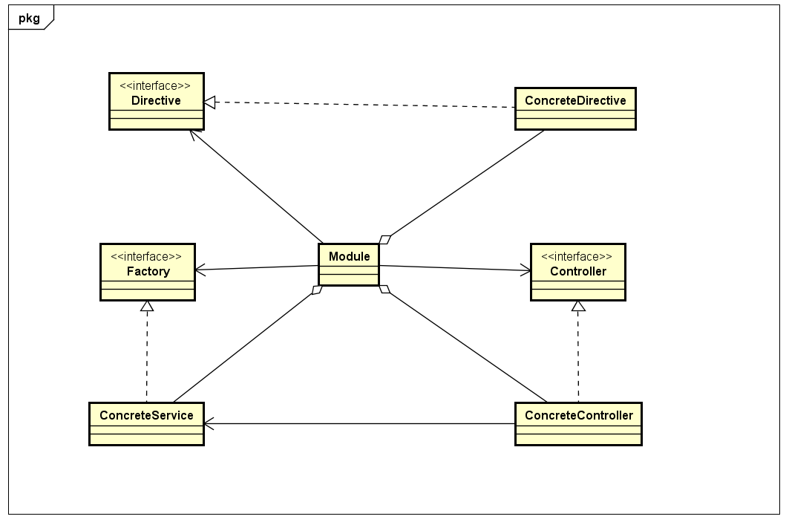

Figure 140Class Diagram of Angular module

### 2.2.1. Mobile Application

#### 2.2.1.1. Login

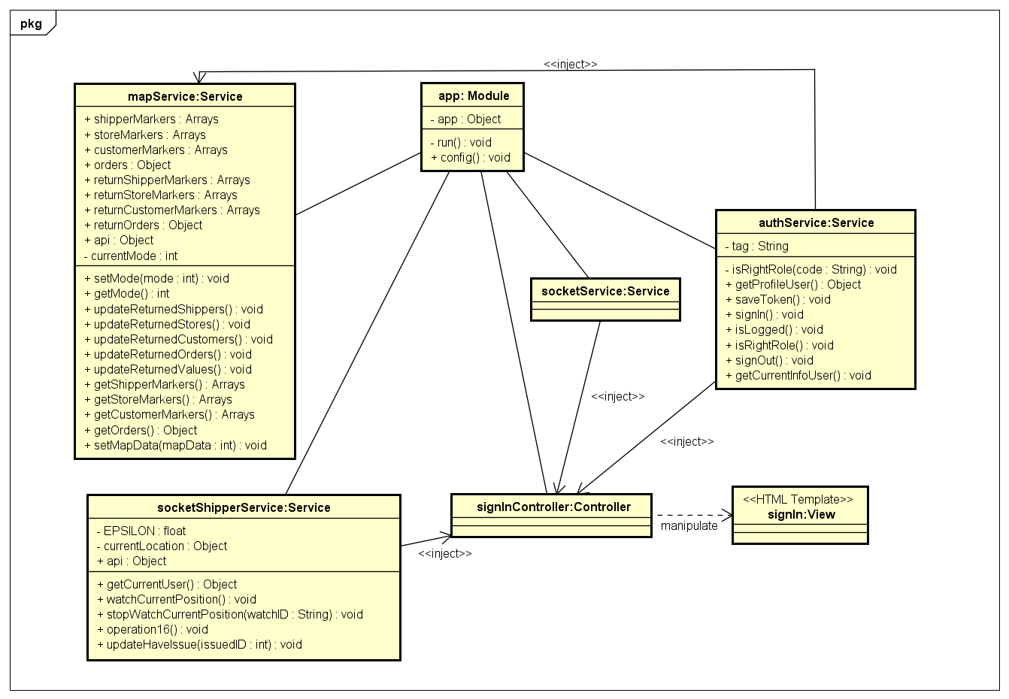

Figure 141ObjectDiagram of Login use case

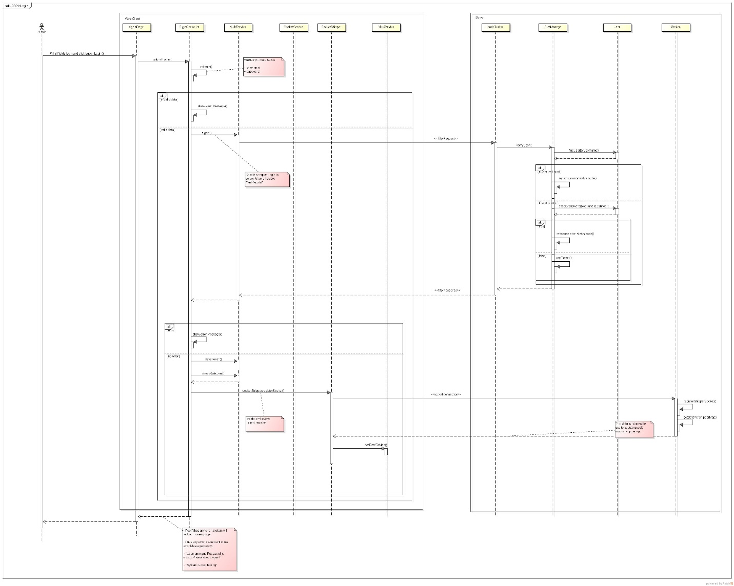

Figure 142SequenceDiagram of Login use case

#### 2.2.1.2. Logout

*Refer to 2.2.1.3.2. Logout*

#### 2.2.1.3. View Profile

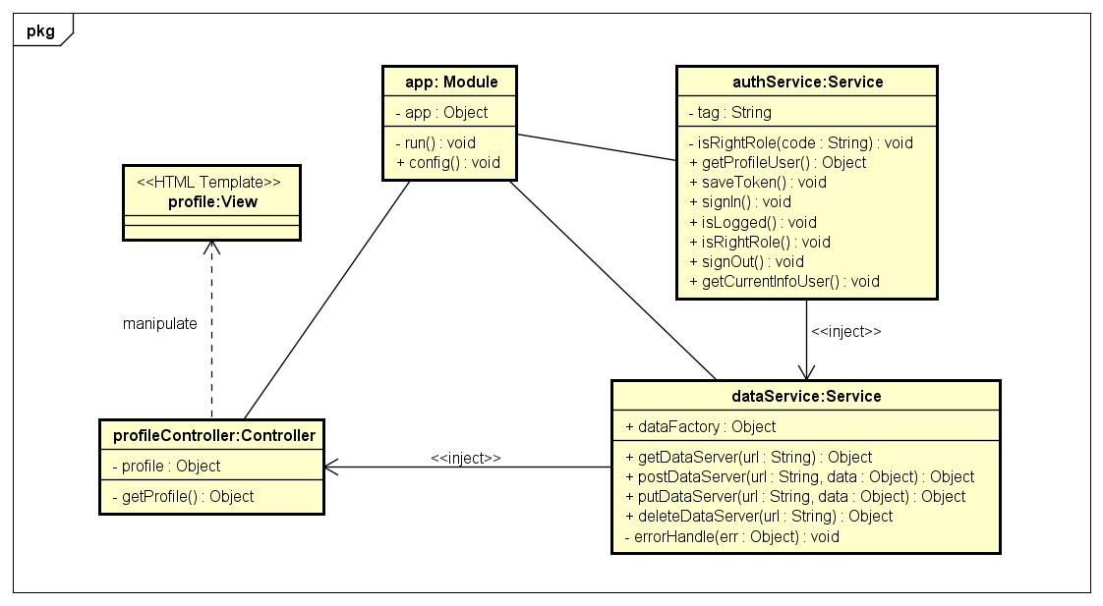

Figure 143ObjectDiagram of View Profile use case

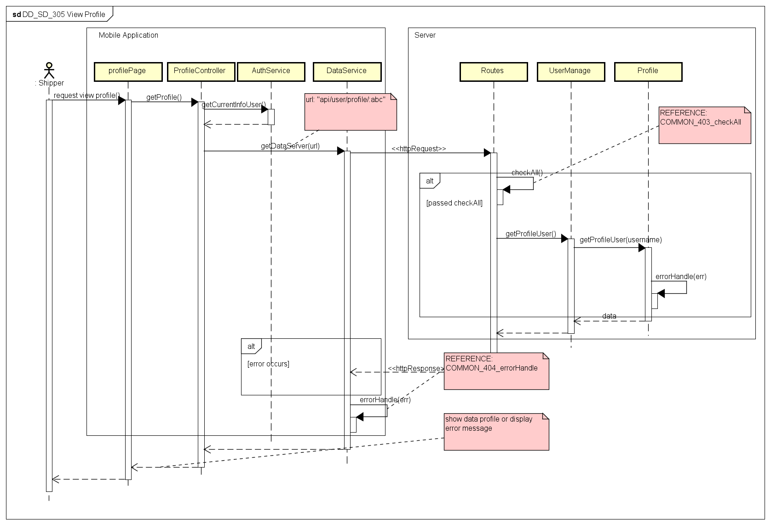

Figure 144SequenceDiagram of View Profile use case

#### 2.2.1.4. Confirm Code

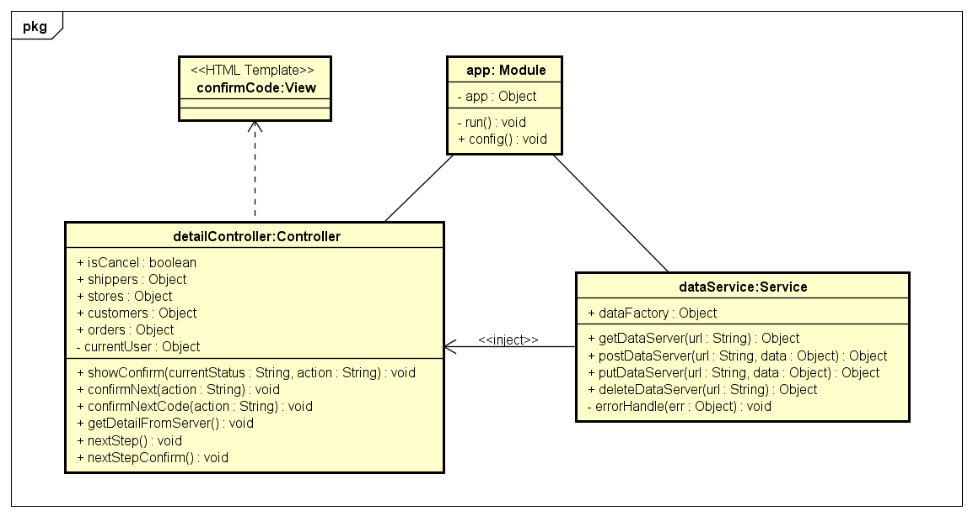

Figure 145ObjectDiagram of Confirm Code use case

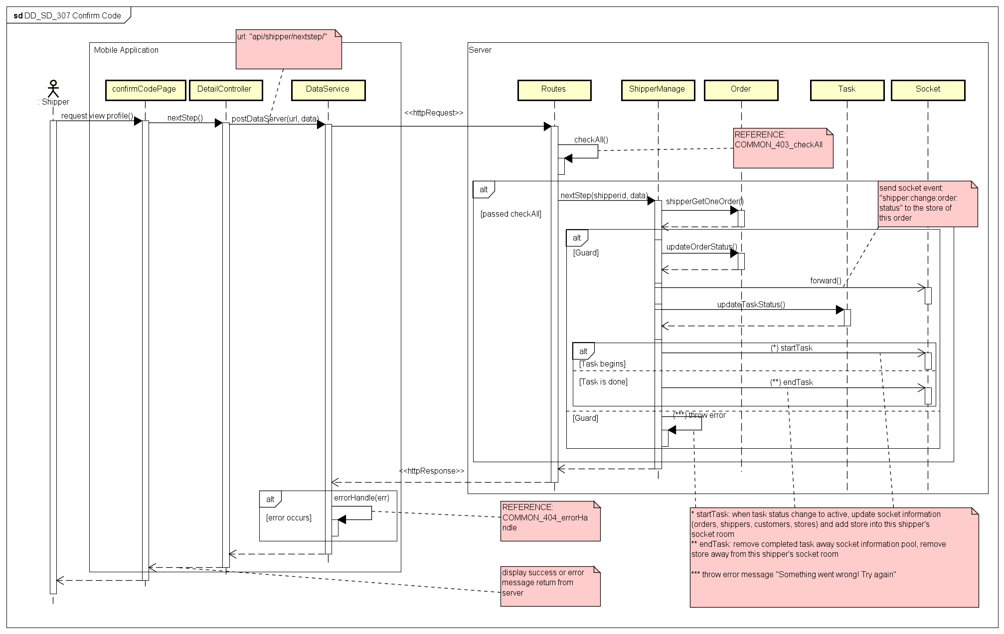

Figure 146SequenceDiagram of Confirm Code use case

#### 2.2.1.5. Grab Order

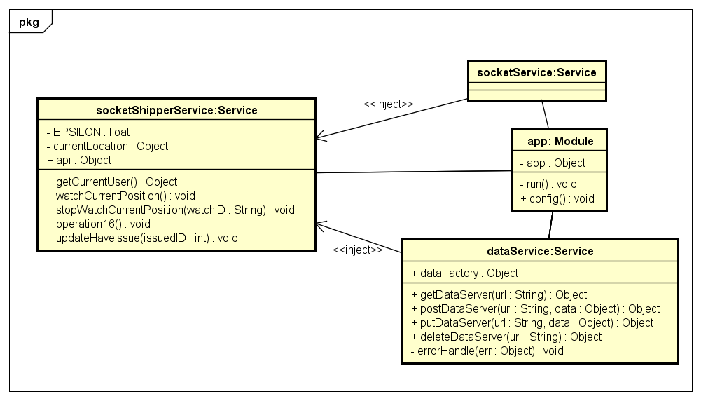

Figure 147.ObjectDiagram of Grab Order use case

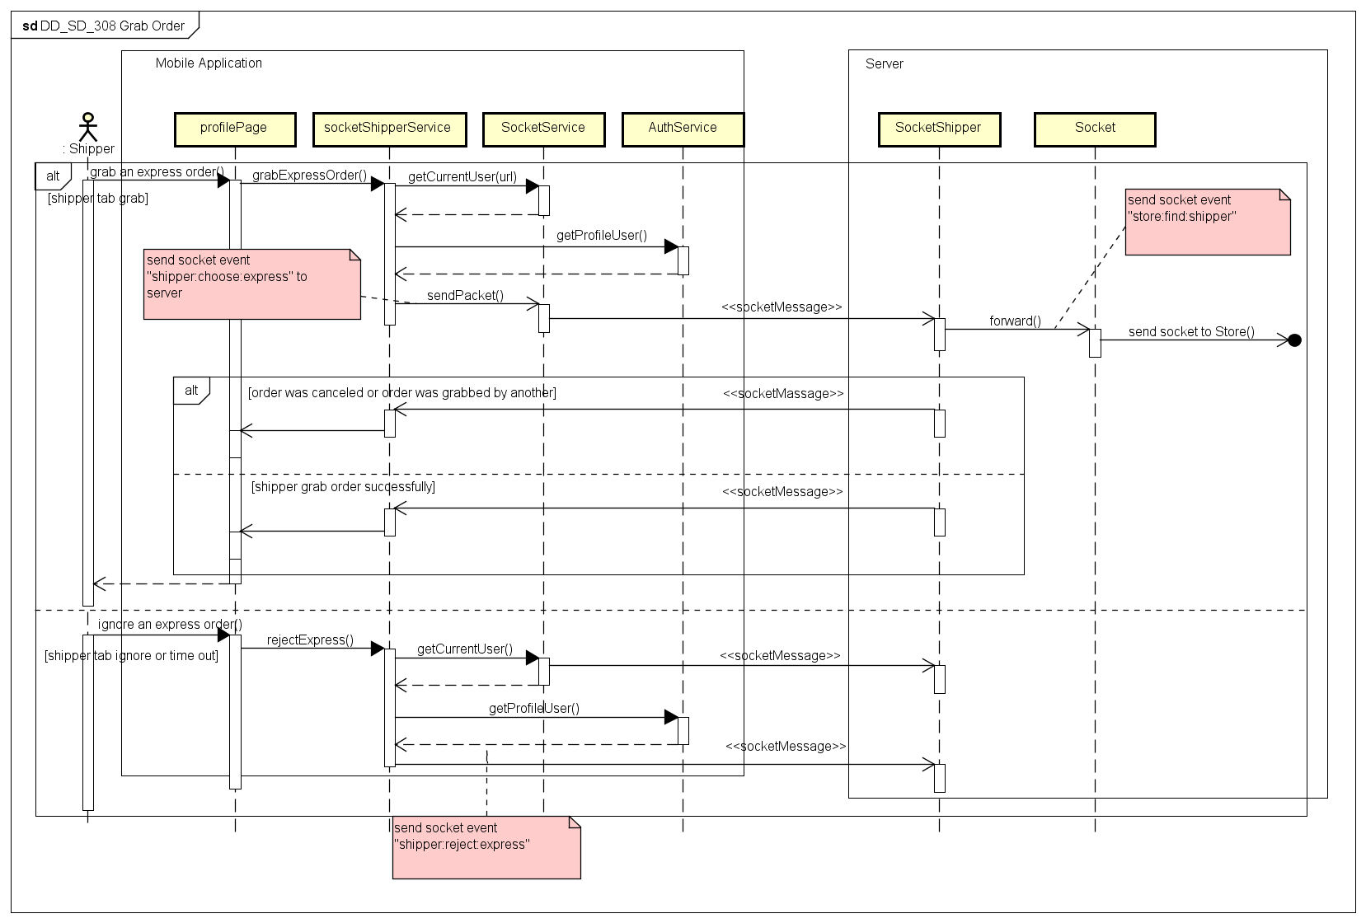

Figure 148.SequenceDiagram of Grab Order use case

#### 2.2.1.6. View Task’s List

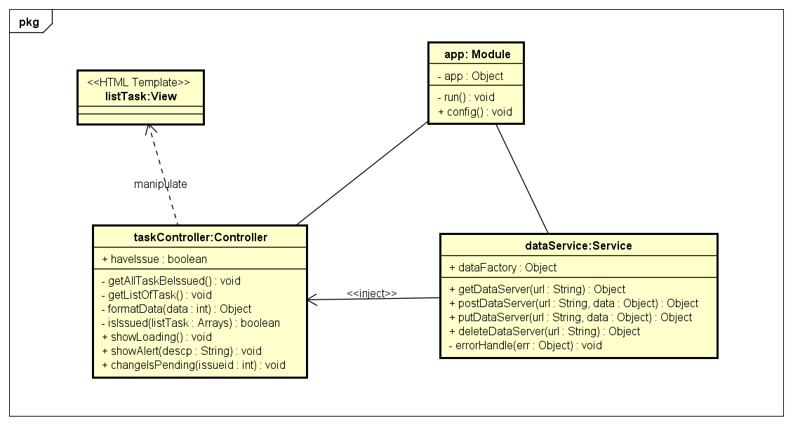

Figure 149ObjectDiagram of View Task’s List use case

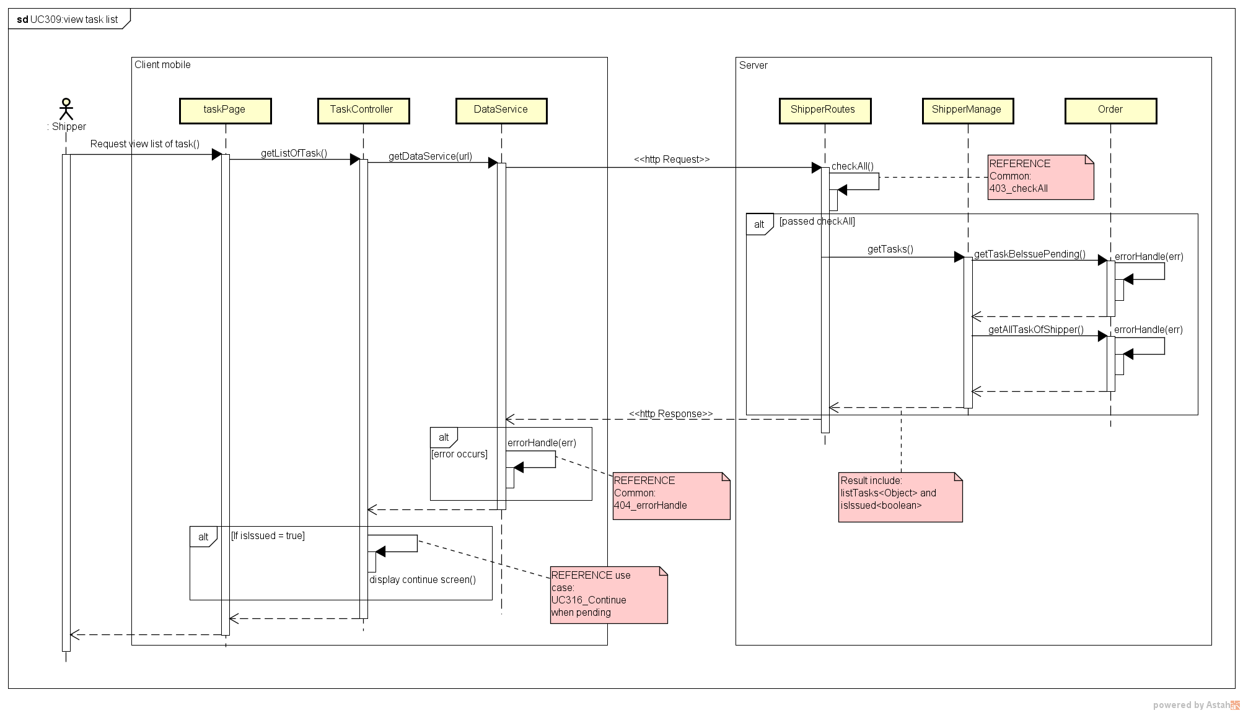

Figure 150SequenceDiagram of View Task’s List use case

#### 2.2.1.7. View Task’s Detail

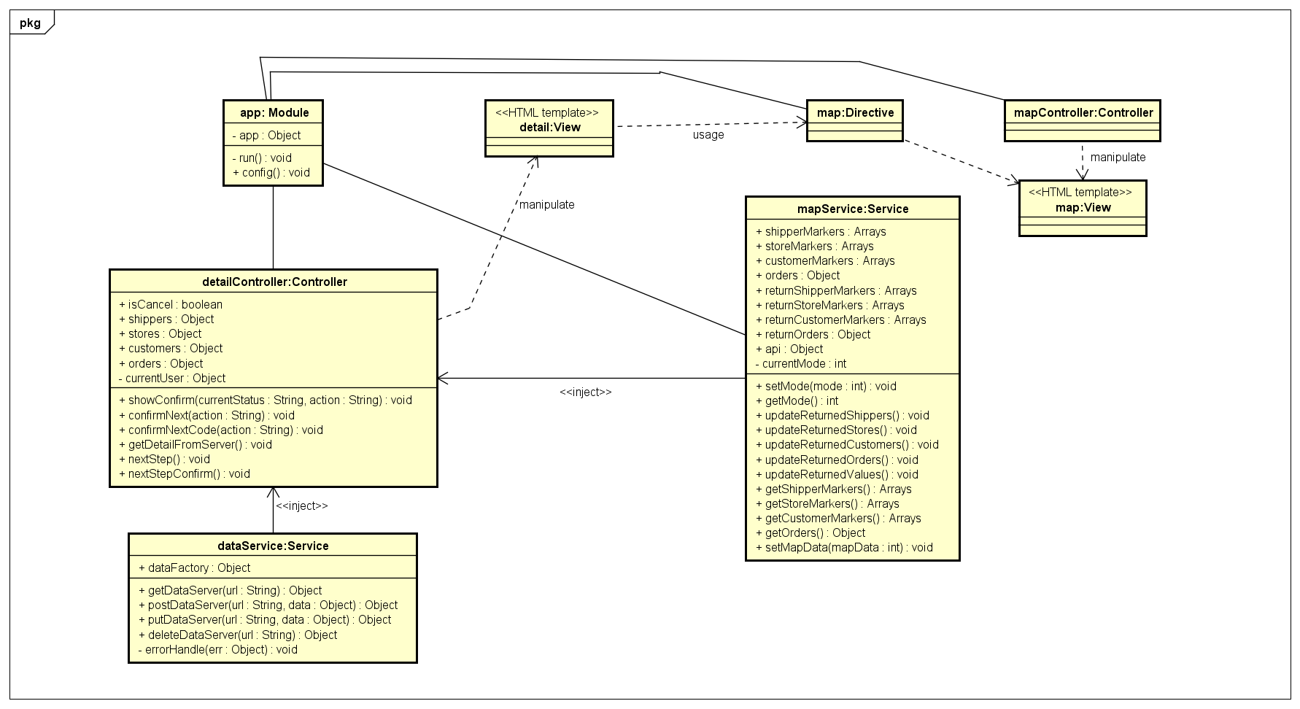

Figure 151ObjectDiagram of View Task’s Detail use case

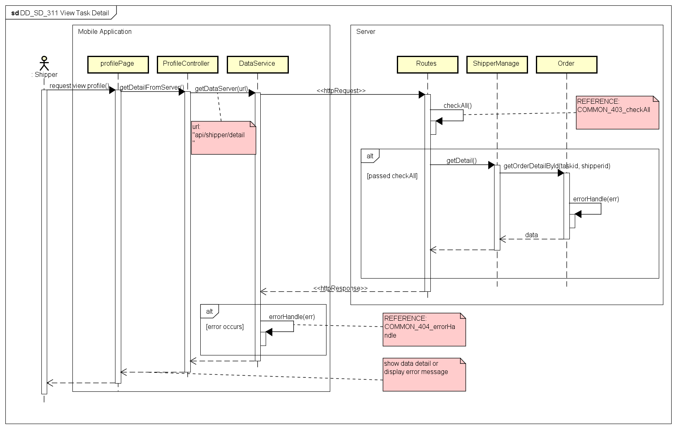

Figure 152SequenceDiagram of View Task’s Detail use case

#### 2.2.1.8. Send Issue Information

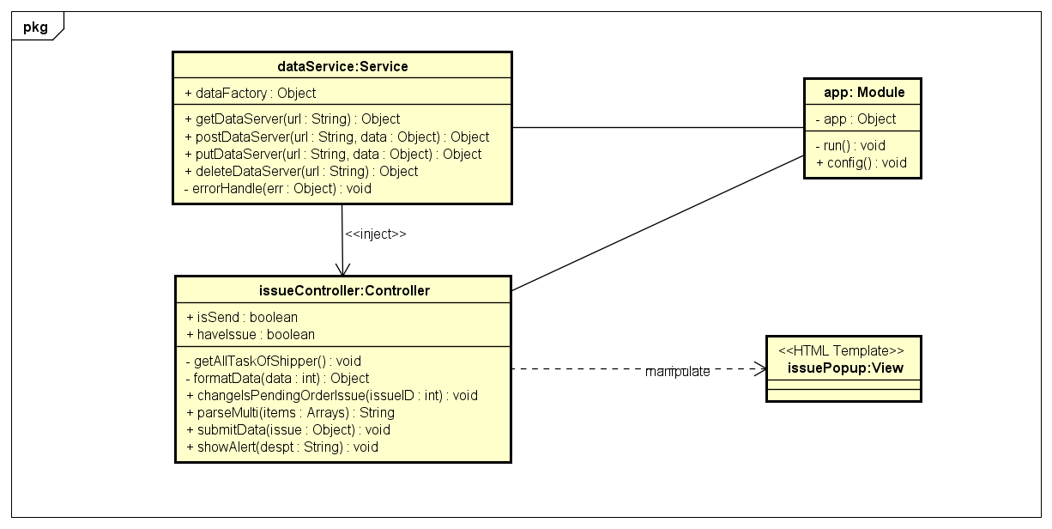

Figure 153ObjectDiagram of Send Issue use case

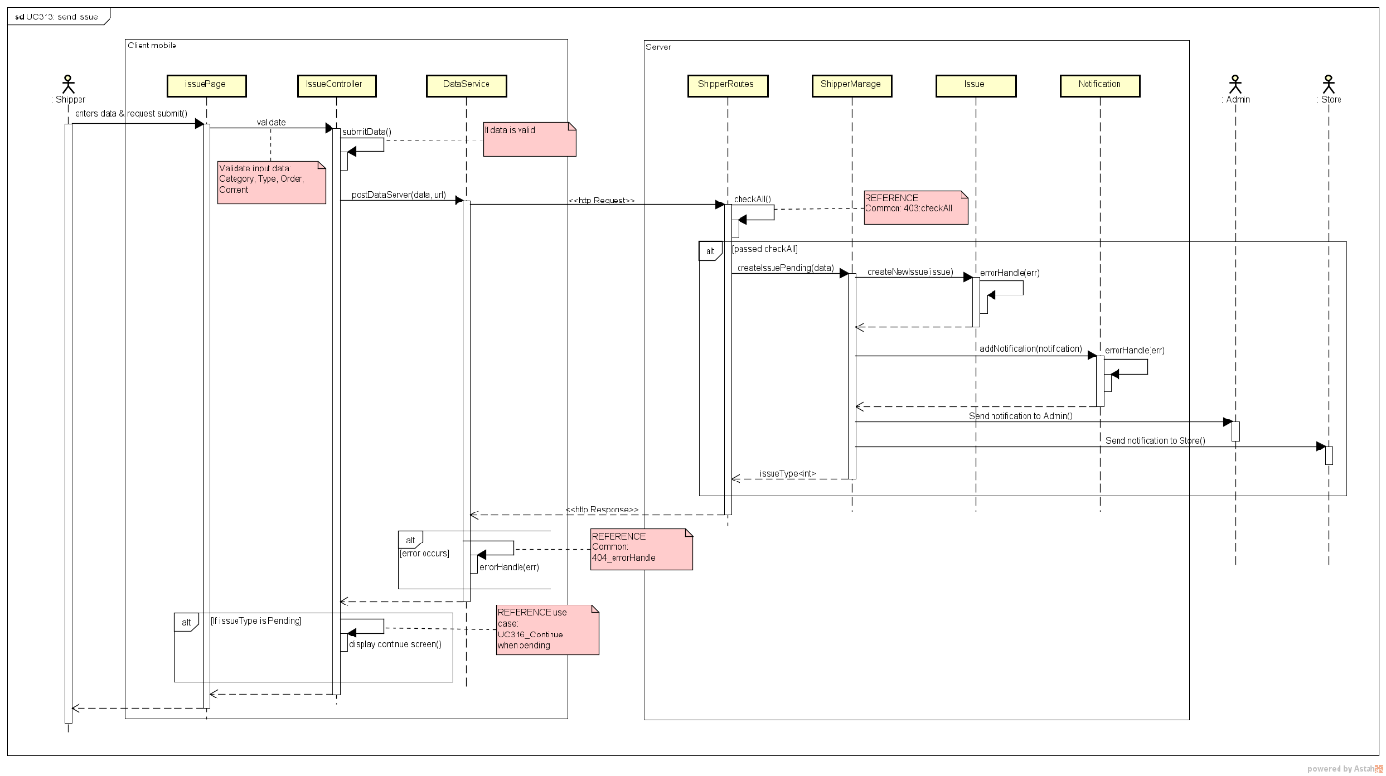

Figure 154SequenceDiagram of Send Issue use case

#### 2.2.1.9. Change Working Status

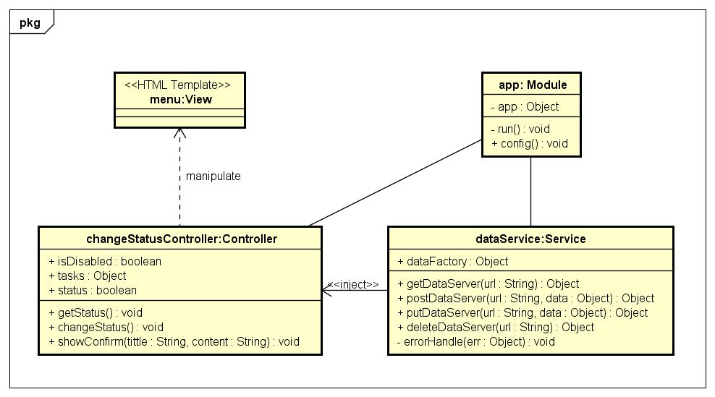

Figure 155.ObjectDiagram of Change Working Status use case

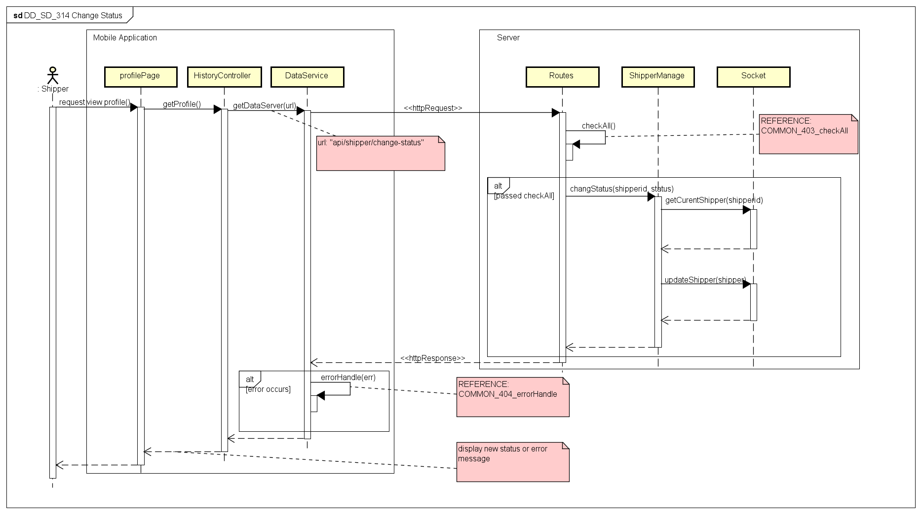

Figure 156.SequenceDiagram of Change Working Status use case

#### 2.2.1.10. View History

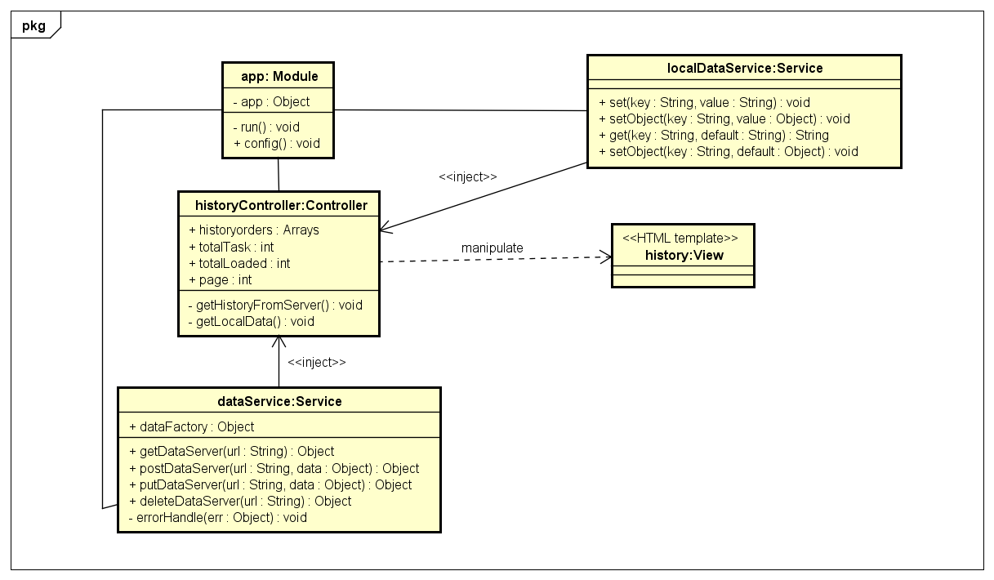

Figure 157.ObjectDiagram of View History use case

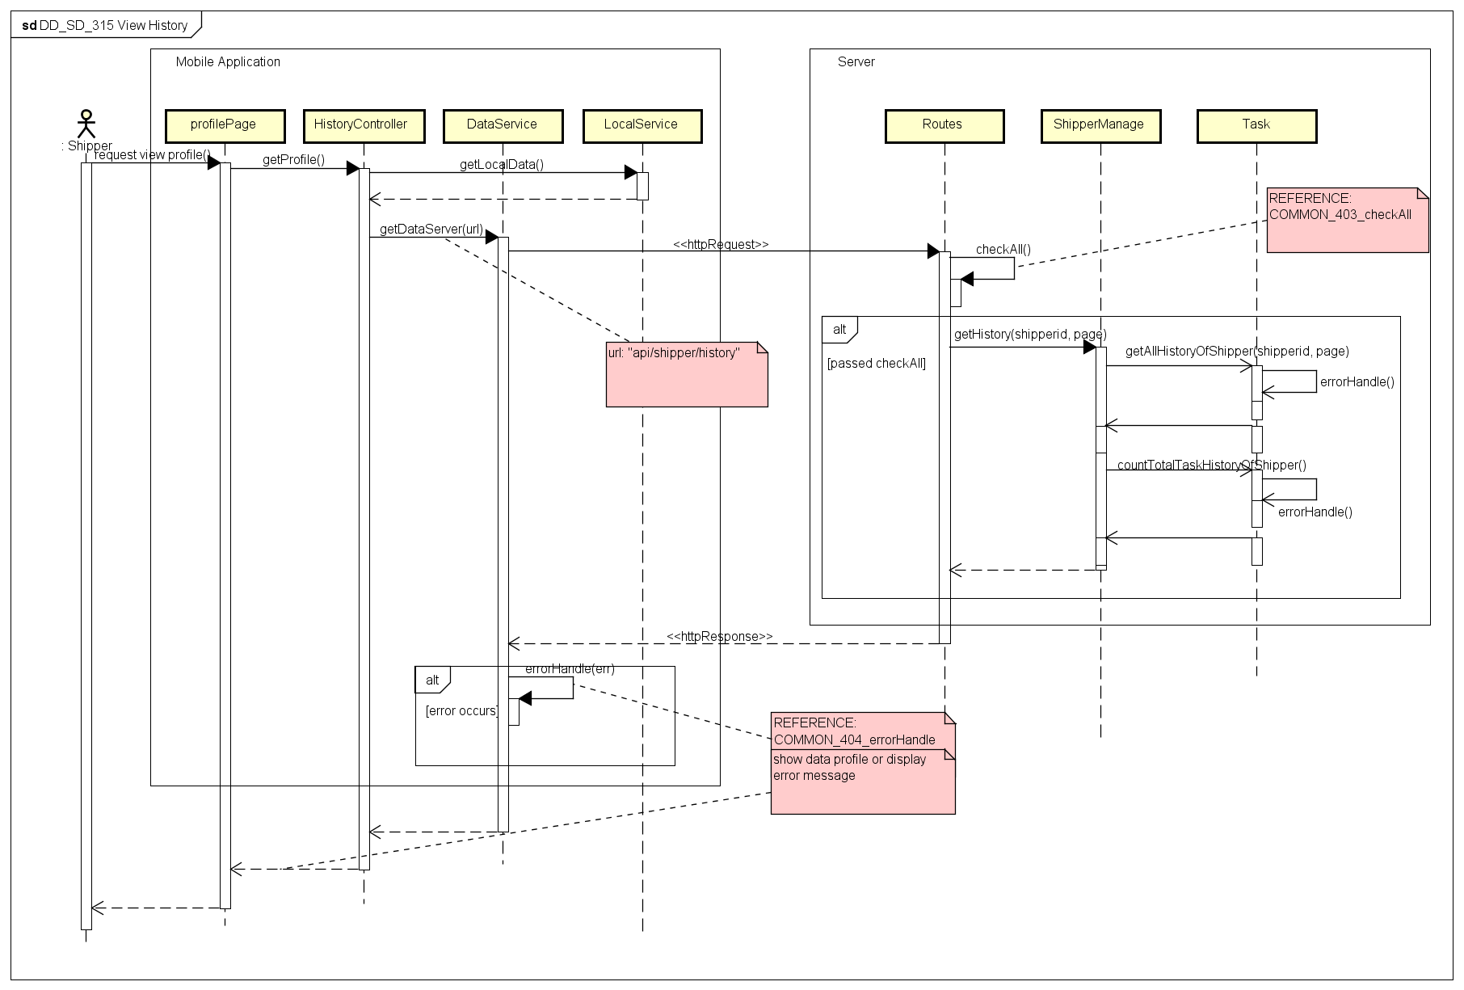

Figure 158.SequenceDiagram of View History use case

#### 2.2.1.11. Continue When Pending

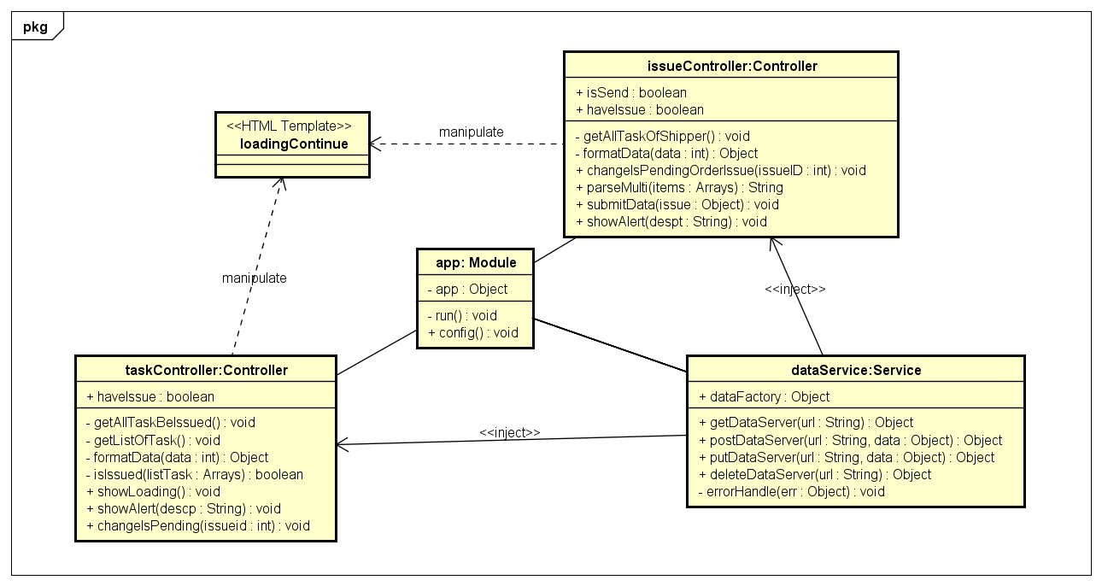

Figure 159.ObjectDiagram of Continue When Pending use case

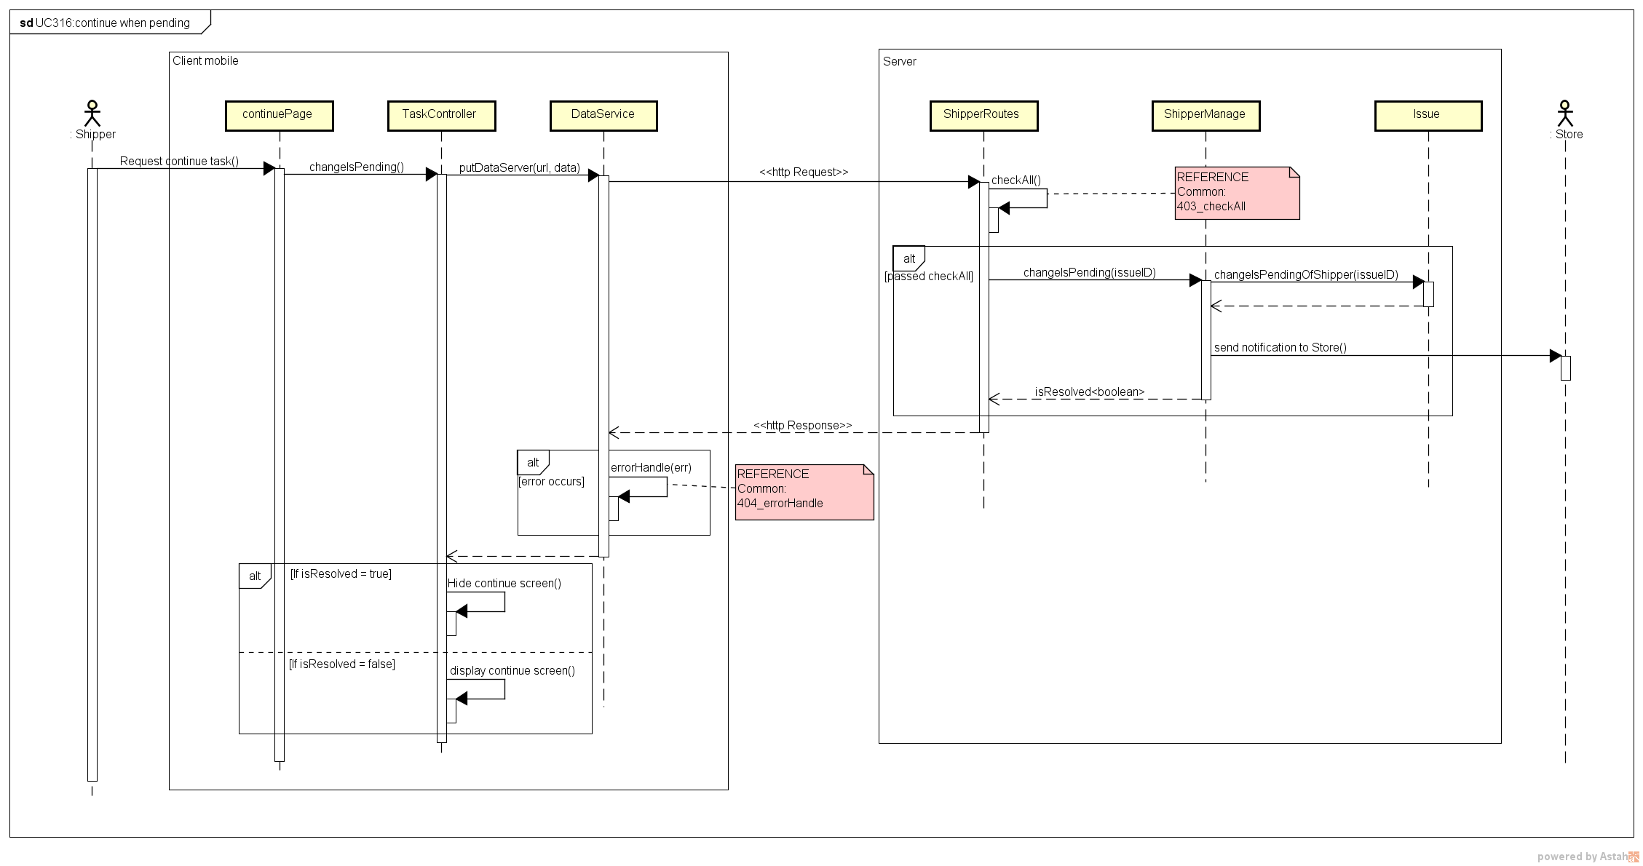

Figure 160.SequenceDiagram of Continue When Pending use case

#### 2.2.1.12. Class Description

##### SigninController

###### Attributes

|  |  |  |  |  |
| --- | --- | --- | --- | --- |
| No | Attributes | Type | Default | Description |
| 1 | User | Object | {} | Content information of logged in user |

###### Methods

|  |  |  |  |  |
| --- | --- | --- | --- | --- |
| No | Methods | Parameters | Return | Description |
| 1 | showError | Object | N/A | Show message error to user |
| 2 | submitFrm | N/A | N/A | Send login request to server |
| 3 | logout | N/A | N/A | Sign out, clear token save in local |

##### DetailController

###### Attributes

|  |  |  |  |  |
| --- | --- | --- | --- | --- |
| No | Attributes | Type | Default | Description |
| 1 | isCancel | boolean | N/A | Is the current order canceled? |
| 2 | Shippers | Object | N/A | Information of shipper to display in map |
| 3 | Stores | Object | N/A | Information of stores to display in map |
| 4 | Customers | Object | N/A | Information of customers to display in map |
| 5 | Orders | Object | N/A | Information of orders that the shipper is having, to connect markers on map |
| 6 | Center | Object | {} | The center of the map |

###### Methods

|  |  |  |  |  |
| --- | --- | --- | --- | --- |
| No | Methods | Parameters | Return | Description |
| 1 | showConfirm | int, String | N/A | Show the pop up to confirm when shipper want to move to next step |
| 2 | confirmNext | String | N/A | Send request to server without confirmation code |
| 3 | confirmNextCode | String | N/A | Send request to server with a confirmation code regard to current task and current status |
| 4 | getDetailFromServer | N/A | N/A | Get detail information of task from server |

##### HistoryController

###### Attributes

|  |  |  |  |  |
| --- | --- | --- | --- | --- |
| No | Attributes | Type | Default | Description |
| 1 | historyOrders | Array | [] | Current loaded history |
| 2 | totalTask | int | 0 | The number of total tasks of the shipper |
| 3 | totalLoaded | int | 0 | The number of total tasks that displayed |
| 4 | Page | int | 1 | Last displayed page of history |

###### Methods

|  |  |  |  |  |
| --- | --- | --- | --- | --- |
| No | Methods | Parameters | Return | Description |
| 1 | getHistoryFromServer | int | N/A | Load data history from server |
| 2 | getLocalData | N/A | N/A | Load data history from local storage |

##### IssueController

###### Attributes

|  |  |  |  |  |
| --- | --- | --- | --- | --- |
| No | Attributes | Type | Default | Description |
| 1 | isSend | boolean | False | If the issue is send or not |
| 2 | haveIssue | boolean | False | If the shipper is having issue or not |
| 3 | issueCategories | Array | [] | List categories of issue |
| 4 | listReasons | Array | [] | List reasons of issue |
| 5 | pendingReasons | Array | [] | List reasons to pending a task |
| 6 | cancelReasons | Array | [] | List reason to cancel a task |

###### Methods

|  |  |  |  |  |
| --- | --- | --- | --- | --- |
| No | Methods | Parameters | Return | Description |
| 1 | getAllTaskOfShipper | N/A | N/A | Get list current tasks of the shipper |
| 2 | formatData | Object | Object | Format data to display in view |
| 3 | parseMulti | Array | String | Parse a list into a string |
| 4 | showLoading | N/A | N/A | Show a loading icon on the screen |

##### ProfileController

###### Attributes

|  |  |  |  |  |
| --- | --- | --- | --- | --- |
| No | Attributes | Type | Default | Description |
| 1 | Profile | Object | {} | Profile information of the shipper |

###### Methods

|  |  |  |  |  |
| --- | --- | --- | --- | --- |
| No | Methods | Parameters | Return | Description |
| 1 | getProfile | N/A | N/A | Request into server to get profile information of shipper display to screen |

##### TaskController

###### Attributes

|  |  |  |  |  |
| --- | --- | --- | --- | --- |
| No | Attributes | Type | Default | Description |
| 1 | haveIssue | boolean | false | If the shipper is having an issue |

###### Methods

|  |  |  |  |  |
| --- | --- | --- | --- | --- |
| No | Methods | Parameters | Return | Description |
| 1 | showLoading | N/A | N/A | Display a loading icon on screen |
| 2 | showAlert | String | N/A | Show a pop up to shipper |
| 3 | getAllTaskBeIssued | N/A | N/A | Get a list tasks having issue and update haveIssue attribute |
| 4 | changeIsPending | int | N/A | Send request to server to continue when shipper resolved his issue |
| 5 | getListOfTask | N/A | N/A | Get list of current task of the shipper |
| 6 | formatData | Object | Object | Format data for html view |
| 7 | isIssued | Array | boolean | Check if the shipper is having issue |

##### MapController

###### Attributes

|  |  |  |  |  |
| --- | --- | --- | --- | --- |
| No | Attributes | Type | Default | Description |
| 1 | haveIssue | boolean | false | If the shipper is having an issue |

###### Methods

|  |  |  |  |  |
| --- | --- | --- | --- | --- |
| No | Methods | Parameters | Return | Description |
| 1 | drawArrow | Object, Object, String, String, Object, Object | N/A | Push list of new order information into the *arrows* attribute |
| 2 | resetArrows | N/A | N/A | Reset value of *arrows* attribute to default |
| 3 | displayRelationship | Object, Object, Object, Object | N/A | Draw arrows on the map, bases on data in *arrows* attribute |

##### AuthService

###### Attributes

|  |  |  |  |  |
| --- | --- | --- | --- | --- |
| No | Attributes | Type | Default | Description |
| 1 | Tag | String | EHID | Name of the local data that holding token information |

###### Methods

|  |  |  |  |  |
| --- | --- | --- | --- | --- |
| No | Methods | Parameters | Return | Description |
| 1 | saveToken | String | N/A | Save token data into the local storage |
| 2 | signIn | Object | N/A | Send sign in request to server |
| 3 | isLogged | N/A | boolean | Check if the user is logged in |
| 4 | isRightRole | int | boolean | Check if the user has role that can access |
| 5 | signOut | N/A | N/A | Log out, clear token in local storage |
| 6 | getCurrentInfoUser | N/A | Object | Return the information of current logged in user |
| 7 | getProfileUser | N/A | Object | Return the profile information of current logged in user |

##### DataService

###### Attributes

|  |  |  |  |  |
| --- | --- | --- | --- | --- |
| No | Attributes | Type | Default | Description |
| 1 | dataFactory | Object | {} | The object to provide API functions for calling from other places |

###### Methods

|  |  |  |  |  |
| --- | --- | --- | --- | --- |
| No | Methods | Parameters | Return | Description |
| 1 | getDataServer | String | Object | Send http request to server with GET method |
| 2 | postDataServer | String, Object | Object | Send http request to server with POST method |
| 3 | putDataServer | String, Object | Object | Send http request to server with PUT method |
| 4 | deleteDataServer | String | Object | Send http request to server with DELETE method |
| 5 | errorHandle | Object | N/A | Handle the error return of sending http request, log out if the error has status 401 (Unauthorized) |

##### LocalDataService

###### Attributes

|  |  |  |  |  |
| --- | --- | --- | --- | --- |
| No | Attributes | Type | Default | Description |
| N/A | N/A | N/A | N/A | N/A |

###### Methods

|  |  |  |  |  |
| --- | --- | --- | --- | --- |
| No | Methods | Parameters | Return | Description |
| 1 | Set | String, String | N/A | Save a pair of String: key and value into local storage |
| 2 | setObject | String, Object | N/A | Save a pair of: key (String) and value(Object) into local storage |
| 3 | Get | String, String | String | Return value of a key save in local storage; if not found, return a default value |
| 4 | getObject | String | Object | Return value of a key save in local storage and parse to object; if not found, return a default value is {} |

##### MapService

###### Attributes

|  |  |  |  |  |
| --- | --- | --- | --- | --- |
| No | Attributes | Type | Default | Description |
| 1 | shipperMarkers | Array | [] | List of shipper markers to display on map |
| 2 | storeMarkers | Array | [] | List of store markers to display on map |
| 3 | customerMarkers | Array | [] | List of customer markers to display on map |
| 4 | Orders | Object | {} | List of order to connect markers on map |
| 5 | returnedShipperMarkers | Array | [] | List of shipper markers that receive from server |
| 6 | returnedStoreMarkers | Array | [] | List of store markers that receive from server |
| 7 | returnedCustomerMarkers | Array | [] | List of customer markers that receive from server |
| 8 | returnedOrders | Object | {} | List information of orders that receive from server |
| 9 | currentMode | Object | N/A | The mode of markers displayed on map |
| 10 | Api | Object | N/A | The object to provide |

###### Methods

|  |  |  |  |  |
| --- | --- | --- | --- | --- |
| No | Methods | Parameters | Return | Description |
| 1 | setMode | Object | N/A | Set mode of markers displayed on map |
| 2 | getMode | N/A | Object | Get the mode of markers on map |
| 3 | updateReturnedShippers | N/A | N/A | Update *returnedShipperMarkers* attribute after receive data from socket server |
| 4 | updateReturnedStores | N/A | N/A | Update *returnedStoreMarkers* attribute after receive data from socket server |
| 5 | updateReturnedCustomers | N/A | N/A | Update *returnedCustomerMarkers* attribute after receive data from socket server |
| 6 | updateReturnedOrders | N/A | N/A | Update *returnedOrders* attribute after receive data from socket server |
| 7 | updateReturnedValues | N/A | N/A | Call method 3, 4, 5, 6 |
| 8 | getShipperMarkers | N/A | Array | Return *returnedShipperMarkers* |
| 9 | getStoreMarkers | N/A | Array | Return *returnedStoreMarkers* |
| 10 | getCustomerMarkers | N/A | Array | Return *returnedCustomerMarkers* |
| 11 | getOrders | N/A | Object | Return *returnedOrders* |
| 12 | setMapData | Object | N/A | Set data for map |

### 2.2.2. Web Application

#### 2.2.2.1. Web Client

##### **2.2.2.1.1. Admin**

###### Add Store

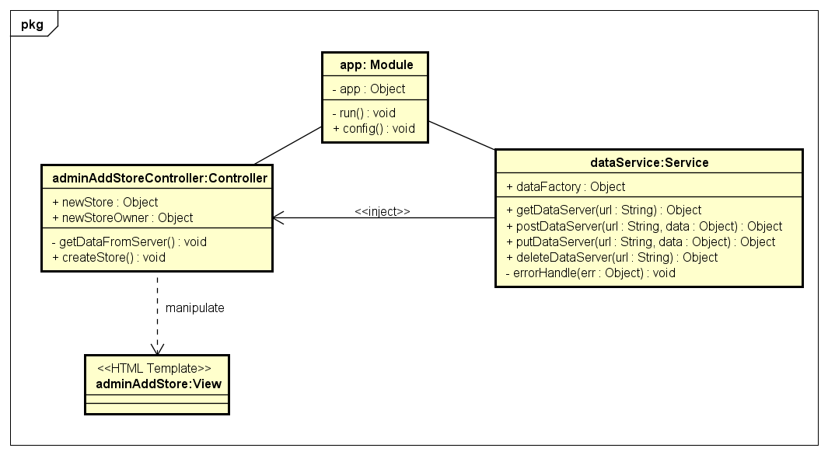

Figure 161.ObjectDiagram of Add Store use case

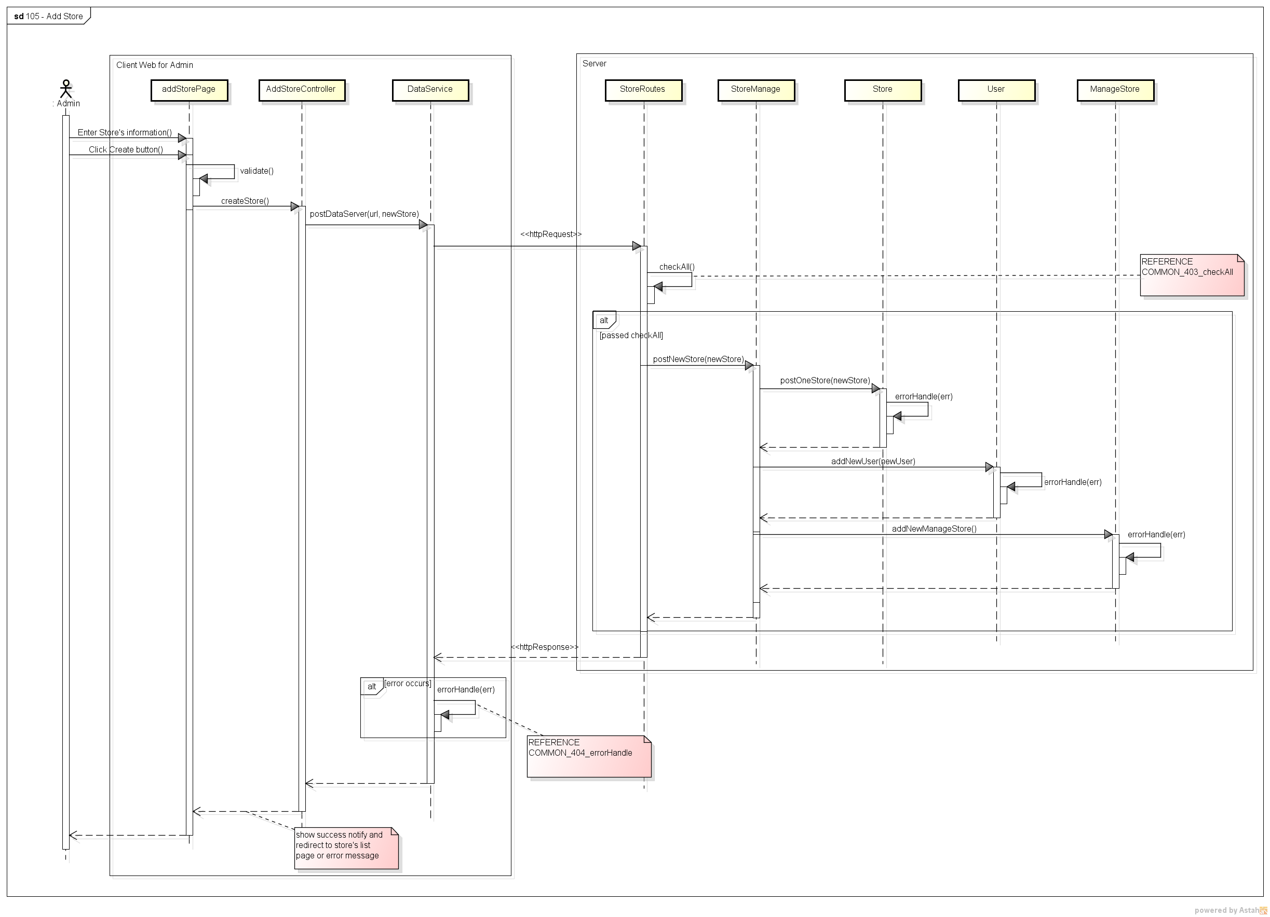

Figure 162.SequenceDiagram of Add Store use case

###### View Store’s List

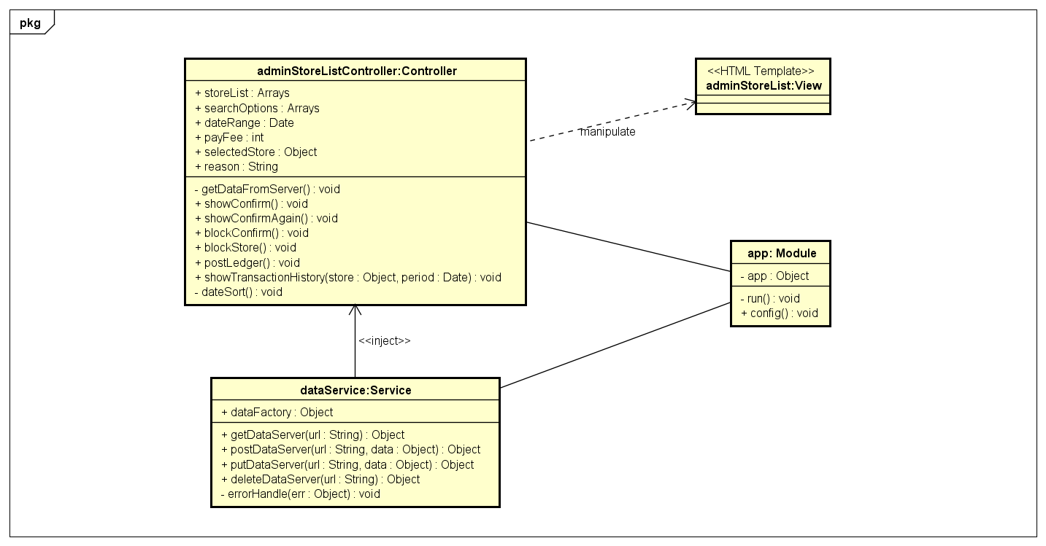

Figure 163.ObjectDiagram of View Store’s List use case

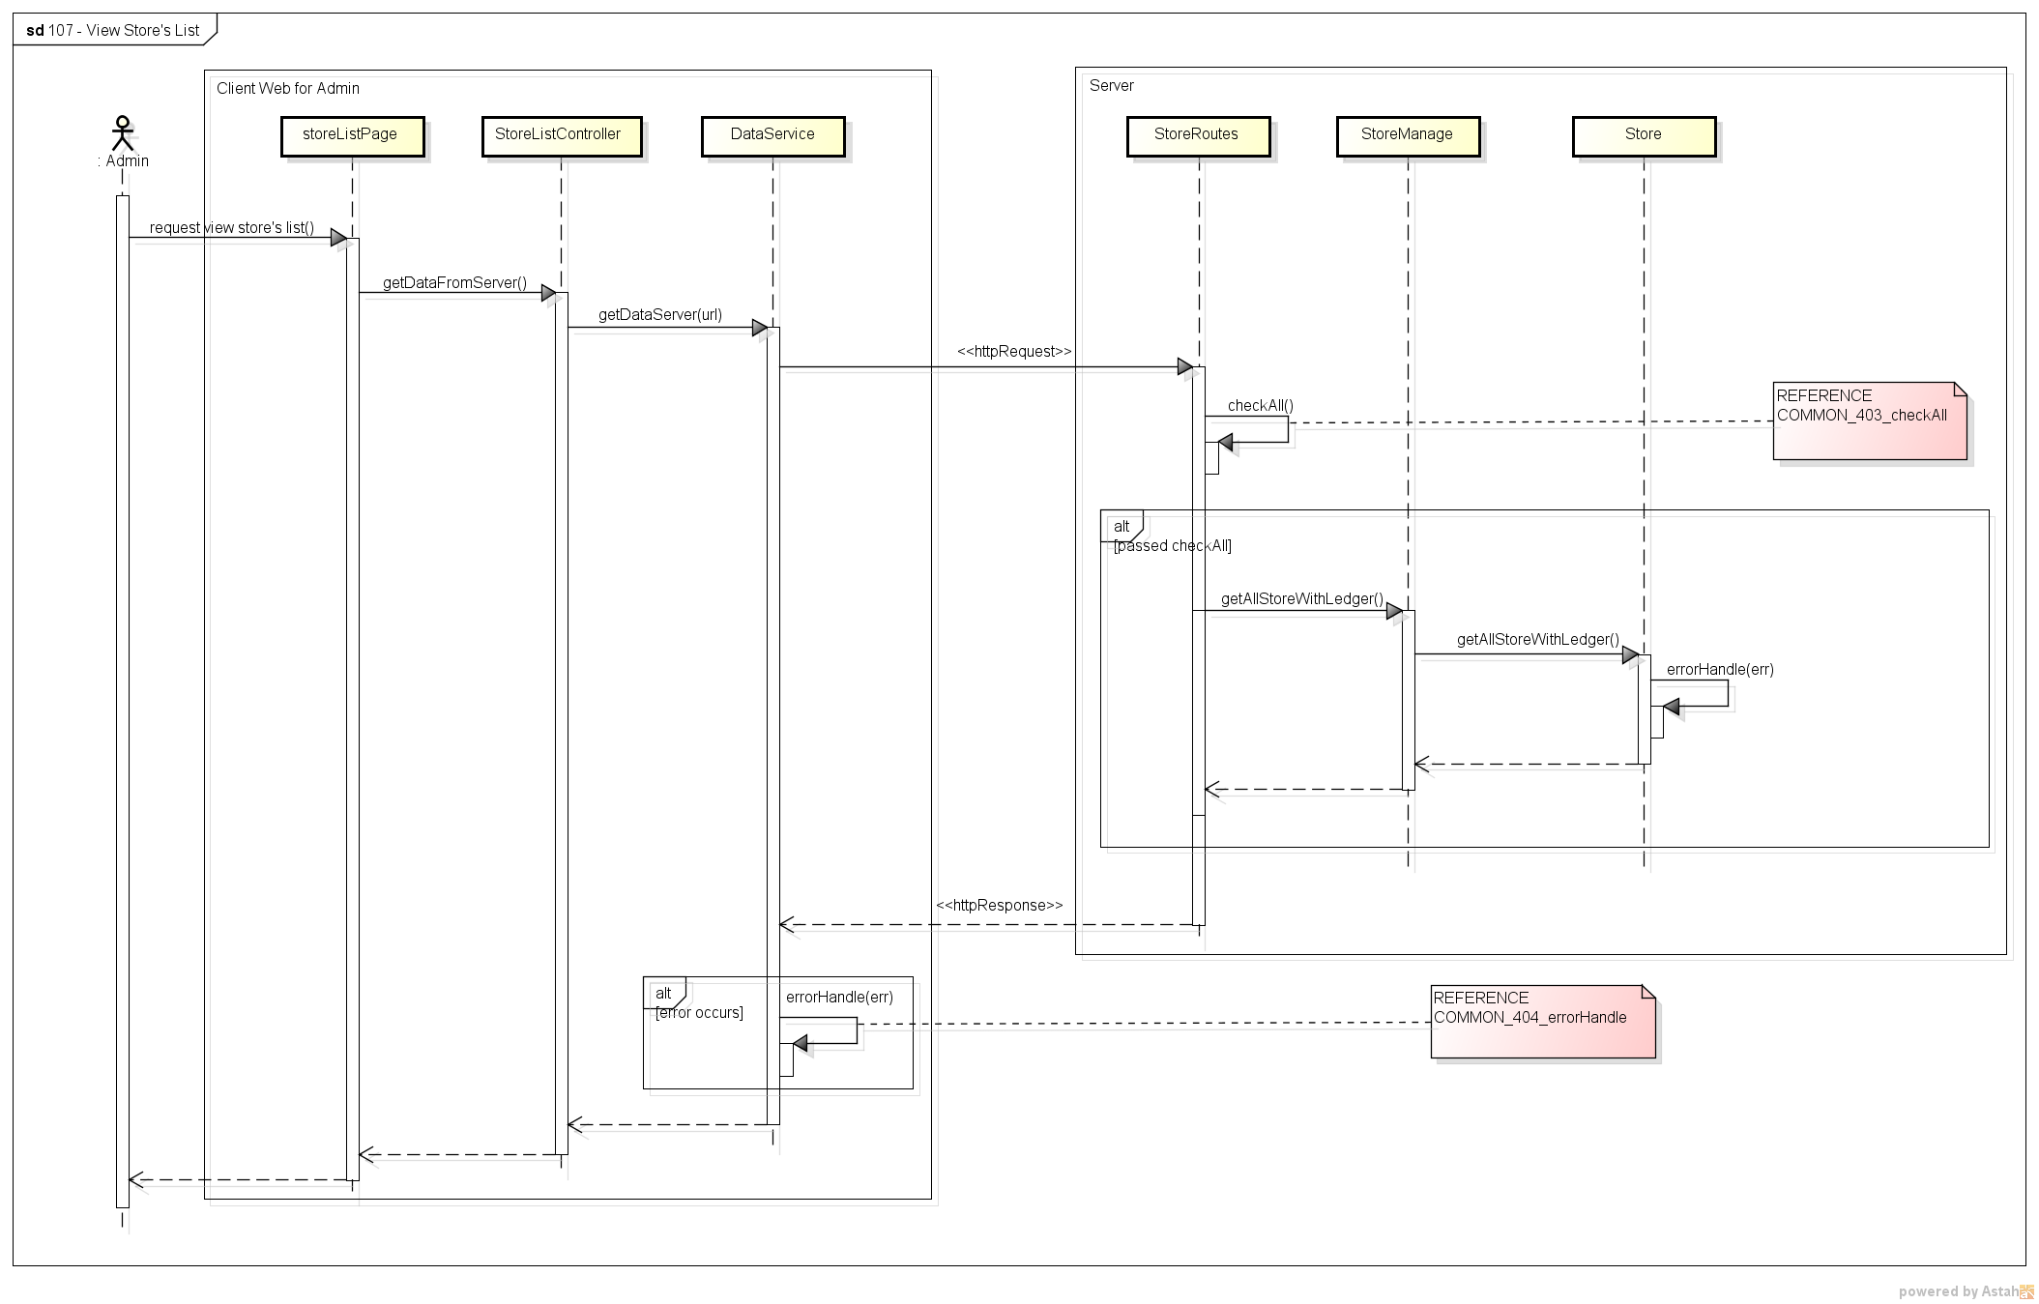

Figure 164.SequenceDiagram of View Store’s List use case

###### Block/Unlock Store

*(*) Object Diagram of Block/Unblock Storeuse case refer to Figure 22*

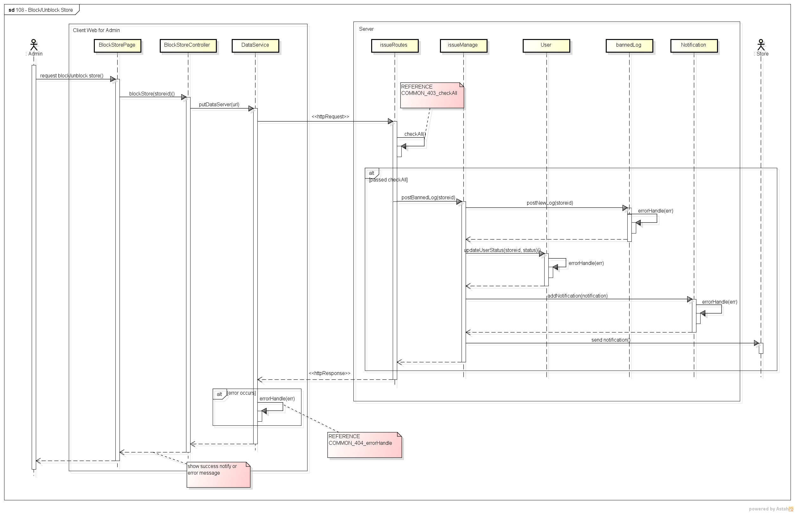

Figure 165.SequenceDiagram of Block/Unblock Store use case

###### View Store’s Detail

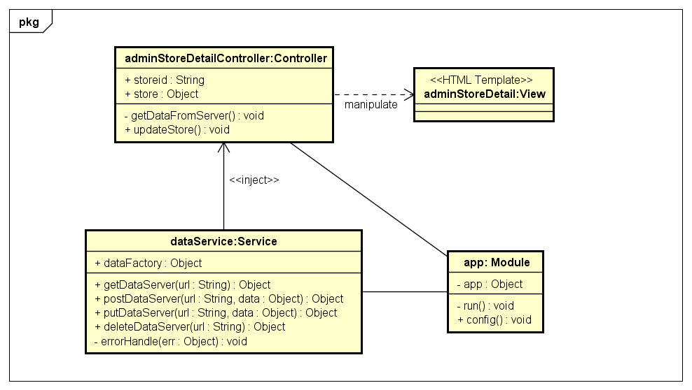

Figure 166.ObjectDiagram of View Store’s Detail use case

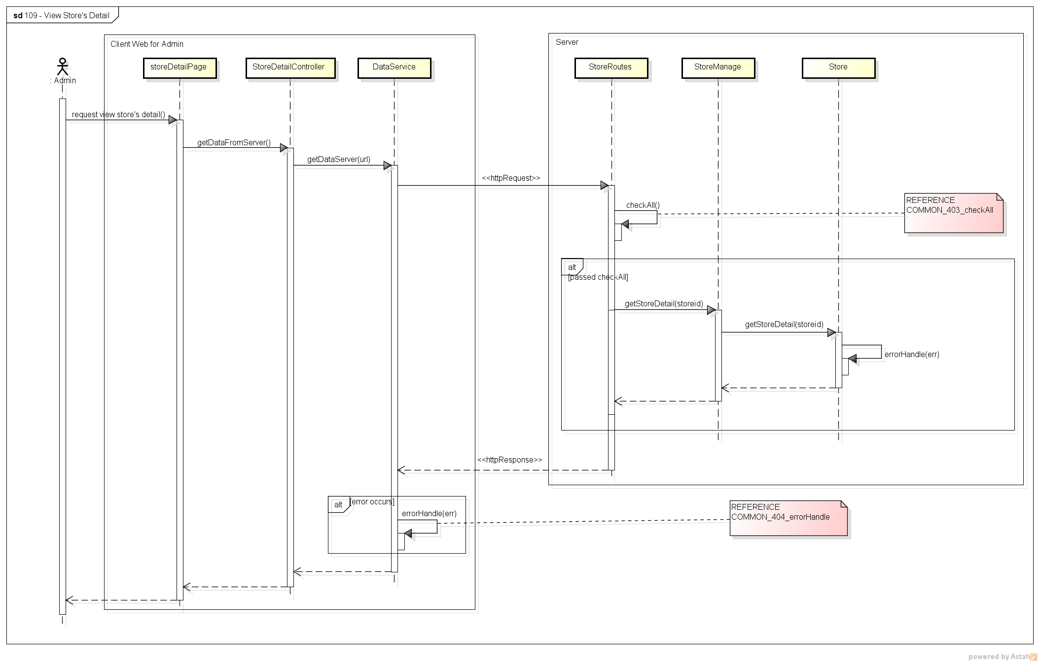

Figure 167.SequenceDiagram of View Store’s Detail use case

###### Confirm Payment

*(*) Object Diagram of Confirm Paymentuse case refer to Figure 22*

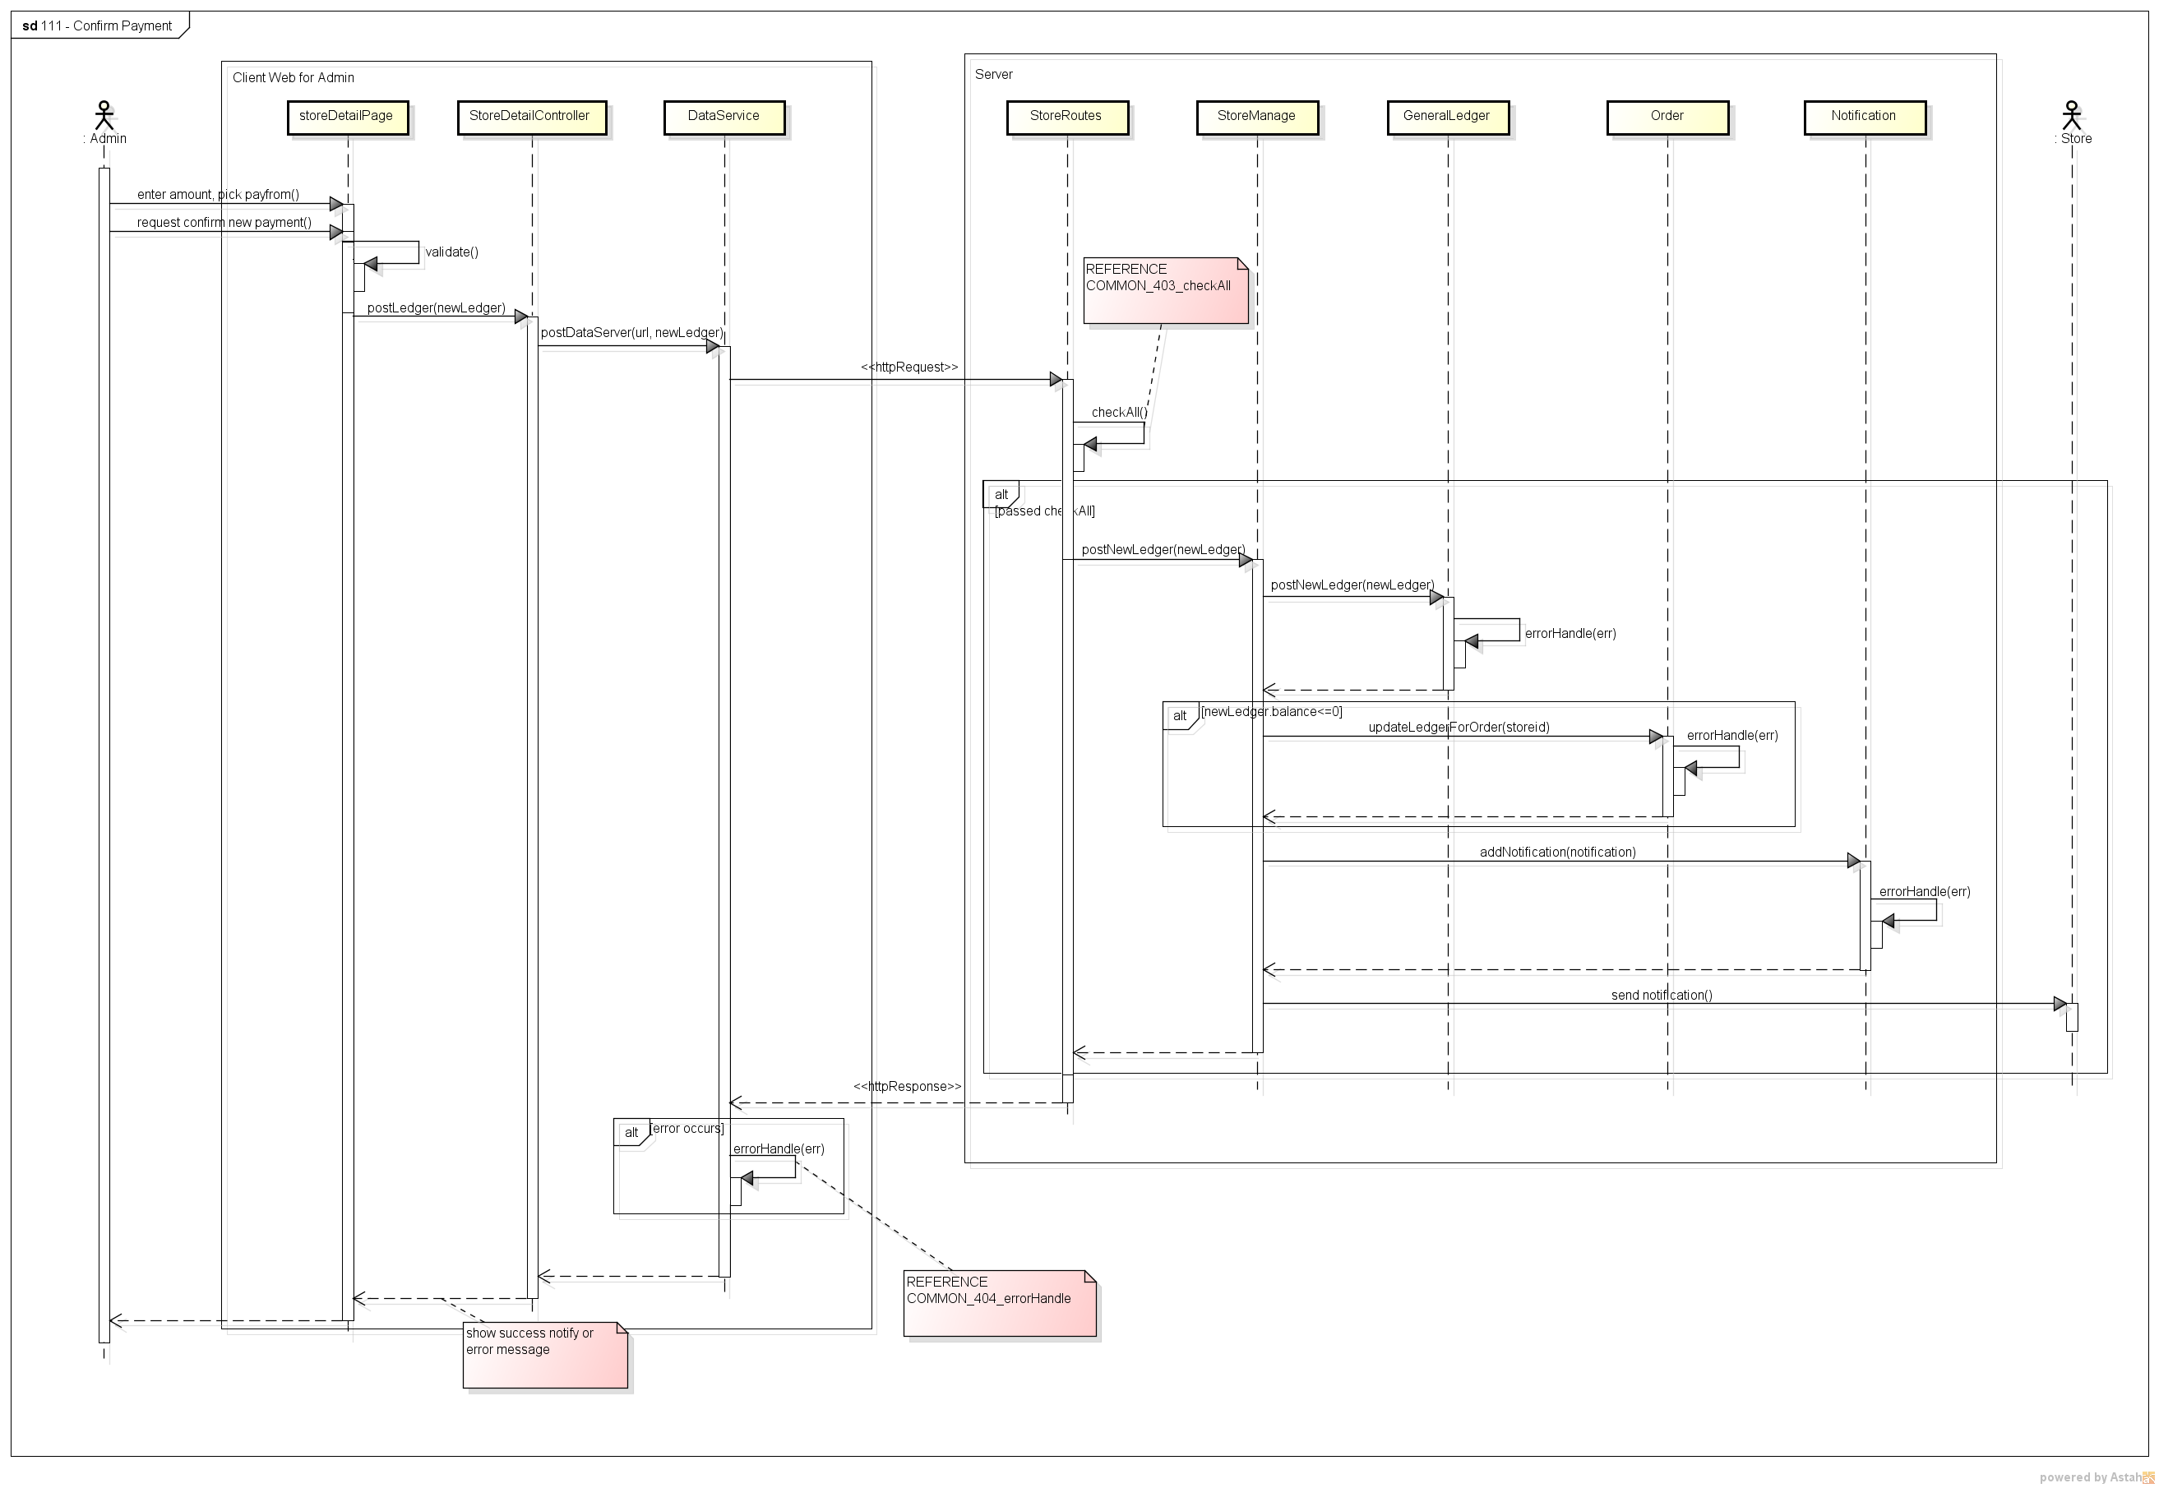

Figure 168.SequenceDiagram of Confirm Payment use case

###### View Transaction History

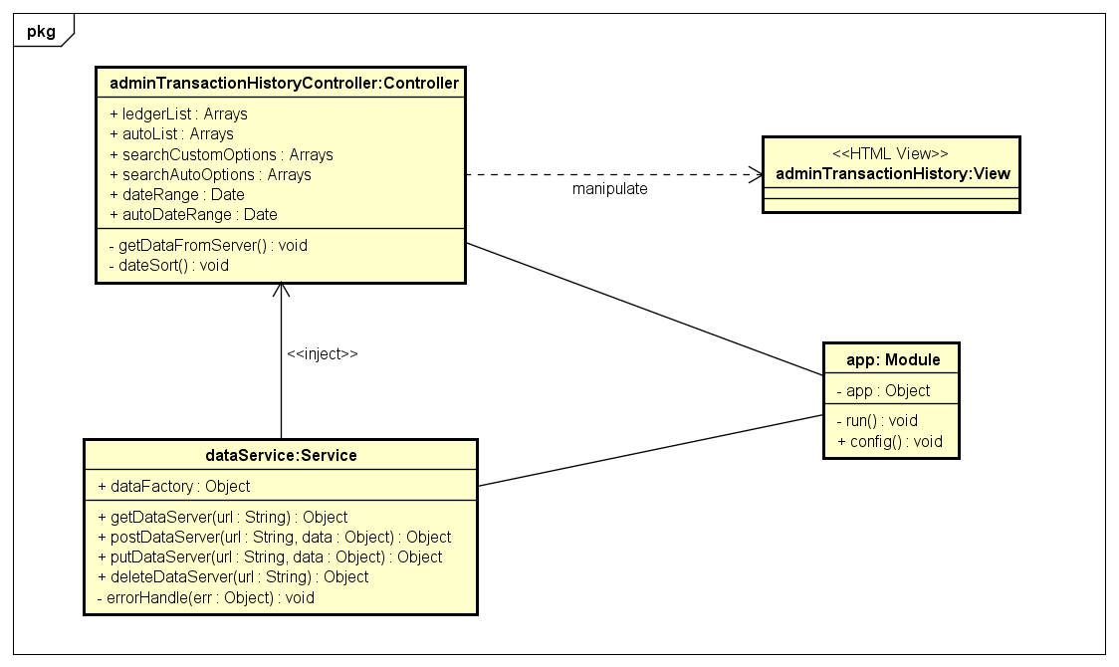

Figure 169.ObjectDiagram of View Transaction History use case

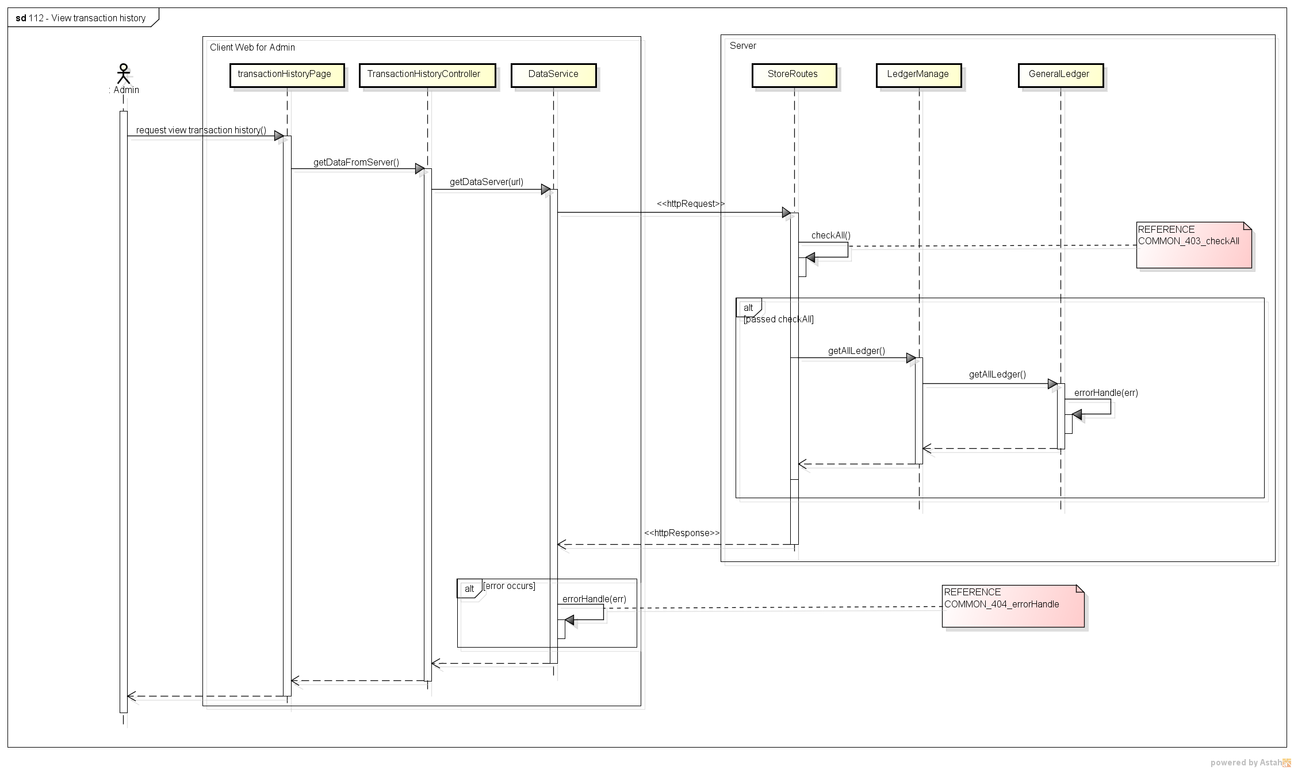

Figure 170SequenceDiagram of View Transaction History use case

###### Add Shipper

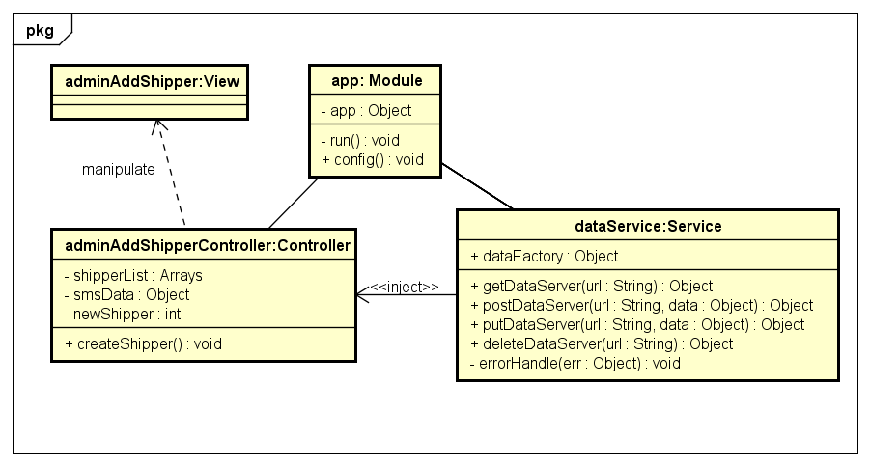

Figure 171.ObjectDiagram of Add Shipper use case

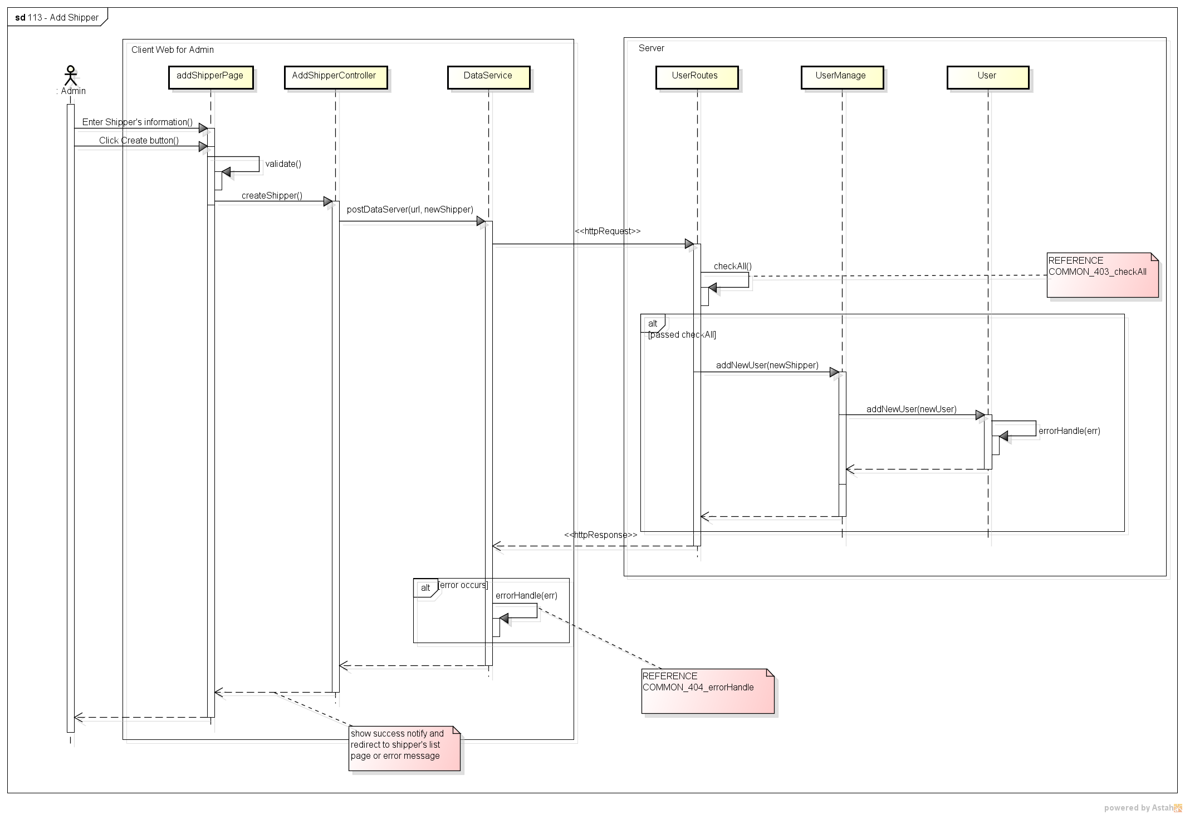

Figure 172.SequenceDiagram of Add Shipper use case

###### View Shipper’s List

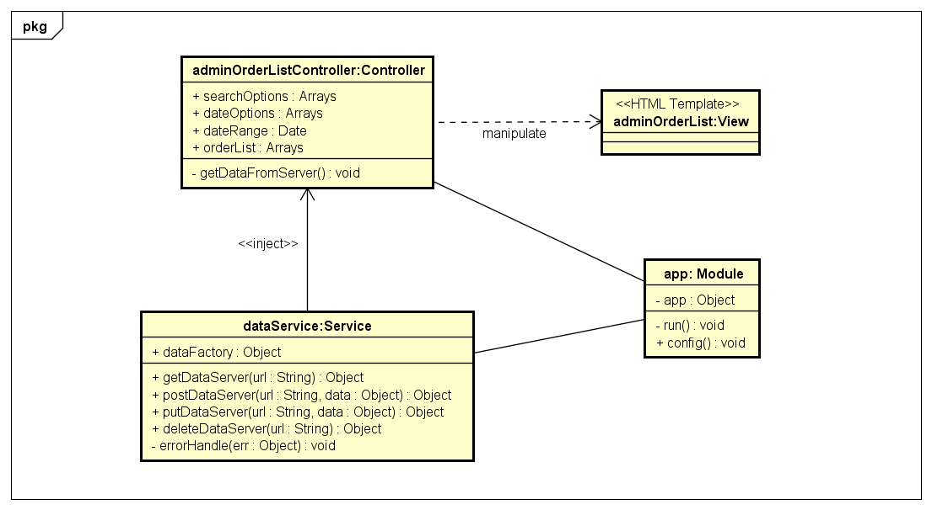

Figure 173.ObjectDiagram of View Shipper’s List use case

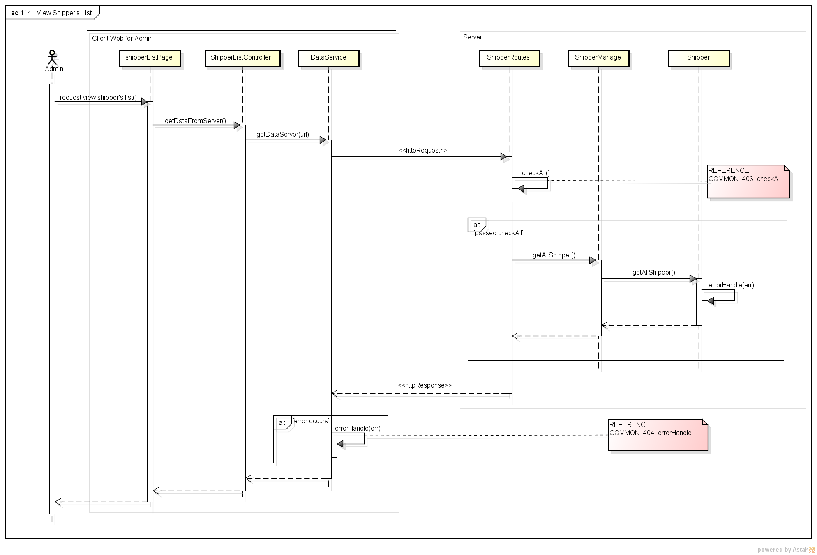

Figure 174.SequenceDiagram of View Shipper’s List use case

###### View Order’s List

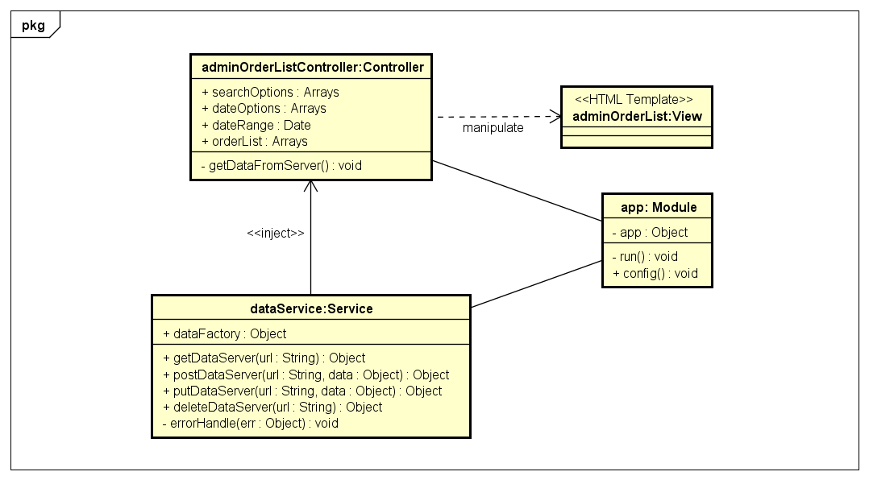

Figure 175.ObjectDiagram of View Order’s List use case

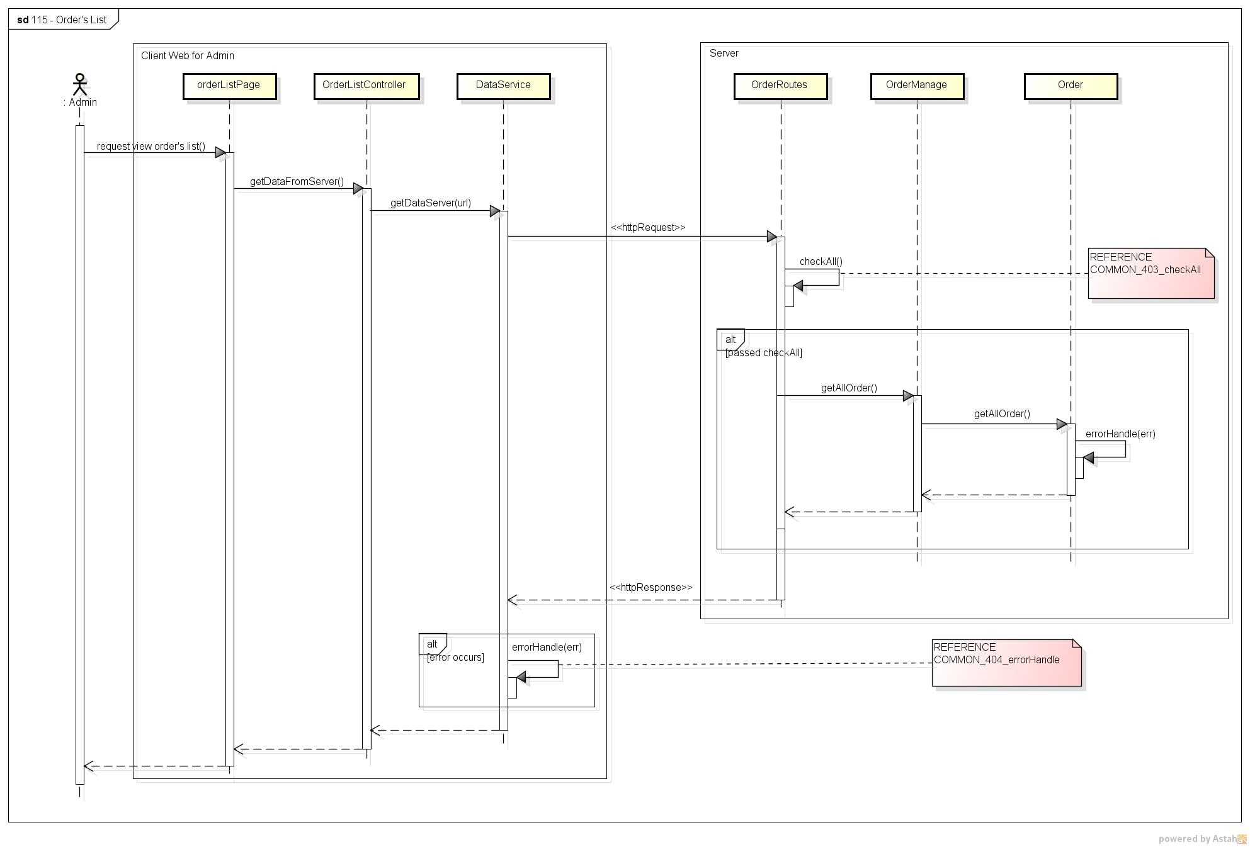

Figure 176.SequenceDiagram of View Order’s List use case

###### View User’s Detail

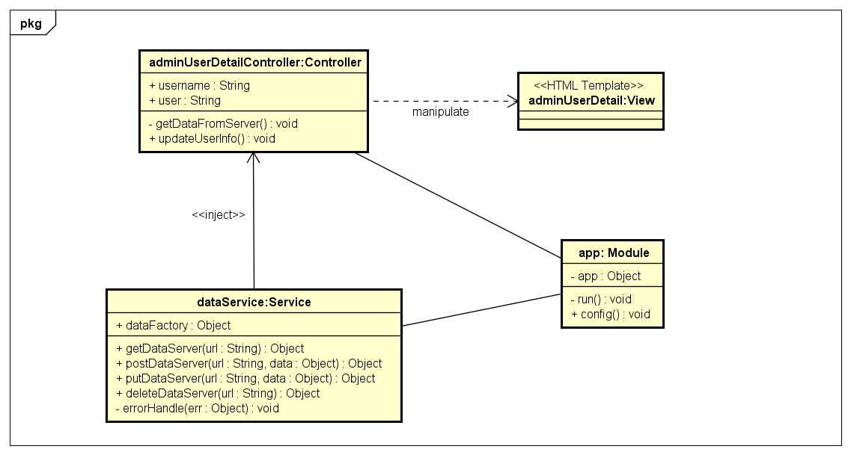

Figure 177.ObjectDiagram of View User’s Detail use case

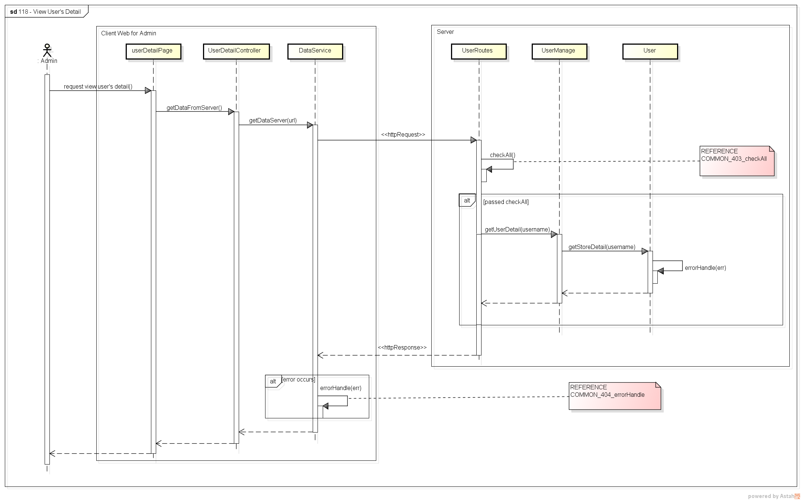

Figure 178.SequenceDiagram of View User’s Detail use case

###### Update User’s Profile

*(*) Object Diagram of Update User’s Profileuse case refer to Figure 37*

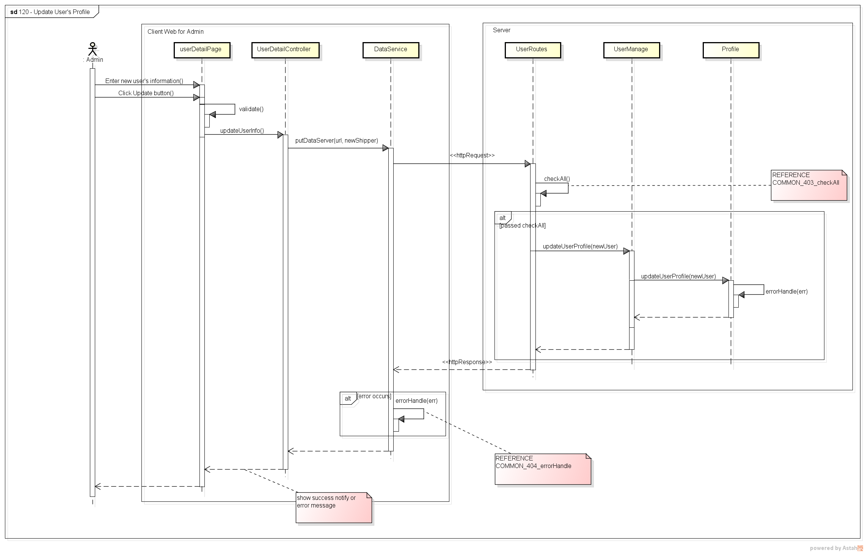

Figure 179.SequenceDiagram of Update User’s Profile use case

###### Update Store’s Information

*(*) Object Diagram of Update Store’s Informationuse case refer to Figure 25*

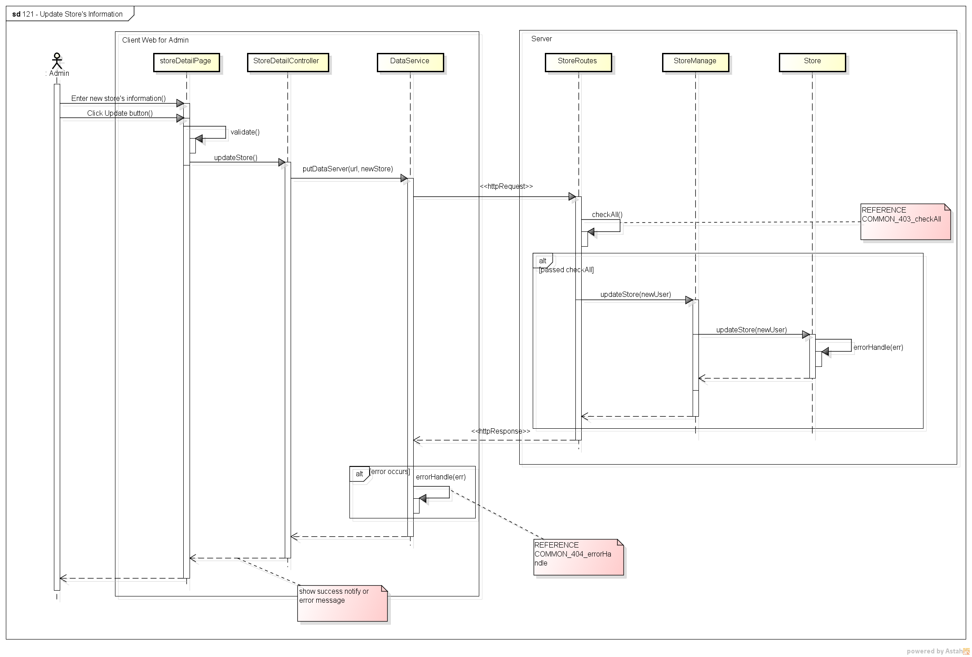

Figure 180.SequenceDiagram of Update Store’s Information use case

###### Assign Task

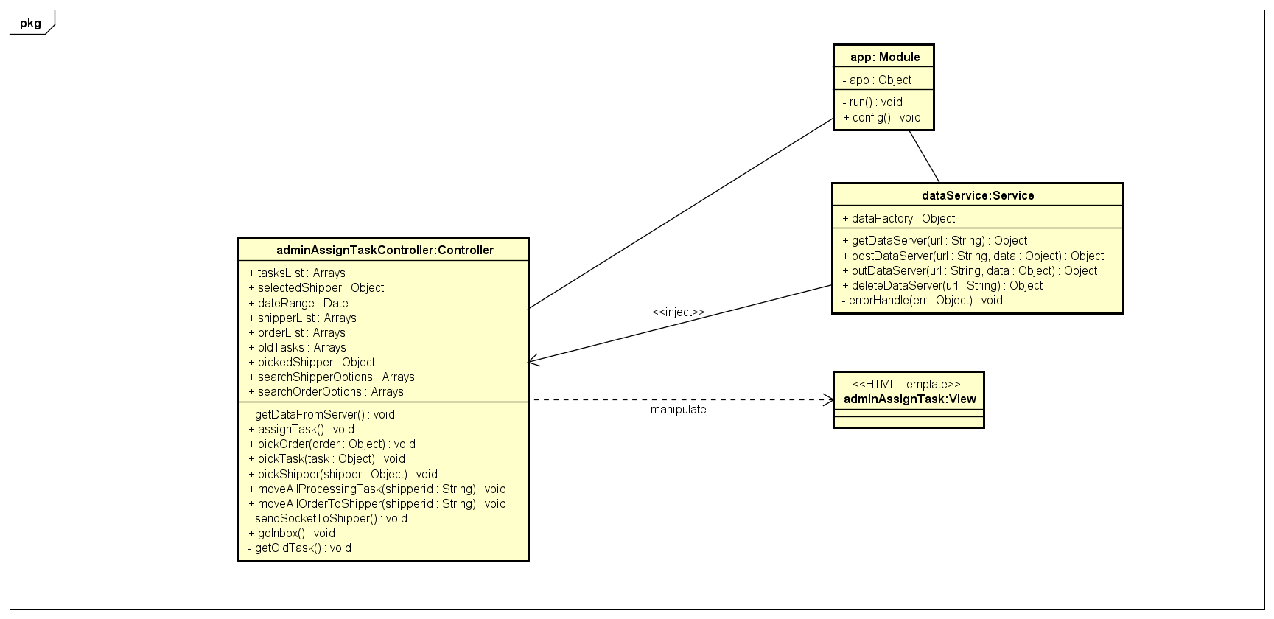

Figure 181.ObjectDiagram of Assign Task use case

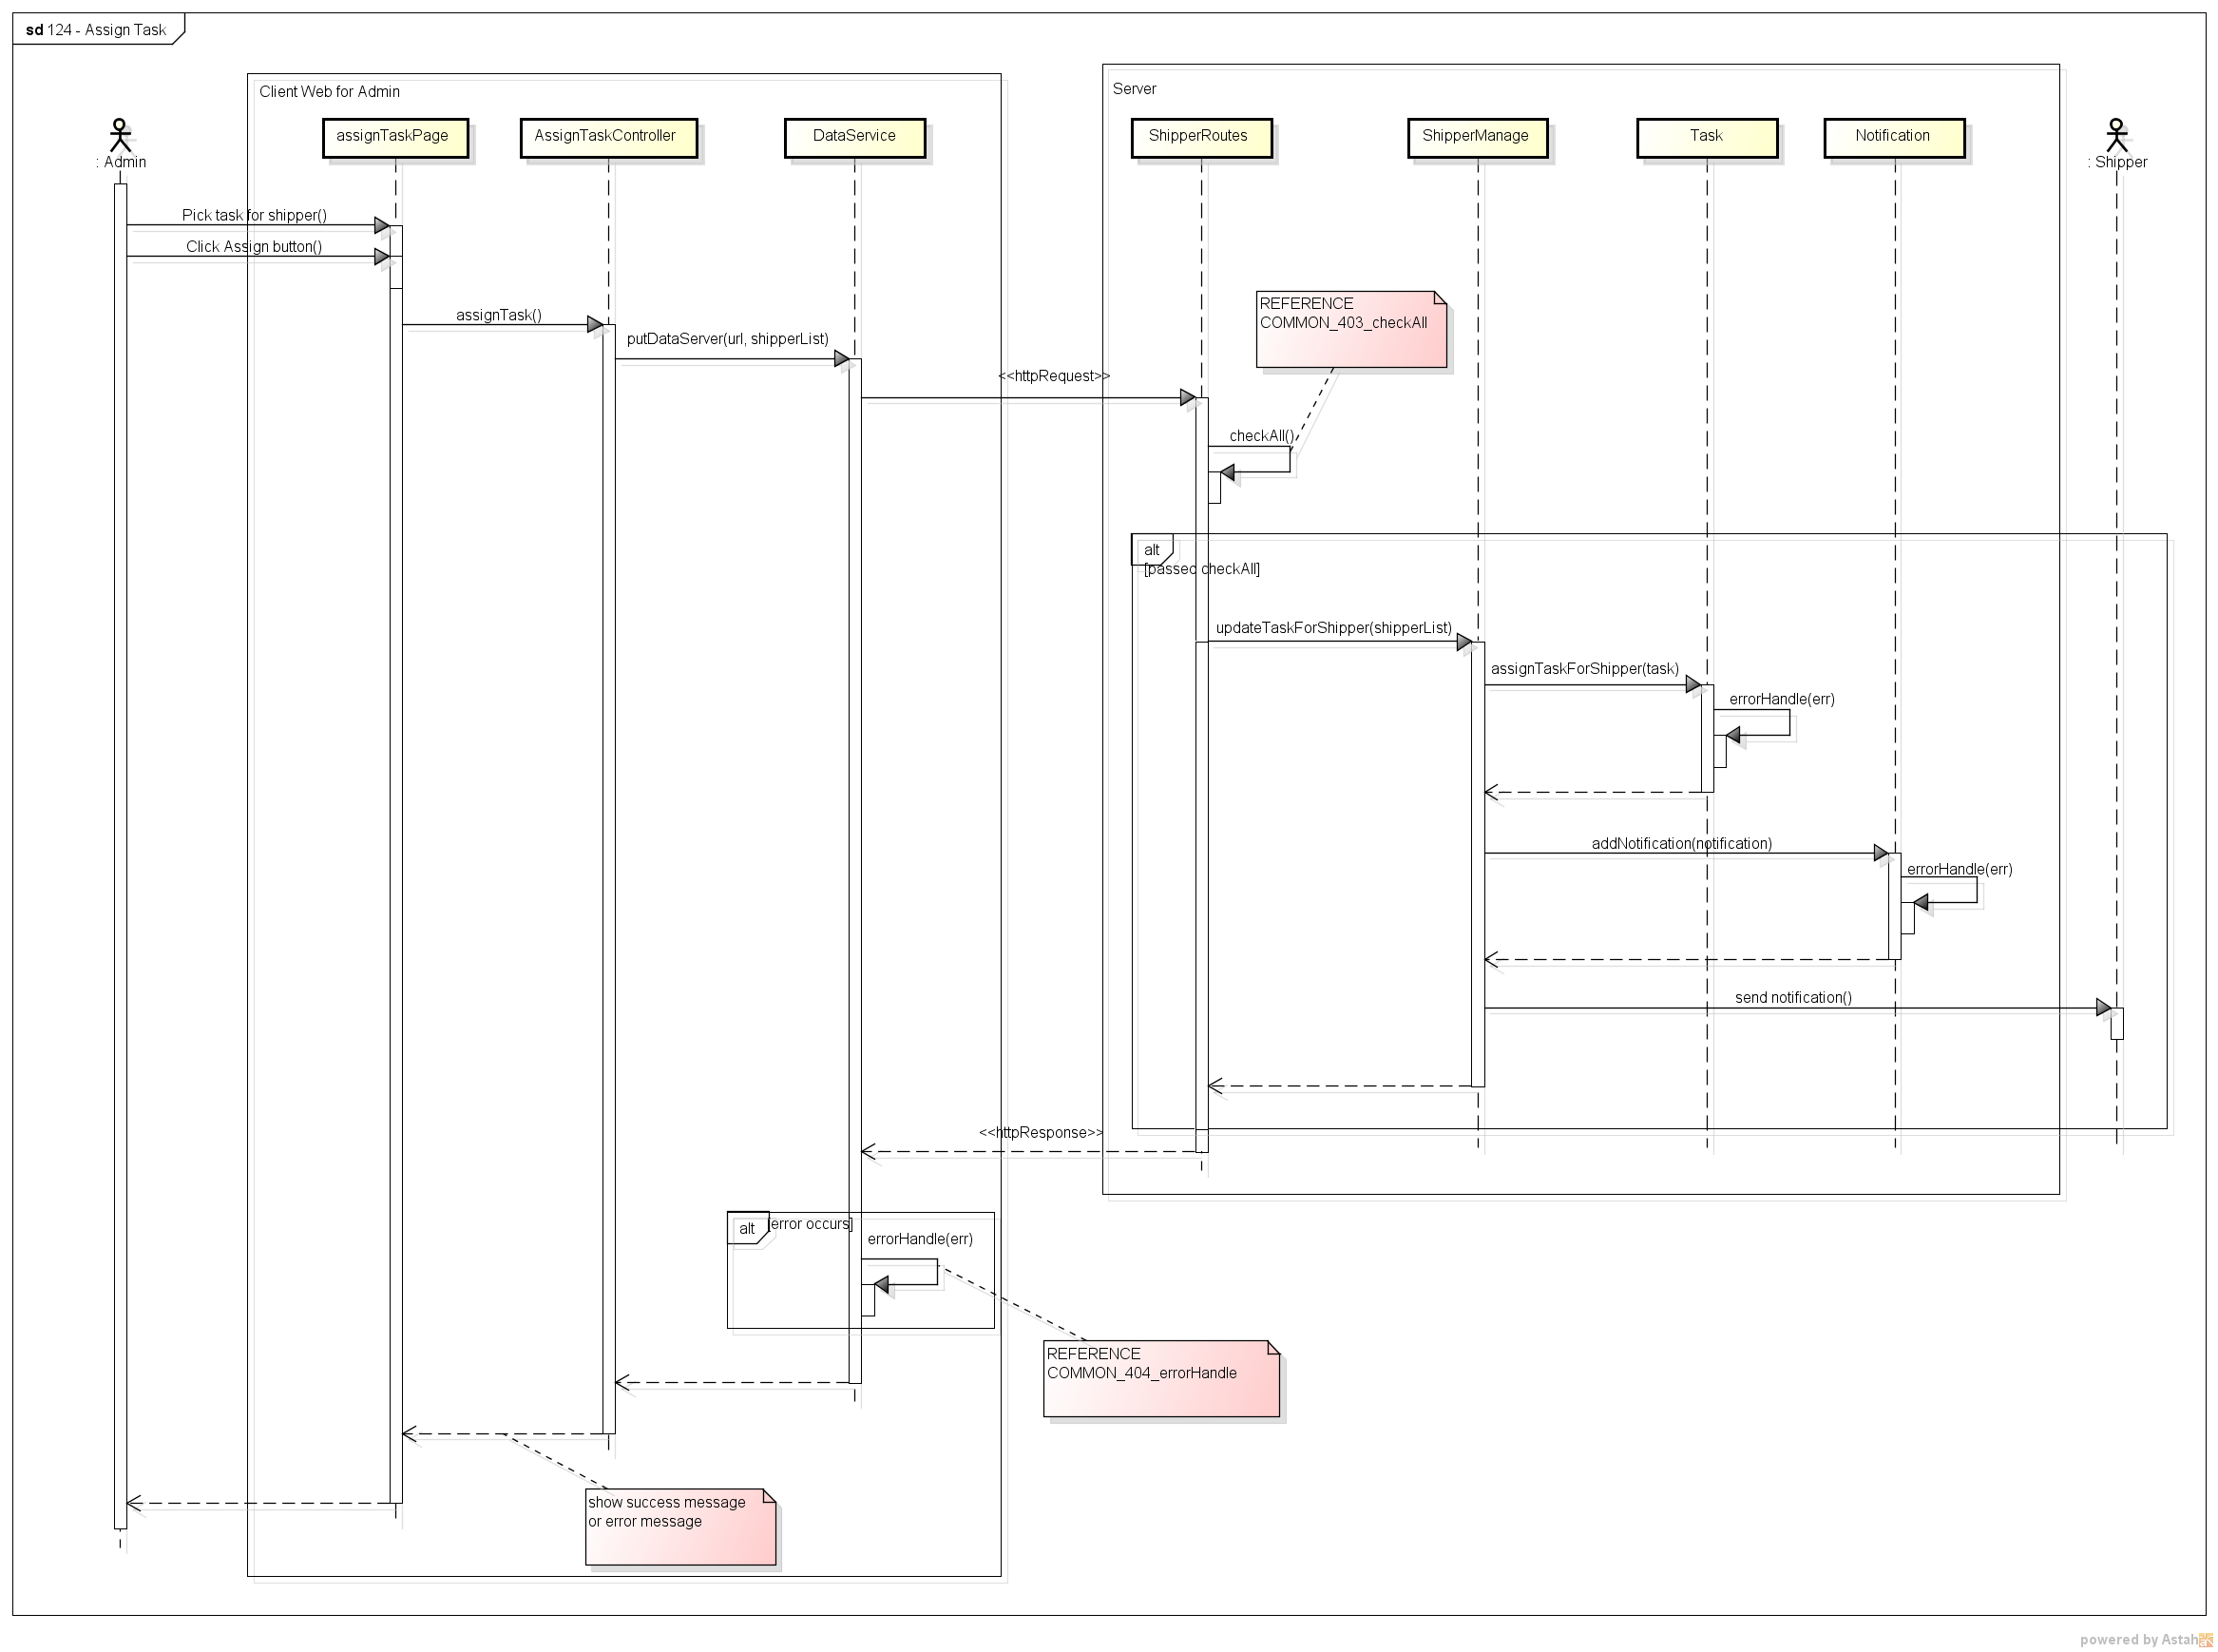

Figure 182.SequenceDiagram of Assign Task use case

###### View Dashboard

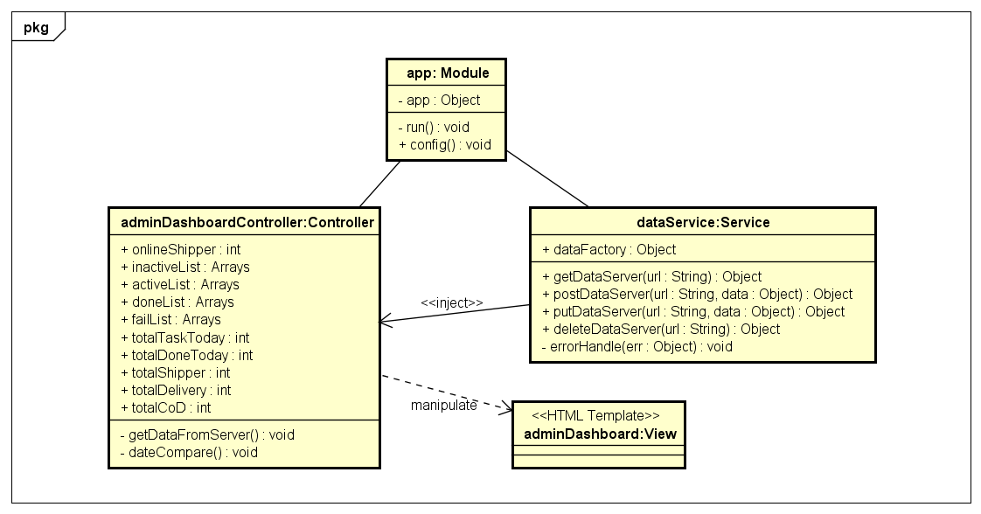

Figure 183.ObjectDiagram of View Dashboard use case

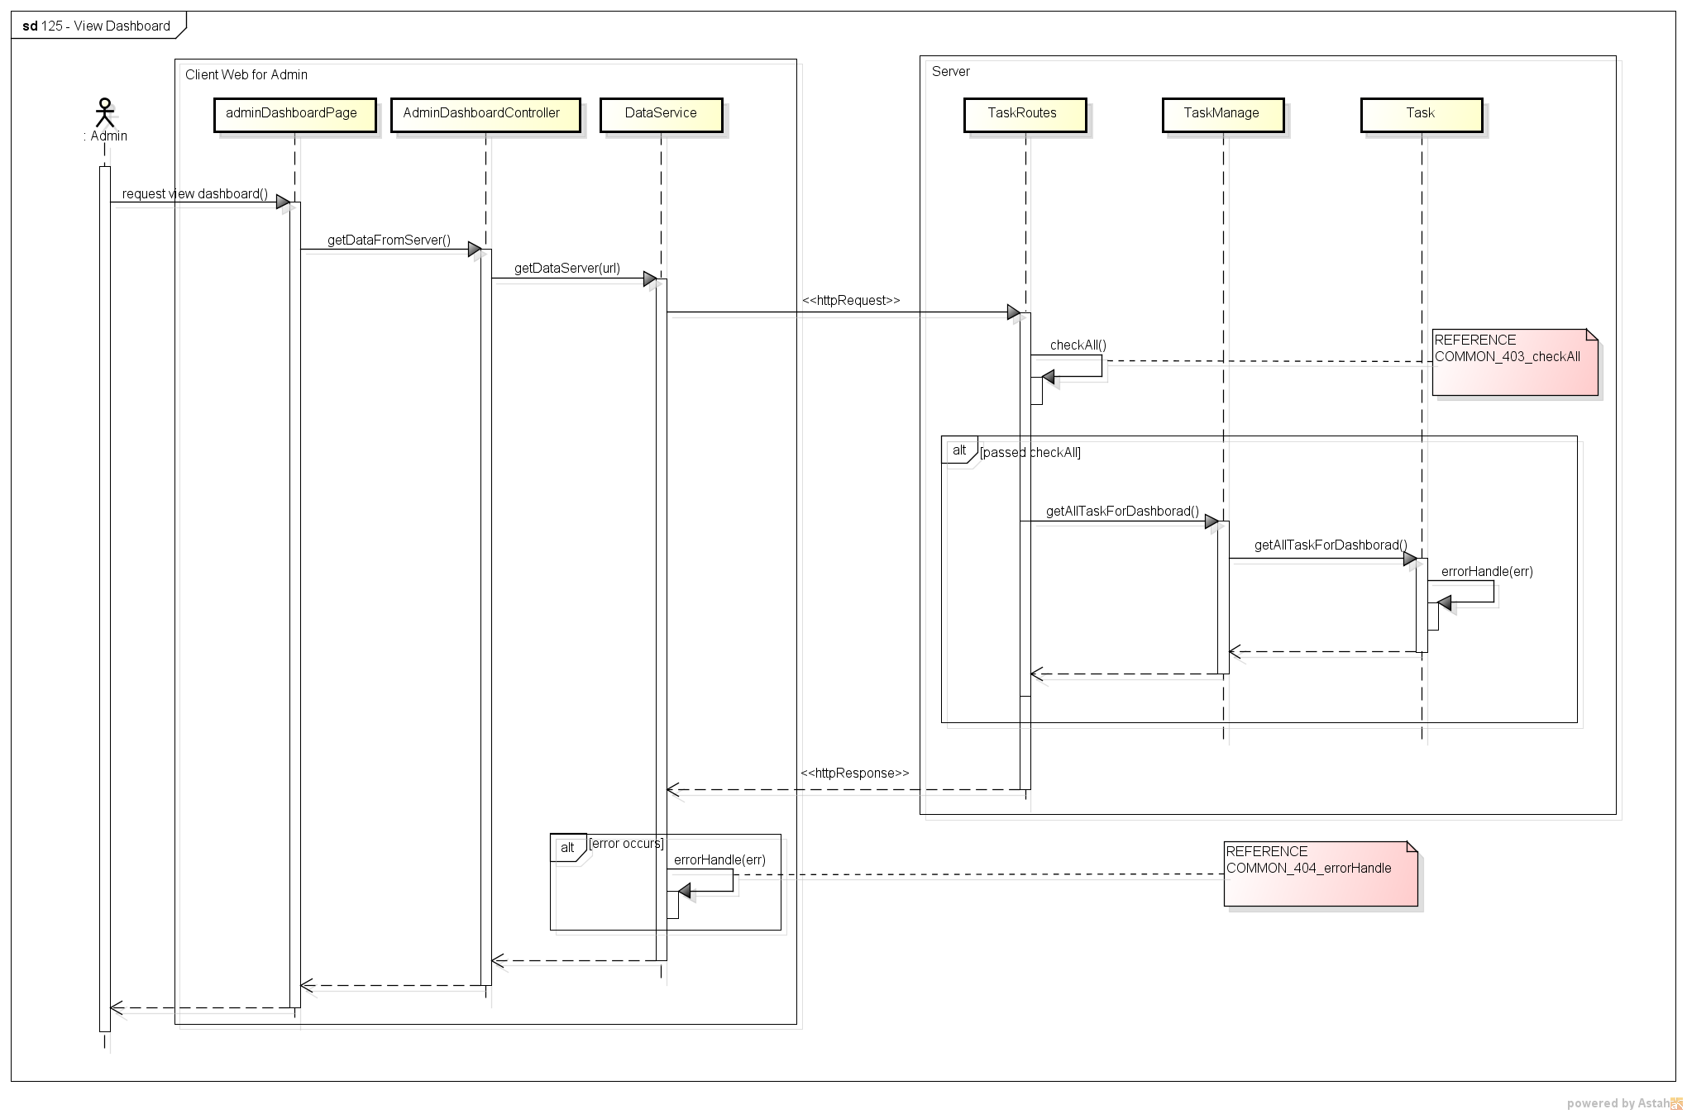

Figure 184.SequenceDiagram of View Dashboard use case

###### View IssueBox

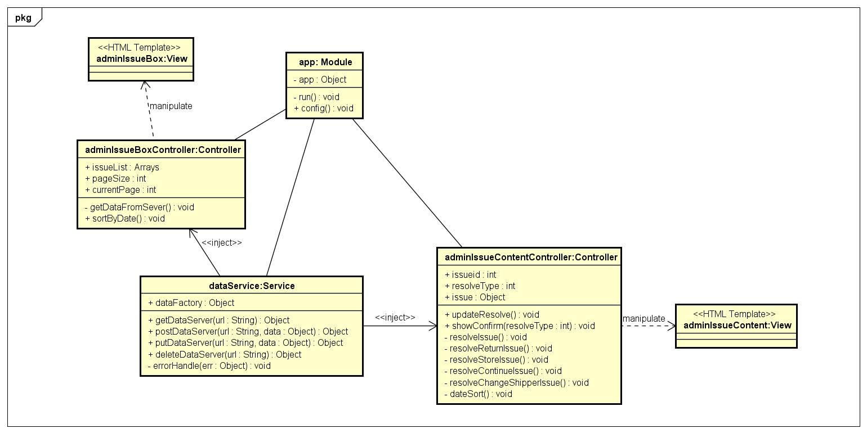

Figure 185.ObjectDiagram of View IssueBox use case

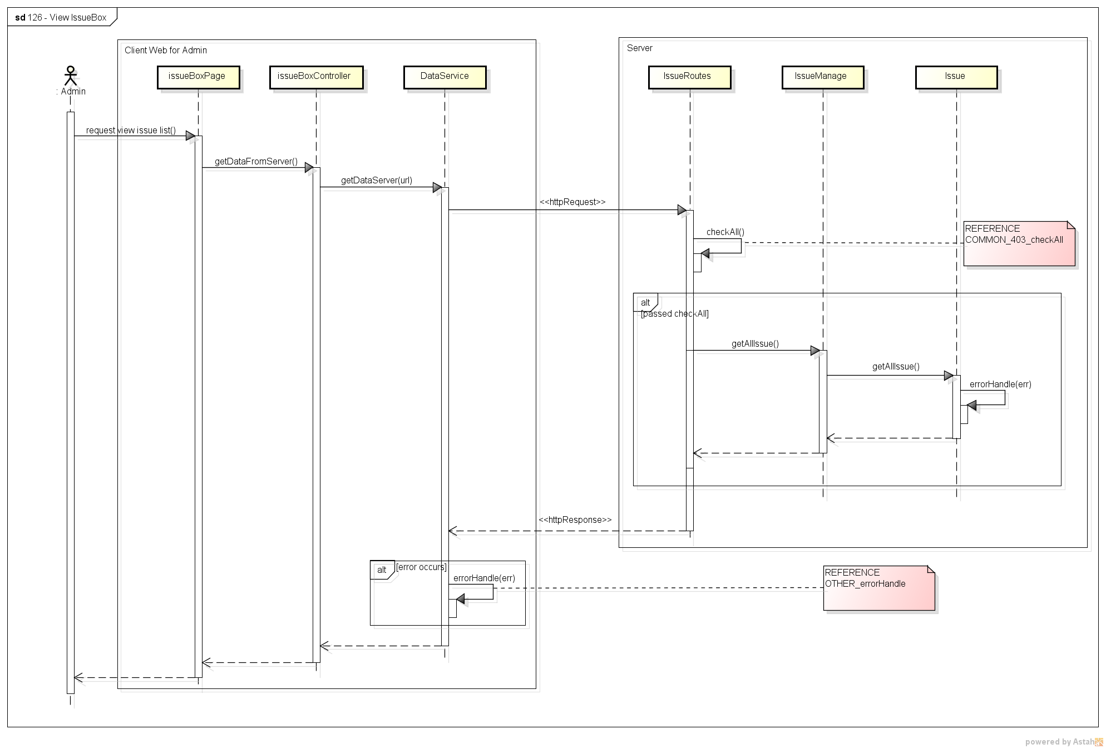

Figure 186.SequenceDiagram of View IssueBox use case

###### Resolve Issue

*(*) Object Diagram of Resolve Issue use case refer to Figure 44*

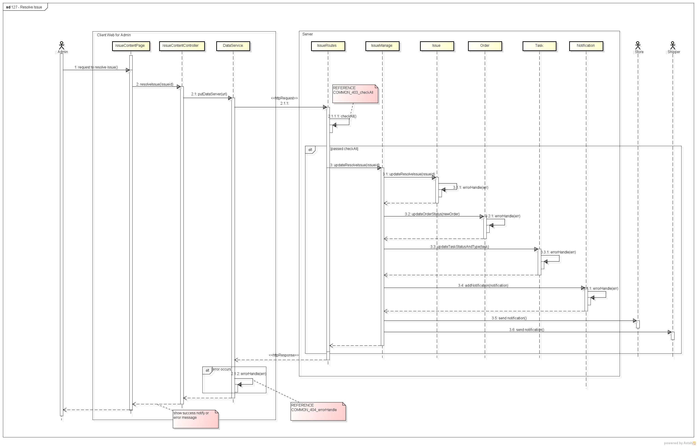

Figure 187.SequenceDiagram of Resolve Issue use case

###### View Task’s List

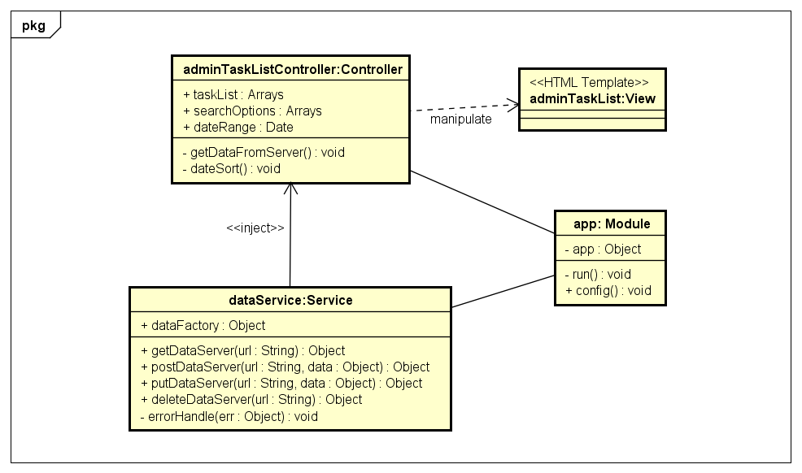

Figure 188.ObjectDiagram of View Task’s List use case

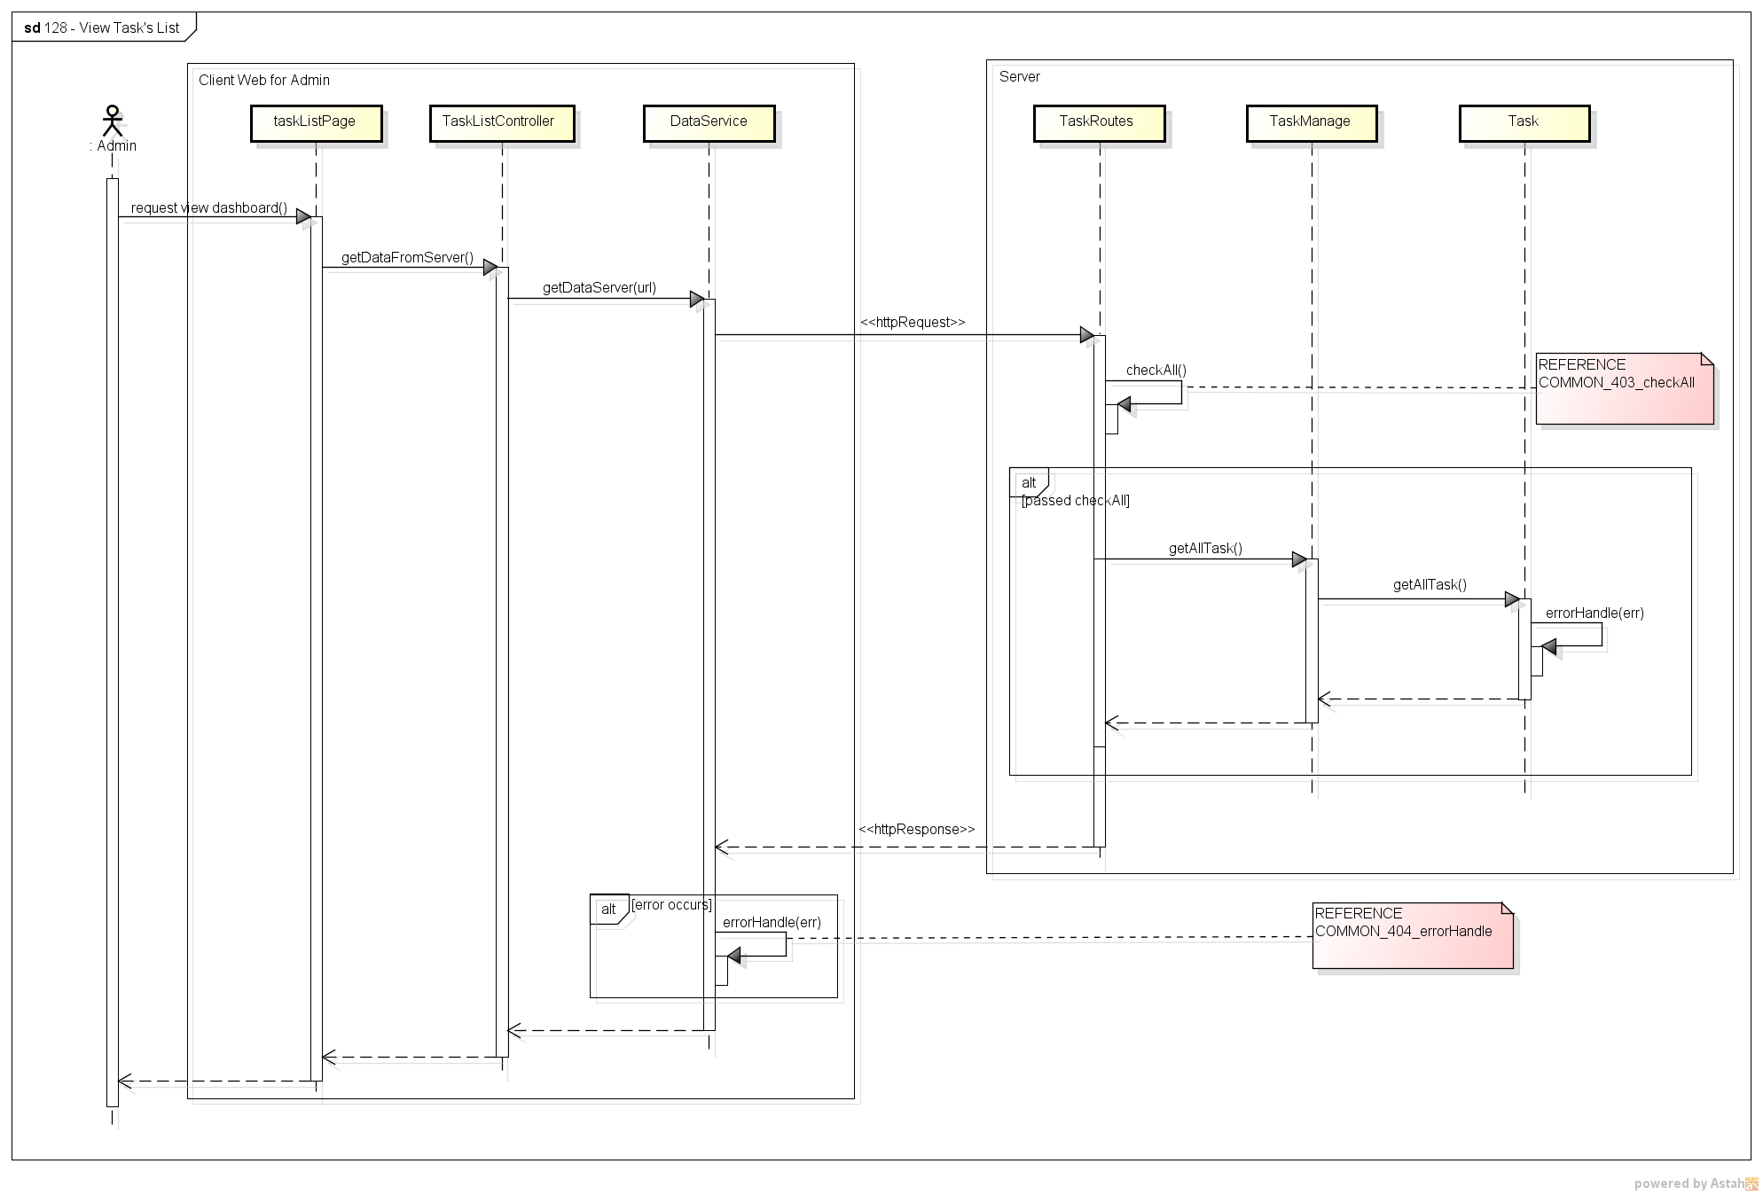

Figure 189.SequenceDiagram of View Task’s List use case

###### View Order’s Detail

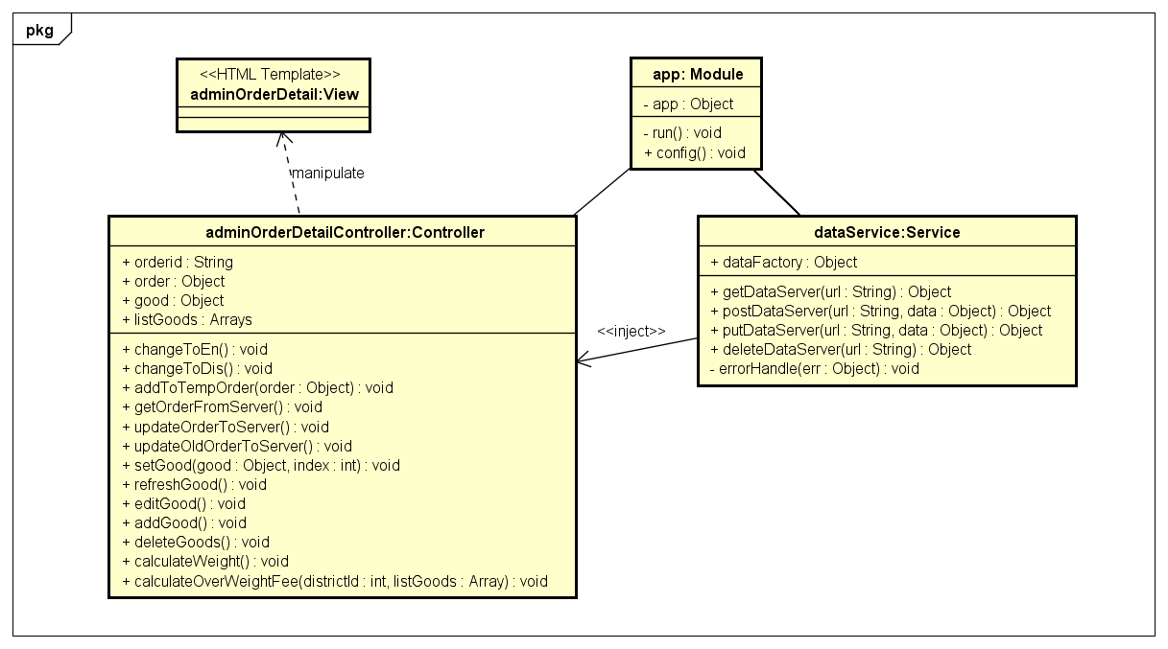

Figure 190.ObjectDiagram of View Order’s Detail use case

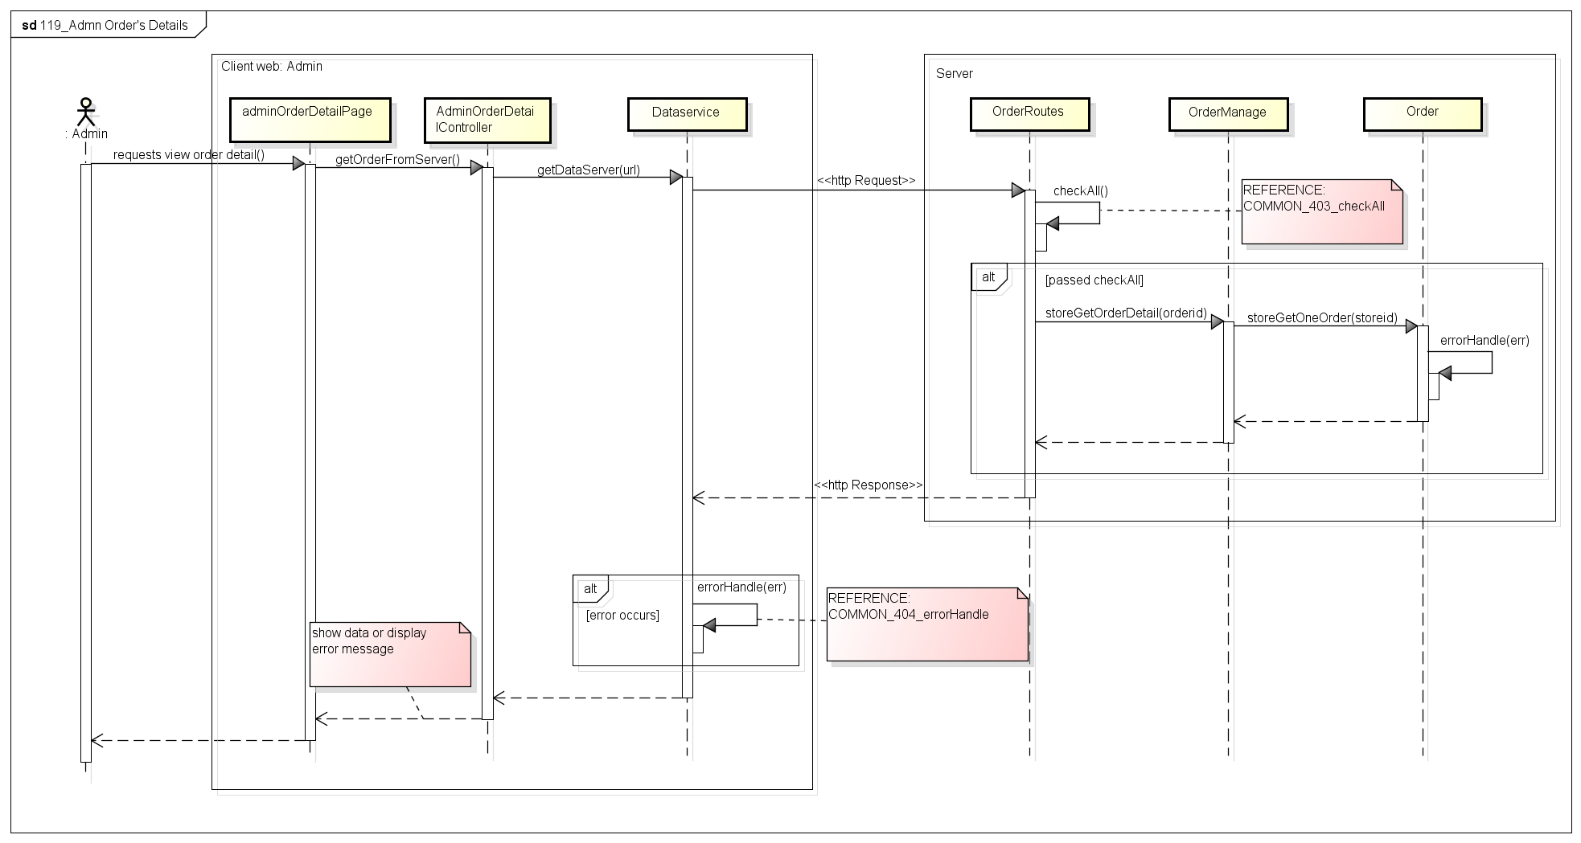

Figure 191.SequenceDiagram of View Order’s Detail use case

###### View Report

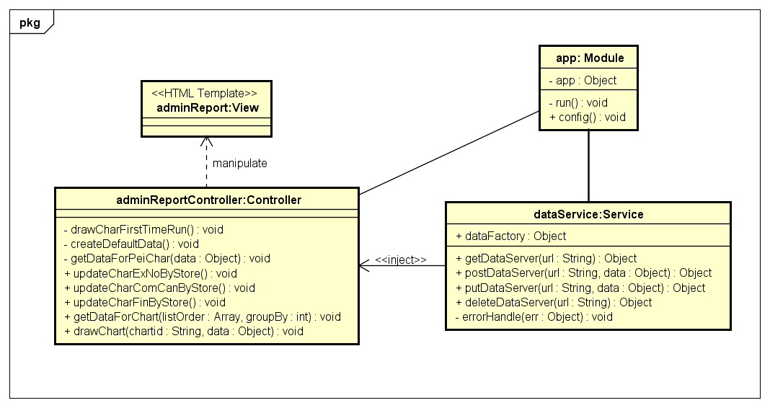

Figure 192.ObjectDiagram of View Report use case

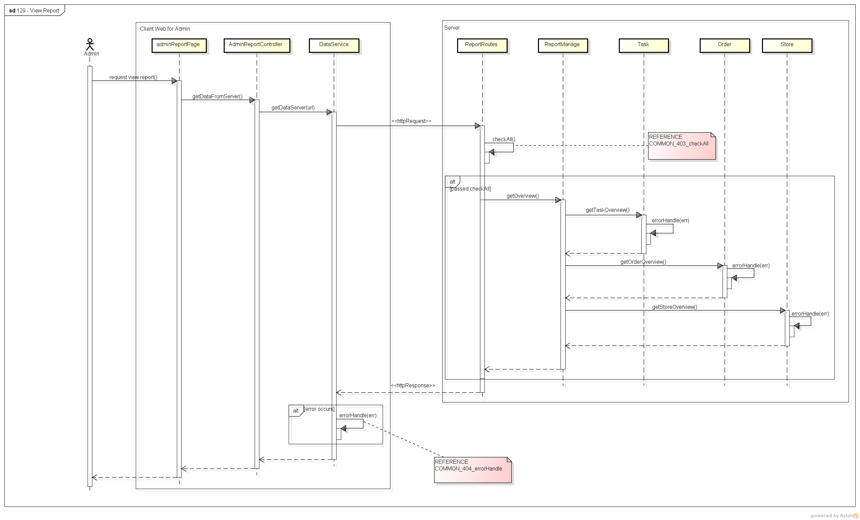

Figure 193.SequenceDiagram of View Report use case

##### **2.2.2.1.2. Store**

###### View Dashboard

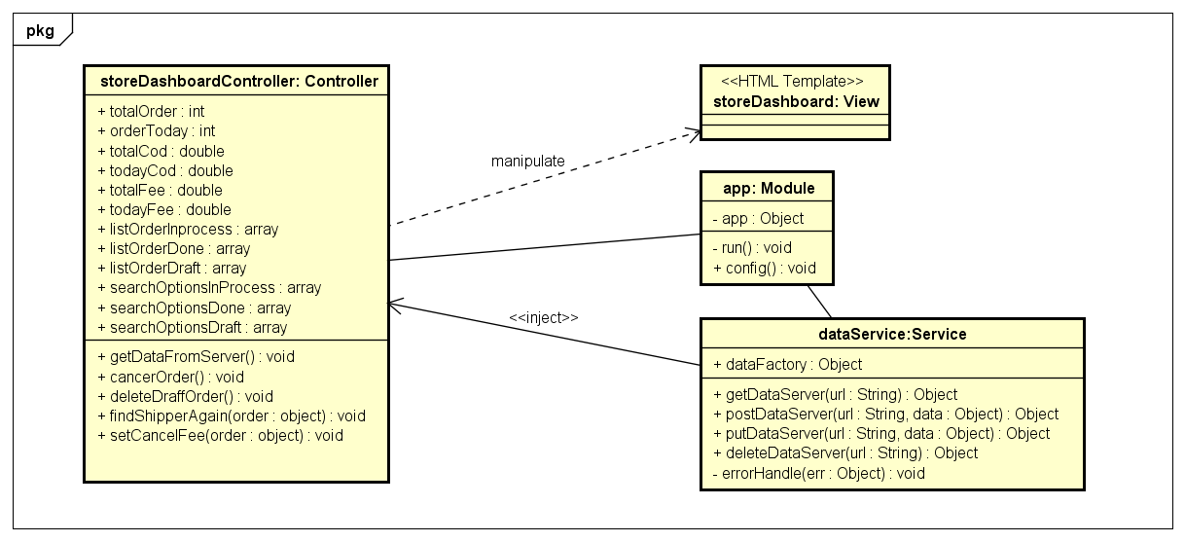

Figure 194. Object Diagram of View Dashboard use case

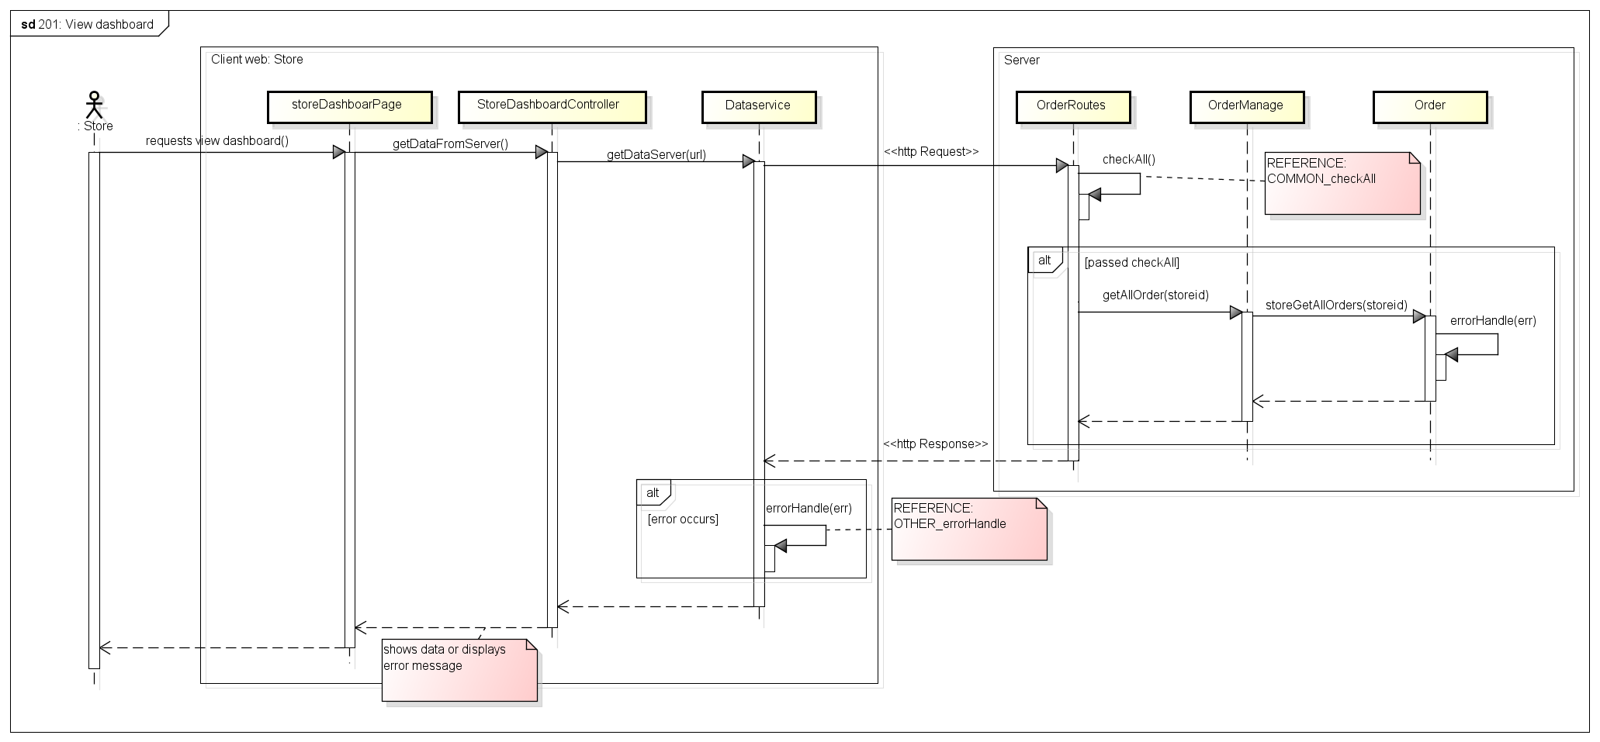

Figure 195.SequenceDiagram of View Dashboard use case

###### View Profile

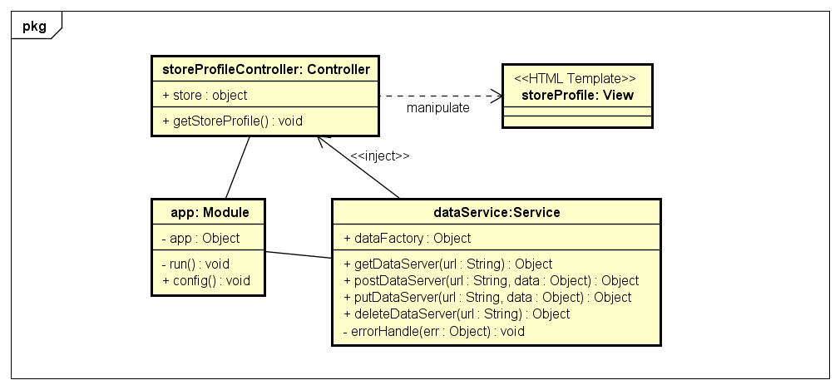

Figure 196. Object Diagram of View Profile use case

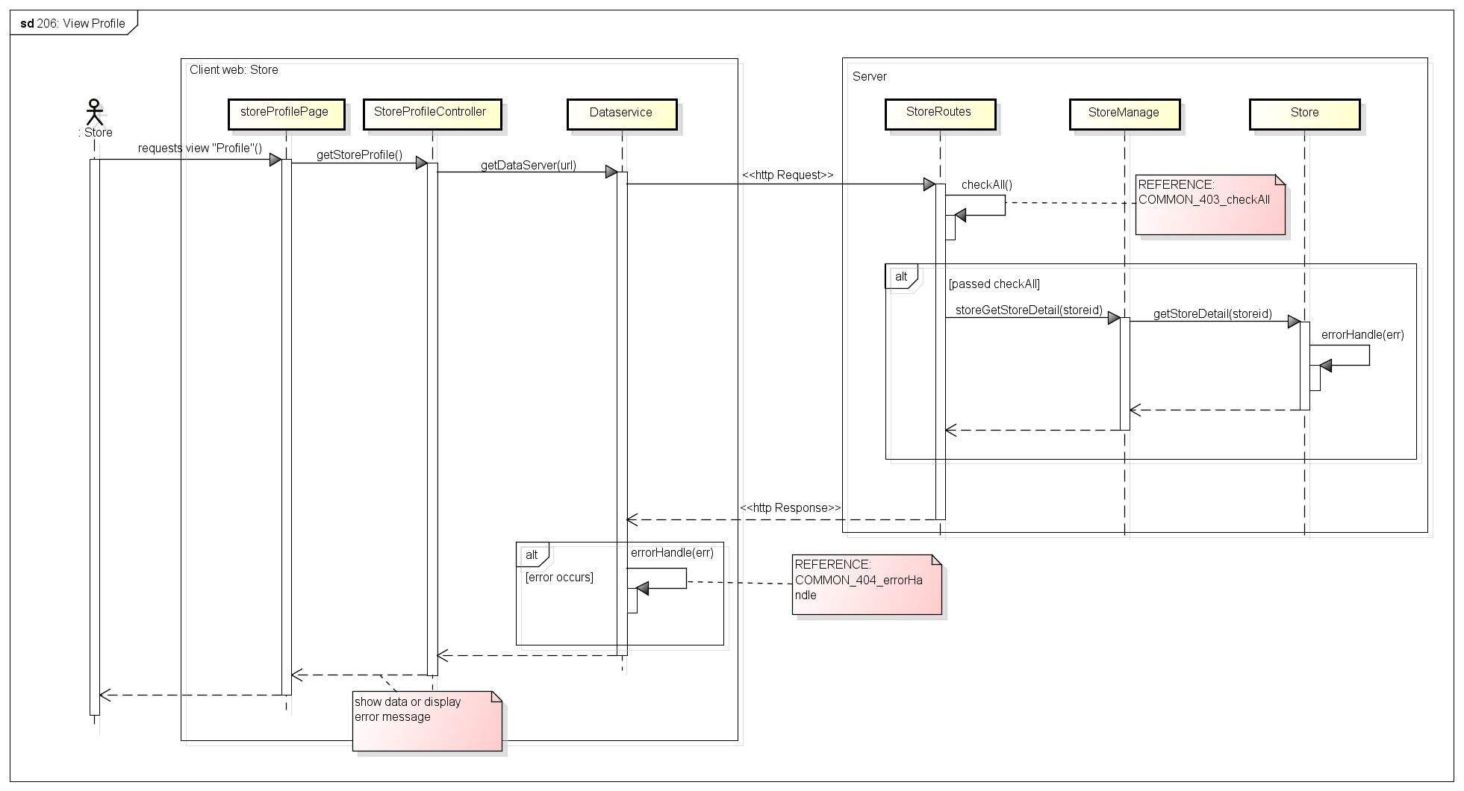

Figure 197. Sequence Diagram of View Profile use case

###### Create Order

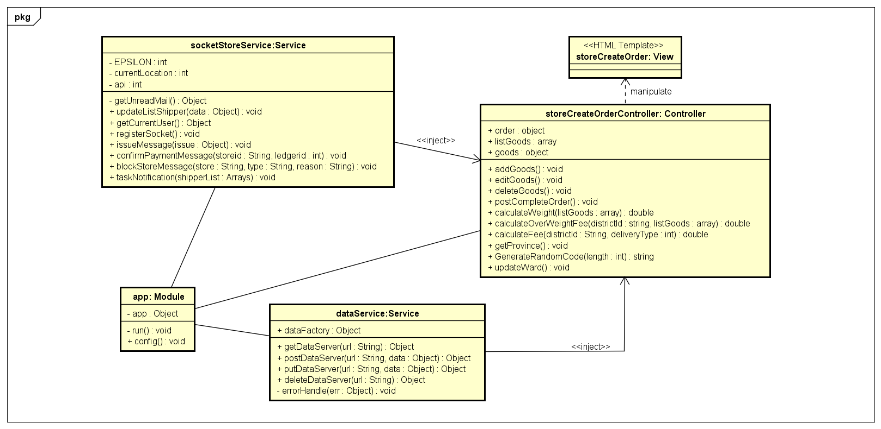

Figure 198. Object Diagram of Create Order use case

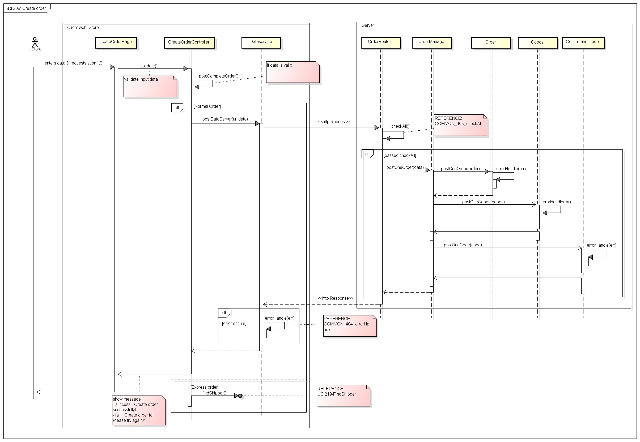

Figure 199. Sequence Diagram of Create Order use case

###### Find Shipper

*(*) Object Diagram of Find Shipper use case refer to Figure57*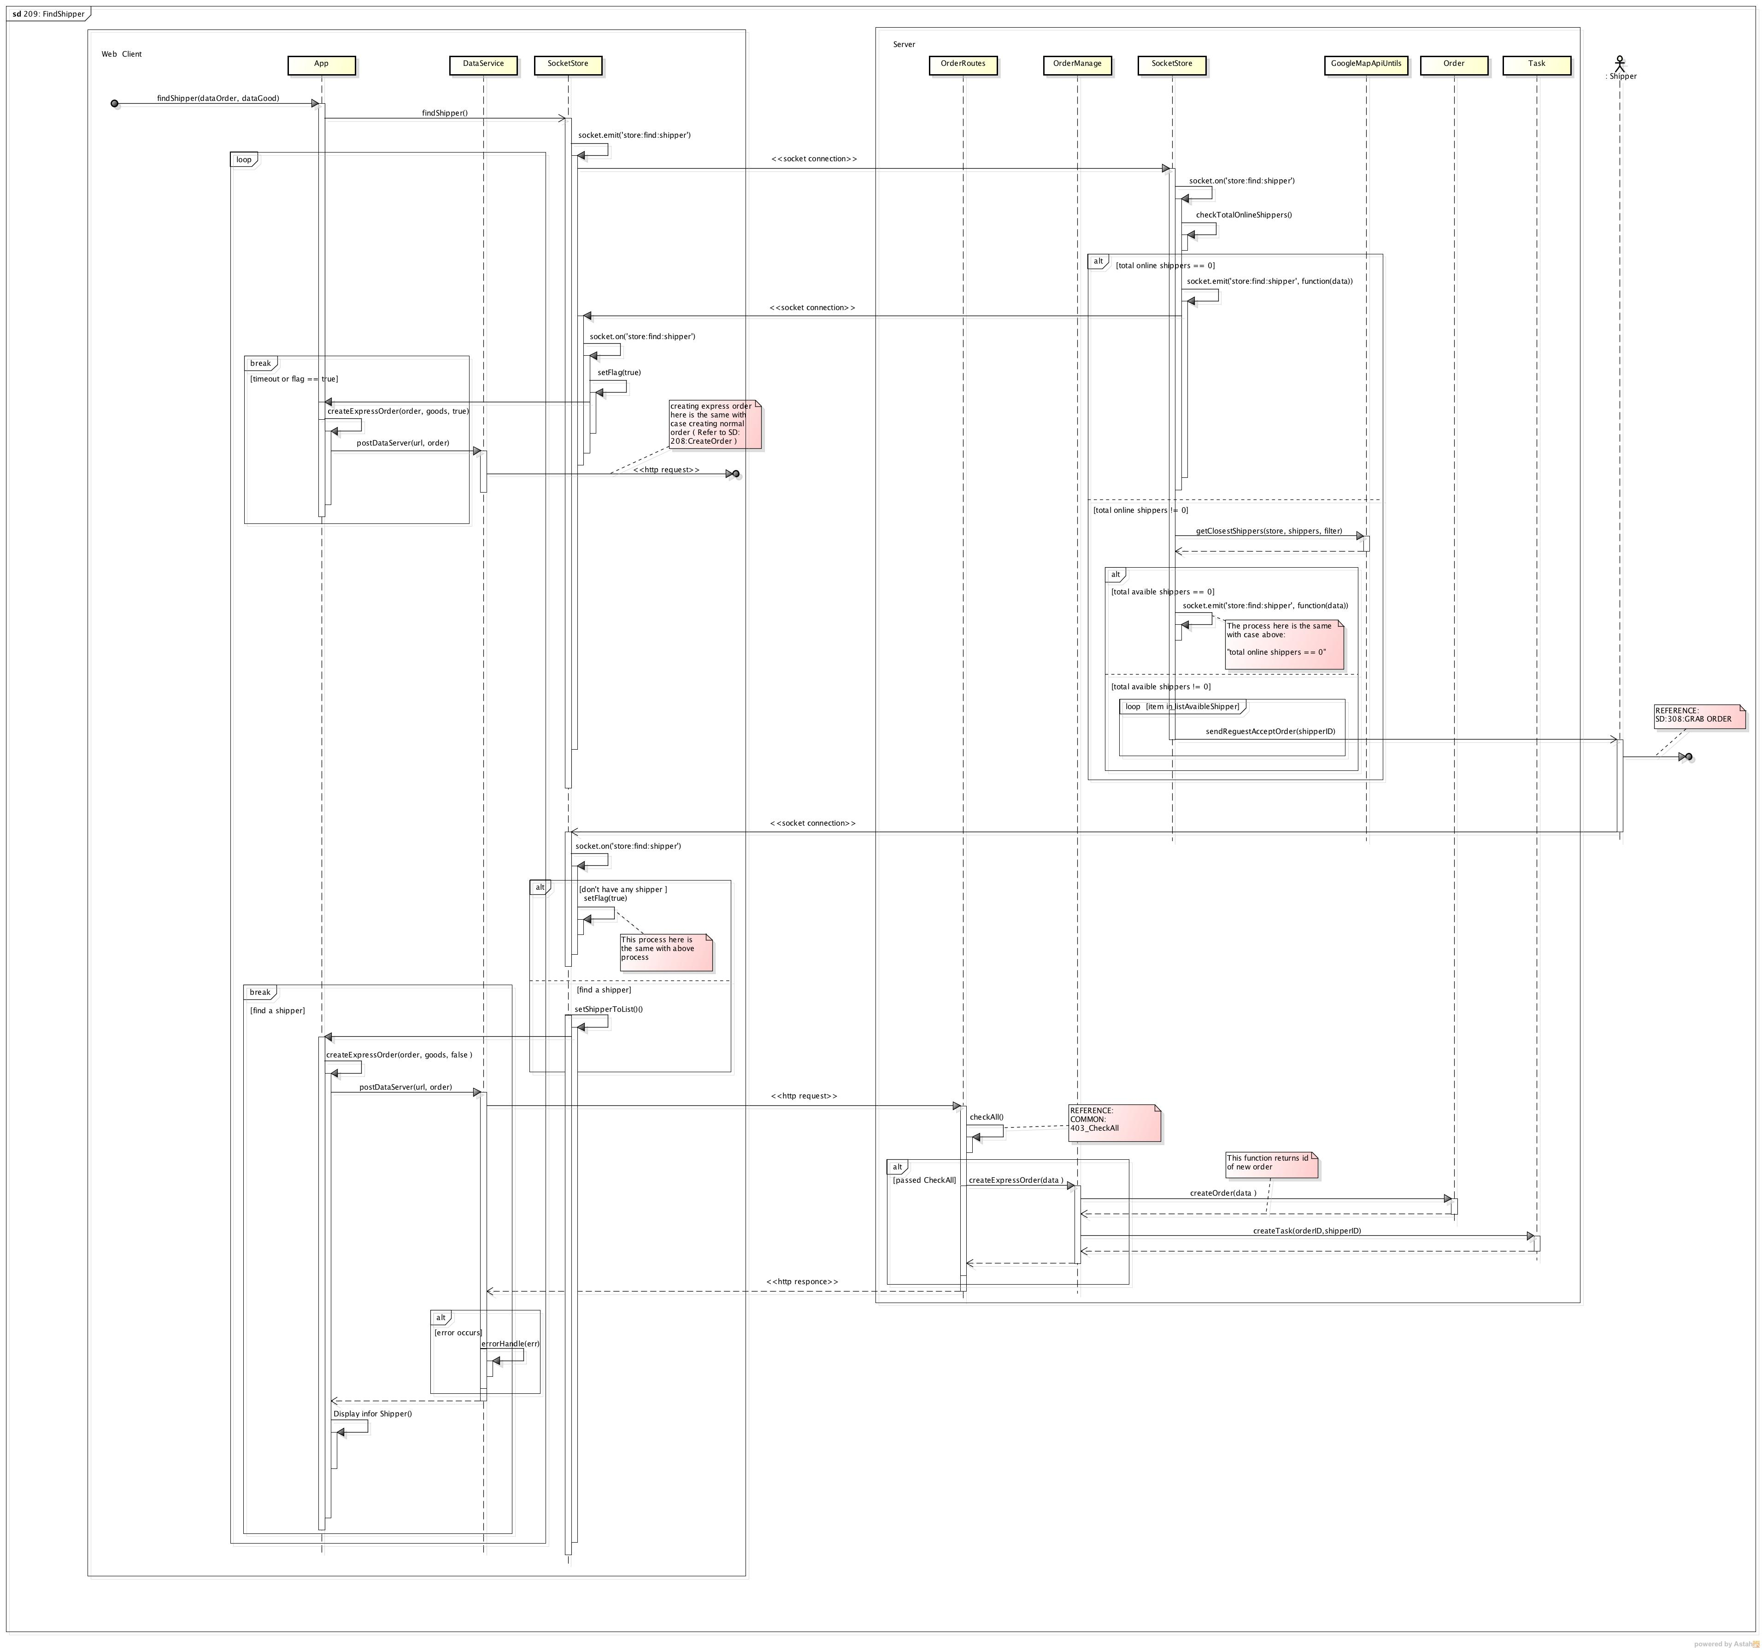

Figure 200. Sequence Diagram of Find Shipper use case

###### Edit Order

*(*) Object Diagram of Edit Orderuse case refer to Figure66*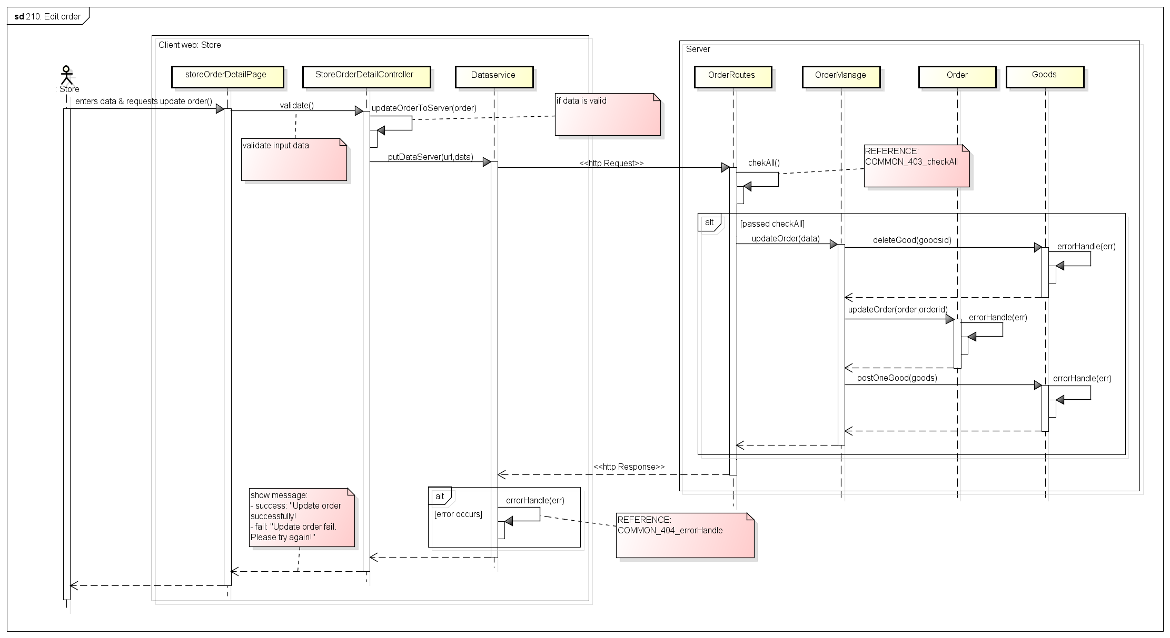

Figure 201. Sequence Diagram of Edit Order use case

###### View Order’s History

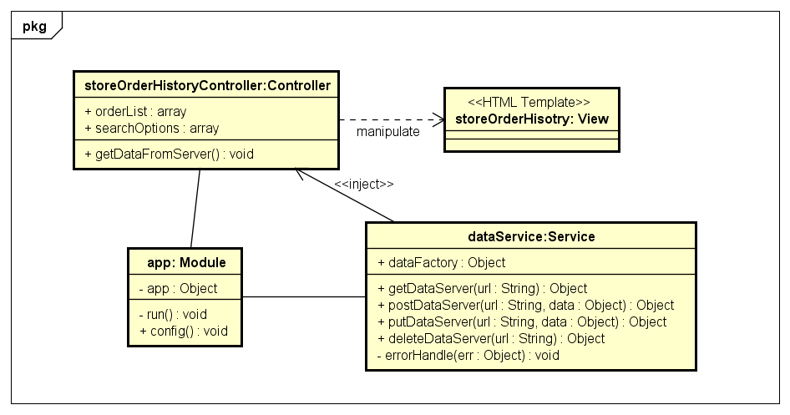

Figure 202. Object Diagram of View Order’s History use case

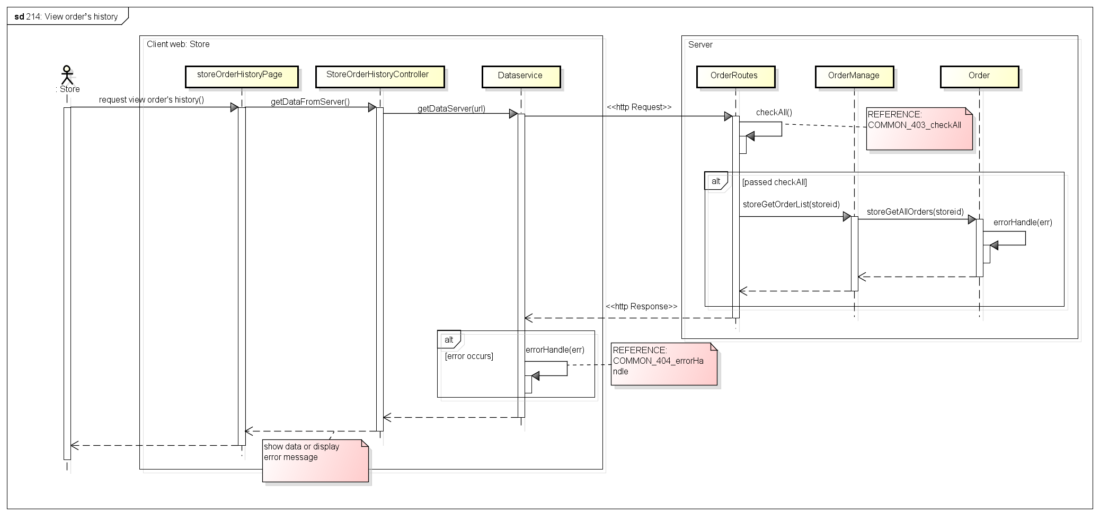

Figure 203. Sequence Diagram of View Order’s History use case

###### Search Order

*(*) Object Diagram of Edit Orderuse case refer to Figure53****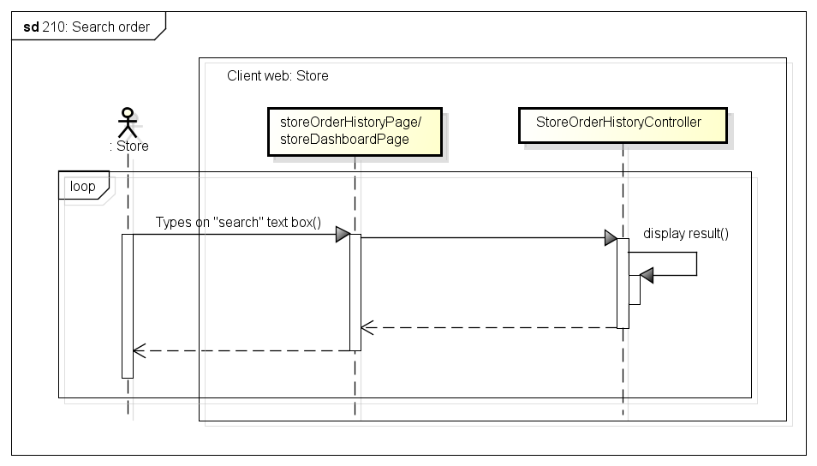***

Figure 204. Sequence Diagram of Search Order use case

###### Cancel Order

*(*) Object Diagram of Edit Order use case refer to Figure53*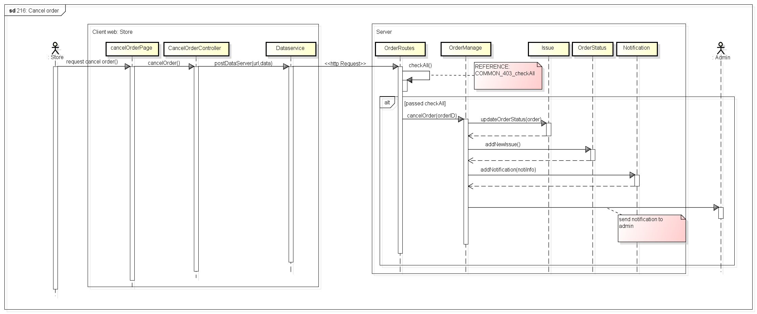

Figure 205. Sequence Diagram of Cancel Order use case

###### Delete Order

*(*) Object Diagram of Edit Order use case refer to Figure53*

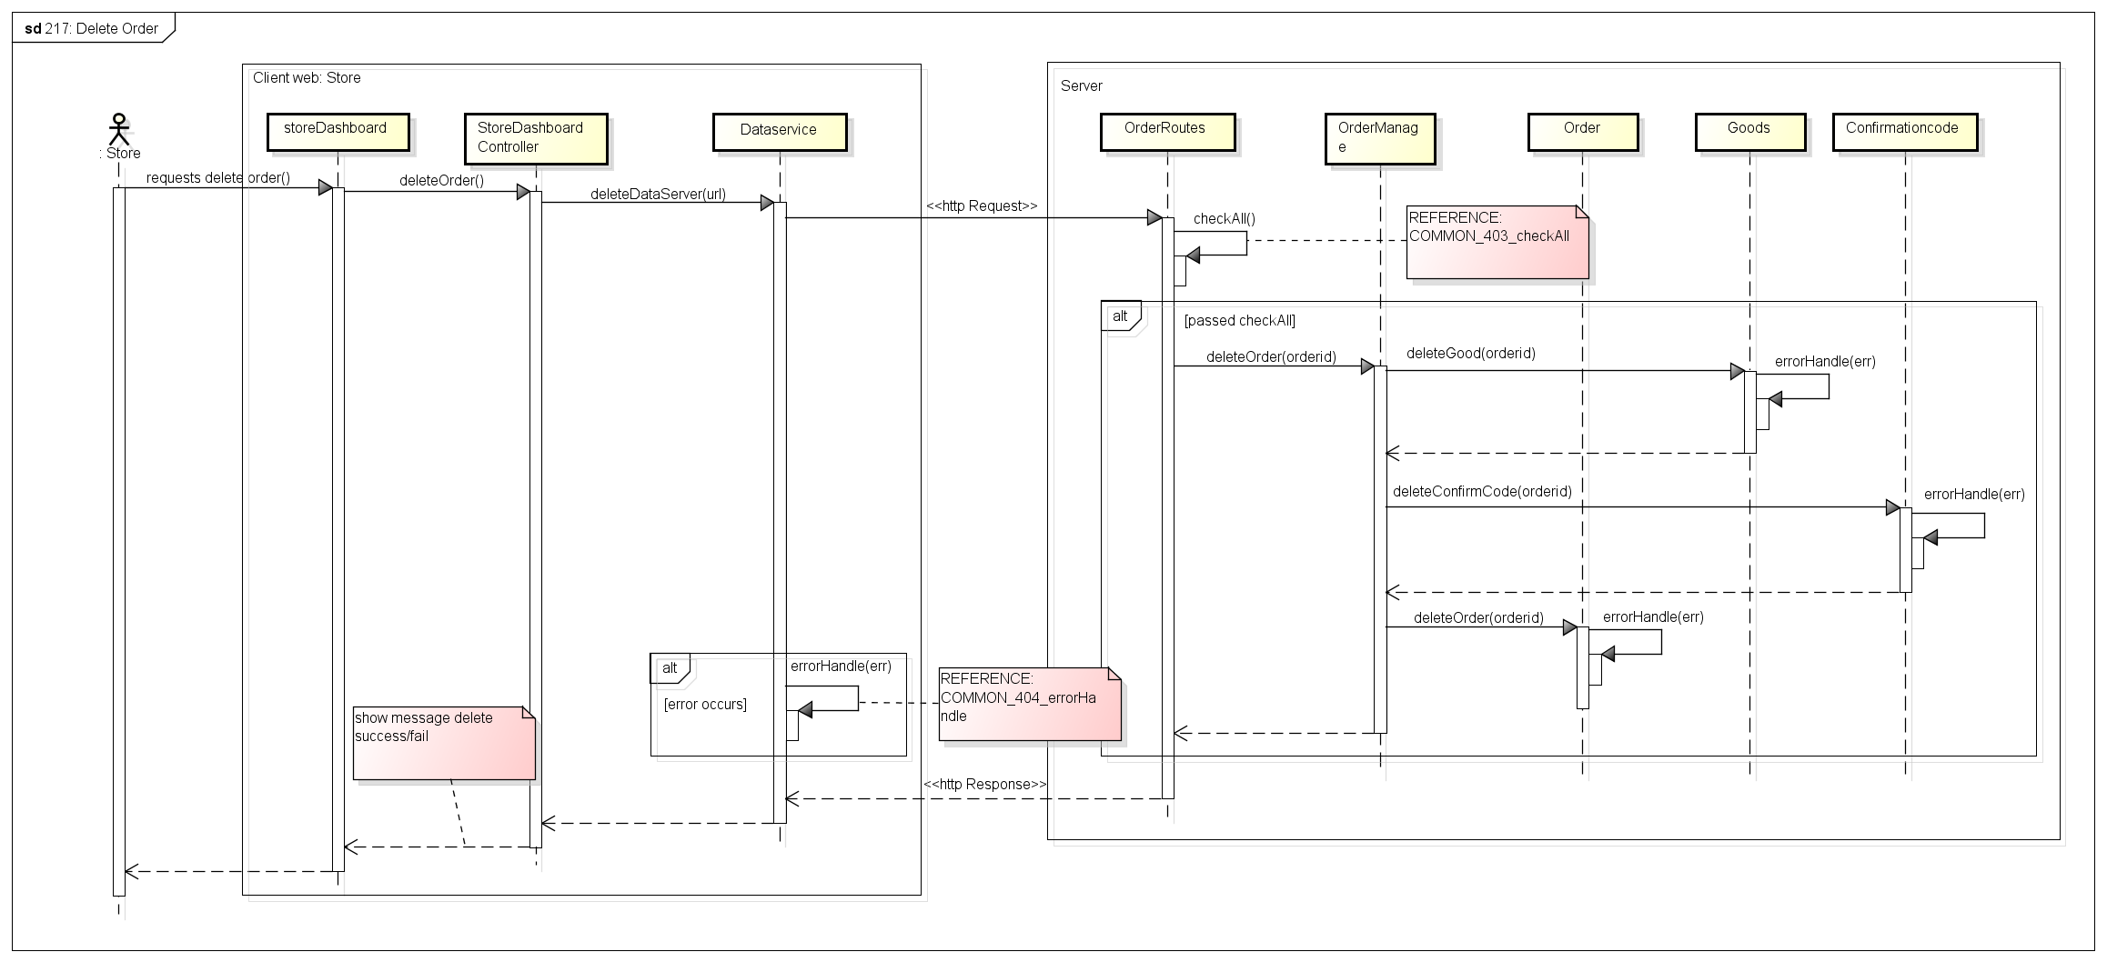

Figure 206. Sequence Diagram of Delete Order use case

###### View Order’s Detail

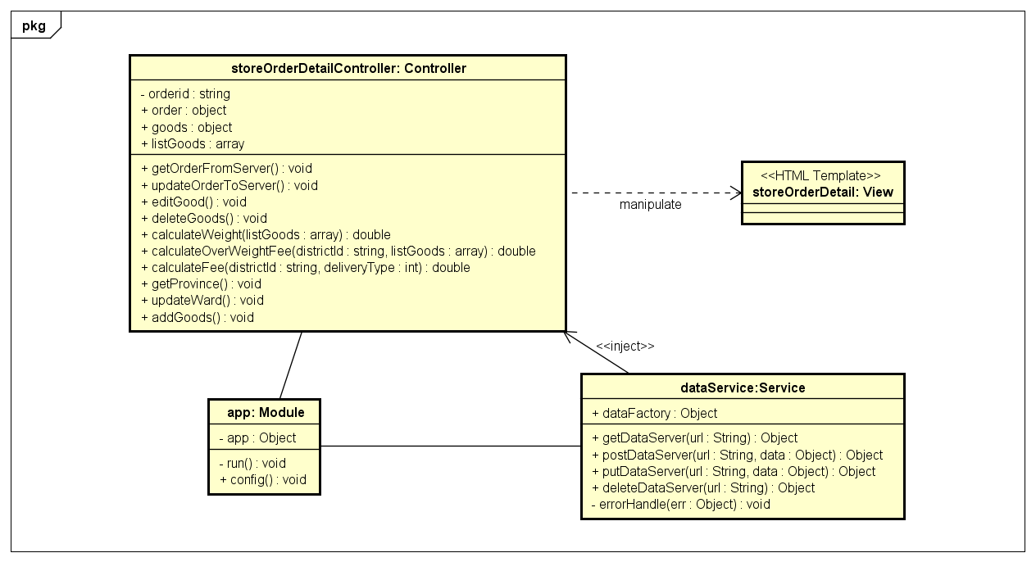

Figure 207. Object Diagram of View Order’s Detail use case

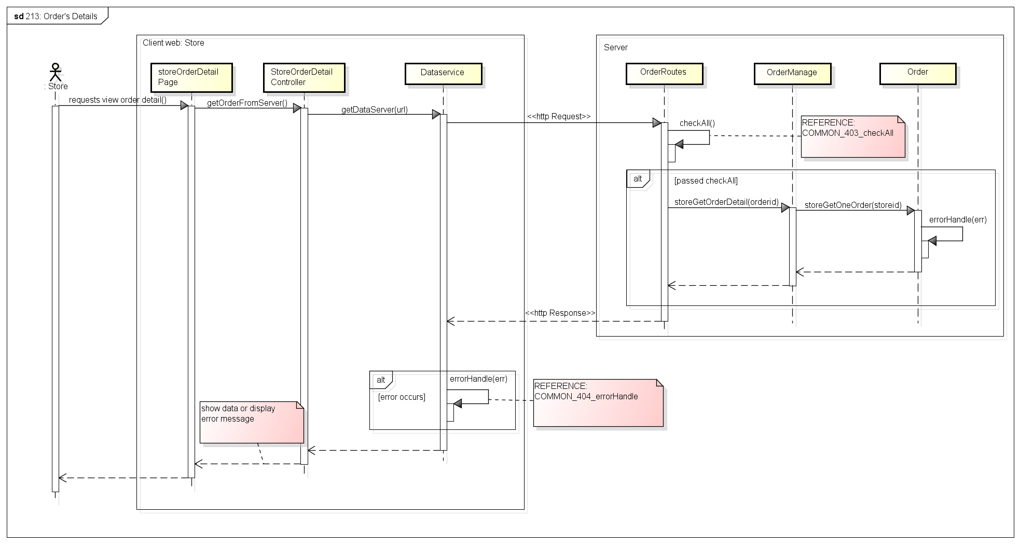

Figure 208. Sequence Diagram of View Order’s Detail use case

###### View Transaction History

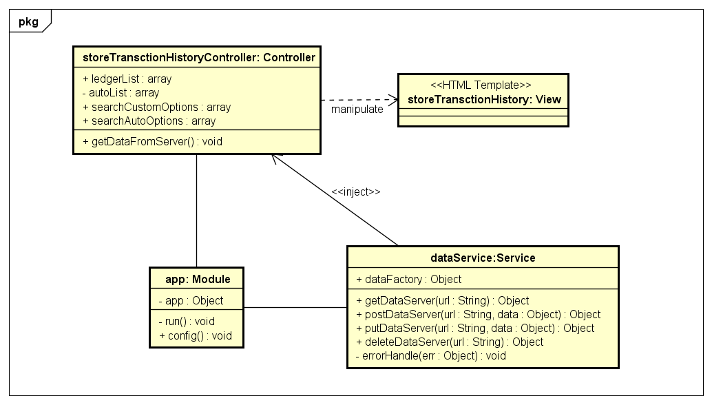

Figure 209. Object Diagram of View Transaction History use case

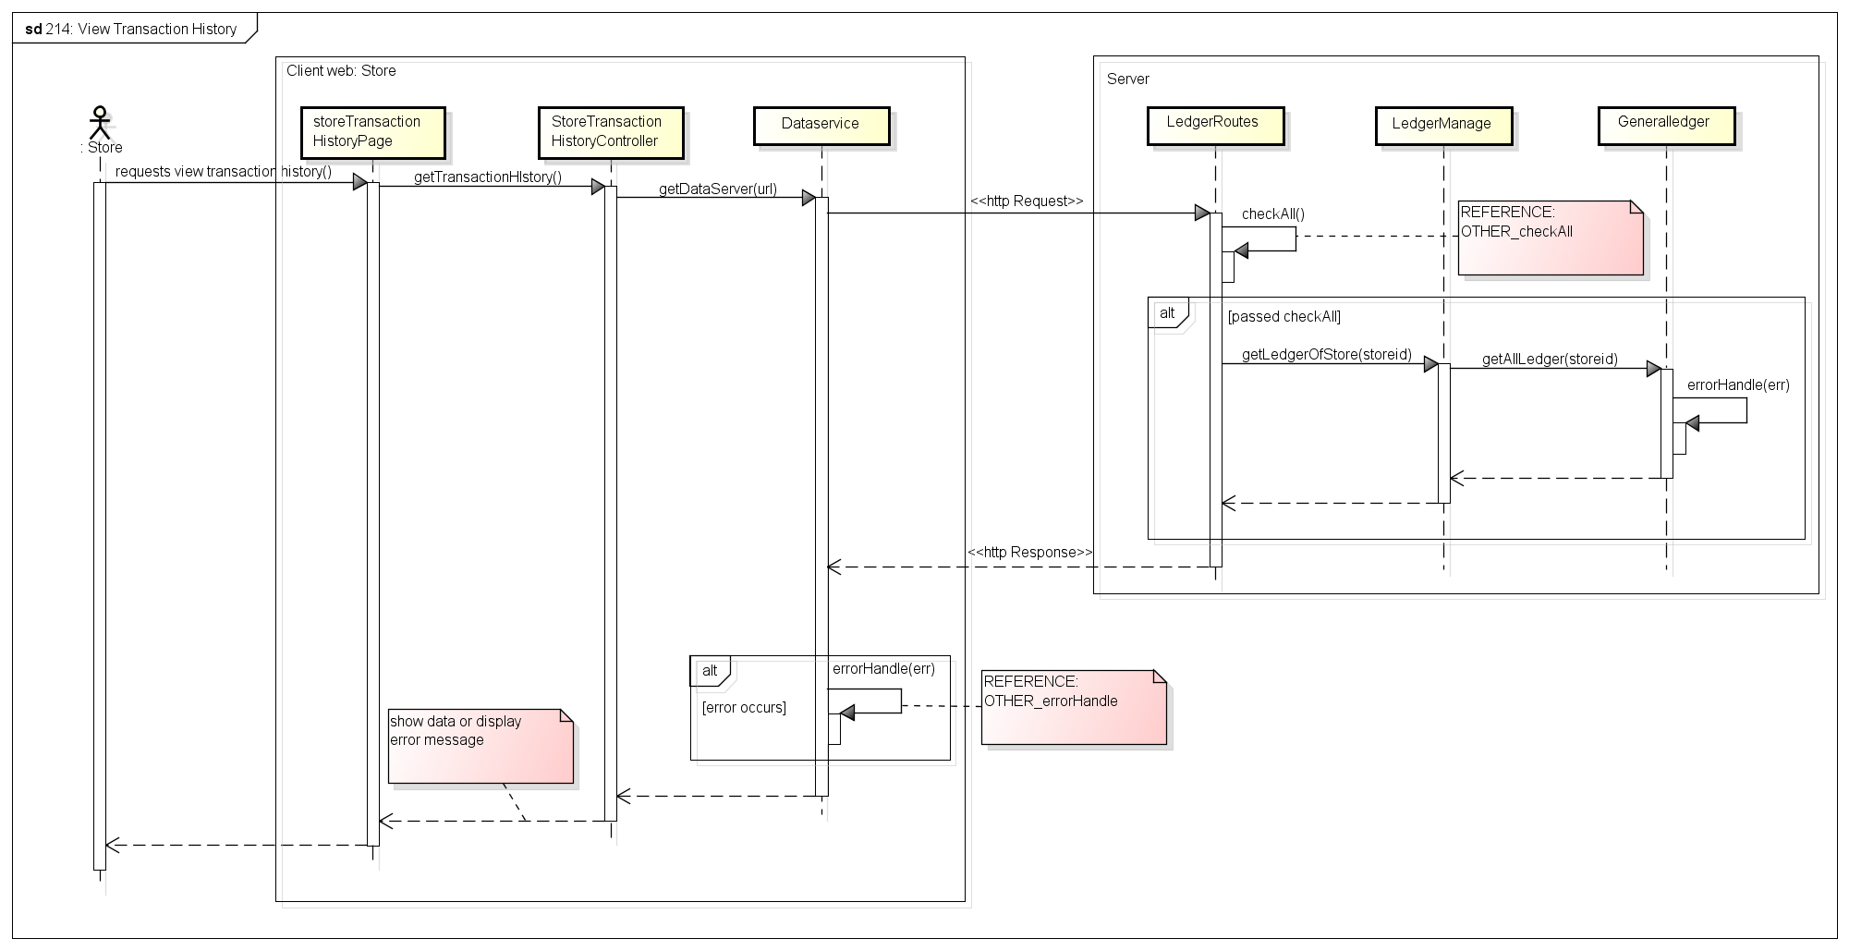

Figure 210. Sequence Diagram of View Transaction History use case

##### **2.2.2.1.3. Common**

###### Login

Figure 211. Object Diagram of Login use case

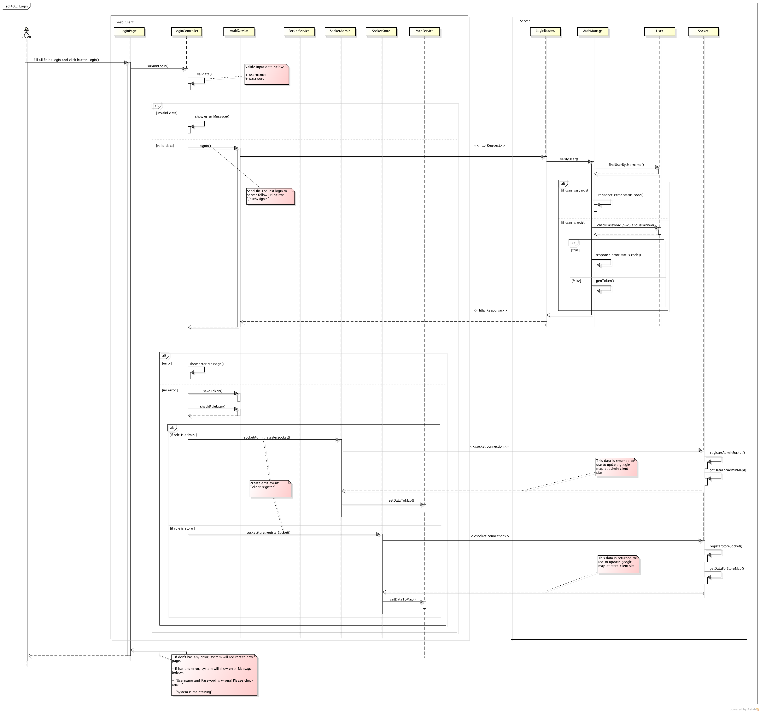

Figure 212. Sequence Diagram of Login

###### Logout

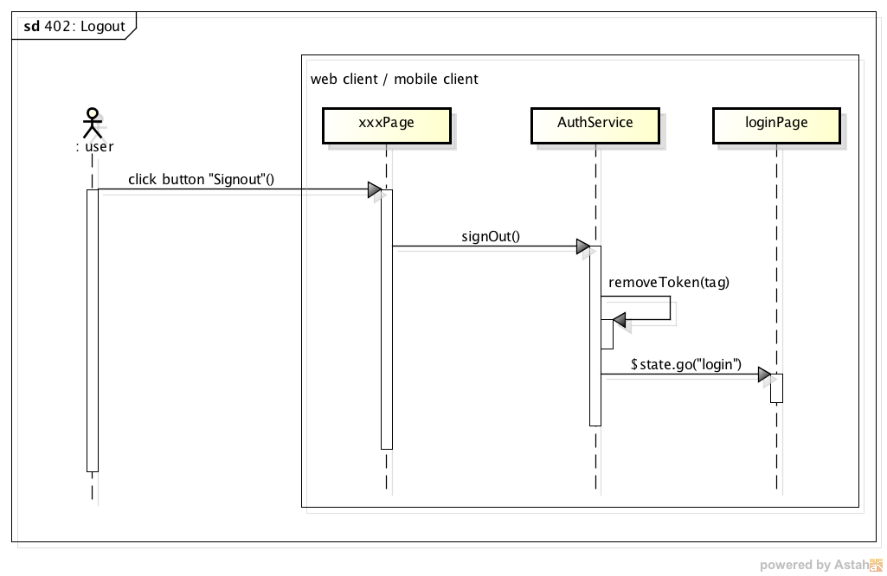

Figure 213. Sequence Diagram of Logout

###### CheckAll

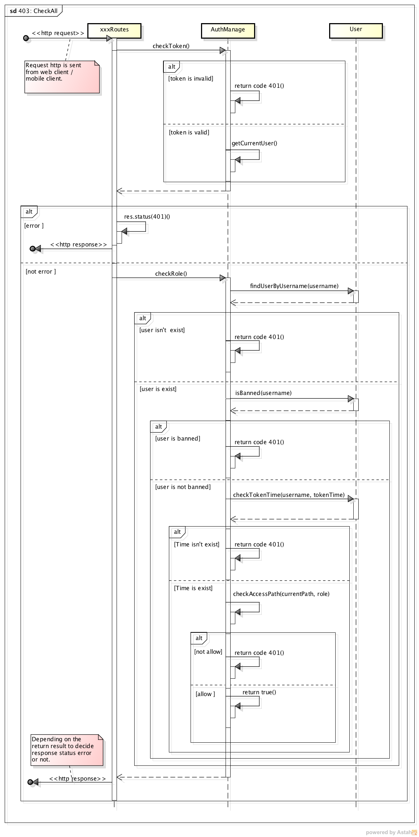

Figure 214. Sequence Diagram of CheckAll

###### ErrorHandle

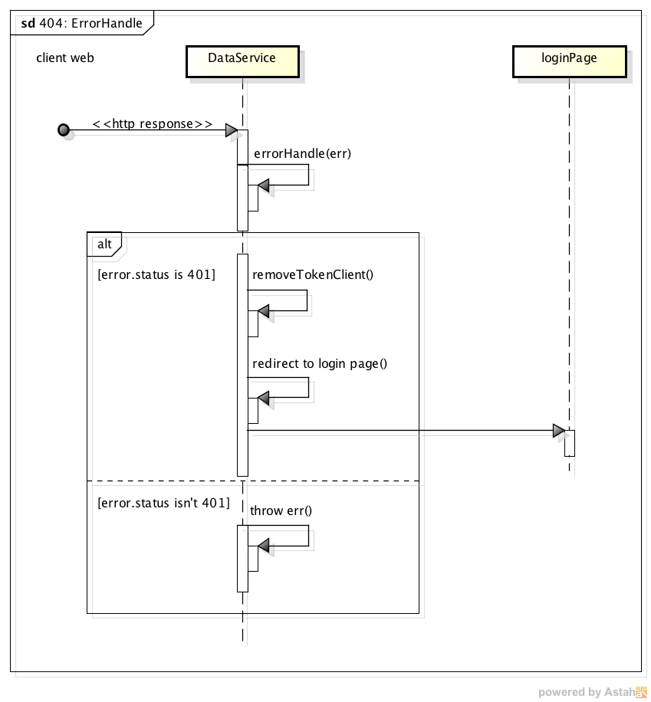

Figure 215. Sequence Diagram of ErrorHandle

###### Notification

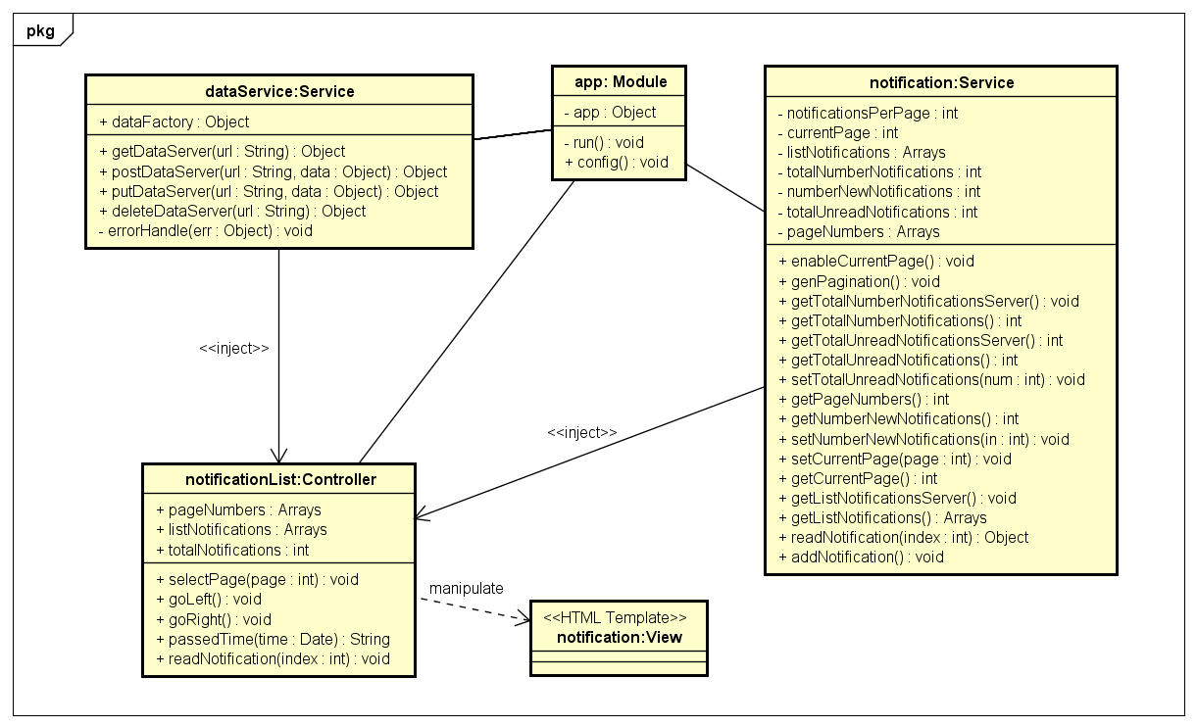

Figure 216. Object Diagram of Notification

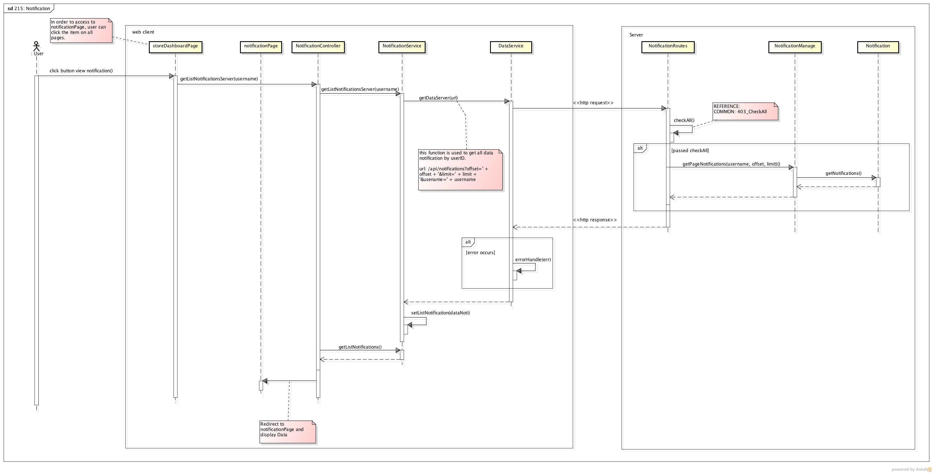

Figure 217. Sequence Diagram of Notification

##### **2.2.2.1.4. Class description**

##### AdminAddStoreController

###### Attributes

|  |  |  |  |  |
| --- | --- | --- | --- | --- |
| No | Attributes | Type | Default | Description |
|  | newStore | Object | N/A | Information of new Store |
|  | newStoreOwner | Object | N/A | Information of new Store Owner |

###### Methods

|  |  |  |  |  |
| --- | --- | --- | --- | --- |
| No | Methods | Parameters | Return | Description |
| 1 | getDataFromServer | N/A | N/A | Get data from server to display to screen |
| 2 | createStore | N/A | N/A | Post adding store request to server |

##### AdminAssignTaskController

###### Attributes

|  |  |  |  |  |
| --- | --- | --- | --- | --- |
| No | Attributes | Type | Default | Description |
| 1 | tasksList | Array | [] | All tasks that can be assigned for other shipper of selected shipper |
| 2 | shipperList | Array | [] | List of all shipper |
| 3 | orderList | Array | [] | List of all orders that can be assigned for shipper |
| 4 | oldTasks | Array | [] | List tasks of shipper before assign |
| 5 | pickedShipper | Object | Null | Shipper is selected |
| 6 | searchShipperOptions | Array | [] | Options in drop-downlist for search shipper |

###### Methods

|  |  |  |  |  |
| --- | --- | --- | --- | --- |
| No | Methods | Parameters | Return | Description |
| 1 | getDataFromServer | N/A | N/A | Get data from server to display to screen |
| 2 | assignTask | N/A | N/A | Send update shipper task request to server |
| 3 | pickOrder | Object | N/A | If user pick an order of order table, order will move to task table |
| 4 | pickTask | Object | N/A | If user pick an order of task table, order will move to order table |
| 5 | pickShipper | Object | N/A | After user select shipper, all tasks that can assigned for other shipper will be displayed in task table |
| 6 | moveAllProcessingTask | String | N/A | Move all orders in task table to order table |
| 7 | moveAllOrderToShipper | String | N/A | Move all orders which get issue to task table |
| 8 | sendSocketToShipper | N/A | N/A | Send a notification that task is assigned to shipper by socket |

##### AdminDashboardController

###### Attributes

|  |  |  |  |  |
| --- | --- | --- | --- | --- |
| No | Attributes | Type | Default | Description |
| 1 | onlineShipper | Int | 0 | Number of online shippers |
| 2 | inactiveList | Array | [] | List of inactive tasks |
| 3 | activeList | Array | [] | List of active tasks |
| 4 | doneList | Array | [] | List of done tasks |
| 5 | failList | Array | [] | List of fail tasks |
| 6 | totalTaskToday | Int | 0 | Number of tasks in today |
| 7 | totalDoneToday | Int | 0 | Number of tasks have been done today |
| 8 | totalShipper | Int | 0 | Number of total shipper in system |
| 9 | totalDelivery | Int | 0 | Total delivery cost today |
| 10 | totalCoD | Int | 0 | Total cash of delivery today |

###### Methods

|  |  |  |  |  |
| --- | --- | --- | --- | --- |
| No | Methods | Parameters | Return | Description |
| 1 | getDataFromServer | N/A | N/A | Get data from server to display to screen |
| 2 | dateCompare | N/A | N/A | Compare date of task for sorting |

##### AdminIssueBoxController

###### Attributes

|  |  |  |  |  |
| --- | --- | --- | --- | --- |
| No | Attributes | Type | Default | Description |
| 1 | issueList | Array | [] | List of all issues |
| 2 | pageSize | Int | 1 | Total page of issue when display in list |
| 3 | currentPage | Int | 1 | Current page of issue list |

###### Methods

|  |  |  |  |  |
| --- | --- | --- | --- | --- |
| No | Methods | Parameters | Return | Description |
| 1 | getDataFromServer | N/A | N/A | Get data from server to display to screen |
| 2 | sortByDate | N/A | N/A | Sort issue list by date when issue is sent |

##### AdminIssueContentController

###### Attributes

|  |  |  |  |  |
| --- | --- | --- | --- | --- |
| No | Attributes | Type | Default | Description |
| 1 | issueid | Int | N/A | IssueID of issue |
| 2 | resolveType | Int | N/A | Type of resolving issue |
| 3 | issue | Object | N/A | Detail of this issue |

###### Methods

|  |  |  |  |  |
| --- | --- | --- | --- | --- |
| No | Methods | Parameters | Return | Description |
| 1 | updateResolve | N/A | N/A | Send update issue request to database after processing in client |
| 2 | showConfirm | Int | N/A | Show confirm resolve popup |
| 3 | resolveIssue | N/A | N/A | Update issue is resolved by resolve type |
| 3 | resolveReturnIssue | N/A | N/A | Update order and task when order is returned to store |
| 4 | resolveStoreIssue | N/A | N/A | Update order and task when order is cancelled by store and shipper hasn’t been taken order |
| 5 | resolveContinueIssue | N/A | N/A | Update order and task when shipper can continue with issue order |
| 6 | resolveChangeShipperIssue | N/A | N/A | Update order and task when order is changed to other shipper |

##### AdminOrderListController

###### Attributes

|  |  |  |  |  |
| --- | --- | --- | --- | --- |
| No | Attributes | Type | Default | Description |
| 1 | orderList | Array | [] | List of all orders |
| 2 | searchOptions | Array | [] | List of type for search order |
| 3 | dateOptions | Array | [] | List of date type for search order by complete date or pickup date |

###### Methods

|  |  |  |  |  |
| --- | --- | --- | --- | --- |
| No | Methods | Parameters | Return | Description |
| 1 | getDataFromServer | N/A | N/A | Get data from server to display to screen |

##### AdminShipperListController

###### Attributes

|  |  |  |  |  |
| --- | --- | --- | --- | --- |
| No | Attributes | Type | Default | Description |
| 1 | shipperList | Array | [] | List of all shippers |
| 2 | searchOptions | Array | [] | List of type for search shipper |

###### Methods

|  |  |  |  |  |
| --- | --- | --- | --- | --- |
| No | Methods | Parameters | Return | Description |
| 1 | getDataFromServer | N/A | N/A | Get data from server to display to screen |
| 2 | getShipperOnline | N/A | N/A | Get status of shipper to display status of shipper is on or off |

##### AdminStoreDetailController

###### Attributes

|  |  |  |  |  |
| --- | --- | --- | --- | --- |
| No | Attributes | Type | Default | Description |
| 1 | storeid | String | N/A | storeID of store |
| 2 | store | Object | N/A | Detail of this store |

###### Methods

|  |  |  |  |  |
| --- | --- | --- | --- | --- |
| No | Methods | Parameters | Return | Description |
| 1 | getDataFromServer | N/A | N/A | Get data from server to display to screen |
| 2 | updateStore | N/A | N/A | Send update store request to server after information is modified by user |

##### AdminStoreListController

###### Attributes

|  |  |  |  |  |
| --- | --- | --- | --- | --- |
| No | Attributes | Type | Default | Description |
| 1 | storeList | Array | [] | List of all store in system with ledger information |
| 2 | searchOptions | Array | [] | Type of store search |
| 3 | payFee | Int | 0 | Amount of payment when user add new transaction |
| 4 | selectedStore | Object | Null | Store is selected |
| 5 | reason | String | Null | Reason why store is blocked or is unblocked |

###### Methods

|  |  |  |  |  |
| --- | --- | --- | --- | --- |
| No | Methods | Parameters | Return | Description |
| 1 | getDataFromServer | N/A | N/A | Get data from server to display to screen |
| 2 | showConfirm | N/A | N/A | Show Confirm Payment popup for user to enter payment |
| 3 | showConfirmAgain | N/A | N/A | Show Confirm Payment Again popup |
| 4 | blockConfirm | N/A | N/A | Show confirm popup when user block or unblock user |
| 5 | blockStore | N/A | N/A | Send update block store request to server |
| 6 | postLedger | N/A | N/A | Send post new transaction request after user confirm a payment |
| 7 | showTransactionHistory | Object, Date | N/A | Show popup contains transaction history of selected Store in specific period |

##### AdminTaskListController

###### Attributes

|  |  |  |  |  |
| --- | --- | --- | --- | --- |
| No | Attributes | Type | Default | Description |
| 1 | taskList | Array | [] | List of all tasks |
| 2 | searchOptions | Array | [] | List of type for search task |

###### Methods

|  |  |  |  |  |
| --- | --- | --- | --- | --- |
| No | Methods | Parameters | Return | Description |
| 1 | getDataFromServer | N/A | N/A | Get data from server to display to screen |
| 2 | dateSort | N/A | N/A | Sort taskList by taskdate |

##### AdminTransactionHistoryController

###### Attributes

|  |  |  |  |  |
| --- | --- | --- | --- | --- |
| No | Attributes | Type | Default | Description |
| 1 | ledgerList | Array | [] | List of all transactions was added by admin |
| 2 | searchCustomOptions | Array | [] | List of type for search custom transaction |
| 3 | autoList | Array | [] | List of all transactions was added automatically by sytem |
| 4 | searchAutoOptions | Array | [] | List of type for search auto transaction |

###### Methods

|  |  |  |  |  |
| --- | --- | --- | --- | --- |
| No | Methods | Parameters | Return | Description |
| 1 | getDataFromServer | N/A | N/A | Get data from server to display to screen |
| 2 | dateSort | N/A | N/A | Sort ledgerList and autoList by paydate |

##### AdminUserDetailController

###### Attributes

|  |  |  |  |  |
| --- | --- | --- | --- | --- |
| No | Attributes | Type | Default | Description |
| 1 | username | String | N/A | username of user |
| 2 | user | Object | N/A | Detail of this user |

###### Methods

|  |  |  |  |  |
| --- | --- | --- | --- | --- |
| No | Methods | Parameters | Return | Description |
| 1 | getDataFromServer | N/A | N/A | Get data from server to display to screen |
| 2 | updateUserInfo | N/A | N/A | Send update user request to server after information is modified by admin |

##### AdminOrderDetailController

###### Attributes

|  |  |  |  |  |
| --- | --- | --- | --- | --- |
| No | Attributes | Type | Default | Description |
| 1 | orderid | String | N/A | Id of Order get from previous screen |
| 2 | order | Object | N/A | Information of order |
| 3 | goods | Object | N/A | Information of goods |
| 4 | listGoods | Array | N/A | List of |

###### Methods

|  |  |  |  |  |
| --- | --- | --- | --- | --- |
| No | Methods | Parameters | Return | Description |
| 1 | getOrderFromServer | N/A | N/A | Get data from server and display to screen |
| 2 | updateOrderToServer | N/A | N/A | Post information of order to server to request update to database |
| 3 | editGoods | N/A | N/A | Edit information of a goods |
| 3 | addGoods | N/A | N/A | Add a goods to order |
| 4 | deleteGoods | N/A | N/A | Delete a goods |
| 5 | calculateWeight | Array | Double | Calculate total weight of goods on order |
| 6 | calculateOverWeightFee | String,Array | Double | Calculate over weight fee for order |
| 7 | calculateFee | String | N/A | Move all orders which get issue to task table |
| 8 | getProvince | N/A | N/A | Get list Province from server to fill to province drop down list |

##### AdminReportController

###### Attributes

|  |  |  |  |  |
| --- | --- | --- | --- | --- |
| No | Attributes | Type | Default | Description |
| N/A | N/A | N/A | N/A | N/A |

###### Methods

|  |  |  |  |  |
| --- | --- | --- | --- | --- |
| No | Methods | Parameters | Return | Description |
| 1 | updateCharExNoByStore | N/A | N/A | Update “Express/Normal” chart when user change store or year |
| 2 | updateCharComCanByStore | N/A | N/A | Update “Complete/Cancel” chart when user change store or year |
| 3 | updateCharFinByStore | N/A | N/A | Update “Finance” chart when user change store or year |
| 4 | drawCharFirstTimeRun | N/A | N/A | Draw charts at first time user access to report page |
| 5 | createDefaultData | N/A | Array | Create default data for charts |
| 6 | getDataForChart | Array, Object | Array | Convert data from server to data for display on Bar Chart |
| 7 | getDataForPeiChar | Object | Array | Convert data from server to data for display on Pei Chart |
| 8 | drawPeiChart | int, Object | N/A | Draw Pei Charts with input data |
| 9 | drawChart | int, Object | N/A | Draw Bar Charts with input data |

##### StoreDashboardController

###### Attributes

|  |  |  |  |  |
| --- | --- | --- | --- | --- |
| No | Attributes | Type | Default | Description |
|  | totalOrder | Int | N/A | Total not yet paid orders |
|  | orderToday | Int | N/A | Total orders on today |
|  | totalCod | Double | N/A | Total cash on delivery of not yet paid orders |
|  | todayCod | Double | N/A | Total cash on delivery on today |
|  | totalFee | Double | N/A | Total ship fee of not yet paid orders |
|  | todayFee | Double | N/A | Total ship fee on today |
|  | listOrderInprocess | Array | N/A | List of in process orders |
|  | listOrderDone | Array | N/A | List of completed orders |
|  | listOrderDraft | Array | N/A | List of draft orders |
|  | searchOptionsInProcess | Array | N/A | List of value for search in process order |
|  | searchOptionsDone | Array | N/A | List of value for search done order |
|  | searchOptionsDraft | Array | N/A | List of value for search draft order |

###### Methods

|  |  |  |  |  |
| --- | --- | --- | --- | --- |
| No | Methods | Parameters | Return | Description |
| 1 | getDataFromServer | N/A | N/A | Get data from server to display to screen |
| 2 | cancerOrder | N/A | N/A | Post request to cancel order of store to server and update screen |
| 3 | deleteDraffOrder | N/A | N/A | Post request to delete order of store to server and update screen |
| 4 | setCancelFee | Object | N/A | Calculate ship fee for order that store want to cancel |
| 5 | findShipperAgain | Object | N/A | Request to find a shipper |

##### StoreCreateOrderController

###### Attributes

|  |  |  |  |  |
| --- | --- | --- | --- | --- |
| No | Attributes | Type | Default | Description |
| 1 | order | Object | N/A | Information of new store |
| 2 | listGoods | Array | [] | List of new goods |
| 3 | goods | Object | N/A | Information of new goods |

###### Methods

|  |  |  |  |  |
| --- | --- | --- | --- | --- |
| No | Methods | Parameters | Return | Description |
| 1 | addGoods | N/A | N/A | Add a goods to order |
| 2 | editGoods | N/A | N/A | Edit information of a goods |
| 3 | deleteGoods | N/A | N/A | Delete a goods |
| 4 | postCompleteOrder | N/A | N/A | Post information of order to server to add to database |
| 5 | calculateWeight | Array | Double | Calculate total weight of goods on order |
| 6 | calculateOverWeightFee | String,Array | Double | Calculate over weight fee for order |
| 7 | calculateFee | String | N/A | Move all orders which get issue to task table |
| 8 | getProvince | N/A | N/A | Get list Province from server to fill to province drop down list |
| 9 | GenerateRandomCode | N/A | String | Generate code for authenticate shipper and end customer |
| 10 | updateWard() | N/A | N/A | Update ward drop down list when store change district. |

##### StoreOrderHistoryController

###### Attributes

|  |  |  |  |  |
| --- | --- | --- | --- | --- |
| No | Attributes | Type | Default | Description |
| 1 | orderList | Array | N/A | List of order |
| 2 | searchOptions | Array | N/A | List value for search orders |

###### Methods

|  |  |  |  |  |
| --- | --- | --- | --- | --- |
| No | Methods | Parameters | Return | Description |
| 1 | getDataFromServer | N/A | N/A | Get data from server to display to screen |

##### StoreProfileController

###### Attributes

|  |  |  |  |  |
| --- | --- | --- | --- | --- |
| No | Attributes | Type | Default | Description |
| 1 | store | Object | N/A | Information of store |

###### Methods

|  |  |  |  |  |
| --- | --- | --- | --- | --- |
| No | Methods | Parameters | Return | Description |
| 1 | getStoreProfile | N/A | N/A | Get data from server to display to screen |

##### StoreOrderDetailController

###### Attributes

|  |  |  |  |  |
| --- | --- | --- | --- | --- |
| No | Attributes | Type | Default | Description |
| 1 | orderid | String | N/A | Id of Order get from previous screen |
| 2 | order | Object | N/A | Information of order |
| 3 | goods | Object | N/A | Information of goods |
| 4 | listGoods | Array | N/A | List of |

###### Methods

|  |  |  |  |  |
| --- | --- | --- | --- | --- |
| No | Methods | Parameters | Return | Description |
| 1 | getOrderFromServer | N/A | N/A | Get data from server and display to screen |
| 2 | updateOrderToServer | N/A | N/A | Post information of order to server to request update to database |
| 3 | editGoods | N/A | N/A | Edit information of a goods |
| 3 | addGoods | N/A | N/A | Add a goods to order |
| 4 | deleteGoods | N/A | N/A | Delete a goods |
| 5 | calculateWeight | Array | Double | Calculate total weight of goods on order |
| 6 | calculateOverWeightFee | String,Array | Double | Calculate over weight fee for order |
| 7 | calculateFee | String | N/A | Move all orders which get issue to task table |
| 8 | getProvince | N/A | N/A | Get list Province from server to fill to province drop down list |

##### StoreTransctionController

###### Attributes

|  |  |  |  |  |
| --- | --- | --- | --- | --- |
| No | Attributes | Type | Default | Description |
| 1 | ledgerList | Array | [] | List of all transactions was added by admin |
| 2 | searchCustomOptions | Array | [] | List of type for search custom transaction |
| 3 | autoList | Array | [] | List of all transactions was added automatically by sytem |
| 4 | searchAutoOptions | Array | [] | List of type for search auto transaction |

###### Methods

|  |  |  |  |  |
| --- | --- | --- | --- | --- |
| No | Methods | Parameters | Return | Description |
| 1 | getDataFromServer | N/A | N/A | Get data from server to display to screen |

##### LoginController

###### Attributes

|  |  |  |  |  |
| --- | --- | --- | --- | --- |
| No | Attributes | Type | Default | Description |
| N/A | N/A | N/A | N/A | N/A |

###### Methods

|  |  |  |  |  |
| --- | --- | --- | --- | --- |
| No | Methods | Parameters | Return | Description |
| 1 | Submit | Object | Object | This function is used to send a request submit form login into server. Then, server will response data back. |

##### Notification

###### Attributes

|  |  |  |  |  |
| --- | --- | --- | --- | --- |
| **No** | **Attributes** | **Type** | **Default** | **Description** |
| 1 | pageNumbers | Array | [] | Array of index of page number for pagination |
| 2 | listNotifications | Array | [] | Array of notifications in a page |
| 3 | totalNotifications | int | 0 | Total number of notifications of a user |

###### Methods

|  |  |  |  |  |
| --- | --- | --- | --- | --- |
| **No** | **Methods** | **Parameters** | **Return** | **Description** |
| 1 | selectPage | int | N/A | Change to a page and update displayed list of notifications |
| 2 | goLeft | N/A | N/A | Go to left page of current page in pagination. |
| 3 | goRight | N/A | N/A | Go to right page of current page in pagination |
| 4 | passedTime | Date | String | Convert created date of notification to amount of elapsed time from current moment |
| 5 | readNotification | int | Object | Request to server to update status isRead of notification |

##### NotificationService

###### Attributes

|  |  |  |  |  |
| --- | --- | --- | --- | --- |
| **No** | **Attributes** | **Type** | **Default** | **Description** |
| 1 | notificationsPerPage | int | 7 | Constant for number of notifications per page in pagination |
| 2 | currentPage | int | 0 | Current selected page of notifications |
|  | listNotifications | Array | [] | Displayed list of notifications of current selected page |
|  | totalNumberNotifications | int | 0 | Total number of notifications of a user |
|  | numberNewNotifications | int | 0 | Total number of unread notifications of a user |
|  | totalUnreadNotifications | int | 0 | Total number of unread notifications of a user |
|  | pageNumbers | Array | [] | Array of index of page number for pagination |

###### Methods

|  |  |  |  |  |
| --- | --- | --- | --- | --- |
| **No** | **Methods** | **Parameters** | **Return** | **Description** |
| 1 | genPagination | N/A | N/A | Generate array of page numbers (pageNumbers) for navigation in pagination based on notificationsPerPage and totalNumberNotifications |
| 2 | getTotalNumberNotificationsServer | N/A | Object | Request to server and return a promise to be resolved for total number of notifications of a user |
| 3 | getTotalUnreadNotificationsServer | N/A | int | Request to server and return a promise to be resolved for total number of unread notifications of a user |
| 4 | getPageNumbers | N/A | int | Return array of index of page number for pagination (pageNumbers) |
| 5 | getNumberNewNotifications | N/A | int | Return total number of unread notifications of a user (numberNewNotifications) |
| 6 | setNumberNewNotifications | int | N/A | Set value for total number of unread notifications of a user |
| 7 | setCurrentPage | int | N/A | Set value for current selected page |
| 8 | getCurrentPage | N/A | int | Return current index page |
| 9 | getListNotificationsServer | N/A | Array | Return list of notifications of current selected page |
| 10 | readNotification | int | Object | Request to server to update status isRead of a notification |
| 11 | addNotification | Object | Object | Request to server to add new notification and return a promise to be resolved for inserted notification |

##### AuthService

###### Attributes

|  |  |  |  |  |
| --- | --- | --- | --- | --- |
| No | Attributes | Type | Default | Description |
| 1 | dataFactory | Object | {} | The object to provide API functions for calling from other places |

###### Methods

|  |  |  |  |  |
| --- | --- | --- | --- | --- |
| No | Methods | Parameters | Return | Description |
| 1 | getDataServer | String | Object | Send http request to server with GET method |
| 2 | postDataServer | String, Object | Object | Send http request to server with POST method |
| 3 | putDataServer | String, Object | Object | Send http request to server with PUT method |
| 4 | deleteDataServer | String | Object | Send http request to server with DELETE method |
| 5 | errorHandle | Object | N/A | Handle the error return of sending http request, log out if the error has status 401 (Unauthorized) |

##### DataService

###### Attributes

|  |  |  |  |  |
| --- | --- | --- | --- | --- |
| No | Attributes | Type | Default | Description |
| 1 | dataFactory | Object | {} | The object to provide API functions for calling from other places |

###### Methods

|  |  |  |  |  |
| --- | --- | --- | --- | --- |
| No | Methods | Parameters | Return | Description |
| 1 | getDataServer | String | Object | Send http request to server with GET method |
| 2 | postDataServer | String, Object | Object | Send http request to server with POST method |
| 3 | putDataServer | String, Object | Object | Send http request to server with PUT method |
| 4 | deleteDataServer | String | Object | Send http request to server with DELETE method |
| 5 | errorHandle | Object | N/A | Handle the error return of sending http request, log out if the error has status 401 (Unauthorized) |

##### SocketService

* Attributes

|  |  |  |  |  |
| --- | --- | --- | --- | --- |
| No | Attributes | Type | Default | Description |
| 1 | socket | Object | N/A | Initial instance |
| 2 | api | Object | N/A | The public object to provide API functions |

###### Methods

|  |  |  |  |  |
| --- | --- | --- | --- | --- |
| No | Methods | Parameters | Return | Description |
| 1 | on | String, function | N/A | Listen the specific event from socket server and then fire the callback function |
| 2 | sendPacket | Object,  Object,  Object,  String,  function | N/A | Send socket event to server and then fire the callback function |
| 3 | disconnect | N/A | N/A | Force disconnect a socket connection |
| 4 | connect | N/A | N/A | Setup a socket connection |

#### 2.2.2.2. Web Server

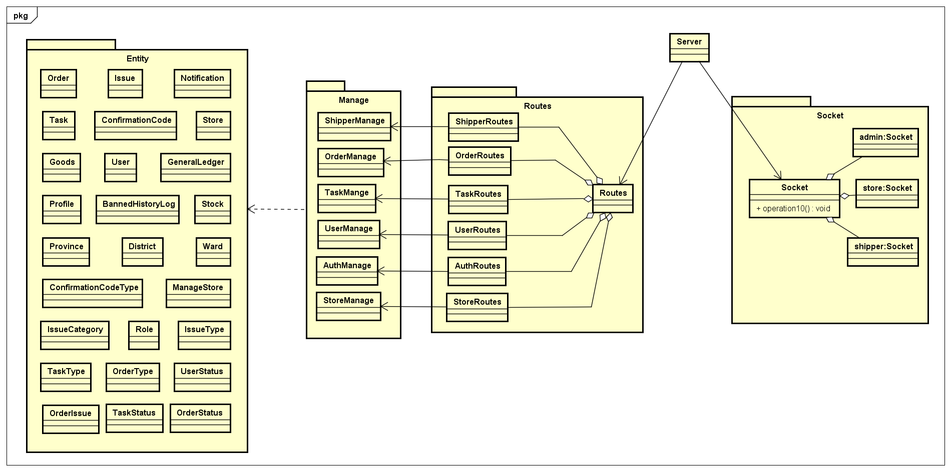

Figure 218. Class Diagram of Server

##### Class Description

##### ShipperManage

###### Attributes

|  |  |  |  |  |
| --- | --- | --- | --- | --- |
| No | Attributes | Type | Default | Description |
| N/A | N/A | N/A | N/A | N/A |

###### Methods

|  |  |  |  |  |
| --- | --- | --- | --- | --- |
| No | Methods | Parameters | Return | Description |
| 1 | getTasks | String | Object | Return an object that hold info of all un-finished tasks regard to shipperID; throw error messages when get error |
| 2 | getHistory | String, int | Object | Return tasks done or fail regard to shipperID and current page to display |
| 3 | getDetail | String, int | Object | Return detail information of an task regard to shipperID and taskid |
| 4 | getOrderStatusList | N/A | Object | Return the object contents all the status of tasks |
| 5 | nextStep | N/A | String | Change the status of order to next step, change status of task; send socket notification to shipper and admin. Return a message success or error. |
| 6 | createIssuePending | String, Object, Array, int | Object | Create a new pending issue and add related order into database  Return the created issue |
| 7 | changeIsPending | String, int | N/A | Resolve an issue and send socket message to the store owns that order |
| 8 | getAllShipper | N/A | Array | Return list of all shippers |
| 9 | getAllOrderToAssignTask | N/A | Array | Return list of all orders that assignable in database |
| 10 | getAllShipperWithTask | N/A | Array | Return list of all shippers and their current tasks |
| 11 | getAllShipperWithTaskForProcessing | N/A | Array | Return list of shippers are having issue |
| 12 | updateTaskForShipper | Array | Object | Update information of a task |
| 13 | getShipperStatus | String | boolean | Get status of shipper by shipperID |
| 14 | getTaskBeIssuePending | String | Array | Get list of task is pending because the shipper got issue |
| 15 | countTaskOfShipper | String | int | Count current task of the shipper by shipperID |
| 16 | changeShipperStatus | String, boolean | String | Change status of shipper to on or off, return message success or error |
| 17 | createShipperID | N/A | String | Create an unique and valid ID for new shipper |

##### IssueManage

###### Attributes

|  |  |  |  |  |
| --- | --- | --- | --- | --- |
| No | Attributes | Type | Default | Description |
| N/A | N/A | N/A | N/A | N/A |

###### Methods

|  |  |  |  |  |
| --- | --- | --- | --- | --- |
| No | Methods | Parameters | Return | Description |
| 1 | getAllIssue | N/A | Array | Get list of all issues in database |
| 2 | getIssueDetail | int | Object | Get detail information of an issue |
| 3 | updateResolveIssue | int, int | Object | Resolve an issue with type of resolve |
| 4 | postBannedLog | Object | Object | Ban a user cause of some reason |
| 5 | createIssueDisconnect | String | Object | Auto raise an issue when shipper disconnect away the socket server in period time |
| 6 | getUserHasIssue | N/A | Array | Get all users who are having un-resolved issue |

##### UserManage

###### Attributes

|  |  |  |  |  |
| --- | --- | --- | --- | --- |
| No | Attributes | Type | Default | Description |
| N/A | N/A | N/A | N/A | N/A |

###### Methods

|  |  |  |  |  |
| --- | --- | --- | --- | --- |
| No | Methods | Parameters | Return | Description |
| 1 | getProfileUser | String | Object | Get profile of a user |
| 2 | getUserDetail | String | Object | Get detail information of a user |
| 3 | putUser | Object | Object | Update data of a user |
| 4 | putProfile | Object | Object | Update profile for a shipper |
| 5 | addNewUser | Object | Object | Create a new user |

##### StoreManage

###### Attributes

|  |  |  |  |  |
| --- | --- | --- | --- | --- |
| No | Attributes | Type | Default | Description |
| N/A | N/A | N/A | N/A | N/A |

###### Methods

|  |  |  |  |  |
| --- | --- | --- | --- | --- |
| No | Methods | Parameters | Return | Description |
| 1 | get | N/A | Array | Get all stores |
| 2 | postNewStore | N/A | Object | Add new Store to database |
| 3 | put | N/A | Object | Update Store with new information to database |
| 4 | getLatestLedgerOfStore | String | Object | Get latest ledger information of specific store |
| 5 | getAllStoreWithLedger | N/A | Array | Get all stores with information of ledger |
| 6 | getTotalFee | N/A | Array | Get total fee of all stores |
| 7 | getTotalCoD | N/A | Array | Get total cash on delivery of all stores |
| 8 | getLatestAutoAccountDate | N/A | Date | Get latest date of ledger that is added automatically by system |
| 9 | updateLedgerForOrder | int | Object | Update which ledger is paid for order |
| 10 | postNewLedger | Object | Object | Add new ledger (transaction) to database |
| 11 | getStoreName | Array | Array | Get list store’s name by storeid |
| 12 | getStoreDetail | String | Object | Get detail of store by storeid |
| 13 | createStoreOwnerID | N/A | String | Create new username for new store owner |
| 14 | createStoreID | N/A | String | Create new storeid for new store |
| 15 | postNewManageStore | N/A | Object | Add relation of new store’s owner and new Store is managed by this store’s owner to database |
| 16 | getAllLedger | N/A | Array | Get all transaction |
| 17 | getLedgerOfStore | String, Date | Array | Get all ledgers of specific store after specific date |
| 18 | storeGetAllLedger | String | Object | Get all ledgers of specific store |

##### OrderMange

###### Attributes

|  |  |  |  |  |
| --- | --- | --- | --- | --- |
| No | Attributes | Type | Default | Description |
|  | wardID | String | N/A | ID of ward |
|  | name | String | N/A | Name of ward |
|  | type | String | N/A | Type of ward |
|  | districtID | String | N/A | ID of district has ward |
|  | location | String | N/A | Location of ward in map |

###### Methods

|  |  |  |  |  |
| --- | --- | --- | --- | --- |
| No | Methods | Parameters | Return | Description |
| 1 | getAllOrder | String | Array | Get all order of store by storeID |
| 2 | calculateShipFee | String, Array, int | double | Calculate ship fee for an Order |
| 3 | calculateOverWeightFee | String, Array, Array | double | Calculate over weight fee for an Order |
| 4 | GenerateRandomCode | int | String | Create confirm codes for an Order |
| 5 | postOneOrder | Object | Object | Create new order into order table |
| 6 | updateOrder | Object | Object | Update order when user edit info of an order |
| 7 | deleteOrder | String | int | Delete an order in order table |
| 8 | putDraff | Object | Object | Add new draft order in order table |
| 9 | cancelOrder | Object | Object | Request cancel order from Store. Insert new row data into issue table, notification table and notify to Admin |
| 10 | getOrderList | Object | Array | Get all order list from order table |
| 11 | getTodayTotal | N/A | Array | Calculate total COD and Fee of all stores |
| 12 | storeGetOrderList | String | Array | Get list order of a store |
| 13 | countOrder | String | Array | Calculate total of order by month or year of a store. |
| 14 | getOverView | N/A | Array | Get all orders, stores, shipper, fee of system to statistical |
| 15 | pushIntoArray | Array, Object | int | Push Item into Array. If item not exist in array, then add item in array. If item exist in array, then update item.  Return index of item in array |
| 16 | getOrderCount | N/A | Array | Get number order of store by month, year |
| 17 | getMoneyCount | N/A | Array | Get total fee and cod of all orders of store |
| 18 | getCountOrdersDoneOrFail | N/A | Array | Count number of done orders and fail orders of all stores |
| 19 | getProvince | N/A | Array | Get all provinces |

# 3. DATABASE DESIGN

## 3.1. Introduction

### 3.1.1. Purpose

This document contains database design and its details so it will make the developer get to know specifically about the database system components. Beside it, the tester implement the unit test base on this design document.

### 3.1.2. Overview

This document is a detail description of the database design of super shipper system. It describes all tables to be created, information stored in each tables, and the relationship between tables.

### 3.1.3. Definition and Acronyms

| **Definition** | **Description** | **Note** |
| --- | --- | --- |
| P/F Key | Primary/ Foreign key | Use to indicate that a field is a primary or foreign key in table*: P: Primary key,*  *F: foreign key, PK: primary key & foreign key* |
|  |  |  |

## 3.2. Database design

### 3.2.1. Entity Relationship Diagram

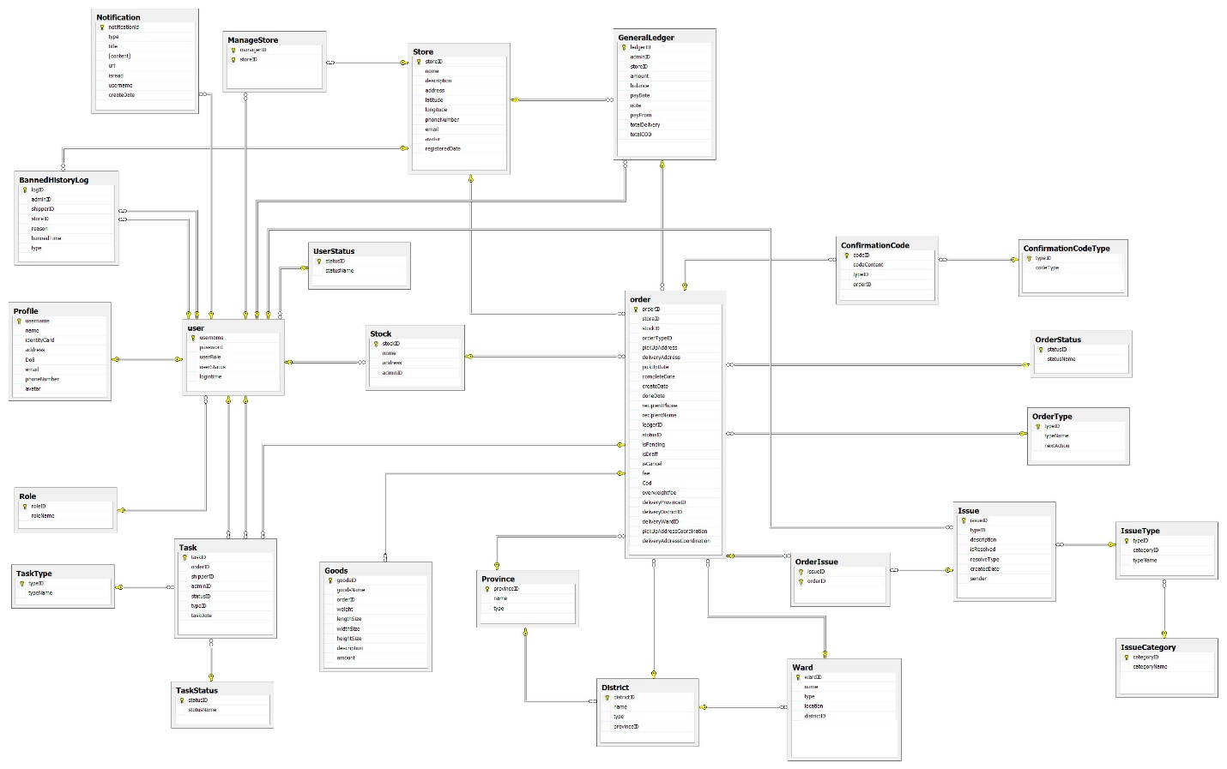

*Figure 2. Entity Relationship Diagram*

|  |  |  |
| --- | --- | --- |
| **No** | **Table** | **Description** |
|  | BannedHistoryLog | Store logs about history of banning account |
|  | ConfimationCode | Store confirmation code for orders and it’s detailed information |
|  | ConfirmationCodeType | Store types of confirmation code |
|  | District | Store district of province |
|  | GeneralLedger | Store transactions with balance of the store and detailed information |
|  | Goods | Store goods and it’s detailed information |
|  | Issue | Store issue’s detailed information |
|  | IssueCategory | Store issue’s category of issue |
|  | IssueType | Store issue’s type of issue |
|  | ManageStore | Store store’s owners and stores which they manage |
|  | Notification | Store detail of all notification |
|  | Order | Store orders and it’s detailed information |
|  | OrderIssue | Store which issue orders have |
|  | OrderStatus | Store statuses of order |
|  | OrderType | Store types of order |
|  | Profile | Store profile of user |
|  | Province | Store provinces in Viet Nam |
|  | Role | Store roles in system |
|  | Stock | Store stocks and it’s detailed information |
|  | Store | Store stores and it’s detailed information |
|  | Task | Store tasks for Shipper with detailed information |
|  | TaskStatus | Store status of task |
|  | TaskType | Store type of task |
|  | User | Store usernames with password, roles and status of username |
|  | UserStatus | Store status of users |
|  | Ward | Store wards of district |

### 3.2.2. Table Diagram

##### User table

|  |  |  |  |  |  |  |  |  |
| --- | --- | --- | --- | --- | --- | --- | --- | --- |
| **No** | **Field name** | **Type** | **Length** | **Allow Null** | **Unique** | **P/F Key** | **Auto increment** | **Description** |
| 1 | username | VARCHAR | 8 | No | x | P |  | unique username for each user |
| 2 | password | VARCHAR | 255 | No |  |  |  | Password of username in MD5 format |
| 3 | userRole | INT |  | No |  | F |  | roleID of username |
| 4 | userStatus | INT |  | No |  | F |  | statusID of username |
| 5 | logintime | DATE |  | Yes |  |  |  | Last time that user logged in |

##### Role Table

|  |  |  |  |  |  |  |  |  |
| --- | --- | --- | --- | --- | --- | --- | --- | --- |
| **No** | **Field name** | **Type** | **Length** | **Allow Null** | **Unique** | **P/F Key** | **Auto increment** | **Description** |
| 1 | roleID | INT |  | No | x | P | x | Unique id of role |
| 2 | roleName | VARCHAR | 20 | No |  |  |  | Role’s name |

##### ManageStore Table

|  |  |  |  |  |  |  |  |  |
| --- | --- | --- | --- | --- | --- | --- | --- | --- |
| **No** | **Field name** | **Type** | **Length** | **Allow Null** | **Unique** | **P/F Key** | **Auto increment** | **Description** |
| 1 | managerID | VARCHAR | 8 | No | x | PF |  | Unique id of manager |
| 2 | storeID | VARCHAR | 6 | No | x | PF |  | Unique id of store |

##### Stores table

|  |  |  |  |  |  |  |  |  |
| --- | --- | --- | --- | --- | --- | --- | --- | --- |
| **No** | **Field name** | **Type** | **Length** | **Allow Null** | **Unique** | **P/F Key** | **Auto increment** | **Description** |
|  | storeID | VARCHAR | 6 | No | x | P |  | Unique id of store |
|  | name | VARCHAR | 50 | No |  |  |  | Store’s name |
|  | description | TEXT |  | No |  |  |  | Description about store |
|  | address | VARCHAR | 100 | No |  |  |  | Address |
|  | email | VARCHAR | 50 | No | x |  |  | Email |
|  | phoneNumber | VARCHAR | 11 | No | x |  |  | Phone number |
|  | avartar | VARCHAR | 50 | No |  |  |  | Link of avatar of store |
|  | registeredDate | DATE |  | No |  |  |  | Date that store registered |
|  | latitude | VARCHAR | 30 | No |  |  |  | Latitude of address in map |
|  | longitude | VARCHAR | 30 | No |  |  |  | Longitude of address in map |

##### BannedHistoryLog table

|  |  |  |  |  |  |  |  |  |
| --- | --- | --- | --- | --- | --- | --- | --- | --- |
| **No** | **Field name** | **Type** | **Length** | **Allow Null** | **Unique** | **P/F Key** | **Auto increment** | **Description** |
|  | logID | INT |  | No | x | P | x | Unique id of log |
|  | adminID | VARCHAR | 8 | No |  | F |  | Id of admin |
|  | shipperID | VARCHAR | 8 | Yes |  | F |  | ShipperID is banned or unbanned |
|  | storeID | VARCHAR | 6 | Yes |  | F |  | StoreID is banned or unbanned |
|  | reason | TEXT |  | Yes |  |  |  | Reason of ban |
|  | bannedTime | DATE |  | No |  |  |  | Time of ban |
|  | type | VARCHAR | 5 | No |  |  |  | Types of ban: ban or unban |

##### Profile table

|  |  |  |  |  |  |  |  |  |
| --- | --- | --- | --- | --- | --- | --- | --- | --- |
| **No** | **Field name** | **Type** | **Length** | **Allow Null** | **Unique** | **P/F Key** | **Auto increment** | **Description** |
| 1. 1 | username | VARCHAR | 8 | No | x | P |  | Unique username of profile |
| 1. 2 | name | VARCHAR | 50 | No |  |  |  | Full name |
| 1. 3 | identityCard | VARCHAR | 10 | No | x |  |  | Identity Card |
| 1. 4 | address | VARCHAR | 100 | No |  |  |  | Address |
| 1. 5 | DoB | DATE |  | No |  |  |  | Date of birth |
| 1. 6 | email | VARCHAR | 50 | No | x |  |  | Email |
| 1. 7 | avartar | VARCHAR | 50 | No |  |  |  | Link of avatar of user |
|  | phoneNumber | VARCHAR | 11 | No | x |  |  | Phone number |

##### UserStatus table

|  |  |  |  |  |  |  |  |  |
| --- | --- | --- | --- | --- | --- | --- | --- | --- |
| **No** | **Field name** | **Type** | **Length** | **Allow Null** | **Unique** | **P/F Key** | **Auto increment** | **Description** |
| 1. 1 | statusID | INT |  | No | x | P | x | Unique id of status |
| 1. 2 | statusName | VARCHAR | 20 | No |  |  |  | Status of user: ban, unban, active,… |

##### Stock table

|  |  |  |  |  |  |  |  |  |
| --- | --- | --- | --- | --- | --- | --- | --- | --- |
| **No** | **Field name** | **Type** | **Length** | **Allow Null** | **Unique** | **P/F Key** | **Auto increment** | **Description** |
| 1. 1 | stockID | INT |  | No | x | P | x | Unique id of stock |
| 1. 2 | name | VARCHAR | 50 | No |  |  |  | Stock’s name |
| 1. 4 | address | VARCHAR | 100 | No |  |  |  | Address |
| 1. 5 | adminID | VARCHAR | 8 | No |  | F |  | ID of admin who manages the stock |

##### Task table

|  |  |  |  |  |  |  |  |  |
| --- | --- | --- | --- | --- | --- | --- | --- | --- |
| **No** | **Field name** | **Type** | **Length** | **Allow Null** | **Unique** | **P/F Key** | **Auto increment** | **Description** |
| 1. 1 | taskID | INT |  | No | x | P | x | Unique id of stock |
| 1. 3 | statusID | INT |  | No |  | F |  | ID of status of task |
| 1. 4 | adminID | VARCHAR | 8 | No |  | F |  | ID of admin who assigns this task |
|  | shipperID | VARCHAR | 8 | No |  | F |  | ID of shipper who does this task |
|  | orderID | VARCHAR | 8 | No |  | F |  | ID of order |
|  | typeID | INT |  | No |  | F |  | ID of type of task |
|  | taskDate | DATE |  | No |  |  |  | When task is created |

##### TaskType table

|  |  |  |  |  |  |  |  |  |
| --- | --- | --- | --- | --- | --- | --- | --- | --- |
| **No** | **Field name** | **Type** | **Length** | **Allow Null** | **Unique** | **P/F Key** | **Auto increment** | **Description** |
| 1. 1 | typeID | INT |  | No | x | P | x | ID of type |
| 1. 2 | typeName | VARCHAR | 20 | No |  |  |  | Name of type |

##### TaskStatus table

|  |  |  |  |  |  |  |  |  |
| --- | --- | --- | --- | --- | --- | --- | --- | --- |
| **No** | **Field name** | **Type** | **Length** | **Allow Null** | **Unique** | **P/F Key** | **Auto increment** | **Description** |
| 1. 1 | statusID | INT |  | No | x | P | x | ID of status |
| 1. 2 | statusName | VARCHAR | 20 | No |  |  |  | Name of status |

##### GeneralLedger table

|  |  |  |  |  |  |  |  |  |
| --- | --- | --- | --- | --- | --- | --- | --- | --- |
| **No** | **Field name** | **Type** | **Length** | **Allow Null** | **Unique** | **P/F Key** | **Auto increment** | **Description** |
| 1. 1 | ledgerID | INT |  | No | x | P | x | Unique id of ledger |
| 1. 2 | adminID | VARCHAR | 8 | No |  | F |  | Who added this ledger |
| 1. 3 | storeID | VARCHAR | 6 | No |  | F |  | ID of store who sends or receives payment |
| 1. 4 | amount | BIGINT |  | No |  |  |  | Amount of payment |
|  | totalDelivery | BIGINT |  | No |  |  |  | Delivery cost |
|  | totalCOD | BIGINT |  | No |  |  |  | CoD cost |
|  | balance | BIGINT |  | No |  |  |  | Balance after payment |
|  | payDate | DATETIME |  | No |  |  |  | When ledger is posted |
|  | note | TEXT |  | Yes |  |  |  | Note |
|  | payFrom | INT |  | No |  |  |  | Ledger is from store or system |

##### ConfirmationCodeType table

|  |  |  |  |  |  |  |  |  |
| --- | --- | --- | --- | --- | --- | --- | --- | --- |
| **No** | **Field name** | **Type** | **Length** | **Allow Null** | **Unique** | **P/F Key** | **Auto increment** | **Description** |
| 1. 1 | typeID | INT |  | No | x | P | x | Unique id of code type |
| 1. 2 | codeType | VARCHAR | 20 | No |  |  |  | Type of code: Pickup order, delivery order,… |

##### ConfirmationCode table

|  |  |  |  |  |  |  |  |  |
| --- | --- | --- | --- | --- | --- | --- | --- | --- |
| **No** | **Field name** | **Type** | **Length** | **Allow Null** | **Unique** | **P/F Key** | **Auto increment** | **Description** |
| 1. 1 | codeID | INT |  | No | x | P | x | Unique id of confirmation code |
| 1. 2 | typeID | INT |  | No |  | F |  | ID of code type |
| 1. 3 | orderID | VARCHAR | 8 | No |  | F |  | ID of order |
| 1. 4 | codeContent | INT |  | No |  |  |  | Content of code |

##### Goods table

|  |  |  |  |  |  |  |  |  |
| --- | --- | --- | --- | --- | --- | --- | --- | --- |
| **No** | **Field name** | **Type** | **Length** | **Allow Null** | **Unique** | **P/F Key** | **Auto increment** | **Description** |
| 1. 1 | goodsID | INT |  | No | x | P | x | Unique id of goods |
|  | goodsName | VARCHAR | 20 | No |  |  |  | Name of goods |
|  | orderID | VARCHAR | 8 | No |  | F |  | ID of order contains goods |
| 1. 2 | weight | FLOAT |  | No |  | F |  | Weight of goods |
| 1. 3 | lengthSize | FLOAT |  | No |  | F |  | LengthSize of goods |
| 1. 4 | widthSize | FLOAT |  | No |  |  |  | WidthSize of goods |
|  | heightSize | FLOAT |  | No |  |  |  | HeightSize of goods |
|  | description | TEXT |  | No |  |  |  | Description of goods |
|  | amount | INT |  | No |  |  |  | Amount of goods |

##### OrderType table

|  |  |  |  |  |  |  |  |  |
| --- | --- | --- | --- | --- | --- | --- | --- | --- |
| **No** | **Field name** | **Type** | **Length** | **Allow Null** | **Unique** | **P/F Key** | **Auto increment** | **Description** |
| 1. 1 | typeID | INT |  | No | x | P | x | ID of order’s type |
| 1. 2 | typeName | VARCHAR | 20 | No |  |  |  | Name of type: normal, express,… |
|  | nextAction | VARCHAR | 20 | No |  |  |  | Next action of this type |

##### OrderStatus table

|  |  |  |  |  |  |  |  |  |
| --- | --- | --- | --- | --- | --- | --- | --- | --- |
| **No** | **Field name** | **Type** | **Length** | **Allow Null** | **Unique** | **P/F Key** | **Auto increment** | **Description** |
| 1. 1 | statusID | INT |  | No | x | P | x | ID of order’s status |
| 1. 2 | statusName | VARCHAR | 20 | No |  |  |  | Name of order’s status: gathering, delivering,… |

##### Order table

|  |  |  |  |  |  |  |  |  |
| --- | --- | --- | --- | --- | --- | --- | --- | --- |
| **No** | **Field name** | **Type** | **Length** | **Allow Null** | **Unique** | **P/F Key** | **Auto increment** | **Description** |
| 1. 1 | orderID | VARCHAR | 8 | No | x | P |  | Unique id of orders |
| 1. 2 | storeID | VARCHAR | 6 | No |  | F |  | ID of store |
| 1. 3 | stockID | INT |  | No |  | F |  | ID of stock contains order |
| 1. 4 | orderTypeID | INT |  | No |  | F |  | typeID of orders |
|  | pickUpAddress | VARCHAR | 100 | No |  |  |  | Address for picking up order |
|  | deliveryAddress | VARCHAR | 100 | No |  |  |  | Address for delivering up order |
|  | pickUpDate | DATE |  | Yes |  |  |  | Date of picking up order |
|  | completeDate | DATE |  | Yes |  |  |  | Date of delivering order |
|  | createDate | DATE |  | No |  |  |  | Date of creating order |
|  | recipientPhone | VARCHAR | 11 | Yes |  |  |  | Phone of recipient |
|  | recipientName | VARCHAR | 50 | Yes |  |  |  | Recipient’s Name |
|  | ledgerID | INT |  | Yes |  | F |  | ID of ledger of order |
|  | statusID | INT |  | No |  | F |  | ID of order status |
|  | goods | INT |  | No |  | F |  | ID of goods |
|  | fee | BIGINT |  | No |  |  |  | Fee of order |
|  | CoD | BIGINT |  | Yes |  |  |  | Cash on delivery |
|  | Overweightfee | INT |  | Yes |  |  |  | Fee of overweight |
|  | deliveryProvinceID | VARCHAR | 5 | No |  | F |  | ID of province of delivery address |
|  | deliveryDistrictID | VARCHAR | 5 | No |  | F |  | ID of district of delivery address |
|  | deliveryWardID | VARCHAR | 5 | No |  | F |  | ID of ward of delivery address |

##### IssueCategory table

|  |  |  |  |  |  |  |  |  |
| --- | --- | --- | --- | --- | --- | --- | --- | --- |
| **No** | **Field name** | **Type** | **Length** | **Allow Null** | **Unique** | **P/F Key** | **Auto increment** | **Description** |
| 1. 1 | categoryID | INT |  | No | x | P | x | ID of category |
| 1. 2 | categoryName | VARCHAR | 20 | No |  |  |  | Category of issue: Shipper Pending,... |

##### IssueType table

|  |  |  |  |  |  |  |  |  |
| --- | --- | --- | --- | --- | --- | --- | --- | --- |
| **No** | **Field name** | **Type** | **Length** | **Allow Null** | **Unique** | **P/F Key** | **Auto increment** | **Description** |
| 1. 1 | typeID | INT |  | No | x | P | x | ID of type |
| 1. 2 | typeName | VARCHAR | 20 | No |  |  |  | Name of type |
|  | categoryID | INT |  | No |  | F |  | ID of issue category |

##### Issues table

|  |  |  |  |  |  |  |  |  |
| --- | --- | --- | --- | --- | --- | --- | --- | --- |
| **No** | **Field name** | **Type** | **Length** | **Allow Null** | **Unique** | **P/F Key** | **Auto increment** | **Description** |
| 1. 1 | issueID | INT |  | No | x | P | x | ID of issue |
| 1. 2 | typeID | INT |  | No |  | F |  | ID of issue type |
|  | isResolved | BOOLEAN |  | No |  |  |  | Issue is resolved or not |
|  | description | TEXT |  | No |  |  |  | Description |
| 1. r | resolveType | INT |  | Yes |  |  |  | Type of resolve |
|  | createdDate | DATE |  | No |  |  |  | When issue is created |
|  | sender | VARCHAR | 8 | No |  | F |  | Who sent issue |

##### OrderIssue table

|  |  |  |  |  |  |  |  |  |
| --- | --- | --- | --- | --- | --- | --- | --- | --- |
| **No** | **Field name** | **Type** | **Length** | **Allow Null** | **Unique** | **P/F Key** | **Auto increment** | **Description** |
| 1. 1 | issueID | INT |  | No |  | PF |  | ID of issue |
| 1. 2 | orderID | INT |  | No |  | PF |  | ID of order which has issues |

##### Notification table

|  |  |  |  |  |  |  |  |  |
| --- | --- | --- | --- | --- | --- | --- | --- | --- |
| **No** | **Field name** | **Type** | **Length** | **Allow Null** | **Unique** | **P/F Key** | **Auto increment** | **Description** |
| 1. 1 | notificationID | INT |  | No | x | P | x | Unique id of notification |
| 1. 2 | type | VARCHAR | 4 | No |  |  |  | Type of notification: info, error |
| 1. 3 | title | TEXT |  | No |  |  |  | Title of notification |
| 1. 4 | content | TEXT |  | No |  |  |  | Content of notification |
|  | url | TEXT |  | No |  |  |  | URL link to page relate to notification |
|  | isRead | BOOLEAN |  | No |  |  |  | Notification has been read or hasn’t |
|  | username | VARCHAR | 8 | No |  | F |  | Who receive notification |
|  | createDate | DATE |  | Yes |  |  |  | When notification is created |

##### Province table

|  |  |  |  |  |  |  |  |  |
| --- | --- | --- | --- | --- | --- | --- | --- | --- |
| **No** | **Field name** | **Type** | **Length** | **Allow Null** | **Unique** | **P/F Key** | **Auto increment** | **Description** |
| 1. 1 | provinceID | VARCHAR | 5 | No | x | P | x | ID of province |
| 1. 2 | name | VARCHAR | 100 | No |  |  |  | Name of province |
|  | type | VARCHAR | 30 | No |  |  |  | Type of province |

##### District table

|  |  |  |  |  |  |  |  |  |
| --- | --- | --- | --- | --- | --- | --- | --- | --- |
| **No** | **Field name** | **Type** | **Length** | **Allow Null** | **Unique** | **P/F Key** | **Auto increment** | **Description** |
| 1. 1 | districtID | VARCHAR | 5 | No | x | P | x | ID of district |
| 1. 2 | name | VARCHAR | 100 | No |  |  |  | Name of district |
|  | type | VARCHAR | 30 | No |  |  |  | Type of district |
|  | provinceID | VARCHAR | 5 | No |  | F |  | ID of province has district |

##### Ward table

|  |  |  |  |  |  |  |  |  |
| --- | --- | --- | --- | --- | --- | --- | --- | --- |
| **No** | **Field name** | **Type** | **Length** | **Allow Null** | **Unique** | **P/F Key** | **Auto increment** | **Description** |
| 1. 1 | wardID | VARCHAR | 5 | No | x | P | x | ID of ward |
| 1. 2 | name | VARCHAR | 100 | No |  |  |  | Name of ward |
|  | type | VARCHAR | 30 | No |  |  |  | Type of ward |
|  | districtID | VARCHAR | 5 | No |  | F |  | ID of district has ward |
|  | location | VARCHAR | 30 | No |  |  |  | Location of ward in map |

# 4. INTERFACE DESIGN

## 4.1. Introduce

This document describes the User Interface for the Karywell Application a Server.

This document is divided into the following sections:

* Structure and layout describes the structure of the application, screen flow

Screen Descriptions, which comprises the main part of the document, contains a detailed description of each screen and its component parts.

## 4.2. Interface Design of Mobile Application

### 4.2.1. Structure and Layout

The overall structure of the application is relatively simple, as shown in the following diagram.

|  |  |  |
| --- | --- | --- |
| **No** | **Screen Name** | **Description** |
| **1** | Login Screen | Where user can login to the System. System provides his or her access credentials in order to use system. |
| **2** | Profile Screen | Where displays the information of User |
| **3** | Task Screen | Where displays the tasks of User. User sees the list of his/her in working tasks. |
| **4** | Task’s Detail Screen | Where user can view detail information of task. Include information of order. |
| **5** | Issue Screen | Where user can send issue. Include two type of Issue: Pending, Cancel. This issue influents and a short description from user. |
| **6** | History Screen | Where displays the history of task which status of task is Done or Fail |

* 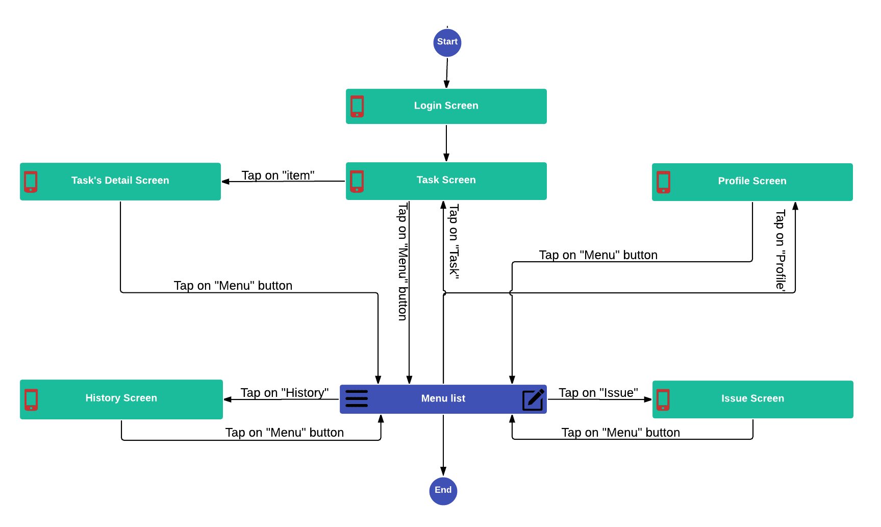Screen Flow:

### 4.2.2. Screen Description

##### Login Screen

This is the first screen after user launched KaryWell application where user can entered account(UserName, Password) to sign-in to the application.

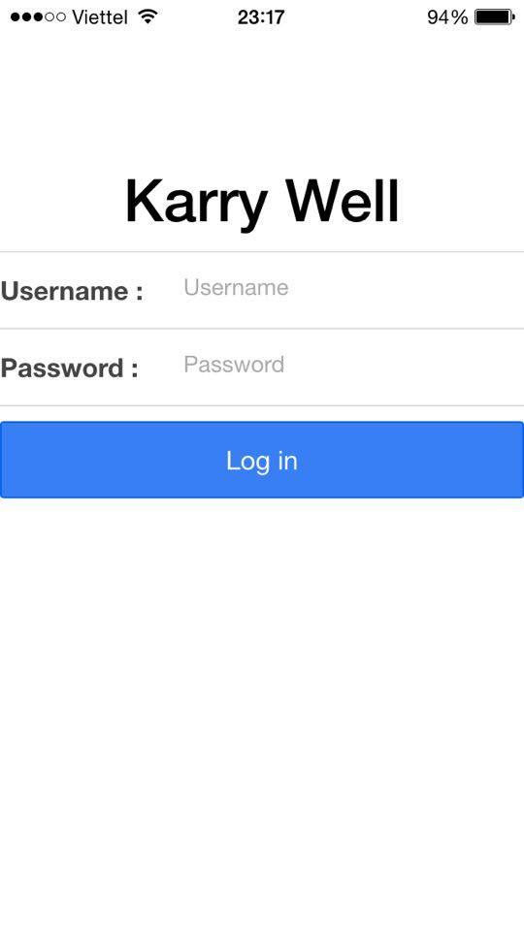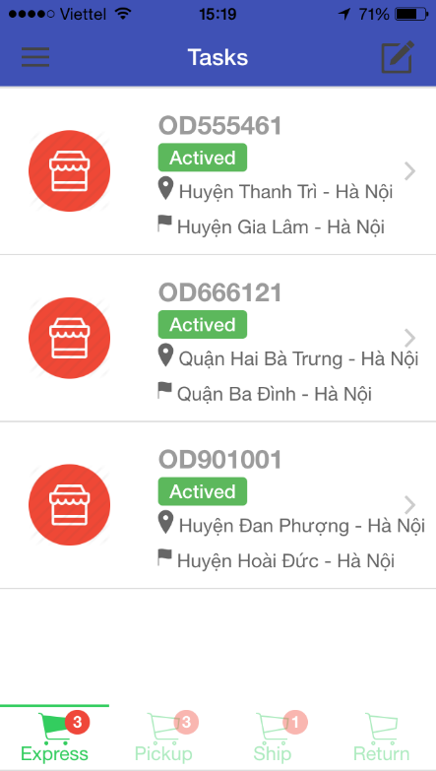

|  |  |  |  |  |
| --- | --- | --- | --- | --- |
| **No** | **Elements** | **Required** | **Type** | **Description** |
| **1** | **Username** | Touch on | Text | Input text for sign-in to the application. |
| **2** | **Password** | Touch on | Password | Input password for sign-in to the application. |
| **3** | **Login** | Touch on | Button | When user click this button, the system provides their access credentials in order to use system. If Sign-in successful then the application will redirect to ‘Task Screen’. |

##### Profile Screen

When user want view their information, KaryWell app will display the information of user. User can view their information: Name, ID, Date of Birth, Identity Card, Phone Number, Email, Address

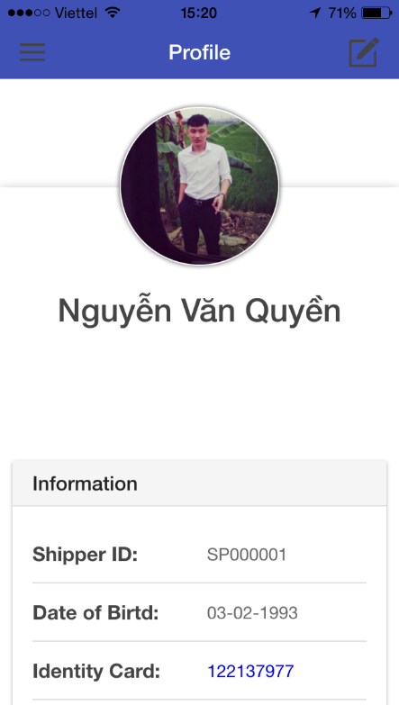

|  |  |  |  |  |
| --- | --- | --- | --- | --- |
| **No** | **Elements** | **Required** | **Type** | **Description** |
| **1** | **Menu** | Touch on | List view | List of the features ( Tasks , History, Send Issue, Profile, Change Status, Logout)when user taped on it.The menu button like a navigation tool to direct to other screens . |
| **2** | **Compose Icon** | Touch on | Button | Button on right of menu bar. If user taped on it, redirect to ‘Send Issue’ Screen. |
| **3** | **Title** |  | Label | The title is “Profile” |
| **4** | **Profile Image** |  | Image | Displays user’s image. |
| **5** | **Profile Information** |  | List view | Displays information of user(ID, Date of Birth, Identity Card, Phone Number, Email, Address). |

##### Task Screen

This is the first screen after user logged to the KaryWell application where user can view and tracking their task. User see the list of their in-working tasks (all of his Active or Inactive of tasks will be displayed here).

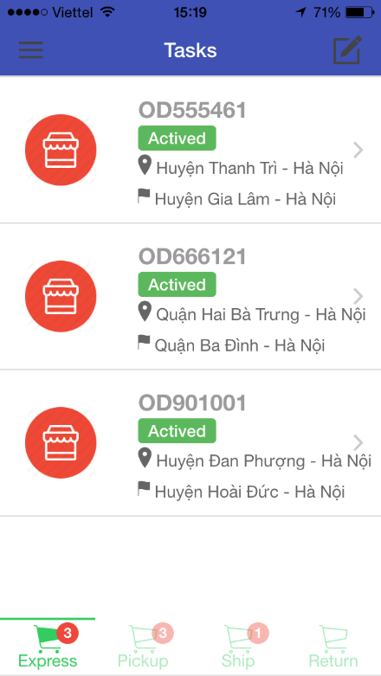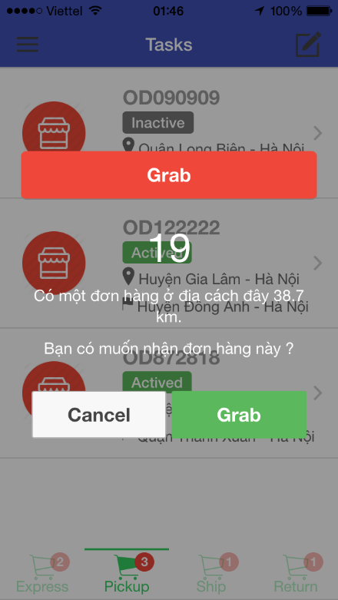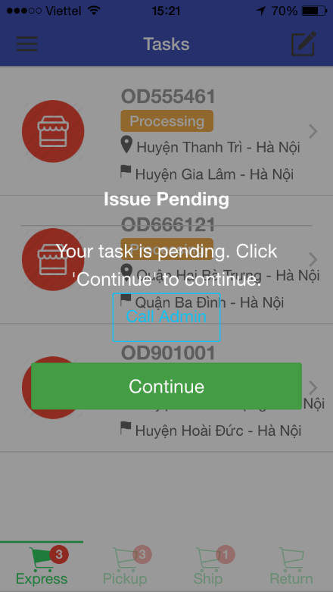

|  |  |  |  |  |
| --- | --- | --- | --- | --- |
| **No** | **Elements** | **Required** | **Type** | **Description** |
| **1** | **Menu** | Touch on | List view | List of the features ( Tasks , History, Send Issue, Profile, Change Status, Logout)when user taped on it.The menu button like a navigation tool to direct to other screens . |
| **2** | **Compose Icon** | Touch on | Button | Button on right of menu bar. If user taped on it, The application will redirect to ‘Send Issue’ Screen. |
| **3** | **Title** |  | Label | The title is “Tasks” |
| **4** | **Tab bar** | Touch on | Sliding tab | Tasks have 4 types correspond 4 tabs: Express, Pickup, Ship, Return. When user click on each of task, the application will show list of their in-working tasks. The number of task is shown on tab icon. |
| **5** | **List Task** | Touch on | List view | A tab has many tasks. Each item is including with information: Order code, Status of Task, Pickup Address and Delivery Address. When user click on task, the application will redirect to ‘Task Detail’ screen. |
| **6** | **Grab Order** | Touch on | ShowDialog | Ask user after have request delivering an order from customer. When user taped on ‘Grab’ button, the application will assign this task for user.  At the main of Dialog is turn the back time (60s). |
| **7** | **Continue** | Touch on | ShowDialog | Ask user after user was issued. If user want continue their work then user requests to Admin to solve this issue.  When user want contact to Admin, then user can click ‘Call Admin’ button. |

##### Task’s Detail Screen

Task’s Detail screen display all detail information of task. User can view map, order status… and tracking that task. User can check code for each step (pickup, delivering, return). The result will be displayed below.

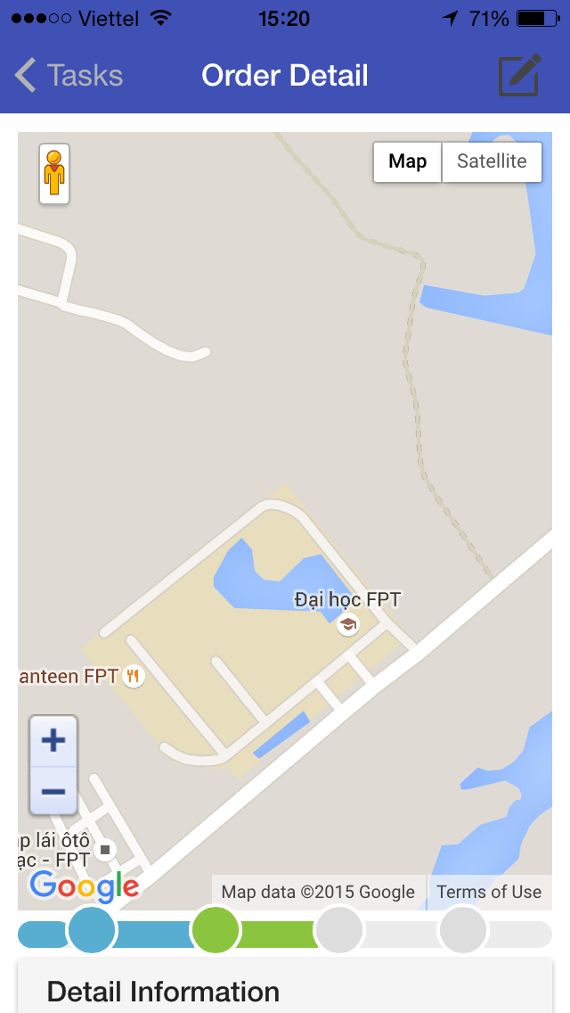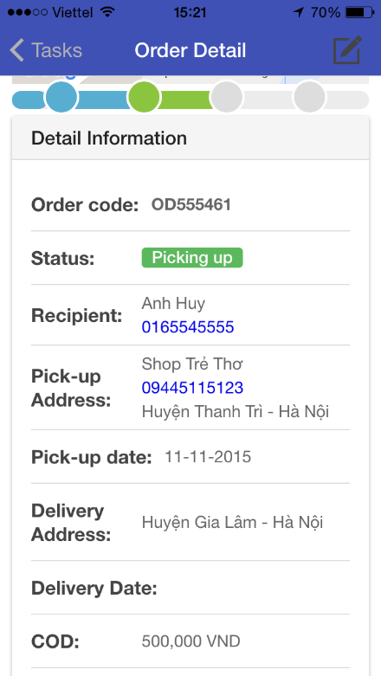

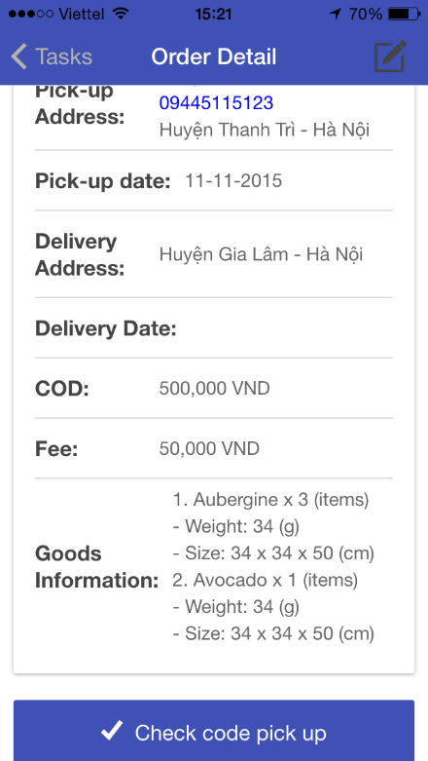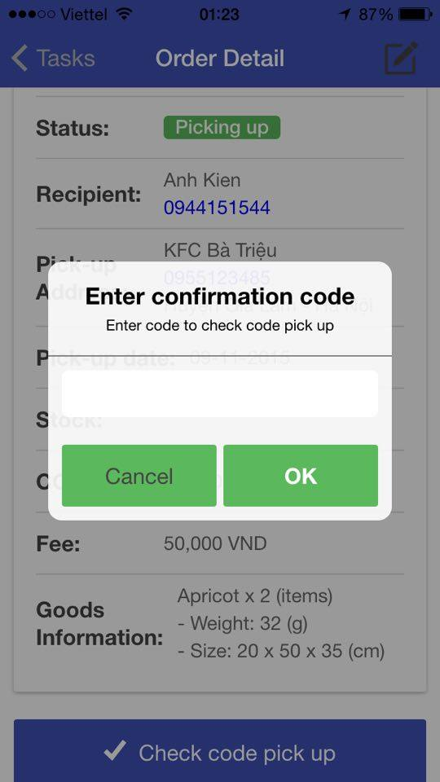

|  |  |  |  |  |
| --- | --- | --- | --- | --- |
| **No** | **Elements** | **Required** | **Type** | **Description** |
| **1** | **Menu** | Touch on | List view | List of the features ( Tasks , History, Send Issue, Profile, Change Status, Logout)when user taped on it.The menu button like a navigation tool to direct to other screens . |
| **2** | **Compose Icon** | Touch on | Button | Button on right of menu bar. If user taped on it, redirect to ‘Send Issue’ Screen. |
| **3** | **Title** |  | Label | The title is “Order Detail” |
| **4** | **Map** | Touch on | Google map item | User can view their current location on map. Use can view the distance from current location to customer of location. |
| **5** | **Timeline** |  | List view | Display timeline of task (Picking up, Delivering, Returning) by status of that task. |
| **6** | **Detail Information** |  | List view | Display detail information of task (Order Code, Status, Recipient, Pick-up Address, Pick-up date, Stock, COD, Fee, Goods Information). |
| **7** | **Check code** |  | Button | User can check code for each process. Example: When user arrived the customer’s location, then user have to tap ‘Check code pick up’ to confirmation. |
| **8** | **Confirmation code** |  | ShowDialog | After taped on ‘Check code’ button, then application will show a confirmation dialog. User have to entered code. To make sure right user.  User tap on “OK” to confirm code. |
|  |  |  |  |  |

##### Issue Screen

Where user can send issue. Include two type of Issue: Pending, Cancel. These issue influents and a short description from user.

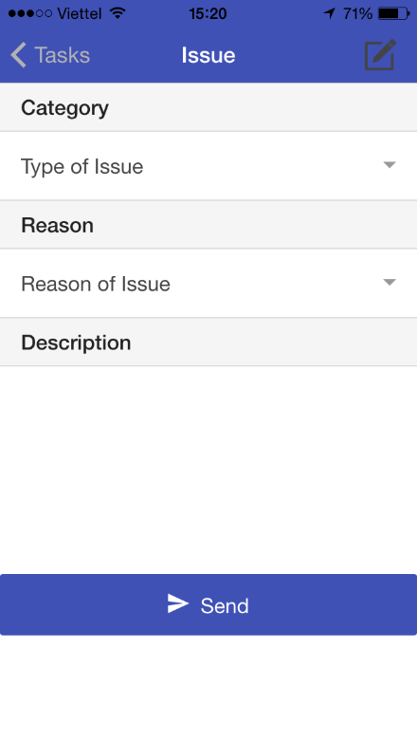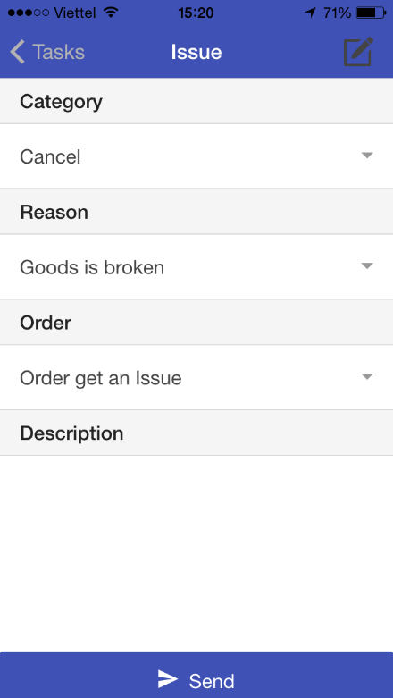

|  |  |  |  |  |
| --- | --- | --- | --- | --- |
| **No** | **Elements** | **Required** | **Type** | **Description** |
| **1** | **Menu** | Touch on | List view | List of the features ( Tasks , History, Send Issue, Profile, Change Status, Logout)when user taped on it.The menu button like a navigation tool to direct to other screens . |
| **2** | **Compose Icon** | Touch on | Button | Button on right of menu bar. If user taped on it, redirect to ‘Send Issue’ Screen. |
| **3** | **Title** |  | Label | The title is “Issue”. |
| **4** | **Category** | Touch on | DropDown List | Display categories include: Pending, Cancel. |
| **5** | **Reason** | Touch on | DropDown List | Display type of each category. If category is Pending, then display list of reason: Traffic jam, Vehicle, Accident, Other. Otherwise If category is Cancel, then list of reason: Good is Broken, Cannot contact with customer. |
| **6** | **Order** | Touch on | List checkbox | This element shown when category of issue is Cancel. User can select order from list. |
| **7** | **Description** | Touch on | TextArea | Use can type short description of that issue. |
| **8** | **Send** | Touch on | Button | When user taped on ‘Send’ button, application will sent an issue to Admin to solve for that issue. |

##### History Screen

History help user saving tasks so that user can review those tasks. When user tap on each task, then application redirect to ‘Task’s Detail’ screen. When history is so long with many records, then application will appear ‘See more…’ button.

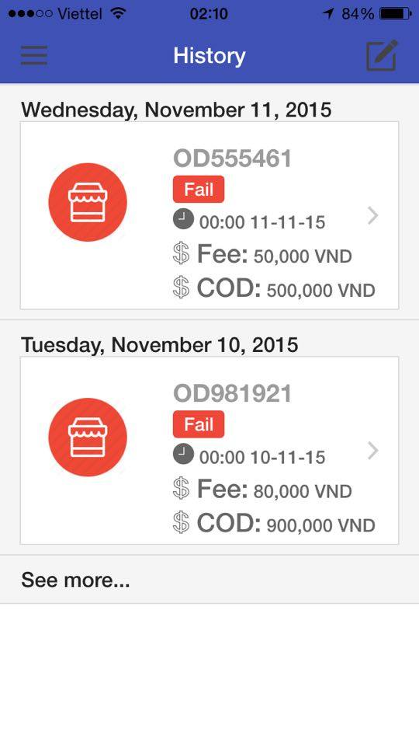

|  |  |  |  |  |
| --- | --- | --- | --- | --- |
| **No** | **Elements** | **Required** | **Type** | **Description** |
| **1** | **Menu** | Touch on | List view | List of the features ( Tasks , History, Send Issue, Profile, Change Status, Logout)when user taped on it.The menu button like a navigation tool to direct to other screens . |
| **2** | **Compose Icon** | Touch on | Button | Button on right of menu bar. If user taped on it, redirect to ‘Send Issue’ Screen. |
| **3** | **Title** |  | Label | The title is “History” |
| **4** | **List task** | Touch on | List view | Each item is including with information: Complete Date, Order code, Status of Task, Time, Fee and COD. If user want view detail information of task, then tap on each item. The application will redirect to detail information of task. |
| **5** | **See more** | Touch on | Button | If list history exceeds 2 then ‘See more’ button will appear at the end of screen. User can view more list history. |

## 4.3. Interface Design of Web Client

### 4.3.1. Admin

##### Structure and Layout

The overall structure of the application is relatively simple, as shown in the following diagram.

|  |  |  |
| --- | --- | --- |
| **No** | **Screen Name** | **Description** |
|  | Dashboard Screen | Displays overview of system about Shipper, Store, Order, Task and Finance |
|  | Create Order Screen | Where admin can create new order |
|  | Order’s List Screen | Displays all orders and related information |
|  | Add Store Screen | Where admin can add new store to system. |
|  | Store’s List Screen | Displays all stores and related information |
|  | Transaction History Screen | Displays all transactions and related information |
|  | Add New Shipper Screen | Where admin can add new shipper to system. |
|  | Shipper’s List Screen | Displays all shippers and related information |
|  | Task’s List Screen | Displays all tasks and related information |
|  | Assign Task Screen | Where admin can assign order to shipper |
|  | IssueBox Screen | Displays all issues and related information |
|  | Report Screen | Displays statistics of system about Shipper, Store, Order, Task and Finance |
|  | User Detail Screen | Displays user’s detail, so admin can update these information |
|  | Store Detail Screen | Displays store’s detail, so admin can update these information |

**Screen flow:**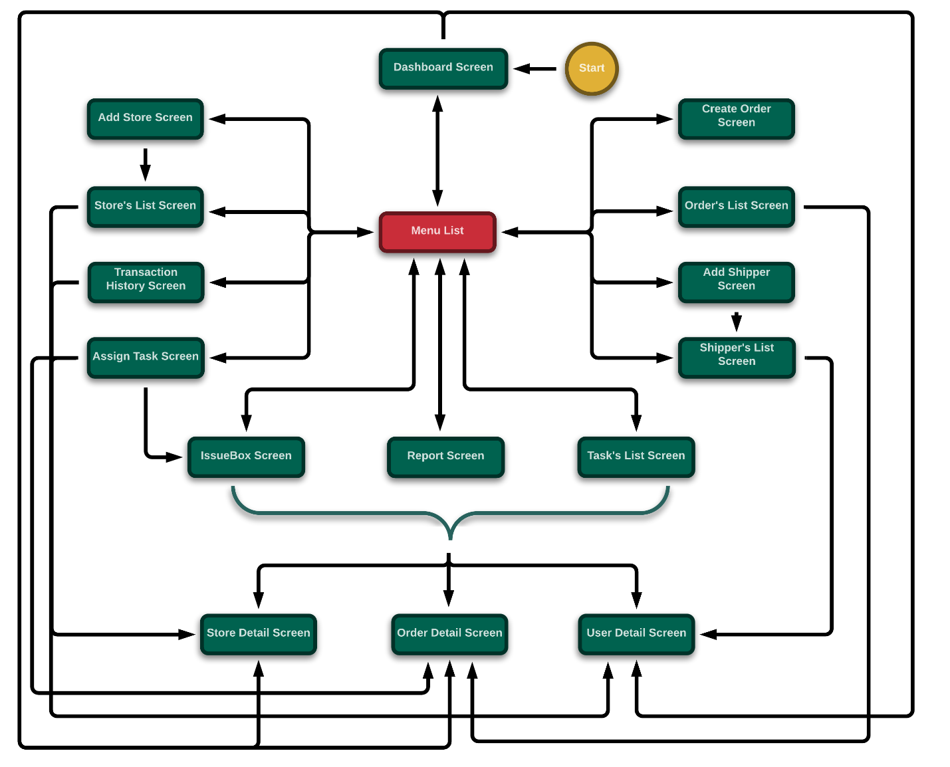

##### Screen Description

##### Login to system

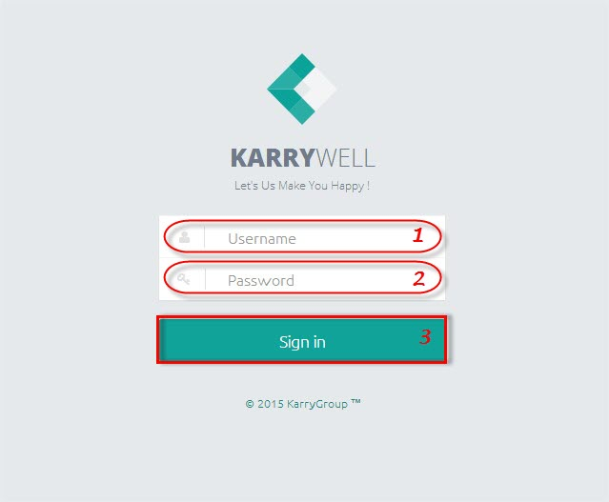

**To login to KaryWell system:**

**Step 1**. Type your “Username” on username text box (“1”)

**Step 2**. Type your “Password” on password text box (“2”)

**Step 3**. Click on “Sign in” button (“3”)

##### Dashboard Screen

This is the first screen after Admin logged in system where overview of system is displayed

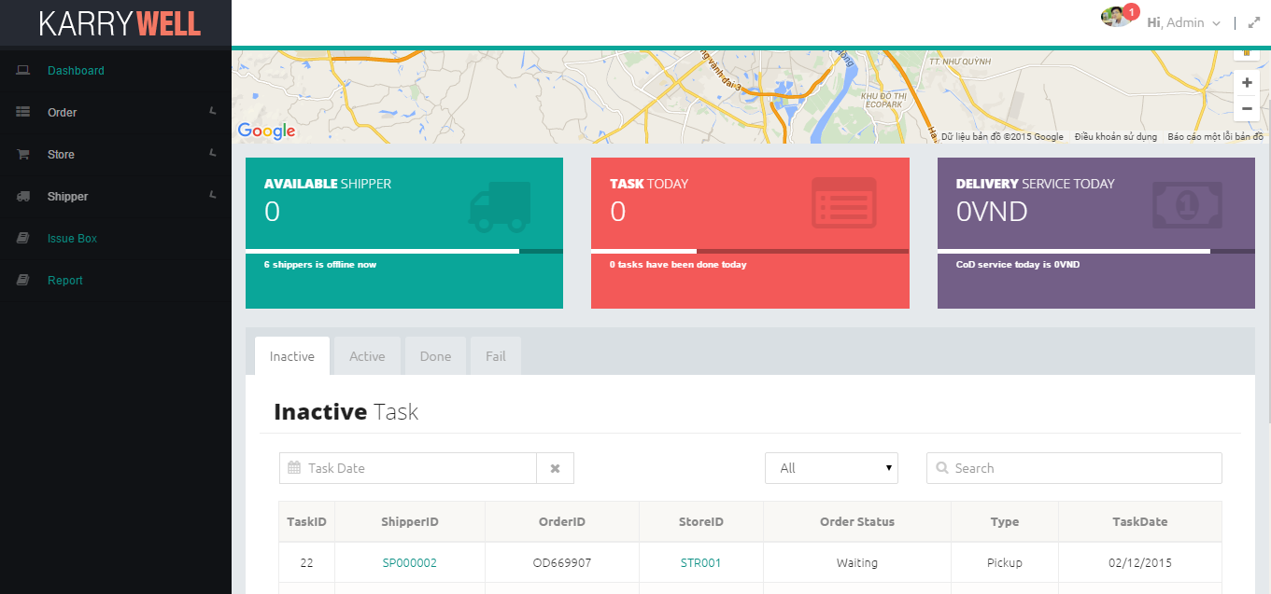

|  |  |  |  |  |
| --- | --- | --- | --- | --- |
| **No** | **Elements** | **Sub-Element** | **Type** | **Description** |
|  | **Menu** |  | List view | List of the pages ( Dashboard , Order(*Create Order ,Order’s List*) , Store(*Add Store, Store’s List, Transaction History*), Shipper*(Add Shipper, Shipper’s List, Task’s List, Assign Task*), Report , IssueBox ) which navigate directly to selected page |
|  | **KARYWELL logo** |  | Image | Logo of system |
|  | **Header** | Avatar | Image | Avatar of user |
| Notification | Button | Number of unread notification, click to view notification list |
| Greeting | Drop-downlist | Include ‘Sign out’, ‘View Profile’ to log out or view user’s profile |
| Full size | Button | Click to view page on full-screen |
|  | **Map** |  | Google map item | Map of all stores and online shippers |
|  | **Shipper box** |  | Box item | Displays number of online and offline shipper |
|  | **Task box** |  | Box item | Displays number of tasks today and tasks which have been done today |
|  | **Finance box** |  | Box item | Displays total delivery cost and cash on delivery |
|  | **Task tab** |  | Tab item | There are 4 tabs: Inactive, Active, Done, Fail. Each tab includes a table of tasks have specific status |
|  | **Task table** | **Date range** | Daterange-picker | Select date range for searching |
| **Clear** | Button | Clear date range value |
| **Type filter** | Drop-downlist | Select type for searching |
| **Search** | Textbox | Enter search key for searching |
| **Table** | Table item | Displays tasks and related information (taskid, shipperid, orderid, storeid, order status, type, task date) |
| **Page navigation** | Navigation item | Click to select page number |

##### Add Store Screen

When admin wants to add a new Store, admin have to create an account for store’s owner and store profile

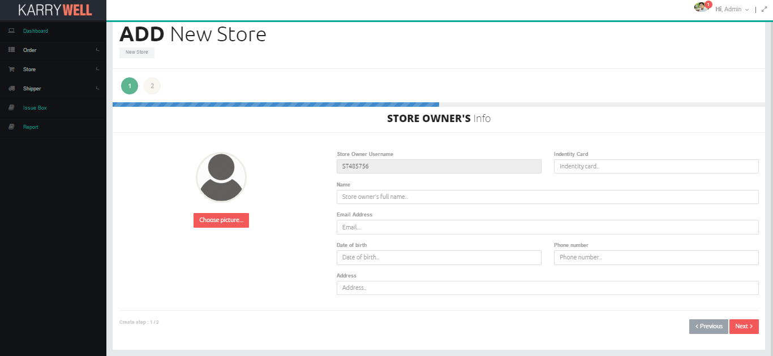

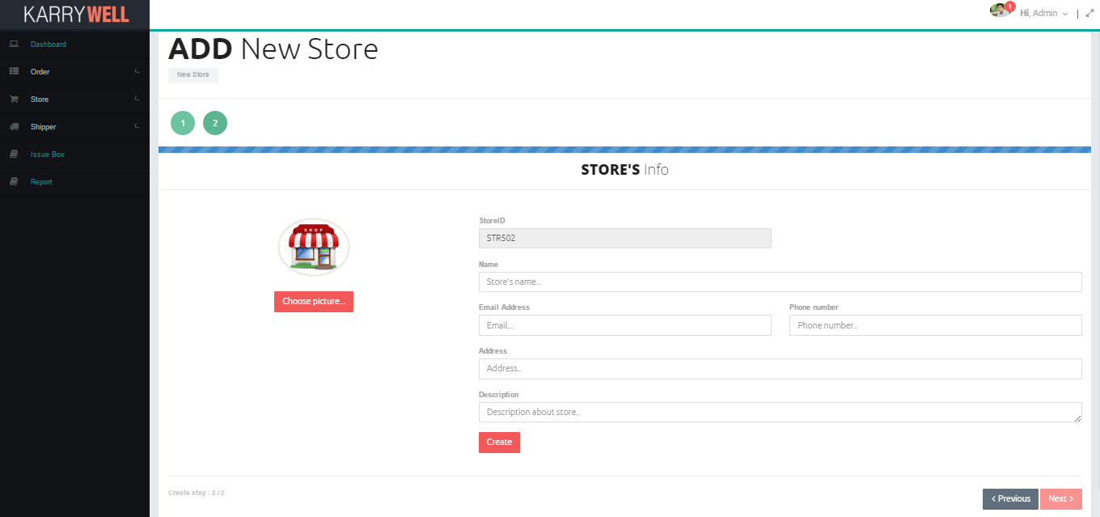

|  |  |  |  |  |
| --- | --- | --- | --- | --- |
| **No** | **Elements** | **Sub-Element** | **Type** | **Description** |
| 1. **1** | **Menu** |  | List view | List of the pages ( Dashboard , Order(*Create Order ,Order’s List*) , Store(*Add Store, Store’s List, Transaction History*), Shipper*(Add Shipper, Shipper’s List, Task’s List, Assign Task*), Report , IssueBox ) which navigate directly to selected page |
| 1. **2** | **KARYWELL logo** |  | Image | Logo of system |
| 1. **3** | **Header** | Avatar | Image | Avatar of user |
| Notification | Button | Number of unread notification, click to view notification list |
| Greeting | Drop-downlist | Include ‘Sign out’, ‘View Profile’ to log out or view user’s profile |
| Full size | Button | Click to view page on full-screen |
| 1. **4** | **Add New Store title** |  | Label | Title |
| 1. **5** | **Step button** |  | Button | Step of adding store process |
| 1. **6** | **Form of step1** | **Store Owner Info Title** | Label | Title of form |
| **Avatar** | Image | Avatar of new shipper |
| **Store Owner Username** | Textbox | Store’s Owner username of new store |
| **Identity card** | Textbox | Identity card of new store’s owner |
| **Name** | Textbox | Full name of new store’s owner |
| **Email** | Textbox | Email of new store’s owner |
| **Date of Birth** | DatePicker item | Date of birth of new store’s owner |
| **Phone number** | Textbox | Phone number of new store’s owner |
| **Address** | Textbox | Address of new store’s owner |
| **Next** | Button | Click to go to next step |
| **Previous** | Button | Click to go to previous step |
| **Choose picture** | Button | Click to add choose avatar for new Shipper |
| 1. **7** | **Form of step2** | **Store Owner Info Title** | Label | Title of form |
| **Avatar** | Image | Avatar of new store |
| **StoreID** | Label | StoreID of new store |
| **Name** | Textbox | Name of new store |
| **Email** | Textbox | Email of new store |
| **Phone number** | Textbox | Phone number of new store |
| **Address** | Textbox | Address of new store |
| **Description** | Textbox | Description about new store |
| **Choose picture** | Button | Click to add choose avatar for new Shipper |
| **Create** | Button | Click to create new store with entered information |
| **Next** | Button | Click to go to next step |
| **Previous** | Button | Click to go to previous step |

##### Store’s List Screen

Admin can view all store of system in map and in table

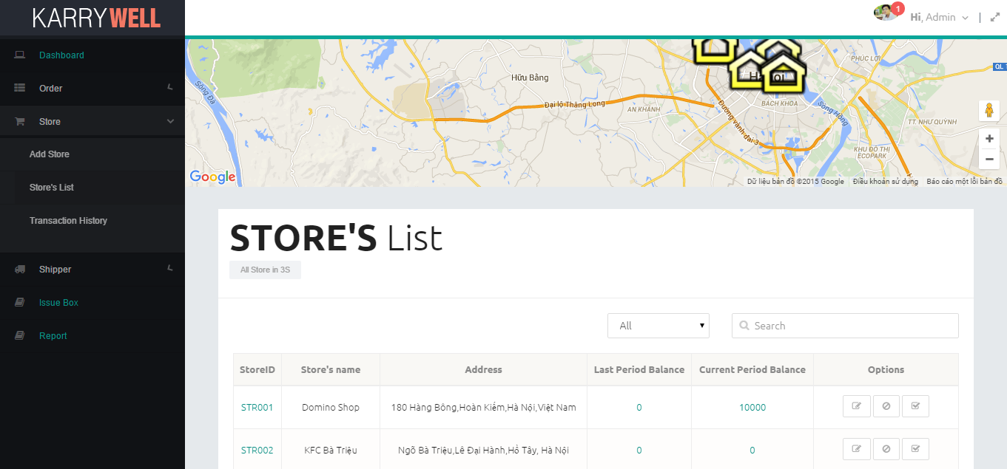

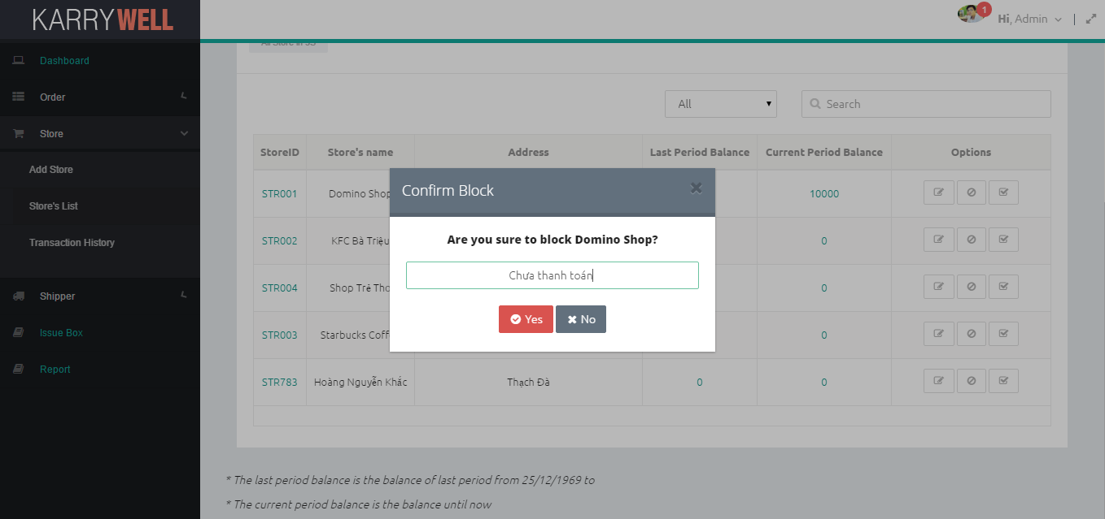

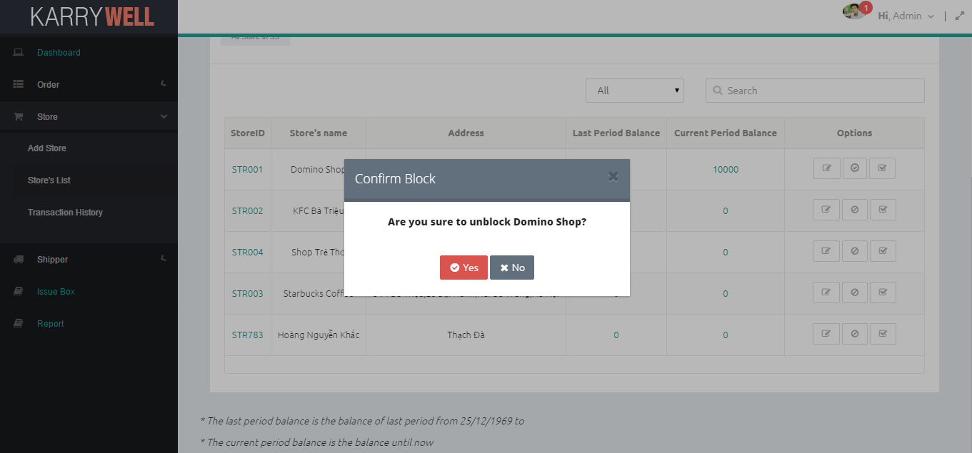

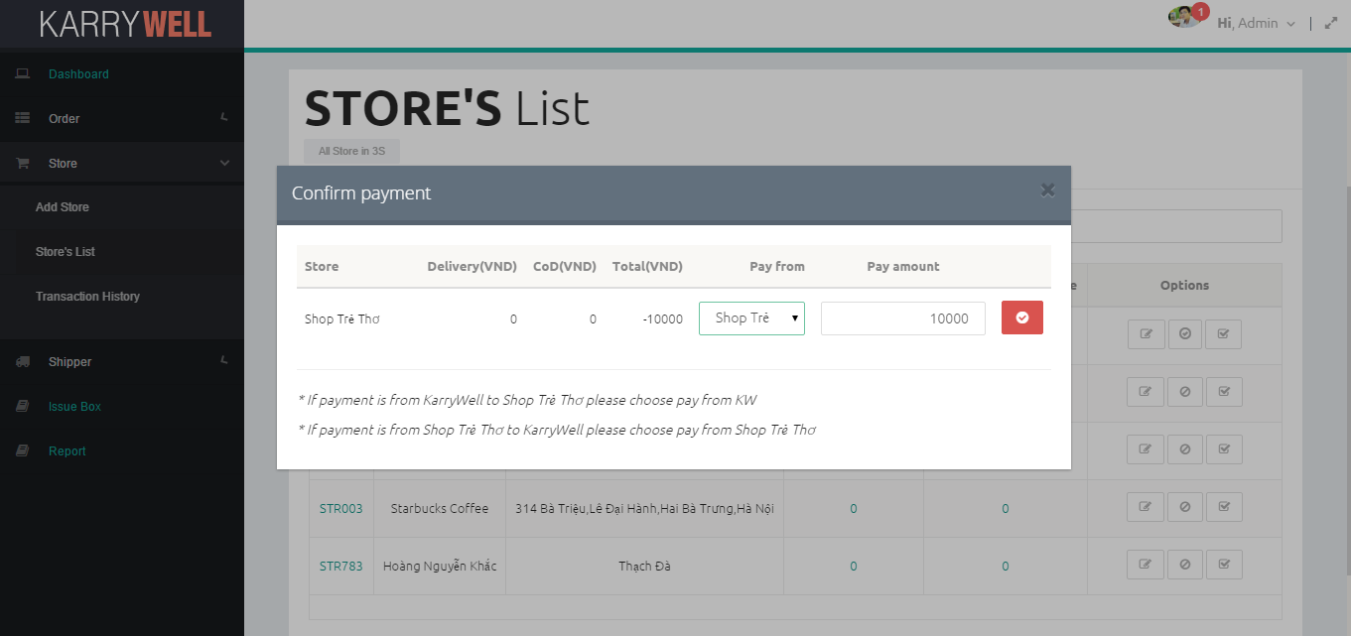

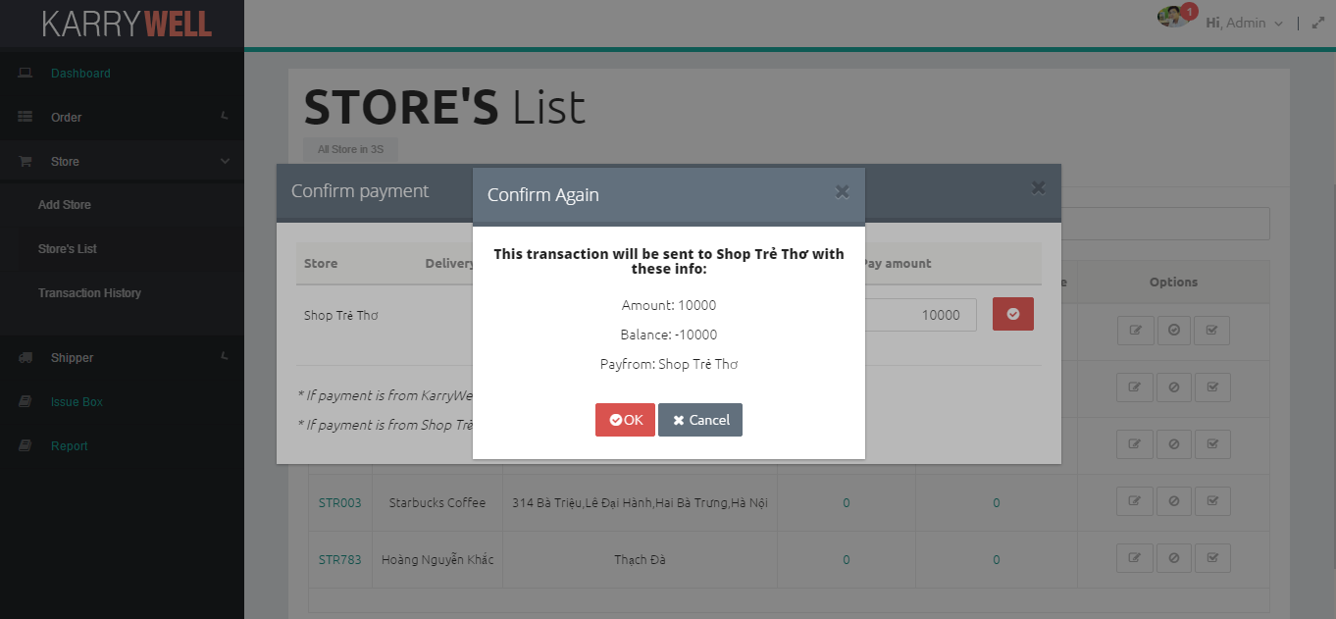

|  |  |  |  |  |  |
| --- | --- | --- | --- | --- | --- |
| **No** | **Elements** | **Sub-Element** | **Type** | **Default** | **Description** |
|  | **Menu** |  | List view |  | List of the pages ( Dashboard , Order(*Create Order ,Order’s List*) , Store(*Add Store, Store’s List, Transaction History*), Shipper*(Add Shipper, Shipper’s List, Task’s List, Assign Task*), Report , IssueBox ) which navigate directly to selected page |
|  | **KARYWELL logo** |  | Image |  | Logo of system |
|  | **Header** | Avatar | Image |  | Avatar of user |
| Notification | Button |  | Number of unread notification, click to view notification list |
| Greeting | Drop-downlist |  | Include ‘Sign out’, ‘View Profile’ to log out or view user’s profile |
| Full size | Button |  | Click to view page on full-screen |
|  | **Store’s List title** |  | Label |  | Title |
|  | **Store table** | **Date range** | Daterange-picker |  | Select date range for searching |
| **Clear** | Button |  | Clear date range value |
| **Type filter** | Drop-downlist |  | Select type for searching |
| **Search** | Textbox |  | Enter search key for searching |
| **Table** | Table item |  | Displays all stores and related information (storeid, name, address, last balance period, current balance, update, block and confirm payment button) |
| **Page navigation** | Navigation item |  | Click to select page number |
|  | **Notes** |  | Label |  | Bonus information about time of last balance period and current balance period |
|  | **Block Store Popup** | **Popup title** | Label | Hide | “Confirm Block” title |
| **Close** | Button | Hide | Click to close popup |
| **Confirm** | Label | Hide | Confirmation text |
| **Reason** | Textbox | Hide | Enter why store is blocked |
| **Yes** | Button | Hide | Click to confirm yes |
| **No** | Button | Hide | Click to cancel |
|  | **Unblock Store Popup** | **Popup title** | Label | Hide | “Confirm Unblock” title |
| **Close** | Button | Hide | Click to close popup |
| **Confirm** | Label | Hide | Confirmation text |
| **Yes** | Button | Hide | Click to confirm yes |
| **No** | Button | Hide | Click to cancel |
|  | **Confirm Payment Popup** | **Popup title** | Label | Hide | “Confirm Payment” title |
| **Close** | Button | Hide | Click to close popup |
| **Payment table** | Table item | Hide | Contains a row: store’s name, deliver, cod, total, pay from drop-downlist, amount textbox, confirm button |
| **Notes** | Label | Hide | Note about this process |
|  | **Confirm Again Popup** | **Popup title** | Label | Hide | “Confirm Again” title |
| **Close** | Button | Hide | Click to close popup |
| **Confirm** | Label | Hide | Confirmation text |
| **Yes** | Button | Hide | Click to confirm yes |
| **Cancel** | Button | Hide | Click to cancel |

##### Transaction History Screen

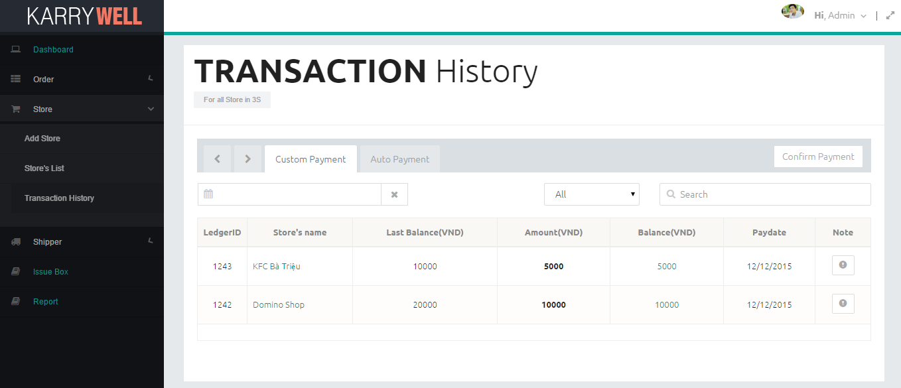All transactions and related information is displayed in table

|  |  |  |  |  |
| --- | --- | --- | --- | --- |
| **No** | **Elements** | **Sub-Element** | **Type** | **Description** |
| 1. **1** | **Menu** |  | List view | List of the pages ( Dashboard , Order(*Create Order ,Order’s List*) , Store(*Add Store, Store’s List, Transaction History*), Shipper*(Add Shipper, Shipper’s List, Task’s List, Assign Task*), Report , IssueBox ) which navigate directly to selected page |
| 1. **2** | **KARYWELL logo** |  | Image | Logo of system |
| 1. **3** | **Header** | Avatar | Image | Avatar of user |
| Notification | Button | Number of unread notification, click to view notification list |
| Greeting | Drop-downlist | Include ‘Sign out’, ‘View Profile’ to log out or view user’s profile |
| Full size | Button | Click to view page on full-screen |
| 1. **4** | **Transaction History title** |  | Label | Title |
| 1. **5** | **Next tab** |  | Button | Move to next tab when clicking |
| 1. **6** | **Previous tab** |  | Button | Move to previous tab when clicking |
| 1. **7** | **Confirm Payment** |  | Button | Redirect to Store’s List page |
| 1. **8** | **Transaction tab** |  | Tab item | There are 2 tabs: Custom Payment, Auto Payment tab includes a table of transaction of custom payment and auto payment |
|  | **Custom Payment table** | **Date range** | Daterange-picker | Select date range for searching |
| **Clear** | Button | Clear date range value |
| **Type filter** | Drop-downlist | Select type for searching |
| **Search** | Textbox | Enter search key for searching |
| **Table** | Table item | Displays transaction is added by admin and related information (ledgerid, store’s name, last balance, amount, balance, pay date) |
| **Page navigation** | Navigation item | Click to select page number |
|  | **Auto Payment table** | **Date range** | Daterange-picker | Select date range for searching |
| **Clear** | Button | Clear date range value |
| **Type filter** | Drop-downlist | Select type for searching |
| **Search** | Textbox | Enter search key for searching |
| **Table** | Table item | Displays transaction is added automatically by system and related information (ledgerid, store’s name, total, delivery, cod, period date). |
| **Page navigation** | Navigation item | Click to select page number |

##### Add Shipper Screen

When admin wants to add a new Shipper, admin have to enter information of shipper’s profile

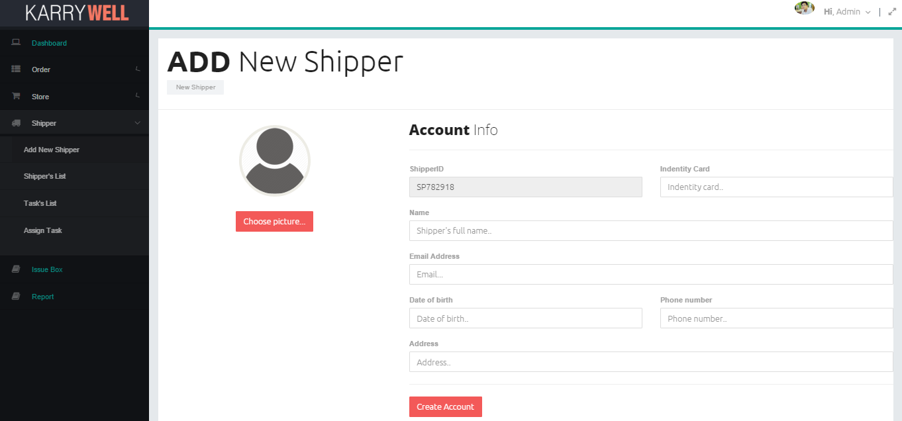

|  |  |  |  |  |
| --- | --- | --- | --- | --- |
| **No** | **Elements** | **Sub-Element** | **Type** | **Description** |
| 1. **1** | **Menu** |  | List view | List of the pages ( Dashboard , Order(*Create Order ,Order’s List*) , Store(*Add Store, Store’s List, Transaction History*), Shipper*(Add Shipper, Shipper’s List, Task’s List, Assign Task*), Report , IssueBox ) which navigate directly to selected page |
| 1. **2** | **KARYWELL logo** |  | Image | Logo of system |
| 1. **3** | **Header** | **Avatar** | Image | Avatar of user |
| **Notification** | Button | Number of unread notification, click to view notification list |
| **Greeting** | Drop-downlist | Include ‘Sign out’, ‘View Profile’ to log out or view user’s profile |
| **Full size** | Button | Click to view page on full-screen |
| 1. **4** | **Add New Shipper title** |  | Label | Title |
| 1. **5** | **Avatar** |  | Image | Avatar of new shipper |
| 1. **6** | **Shipper ID** |  | Textbox | ShipperID of new Shipper |
| 1. **6** | **Identity card** |  | Textbox | Identity card of new Shipper |
| 1. **6** | **Name** |  | Textbox | Full name of new Shipper |
| 1. **6** | **Email** |  | Textbox | Email of new Shipper |
| 1. **6** | **Date of Birth** |  | DatePicker item | Date of birth of new Shipper |
| 1. **6** | **Phone number** |  | Textbox | Phone number of new Shipper |
| 1. **6** | **Address** |  | Textbox | Address of new Shipper |
| 1. **6** | **Create account** |  | Button | Click to add new shipper to system |
|  | **Choose picture** |  | Button | Click to add choose avatar for new Shipper |

##### Shipper’s List Screen

Admin can view all shipper of system in map and in table

|  |  |  |  |  |
| --- | --- | --- | --- | --- |
| **No** | **Elements** | **Sub-Element** | **Type** | **Description** |
|  | **Menu** |  | List view | List of the pages ( Dashboard , Order(*Create Order ,Order’s List*) , Store(*Add Store, Store’s List, Transaction History*), Shipper*(Add Shipper, Shipper’s List, Task’s List, Assign Task*), Report , IssueBox ) which navigate directly to selected page |
|  | **KARYWELL logo** |  | Image | Logo of system |
|  | **Header** | **Avatar** | Image | Avatar of user |
| **Notification** | Button | Number of unread notification, click to view notification list |
| **Greeting** | Drop-downlist | Include ‘Sign out’, ‘View Profile’ to log out or view user’s profile |
| **Full size** | Button | Click to view page on full-screen |
|  | **Shipper’s List title** |  | Label | Title |
|  | **Shipper table** | **Date range** | Daterange-picker | Select date range for searching |
| **Clear** | Button | Clear date range value |
| **Type filter** | Drop-downlist | Select type for searching |
| **Search** | Textbox | Enter search key for searching |
| **Table** | Table item | Displays all shippers and related information (shipperid, full name, address, phone number, status, date of birth, update button). |
| **Page navigation** | Navigation item | Click to select page number |

##### Task’s List Screen

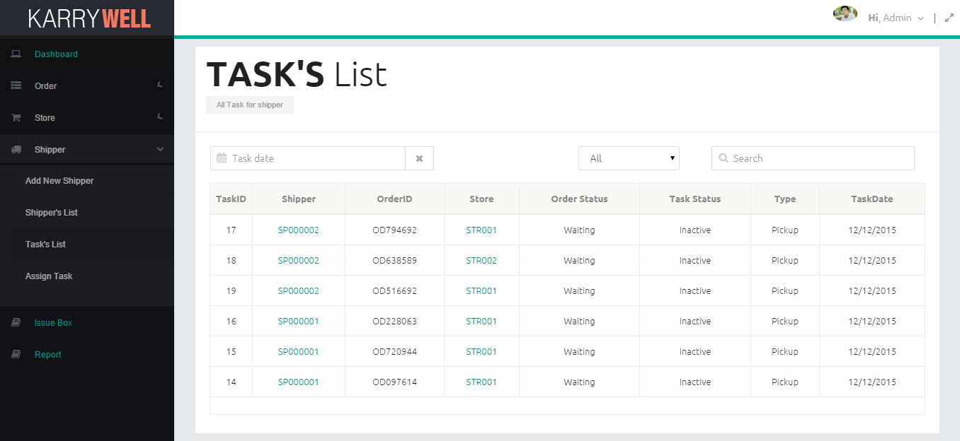Admin can view all tasks of system in table

|  |  |  |  |  |
| --- | --- | --- | --- | --- |
| **No** | **Elements** | **Sub-Element** | **Type** | **Description** |
|  | **Menu** |  | List view | List of the pages ( Dashboard , Order(*Create Order ,Order’s List*) , Store(*Add Store, Store’s List, Transaction History*), Shipper*(Add Shipper, Shipper’s List, Task’s List, Assign Task*), Report , IssueBox ) which navigate directly to selected page |
|  | **KARYWELL logo** |  | Image | Logo of system |
|  | **Header** | **Avatar** | Image | Avatar of user |
| **Notification** | Button | Number of unread notification, click to view notification list |
| **Greeting** | Drop-downlist | Include ‘Sign out’, ‘View Profile’ to log out or view user’s profile |
| **Full size** | Button | Click to view page on full-screen |
|  | **Task’s List title** |  | Label | Title |
|  | **Task table** | **Date range** | Daterange-picker | Select date range for searching |
| **Clear** | Button | Clear date range value |
| **Type filter** | Drop-downlist | Select type for searching |
| **Search** | Textbox | Enter search key for searching |
| **Table** | Table item | Displays all tasks and related information (taskid, shipperid, orderid, storeid, order status, type, task date). |
| **Page navigation** | Navigation item | Click to select page number |

##### Assign Task Screen

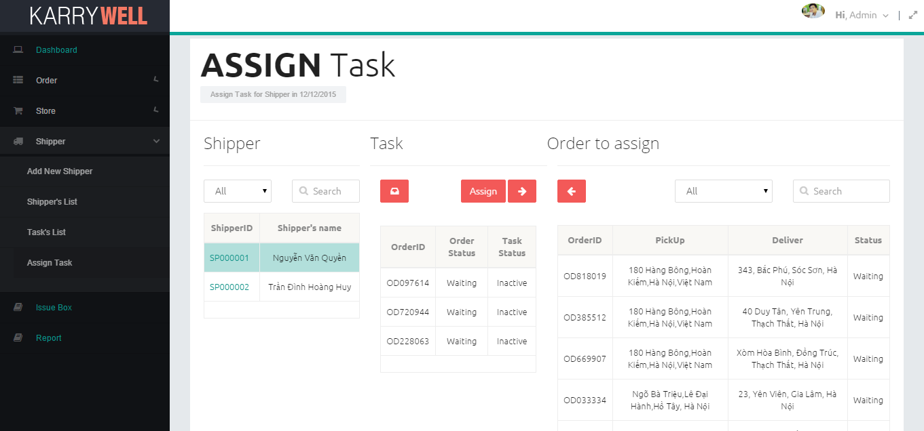Admin can assign orders for shippers

|  |  |  |  |  |
| --- | --- | --- | --- | --- |
| **No** | **Elements** | **Sub-Element** | **Type** | **Description** |
|  | **Menu** |  | List view | List of the pages ( Dashboard , Order(*Create Order ,Order’s List*) , Store(*Add Store, Store’s List, Transaction History*), Shipper*(Add Shipper, Shipper’s List, Task’s List, Assign Task*), Report , IssueBox ) which navigate directly to selected page |
|  | **KARYWELL logo** |  | Image | Logo of system |
|  | **Header** | **Avatar** | Image | Avatar of user |
| **Notification** | Button | Number of unread notification, click to view notification list |
| **Greeting** | Drop-downlist | Include ‘Sign out’, ‘View Profile’ to log out or view user’s profile |
| **Full size** | Button | Click to view page on full-screen |
|  | **Assign Task title** |  | Label | Title |
|  | **Shipper table title** |  | Label | Title of shipper table |
|  | **Task table title** |  | Label | Title of Task of picked shipper table |
|  | **Order table title** |  | Label | Title of order table |
|  | **Assign** |  | Button | Click to assign orders for shippers after picking orders and tasks |
|  | **Inbox** |  | Button | Redirect to IssueBox page |
|  | **Move all to left** |  | Button | Move all orders which was assigned for selected shipper to order table |
|  | **Move all to right** |  | Button | Move all orders to task table to assign for selected shipper |
|  | **Shipper table** | **Type filter** | Drop-downlist | Select type for searching |
|  | **Search** | Textbox | Enter search key for searching |
|  | **Table** | Table item | Displays all shippers can be assigned task and related information (shipperid, shipper’s name). |
|  | **Page navigation** | Navigation item | Click to select page number |
|  | **Task table** |  | Table item | Displays all inactive tasks of selected shipper and related information (orderid, order status, task status). |
|  | **Order table** | **Type filter** | Drop-downlist | Select type for searching |
| **Search** | Textbox | Enter search key for searching |
| **Table** | Table item | Displays all orders can be assigned for shipper and related information (orderid, pickup address, delivery address, status) |
| **Page navigation** | Navigation item | Click to select page number |

##### Order’s List Screen

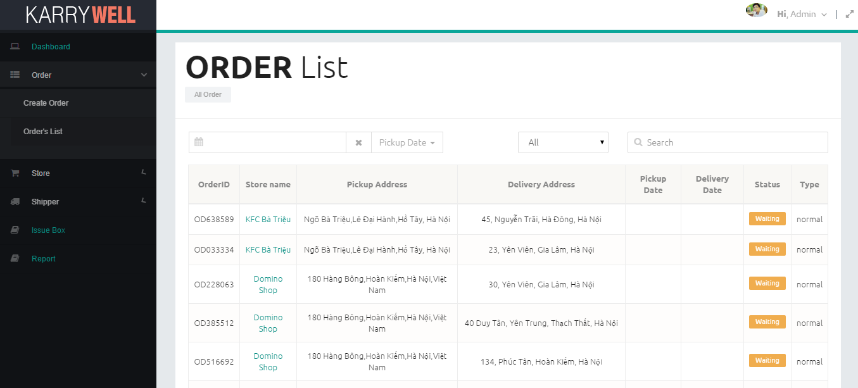Admin can view all orders of system in table

|  |  |  |  |  |
| --- | --- | --- | --- | --- |
| **No** | **Elements** | **Sub-Element** | **Type** | **Description** |
|  | **Menu** |  | List view | List of the pages ( Dashboard , Order(*Create Order ,Order’s List*) , Store(*Add Store, Store’s List, Transaction History*), Shipper*(Add Shipper, Shipper’s List, Task’s List, Assign Task*), Report , IssueBox ) which navigate directly to selected page |
|  | **KARYWELL logo** |  | Image | Logo of system |
|  | **Header** | **Avatar** | Image | Avatar of user |
| **Notification** | Button | Number of unread notification, click to view notification list |
| **Greeting** | Drop-downlist | Include ‘Sign out’, ‘View Profile’ to log out or view user’s profile |
| **Full size** | Button | Click to view page on full-screen |
|  | **Order’s List title** |  | Label | Title |
|  | **Order table** | **Date range** | Daterange-picker | Select date range for searching |
| **Clear** | Button | Clear date range value |
| **Type filter** | Drop-downlist | Select type for searching |
| **Search** | Textbox | Enter search key for searching |
| **Table** | Table item | Displays all orders and related information (orderid, store’s name, pickup address, delivery address, pickup date, delivery date, status, type). |
| **Page navigation** | Navigation item | Click to select page number |

##### IssueBox Screen

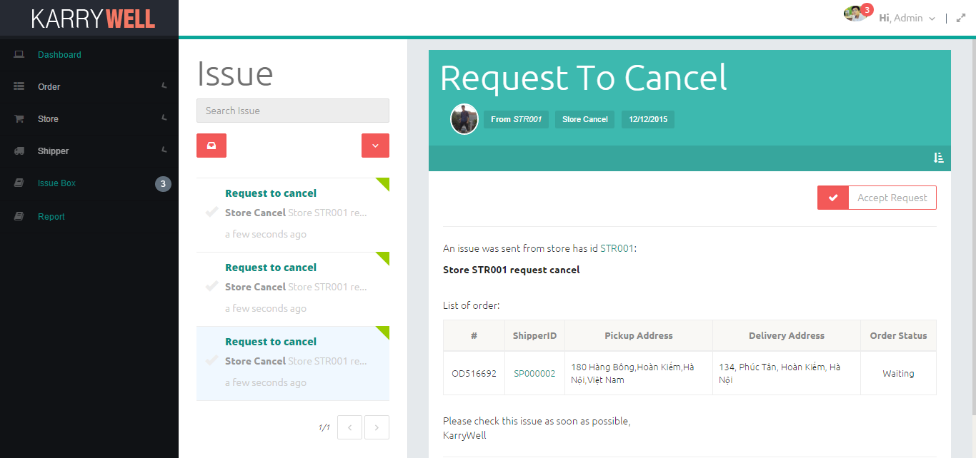Admin can view all orders of system in table

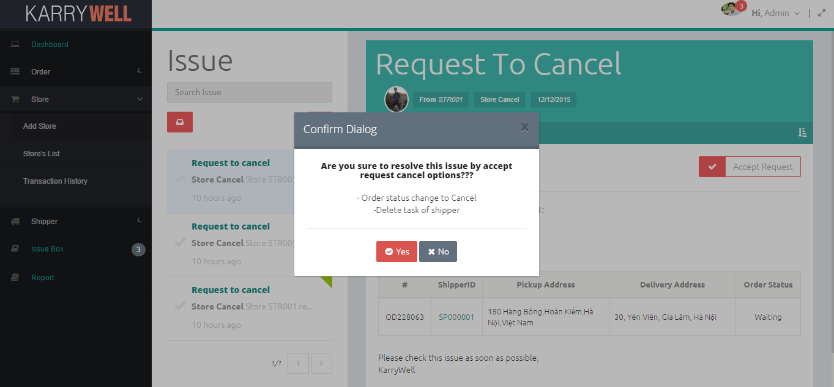

|  |  |  |  |  |  |
| --- | --- | --- | --- | --- | --- |
| **No** | **Elements** | **Sub-Element** | **Type** | **Default** | **Description** |
|  | **Menu** |  | List view |  | List of the pages ( Dashboard , Order(*Create Order ,Order’s List*) , Store(*Add Store, Store’s List, Transaction History*), Shipper*(Add Shipper, Shipper’s List, Task’s List, Assign Task*), Report , IssueBox ) which navigate directly to selected page |
|  | **KARYWELL logo** |  | Image |  | Logo of system |
|  | **Header** | **Avatar** | Image |  | Avatar of user |
| **Notification** | Button |  | Number of unread notification, click to view notification list |
| **Greeting** | Drop-downlist |  | Include ‘Sign out’, ‘View Profile’ to log out or view user’s profile |
| **Full size** | Button |  | Click to view page on full-screen |
|  | **Issue title** |  | Label |  | Title |
|  | **Issue List** | **Filter** | Drop-downlist |  | Filter issue with picked type: Resolved, Unresolved, Shipper Pending, Shipper Cancel, Store Cancel |
| **All Issue** | Button |  | List all issue |
| **Search** | Textbox |  | Enter search key for searching |
| **Issue List** | List View |  | Displays all issue and related information (type, category, content, time) |
| **Page navigation** | Navigation item |  | Click to select page number |
|  | **Issue Content** | **Category** | Label |  | Category of issue |
| **Sender avatar** | Image |  | Avatar of sender |
| **Sender** | Label |  | Name of sender |
| **Time** | Label |  | When issue is sent |
| **Resolve** | Button |  | There are 3 types: Continue, Change Shipper and Accept Request |
| **Content** | Label |  | Content of issue |
| **Orders** | Table item |  | Displays all orders which get issue and related information (orderid, store’s name, pickup address, delivery address, status). |
|  | **Confirm Resolve** | **Popup title** | Label | Hide | “Confirm Dialog” title |
| **Close** | Button | Hide | Click to close popup |
| **Confirm** | Label | Hide | Confirmation text |
| **Description** | Label | Hide | What system will do to resolve issue |
| **Yes** | Button | Hide | Click to confirm yes |
| **Cancel** | Button | Hide | Click to cancel |

##### User Detail Screen

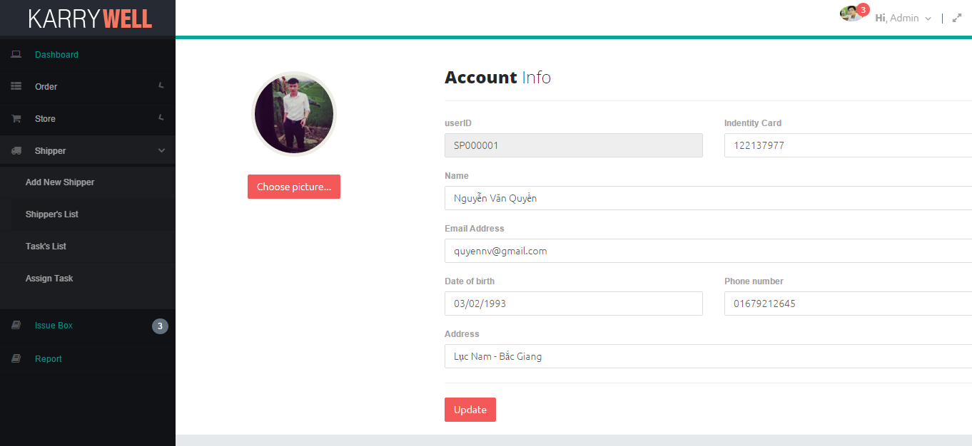Admin can view detail information of user

|  |  |  |  |  |
| --- | --- | --- | --- | --- |
| **No** | **Elements** | **Sub-Element** | **Type** | **Description** |
|  | **Menu** |  | List view | List of the pages ( Dashboard , Order(*Create Order ,Order’s List*) , Store(*Add Store, Store’s List, Transaction History*), Shipper*(Add Shipper, Shipper’s List, Task’s List, Assign Task*), Report , IssueBox ) which navigate directly to selected page |
|  | **KARYWELL logo** |  | Image | Logo of system |
|  | **Header** | **Avatar** | Image | Avatar of user |
| **Notification** | Button | Number of unread notification, click to view notification list |
| **Greeting** | Drop-downlist | Include ‘Sign out’, ‘View Profile’ to log out or view user’s profile |
| **Full size** | Button | Click to view page on full-screen |
|  | **Account Info title** |  | Label | Title |
|  | **Avatar** |  | Image | Avatar of user |
|  | **Choose picture** |  | Button | Click to change avatar |
|  | **Username** |  | Label | Username of user |
|  | **Identity card** |  | Textbox | Identity card of user |
|  | **Name** |  | Textbox | Full name of user |
|  | **Email** |  | Textbox | Email of user |
|  | **Date of Birth** |  | DatePicker item | Date of birth of user |
|  | **Phone number** |  | Textbox | Phone number of user |
|  | **Address** |  | Textbox | Address of user |
|  | **Update** |  | Button | Click to update new information that modified for user |

##### Store Detail Screen

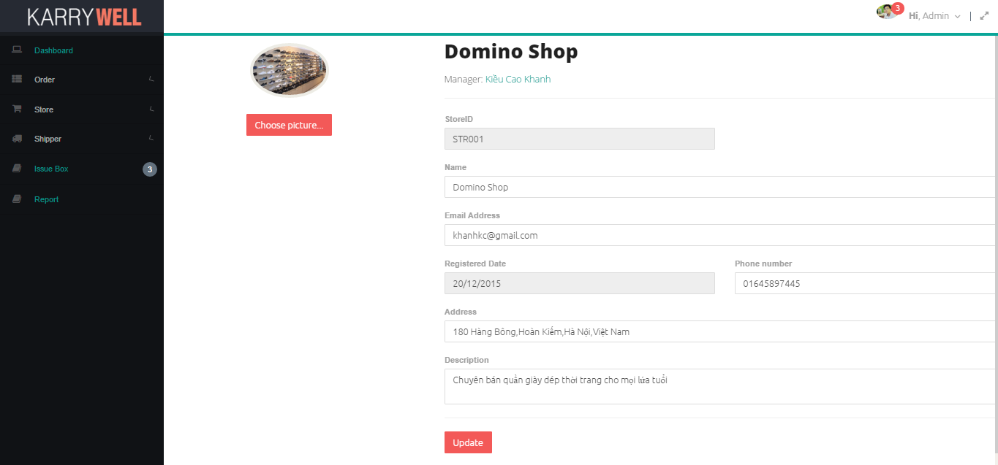Admin can view detail information of store

|  |  |  |  |  |  |
| --- | --- | --- | --- | --- | --- |
| **No** | **Elements** | **Sub-Element** | **Required** | **Type** | **Description** |
|  | **Menu** |  | Click | List view | List of the pages ( Dashboard , Order(*Create Order ,Order’s List*) , Store(*Add Store, Store’s List, Transaction History*), Shipper*(Add Shipper, Shipper’s List, Task’s List, Assign Task*), Report , IssueBox ) which navigate directly to selected page |
|  | **KARYWELL logo** |  |  | Image | Logo of system |
|  | **Header** | **Avatar** |  | Image | Avatar of user |
| **Notification** | Click | Button | Number of unread notification, click to view notification list |
| **Greeting** | Click | Drop-downlist | Include ‘Sign out’, ‘View Profile’ to log out or view user’s profile |
| **Full size** | Click | Button | Click to view page on full-screen |
|  | **Store’s name title** |  |  | Label | Title |
|  | **Avatar** |  |  | Image | Avatar of store |
|  | **Choose picture** |  | Click | Button | Click to change avatar |
|  | **Store Manager** |  | Click | Hyperlink | Link to store’s owner detail |
|  | **StoreID** |  |  | Label | StoreID of store |
|  | **Name** |  |  | Textbox | Name of store |
|  | **Email** |  |  | Textbox | Email of store |
|  | **Registered Date** |  |  | Textbox | Registered date of store |
|  | **Phone number** |  |  | Textbox | Phone number of store |
|  | **Address** |  |  | Textbox | Address of store |
|  | **Description** |  |  | Textbox | Description about store |
|  | **Update** |  | Click | Button | Click to update new information that modified for store |

##### Order detail screen

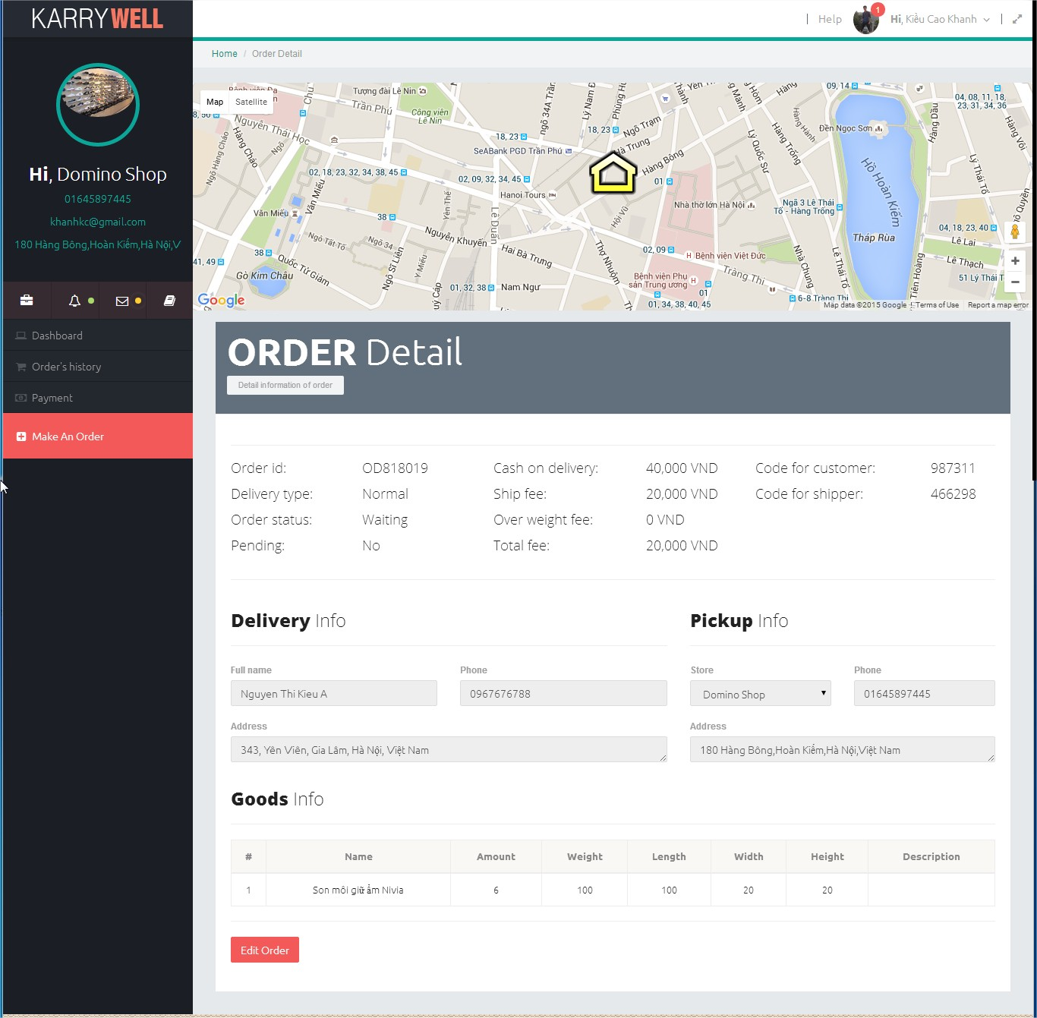Display detail information of an order

|  |  |  |  |  |
| --- | --- | --- | --- | --- |
| **No** | **Component** | **Element** | **Type** | **Description** |
| **1** | **Menu** | As “Menu” element on Dashboard screen. | | |
| **2** | **Header** | As “Header” element on Dashboard screen. | | |
| **3** | **Drop down menu** | As “Drop down menu” element on Dashboard Screen. | | |
| **4** | **Title** | Title | Label | Content: “Order Detail” |
| **5** | **Over view** | Order id | Label | Id of order |
| Delivery type | Label | Delivery type of order |
| Order status | Label | Status of order in moment |
| Pending | Label | Yes/No |
| Cash on delivery | Label | Cash on delivery of order |
| Ship fee | Label | Amount of money store has to pay for delivery service |
| Over weight | Label | Amount of money store has to pay for order heavier than 30000gam |
| Total fee | Label | Sum of Ship fee and Overweight fee |
| Code for customer | Label | Code for authenticate end customer |
| Code for shipper | Label | Code for authenticate Shipper |
| **6** | **Delivery Info** | Title | Label | Content: Delivery Info |
| Full name | Text field | Full name of end customer |
| Phone | Text field | Phone number of end customer |
| Address | Text field | Address of end customer |
| **7** | **Pickup Info** | Title | Label | Content: Pickup info |
| Store | Text field | Name of store where shipper go to pickup goods |
| Phone | Text field | Phone number of store |
| Address | Text field | Address of store |
|  |  |  |
| **8** | **Goods Info** | Title | Label | Content: Goods Info |
| Table of goods | Label | List all goods of order with below info (Name, amount, weight, length, weight, height, description) |
| **9** | **Footer** | Edit Order | Button | Enable Text fields and Table of goods for edit. This button will be enable if status of order is W=”Waiting” or order is a draft order. |

##### Admin report screen

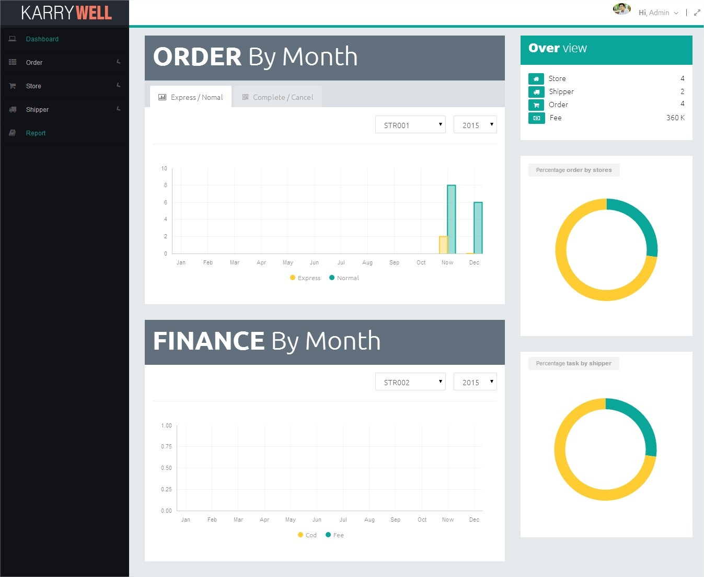This popup is use to edit info of goods in tables of goods on “Create order screen” and “Edit order screen”

|  |  |  |  |  |
| --- | --- | --- | --- | --- |
| **No** | **Component** | **Element** | **Type** | **Description** |
| **1** | **Menu** |  | | |
| **2** | **Header** |  | | |
| **3** | **Drop down menu** |  | | |
| **4** | **Over View** | Title | Label | “Over View” |
| Store | Label | Total number of store in system |
| Shipper | Label | Total number shipper in system |
| Order | Label | Total order made by stores |
| Fee | Label | Total delivery fee of system |
| **5** | **Order by month** | Title | Label | “Order By Month” |
| Report tab bar | Tab bar | Include 2 tabs:  - Express/Normal: Display bar chart of express and normal order by month.  - Complete/Cancel: Display bar chart of complete and cancel order by month. |
| Store Filter | Drop down list | Admin can use filter to view chart of each store |
| Year Filter | Drop down list | Admin can use filter to view chart of each store |
| Chart | Chart | Display chart for Express/Normal tab or Complete/Cancel tab |
| **6** | **Finance by month** | Title | Label | “Finance by month” |
| Store Filter | Drop down list | Admin can use filter to view chart of each store |
| Year Filter | Drop down list | Admin can use filter to view chart of each store |
| Chart | Chart | Display bar chart of cash on delivery and delivery fee by month. |
| **7** | **Order Pei Chart** | Title | Label | Percentage order by stores |
| Chart | Pei Chart | Display percentage order of top 10 stores in system |
| **8** | **Footer** | Title | Label | Percentage task by stores |
| Chart | Pei Chart | Display percentage task of top 10 shipper in system |

### 4.3.2. Store

#### 4.3.2.1. Structure and Layout

The overall structure of the application is relatively simple, as shown in the following diagram.

|  |  |  |
| --- | --- | --- |
| **No** | **Screen Name** | **Description** |
|  | Login Screen | This screen use to help store login to system |
|  | Dashboard Screen | This screen displays the overview of current activity of the store |
|  | Order History Screen | Display all order that created by store. |
|  | Create order screen | Store use this screen to create a new order and request delivery service form system. |
|  | Profile screen | Display detail information of an order. |
|  | Order detail screen | Displays all stores and related information |
|  | Edit order screen | This screen helps store edit information of order. |
|  | Transaction history screen | Display finance transaction history between store and KaryWell. |
|  | Add goods popup | This popup is use to add goods to tables of goods on “Create order screen” and “Edit order screen |
|  | Edit goods popup | This popup is use to edit info of goods in tables of goods on “Create order screen” and “Edit order screen |

**Screen flow:**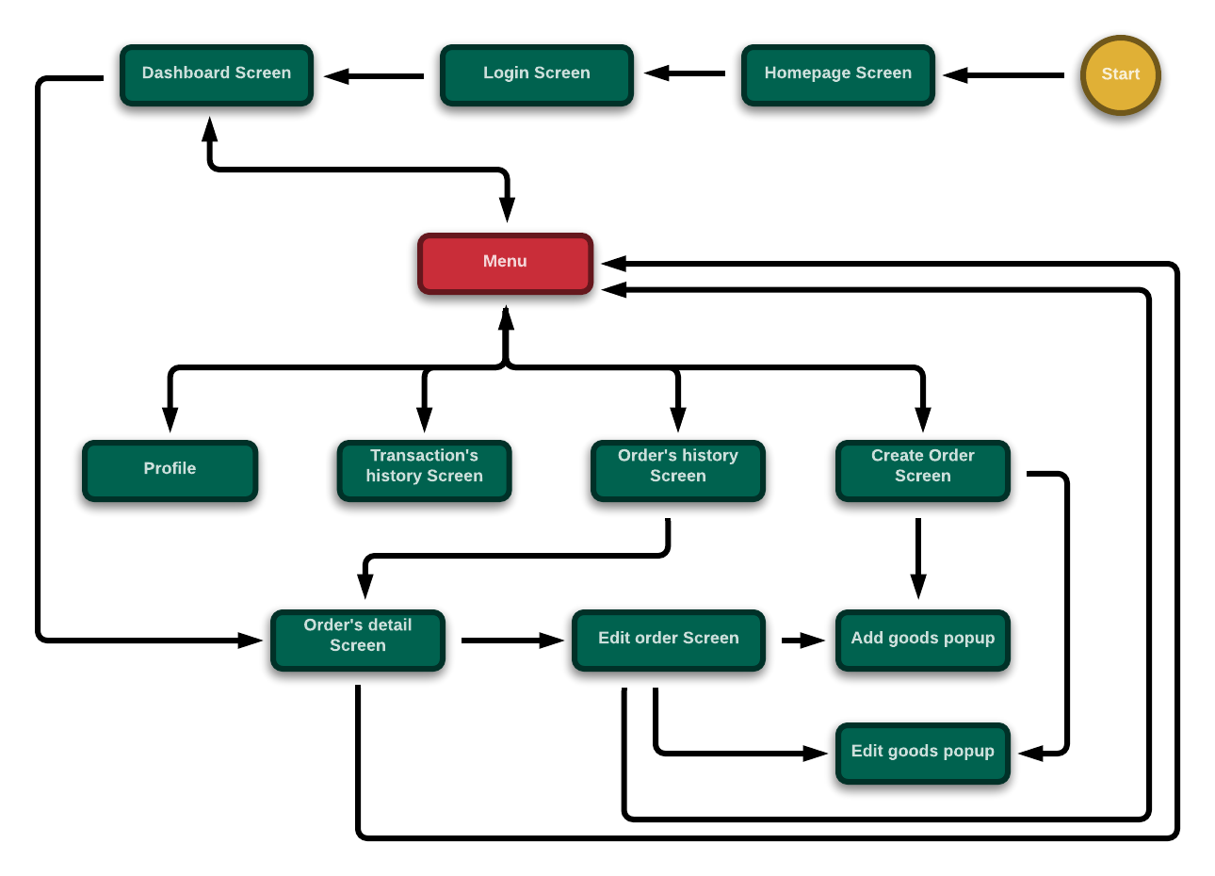

Figure 124: Screen flow of Client Web for Store

#### 4.3.2.2. Screen Description

##### Login screen

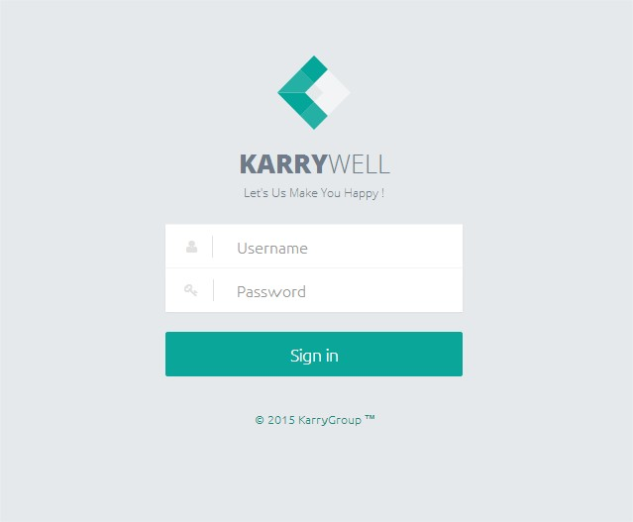This screen use to help store login to system.

|  |  |  |  |
| --- | --- | --- | --- |
| **No** | **Element** | **Type** | **Description** |
| **1** | Logo | Logo | Logo of KaryWell |
| Slogan | Label | Slogan of KaryWell |
| **2** | Username | Text field | Where store input “Username” for login to system |
| **3** | Password | Text field | Where store input “Password” for login to system |
| **4** | Sign in button | Button | After store click on this button if username and password is correct system will log store into system |

##### Dashboard Screen

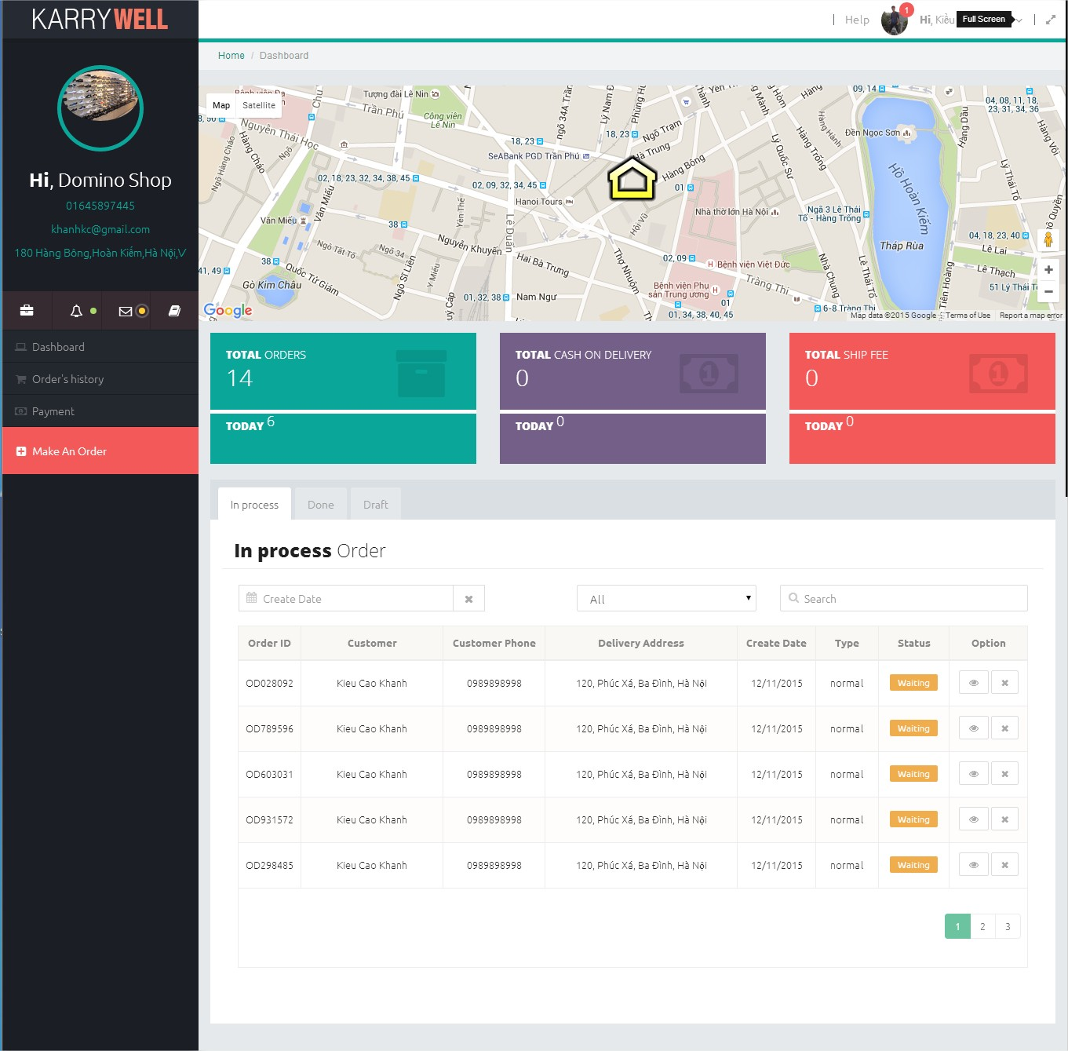This screen displays the overview of current activity of the store.

|  |  |  |  |  |
| --- | --- | --- | --- | --- |
| **No** | **Component** | **Element** | **Type** | **Description** |
| **1** | **Menu** | Logo | Logo | KaryWell logo. |
| Avatar | Image | Avatar of Store |
| Store info | Label group | Info of Store include:  - Name  - Phone number  - Email  - Address |
| Menu item | Hyperlink list | List of the link to direct to other screen ( Create Order , Order’s history ,Transaction’s history , Profile) |
| **2** | **Header** | Manager avatar | Image | Avatar of store manager |
| Notification number | Label | Display number of notification and include a hyperlink to direct to notification screen |
| Store manager’s name | Label | Name of Store manager |
| Full screen button | Button | Enable full screen for page |
| **3** | **Drop down menu** | Profile item | Menu item | Direct to “Profile” screen |
| Signout item | Menu item | Log store out from system. |
| **4** | **Maps** | Maps | Google maps item | Displays location of Shipper who are working delivery for store and location of Customers of store. |
| **5** | **Total order box** | Total order box | Box item | Displays quantity of orders on today and orders that didn’t have finance transaction |
| **6** | **Total COD box** | Total COD box | Box item | Display total cash on delivery of orders on today and orders that didn’t have finance transaction |
| **7** | **Total ship fee box** | Total ship fee box | Box item | Display total delivery fee of orders on today and orders that didn’t have finance transaction |
| **8** | **Orders Tab** | In process tab | Tabs bar | Display table of running orders |
| Done tab | Tabs bar | Display table of done orders that didn’t have finance transaction. |
| Draft tab | Tabs bar | Draft: Display table of express orders that are not yet grab by any shipper |
| **9** | **Table order** | Date range filter | Date piker | Store can use this date piker to show orders in a period of time |
| Drop down list filter | Drop down list | Search result will depend on item store chose from this drop down list |
| Search box | Text field | Store type on this text field to search. |
| Table | table | Display list of order and search result |

##### Order history screen

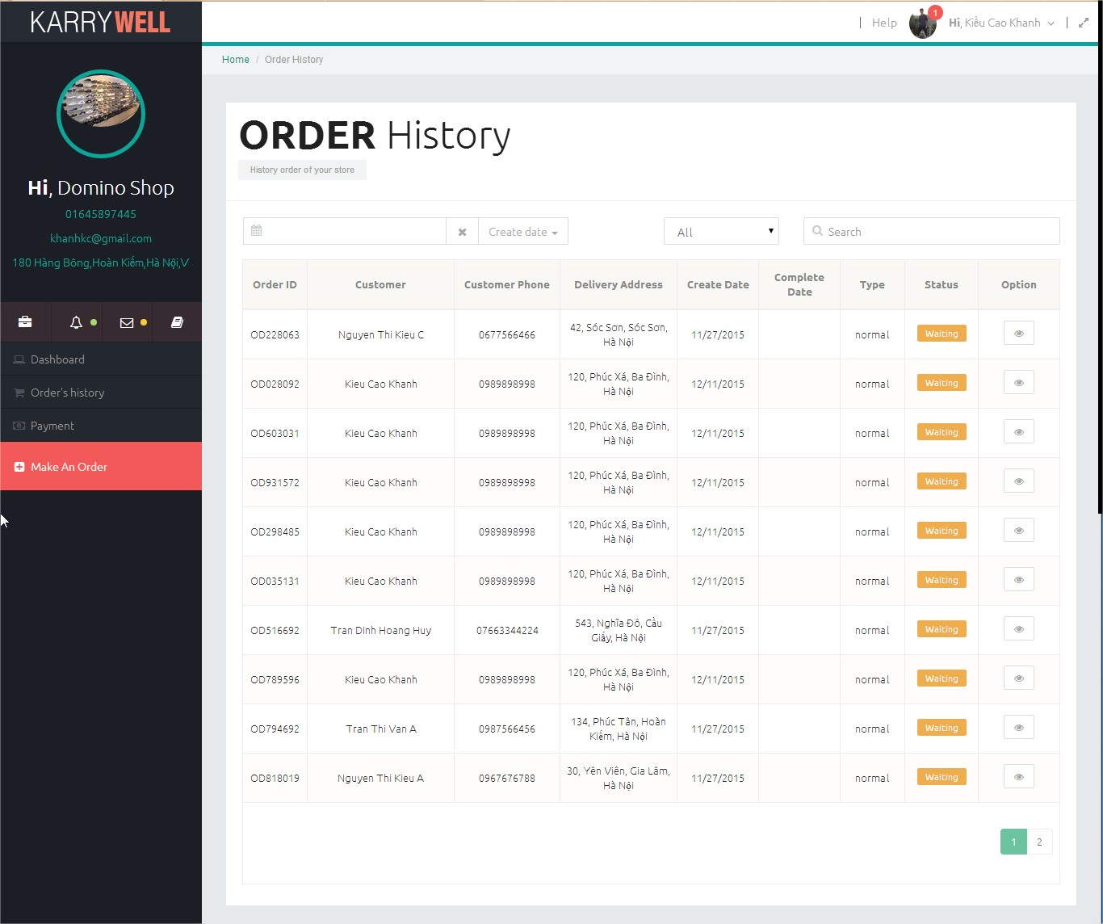Display all order that created by store.

|  |  |  |  |  |
| --- | --- | --- | --- | --- |
| **No** | **Component** | **Element** | **Type** | **Description** |
| **1** | **Menu** | As “Menu” element on Dashboard screen. | | |
| **2** | **Header** | As “Header” element on Dashboard screen. | | |
| **3** | **Drop down menu** | As “Drop down menu” element on Dashboard Screen. | | |
| **8** | **Title** | Title | Label | “Order History” |
| **9** | **Table order** | Date range filter | Date piker | Store can use this date piker to show orders in a period of time |
| Drop down list filter | Drop down list | Search result will depend on item store chose from this drop down list |
| Search box | Text field | Store type on this text field to search. |

##### Create order screen

Store use this screen to create a new order and request delivery service form system.

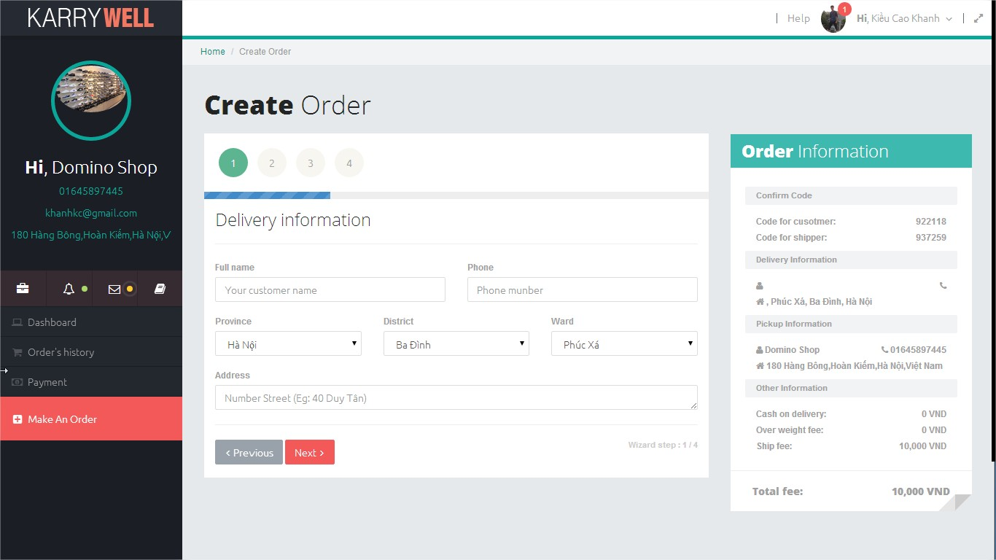

|  |  |  |  |  |
| --- | --- | --- | --- | --- |
| **No** | **Component** | **Element** | **Type** | **Description** |
| **1** | **Menu** | As “Menu” element on Dashboard screen. | | |
| **2** | **Header** | As “Header” element on Dashboard screen. | | |
| **3** | **Drop down menu** | As “Drop down menu” element on Dashboard Screen. | | |
| **4** | **Title** | Title Label | Label | “Create Order” |
| **5** | **Wizard form(Step 1)** | Full name | Textbox | Full name of customer |
| Phone | Textbox | Phone of customer |
| Province | Drop down list | List province of Vietnam |
| District | Drop down list | List districts of Vietnam |
| Ward | Drop down list | List ward of Vietnam |
| Address | Textbox | Address of customer. |
| Next button | Button | Go to step 2 of wizard form |
| Previous button | Button | Disabled |
| **6** | **Wizard form (Step 2)** | Table of goods | Table | Abc |
| Add goods | Button | After click on this button, “Add goods” popup will be displayed. |
| Delivery type | Radio button group | Include 2 radio button: Express, Normal |
| Cash on delivery | Text field | Where store input cash on delivery of order. |
| Next | Button | Go to “Step 3” of wizard form |
| Previous | Button | Go to “Step 1” of wizard form |
| **7** | **Wizard form (Step 3)** | Store | Drop down list | List all name ( abcnen dung store hay |
| Phone | Text field | Display phone number of store (View only) |
| Address | Text field | Display address of store (View only) |
| Previous | Button | Go to “Step 2” of wizard form |
| Submit | Submit button | After click this button information of order will be save to database or active “Find shipper” function if delivery type is express. |
| **8** | **Order Information area** | Header | Header | Content: “Order Information” |
| “Confirm Code area” | Label group | Include: authentication code with shippers and last customer |
| “Delivery Information” area | Label group | Include information of last customer that store entered in wizard form.(Full name, Phone, Address) |
| “Pickup information” area | Label group | Include information of store (where shipper will go to pickup goods): Name, phone, address. |
| “COD/Fee information” area | Label group | Include information about cash on delivery, ship fee, over weight fee and total fee |

##### Profile screen

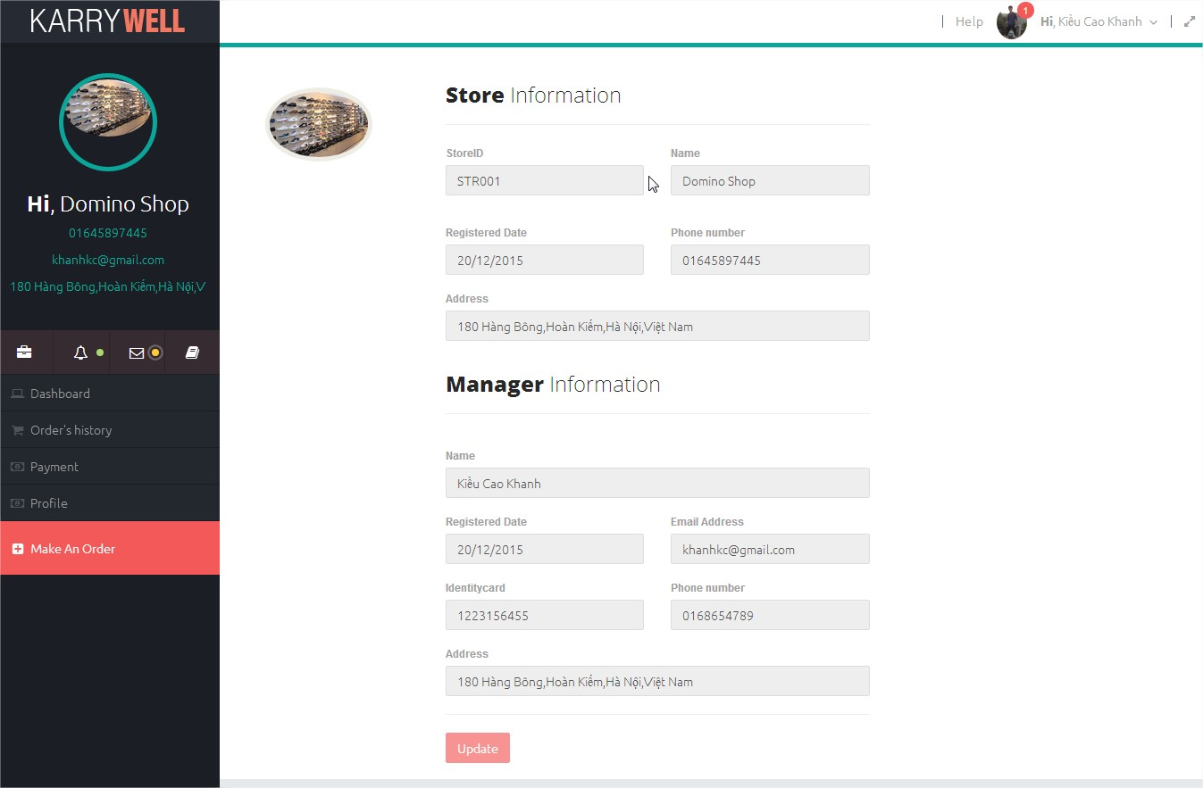Display detail information of store and store manager

|  |  |  |  |  |
| --- | --- | --- | --- | --- |
| **No** | **Area** | **Element** | **Type** | **Description** |
| **1** | **Menu** | As “Menu” element on Dashboard screen. | | |
| **2** | **Header** | As “Header” element on Dashboard screen. | | |
| **3** | **Drop down menu** | As “Drop down menu” element on Dashboard Screen. | | |
| **4** | **Avatar** | Avatar | Image | Avatar of store |
| Choose picture | Button | Active change avatar function |
| **5** | **Store Information** | Header | Label | Content: Store information |
| StoreID | Text field | ID of store |
| Name | Text field | Name of store |
| Registered Date | Text field | Registered Date of store |
| Phone number | Text field | Phone number of store |
| Address | Text field | Address of store |
| **6** | **Manager information** | Header | Label | Content: Manager information |
| Name | Text field | Name of store manager |
| Email address | Text field | Email of store |
| Identity card | Text field | Registered Date of store |
| Phone number | Text field | Phone number of Manager |

##### Order detail screen

Display detail information of an order

|  |  |  |  |  |
| --- | --- | --- | --- | --- |
| **No** | **Component** | **Element** | **Type** | **Description** |
| **1** | **Menu** | As “Menu” element on Dashboard screen. | | |
| **2** | **Header** | As “Header” element on Dashboard screen. | | |
| **3** | **Drop down menu** | As “Drop down menu” element on Dashboard Screen. | | |
| **4** | **Title** | Title | Label | Content: “Order Detail” |
| **5** | **Over view** | Order id | Label | Id of order |
| Delivery type | Label | Delivery type of order |
| Order status | Label | Status of order in moment |
| Pending | Label | Yes/No |
| Cash on delivery | Label | Cash on delivery of order |
| Ship fee | Label | Amount of money store has to pay for delivery service |
| Over weight | Label | Amount of money store has to pay for order heavier than 30000gam |
| Total fee | Label | Sum of Ship fee and Overweight fee |
| Code for customer | Label | Code for authenticate end customer |
| Code for shipper | Label | Code for authenticate Shipper |
| **6** | **Delivery Info** | Title | Label | Content: Delivery Info |
| Full name | Text field | Full name of end customer |
| Phone | Text field | Phone number of end customer |
| Address | Text field | Address of end customer |
| **7** | **Pickup Info** | Title | Label | Content: Pickup info |
| Store | Text field | Name of store where shipper go to pickup goods |
| Phone | Text field | Phone number of store |
| Address | Text field | Address of store |
|  |  |  |
| **8** | **Goods Info** | Title | Label | Content: Goods Info |
| Table of goods | Label | List all goods of order with below info (Name, amount, weight, length, weight, height, description) |
| **9** | **Footer** | Edit Order | Button | Enable Text fields and Table of goods for edit. This button will be enable if status of order is W=”Waiting” or order is a draft order. |

##### Edit order screen

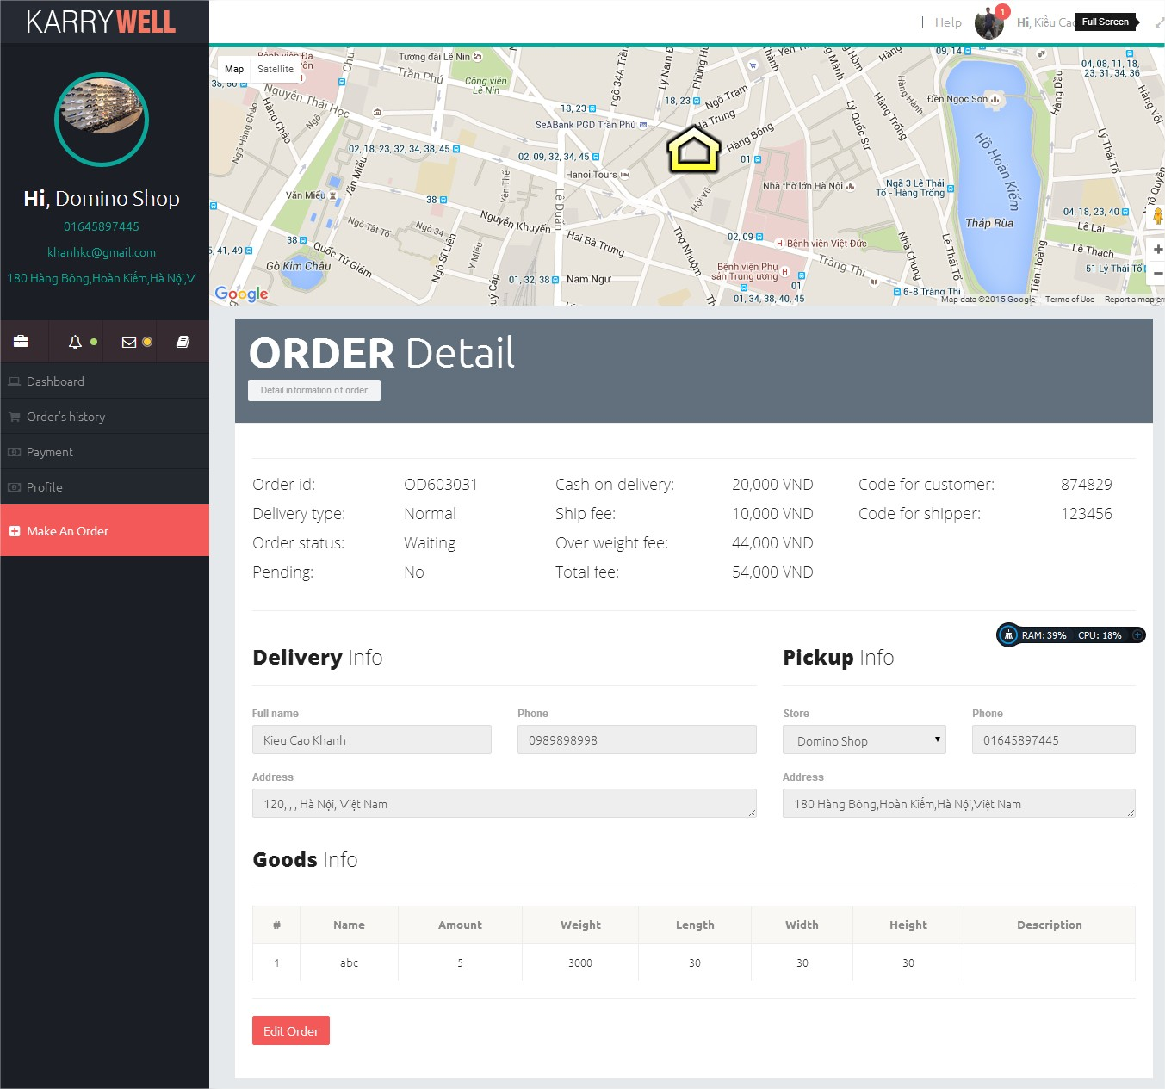This screen helps store edit information of order.

|  |  |  |  |  |
| --- | --- | --- | --- | --- |
| **No** | **Component** | **Element** | **Type** | **Description** |
| **1** | **Menu** | As “Menu” element on Dashboard screen. | | |
| **2** | **Header** | As “Header” element on Dashboard screen. | | |
| **3** | **Maps** | As “Maps” element on Dashbard screen but it only display location of shipper and end customer for this order. | | |
| **4** | **Drop down menu** | As “Drop down menu” element on Dashboard Screen. | | |
| **5** | **Title** | Title | Label | Content: “Order Detail” |
| **6** | **Over view** | As “Over view” area on “Order detail screen” | | |
| **7** | **Delivery Info** | Title | Label | Content: Delivery Info |
| Full name | Text field | Full name of end customer |
| Phone | Text field | Phone number of end customer |
| Province | Drop down list | Store click on to select province of end customer |
| District | Drop down list | Store click on to select district of end customer |
| Ward | Drop down list | Store click on to select ward of end customer |
| Address | Text field | Address of end customer |
| Full address | Text field(disable) | Display full address of end customer |
| **8** | **Pickup Info** | Title | Label | Content: Pickup info |
| Store | Text field | Name of store where shipper go to pickup goods |
| Phone | Text field | Phone number of store |
| Address | Text field | Address of store |
| Cash on delivery | Text field | Cash on delivery of order |
| **9** | **Goods Info** | Title | Label | Content: Goods Info |
| Table of goods | Label | List all goods of order with below info (Name, amount, weight, length, weight, height, description, edit and delete button) |
| Add goods button | Button | Store click on this button to show add goods popup |
| **10** | **Footer** | Update Order | Button | After click on this button information of order will be saved to database |
| Cancel | Button | Discard any change an display previous info of order |

##### Transaction history screen

Display finance transaction history between store and KaryWell.

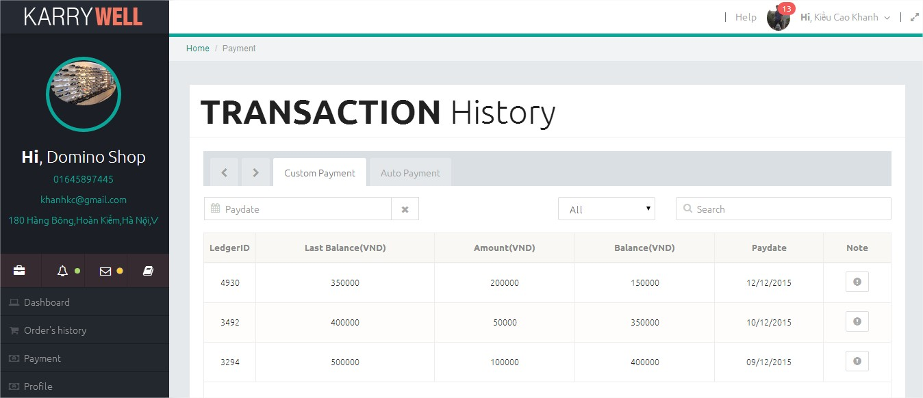

|  |  |  |  |  |
| --- | --- | --- | --- | --- |
| **No** | **Component** | **Element** | **Type** | **Description** |
|  |  | As “Menu” element on Dashboard screen. | | |
| **1** | **Menu** | As “Header” element on Dashboard screen. | | |
| **2** | **Header** | As “Drop down menu” element on Dashboard Screen. | | |
| **3** | **Drop down menu** | As “Menu” element on Dashboard screen. | | |
| **8** | **Transaction Tab** | Click | Tabs bar | There are 3 tabs:  - In process: Display table of running orders  - Done: Display table of done orders that didn’t have finance transaction.  - Draft: Display table of express orders that are not yet grab by any shipper |
| **9** | **Table order** | Date range filter | Date piker | Store can use this date piker to show transactions in a period of time |
| Drop down list filter | Drop down list | Search result will depend on item store chose from this drop down list |
| Search box | Text field | Store type on this text field to search. |
| Table | table | Display list of transactions and search result |

##### Add goods popup

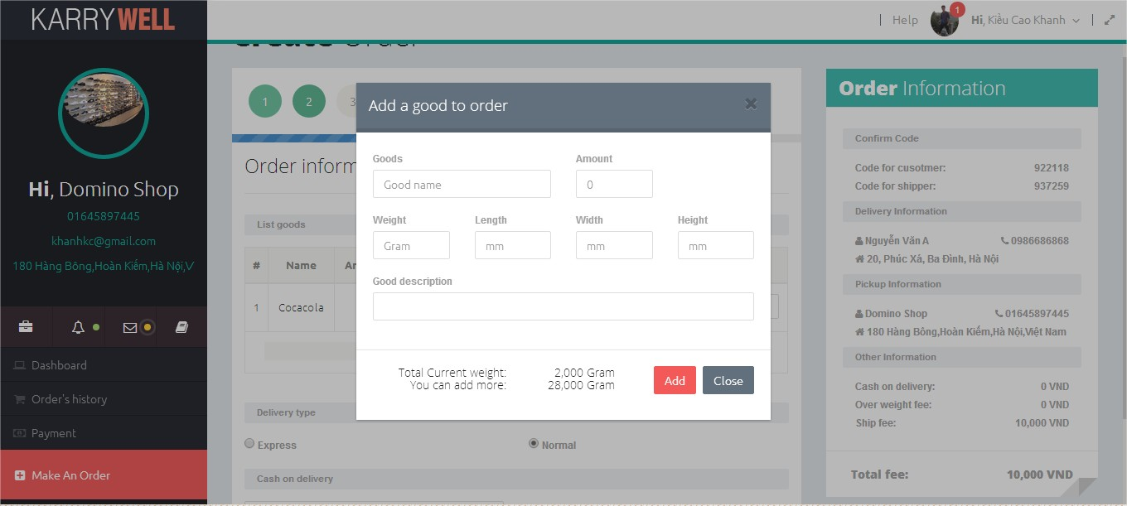This popup is use to add goods to tables of goods on “Create order screen” and “Edit order screen”

|  |  |  |  |  |
| --- | --- | --- | --- | --- |
| **No** | **Area** | **Element** | **Type** | **Description** |
| **1** | **Popup header** | Title | Label | “Add a goods to orders |
| “X” button | Button | Close popup |
| **2** | **Popup body** | Goods | Text field | Store enters name of goods |
| Weight | Text field | Store enters weight of goods |
| Amount | Text field | Store enters amount of goods |
| Length | Text field | Store enters length size of goods |
| Width | Text field | Store enters width size of goods |
| Height | Text field | Store enters height size of goods |
| Goods description | Text field | Store enters description of goods |
| **3** | **Popup footer** | Total current weight | Label | Display total weight of goods on order |
| You can add more | Label | Display total weight that store can add to order |
| Add button | Button | Save info of goods to table of goods |
| Close button | Button | Close popup |

##### 

##### Edit goods popup

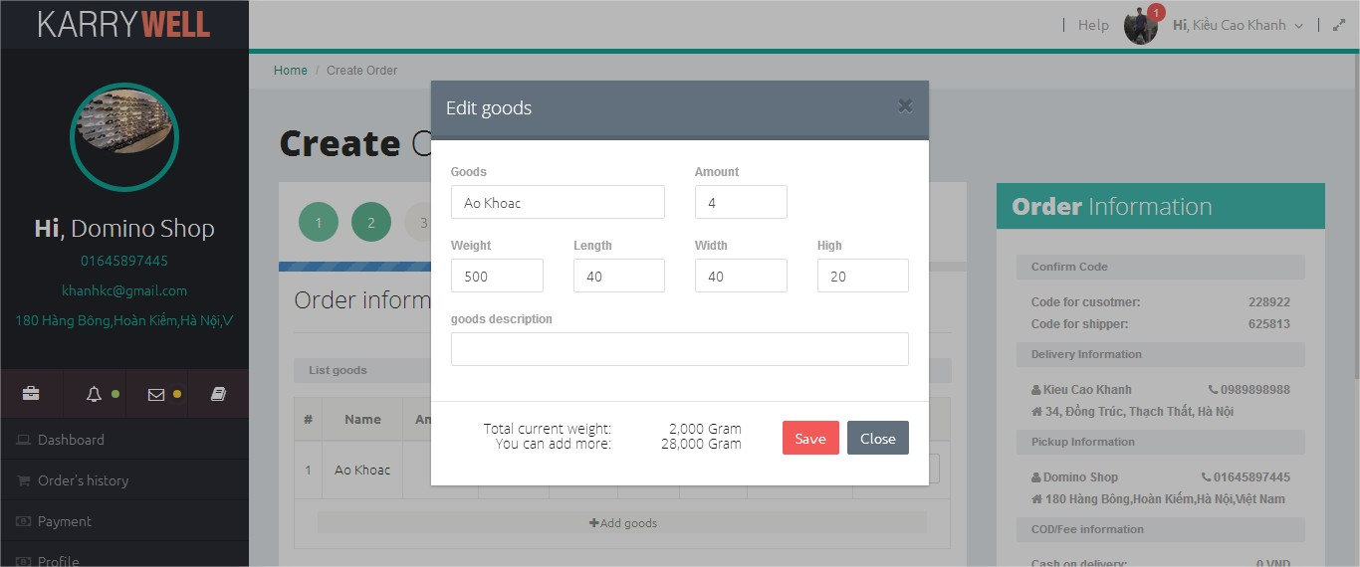This popup is use to edit info of goods in tables of goods on “Create order screen” and “Edit order screen”

|  |  |  |  |  |
| --- | --- | --- | --- | --- |
| **No** | **Area** | **Element** | **Type** | **Description** |
| **1** | **Popup header** | Title | Label | “Edit goods” |
| “X” button | Button | Close popup |
| **2** | **Popup body** | Goods | Text field | Store enters name of goods |
| Weight | Text field | Store enters weight of goods |
| Amount | Text field | Store enters amount of goods |
| Length | Text field | Store enters length size of goods |
| Width | Text field | Store enters width size of goods |
| Height | Text field | Store enters height size of goods |
| Goods description | Text field | Store enters description of goods |
| **3** | **Popup footer** | Total current weight | Label | Display total weight of goods on order |
| You can add more | Label | Display total weight that store can add to order |
| Save button | Button | Save info of goods to table of goods |
| Close button | Button | Close popup |

# V. TEST

# 1. TEST PLAN

## 1.1. Introduction

### 1.1.1. Purpose

The purpose of testing is to qualify a software program’s quality by measuring its attributes and capabilities against expectations and applicable standards. Gaining confidence in and providing information about the level of quality. And to make sure that the end result meets the business and user requirements

### 1.1.2. Scope of testing

The purpose of this document is to outline the test strategy and overall test approach for the Karywell project. This includes test methodologies, traceability, resources required, testing environment and estimated schedule.

* **Stages of testing:**

There are 4 phases in Testing Process: Unit testing, Integration testing, System testing and Acceptance testing.

* **Types of testing:**

The test team has to test the following type on both Google Chrome and Firefox

* Function test
* GUI test
* Regression test
* Performance test
* **Range of testing:**
* Team performs all functions defined in the SRS based on the approved version.

### 1.1.3. Contraints

The following constraints may apply when testing is performed on system:

* Deadline for testing only can be met if development progress is on time
* Test execution can be performed when system passes Unit Test Inspection
* At least one round of testing must be performed for requirements

### 1.1.4. Risks List

|  |  |  |  |  |
| --- | --- | --- | --- | --- |
| **No** | **Risks** | **Source** | **Probability** | **Contingency** |
| 1 | Test phrases is not completed due to testers’ lack of experience | Human | Medium | Training |
| 2 | Requirements are not base-lined on time | Human | High | KW team must follow-up to get requirements base-lined on time |
| 3 | Late response on issues | Human | Medium | The feedback must be provided in 3 working day when an issue is raised |
| 3 | Virus effectively | Device | High | High light this everyone in team, update the newest version for anti virus program |

## 1.2. Requirement For Test

### 1.2.1. Features to be tested

##### Admin

|  |  |  |
| --- | --- | --- |
| **No** | **Usercase Name** | **Features to be tested** |
| 1 | UC-101: Login | Login |
| 2 | UC-102: Logout | Logout |
| 3 | UC- 105: Add Store | Add Store |
| 4 | UC- 106: Search Store | Search Store |
| 5 | UC- 107: View Store’s list | View Store’s list |
| 6 | UC- 108: Block/Unblock store | Block/Unblock store |
| 7 | UC- 109: View Store’s details | View Store’s details |
| 8 | UC- 111: Confirm Store’s payment | Confirm Store’s payment |
| 9 | UC- 112: View transaction history of Store | View transaction history of Store |
| 10 | UC- 113: Add Shipper | Add Shipper |
| 11 | UC- 114: View Shipper’s list | View Shipper’s list |
| 12 | UC- 115: View Order’s list | View Order’s list |
| 13 | UC- 116: Search Shipper | Search Shipper |
| 14 | UC- 117: Search Order | Search Order |
| 15 | UC- 118: View Shipper’s profile | View Shipper’s profile |
| 16 | UC- 119: View Order’s details | View Order’s details |
| 17 | UC- 120: Update User’s Profile | Update User’s Profile |
| 18 | UC- 121: Update Store’s Information | Update Store’s Information |
| 19 | UC- 124: Assign Task | Assign Task |
| 20 | UC- 125: View Dashboard | View Dashboard |
| 21 | UC- 126: View IssueBox | View IssueBox |
| 22 | UC-127: Resovle Issue | Resovle Issue |
| 23 | UC- 128: View Task’s list | View Task’s list |
| 24 | UC- 129: View Report | View Report |
| 25 | UC- 130: Search Task | Search Task |
| 26 | UC- 131: Search Transaction | Search Transaction |
| 27 | UC- 132: Search Issue | Search Issue |

##### Store

|  |  |  |
| --- | --- | --- |
| **No** | **Usercase Name** | **Features to be tested** |
| 1 | UC-201: Login | Login |
| 2 | UC-202: Logout | Logout |
| 3 | UC-206: View profile | View profile |
| 4 | UC-208: Create order | Create order |
| 5 | UC-210: Edit Order | Edit Order |
| 6 | UC-211: Add goods | Add goods |
| 7 | UC-212: Edit goods | Edit goods |
| 8 | UC-213: Delete goods | Delete goods |
| 9 | UC-214: View order’s history | View order’s history |
| 10 | UC-215: Search orders | Search orders |
| 11 | UC-216: Cancel order | Cancel order |
| 12 | UC-217: Delete order | Delete order |
| 13 | UC-218: View order’s details | View order’s details |
| 14 | UC-219: View transaction history | View transaction history |
| 15 | UC-220: Search transaction history | Search transaction history |
| 16 | UC-221: View notifications | View notifications |
| 17 | UC-201: View dashboard | View dashboard |

##### Shipper

|  |  |  |
| --- | --- | --- |
| **No** | **Usercase Name** | **Features to be tested** |
| 1 | UC-301: Login | Login |
| 2 | UC-302: Logout | Logout |
| 3 | UC-303: View Profile | View Profile |
| 4 | UC-307: Confirm Code | Confirm Code |
| 5 | UC-308: Grab Order | Grab Order |
| 6 | UC-309: View Task List | View Task List |
| 7 | UC-3011: View Task’s Detail | View Task’s Detail |
| 8 | UC-313: Send Issue’s Information | Send Issue’s Information |
| 9 | UC-314: Change Working Status | Change Working Status |
| 10 | UC-315: View History | View History |
| 11 | UC-316: Continue When Pending | Continue When Pending |

### 1.2.2. Features not to be tested

Out of scope features will not to be tested.

## 1.3. Acceptance Test Criteria

|  |  |  |
| --- | --- | --- |
| **No** | **Test Stages** | **Qualified ratios** |
| **1** | Unit Test | - To pass this stage, all unit test cases must be tested and passed 100%. All defects should be fixed and re-tested.  - Weight defects/KLOC:8 - 9bugs/1KOLC. |
| **2** | Integration Test | - To pass this stage, all unit test cases must be tested and passed 100%. All defects should be fixed and re-tested.  - Weight defects/KLOC:2 - 4bugs/1KOLC. |
| **3** | System Test | - To pass this stage, all unit test cases must be tested and passed 100%. All defects should be fixed and re-tested.  - Weight defect/KLOC:2 - 4bugs/1KLOC. |

## 1.4. Test strategy

### 1.4.1. Test type

##### Function Testing

Function testing of the target-of-test should focus on any requirements for test that can be traced directly to use cases or business functions and business rules. The goals of these tests are to verify proper data acceptance, processing, and retrieval, and the appropriate implementation of the business rules. This type of testing is based upon black box techniques; that is verifying the application and its internal processes by interacting with the application via the Graphical User Interface (GUI) and analyzing the output or results. Identified below is an outline of the testing recommended for each application:

|  |  |
| --- | --- |
| Test Objective: | Ensure proper target-of-test functionality, including navigation, data entry, processing, and retrieval |
| Technique: | Execute each use case, use-case flow, or function, using valid and invalid data, to verify the following:  • The expected results occur when valid data is used.  • The appropriate error or warning messages are displayed when invalid data is used.  •Each business rule is properly applied. |
| Completion Criteria: | • All planned tests have been executed.  • All identified defects have been addressed. |
| Special Considerations: | Identify or describe those items or issues (internal or external) that impact the implementation and execution of function test |

##### User Interface Testing

User Interface (UI) testing verifies a user’s interaction with the software. The goal of UI testing is to ensure that the User Interface provides the user with the appropriate access and navigation through the functions of the target-of-test. In addition, UI testing ensures that the objects within the UI function as expected and conform to corporate or industry standards.

|  |  |
| --- | --- |
| **Test Objective:** | Verify the following:   * Navigation through the target-of-test properly reflects business functions and requirements, including window-to-window, field-to- field, and use of access methods (tab keys, mouse movements, accelerator keys) * Window objects and characteristics, such as menus, size, position, state, and focus conform to standards. |
| **Technique:** | Create or modify tests for each window to verify proper navigation and object states for each application window and objects. |
| **Completion Criteria:** | Each window successfully verified to remain consistent with benchmark version or within acceptable standard |
| **Special Considerations:** | Not all properties for custom and third party objects can be accessed |

##### Performance Profiling

Performance profiling is a performance test in which response times, transaction rates, and other time-sensitive requirements are measured and evaluated. The goal of Performance Profiling is to verify performance requirements have been achieved. Performance profiling is implemented and executed to profile and tune a target-of-test's performance behaviors as a function of conditions such as workload or hardware configurations.

|  |  |
| --- | --- |
| **Test Objective:** | Verify performance behaviors for designated transactions or business functions under the following conditions:   * Normal anticipated workload * Anticipated worst case workload |
| **Technique:** | Use Test Procedures developed for Function or Business Cycle Testing.  Modify data files to increase the number of transactions or the scripts to increase the number of iterations each transaction occurs.  Scripts should be run on one machine (best case to benchmark single user, single transaction) and be repeated with multiple clients (virtual or actual, see Special Considerations below). |
| **Completion Criteria:** | Single Transaction or single user: Successful completion of the test scripts without any failures and within the expected or required time allocation per transaction.  Multiple transactions or multiple users: Successful completion of the test scripts without any failures and within acceptable time allocation. |
| **Special Considerations:** | Comprehensive performance testing includes having a background workload on the server.  There are several methods that can be used to perform this, including:  “Drive transactions” directly to the server, usually in the form of Structured Query Language (SQL) calls.  Create “virtual” user load to simulate many clients, usually several hundred. Remote Terminal Emulation tools are used to accomplish this load. This technique can also be used to load the network with “traffic”.  Use multiple physical clients, each running test scripts to place a load on the system.  Performance testing should be performed on a dedicated machine or at a dedicated time. This permits full control and accurate measurement.  The databases used for Performance Testing should be either actual size or scaled equally. |

##### Regression Testing

Regression testing is a necessary maintenance activity aimed at showing that code has not beenadversely affected by changes. Define trigger for regression test (applied for maintenance projects), period and scope of regression test.

|  |  |
| --- | --- |
| **Test Objective:** | Regression testing is to validate modified parts of the software, to make sure that the modification does not cause errors in other parts. |
| **Technique:** | Reuse the setoftestcases froman existingtestsuiteto testa modified module.  Constructa program-analysis infrastructure.Wearebuildingan extensible infrastructuretoimplementandevaluatea program-analysis.Basingon the analysis result,weidentifyscopeofregressiontest. |
| **Completion Criteria:** | All test cases are performed and passed  All selected test cases are performed and passed |
| **Special Considerations:** | N/A |

### 1.4.2. Test stages

##### Unit Test

The programmer usually does unit Test. This phase should be taken as soon as possible in the programming phase and throughout the software development cycle. The purpose of Unit Test is to ensure that the information processed and exported from the unit is accurate, in correlation with input data and functions of unit.

As well as other tests, Unit Test requires advanced preparation for situations (test case) or scenarios (script) in which specified input, the steps taken and the data expected to come out. The situations (test cases) and scenarios (scripts) should be retained for reuse.

##### Integration Test

Integration test combines the components of an application and checks it as a complete application. While the unit test checks components and individual units, the Integration Test matches them together and checks the communication between them.

Integration Test has two main goals:

* Detect communication errors occur between units.
* Integrate single units into subsystem and finally a complete system to prepare for the test at the system level.

Except for a few exceptions, Integration Test should only be done on the unit, which has been carefully checked previously by Unit Test and all levels Unit error has been corrected.

##### System Test

Purpose of System Test is to check the design and whole system after integration, whether they satisfy requirements or not.

System Test starts when all the parts of the software were successfully integrated. The key difference between Integration Test and System Test is that the System Test focuses on behaviors and system errors, while Integration Test focuses on communication between individuals or objects when they work together. Usually we have to perform Unit Test and Integration Test to make sure all Units and the interaction between them work correctly before performing System Test.

The planning for System Test should start at formation and requirement analysis phase. System Test checks all functional behavior of software as well as the requirements of quality such as reliability, convenience of use, performance and security.

##### Acceptance Test

Usually, the phase after System Test is Acceptance Test that is done by customers. The purpose of Acceptance Test is to demonstrate that the software meets all requirements of the customer, and whether customer accepts it or not.

Acceptance Test has a very important significance, although in most cases, the tests of System Test and Acceptance Test are almost the same, but the nature and implementation method are very different.

Acceptance Test is usually associated with a group of services and attached documents, such as the installation guide, user guide…etc. All attached documents must be updated and checked strictly.

|  |  |  |  |
| --- | --- | --- | --- |
| Stage  Type | Unit | Intergation | System |
| Funtion | x | x | x |
| GUI |  | x | x |
| Performance |  |  | x |
| Regresstion | x | x | x |

### 1.4.3 Test Model

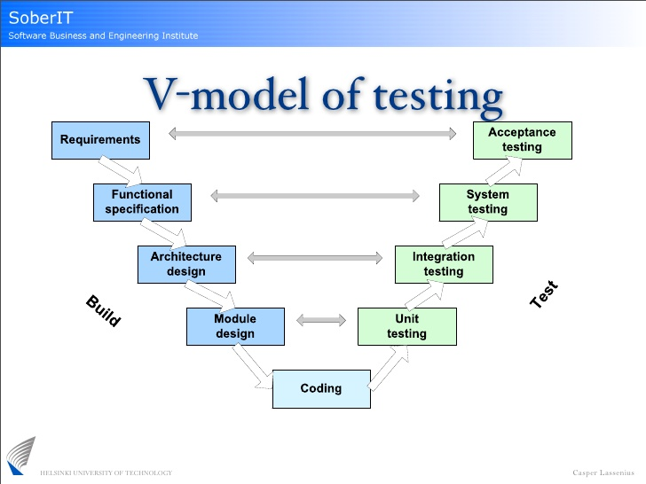

Figure 219: V-model

Due to requirement of project must be always suitable with user, we choose V-model to implement testing process. With V-Model, software development is separated into two appropriate phase’s groups: development and testing. In this model, the verification and validation will be done side by side. It emphasizes the strict process flow to develop a quality product. The errors occurred in any phase will be corrected in that phase. Proactive defect tracking defects, which are found at early stages even, may be in the development phase before application being tested

### 1.4.4. Testing Process

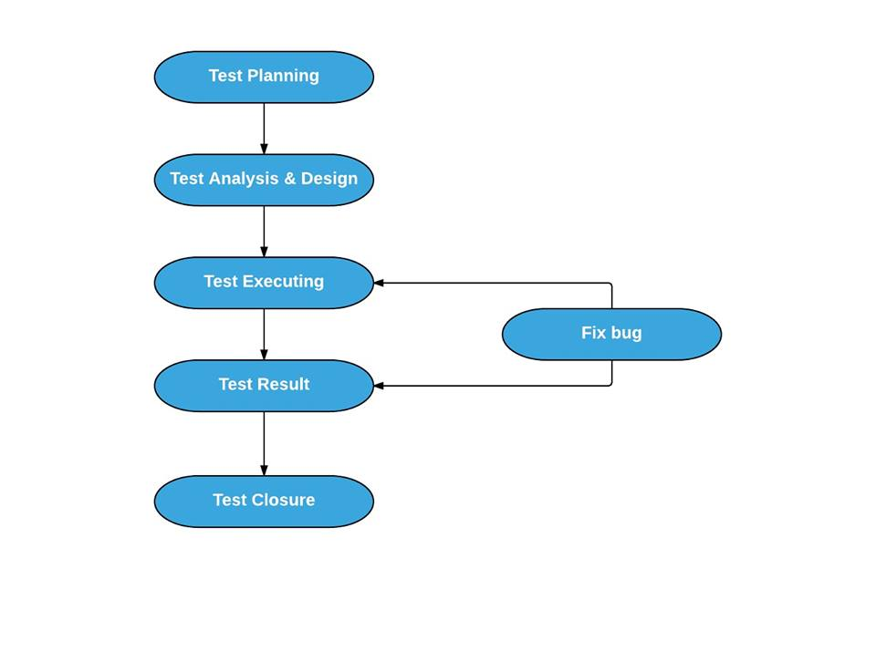

Figure 220: Test Process

## 1.5. Resource

### 1.5.1. Human resource

|  |  |  |
| --- | --- | --- |
| Name | Roles | Responsibility |
| NhungNTH | Test leader | Manage Testresource and assign testtasks  CreateTPSTITTC Review TC  Execute test |
| HoangLVQ | PM + Developer | Review test plan  Review test report  Create UT & execute test |
| HoangNK | Technical leader | Create UT & execute test  Report test result |
| HuyTDH | Developer | Create UT & execute test  Report test result |
| QuyenNV | Developer | Create UT & execute test  Report test result |
| KhanhKC | Developer | Create UT & execute test  Report test result |

### 1.5.2. Environmentrecourse

|  |  |
| --- | --- |
| Software | Hardware |
| Window 7  Google Chrome 46.0.2490.86 m  Fire fox 8.0.1 | IPhone5 iOSversion 7.1.1  Google Nexus 5 Android version 6.0  Laptop Window 7 |

## 1.6. Test Milestones

|  |  |  |  |
| --- | --- | --- | --- |
| **MilestoneTask** | **Effort (pd)**  **(pd)** | **Start Date** | **EndDate** |
| * **Increment 1** | | | |
| Create test plan v1.0 | 4 | 22/10/2015 | 26/10/2015 |
| Create system test cases | 4 | 26/10/2015 | 30/11/2015 |
| Create integration test case | 3 | 01/11/2015 | 03/11/2015 |
| Execute test | 4 | 04/11/2015 | 08/11/2015 |
| Test report v1.0 | 1 | 08/11/2015 | 08/11/2015 |
| * **Increment 2** | | | |
| Createtest plan ver2.0 | 1 | 09/11/2015 | 09/11/2015 |
| Update test cases | 4 | 09/11/2015 | 13/11/2015 |
| Execute test | 12 | 16/11/2015 | 30/11/2015 |
| Create and execute unit test cases | 7 | 23/11/2015 | 01/12/2015 |
| Test report v2.0 | 1 | 30/11/2015 | 30/11/2015 |
| * **Increment 3** | | | |
| Execute test | 4 | 09/12/2015 | 13/12/2015 |
| Submit final report of testing | 1 | 13/12/2015 | 13/12/2015 |

## 1.7. Deliverables

|  |  |  |  |  |
| --- | --- | --- | --- | --- |
| **No** | **Deliverables** | **DeliveredDate** | **Deliveredby** | **Deliveredto** |
| * **Increment 1** | | | | |
| 1 | Test plan ver1.0 | 08/11/2015 | NhungNTH | HoangLVQ |
| 2 | System test cases ver1.0 | 08/11/2015 | NhungNTH | HoangLVQ |
| 3 | Integration test cases ver1.0 | 08/11/2015 | NhungNTH | HoangLVQ |
| * **Increment 2** | | | | |
| 5 | Test plan ver2.0 | 20/11/2015 | NhungNTH | HoangLVQ |
| 6 | Unit test cases and result | 01/12/2015 | Developer | HoangLVQ |
| 7 | System test case ver2.0 | 13/11/2015 | NhungNTH | HoangLVQ |
| 8 | System result 1.0 | 01/12/2015 | NhungNTH | HoangLVQ |
| 9 | Integration test cases ver2.0 | 14/11/2015 | NhungNTH | HoangLVQ |
| 10 | Integration result | 01/12/2015 | NhungNTH | HoangLVQ |
| * **Increment 3**   **31/5/2015**  **MaiNT** | | | | |
| 11 | System result 2.0 | 13/12/2015 | NhungNTH | HoangLVQ |
| 12 | Final report of testing | 13/12/2015 | HoangLVQ | Supervisor |

# 2. TEST CASE

## 2.1. Unit test

* Reference: KW_UnitTest_QuyenNV.xlsx
* Reference: KW_UnitTest_HuyTDH.xlsx
* Reference: KW_UnitTest_HoangNK.xlsx
* Reference: KW_UnitTest_KhanhKC.xlsx
* Reference: KW_UnitTest_HoangLVQ.xlsx

## 2.2. Integration test

* Reference: KW_IntegrationTest.xlsx

## 2.3. System test

* Reference: KW_Admin_TestCase.xlsx
* Reference: KW_Store_TestCase.xlsx
* Reference: KW_Shipper_TestCase.xlsx

# 3. TEST REPORT

## 3.1. Unit test

- KW_UnitTest_QuyenNV: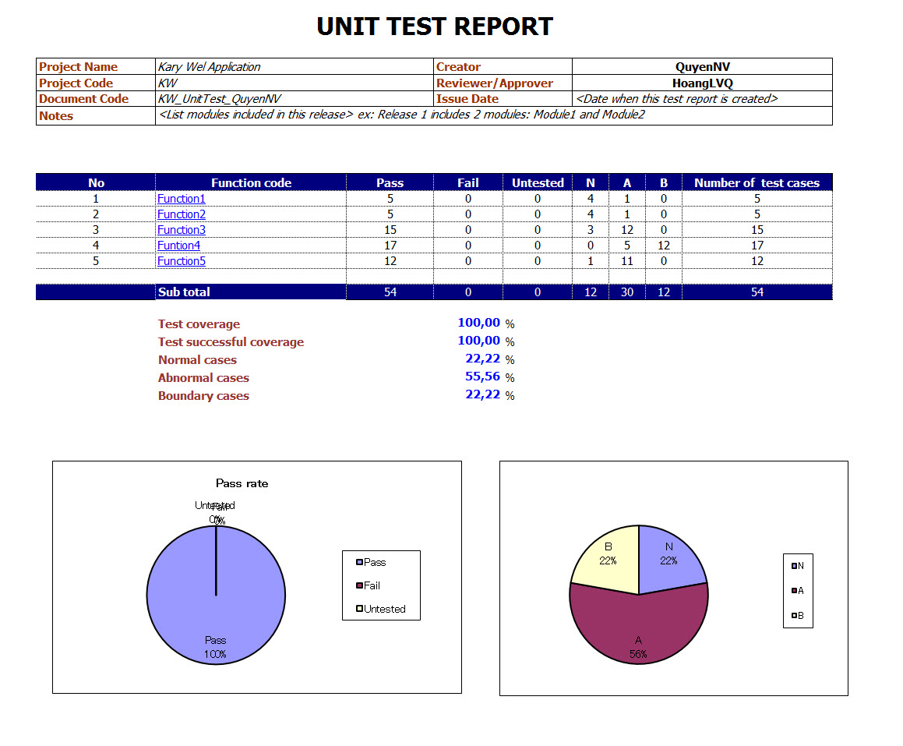

Figure 221: KW_UnitTest_QuyenNV

* 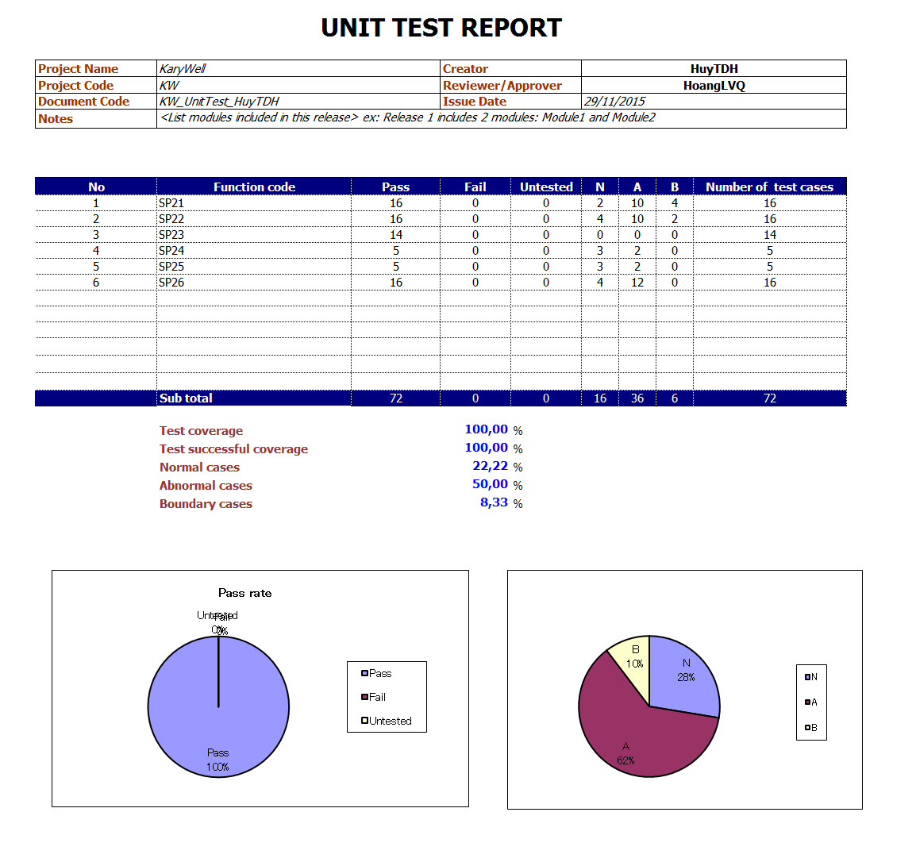KW_UnitTest_HuyTDH

Figure 222: KW_UnitTest_HuyTDH

* KW_UnitTest_HoangNK

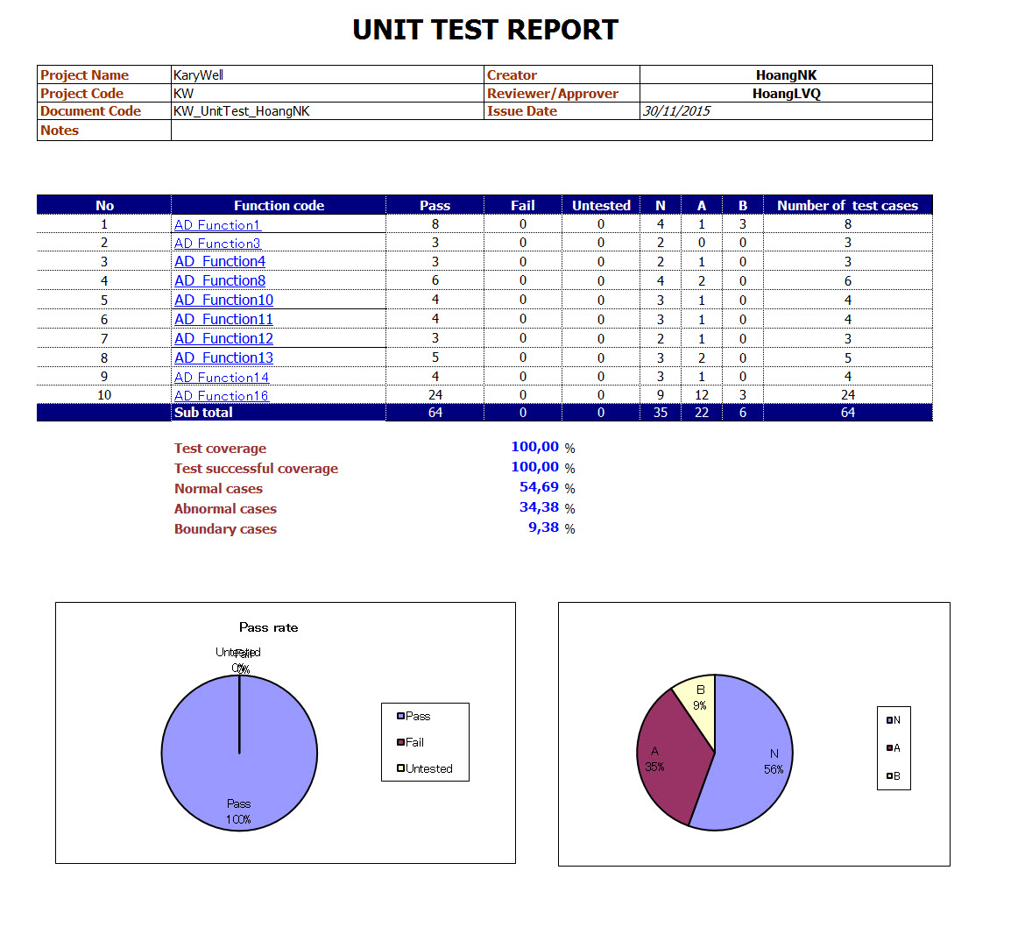

Figure 223: KW_UnitTest_HoangNK

* KW_UnitTest_KhanhKC

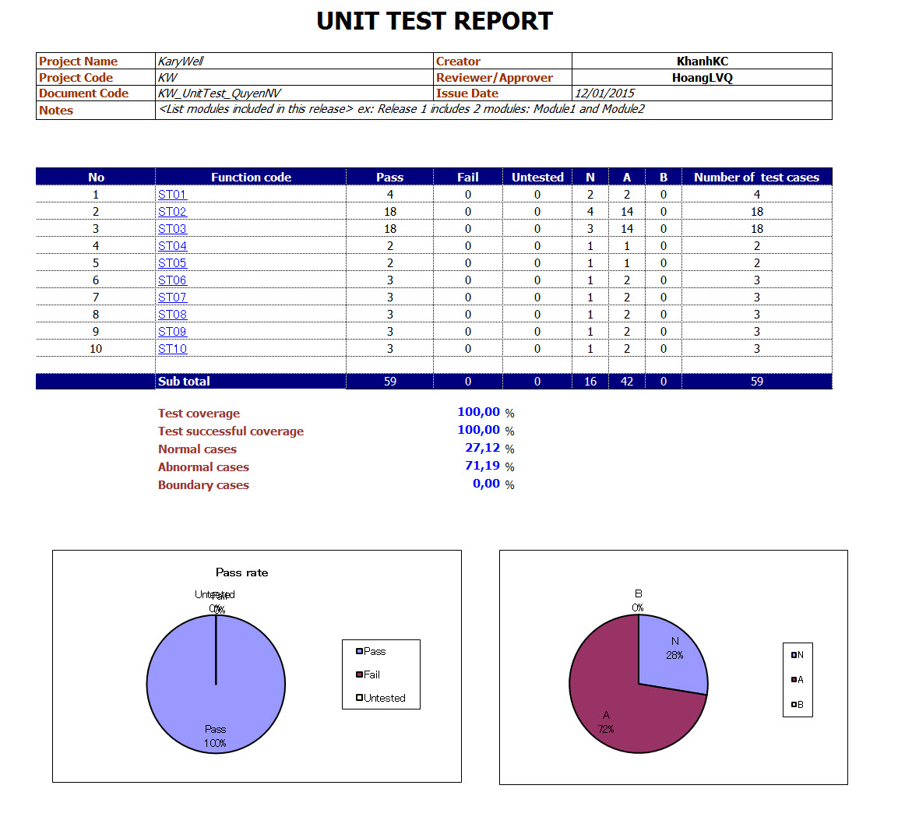

Figure 224: KW_UnitTest_KhanhKC

## 3.2. Integration test

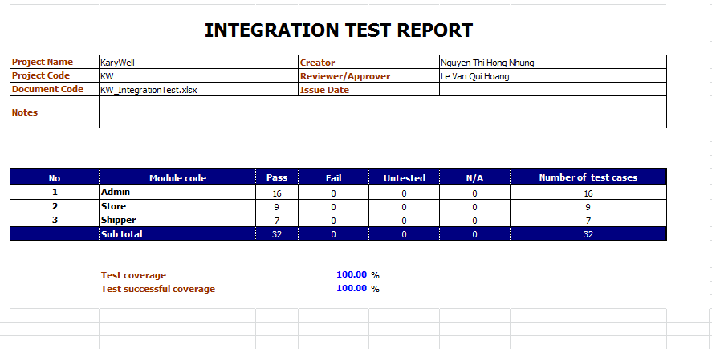

Figure 225: KW_IntegrationTest_Report

## 3.3. System test

### 3.3.1. Increment 1

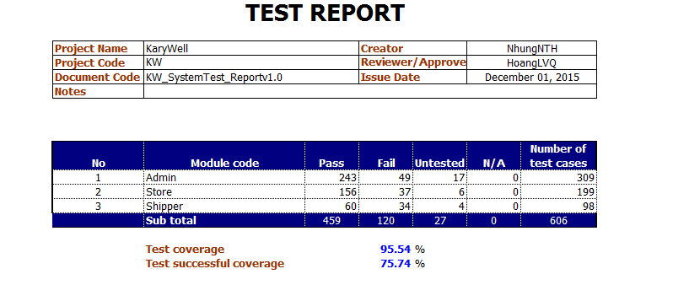

Figure 226: KW_SystemTest_Reportv1.0

### 3.3.2. Increment 2

#### 3.3.2.1.Admin

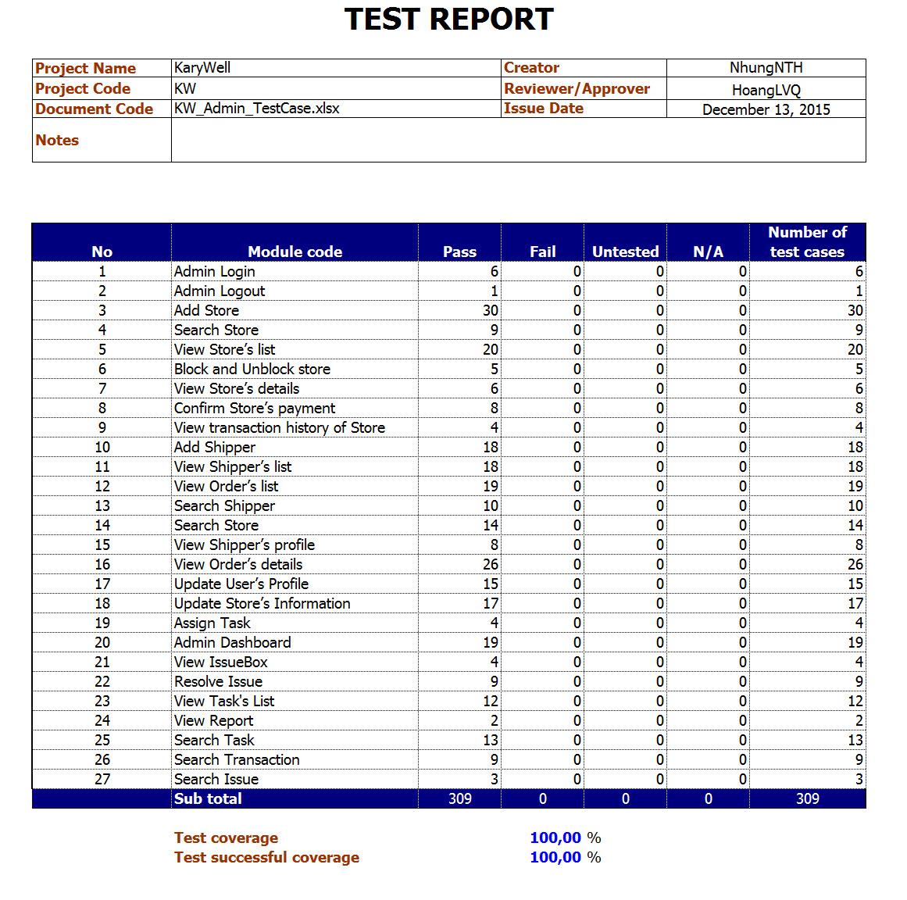

Figure 227: KW_Admin_TestCase

#### 3.3.2.2.Store

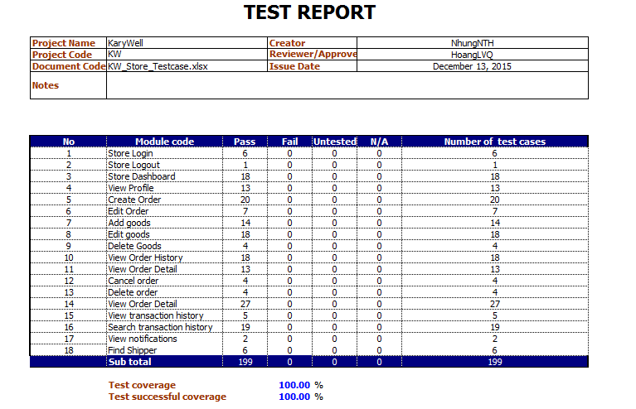

Figure 228: KW_Store_TestCase

#### 3.3.2.3. Shipper

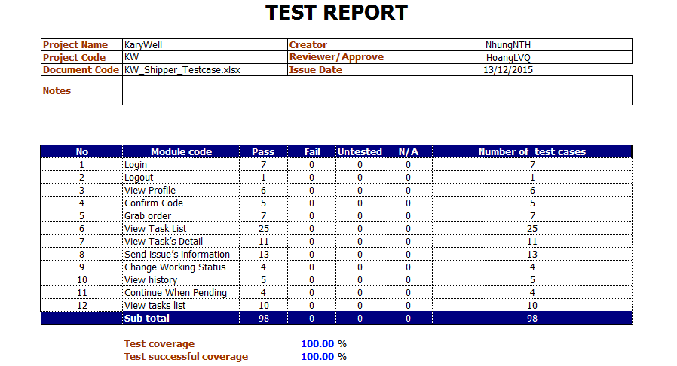

Figure 229:KW_Shipper_TestCase

## 3.4. Bug control chart

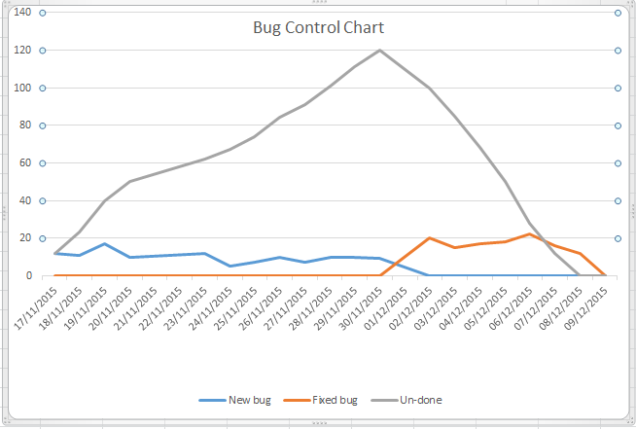

Figure 230:KW_Bug_ControlChart

# 4. CHECKLIST

Figure 231: KW_TestPlan_Checklist

# VI. INSTALLATION GUIDE AND USER MANUAL

# 1. INSTALLTION GUIDE

**1.1. English Version**

### 1.1.1. Prerequisites

This section contains the list of prerequisites that must be fulfilled before install.

* A smart phone running on Android ver6.0 or higher. Or A smart phone running on IOS ver7.0 or higher.
* 20MB free or higher

### 1.1.2. Installation procedures

* IOS: Copy ‘Karywell.ipa’ file to the targeted device. Open and install
* Android:

1. Connect to internet
2. Tap on **Google play** icon on screen
3. Search Karywell
4. Tap on **Install** button
5. Tap **Accept** button confirmation dialog

### 1.1.3. Uninstall procedures

1. Tap **Apps** in the upper right hand corner

1. Tap on **Setting**
2. Tap **Applications** to the left of the screen.
3. Tap **Manage applications** on the right side of the screen.
4. Tap on **Karywell**
5. Tap the **Uninstall** button.
6. To confirm you want to uninstall this app tap **OK**.
7. Click **OK** once finished.

**1.2. Japanese Version**

### 1.2.1. 前提条件

このセクションにはアプリをインストールするための前提条件を表します。

* Android バージョン4.4.2以上, IOS バージョン7.0 以上で動くスマートフォン
* 20MB以上のフリーの容量

### 1.2.2. インストール手順

* IOS: IOS 端末に‘Karywell.ipa’ファイルをファクスす
* Android:
  + 1. インターネットに接続する
    2. 画面に現れるグーグルプレアイコンに押す
    3. Karywellを検索する
    4. インストールボタンに押す
    5. 確認ダイアログのはいボタンに押す

### 1.2.3. アンインストール手順

1. 右上コーナーにアプリを押す
2. 設定に押sす
3. 画面の左に現れるアプリケーションに押す
4. 画面の右側にあるアプリ管理に押す
5. Karywell に押す
6. アンインストールボタンに押す
7. このアプリのアンインストールを確認するためOKに押す
8. アンインストールが終わったらOKに押す

**2. USER MANUAL**

**2.1. Web Application**

### 2.1.1. Admin

This document guides you how to use Karywell client-web application for admin. You will need only 10 minutes to learn.

2.1.1.1. Login to system



**To login to Karywell system:**

**Step 1**. Type your “Username” on username text box (“1”)

**Step 2**. Type your “Password” on password text box (“2”)

**Step 3**. Click on “Sign in” button (“3”)

2.1.1.2. Select a screen

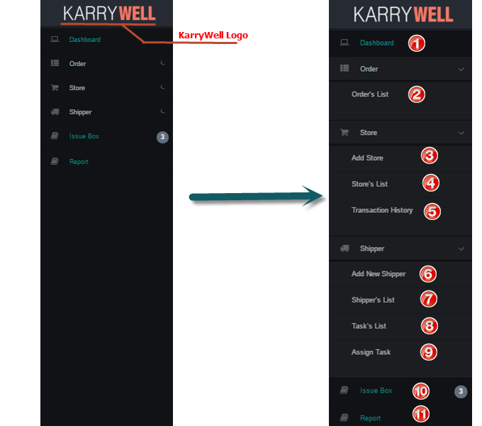

**To select a screen**

1. Click on screen that you want to go on left navigate bar

* ➊Dashboard: used to view statistics and overview of system
* ➋Order’s List: used to view all orders and related information
* ➌Add Store: used to add new Store to system
* ➍Store’s List : used to view all Store, block store and confirm payment
* ➎Transaction History: used to view all transactions
* ➏Add Shipper: used to add new Shipper to system
* ➐Shipper’s List: used to view all Shipper and related information
* ➑Task’s List: used to view all Tasks and related information
* ➒Assign Task: used to assign order to shipper
* ➓Issue Box: used to view and resolve issue
* ⓫Report: used to view statistics about system by month, year

2.1.1.3. Add new Store

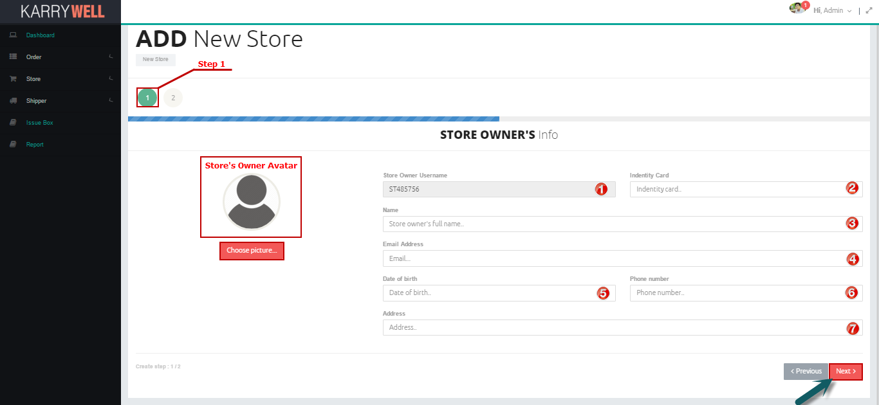

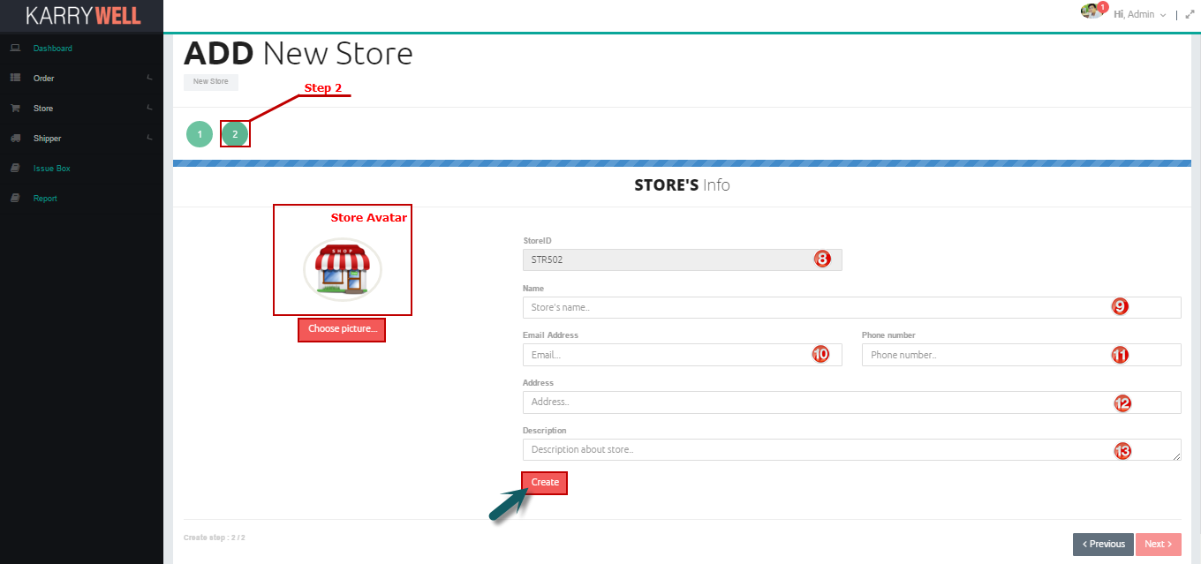

**To add new Store**

1. Open “Add Store” Screen
2. Enter valid store owner information into textbox, choose avatar if it is necessary:

* Identity card➋: identity card of store’s owner, user have to enter a string of digits from 9 to 12 characters
* Name➌: Full name of store’s owner
* Email➍: Email of store’s owner, must follow email format
* Date of Birth➎: date of birth of store’s owner, click into textbox, a calendar will be showed, user click into day in calendar to pick.
* Phone Number➏: phone number of store’s owner, user have to enter a string of digits from 11 to 12 characters
* Address➐: detail address of store’s owner

1. Click Next button
2. Enter valid store information into textbox, choose avatar if it is necessary

* Name➒: Full name of store
* Email➓: Email of store, must follow email format
* Phone Number⓫: phone number of store, user have to enter a string of digits from 11 to 12 characters
* Address⓬: detail address of store
* Description⓭: description about store

1. Click Create button

2.1.1.4. Add new Shipper

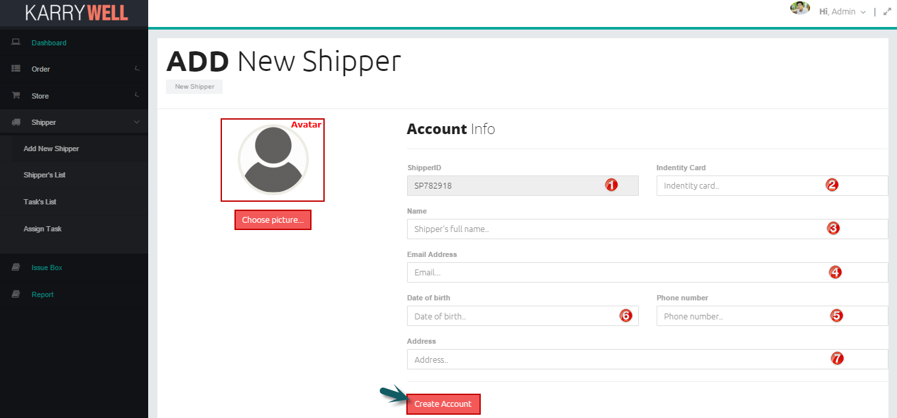

**To add new Shipper**

1. Open “Add Shipper” Screen
2. Enter valid shipper information into textbox, choose avatar if it is necessary

* Identity card ➋: identity card of shipper, user have to enter a string of digits from 9 to 12 characters
* Name ➌: Full name of shipper
* Email➍: Email of shipper, must follow email format
* Date of Birth➏: date of birth of shipper, click into textbox, a calendar will be showed, user click into day in calendar to pick.
* Phone Number➎: phone number of shipper, user have to enter a string of digits from 11 to 12 characters
* Address➐: detail address of shipper

1. Click Create button

2.1.1.5. Confirm Payment

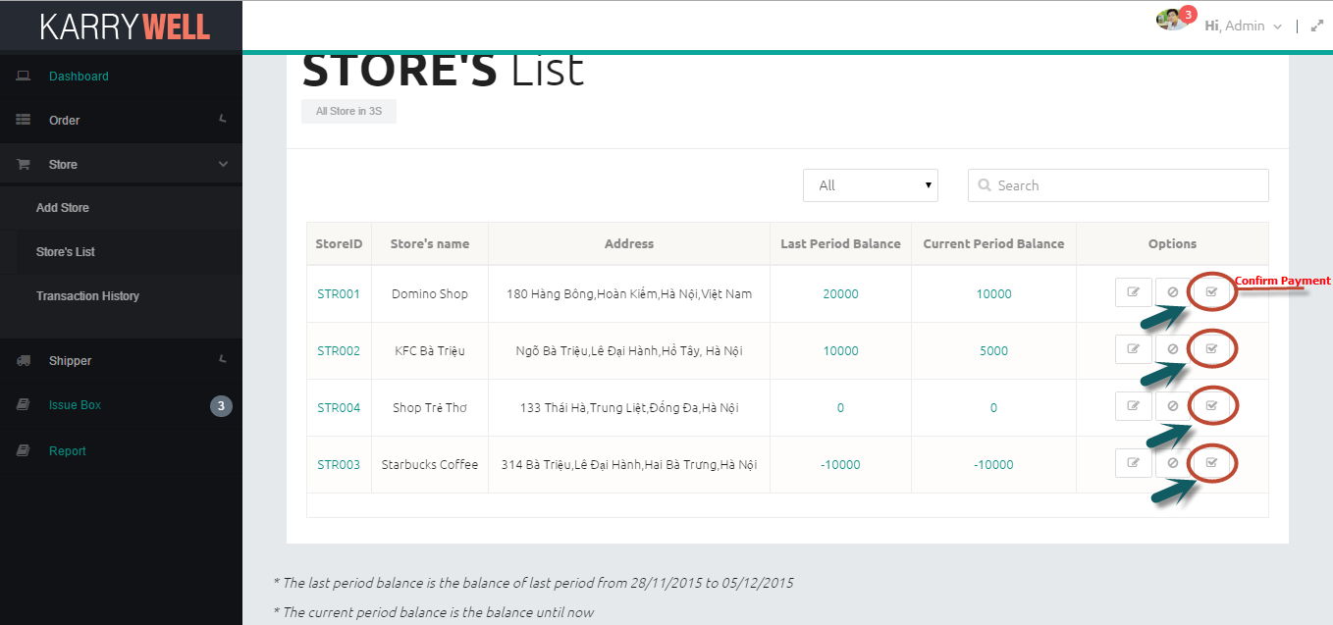

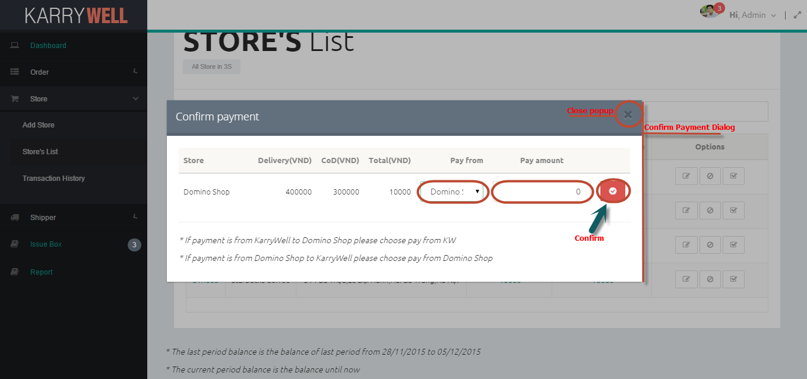

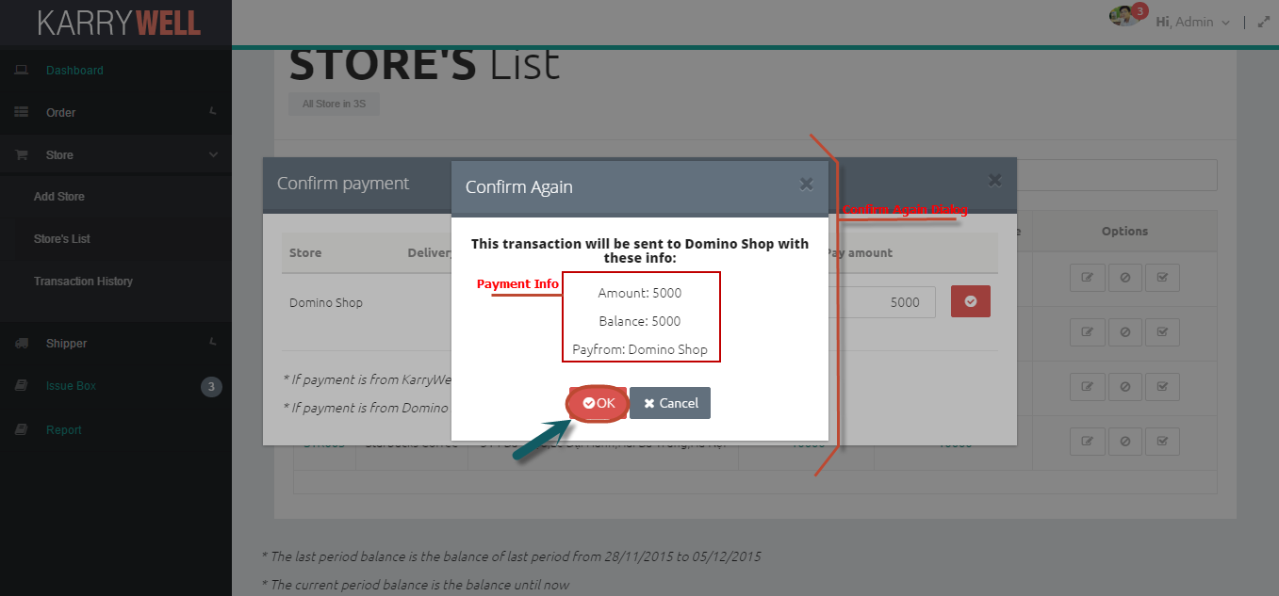

**To confirm payment**

1. Open “Store’s List” Screen
2. Click on Confirm Payment icon button
3. After confirm payment popup is showed:

* Pick payfrom drop-down list ➊:

+ If pick Karywell, this payment is from system to store

+ If pick store’s name, this payment if from store to system

* Enter amount ➋ of payment, amount must be digits and not equal 0

1. Click on button Confirm
2. After Confirm Again popup is showed, user read payment information carefully then click “OK” button to add this transaction or cancel to close this popup

2.1.1.6. Block/Unblock Store

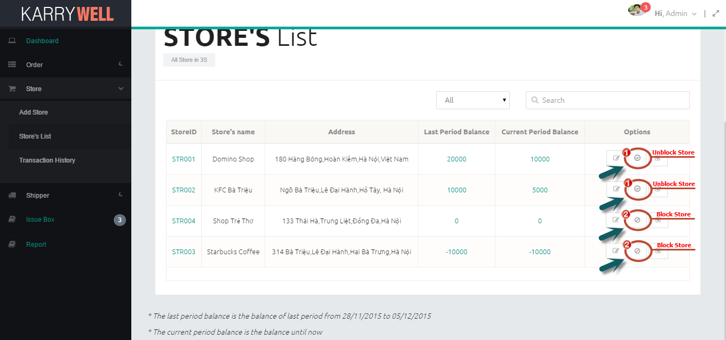

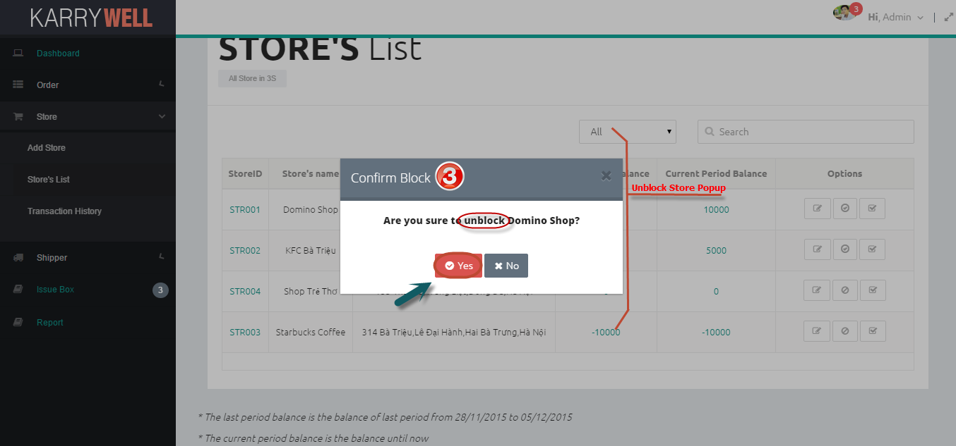

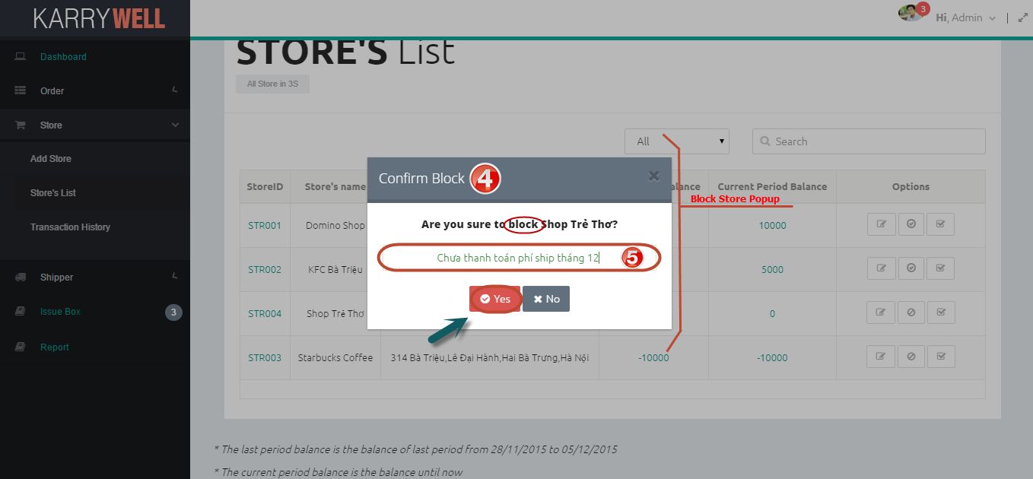

**To block/unblock store**

1. Open “Store’s List” Screen
2. Click on Block ➊ or Unblock ➋ store icon button
3. A popup will be showed:

* If Unblock Popup ➌ is showed, user click button “Yes” to unblock this store or “No” to close popup
* If Block Popup ➍ is showed, user enter reason in reason textbox ➎ (not blank) then click button “Yes” to block this store or “No” to close popup.

2.1.1.7. Assign Task

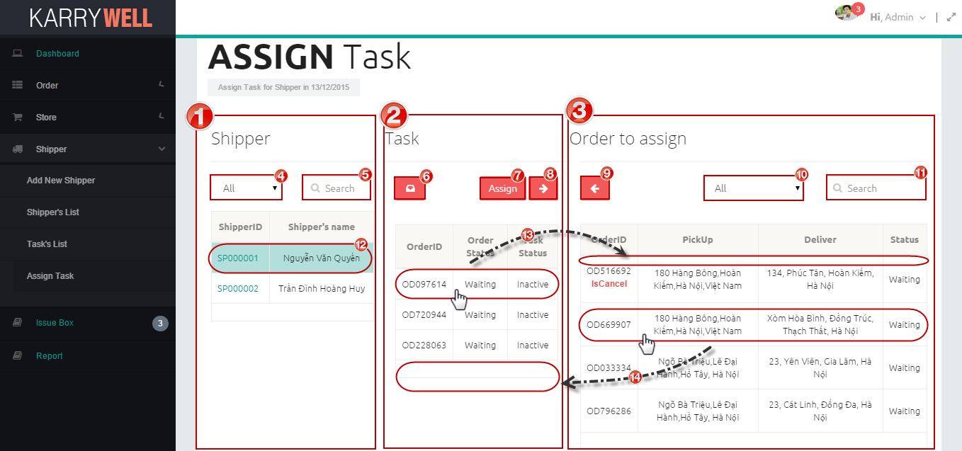

**Screen Description:**

1. Shipper area ➊: includes all shippers, textbox and filter for search shipper

* Filter ➍: user can pick type to search shippers by name, id or both
* Search ➎: user type search key to search shipper
* ⓬ When user select a row of shipper, all tasks of this shipper that can be assigned for other shipper will be listed in task table

1. Task area ➋: includes all tasks that can be assigned for other shipper and function buttons:

* Issue Box➏: click to go to Issue Box page
* Assign➐: Click to assign task
* Move all to left➑: Move all order of picked shipper to Order table
* ⓭When user pick task in a row of task table, order of this row will be moved from task table to order table

1. Order Area ➌: includes all orders can be assigned for shipper in order table, textbox and filter for search order:

* Filter ➓: user can pick type to search orders by id, address, status or all
* Search⓫ : user type search key to search order
* Move all to right➒: Move all order in Order table to task table
* ⓮When user pick order in a row of order table, order of this row will be moved from order table to task table

**To assign task for Shipper**

1. Open “Assign Task” Screen
2. Select Shipper to assign by select row of shipper table ⓬
3. Pick order for shipper by select order on order table ⓮. User also can cancel task by select row of task in task table ⓭, but task is cancelled must be assigned for other shipper.

User can user button move all ➑➒ to pick order and task faster.

1. Click Assign button to assign tasks for shippers

2.1.1.8. Resolve Issue

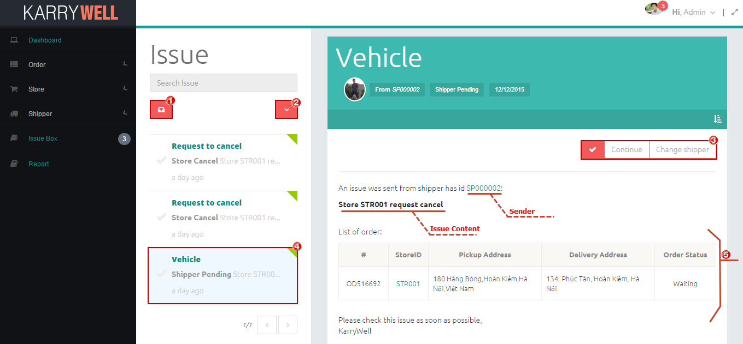

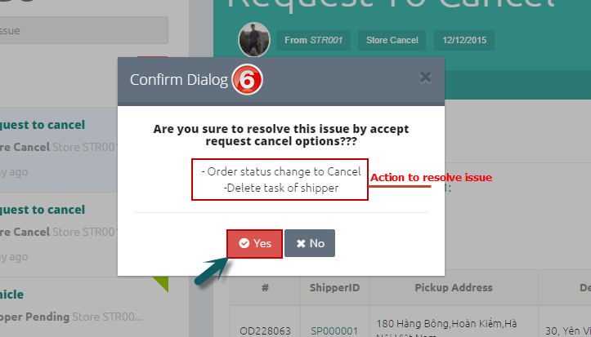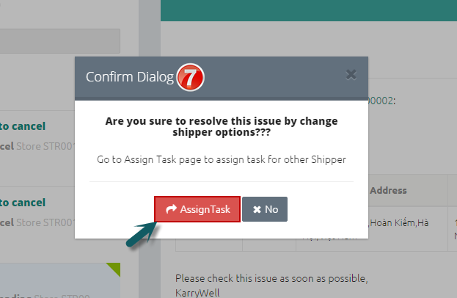

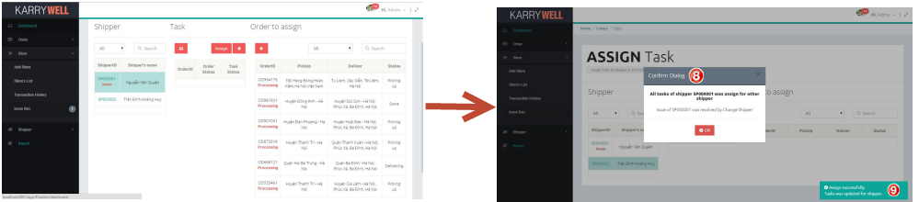

**Screen Description:**

1. Click ➊ to list all issues
2. Filter ➋: Click to view only selected type of issue, includes: Resolved, Unresolved, Shipper Pending, Shipper Cancel, Store Cancel
3. Click on button of resolve type ➌ to resolve issue, there are 3 types:

* Continue: for Shipper Pending issue, allow shipper continue orders which get issue
* Change Shipper: for Shipper Pending issue, change orders to other shipper
* Accept Request: for Shipper Cancel and Store Cancel, accept cancel request

1. Issue ➍: include type (hyperlink), category, content and resolve icon (✓) (is yellow if issue was resolved). User can click on type to view issue detail
2. ➎List of orders that get issue

**To resolve issue**

1. Open “Issue Box” Screen
2. Pick issue on issue list to resolve
3. After reading content of issue carefully, user choose type of resolve: Continue, Change Shipper or Accept Request
4. A popup will be showed:

* If resolve type is Continue and Accept Request, a popup ➏ shows what system do to resolve issue, then user click “Yes” button to resolve issue or click “No” button to close popup
* If resolve type is Change Shipper:

+ Click “Assign Task” button on popup ➐ to go to Assign page

+ Assign Task for other Shipper (read user manual 2.5 for more detail)

+ After assign, if all issue orders of shipper is assigned for other shipper, a notify popup ➑ and notify message ➒ will be showed. User click “OK” button to back to IssueBox Screen

2.1.1.9. Search

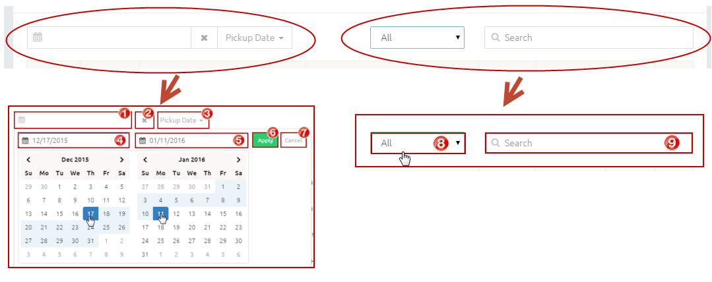

In each view list screen, there is a search tool to help user to search faster

**Screen Description:**

1. Click ➊ to show calendar to pick date
2. Click ➋ to clear date in textbox ➊
3. Click ➌ to choose which type of date will be searched, and some screens don’t have this
4. ➍ Start Date of date range
5. ➎End Date of date range
6. Click ➏ to apply date range after choose start date and end date
7. Click ➐ to Cancel
8. Click ➑ to show filter for search
9. Enter search key into textbox ➒ to search

**To search by date range**

1. Choose date type ➋. If screen doesn’t have drop down list ➋, default type of search date is which type of date in table below
2. Click date range textbox ➊ to pick date
3. Click start date and end date
4. Click “Apply” button ➏, then result will be displayed

**To search by word**

1. Choose type to filter ➑. “All” is search by all information in table below
2. Enter search key into textbox ➒. Whenever type any key in search textbox, result will be displayed immediately

2.1.1.10. View Detail

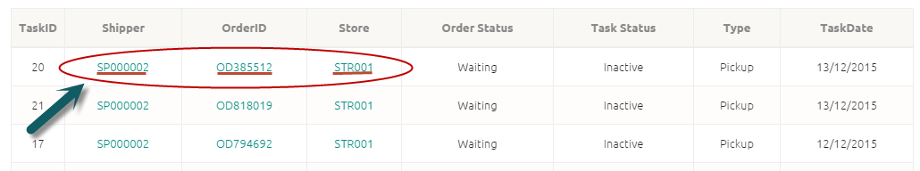

In each view list screen, there are hyperlink to store detail, order detail, shipper’s profile. User just click to this hyperlink to view detail

### 2.1.2. Store

2.1.2.1. Login to system

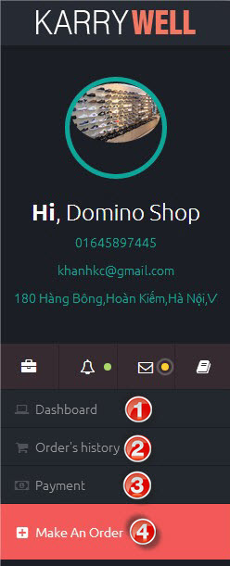

**To login to Karywell system:**

**Step 1**. Type your “Username” on username text box (“1”)

**Step 2**. Type your “Password” on password text box (“2”)

**Step 3**. Click on “Sign in” button (“3”)

2.1.2.2. Open a screen

**To open a page:**

On right menu, have a list names of screen. You can click on those name to open a screen.

- ➊: Open Dashboard screen.

- ➋: Open Order’s history screen.

-➌: Open Transaction history screen.

-➍: Open Create order screen.

2.1.2.3. View Profile

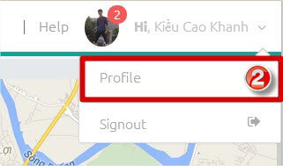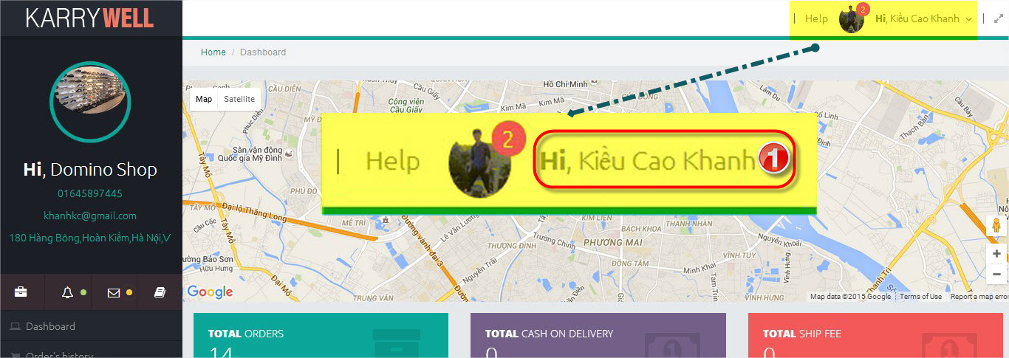

You can access to profile screen from any screen.

**To view profile screen:**

**Step 1**. Click on your name on header (➊). A menu will appear.

**Step 2**. Click on “Profile” item on menu (➋).

2.1.2.4. Create an order

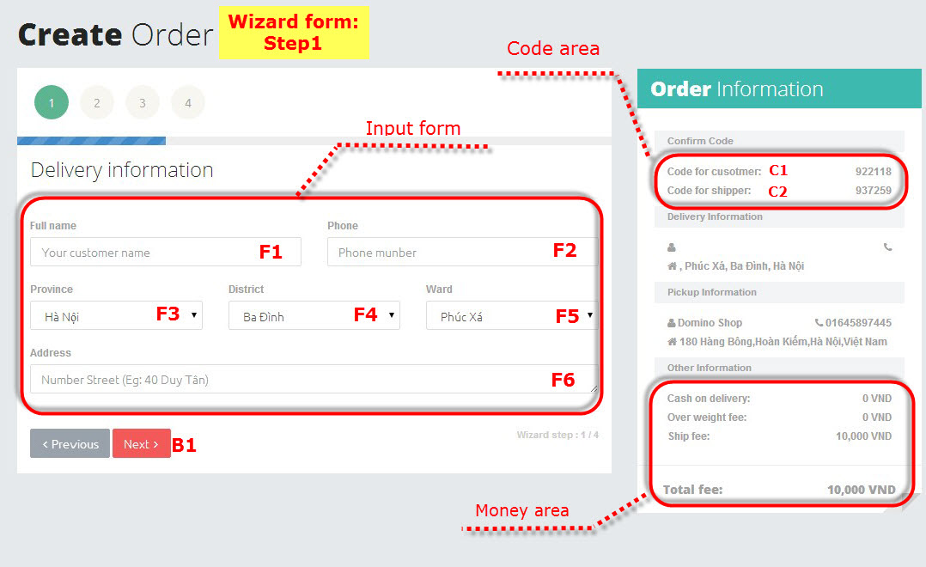

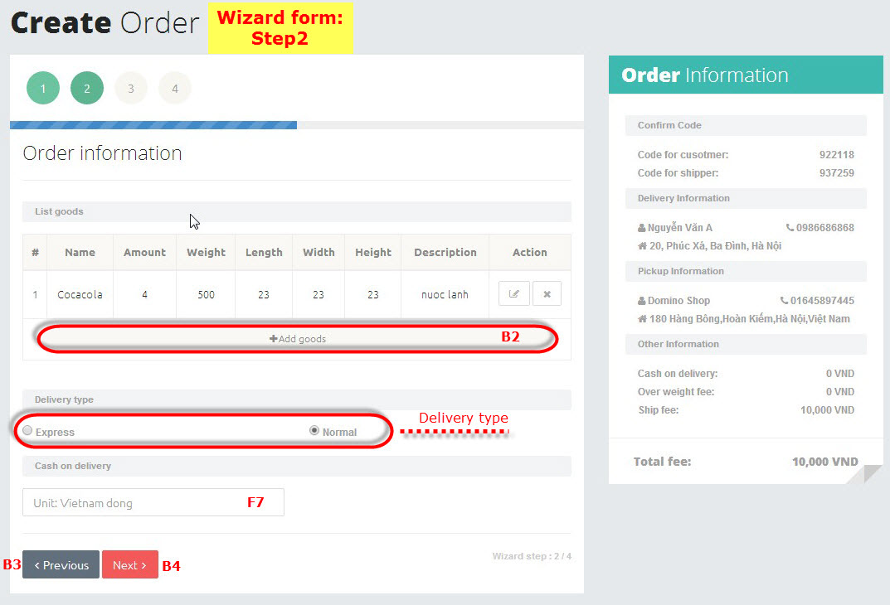

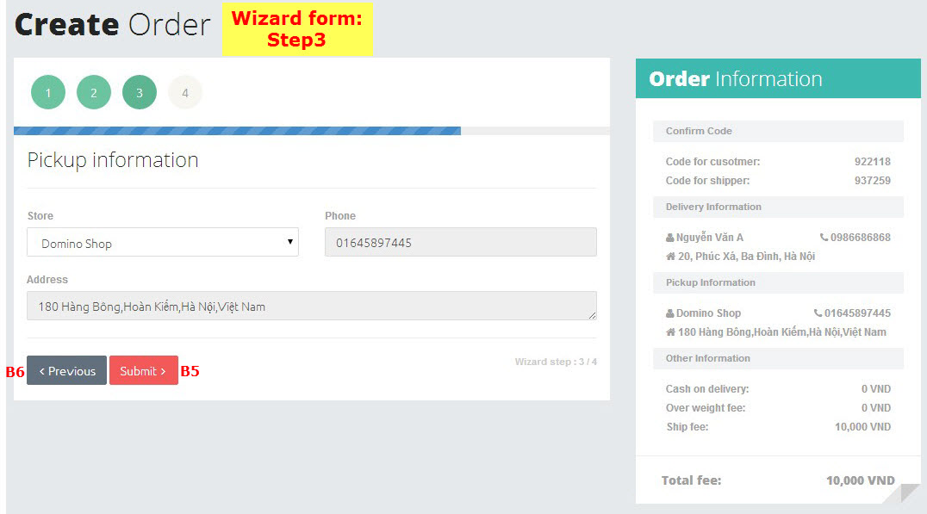

- There is one wizard form on “Create order” screen. You just need to follow on below steps to create an order.

**To create an order:**

**At “Wizard form: Step1”**

**Step 1**. Open “Create order” screen (see 3.2.2: Open a screen).

**Step 2**. Input data on “Input form”

- 1. Type the full name of your customer on (F1).

- 2. Type the phone number of your customer on (F2).

- 3. Click on (F3) to select province of your customer.

- 3. Click on (F4) to select district of your customer.

- 4. Click on (F5) to select ward of your customer.

- 5. Type the address of your customer on (F6).

**Step 3**. Click on “Next” button (B1) to go to “**Wizard form: Step 2**”.

**At “Wizard form: Step2”**

**Step 4**. Click button “Add goods” (B2) to add a goods to order (see 3.2.5: Add a goods).

You can edit and delete goods on table of goods (see 3.2.6: Edit a goods and 3.2.7: Delete a goods)

**Step 5**. Select delivery type on “Delivery type” area.

- Express: System will find a shipper for you and that shipper will come to pick up your goods immediately.

- Normal: Shipper will come to pick up your goods in tomorrow.

**Step 6**. Type amount of cash on delivery on “Cash on delivery” text box (F7)

**Step 7.** Click “Next” button (B4) to go to “Wizard form: Step 3”. If you want to go to “Wizard form: step 1” click on “Precious” button (B3).

**At “Wizard form: Step 3”** (This screen display information of your store)

**Step 8:** Click on “Submit” button (B5) to submit your order.

- If at “**Step 5**” you chose “Normal”, you are create an order successfully, go to “Dashboard” screen to view you order.

- If at “**Step 5**” you chose “Express” system will find a shipper for you. (see 3.2.13.Find a shipper

2.1.2.5. Add a goods

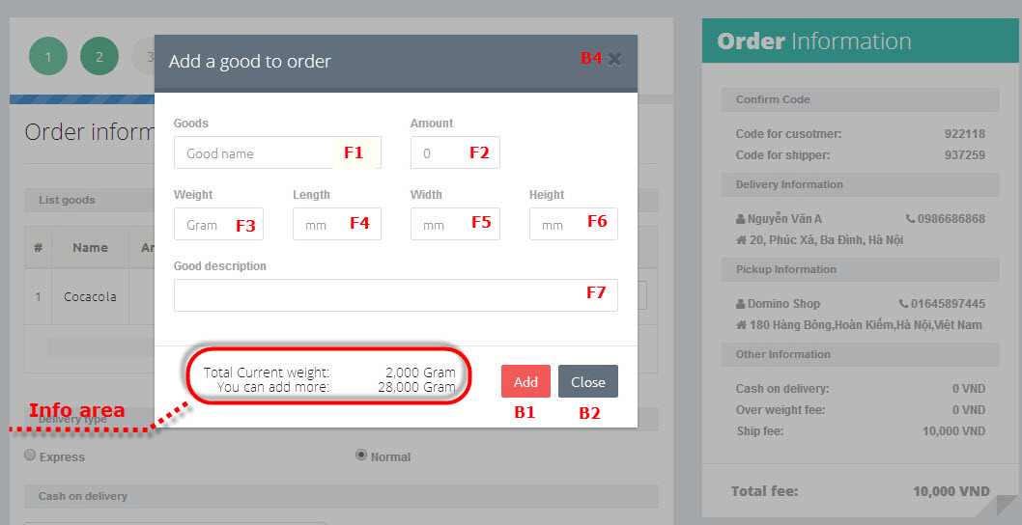

You can add a goods to order form “Create an order” screen (see 3.2.4. Create an order) and “Edit an order” screen (see 3.2.11. Edit an order)

**To add a goods to order**

**Step 1. Type information of goods**

- 1. Type name of goods on “Goods name” text box (F1).

- 2. Type amount of goods on “Amount” text box (F2).

- 3. Type weight of goods on “Weight” text box (F3).

- 4. Type length size of goods on “Length” text box (F4).

- 5. Type width size of goods on “Width” text box (F5).

- 6. Type height size of goods on “Height” text box (F6).

- 7. Type description of goods on “Description” text box (F7)

**Step 2.** Clicks on “Add” button (B1) to add goods to order. If you don’t want to add goods click on “Close” button (B2) or “X” button (B4)

**\* Note**: On Info area there are 2 line

- Total current weight: total weight of all goods in order.

- You can add more: total weigh you can add to order.

2.1.2.6. Edit a goods

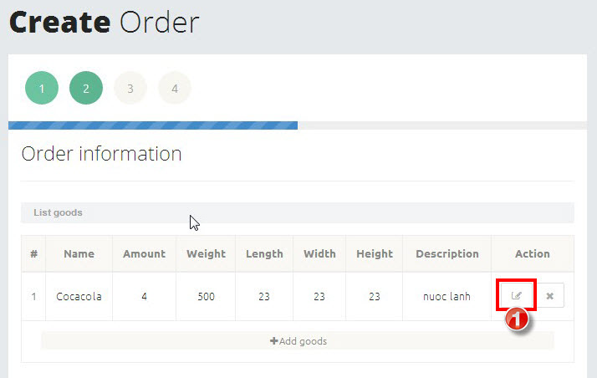

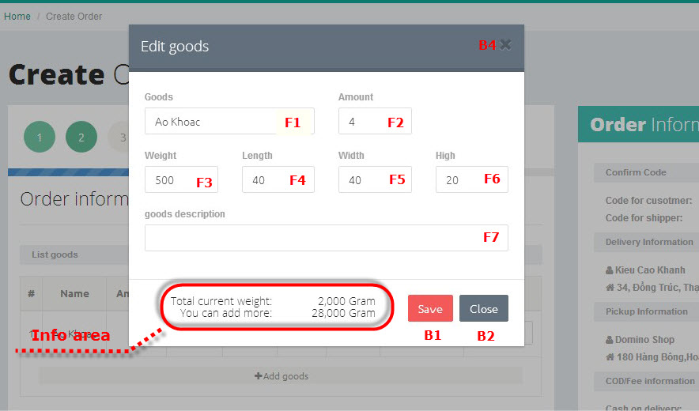

You can edit a goods on “Create an order” screen (see 3.2.4. Create an order) and “Edit an order” screen (see 3.2.11. Edit an order)

**To edit a goods**

**Step 1.** Click on pen icon (➊).

**Step 2.** Editinformation of goods.

- 1. Edit name of goods on “Goods name” text box (F1).

- 2. Edit amount of goods on “Amount” text box (F2).

- 3. Edit weight of goods on “Weight” text box (F3).

- 4. Edit length size of goods on “Length” text box (F4).

- 5. Edit width size of goods on “Width” text box (F5).

- 6. Edit height size of goods on “Height” text box (F6).

- 7. Edit description of goods on “Description” text box (F7)

**Step 3.** Clicks on “Save” button (B1) to save information of goods. If you don’t want to save the change click on “Close” button (B2) or “X” button (B4)

**\* Note:** On Info area there are 2 line

- Total current weight: total weight of all goods in order.

- You can add more: total weigh you can add to order.

2.1.2.7. Delete a goods

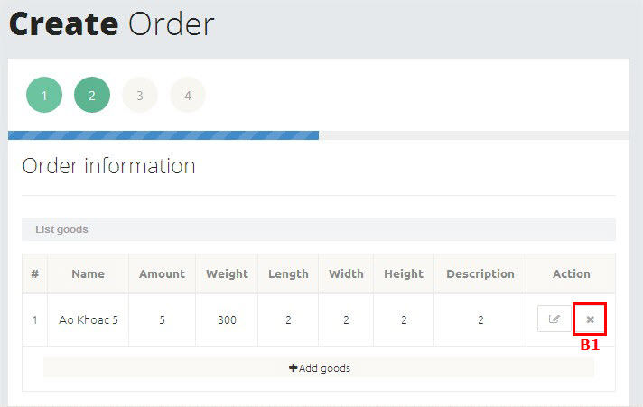

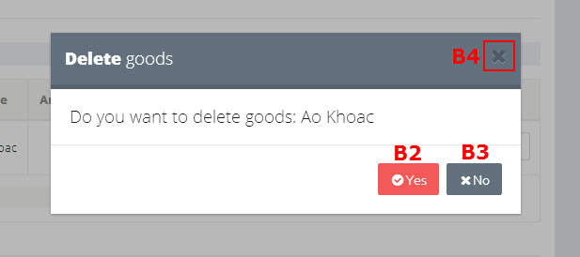

You can delete a goods from “Create an order” screen (see 3.2.4. Create an order) and “Edit an order” screen (see 3.2.11. Edit an order)

**To delete a goods**

**Step 1.** Click on “X” button (B1). A confirm popup will appear.

**Step 2.** Click on “Yes” button to delete goods. If you don’t want to delete that goods any more click on “No” button (B3) or “X” button (B4) to close confirm popup.

2.1.2.8. Delete an order

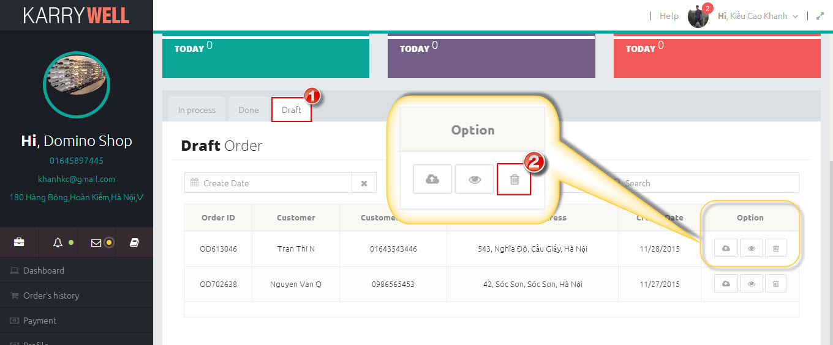

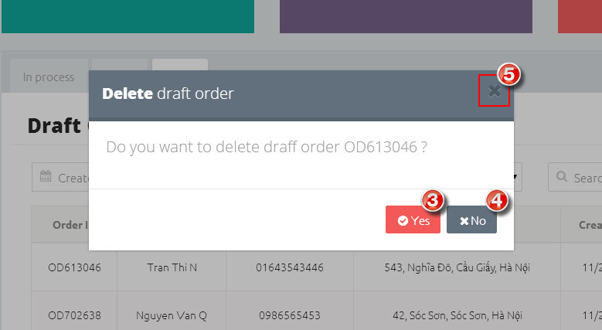

**\* Note:** You can only delete orders that have not been grabbed yet by any shipper (Draft order)

**To delete an order**

**Step 1.** Click on “Draft” tab (➊) on “Dashboard” screen to open table of draft orders.

**Step 2.** Click on trash icon (➋). A popup will appear.

**Step 3.** Click on “Yes” button (➌) to confirm delete order. If you don’t want to delete that order any more, click on “No” button (➍) or “X” button (➎) to close popup.

2.1.2.9. Cancel an order

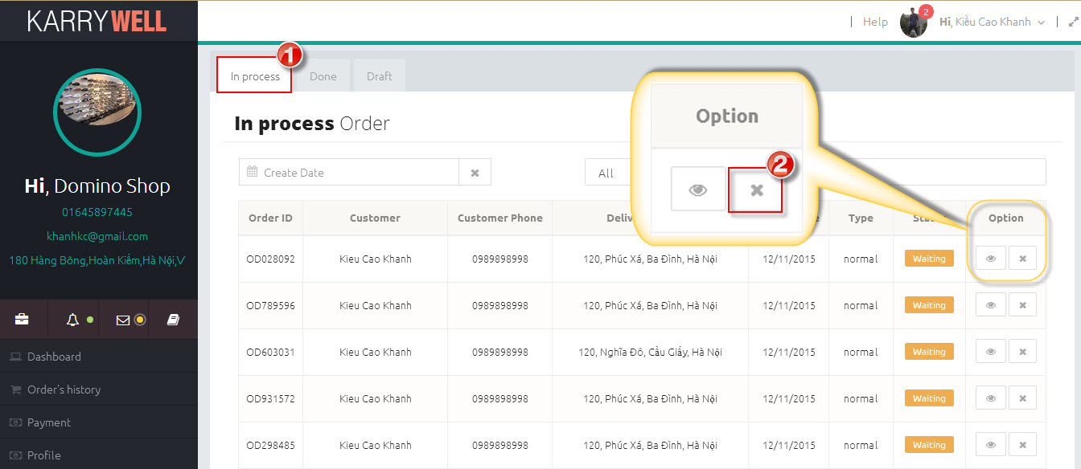

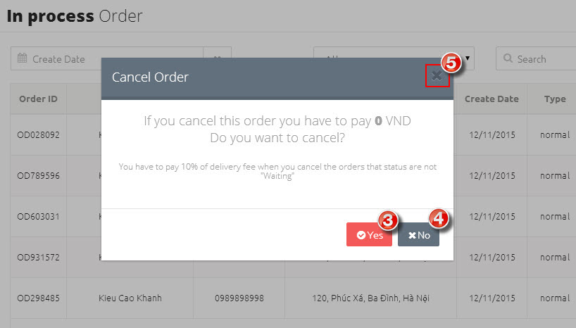

**\* Note:** You can only cancel an orders that have not been completed.

**To cancel an order**

**Step 1.** Click on “In process” tab (➊) on “Dashboard” screen to open table of draft orders.

**Step 2.** Click on “X” button (➋). A popup will appear.

**Step 3.** Click on “Yes” button (➌) to confirm cancel order. If you don’t want to cancel that order any more, click on “No” button (➍) or “X” button (➎) to close popup.

2.1.2.10. View detail of an order

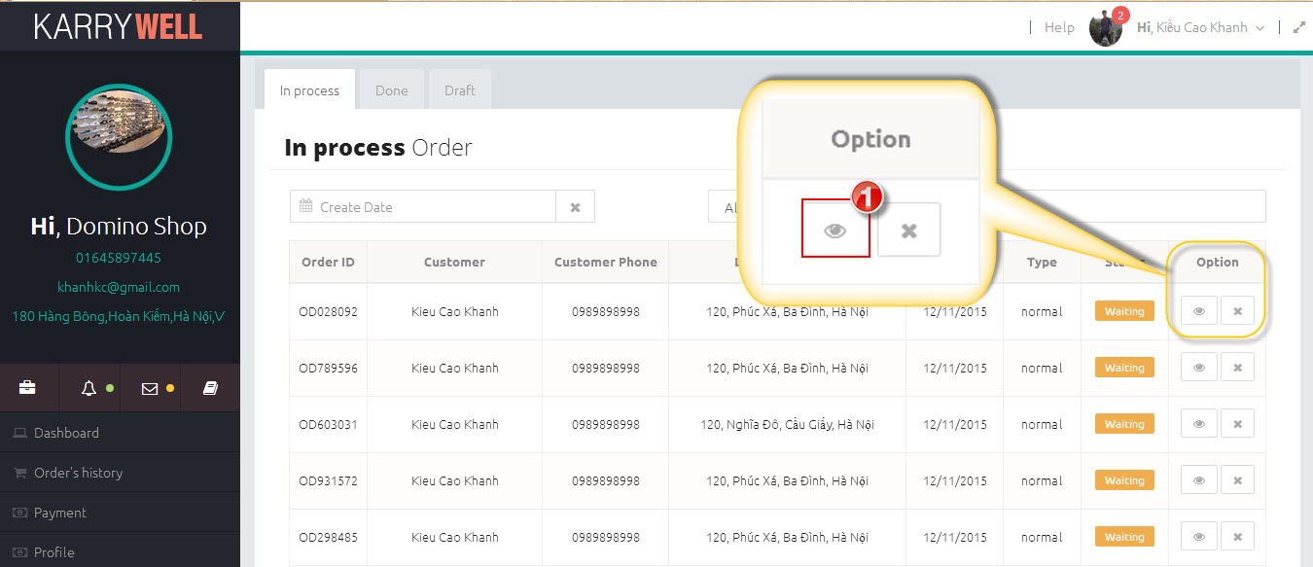

**To view detail of an order:**

You can view detail of an order by click on button that has an eye icon inside.

2.1.2.11. Edit an order

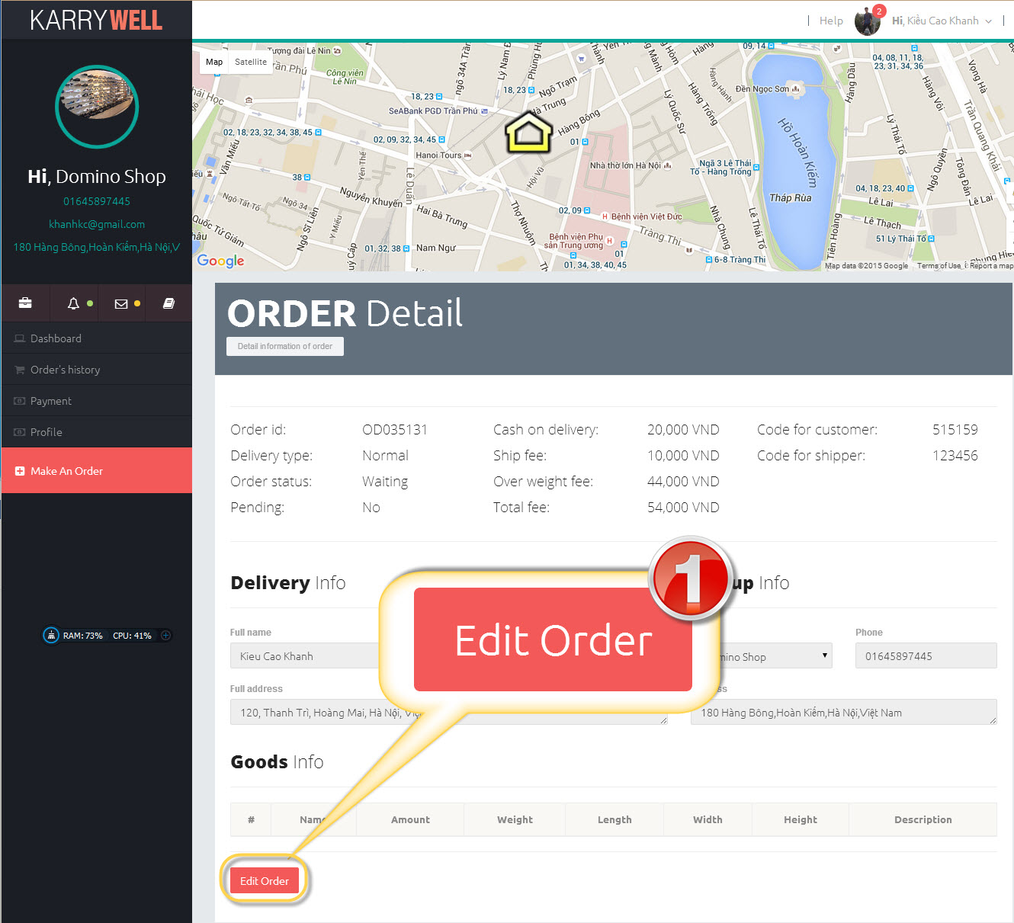

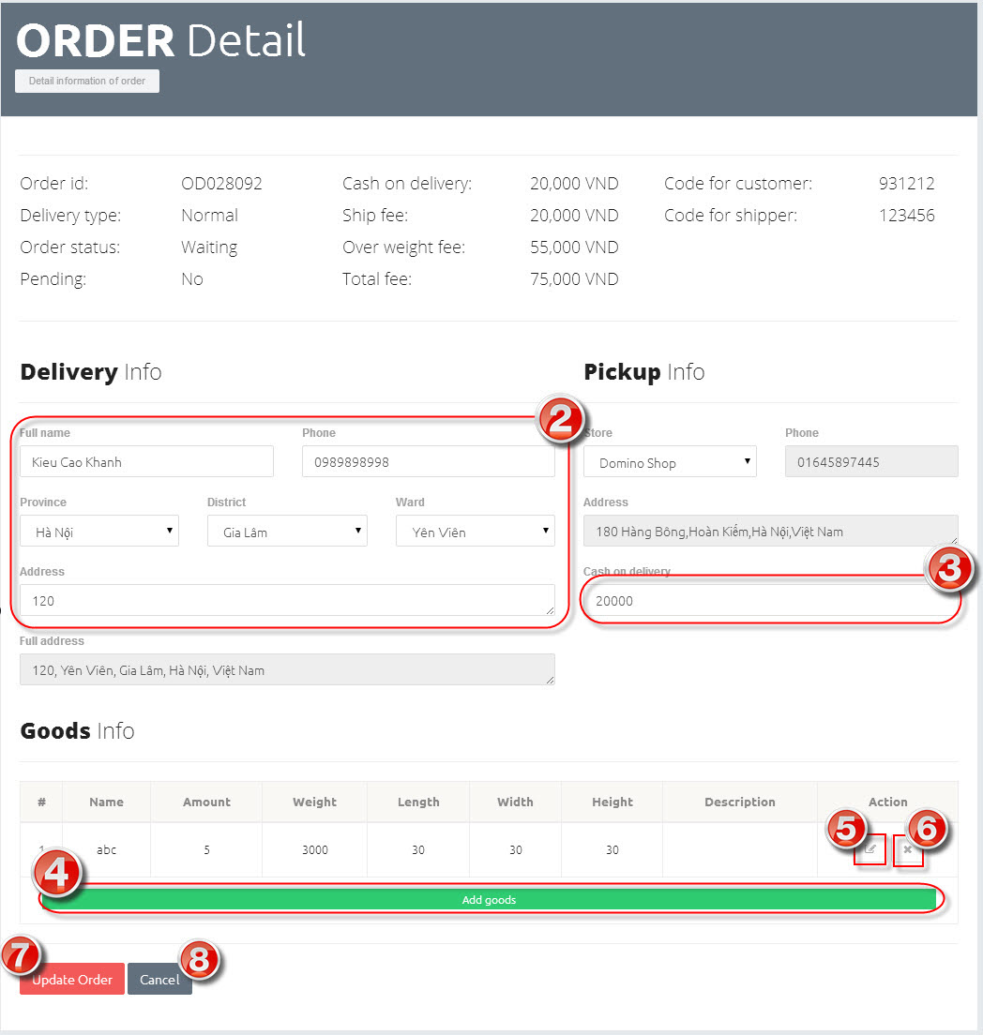

**\* Note:** You can only edit orders that have not been grabbed yet by any shipper or in status “Waiting”

**To view detail of an order:**

**Step 1.** Click on “Edit Order” button (➊). The elements on “Order detail” screen will be enable.

**Step 2.** Edit information of order in text boxes in (➋) and (➌).

**Step 3.** Click on “Add goods” button (➍) to add new goods (see 3.2.5.Add a goods), “Edit” button (➎) to edit a goods (see 3.2.6: Edit a goods) and “X” button (➏) to delete a goods (see 3.2.7. Delete a goods).

**Step 4.** Click on “Update order” button (➐) to update your change or click on “Cancel” button (➑) to discard the change.

2.1.2.12. Search



In each view list screen, there is a search tool to help user to search faster. Store can use this tool to search order or transaction history.

**Screen Description:**

1. Click ➊ to show calendar to pick date
2. Click ➋ to clear date in textbox ➊
3. Click ➌ to choose which type of date will be searched, and some screens don’t have this
4. ➍ Start Date of date range
5. ➎End Date of date range
6. Click ➏ to apply date range after choose start date and end date
7. Click ➐ to Cancel
8. Click ➑ to show filter for search
9. Enter search key into textbox ➒ to search

**To search by date range**

1. Choose date type ➋. If screen doesn’t have drop down list ➋, default type of search date is which type of date in table below
2. Click date range textbox ➊ to pick date
3. Click start date and end date
4. Click “Apply” button ➏, then result will be displayed

**To search by word**

1. Choose type to filter ➑. “All” is search by all information in table below

Enter search key into textbox ➒. Whenever type any key in search textbox, result will be displayed immediately

2.1.2.13. Find a shipper

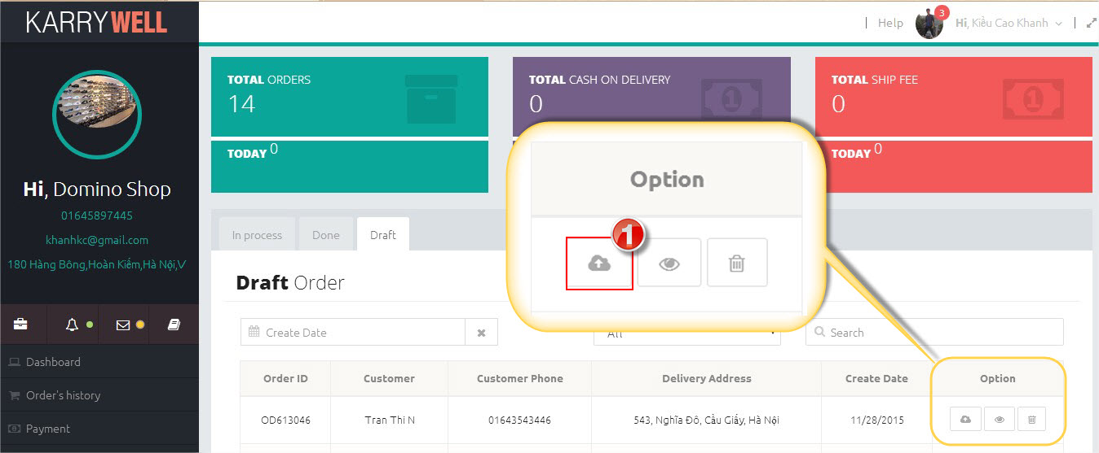

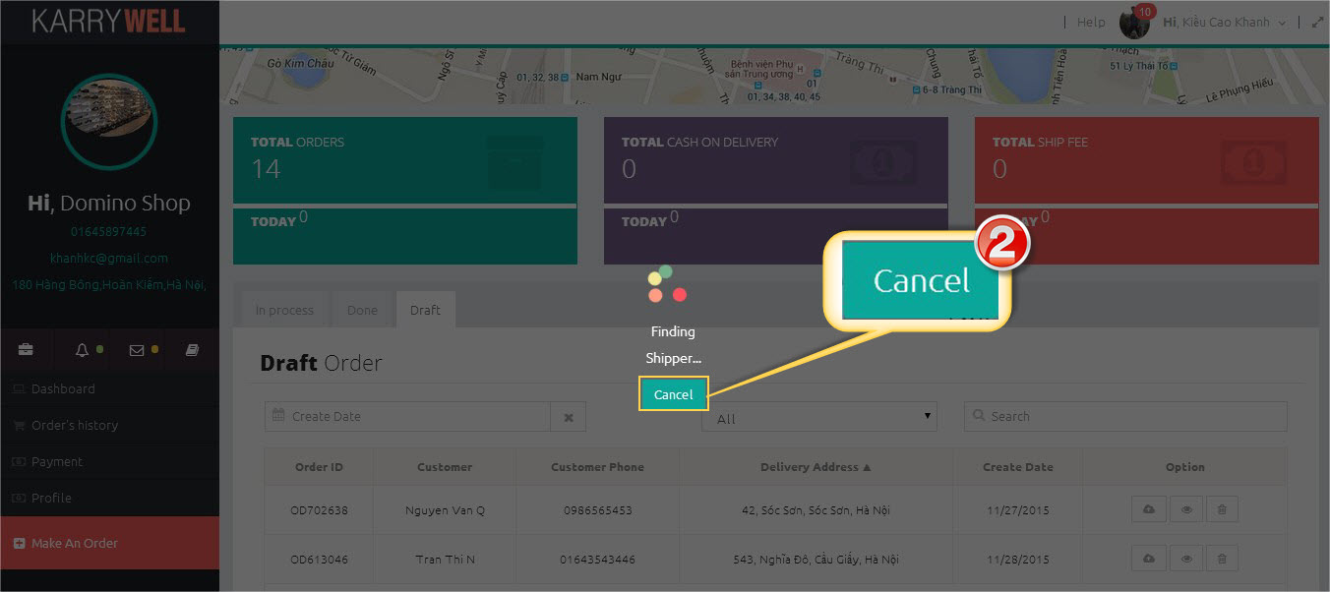

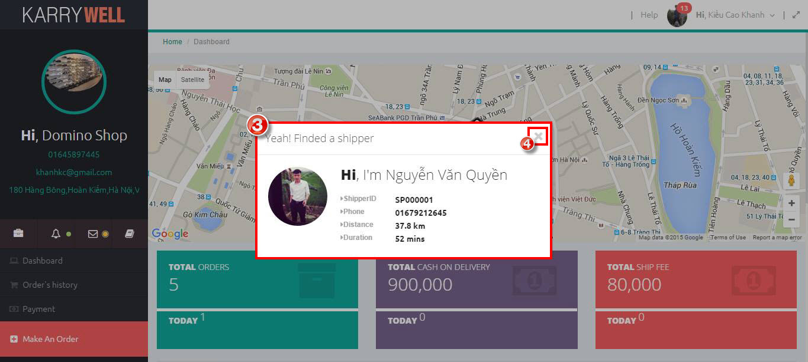

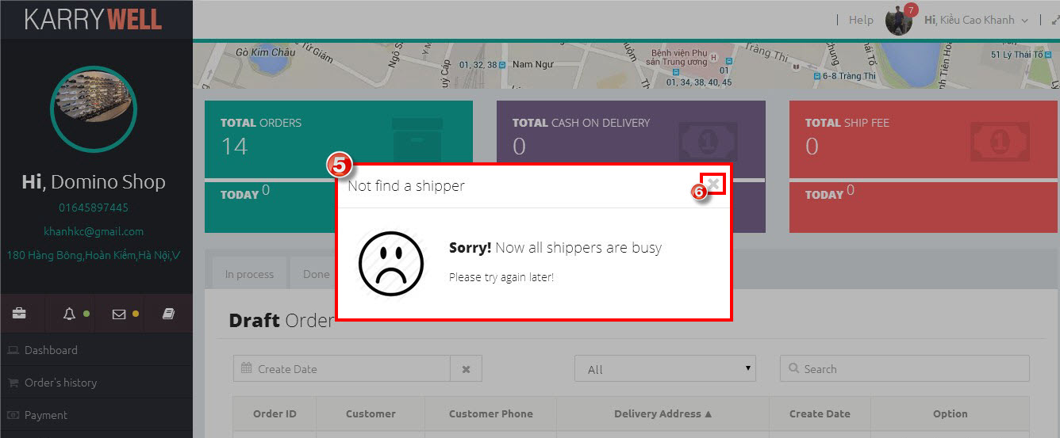

**To find a shipper:**

To find a shipper, **c**lick on “Submit” button (➊). “Find shipper” screen will appear. You can click on “Cancel” button (➋) to cancel finding process.

If finding process is successful a popup will appear (➌). This popup contain information of shipper who’ll come to pick up your goods. Click on “X” button (➍) to close popup.

If finding process is fail a popup will appear (➎). Click on “X” (➏) to close popup.

2.1.2.14. Sign out

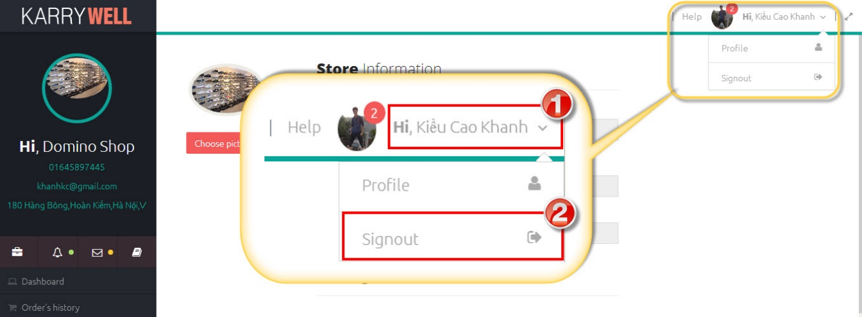

**To sign out:**

**Step 1:** Click on your name on header (➊). A menu will appear.

**Step 2:** Click on “Sign out” item (➋) to sign out.

**2.2. Mobile Application**

This document guides you how to use Karry Well application. You will need only 10 minutes to learn.

2.2.1. Select

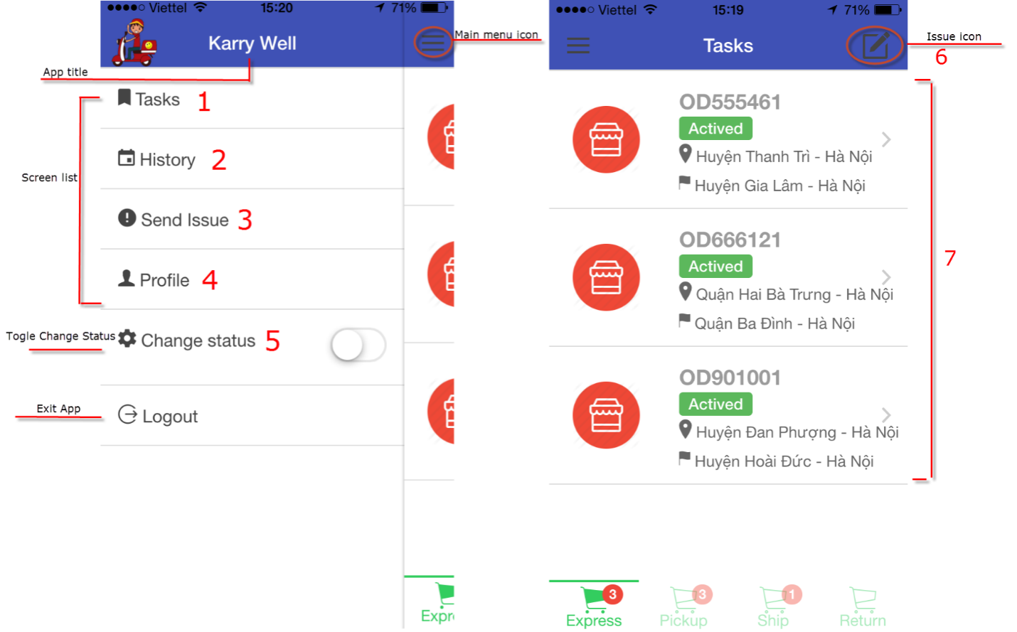

**To select a screen**

1. Tap on Main Menu icon on the upper left corner. The Main Menu will show listing all screen of the application.
2. Tap on the screen that you want to use.

* (1) Tasks Screen: used to view tasks of user.
* (2) History Screen: user want to review history.
* (3) and (6) Send Issue Screen: used to send issue to Admin. When user was issued, then user can send their issue.
* (4) Profile Screen: used to view profile of user.
* (5) Change status Screen: used to change status of user. User want to switch his status between ready to work or not ready.
* (7) Detail Screen: used to view detail of Task. User tap on item, then application redirect to detail screen.

2.2.2. Login

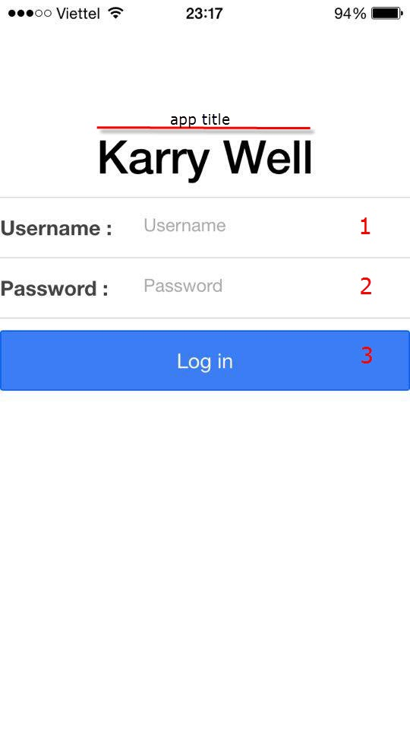

**To Sign-In to Application**

1. Type the text in the text field (1).
2. Type the text in the text field (2).
3. Tap on ‘Login’ button (3).

2.2.3. View Tasks

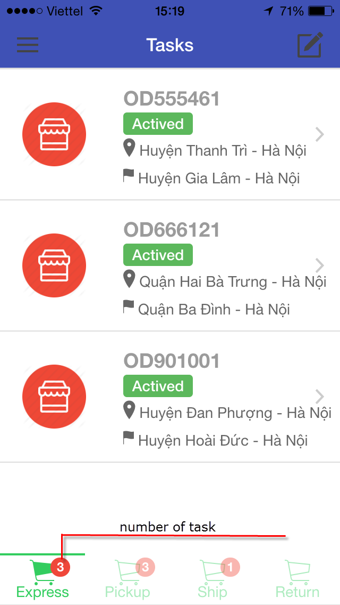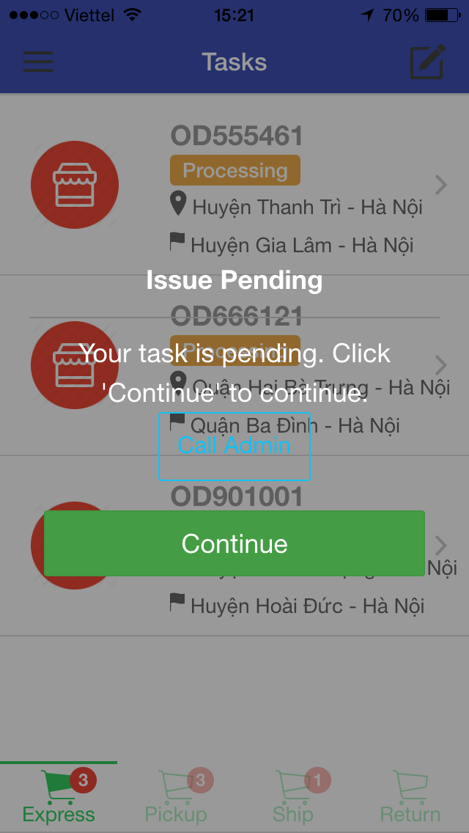

- To view Tasks screen, select Tasks screen from Main Menu (refer 2.1).

- To view detail information of task by tap on each task.

- To view type of task by tap on each tab (Express, Pickup, Ship, Return).

- To view Issue Pending Dialog, send issue from Send Issue Screen (refer 2.4).

To continue user of task

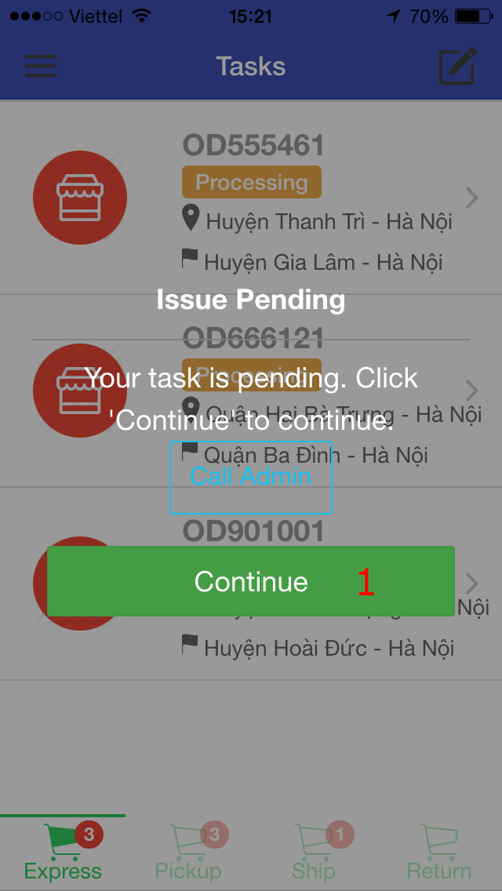

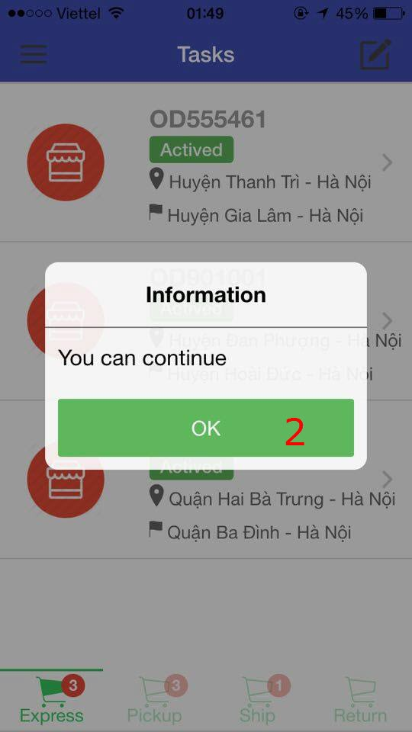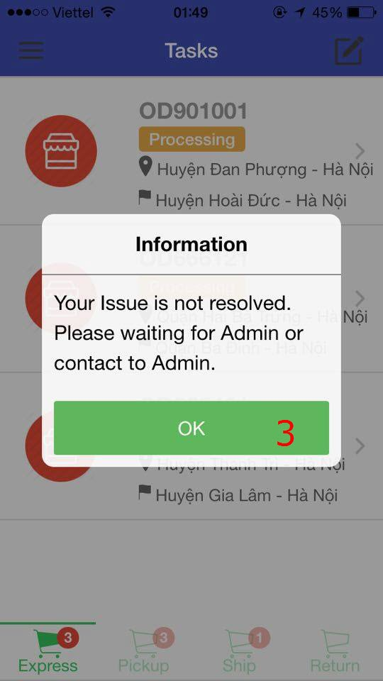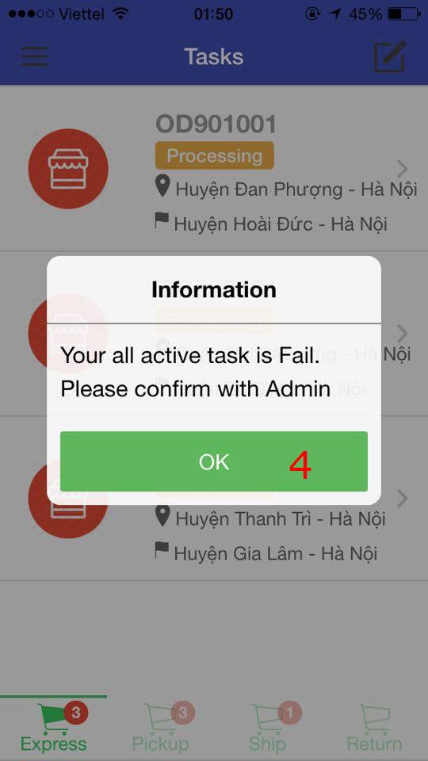

1. Tap on ‘Continue’ button screen (1).
2. If Admin accept for user continue their task, A Dialog (2) appear with content: You can continue.

If Admin haven’t resolve that issue, A Dialog (3) appear with content: Your Issue is not resolved, please waiting for Admin or contact to Admin.

If Admin reject that issue and assign task to other user, A Dialog (4) appear with content: Your all active task is fail. Please confirm with Admin.

1. Tap OK button of the confirmation of dialog.

2.2.4. Send Issue

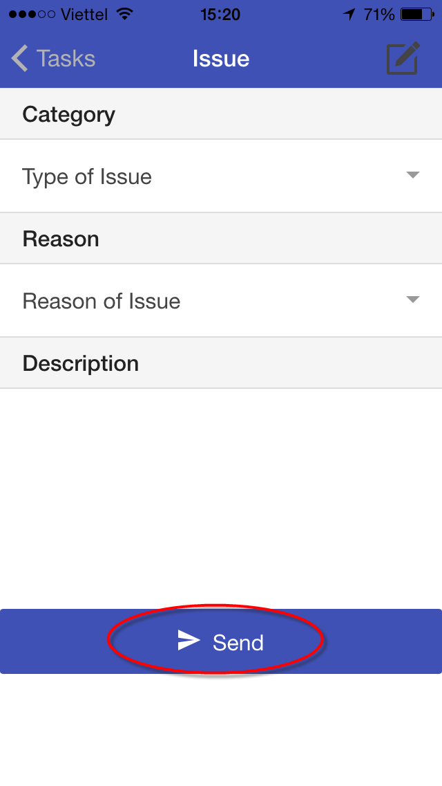

**To Send Issue’s information to Admin**

1. Tap on Category Dropdown list. (Pending, Cancel).
2. Tap on Reason Dropdown list (Traffic jam, Vehicle, Accident, Good is Broken, Cannot contact with customer).
3. Type Description.
4. Tap Send button

2.2.5. View DetailTask

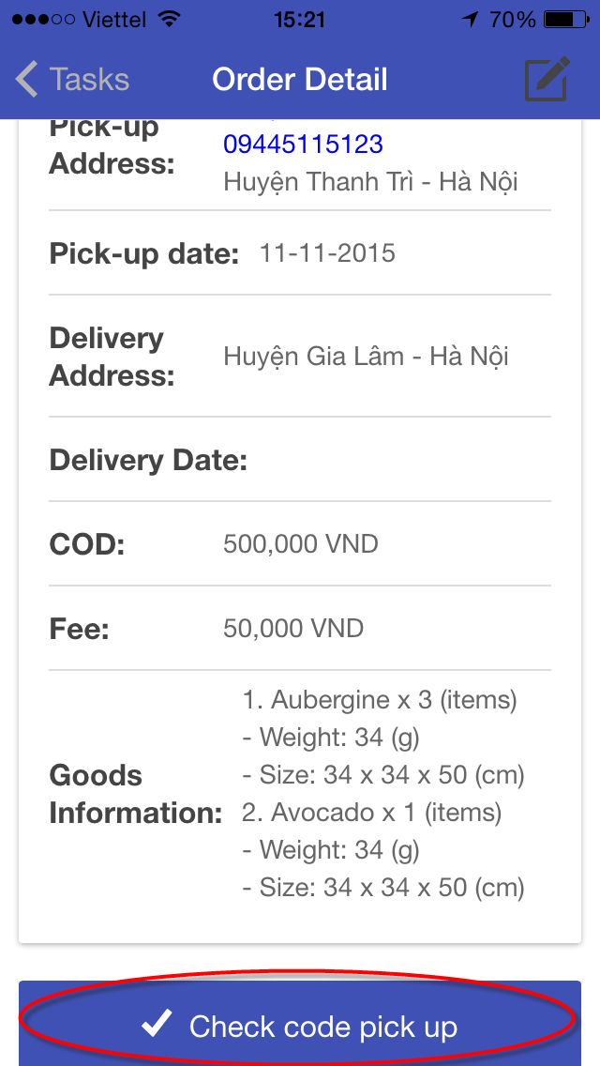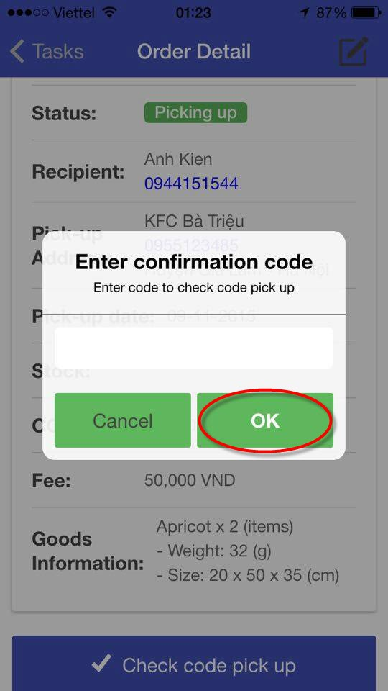

To view Detail’s Task screen, tap on item in list of Task from Tasks screen (see 2.3).

**To check code for Order**

1. Tap Check code pick up button at the end of Detail’s Task screen.
2. Type code on text box of confirmation code.
3. Tap OK button.

2.2.6. View History

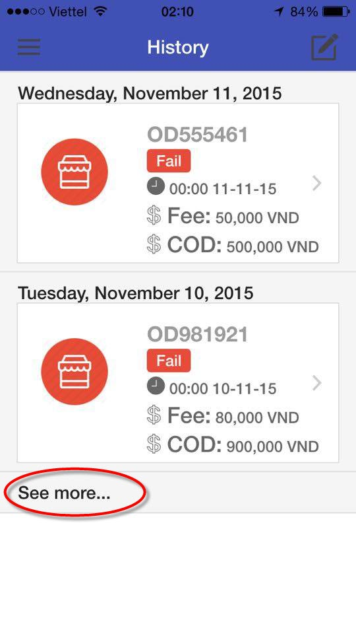

- To view History screen, select History screen from Main Menu (refer 2.1).

- To view detail information of task by tap on each item.

- To view more list of history by tap on See more button.

2.2.7. Change Working Status

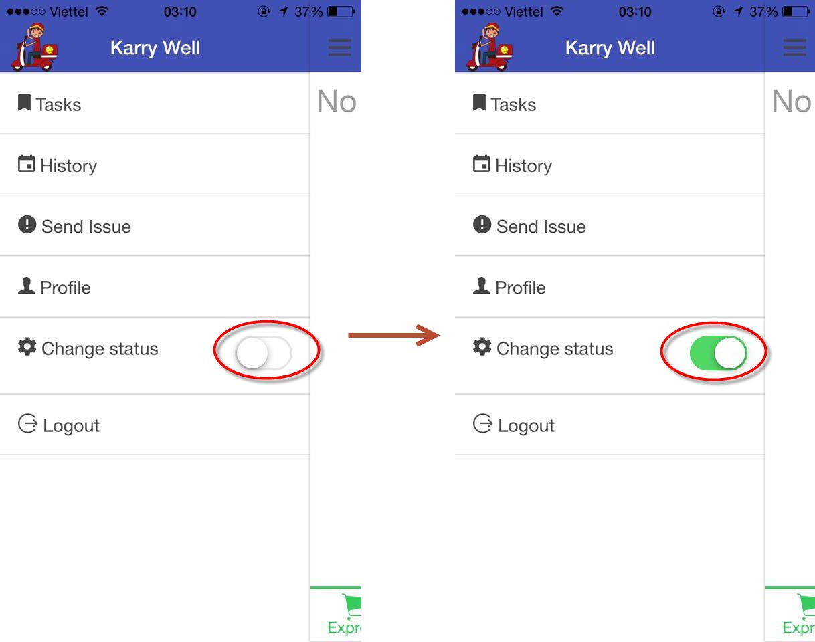

- To change status of current user, tap on toggle Change status.

2.2.8. Grab Order

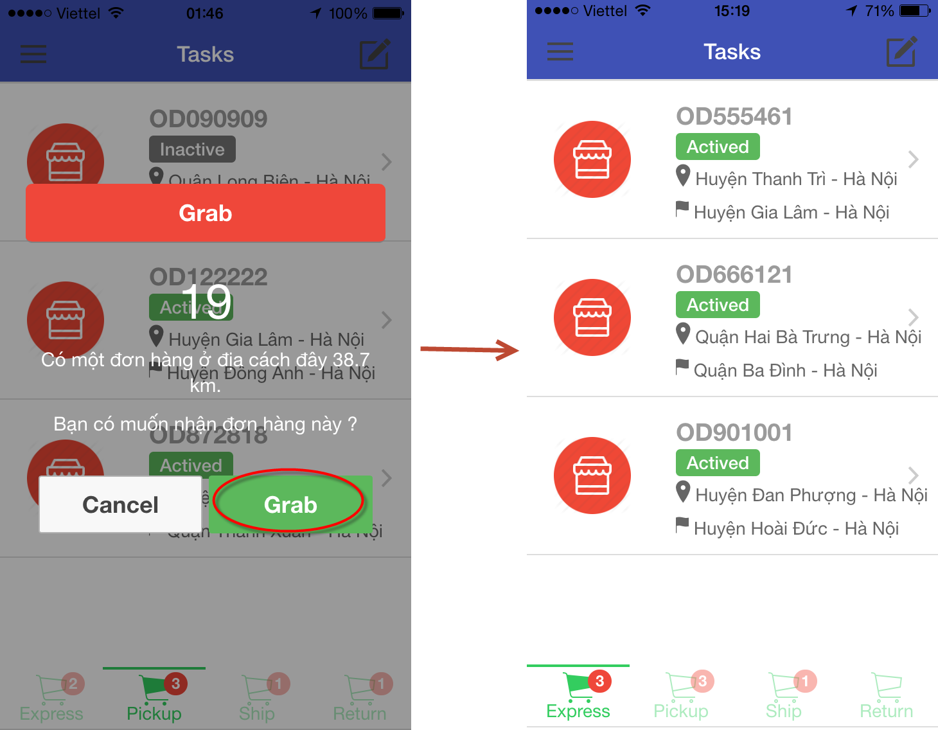

- Tap on Grab button, Task have recently grab, it will appear at tab Express of Task screen.

# VII. CONCLUSION

# 1. LESSONS LEARN

This project is wonderful opportunity for us to apply all knowledge and skills that we have studied. This project also is first time all team members have worked together to create own software and execute it in specific development process. During the project, there was pressure, misunderstanding and unexpected problems so we have tried our best to study new technology and resolve a lot of problems. Especially, we have learned a lot of things from this project: technical knowledge, working in team together, experience in document writing, communication skill, project management skill, planning skill and improved our skills and knowledge. We are really happy that we completed the product as expected.

# 2. FUTURE WORK

Although completed the product, we want more time to improve our product. We plan to develop API for store, stock manage function, pay fee via banking service,…

Besides, we want to improve infrastructure and quality of product. So we will develop system to everyone and help them have better servic